**Chichester District Council**

**Community Infrastructure Levy Charging Rates for 2023**

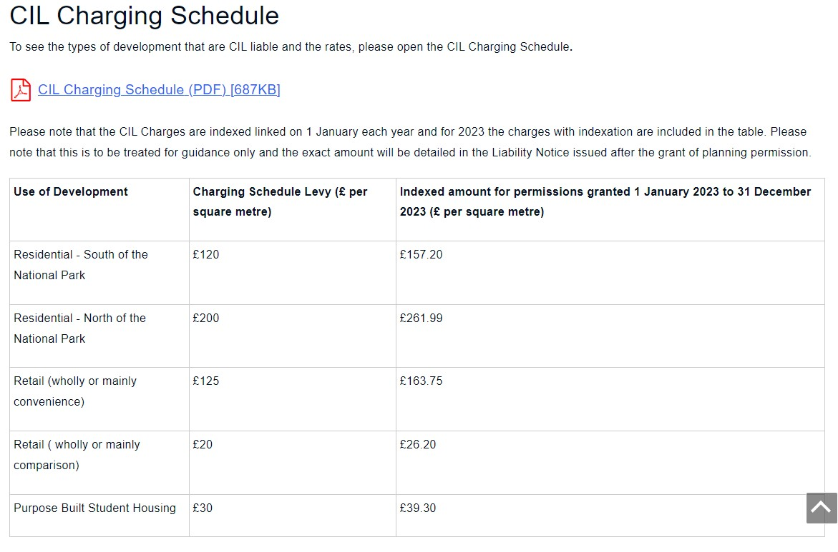

**Community Infrastructure Levy Charging Rates for 2022**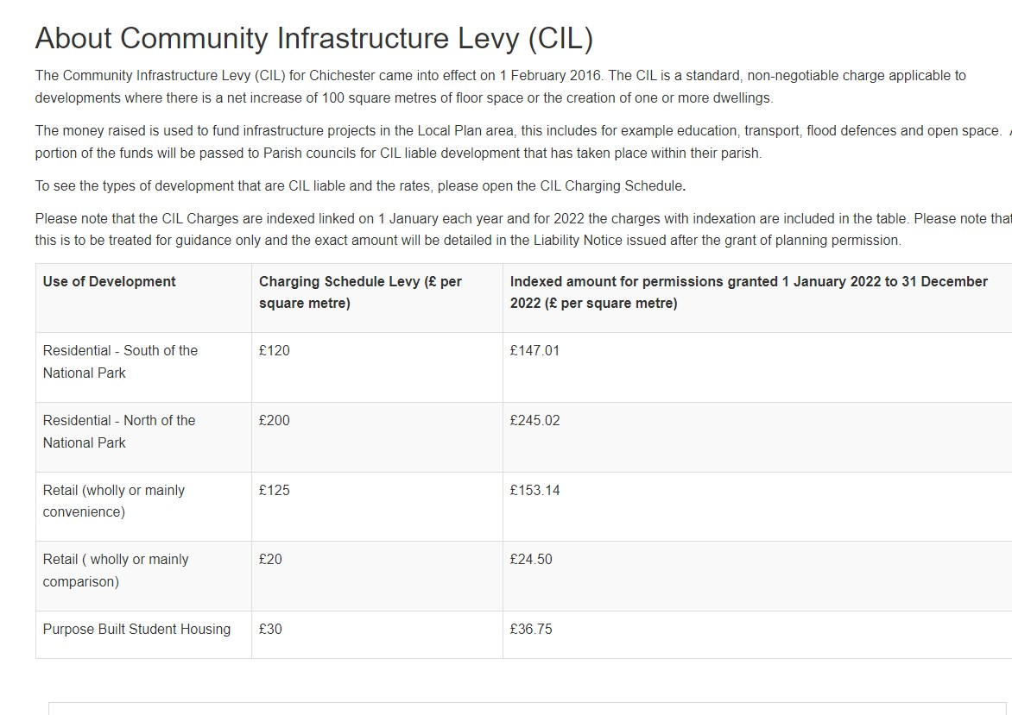

**Community Infrastructure Levy Charging Rates for 2021** **Table showing Community Infrastructure Levy charging rates for 2023
1**

**Community Infrastructure Levy Charging Rates for 2020**

