|  |  |
| --- | --- |
| To Let: Retail Unit  Shop 4, Flat 10 and Garage 12  Crossfield, Fernhurst, GU27 3JL | Chichester District Council emblem |

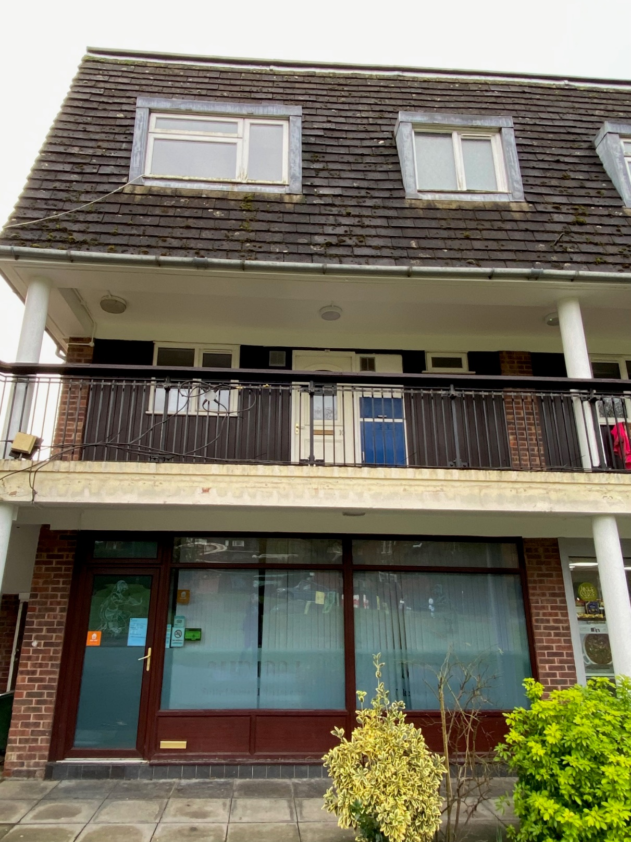

## Description and location

The Crossfield shopping parade is located off of Vann Road in Fernhurst which is around 18 miles north of Chichester. The parade comprises 6 lock up retail units at ground floor level with residential accommodation on the two upper floors, each let with a single garage unit in a nearby block. Shop 4 on the ground floor measures 47.37 sq m (510 sq ft). The first and second floor maisonette comprises a hallway, living/dining room, kitchen, WC and small roof terrace on the first floor with 3 bedrooms and a separate bathroom/WC on the second floor.

## Use

The previous use of the premises was as an Indian Takeaway. The permitted use of the ground floor under the Town and Country Panning (Use Classes) order 1987 as amended by the Changes to the Use Classes Order and General Permitted Development Order April 2005 is Class A3 – Restaurant and Takeway. A number of alternative uses may be appropriate (subject to landlord’s consent and planning permission). The use must however be complementary to the use of the other shops in the parade.

## Terms

The property is available to let by way of a new 10 year (effectively) full repairing and insuring lease at a guide price of between £16,500 p.a and £17,500 p.a. exclusive. The lease will be contracted out of the security provisions of the Landlord and Tenant Act 1954 Sections 24-28.

## Energy Performance Certificate (EPC)

The shop premises has an EPC rating of B.

The Flat has an EPC rating of E.

Rates/ Council Tax

4 Crossfield

Rateable Value: £6,100

The current tax year’s charge is **£3,096.55**

Please refer to the Council’s website for more information:

[Business rates - Chichester District Council](https://www.chichester.gov.uk/businessrates)

Flat 10 Crossfield

The current Council tax year’s charge is **£1,642.15 (Band B)**

## Repairs and maintenance

The tenant is to be responsible for all repairs other than those that are the subject to a service charge or recharge of the Council’s costs of undertaking the work on a common basis.

## Service charge

There is an annual service charge payable to cover external repairs and maintenance of the parade and common parts.

## Outgoings

The lessee will be responsible for rates, utilities, reimbursement of the insurance costs, insurance of contents and any other outgoings that may be applicable.

## Rent deposit / guarantee

The Council will require both a rent deposit and a guarantor as guarantee for the rent and the tenant’s leasehold obligations.

## Viewing

Prospective tenants wishing to be considered for a tenancy of this property should contact the Estates Service at;

[estatesservice@chichester.gov.uk](mailto:estatesservice@chichester.gov.uk)

<https://www.chichester.gov.uk/commercialproperty>

Chichester District Council

East Pallant House

1 East Pallant

Chichester

West Sussex, PO19 1TY

01243 534632

Viewing is by appointment only.

## Costs

The incoming tenant will be responsible for the Council’s Legal and Surveyors costs in the preparation and granting of this lease.

Chichester District Council declares that (1) these particulars are set out as a general outline only and do not constitute part of any offer or contract (2) all descriptions, dimensions, reference to condition and other details are given without responsibility on the part of the Council and prospective purchasers/lessees must satisfy themselves as to their correctness and in particular no services or appliances mentioned have been tested (3) the Council nor any person in their employment has any authority to make or give any representation or warranty in respect of the property'

## 

## Location Plan (not to scale)

Shop 4, Flat 10 and Garage 12 Crossfield, Fernhurst

|  |  |
| --- | --- |
|  |  |