**Hackney Carriage and Private Hire Licensing 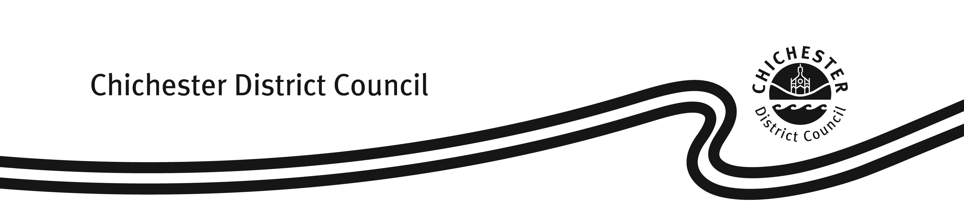Fees & Charges**

**Fees and charges with effect from 1 April 2024**

|  |  |
| --- | --- |
| **Hackney Carriage/ Private Hire/ Dual Driver’s Licence** | |
| Application Fee (1 year licence) | £166.00 |
| Renewal Fee (1 year licence) | £134.00 |
| Application Fee (3 year licence) | £369.50 |
| Renewal Fee (3 year licence) | £337.50 |
| Knowledge Test – 1st test per round of 3 | £48.50 |
| Knowledge Test – Resit | £23.50 |
| DAVIS DVLA Driving Licence Check  (1 year licence) | £3.50 |
| DAVIS DVLA Driving Licence Check  (3 year licence) | £10.50 |
|  | |
| **Hackney Carriage/ Private Hire Vehicle Licence** | |
| Application Fee (inc standard/ exemption plate) | £137.50 |
| Renewal Fee | £137.50 |
|  | |
| **Private Hire Operator’s Licence** | |
| Application Fee (1 year licence) | £215.50 |
| Renewal Fee (1 year licence) | £182.50 |
| Application Fee (5 year licence) | £825.00 |
| Renewal Fee (5 year licence) | £794.00 |
|  | |
| **Miscellaneous Charges** | |
| Replacement copy of paper licence | £12.50 |
| Driver badge or driver/ vehicle internal ID replacement | £10.50 |
| Private hire door badges (two required per vehicle) | £7.00 |
| Transfer of vehicle ownership/ licence | £28.00 |
| Vehicle plate replacement (inc standard & exemption plates) | £18.50 |
| Change of Vehicle Registration Mark | £31.00 |

Fees and charges from 1 April 2024 recommended by General Licensing Committee at its meeting on 28 February 2024 and subsequently approved by Cabinet on 5 March 2024.

Fees (v2) (01.04.2024)