**APPENDIX D**

**Hackney Carriage and Private Hire Licensing 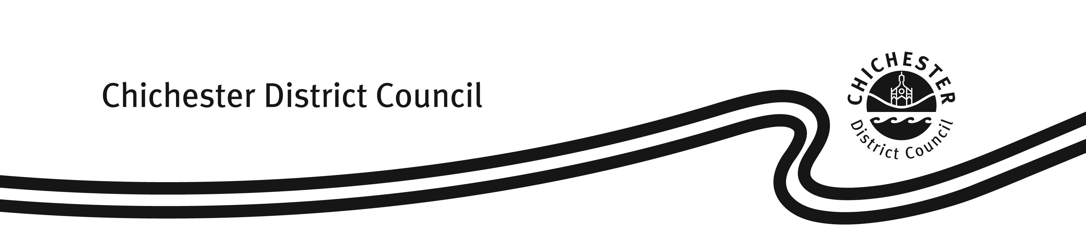Fees & Charges**

**Fees and charges with effect from 1 April 2025**

|  |  |
| --- | --- |
| **Hackney Carriage/ Private Hire/ Dual Driver’s Licence** | |
| Application Fee (1 year licence) | £196.71 |
| Renewal Fee (1 year licence) | £158.79 |
| Application Fee (3 year licence) | £437.86 |
| Renewal Fee (3 year licence) | £399.94 |
| Knowledge Test – 1st test per round of 3 | £57.47 |
| Knowledge Test – Resit | £27.85 |
| DAVIS DVLA Driving Licence Check  (1 year licence) | £3.50 |
| DAVIS DVLA Driving Licence Check  (3 year licence) | £10.50 |
|  | |
| **Vehicle Licence** | |
| Application Fee (inc standard/ exemption plate) | £162.94 |
| Renewal Fee | £162.94 |
|  | |
| **Operator’s Licence** | |
| Application Fee (1 year licence) | £255.37 |
| Renewal Fee (1 year licence) | £216.26 |
| Application Fee (5 year licence) | £977.63 |
| Renewal Fee (5 year licence) | £940.89 |
|  | |
| **Miscellaneous Charges** | |
| Replacement copy of paper licence | £14.81 |
| Driver badge or driver/ vehicle internal ID replacement | £12.44 |
| Private hire door badges (two required per vehicle) | £8.29 |
| Transfer of vehicle ownership/ licence | £33.18 |
| Vehicle plate replacement (inc standard & exemption plates) | £21.92 |
| Change of Vehicle Registration Mark | £36.73 |

Fees and charges from 1 April 2025 recommended by General Licensing Committee at its meeting on 28 February 2024 and subsequently approved by Cabinet on 5 March 2024.