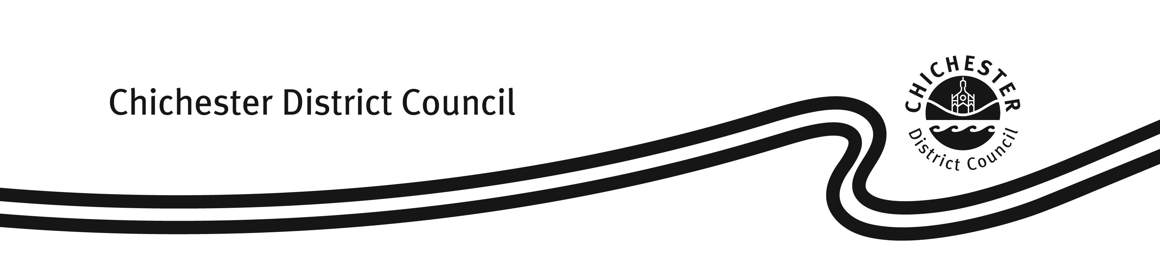

**APPENDIX D**

**Hackney Carriage & Private Hire Licensing Fees & Charges**

**With effect from 5 June 2025**

|  |  |
| --- | --- |
| **Hackney Carriage/ Private Hire/ Dual Driver’s Licence** | |
| Application Fee (1 year licence) | £216.00 |
| Renewal Fee (1 year licence) | £174.50 |
| Application Fee (3 year licence) | £481.50 |
| Renewal Fee (3 year licence) | £439.50 |
| Knowledge Test – 1st test per round of 3 | £63.00 |
| Knowledge Test – Resit | £30.50 |
| DAVIS DVLA Driving Licence Check (1 year licence) | £3.50 |
| DAVIS DVLA Driving Licence Check (3 year licence) | £10.50 |
| **Hackney Carriage/ Private Hire Vehicle Licence** | |
| Application Fee (inc standard/ exemption plate) | £179.00 |
| Renewal Fee | £179.00 |
| **Private Hire Operator’s Licence** | |
| Application Fee (1 year licence) | £280.50 |
| Renewal Fee (1 year licence) | £237.50 |
| Application Fee (5 year licence) | £1,075.00 |
| Renewal Fee (5 year licence) | £1,034.50 |
| **Miscellaneous Charges** | |
| Replacement copy of paper licence | £16.00 |
| Driver badge or driver/ vehicle internal ID replacement | £13.50 |
| Private hire door badges (two required per vehicle) | £9.00 |
| Transfer of vehicle ownership/ licence | £36.50 |
| Vehicle plate replacement (including standard & exemption plates) | £24.00 |
| Change of Vehicle Registration Mark | £40.00 |
| Reissue of a paper licence, driver badge and driver internal ID following a statutory right to work check | £43.50 |
| Issue of a paper licence, driver badge and driver internal ID (where the licence holder holds both a Private Hire and Hackney Carriage Driver’s Licences) | £43.50 |

Fees & charges from 5 June 2025 approved by General Licensing Committee on 4 June 2025