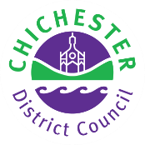

Where to Park

Chichester & District
2024-2025

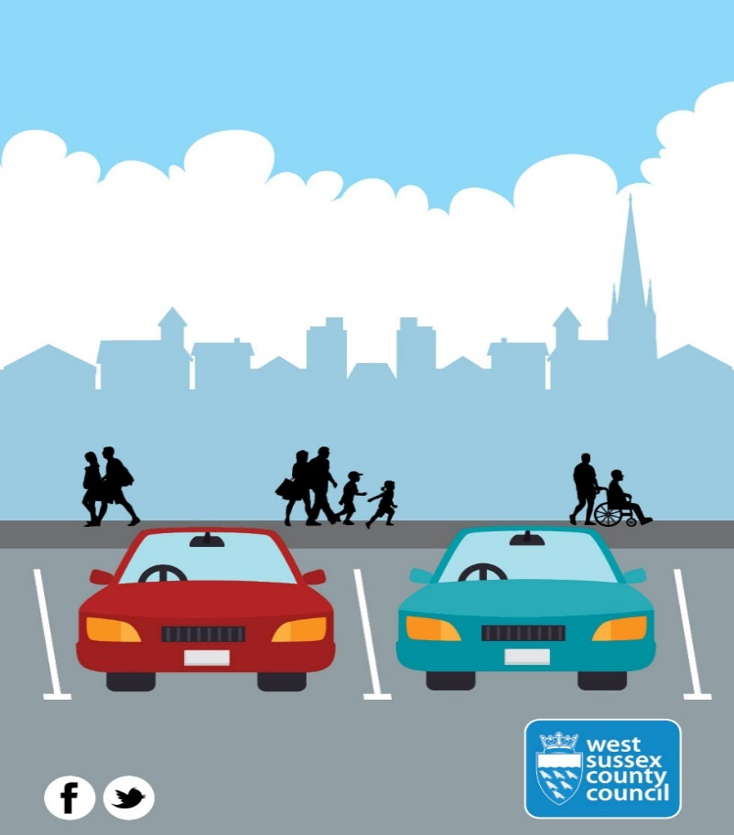

Chichester District Council is responsible for 31 car parks in
the district and provides on-street parking enforcement on
behalf of West Sussex County Council.

Electric Vehicle Charging Points
There are eighteen electric vehicle charging points located across many of our car parks:
- Avenue de Chartres car park, Chichester
- Bosham Lane car park, Bosham
- East Pallant car park, Chichester
- East Street car park, Selsey
- Northgate car park, Chichester
- Northern Crescent car park, East Wittering
- North Street car park, Midhurst
- Pound Street car park, Petworth
For information about how to sign up to use the charging points, please visit: https://uk.mer.eco/

Pay on Foot Parking
The Avenue de Chartres car park operates a barrier entry system. Customers can park for as long as needed and pay for parking before returning to their vehicle and leaving the car park.

On Street Pay & Display
There are 29 On-Street Pay & Display machines installed throughout Chichester City Centre. These enable convenient, short-term parking for up to 1 hour.
Season Tickets
Season tickets can be purchased for a number of our car parks. For more information, please visit our website: https://www.chichester.gov.uk/seasontickets

Cashless Pay & Stay Using MiPermit
In addition to cash, contactless and card payments in many of the car parks, MiPermit offers customers the following choices to pay for parking:
- Your mobile phone by SMS
- The smartphone application
- Online, or
- By telephone

Each of our car parks has a ‘Location Code’ which identifies where you are parking. The Location Codes are 6-digit codes which are stated on the Charges Boards or at machines within the car parks. Use the MiPermit App (available from your App store) or visit http://kb.mipermit.com/en/

Parking for Disabled Badge Holders
To help people with disabilities gain easy access to the city, most Pay and Display car parks have specially allocated parking spaces. These spaces, along with any others in the Pay and Display car parks can be used free of charge (excluding Avenue de Chartres), provided the vehicle is displaying a valid blue badge or foreign disabled badge and the registered disabled person is driving or is a passenger. Blue badge holders can park without time limit in on-street pay and display or limited waiting bays while clearly displaying a valid blue badge. A parking disc/clock must be displayed with a blue badge when parking on yellow line waiting restrictions for up to 3 hours. Please see www.chichester.gov.uk/parking for more information.

Motorcycle Parking
Free motorcycle parking facilities are available in designated areas in the Cattle Market, Northgate, Little London, South Pallant and East Pallant car parks. Baffins Lane and Westgate car parks have free and secure motorcycle parking. Alternatively, motorcycles can park in any of the Pay and Display car parks within a marked bay, providing the appropriate charge is paid. The MiPermit facility is also available to pay for motorcycle parking. Motorcyclists are also able to use city centre on-street Pay and Display parking bays, free of charge and without time limit if they are parked at right angles to the kerb.

Civil Enforcement Officers
Chichester District Council has a dedicated team of Civil Enforcement Officers helping to sustain parking control measures. Their work also helps maintain safety on the Highway, eases the flow of traffic and ensures that motorists have fair access to parking spaces.

If you see a vehicle in possible contravention, please visit our website to make a report using the address below.
www.chichester.gov.uk/reportaparkingproblem

The Civil Enforcement Officers check pay and display machines each day. If you do find a problem with one of the machines, please contact us on (01243) 534500, or visit the link below:
If you wish to report a parking concern, please visit our website to make a report using the address below.
www.chichester.gov.uk/reportaparkingproblem

Rural & Coastal car park charges

Bosham

Monday to Sunday 8am to 6pm Inclusive
Time parked | Parking charge
Up to 1 hour | £1.10
Up to 2 hours | £2.20
Up to 3 hours | £3.20
Up to 4 hours | £4.30
Up to 6 hours | £4.80
Up to 24 hours | £5.40
Up to 48 hours | £7.70
Additional 24 hours | £3.80
Up to 7 days (maximum) | £22.60
Coaches per day | £8.00

Bracklesham Bay - Bracklesham Lane

Monday to Sunday 8am to 6pm Inclusive
Time parked | Parking charge
1 April – 31 October  Up to 2 hours 8am - 6pm | £2.70
Up to 4 hours | £5.20
Up to 10 hours | £6.60
1 November – 31 March  Up to 2 hours 8:00am - 6:00pm | 90p
Up to 10 hours | £2.30

Midhurst – Grange Road

Monday to Saturday 8am to 6pm – Sunday 10am to 5pm
Time parked | Parking charge
Up to 2 hours | Free
Up to 3 hours | £1.20
Up to 4 hours | £1.40
Up to 5 hours | £1.90
Up to 6 hours | £2.20
Up to 8 hours | £2.50
Up to 10 hours | £3.20

Midhurst - North Street / Post Office
Selsey - East Street
Petworth – Pound Street
East Wittering – Northern Crescent

Monday to Saturday 8am to 6pm – Sunday 10am to 5pm
Time parked | Parking charge
Up to 1 hour | Free
Up to 2 hours | 80p
Up to 3 hours | £1.20
Up to 4 hours | £1.40
Up to 5 hours | £1.90
Up to 6 hours | £2.20
Up to 8 hours | £2.50
Up to 10 hours | £3.20

Selsey - East Beach / Marine
*Seasonal charges apply in these car parks, chargeable 7 months.
1 April to 31 October
Monday to Sunday 8am to 6pm Inclusive.

Time parked | Parking charge
Up to 1 hour | 70p
Up to 10 hours | £2.20

West Wittering – Marine Drive

Time parked | Parking charge

Marine Drive - 1 April to 31 October

Monday to Sunday 8am to 6pm Inclusive
Up to 2 hours | £2.70
Up to 4 hours | £5.10
Up to 10 hours | £6.60
Marine Drive - 1 November to 31 March
Monday to Sunday 8am to 6pm Inclusive
Up to 2 hours | 90p
Up to 10 hours | £2.30

Petworth - Sylvia Beaufoy Car Park

Fernhurst – Crossfield Car Park
Time parked | Parking charge
All hours | Free

Places of Interest & Visitor Information
The Tourist Information Centre is in The Novium Museum in Tower Street (PO19 1QH)
For more on their collections and exhibitions please use this link: www.thenovium.org.uk/

Westgate Leisure (PO19 1RJ) offers facilities for all fitness needs. Customers using the centre can also take advantage of two hours free parking.
For more information, please use this link: www.everyoneactive.com/centre/Westgate-Leisure-Centre/

A large Traders’ Market is held on Wednesdays, and a Farmers’ Market is held on the 1st and 3rd Friday of each month - both located on the pedestrian precinct in the city. A Car Boot Sale is held on Sundays within the Cattle Market car park.
For more information: www.chichester.gov.uk/generalmarkets
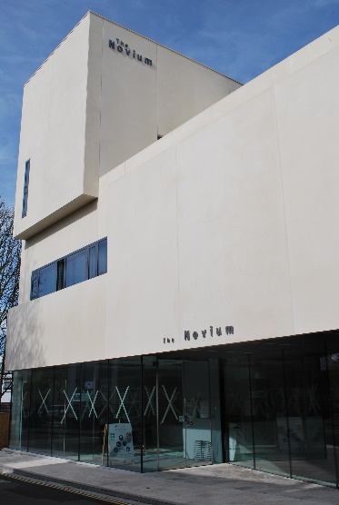

Season Ticket Prices
Season Tickets | Price per Month | Discounts for 6 or 9 months | Discount per Year 12 months for the price of 11
Avenue de Chartres | £57.00 | £324.90 or £477.09 | £627.00
X Roving Season Tickets, valid in all the following car parks-
Basin Road, Cattlemarket, Northgate | £68.00 | £387.60 or £569.16 | £748.00
Part-Time X Roving Season Tickets, valid in all the following car parks-
Basin Road, Cattlemarket, Northgate | £41.00 per month
Specific Season Tickets, valid in only 1 of the following car parks-
Market Road (A)  OR  Orchard Street (D) Season Ticket Section only | £105.00 | £598.50 or £878.85 | £1155.00
1 to 12 months can be purchased in advance

Rural & Coastal Season Tickets
Car Park Specific Season Tickets | Price per month | Annual price
Bosham – Bosham Lane | £26.00 | £312.00
Midhurst - Grange Road | £24.00 | £288.00
Midhurst - North Street
Midhurst - Post office
Petworth - Pound Street
Selsey - East Street
Seasonal Car Parks
*West Wittering – Marine Drive (1 Apr - 31 Oct) | £24.00 | £168.00
*Selsey - East Beach  (1 Apr - 31 Oct) | £24.00 | £168.00

Locations of Chichester District Council Car Parks as numbered on the Map.
- Little London Car Park
- Baffins Lane Car Park
- Orchard Street Car Park (D)
- Sy Cyriacs Car Park
- South Pallant Car Park
- East Pallant Car Park
- St John’s Street Car Park
- Market Road Car Park (A)
- Market Avenue Car Park
- New Park Road Car Park
- Cawley Priory Car Park
- Coach & Lorry Park
- Northgate Car Park
- Cattle Market Car Park
- Basin Road Car Park
- Avenue De Chartres Car Park
- Westgate Car Park

City Centre Short Stay car park charges

Little London (1) / Baffins Lane (2)
Monday to Saturday 8am to 8pm – Sunday 10am to 5pm

Time parked | Parking charge
Up to 1 hour | £2.30
Up to 2 hours | £4.70
Up to 3 hours | £7.00
Up to 4 hours | £9.40
Up to 5 hours | £11.70
Up to 6 hours | £14.00
Up to 8 hours | £16.40
Up to 10 hours | £18.70
Up to 12 hours | £20.00

Orchard Street (P & D area) (3) St Cyriacs (4)
South Pallant (5) East Pallant (6)
St John’s Street (7) Market Road (8)
Market Avenue (9) New Park Road (10)
Cawley Priory (11)
Monday to Saturday 8am to 8pm – Sunday 10am to 5pm
Time parked | Parking charge
Up to 30 mins | 70p
Up to 1 hour | £1.80
Up to 2 hours | £3.50
Up to 3 hours | £5.50
Up to 4 hours | £7.30
Up to 5 hours | £9.20
Up to 6 hours | £11.00
Up to 8 hours | £14.40
Up to 10 hours | £17.10
Up to 12 hours | £18.50

Coach and Lorry Park (12)

Coaches – Monday to Saturday 8am – 5pm, Sunday 10am – 5pm
Maximum stay 24 hours

Overnight Lorries – Monday to Sunday 5pm – 8am

Time parked | Parking charge
Coaches Up to 2 hours | £4.30
Coaches Up to 9 hours | £8.50
Lorry Overnight fee | £8.50

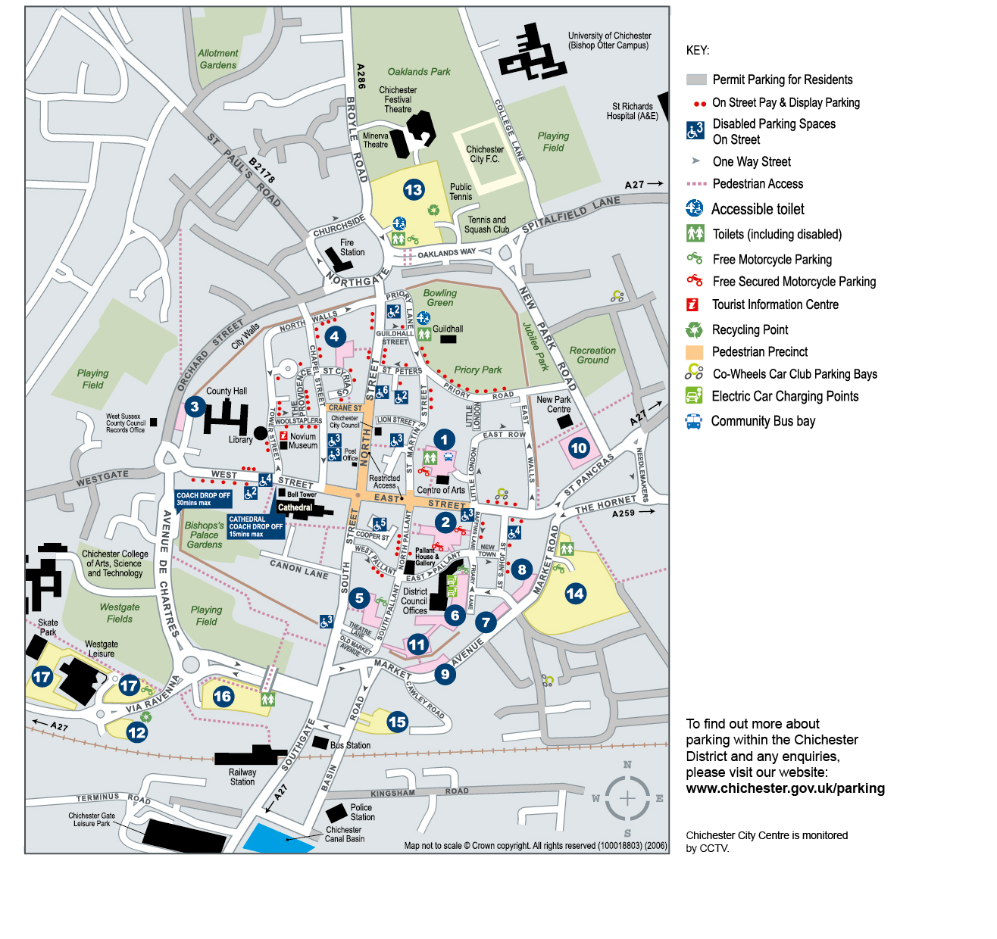

City Centre Long Stay car park charges

Northgate (13) Cattle Market (14) Basin Road (15)
Avenue de Chartres (16)
(13) Monday – Saturday 8am – 8pm
(14) (15) (16) Monday – Saturday 8am – 6pm
(13) (14) (15) (16) Sunday 10am – 5pm
Time parked | Parking charge
Up to 30 mins | 70p
Up to 1 hour | £1.10
Up to 2 hours | £2.20
Up to 3 hours | £3.30
Up to 4 hours | £4.40
Up to 5 hours | £5.40
Up to 6 hours | £6.10
Up to 8 hours | £7.30
Up to 10 hours | £8.40
Up to 12 hours  (Northgate) | £9.50

Westgate (17)

Monday to Saturday 8am to 6pm – Sunday 10am to 5pm
Up to 2 hours free for customers at Westgate Leisure Centre

Time parked | Parking charge
Up to 30 mins | 70p
Up to 1 hour | £1.10
Up to 2 hours | £2.20
Up to 3 hours | £3.30
Up to 4 hours | £4.40
Up to 5 hours | £5.70
Up to 6 hours | £6.70
Up to 8 hours | £8.00
Up to 10 hours | £9.00

Car Park Height Restrictions

Location | Car Park | Height Restriction
Chichester | Avenue De Chartres | 1.93 metres
Chichester | Cattle Market | 2 metres
Chichester | Westgate | 2 metres
Selsey | East Beach | 2.1 metres
Selsey | Selsey Marine | 2.1 metres
West Wittering | Marine Drive (grassed area) | 1.88 metres

