# Appendix D: Density Case Studies Narratives

Table D1: Summary of Cases and Headline Findings

|  |  |  |  |  |  |  |  |  |  |  |
| --- | --- | --- | --- | --- | --- | --- | --- | --- | --- | --- |
| **Site Address** | **App. No.** | **Parish** | **Dev. Scale** | **No. of Dwellings** | **Greenfield / PDL** | **Calculated Net Density (dph)** | **Stated Net Density (dph)** | **NDSS Met?** | **Proximity to Settlement Boundary** | **Walking Time to Train Station** |
| 19 Southgate | 17/03136/FUL / 18/01761/FUL  &  19/01682/FUL | Chichester | Small & Small | 9 (4 flats) and 6 (6 flats) | PDL | 151 & 88 | N/A | Partially | Within | Within 5 mins |
| Graylingwell Hospital (Phase 9a) | 20/02905/REM | Chichester | Strategic | 106 (44 flats) | Greenfield | 48 | 45 | Partially | Within | More than 10 mins |
| Land South of Graylingwell Drive | 17/02571/REM | Chichester | Strategic | 160 (48 flats) | PDL | 32 | 35 | Yes | Within | More than 10 mins |
| Land West of Centurion Way and West of Old Broyle Road (Phase 2B) | 19/01531/REM | Chichester | Strategic | 91 | Greenfield | 39 | 31.5 / 34 | Partially | Within 400m | More than 10 mins |
| Land on the West Side of Boyle Road (Phase 3D) | 19/02626/REM | Chichester | Strategic | 29 (9 flats) | Greenfield | 46 | 39 | Partially | Within 400m | More than 10 mins |
| 49-51 Fishbourne Road | 17/01287/FUL | Chichester | Medium | 37 (32 flats) | PDL | 83 | 60 | Yes | Within | More than 10 mins |
| Land North of Cooks Lane | 22/00157/REM | Southbourne | Large | 199 (8 flats) | Greenfield | 25 | 25 | Partially | Within 400m | Within 5 mins |

**19 Southgate: High Density Retail Conversion and Extension in Sustainable Location**

The development permitted by 17/03136/FUL entailed the change of use of part of the ground and first floors and the creation of a second floor within a retail premises to provide 9 dwellings comprising 5 townhouses/duplexes and 4 flats, achieving a high density (151 dph) scheme within a sustainable and accessible location. The brownfield site is located within the Chichester City Centre and Conservation Area, approx. 200m from the mainline train station, with the retained retail element forming part of the City’s Secondary Shopping Frontage.

During determination, the officer’s report considered the appropriateness of introducing residential accommodation at the site, recognising the overall suitability of the city as a sustainable location. Their comments reflected on the compatibility of residential use with continued retail use, as well as with neighbouring property uses, including a licenced premises and its associated noise impacts. The most significant external changes proposed included the formation of increased bulk at first and second floor level and the introduction of a ‘warehouse’ aesthetic to the rear elevation. The alterations were considered an enhancement to the existing form, and to the character and appearance of the Conservation Area (see Figures 1 and 2 for comparison). The new dwellings do not benefit from any on-site parking, considered acceptable in a highly sustainable location with good access to public transport provision and nearby public car parks.

Having established the principle of residential development, an alternative scheme for the same number of dwellings, albeit entirely flatted rather than a mixed scheme, was approved by 18/01761/FUL. In addition, permitted development rights enabled the creation of 2 further residential flats at second floor level (certified by 18/01477/PLD). Furthermore, 19/01682/FUL was approved for the formation of 6 more flats through internal floorspace creation at second and third floor level, with external alterations limited to the addition of rooflights, dormers and windows. The officer’s report again reflected consideration of residential amenity, assessing the proposed flats to be broadly in line with Nationally Described Space Standards (NDSS), and the provision of private outside spaces or balconies, as well as access to sufficient natural light, offering an acceptable living environment. This study determined, however, that for 2-bedroom flats permitted through both 9 dwelling schemes and the 6-dwelling scheme, the majority failed to meet NDSS on the basis of small Gross Internal Areas (GIA) or bedroom dimensions. By contrast, the originally permitted 3-bedroom duplexes would have met NDSS. Achieving NDSS was not a policy requirement at the time of determination, however. Considered on its own merits, the 6 dwelling scheme was calculated to achieve a density of 88dph. Considered in totality, the development of the site is calculated to have achieved in a high-density residential scheme of approx. 250dph.

Overall, this case illustrates the ability to deliver high density residential development within the city centre that responds to the surrounding historic environment, is commensurate with the surrounding built form in terms of scale, is compatible with neighbouring uses, enables the retention of retail space, and benefits from accessibility to sustainable travel modes. The incremental nature of the applications, however, suggests achieving high density was not a key objective from the outset, rather a result of the developer responding to opportunities to ensure the viability of the scheme. As a result of this iterative approach, compromises to amenity standards (as quantified by NDSS) have occurred.

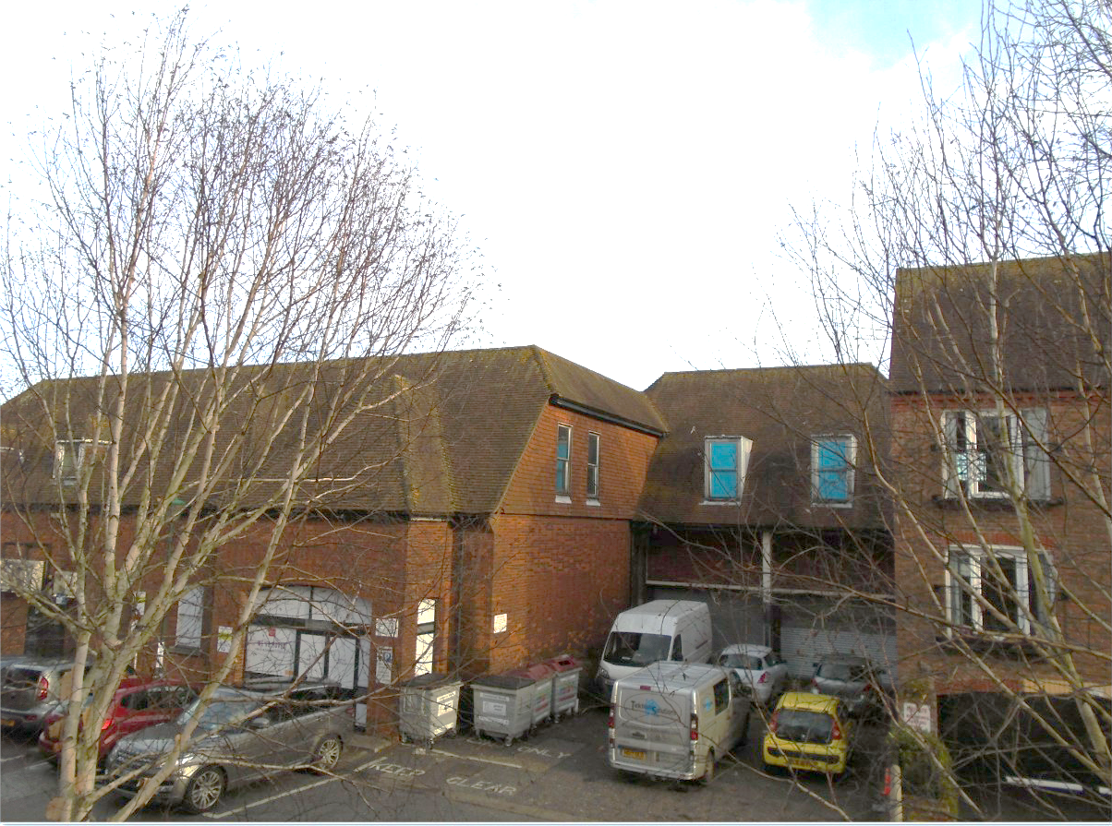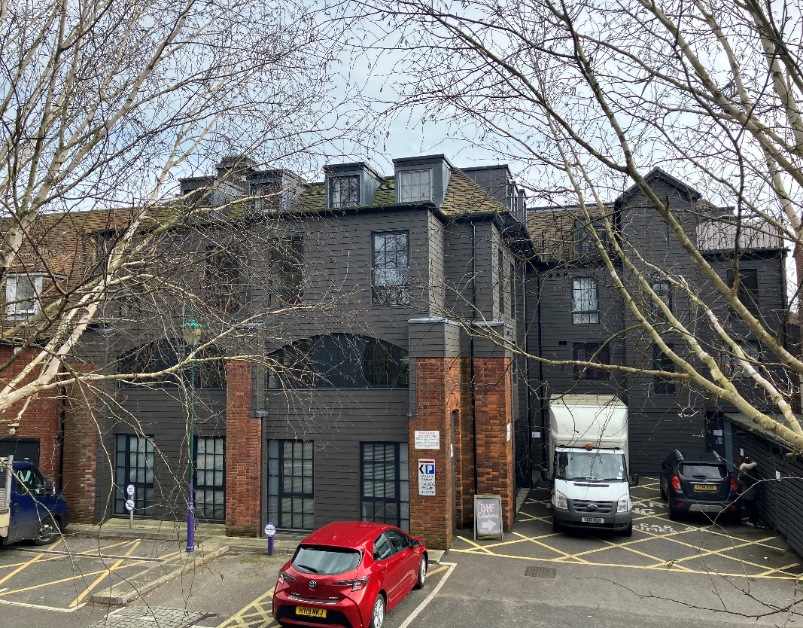

Figures D1 and D2: Photographs of 19 Southgate rear elevation pre- and post-development.

**Chichester City North: New Development in Historic Strategic Location**

The Graylingwell Hospital development is a strategic development of 750 dwellings to the north of Chichester City centre, within the Chichester settlement boundary. It is part of Chichester City North, a focus area for substantial new development as described by Policy 14 of the adopted Local Plan. The overall site generally constitutes previously developed land, consisting of former hospital buildings, other listed buildings, a scheduled monument, and the Grade II registered park and gardens in which they sit. Much of the development site is within the Graylingwell Conservation Area, with notable views towards the Grade I Chichester Cathedral. Residential development within the site has involved the conversion of a number of retained historic hospital buildings, and several new build phases. The broader development has been recognised for its successful delivery of increased residential density in a historic environment[1]. Historic England (HE) noted the importance of characterisation studies to the identification of distinct zones within the site, enabling the creation of an integrated development which was considered to optimise the historic character while intensifying use, providing housing densities ranging from 25 dph around key buildings and the rural edge, to 65-75 dph within the inner core.

Application 20/02905/REM concerned appearance, landscaping, layout and scale for Phase 9a of the strategic development, permitting 106 new dwellings (62 houses and 44 flats) within the southeast sector of the Graylingwell Estate. The site’s greenfield location, slightly separated from the main estate, was considered to enable a higher density development and more traditional design that that developed within more sensitive areas of the strategic location to accommodate retained historic assets. The calculated net density for the Phase 9a development is 48 dph, determined from a net development area of 2.21ha (reduced from the gross site area of 3.32ha). The net site area quoted within the application was 2.37ha, however, suggesting a lower net density of 45 dph. The application site includes a section for landscaping and drainage, as well as the Kingsmead Avenue principal access road serving the broader estate. As a result of accommodating these services and infrastructure, the higher density figure is considered to be the most accurate.

The officer’s report reflects an earlier reserved matters approval had been secured for the development of 101 dwellings on the site. The scheme was redesigned in response to market conditions in favour of smaller family market and affordable new homes and now accommodates a larger number of dwellings at a higher density by substituting larger units for smaller ones, with associated increase to open parking due to loss of garaging. The changes also enabled a reduction in the height of previously 2.5 storey houses to 2 storeys. The closer examination of permitted plans suggests all 3-bedroom housing would fail to meet current NDSS, however, either due to GIA or bedroom dimensions. Flatted dwellings comprise 3 three storey blocks. The majority of 2-bedroom flats within the development would meet NDSS.

The scale and layout of buildings within Phase 9a were purportedly informed by characterisation studies and set out in the outline masterplan (14/01018/OUT), designed to provide a sense of arrival to the broader development, defining its rural edge and framing and focusing views to the countryside. The densification of the built area, in conjunction with use of less innovative, more standard housing types, may have resulted in compromises to residential amenity and visual amenity, however, reducing the overall success of the scheme and is coherence with the broader development and surroundings.

By contrast, a 160-home development at Land South of Graylingwell Drive is also within the Chichester City North strategic area, outside the Graylingwell Estate, but closer to the re-developed former Victorian hospital buildings and surrounding grounds. The development is on previously developed land, comprising single storey NHS buildings, a sports pitch with derelict pavilion and a 19th Century farmhouse. The eastern half of the site (predominantly consisting of the sport pitch) lies within the Chichester Conservation Area, which also borders the site to the north at Graylingwell Drive. Outline permission (15/00743/OUT) included retention and improvement of the sports pitch, pavilion, and farmhouse.

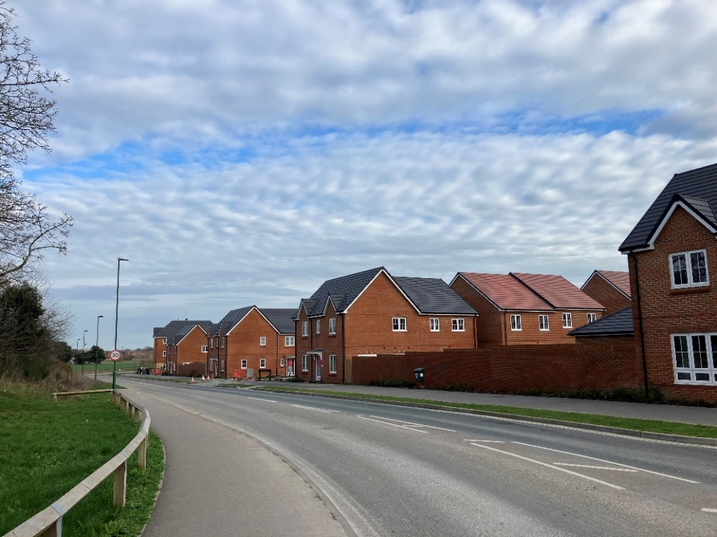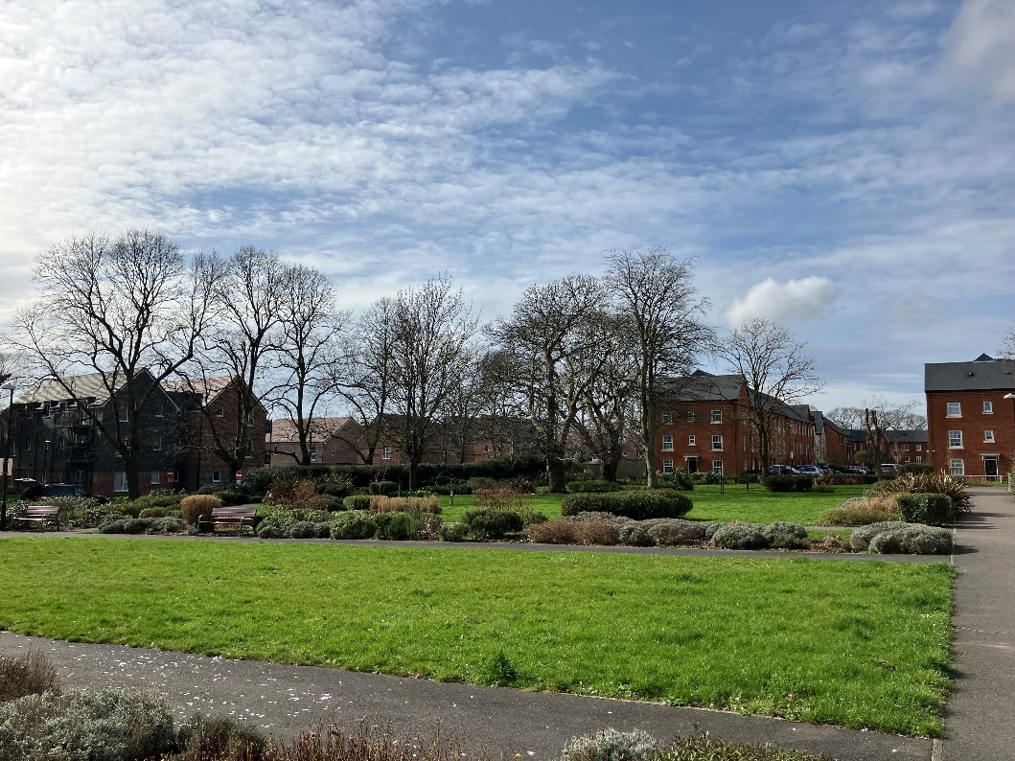

Figure D3: Graylingwell Phase 9a from principal access road, with 3 storey block in background; Figure D4: Land south of Graylingwell Road (left, behind trees) viewed from Graylingwell Hospital Grounds and Conservation Area, with Graylingwell Penny Acre development to right

The density of the Land south of Graylingwell site is lower than that of Phase 9a. Application 17/02571/REM established a developable area of approx. 4.6ha with an associated density of 35dph, once open space provisions (which significantly exceed requirements) are accounted for. This is higher than the study calculated density of 32dph, reflecting the extent of the atypical open space provision. The building forms enable relatively high density within the residual developable area, however, comprising four 3-storey apartment blocks, with the remaining housing being 2-storey. The layout of the site was subject to considerable scrutiny, with amendments to the illustrative masterplan to locate the apartment blocks adjacent to Graylingwell Drive, grouping the highest buildings where they are seen in the context of equivalent 3-storey development on the main Graylingwell Park site to the north. Analysis of permitted plans for 2-bedroom flats and 3-bedroom houses within the development reveal that the dwellings would all meet NDSS.

The comparison of the two sites within the broader strategic development area demonstrates the varying successes of schemes incorporating higher density housing, especially 3-storey apartment blocks. Consideration of the surrounding historic environment and provision of open space influenced the design and layout of adjacent buildings within the Land south of Graylingwell sites, arguably achieving a more successful scheme, albeit at lower density than the Phase 9a development.

**West of Chichester: Varied Housing Mix within Greenfield Urban Extension**

The case study development relates to 19/01531/REM, a reserved matters application for 91 dwellings, and 19/02626/REM for 29 dwellings, part of Phase 1, approved for up to 750 homes, within the West of Chichester Strategic Development Location. The overall SDL for mixed use development, including for 1600 new homes, is planned as a sustainable urban extension of Chichester City. The application sites considered within this density study are located within the north of the Phase 1 site, either side of a central green corridor, and were formerly comprised of unfarmed agricultural land.

The permitted outline application (14/04301/OUT) included a Quantum Development parameter plan, which envisaged a range of densities throughout Phase 1, with higher densities (identified as 35-45dph) towards the centre of the site, through to lower densities (20-25dph) closer to the edges of the site. This approach was considered to respect landscape sensitivities and help to establish the development within its surroundings. Particular sensitivities noted included neighbouring Grade II-listed Whitehouse Farm and the off-road Centurion Way cycle path to the east, as well as views to Chichester Cathedral. Furthermore, the submitted Storey Height parameter plan proposed development of predominantly two storey dwellings to address concerns relating to impact on long distance views from the South Downs National Park. A range of character areas were identified within the Phase 1 development area, defined by existing vegetation and site features.

Reserved matters approval for Phase 2B was granted for a stated overall site density of 31.5dph for a site of 2.89ha. Closer analysis of approved details provides an alternative (net) residential area of 2.672ha within the land use plan, giving a density of 34 dph. This takes into account 0.218ha of open space provision. This figure is lower than the net density of 39 dph calculated within this density study (based on a gross site area of 2.89ha, and a derived net site area of 2.34ha, accounting for both open space provision as well as applying a land area adjustment). It is considered that the land area adjustment may be unnecessary in this case, with broader development infrastructure and services provided offsite, including a spine road to the north of the site, and SANGs land to the west. The calculated 39dph density is most consistent with the previously approved quantum of development parameter plan, however.

For Phase 2B, the officer recommendation considered that the proposed building forms and layout (two storey dwellings arranged mainly as a mix of detached and semi-detached properties) comprised an appropriate response to the characteristics of the land parcel, which provide a semi-rural context to the development and have high visibility due to its topography (see Figure 4). This study determined, however, that the approved plans for 3-bedroom houses would not meet NDSS for 50% of the dwelling types. Regardless, the layout was determined to comply with the previously approved Residential Architectural Design Strategy, required as a condition of the outline permission.

By contrast, the calculated net density for Phase 3D was 46dph (based on the stated site area of 0.78ha, and a derived net site area of 0.63ha). The officer stated net density was 39dph, however, determined from a net residential area of 0.748, with an additional 0.028 open space provision. As with Phase 2B, the lower density figure does not include a land area adjustment but was considered to accord with the outline parameter plan. The density of Phase 3D is higher than for Phase 2B as a result of its design and housing mix, consisting of 2 and 3 storey buildings, including an L-shaped 3 storey flatted building providing a contemporary focal feature at the southeastern corner of the site (see Figure 5). Permitted plans for 2-bedroom flats therein were analysed to conform with NDSS, in contrast to housing, which similarly to Phase 2B, was found to not meet standards for the majority of 3-bedroom dwelling types. Furthermore, the block’s design is considered to appropriately respond to the adjacent green corridor, as well as provide a transitional frontage for this part of the SDL, adjoining the mixed-use Local Centre (to be developed). The comparison of the two phases of the SDL demonstrates the outcome of the developer’s strategic consideration of density at outline stage, with dwelling layouts and forms responding to the prevailing topography and landscape of the greenfield site, and the use of apartment buildings in appropriate site locations enabling higher density schemes.

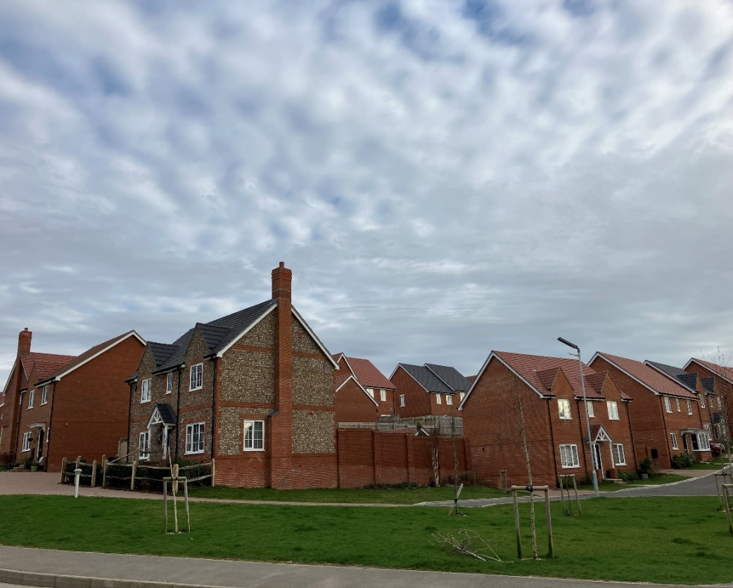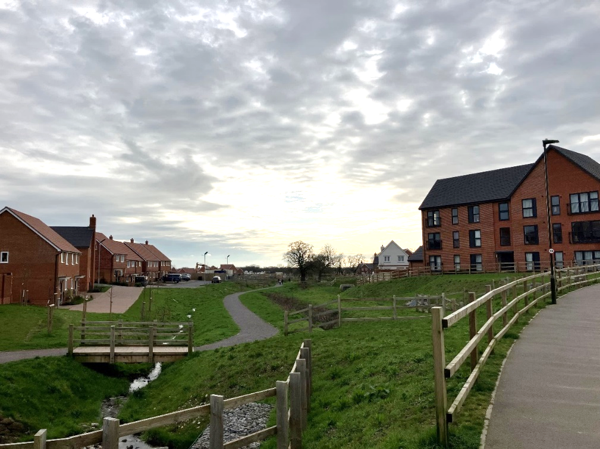

Figure D4: Elevated topography of West of Chichester Phase 2B, as viewed from spine road; Figure D5: West of Chichester Central Green Corridor, with Phase 2B to left of photograph, and 3 storey flatted block within Phase 3D to right.

**49-51 Fishbourne Road East: Non-residential Redevelopment to Provide Affordable Housing**

The case study considers the redevelopment (by demolition and replacement, permitted by 17/01287/FUL) of a site to the west of Chichester city, adjacent to the A27 dual carriageway and the settlement boundary. Previous use of the site was for offices and associated carparking. The permitted layout comprises two 3-storey buildings at the front of the site, reducing to 2.5 storeys at the rear, and a further 3 storey block, two 2 storey blocks and 2 storey semi-detached houses are within the site. The design was considered to respond to existing building lines, trees (providing screening from the A27), potential for overlooking of neighbouring properties and the provision of public and private open spaces.

The officer’s report considered that the proposed housing mix and associated tenure (100% affordable units) was acceptable owning to the specific characteristics of the site and its location, recognising a high number of social housing units in the immediate vicinity. The potential for noise impacts associated with the adjacent A27 flyover, as well as daylight/sunlight assessments influenced proposal changes and design-related conditions. Overall, the proposals were assessed to provide an acceptable living environment. This is supported by this study’s analysis of permitted plans against NDSS, which found all 2-bedroom flat dwelling types to comply with the standards. Externally, the innovative site layout was enhanced by the use of shared surfaces to ensure efficient use of space for car parking and vehicle and pedestrian access. Despite being located more than 800m from the train station, the officer’s report considered the site to be in a reasonably sustainable location, being on a bus route and within 1.6km from the city centre. The proximity of a superstore 250 metres to the southeast was recognised.

In terms of density, the application information suggests a housing density of approx. 60dph, based on a site area of 0.62 hectares. However, it is assessed that this figure does not accurate account for open space provision provided. The calculated net density of approx. 83dph is considered to more accurately represent the high-density nature of the development, applying a 15% land area reduction appropriate for the development scale, as well as recognising open space provision. The design-led innovative approach taken in this case demonstrates that high density and high amenity schemes are achievable on previously developed and constrained sites.

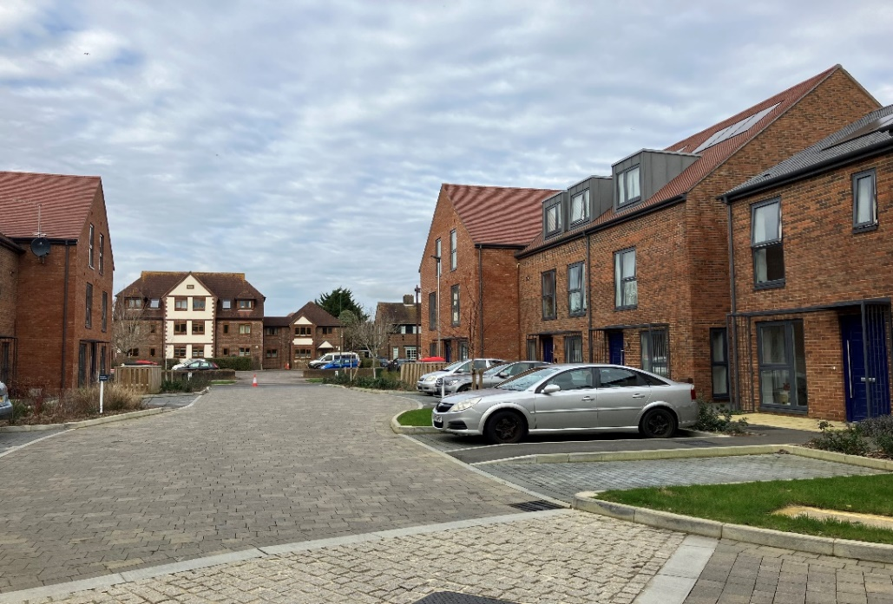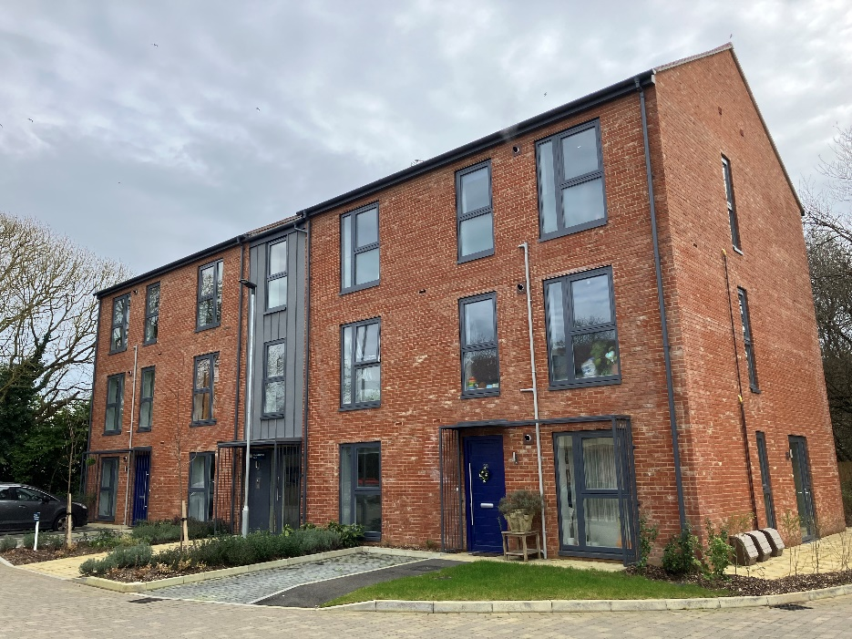

Figure D6: 3, 2.5 and 2 storey dwellings within Fishbourne Road redevelopment, with contextual neighbouring development in the background; Figure D7: 3 storey apartment block, with tree screening visible to rear.

**Land North of Cooks Lane: Large Greenfield Development within Sustainable Settlement Hub**

The location of this large development site is adjacent to the settlement boundary and recent residential development within the settlement hub of Southbourne. Previous use of the site was for agricultural purposes. The surrounding landscape includes flat, open countryside, allowing views to and from the SDNP to the north. Approval of outline permission 18/03145/OUT for 199 homes was allowed via appeal in March 2020. The officer’s original report for the outline permission refusal recognised the sustainability of the location, being within accepted walking and cycling isochrones of infrastructure and facilities, including approx.700m from the mainline railway station and parade of shops. Primary and secondary schools are also within 10 minutes walking times.

The outline application advises that the development will achieve a density of 25dph, a figure ratified by the study calculations, and understood to include minor roads, swales and incidental open space. The proposed density was informed by a residential density study of housing typologies in Southbourne, which identified a range of densities in the vicinity from medium (Guildford Close - 33dph) to low (Kelsey Avenue – 26dph). The application suggests the proposed development’s layout, scale and form provide opportunity for a softer transition from the settlement boundary to the countryside, with design complementary to the existing character of the town.

The Design and Access statement to inform the reserved matter application reflects the proposed incorporation of a landscape buffer and green ring to screen the development from wider views of the north and east, as well as a further buffer to provide separation and privacy for existing residential development to the west. The statement also recognises distinct character areas. Within the Rural Edge and Green Corridor areas, the proposed building forms include detached houses and bungalows to provide a reduced density and streetscape. The officer’s report comments favourably on the benefits of the green ring provision, including SuDS, habitats, and amenity space, as well as its function in filtering distant views of the development from the national park.

The proposed housing mix comprised 159 2 storey houses, 8 flats and 32 bungalows. The applicant’s Planning Statement reflects that the site has sufficient space to accommodate more than the approved 199 units, but the overriding intention is to implement the outline consent despite the proposed number of units resulting in inefficient use of land. The statement comments on market need for additional floorspace within properties, responding to home working demand. Despite this comment, analysis of permitted floor plans for 3-bedroom housing reveals that two of the eight 3-bedroom housing types do not meet NDSS. Notwithstanding, the officer report comments that the high preponderance of bungalows with more spacious plots is a welcome feature that reflects the variety and eclectic mix of different housing types in Southbourne. The domestic scale of the buildings was considered appropriate and acceptable.

This case demonstrates the balancing of local landscape constraints and market need with ensuring efficient use of land and development viability. There is recognition that inappropriate building forms and high densities may be out of the character with the existing area, resulting in a low-density development despite the accessibility and sustainability of the settlement hub. It is notable that the 25dph density achieved is slightly higher than the average existing density of Southbourne, calculated within this study to be approx. 23 dph. Recognising proposed significant growth within the location, the Southbourne Allocation DPD provides a means of further exploring opportunities for gentle densification to achieve local housing needs while having regard to character and community concerns.

1. Historic England’s Increasing Residential Density in Historic Environments (2018): [historicengland.org.uk/images-books/publications/increasing-residential-density-in-historic-environments/160718-increasing-residential-density-in-historic-environments-final-report/](https://historicengland.org.uk/images-books/publications/increasing-residential-density-in-historic-environments/160718-increasing-residential-density-in-historic-environments-final-report/)