Chichester Local Plan 2021 – 2039

East Hampshire Local Plan 2021-2040

Statement of Common Ground between

Chichester District Council and

East Hampshire District Council

*****

January 2024

Version

|  |  |  |
| --- | --- | --- |
| Version | Date | Changes |
| Version 0.1 | 26/01/23 | First draft (CDC) |
| Version 0.2 | 09/02/23 | Amends (EHDC) |
| Version 0.3 | 08/12/23 | Amends (EHDC) |
| Version 0.4 | 19/12/23 | Amends (CDC) |
| Version 0.5 | 09/01/24 | EHDC Signed |
| Version 0.6 | 18/01/24 | CDC Signed |

**Contents**

1. Introduction 1

2. List of parties involved 1

3. Relationship with other documents 1

4. Strategic geography 1

5. Planning documents – current status 2

6. Strategic matters and record of agreement 3

7. Nitrate Neutrality 7

8. Governance arrangements 7

9. Timetable for agreement, review and updating 7

10. Signatories 8

Appendix 1 – Local Plan areas 9

1. **Introduction**
   1. This Statement of Common Ground (the Statement) has been prepared by Chichester District Council (CDC) and East Hampshire District Council (EHDC) (the parties) to support the Chichester Local Plan 2021 – 2039 and the East Hampshire Local Plan 2021-2040.
   2. This Statement ensures the requirements set out in the National Planning Policy Framework (NPPF) have been met. The NPPF states: *‘Local planning authorities and county councils (in two-tier areas) are under a duty to cooperate with each other, and with other prescribed bodies, on strategic matters that cross administrative boundaries.’*[1] The purpose of the Statement is to document the strategic matters being considered and the progress made in cooperating to address them at this stage of the plan making process. It focusses on areas where there is agreement, and if appropriate those matters where work is ongoing to resolve differences. The Statement is intended to be ‘live’, updated as circumstances change, and agreement occurs on any outstanding issues. The Statement also forms part of the evidence to demonstrate compliance with the Duty to Cooperate during the preparation of the Chichester Local Plan 2021 – 2039 and the East Hampshire Local Plan 2021-2040.
2. **List of parties involved**
   1. This Statement has been prepared between CDC and EHDC.
3. **Relationship with other documents**
   1. Where appropriate East Hampshire District Council has prepared separate Statements with other duty to cooperate prescribed bodies. All Statements will be published on East Hampshire District Council’s [website](https://www.easthants.gov.uk/planning-services/planning-policy/local-plan/emerging-local-plan/evidence-base/other-evidence-3).
4. **Strategic geography**
   1. The plan areas are identified in Appendix 1.
   2. Although adjoining administrative areas, Chichester District falls within West Sussex and East Hampshire District falls within Hampshire. The administrative boundary between the two local authorities also marks the boundary between the two counties. Significant parts of both authorities lie within the South Downs National Park (SDNP) and, as a consequence, only that part of the Chichester Local Plan Area around Camelsdale and Hammer adjoins the area covered by the East Hampshire Local Plan.
   3. CDC is a member of the West Sussex and Greater Brighton Strategic Planning Board (WS&GBSPB). The WS&GBSPB have agreed to explore options for meeting unmet housing needs across the sub-region and to progress updating the Local Strategic Statement (LSS3). EHDC is one of the 12 local authority members of the Partnership for South Hampshire (PfSH), which works jointly to support the sustainable growth of the South Hampshire sub-region. PfSH has set out the intention to address the issue of unmet housing need across the sub-region through the preparation of a new Joint Strategy.
5. **Planning documents – current status**
   1. CDC’s current adopted Local Plan comprises the adopted Local Plan: Key Policies 2014-2029 (July 2015) and adopted Site Allocation Development Plan Document (DPD) (January 2019). CDC is at an advanced stage of preparing a new Local Plan (Chichester Local Plan 2021 - 2039) which will replace the Key Policies 2014-2029 and cover the period to 2039. A revised Site Allocation DPD is to be produced following adoption of the new Local Plan.
   2. Information on the stages that have taken place and the expected timetable for adoption of the new Chichester Local Plan is set out in Table 1 below.

**Table 1: Preparation of Chichester Local Plan Review**

|  |  |  |  |
| --- | --- | --- | --- |
| **Regulation 18 consultation** | **Regulation 19 consultation** | **Submission** | **Adoption date** |
| Issues and Options (June – August 2017)  Preferred Approach (December 2018 – February 2019) | Publication February/March 2023 | Early 2024 | Winter 2024 |

* 1. The adopted East Hampshire Local Plan comprises the Joint Core Strategy (May 2014)[2] prepared with the South Downs National Park Authority, the Local Plan (Part 2): Housing and Employment Allocations (April 2016) and the saved policies of the Local Plan Second Review (2006).
  2. A review of the Local Plan commenced in 2017, with two Regulation 18 consultations taking place during 2019. In May 2022, the Council took the decision to undertake further Regulation 18 consultation to revisit the Local Plan in light of changing Government guidance and increased housing requirements. An Issues and Priorities consultation took place between November 2022 and January 2023. Consultation on a draft Local Plan (Reg18) is scheduled to start in January 2024 for 6 weeks.
  3. Information on the stages that have taken place and the expected timetable for adoption of the East Hampshire Local Plan is set out in Table 2 below.

**Table 2: Preparation of East Hampshire Local Plan Review**

|  |  |  |  |
| --- | --- | --- | --- |
| **Regulation 18 consultation** | **Regulation 19 consultation** | **Submission** | **Adoption date** |
| Issues and Priorities consultation November 2022/January 2023  Draft Local Plan January 2024 | Publication Summer 2024 | Winter 2024 | Autumn 2025 |

1. **Strategic matters and record of agreement**
   1. As documented in the East Hampshire [Duty to Co-operate Framework 2022](https://www.easthants.gov.uk/planning-services/planning-policy/local-plan/emerging-local-plan/evidence-base/other-evidence-3), the strategic cross boundary matters concerning the two authorities are:

* Meeting identified housing needs within the District and wider unmet housing needs
* Meeting the identified need for Gypsy, Traveller and Travelling Showpeople accommodation within the District and wider unmet needs
* Consideration of the potential need for transit accommodation for Travellers (with regards to travelling routes across districts/boroughs).
* Supporting economic growth and opportunity, creating the conditions in which businesses can invest, expand and adapt
* Transport impacts and mitigation from proposed development
* Responding to Climate Emergency
* Achieving nutrient neutrality - the potential impacts of development on water quality in the Solent.
  1. This statement sets out the confirmed points of agreement with regard to:
* Housing need
* Gypsy and Traveller accommodation needs
* Transport

**Housing need**

* 1. Analysis of the housing market areas across the Coastal West Sussex and Greater Brighton area[3] found that Chichester District is mainly located within the Chichester and Bognor Regis Housing Market Area (HMA) but that a small part of the western part of the district at Southbourne was within the Portsmouth HMA. The Portsmouth HMA includes the southern parts of East Hampshire outside of the SDNP. The remaining parts of East Hampshire were identified as forming part of the Central Hampshire HMA.
  2. Using the Government’s standard method and most recently published data on affordability ratios (March 2023), the Local Housing Need (LHN) figure for Chichester, excluding that part of the district falling within the SDNP, is 639 dwellings per annum (dpa).
  3. The Chichester Local Plan Preferred Approach (December 2018) proposed a housing requirement for the plan period to meet the LHN in full plus an allowance to accommodate unmet needs from the National Park. Since the publication of the Local Plan Preferred Approach constraints, particularly highways and wastewater capacity, has led CDC to consider a housing requirement below the LHN derived from the standard method. The proposed Chichester Local Plan housing requirement, as set out in the Regulation 19 Chichester Local Plan, is 575dpa: 535dpa in the southern plan area and 40dpa in the northern plan area. This results in an unmet need of 1,152 dwellings for the Chichester Plan Area over the plan period. CDC have subsequently confirmed that the previous undertaking to meet some of the unmet housing need arising from that part of the National Park within Chichester District can no longer be accommodated.
  4. East Hampshire’s [Technical Note Update (September 2023)](https://www.easthants.gov.uk/sites/default/files/2023-11/East%20Hampshire%20technical%20note%20-%20September%202023.pdf) calculated (using the standard method) a local housing need figure of 464dpa for the area covered by the East Hampshire Local Plan, this is equivalent to 8,816 new homes . The Technical Note identifies a local housing need in the National Park part of East Hampshire of 114dpa, however, it is acknowledged that it will be for the South Downs National Park Authority (SDNPA) to work through its own process to calculate local housing needs for its area. In order to estimate any potential unmet needs for the Draft Local Plan, a pragmatic approach has been taken based on past delivery and historic agreements with the SDNPA. Based on the delivery of 100 dwellings per annum within the part of East Hampshire that falls within the National Park, it is estimated that there would be a residual requirement (potential unmet need) of 14 dwellings per annum (266 dwellings over the plan period). As a result, the minimum number of homes required in East Hampshire’s Local Plan Area between 2021 and 2040 is 9,082 dwellings. This is equivalent to 478 dwellings per annum.
  5. As detailed in the Partnership for South Hampshire (PfSH) Spatial Position Statement (December 2023) there is an unmet need across the sub-region of approximately 12,000 homes to 2036. It is acknowledged that in the short to medium term that EHDC should be able to meet NPPF 2023 standard-method based housing needs. The Spatial Position Statement acknowledges that in the longer term, Broad Areas of Search for Growth will need to be considered in local plans, including the contribution they can make to ongoing unmet housing need in the sub-region. However, none of these Areas of Search are identified in the Local Plan Area.
  6. For the purposes of EHDC’s Draft Local Plan, no assumptions are made on the unmet needs of other neighbouring local planning authorities (with the exception of the SDNPA), but any dwellings surplus to the identified requirements could be attributed to any future identified unmet need, particularly in the South Hampshire sub-region.
  7. Taking account of committed supply, there is a residual requirement of about 2,828 new homes over the plan period. In the context of the need for flexibility and addressing the potential unmet needs of the wider South Hampshire sub-region, the housing strategy identified in the EHDC Draft Local Plan makes provision for about 3,500 new homes in the most sustainable and accessible locations in the Local Plan Area.
  8. As referred to earlier, the WS&GBSPB have agreed to explore options for meeting unmet housing needs across the sub-region and to progress updating the Local Strategic Statement (LSS3). Currently progress on LSS3 has been delayed and whilst it would have considered the issue of unmet needs across the sub-region, this has not reached a stage such that it was able to inform the CDC Local Plan at Regulation 19 stage. There is, however, a commitment from all WS&GBSPB authorities to make progress and establish a common understanding and position.
  9. CDC has separately engaged with neighbouring authorities, including EHDC, and in the wider housing market areas on their ability to accommodate some or all of CDC’s unmet housing need, contacting authorities in December 2021 and then again in December 2022. In response to the December 2021 letter, CDC and EHDC held discussions in early May 2022 on the spatial and strategic relationships between the two plan areas and the opportunities for meeting unmet need in East Hampshire. The outcome of these discussions was that it was agreed that whilst there are functional relationships between CDC and EHDC, in housing and employment terms, relationships between EHDC and other areas (Havant and Waverley) are more significant. The key spatial relationships between CDC and EHDC primarily present themselves within the area covered by the SDNP and being quite remote from the Chichester Local Plan area; linkages outside of the SDNP between CDC and EHDC are present to a much lesser extent. Further, no sites were identified in EHDC with clear opportunities to help meet any of CDCs unmet need. It was agreed, however, that CDC would continue work on defining the quantum of unmet need and that this information feed into EHDC’s testing of Local Plan options, whilst noting that the unmet needs of other local authorities, particularly those associated with the South Hampshire sub-region, would also form part of the options testing.
  10. The above discussions took place in the context of EHDC progressing towards publication of a Regulation 19 Local Plan during 2022. However, since then EHDC have taken a step back to undertake further consultation under Regulation 18 and are undertaking further work on determining their housing requirement and development strategy options. As such, it is too early to know whether EHDC will be in a position to assist in meeting any of the unmet needs from the Chichester Local Plan area in the future, or indeed any other local planning authority. EHDC is considering how it may be able to assist in helping meet some needs from the SDNP in the first instance, and any needs from PfSH would follow that.

*Areas of agreement*

* 1. It is agreed that CDC consider that they are unable to accommodate their full local housing need for the Chichester Local Plan area.
  2. It is further agreed that EHDC are unable to confirm what housing number it may be able to accommodate through their Local Plan review and whether that may be able to include any element of unmet need from adjoining authorities. CDC and EHDC will continue, through existing duty to cooperate arrangements, to work together to consider whether and how unmet needs can be met.

**Gypsy and Traveller Accommodation Provision**

* 1. The Chichester Gypsy and Traveller and Travelling Showpeople Accommodation Assessment (GTAA) (2022) identified a need for 158 pitches[4] and 40 plots over the plan period. The Council propose to meet the pitch need through the allocation of new sites and intensification of a number of existing sites, making a proportionate provision on strategic allocations and a requirement for provision on all other sites over 200 dwellings that may come forward over the plan period (provided a need is remaining at the time) and through the development of windfall sites when assessed against a criteria based policy. However, there will remain an unmet need of at least 39 pitches over the plan period[5].
  2. Plot provision will be made through the provision of additional plots on an existing site, making provision within the Southbourne Broad Location for Development and as part of the employment allocation south of Bognor Road, Chichester. However, this is only likely to be deliverable after the first five years and there will, therefore, be an unmet need of at least 3 plots over the plan period.
  3. The GTAA (2020) covering East Hampshire identified a need for 66 Gypsy and Traveller pitches (meeting the planning definition) and 47 Travelling Showpeople plots over the period 2020 - 2036. An update to the GTAA to reflect the revised plan period is planned for 2023. Through the Land Availability Assessment 2023, EHDC has been unable to identify sufficient land to meet the needs identified by the 2020 GTAA: the developable land identified can only accommodate 7 Traveller pitches and 6 Travelling Showpeople plots. As part of the Regulation 18 consultation (2022/23) EHDC undertook a further call for sites, which did not produce any developable additional sites.
  4. There is likely unmet need for traveller accommodation arising from the East Hampshire District Local Plan 2021-2040. East Hampshire District Council asked Chichester District Council for assistance with meeting this need (August 2023). However, Chichester District Council is not currently in a position to accommodate the needs of any neighbouring authorities and has itself made requests of other neighbouring authorities in this regard, none of whom have been able to assist.
  5. CDC have discussed unmet Gypsy and Traveller and Travelling Showpeople accommodation needs with neighbouring authorities at duty to cooperate liaison meetings and wrote in December 2022 to neighbouring authorities, and those in the wider housing market areas, to establish if any were in a position to assist; this included EHDC. However, at the current time no authority has confirmed that they are in a position to assist.

*Areas of agreement*

* 1. It is agreed that CDC and EHDC will continue, through existing duty to cooperate arrangements, to work together to consider whether and how unmet Gypsy and Traveller and Travelling Showpeople accommodation needs can be met.

**Transport impacts**

* 1. CDC has undertaken several transport studies of both the proposed development sites and strategic housing numbers proposed in the Chichester Local Plan to understand the impacts on the highway network in the plan area and surrounding area. The studies have identified that a package of measures will be required to mitigate the impact of the development now planned in this Local Plan.
  2. The Preferred Approach Local Plan was accompanied by a Transport Study (2018), which modelled three scenarios based on different levels of growth including the scale of development envisaged in the Preferred Approach Plan (650dpa[6]) over the period to 2035. The committed development and mitigations within the administrative neighbouring authorities were included in the transport modelling Reference Case or, as in the case of EHDC, the projected demands included in the background growth of future travel demand. No specific highway impacts were identified in respect of East Hampshire.

* 1. During 2022, further transport modelling of the proposed housing requirement and distribution was undertaken (Transport Study, 2023) looking over an extended time horizon to cover the plan period to 2039. However, the findings in relation to the impact on East Hampshire remain unchanged from the 2018 Transport Study.

*Areas of agreement*

* 1. The parties agree that the transport evidence prepared for the Chichester Local Plan has not identified that development proposed in the Chichester Local Plan will result in any severe impacts on the highway network within East Hampshire.

1. **Nitrate Neutrality**
   1. The issue of increased amounts of nitrogen discharging into the Solent catchment (which within the Plan Areas include Chichester and Langstone Harbours Special Protection Areas) can have a significant harmful impact. As a result, Natural England have advised that certain types of development need to be nutrient neutral to avoid detrimental harm to the ecology and conservation of the Harbours.
   2. The Regulation 19 Chichester Local Plan contains a policy (Policy NE19 Nutrient Neutrality) that seeks to ensure that any development within the Chichester and Langstone Harbours hydrological catchment resulting in a net gain in overnight accommodation must demonstrate that it will be nutrient neutral for the lifetime of the development. Development in Chichester has also been using a range of solutions to deliver nutrient mitigation including private schemes selling nutrient mitigation credits in the South Downs National Park. A nutrient budget for the Local Plan has been prepared and considered as part of the Habitats Regulations Assessment of the Regulation 19 Chichester Local Plan.
   3. Although outside the area covered by the Partnership for South Hampshire (PfSH), of which EHDC are a member, CDC are involved in the PfSH Water Quality Working Group, which is co-ordinating a Solent wide solution to nutrient neutrality in the medium to long term. CDC have also part funded PfSH’s appointment of a Strategic Environmental Planning team to coordinate progress on mitigation schemes.

*Areas of agreement*

* 1. Both CDC and EHDC will continue to work through the PfSH Water Quality Working Group on nutrient neutrality and mitigations.

1. **Governance arrangements**
   1. In terms of governance arrangements, the two parties agree to:

* Keep a dialogue open on matters arising which are likely to have significant impacts and implications for the delivery of local plan policies;
* To work together to achieve identified outcomes in relation to strategic matters;
* To review and update this Statement in light of any material change in circumstance and
* To maintain positive principles of cooperation.

1. **Timetable for agreement, review and updating**
   1. This statement has been informed by ongoing engagement between the two parties and the parties will continue to work together to address identified strategic matters. This Statement is intended to be a living document that can be reviewed and updated, informed by continued communication between the parties through meetings, statutory consultation at key plan making stages and electronic communication.
2. **Signatories**
   1. We confirm that the information in this Statement reflects the joint working to address identified strategic matters that has been undertaken between Chichester District Council and East Hampshire District Council. The parties will continue to work together to address cross boundary issues.

|  |  |
| --- | --- |
| Signed: | Signed: |
|  |  |
| Name: Cllr Bill Brisbane | Name: Cllr Angela Glass |
|  |  |
| Position: Cabinet Member for Planning | Position: Portfolio Holder for Regulation and Enforcement |
|  |  |
| Chichester District Council | East Hampshire District Council |
|  |  |
| Date: 18/01/2024 | Date: 09/01/2024 |

**Appendix 1 – Local Plan areas**

**Chichester Local Plan area**

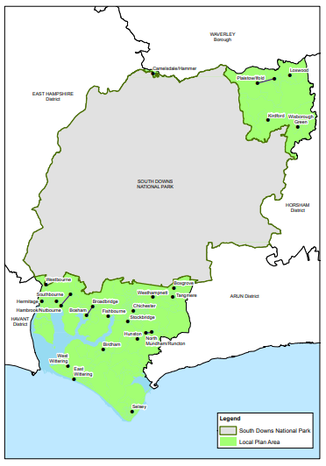

**East Hampshire Local Plan Area**

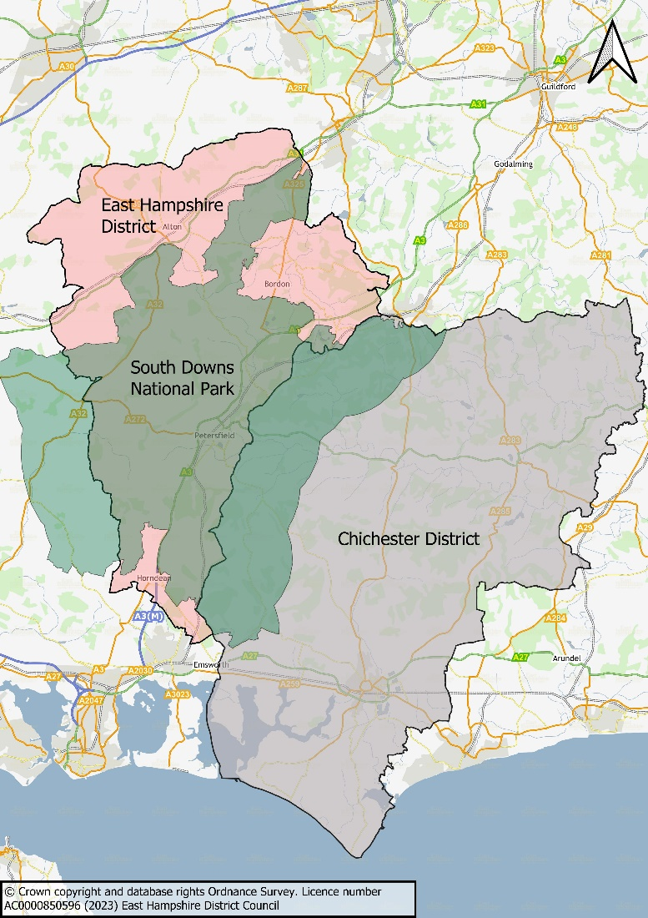

1. Paragraph 24, NPPF (2023)
2. This was superseded within the South Downs National Park by the South Downs Local Plan, adopted July 2019.
3. Defining the HMA and FEMA (February 2017), GL Hearn for the Greater Brighton and Coastal West Sussex Strategic Planning Board. Available at <https://www.adur-worthing.gov.uk/media/Media,147057,smxx.pdf>
4. This includes the needs of both those who meet the Planning Policy for Travellers Sites (2015) definition of Traveller and those that do not.
5. The figure for CDC unmet pitch and plot provision are correct at the time of drafting the Statement.
6. This included an allowance for accommodating unmet need arising from the Chichester District part of the South Downs National Park