|  |
| --- |
| Chichester District Council logo |
|  |
| **Parking Strategy 2023-2027**  Illustration of person using MiPermit app on phone with cars and cathedral in the background |

[www.chichester.gov.uk/parking](http://www.chichester.gov.uk/parking)

Foreword 1

1. Introduction 2

1.1. Parking Strategy Key Objectives 3

2. Local Context – Chichester District Characteristics 4

3. Car Park Provision 5

3.1 Location of Chichester City Centre Car Parks map 6

4. Pricing Strategy 7

5. Season Ticket Scheme 8

6. Anticipated changes to parking provision 8

7. Parking Interventions 9

8. Electric Vehicle Charging Parking 10

9. Disabled Parking Provision 11

10. On Street parking 11

11. Car Park Data 12

12. Overall District Car Parking Demand 13

12.1 Ticket Transaction Type 14

12.2 Chichester City 14

12.3 Midhurst 14

12.4 Coastal 15

12.5 Petworth and Fernhurst 15

13. Covid-19 Impact 16

14. Future Demand 17

15. Car Parking Delivery Action Plan 2023-2027 18

# 

# Foreword

Welcome to Chichester District Council’s Parking Strategy. This sets out the Council’s plans and ambitions for the Council’s car parks for the next four years.

Public car parking is an important element of our local infrastructure. The rural nature of our district and the fact that it attracts many commuters and tourists heightens the importance of public parking to our communities. Provided and managed well it can contribute to the attractiveness, convenience and prosperity of a place to do business, visit or live in.

An effective parking strategy assists with ensuring that parking demand is managed efficiently, enables technological enhancements to be delivered and reflects the changing nature of the high streets



# Introduction

Travel by means of private car remains the most common mode of transport for residents, commuters and visitors in Chichester District. This can result in conflicting demands for parking during peak seasons and therefore parking supply needs to be monitored and managed to meet demands and maximise supply. Demand must be managed in order that congestion is minimised, air quality is improved, along with supporting the economic growth of the city and towns and addressing national and global climate-related issues.

Chichester District’s Parking Strategy and Action Plan provides a review of the current parking demand across Chichester District Council’s car parks, recognising the impact on parking which has been seen as a result of the Covid-19 pandemic. Whilst the long-term impact is still not fully known, it is recognised that an effective strategy must be reviewed to reflect the changing nature of factors such as recovery; economic impact; working practices and travel patterns. The strategy and action plan therefore must be dynamic and flexible to meet demands going forward.



## Parking Strategy Key Objectives

Chichester District Council’s Parking Strategy 2010-2020 identified the importance of car parking across the district and provided a number of options for Chichester District Council to consider, along with reviewing key documents and background studies at the time.

This new parking strategy and action plan have been developed using up-to-date parking demand data to ascertain the baseline conditions across the district. The outcomes of this have informed the recommendations which have been developed to consider the key objectives of the strategy, which include:

* Consideration of the factors affecting the need for parking in the district and determine the quantity of parking required to support anticipated growth in housing numbers but potential decline in the need for spaces linked to employment.
* Consideration of issues and demands which will be seen over the coming years in the district.
* Current car park usage including spare capacity and predictions of future use.
* Consideration of new technological advances in cars and parking infrastructure.
* Provide an updated vision for parking to ensure it is relevant for the district.
* Consideration of whether a Park and Ride solution is required or appropriate for Chichester and suggestions relating to how this might be introduced.
* The strategy will primarily focus on off-street parking; however, it will be essential that this work is developed in line with West Sussex County Council’s on-street parking policies and that the link between on and off-street parking is carefully considered.

# Local Context – Chichester District Characteristics

Chichester District covers an area of approximately 800km2 and is the largest of the seven districts and boroughs within West Sussex, with an estimated population of 124,000 (2021 census). The district boundary extends from the south coast to the southern borders of Surrey and East Hampshire in the north, and from South Hampshire in the west to Arun and Horsham in the east. Much of the district falls within the South Downs National Park.

The city of Chichester is the only city in the district and within West Sussex. The three areas of Midhurst, Selsey and Petworth comprise the towns in the district with the remaining settlements comprising of villages.

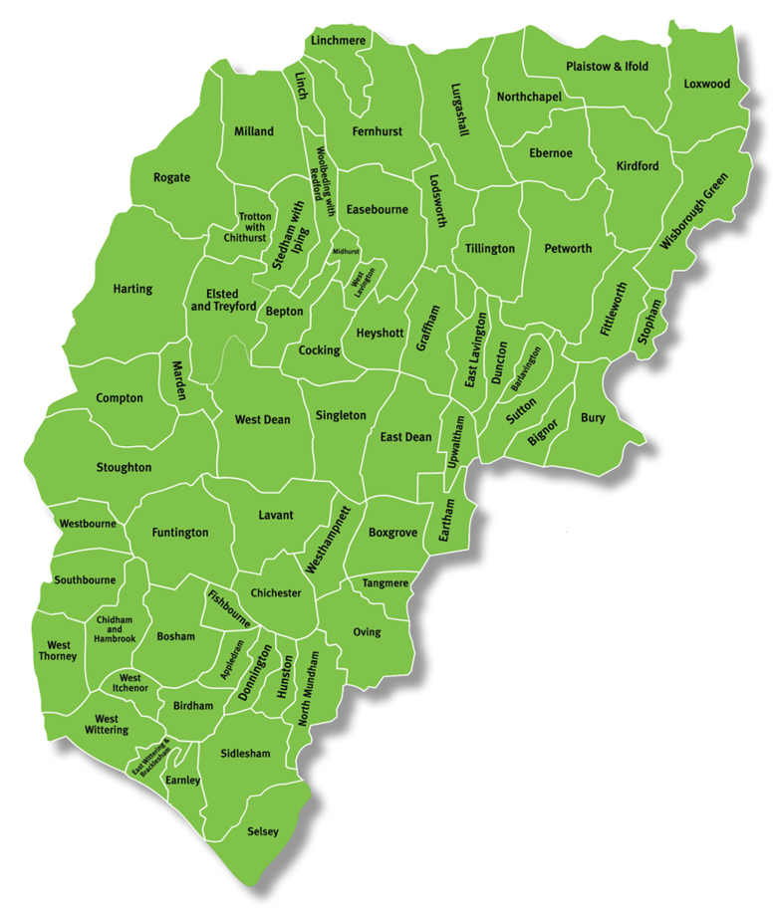

Chichester District provides active shopping streets, regionally and nationally renowned arts and cultural scene and attractive coastlines popular with visitors. The high-quality environment underpins and supports the local economy. The district is viewed as an attractive location for leisure opportunities and prestigious businesses. However, the rural nature of the district, along with purely an east-west rail link across the southern region of the district result in a high level of car use within the district.

# Car Park Provision



Chichester District Council own and manage 31 car parks across the district with a maximum of 5,942 off-street car parking spaces. There is a lower provision of 5,553 spaces at weekends during the winter months due to seasonal uses of some car parks and weekend markets. The council provides three different types of car parks: city centre short stay; city centre long stay; and rural and coastal. The 11 short stay car parks in Chichester city centre provide around 900 spaces and should discourage long term parking and encourage a higher turnover of spaces for those wishing to find a convenient place to park close to shops and other local services. Parking tariffs are adjusted to suit, with short stay parking having higher hourly charges compared to the long stay.

The 6 long stay car parks in the city are located on the periphery of the city centre. The pricing tariffs on the long stay car parks aim to target those working in the city and wanting to park all day. The council has successfully been awarded the British Parking Association’s Safer Parking Award Accreditation for the majority of its car parks. This accreditation illustrates the council’s commitment in reducing crime and the fear of crime in car parks and provides assurances to the public that measures have been introduced to ensure that the parking facility is a safe environment.

Coastal and rural car parks are in the smaller towns and villages outside of Chichester. These car parks are subject to seasonal variations in parking demand particularly in the summer periods where the coastal regions see an increase in tourism.

## Location of Chichester City Centre Car Parks map

Map of Chichester City car parks






|  |  |  |  |
| --- | --- | --- | --- |
| Chichester car parks | | 9 | Market Avenue |
| 1 | Little London | 10 | New Park Road |
| 2 | Baffins Lane | 11 | Cawley Priory |
| 3 | Orchard Street | 12 | Avenue de Chartres |
| 4 | St Cyriacs | 13 | Basin Road |
| 5 | South Pallant | 14 | Northgate |
| 6 | East Pallant | 15 | Cattle Market |
| 7 | St John’s Street | 16 | Westgate |
| 8 | Market Road | 17 | Coach and Lorry Park |

|  |  |
| --- | --- |
| Rural and Coastal car parks |  |
| Grange Road, Midhurst | Northern Crescent, West Wittering |
| North Street, Midhurst | Marine Drive, East Wittering |
| Post Office, Midhurst | East Street, Selsey |
| Pound Street, Petworth | East Beach, Selsey |
| Bosham Lane, Bosham | Marine, Selsey |
| Bracklesham Lane, Bracklesham |  |

# Pricing Strategy

Car parks managed by Chichester District Council have a structured pricing strategy which is relative to the location and type of car park, with tariffs increasing incrementally in line with the duration of stay. In selected rural and coastal locations free parking is available for up to 1-2 hours. Charges are operational 24-hours per day, with charges applicable generally on Monday to Saturday from 8am to 6pm and on Sundays from 10am to 5pm.

Free parking on Sundays is available at some car parks in the rural areas. Some of the car parks in the rural areas provide free of charge parking either on a seasonal basis or at all times throughout the year.

Consultation is undertaken each time parking charges are reviewed. Consultation includes engaging with the Chichester District Parking Forum, which involves representatives from business, community, key stakeholders, accessibility representatives, and resident groups. Wider public consultation is also undertaken to ensure that the public is made aware of the proposals and have the opportunity to provide comments on the proposals.

The council’s current fees and charges policy requires that all charges should be increased each year at least by the rate of inflation unless an appropriate alternative is put forward and agreed.

To view all charges on the Council’s website, visit [www.chichester.gov.uk/carparks](http://www.chichester.gov.uk/carparks)

# Season Ticket Scheme

Chichester District Council’s season ticket scheme offers regular customers the option to purchase a season ticket (minimum of 1 month) at a number of car parks across the district. Season tickets offer a heavily discounted form of parking for customers who are regularly using the car parks. Season tickets are virtual, with customers accessing these through the MiPermit app and having the ability to update, amend or cancel their season tickets independently. The council regularly reviews the type of season tickets provided, and, in 2021, introduced a part-time season ticket to some of the car parks in Chichester city. This was in response to a demand for this type of season ticket and the changing nature of work patterns

# 6. Anticipated changes to parking provision

The provision of car parks is kept under review on a continuous basis to ensure that they meet the needs of users. Car parks are considered for viability for alternative uses, and part of this consideration includes a decision being made that the Basin Road Car Park in Chichester is closed as part of the Southern Gateway project which will provide new housing, offices and retail development. Alongside this, another project actively being progressed is the introduction of a permanent event space into the northern area of Cattle Market car park.

# 7. Parking Interventions

Alongside the traditional method of payment via cash, contactless and card payments in the district’s car parks, a payment by phone / app solution is also in place. This system provides greater flexibility of being able to remotely extend the current parking stay without the need to physically return to the vehicle.

A Car Club is in place within the district, providing a range of fuel-efficient and low emission vehicles available to hire on demand. This service enables users to book a Co-Wheels car (either online or by phone) for collection from a preferred location, drive and then return it to the bay it was collected from. Cars can be booked for 30 minutes or days at a time. There are currently five cars available at five locations in and around Chichester city centre.

A shopmobility service is provided within Chichester, from one of the district council’s car parks, several times each week. The scheme provides access to a selection of powered and manual wheelchairs and powered scooters to support those with limited mobility getting around the central shopping areas.



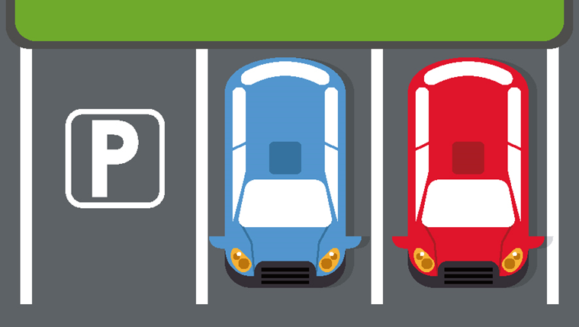

# 8. Electric Vehicle Charging Parking



Chichester District Council is committed to developing a cleaner, safer and less car-dominated environment throughout the district. Following the successful bid for funding, charging points were introduced into eight of the district council-owned car parks in 2019.

The parking services team actively monitor the usage of these spaces and data will be used as the evidential basis of the implementation of additional EV charging spaces in key locations.

# 9. Disabled Parking Provision

The blue badge scheme is an arrangement of parking concessions for people with permanent severe walking difficulties, and who travel either as drivers or passengers. The scheme also applies to registered visually impaired people, and people with very severe upper limb disabilities who regularly drive a vehicle but cannot turn a steering wheel by hand. To help people with disabilities gain easy access to the city and towns, most of Chichester District Council car parks have specially allocated parking bays. Blue Badge holders can also park in any bays within car parks free of charge with the exception of the Avenue de Chartres car park.

# 10. On Street parking

While the focus of this study is for off-street parking, on-street parking plays an important role in catering for a range of needs and users. Demand for on-street parking can often outweigh supply particularly in towns and cities where there are conflicting parking needs, therefore management schemes can be an effective method to ensure those who need parking the most have some priority. Pay and display provisions are in place within the central area of the city centre and parkers are able to park on-street for a maximum stay of 1-hour Mondays to Saturdays between 9am and 5.30pm. Time restrictions assist with ensuring that the city centre spaces are turning over effectively to support nearby shops and businesses. Alongside this, there is a Residents’ Parking Scheme within the city, which assists with the supply, regulation, enforcement and cost of all types of parking on the highway. This RPS also known as a Controlled Parking Zone (CPZ) covers all roads within the city centre and stretches out to include residential areas across the wider city, including areas south of the A27 in Stockbridge. The scheme requires drivers parking within the area to apply for a permit. A number of different types of permits are available to cover the needs of residents, visitors, students, carers, traders and businesses.

# 11. Car Park Data

As a result of the Covid-19 pandemic, travel trends and behaviours have changed the requirements for car parking provision, these changes in trends and behaviour will impact on the future parking demand. Evaluation of pre-Covid car park datasets has been undertaken, (which is considered for this strategy to be a neutral year), and this has been compared to post-Covid datasets for 2021. Information considered includes:

* Pay and display machine transactions;
* Phone / app parking transaction data;
* Entry and Exit barrier data (Avenue de Chartres only); and;
* Season ticket sales.

It is recognised that there are seasonal variations in demand in the district for parking and therefore the baseline data considered a range of seasons throughout the year. A number of assumptions were applied to the data to ensure that the data was as close as possible to reflecting the actual car park use.



# Overall District Car Parking Demand

Evaluation of parking demand assessment across all CDC managed car parks highlights the following:

* December has the greatest parking demand during both a weekday (95%) and on a weekend (80%) in the peak periods.
* During the weekday peaks, the proportion of occupied spaces remains relatively consistent between 83% and 90% across March, August and October.
* At the weekend, August and October recorded similar maximum demands on parking spaces with almost three quarters of all parking spaces occupied in the peak hour.
* The period with the lowest peak hour parking demand was during the March weekend assessment where 67% of spaces were occupied.

Ticket transaction data trends across the years of 2018 and 2019 are very similar with clear periods of high activity around the summer months, peaking in August during both years, and a second peak in transactions in the December month. The lowest number of ticket transactions were seen in February and March.

Parking demand analysis for 2021 has been undertaken to understand the changes from 2019 to 2021. In general, all car parks saw a reduced occupancy in 2021 when compared to 2019. The analysis demonstrates that demand for parking spaces across the district has reduced, which has resulted in lower sales of daily and season ticket purchases.

## 12.1 Ticket Transaction Type

Non-Resident Permit holders account for 4% of permits issued during 2020-21. While it was expected that the demand for Non Resident Permits would reduce during the pandemic, as commuter parking was less likely to be needed the level of permits remained much the same. This may be due to the permits being used by essential workers who still required parking. Non-Resident Permits are offered to customers in roads where surplus capacity is recorded by CEOs.

## 12.2 Chichester City

Chichester is the largest urban area across the district, attracting a range of people and users to the car parks including workers, students and visitors. The Cathedral, Theatre and Christmas events in the city centre generate a wider catchment of visitor demand extending beyond the city and district boundaries. The city provides short and long stay car parking, with short stay generally within the ‘inner’ city centre area while the long stay car parks are located around the perimeter of the city centre. All car parks are surface level, with the exception of the Avenue de Chartres, which is a multi-storey car park.

## 12.3 Midhurst

The market town of Midhurst is located 19.5km north of Chichester city and is within the South Downs National Park. Within Midhurst town centre there are a total of three public car parks which are North Street, Grange Road and Post Office, providing a collective provision of 516 spaces. All three car parks are surface level. Alternative parking provision is located within the town at the local supermarket.

The main high street in Midhurst is characterised by on-street parking on both sides of the road. Some bays are dedicated for loading only at specific times of the week, with public parking being available outside of this time. The designation and use of some of the on-street bays in the town have been raised as a concern by local residents, businesses and stakeholders, with suggestions that this results in congestion, poor air quality and delays to vehicle movements.

Due to the limited availability of parking at North Street and Post Office Car Parks, (which are the closest to the high street), these are often the busiest and as such visitors arrive looking for the next closest alternative, which in this case is on-street parking. This may further impact on the high street parking issues as identified

## Coastal

The coastal region of Chichester district includes the town of Selsey and the villages of Bracklesham, Bosham and East and West Wittering. There are a total of seven car parks which have been included in the coastal car parks. Seasonal variations can result in the demand for parking in coastal regions to be lower with some car parks remaining largely underutilised. Pricing and parking provisions is therefore actively amended to reflect this.

## 12.5 Petworth and Fernhurst

The village of Fernhurst is located in the north of Chichester district, with a single car park located behind the shops providing 58 spaces. Petworth is located 20km northeast of Chichester city centre, with a total of 321 public car parking spaces being provided in the two public car parks – Pound Street and Sylvia Beaufoy.

# 13. Covid-19 Impact

The Covid-19 pandemic has resulted in a number of implications which have had, and are estimated to continue to have, an impact on parking use within the district. This includes an increase in online shopping, resulting in a permanent impact on physical and in-store sales. Alongside this, there has been a rise of homeworking, in combination with businesses reviewing their real estate and opting for smaller offices or taking up flexible options. Working from home has led to an increase in demand for on-street parking. Analysis of trends suggests that there may be a number of challenges going forward. These include:



* Reduced town and city centre employment;
* Reduced footfall associated to retail;
* Changes in tourism behaviours;
* Increase in homeworking and rise in on-street parking;
* Change in season ticket demand; and;
* Decline in Revenue from car parking.

# 14. Future Demand

Future parking demand has been calculated through analysing the level of use of car parks in 2019, 2020 and 2021. This analysis has demonstrated that demand across the district has reduced, as a result of an increase in the number of people working from home and the rise in online shopping.

This Strategy covers a period up to 2026, during which time it is expected that there will be changes to parking needs beyond the changes observed between 2019 and 2021. Factors affecting parking demand in the future include the following:

* Increase in demand as a result of new homes and new employment opportunities.
* New highway infrastructure;
* Changes to on-street parking provision and schemes;
* The closure or consolidation of parking;
* New car parks; and
* Changes in behaviours with regards to car ownership, mode of travel and workplaces.

Development of new technologies, driverless vehicles and greater level of remote working will also contribute to changes in parking demand and changes to how we are travelling for both employment and social needs.

It is accepted that whilst cars will remain the primary form of transport in the district, that CDC’s policies should attempt to continue to encourage modal shift to continue our journey of carbon reduction.

Based on forecasts undertaken, it is currently predicted that CDC does not need to make any additional provision for additional car parking spaces and there is potentially a surplus, in the region of 289 spaces, which will allow projects to come forward, however due to the fast-changing pace of the economy the space requirements this will need to be kept under annual review.

# 15. Car Parking Delivery Action Plan 2023-2027

|  | **Action / Issue** | **Timescale** |
| --- | --- | --- |
| 1 | Consideration to whether approximately 120 spaces could be released within Cattle Market car park to enable the introduction of a permanent market/events facility. | March 2023 |
| 2 | Release of some or all of EPH car parking (loss of up to 150 spaces). | March 2026 |
| 3 | Release of Car Park land at Market Avenue (potential loss of up to 154 spaces).  There is the possibility to close all or either of St Johns Street, Market Road or Market Avenue car park. This would require an analysis of the changing demand on an annual basis and potentially additional car parking spaces elsewhere within the city. | Annual review of demand to release land |
| 4 | Improvements to Little London car park to include special bays for electric vehicle charging and increasing the number of disabled bays, this would result in a reduction of the number bays. Consider and include key stakeholders as part of the project. | March 2024 |
| 5 | Undertake a review of the opportunities for redevelopment of city centre car parks, with replacement parking provided outside the city centre if required. | Annually |
| 6 | To work with WSCC and other relevant partners to consider either partial or full removal of on-street parking to improve the public realm and traffic flow in Midhurst and to install variable message signs (VMS) to direct to off street car parking within the town. | March 2025 |
| 7 | To review any further technological enhancements, including real-time smart parking availability installations, shared mobility and Car Clubs (On-Street apps (to show location and availability); enhanced network of Variable message signage. | March 2026 |
| 8 | To work with other active travel providers to encourage Cycling and walking and to ensure there is adequate cycle parking in car parks where required. | March 2024 |
| 9 | To review the Government trials of the use of E-Bikes and Scooters to asses if they are any further requirements linked to parking, and whether opportunities can be explored for car parks. | April 2023 |
| 10 | To continue to explore the availability of Government grants to assist in the implementation of electric vehicle charging points and other opportunities for encouraging modal shift within our car parks. | On going |
| 11 | To continue to work with WSCC to review the most appropriate method of the installation of additional electric vehicle charging points in our car parks. | On going |
| 12 | To undertake a feasibility study for the redesign of Northgate car park, to improve the connectivity to the City centre and surrounding visitor and business attractions along with improving the layout within the car park. Should this feasibility study be approved a further action plan will be developed to deliver the project. | March 2023 |
| 13 | To undertake a feasibility study of options for Bosham Car Park to improve layout, to make the best use of the land, considering overall design and layout of the area, enhanced traffic flows and spaces, improved signage and a more welcoming first impression. Should this feasibility study be approved a further action plan will be developed to undertake the works. | March 2023 |
| 14 | To undertake resurfacing and re-lining of car parks as per the priority programme of works, ensuring that this reflects the latest guidelines regarding size of parking bays and number of allocated disabled spaces. | On going |
| 15 | Annual review of tariffs in car parks including any incentives. | September to November each year |
| 16 | Review of the parking payment options across all car parks to ensure that these are appropriate, efficient and reflective of latest technology and customer needs. | June 2023 and ongoing |
| 17 | Review of parking payment options at Avenue de Chartres multi-story car park, to include signage and encouraging maximum usage*.* | March 2024 |
| 18 | Improve marketing and promotion of our car parks, to include enhanced signage both within and outside of the car park, along with advertising the parking provision. | On going |
| 19 | Review of car park lighting to inform an action plan to enable energy efficiencies and improvements. | June 2023 |
| 20 | Review of landscaping and planting within car parks to improve the public realm and create a more welcoming experience. | On going |
| 21 | Consider opportunities for solar panels in car parks where these are feasible and appropriate. | On going |
| 22 | Consider options for alternative uses of car parks to enable short-term opportunities. | On going |



Parking Services,

Chichester District Council,

East Pallant House, 1 East Pallant,

Chichester PO19 ITY

01243 534500

parkingservices@chichester.gov.uk

[www.chichester.gov.uk/parking](http://www.chichester.gov.uk/parking)