**Chichester District Council**

**Council’s suggested modifications schedule**

Suggested changes to the Local Plan 2021 – 2039 Proposed Submission (2023)

**Appendices 1- 7**

**Appendix 1**

Key Diagram amendments

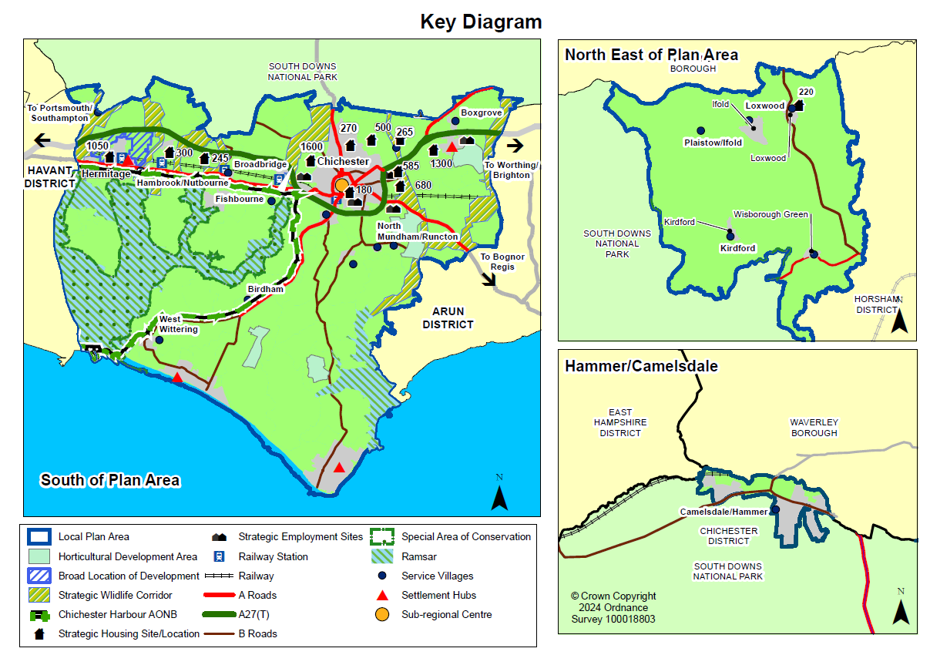

**Appendix 2**

Policy H1 – Table amendments

|  |  |  |  |
| --- | --- | --- | --- |
| Category |  | Number of dwellings | |
| Housing requirement for the full Plan Period (1 April 2021 to 31 March 2039) | | **10,350** | |
| Housing supply  (1 April 2021 to 31 March 2039) | a. Completions 1 April 2021 - 31st March ~~2022~~**2023** | ~~712~~**1616** | |
| b. Known commitments *(comprising)* | ~~5,674~~**5,772** | |
| *Outstanding 2015 Local Plan [1] and Site Allocation DPD 2014 – 2029 allocations[2] without planning permission* | *2,210* |  |
| *Outstanding 'made' Neighbourhood Plan allocations without planning permission* | *~~100~~****94*** |  |
|  | *Planning permissions as of ~~1 January 2023~~* ***31******March 2024*** | *~~3,364~~****3,468*** |  |
|  |  | | |
|  | New Strategic Locations/Broad Location for Development and Allocations | *3,210* |  |
|  | c. *Remaining figure without planning permission* | *~~3,056~~****2,396*** | |
|  | Non-strategic Parish Housing Requirements | *310* |  |
|  | d. *Remaining figure without planning permission* | *~~260~~****248*** | |
|  | e. Windfall | *~~657~~****720*** | |
| **Total supply for the full Plan period** (1 April 2021 to 31 March 2039) (=a+b+c+d+e) | | *~~10,359~~****10,752*** | |

The broad spatial distribution of this supply of housing across the different plan areas is indicated in the table below:

|  |  |
| --- | --- |
| **Sub-Area** | **Housing provision 2021-2039** |
| East-West Corridor | ~~8,717~~**8414** |
| Manhood Peninsula | ~~963~~**1013** |
| North of Plan Area | ~~679~~**605** |
| **Total excluding windfall** | **10,032** |
| **Plan Area Total** | **10,752** |

**Appendix 3**

Map 10.8 – Policy A14 Land West of Tangmere

Suggested Change - Amend map to remove land immediately to the west of Saxon Meadow

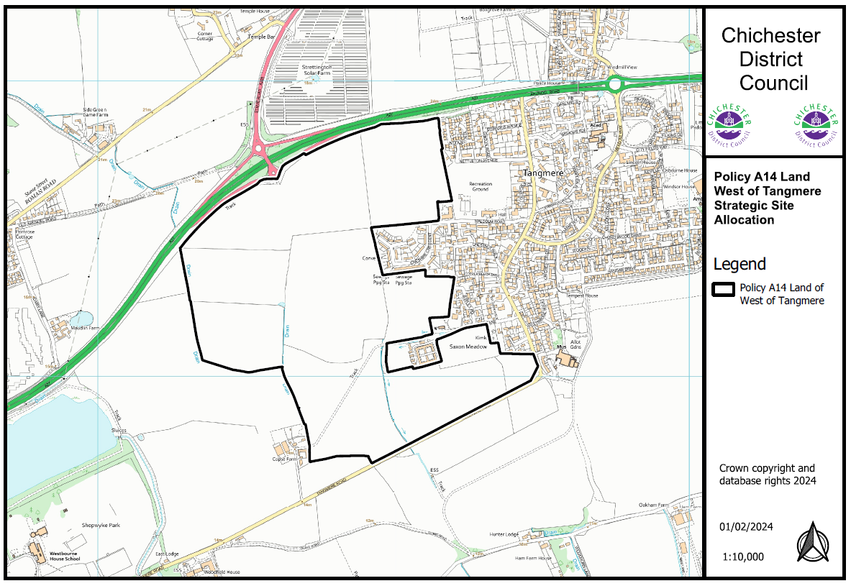

**Appendix 4**

Appendix A - Plan Area sub-area maps

Suggested Change - Maps are dated 2013 and Map A3 shows Parish of Plaistow and Ifold as “Plaistow CP”. Current maps to be generated and Plaistow and Ifold correction to be made.

**Map A1 – East-West Corridor**

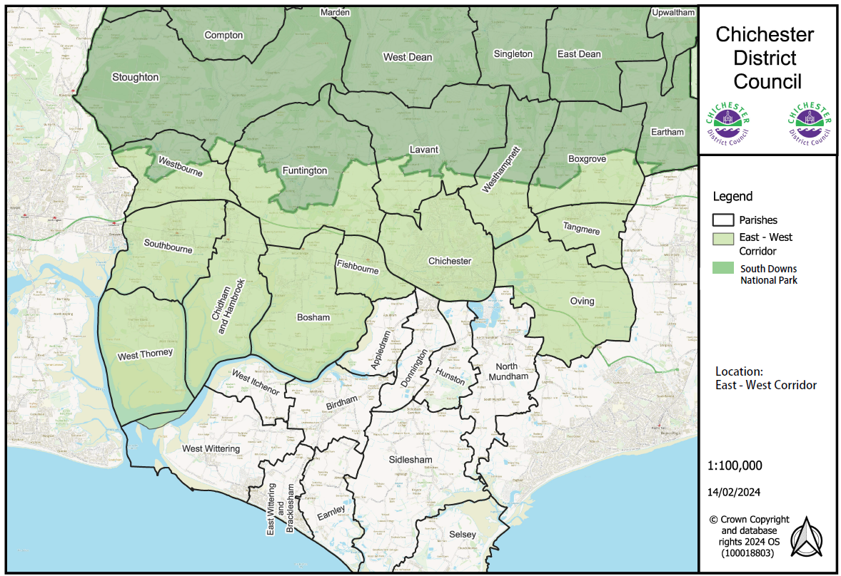

**Map A2 – Manhood Peninsula**

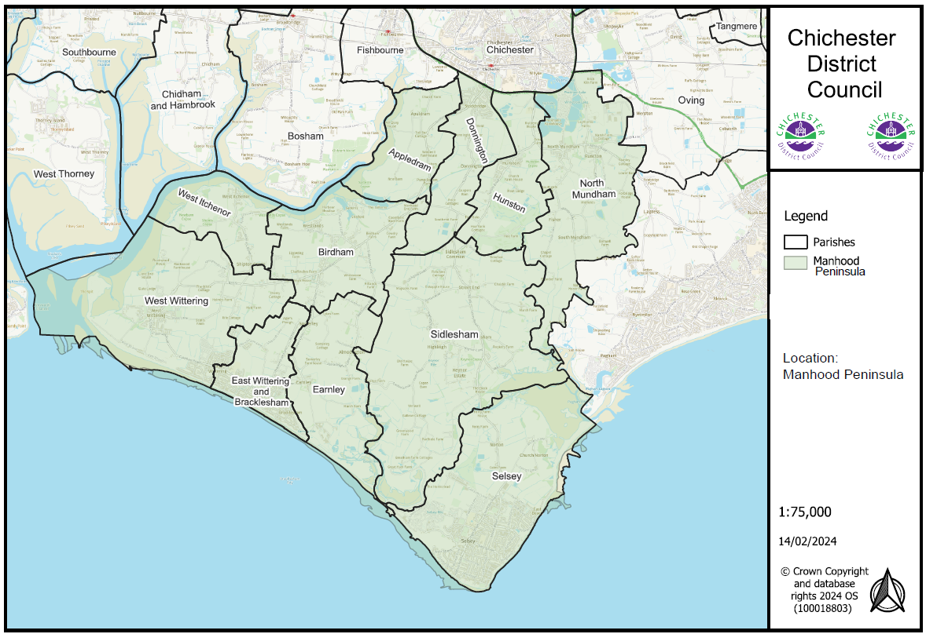

**Map A3 – North of the Plan Area**

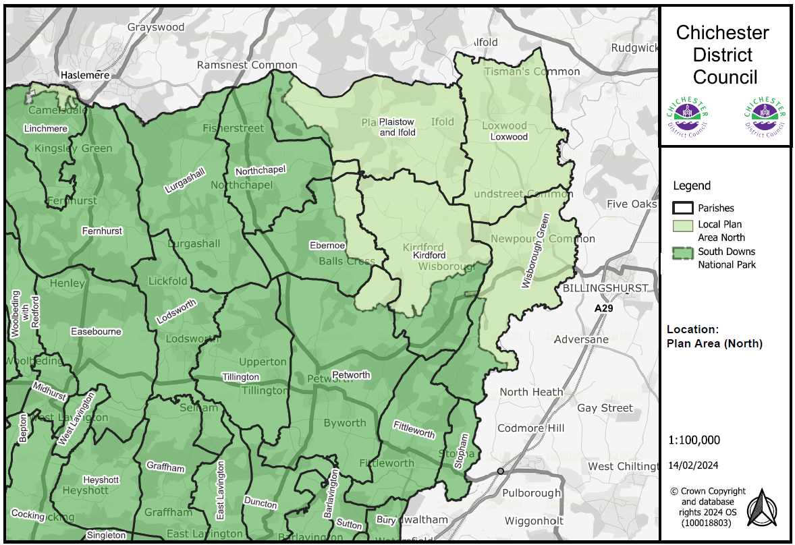

**Appendix 5**

Appendix B - Map of designated rural areas

Suggested Change - Ifold should be added to Plaistow entry

**Map B1 – Areas designated as Rural and Non-Rural Areas**

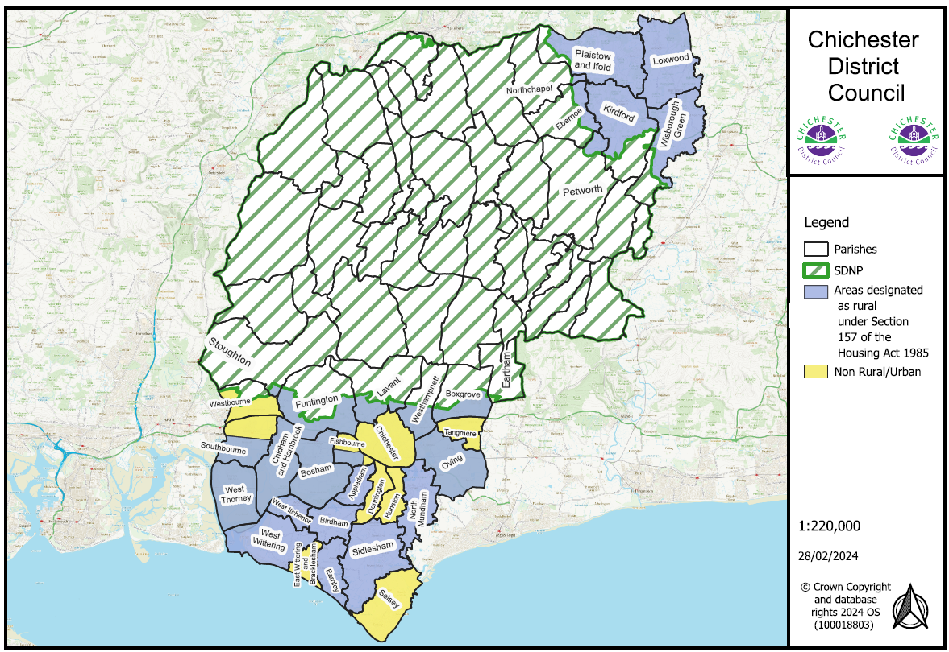

**Appendix 6**

Appendix E – Housing Trajectory

Suggested Change – Update trajectory to include new permissions, updated phasing

|  |  |  |  |  |  |  |  |  |  |  |  |  |  |  |  |  |  |  |  |  |  |  |  |  |  |  |  |  |
| --- | --- | --- | --- | --- | --- | --- | --- | --- | --- | --- | --- | --- | --- | --- | --- | --- | --- | --- | --- | --- | --- | --- | --- | --- | --- | --- | --- | --- |
| **Indicative Housing Trajectory 2021-2039**  **Local Plan Housing Delivery & Phasing** | | | | | |  |  |  |  |  |  |  |  |  |  |  |  |  |  |  |  |  |  |  |  |  |  |  |
|  |  |  |  |  |  |  |  |  |  |  |  |  |  |  |  |  |  |  |  |  |  |  |
|  | |  |  |  |  | 2021/22 | 2022/23 | 2023/24 | 2024/25 | 2025/26 | 2026/27 | 2027/28 | 2028/29 | 2029/30 | 2030/31 | 2031/32 | 2032/33 | 2033/34 | 2034/35 | 2035/36 | 2036/37 | 2037/38 | 2038/39 |  |  |  |  |  |
| **Local Plan Area net housing requirement** | | | | | |  |  |  |  |  |  |  |  |  |  |  |  |  |  |  |  |  |  |  |  |  |  |  |
| **Annual net housing target (575)** | | | | | | 575 | 575 | 575 | 575 | 575 | 575 | 575 | 575 | 575 | 575 | 575 | 575 | 575 | 575 | 575 | 575 | 575 | 575 |  |  |  | **10350** |  |
| **Cumulative net housing requirement** | | | | | | 575 | 1150 | 1725 | 2300 | 2875 | 3450 | 4025 | 4600 | 5175 | 5750 | 6325 | 6900 | 7475 | 8050 | 8625 | 9200 | 9775 | 10350 |  |  |  |  |  |
|  | |  |  |  |  |  |  |  |  |  |  |  |  |  |  |  |  |  |  |  |  |  |  |  |  |  |  |  |
| Net Completions | | | | | | 712 | 904 |  |  |  |  |  |  |  |  |  |  |  |  |  |  |  |  |  |  |  |  |  |
| Cumulative net completions | | | | | | 712 | 1616 |  |  |  |  |  |  |  |  |  |  |  |  |  |  |  |  |  |  |  | 1616 |  |
| Completions above/below housing requirement | | | | | | 137 | 466 |  |  |  |  |  |  |  |  |  |  |  |  |  |  |  |  |  |  |  | 466 |  |
|  |  |  |  |  |  |  |  |  |  |  |  |  |  |  |  |  |  |  |  |  |  |  |  |  |  |  |  |  |
|  |  |  |  |  |  |  |  |  |  |  |  |  |  |  |  |  |  |  |  |  |  |  |  |  |  |  |  |  |
| **Projected Housing Supply** | | | | | |  |  |  |  |  |  |  |  |  |  |  |  |  |  |  |  |  |  |  | **2023-28** | **2028-39** | **2023-39** |  |
|  |  |  |  |  |  |  |  |  |  |  |  |  |  |  |  |  |  |  |  |  |  |  |  |  |  |  |  |  |
| **Sites of 10+ dwellings currently under construction** | | | | | |  |  | 544 | 505 | 306 | 134 | 65 | 0 | 1 | 1 | 0 | 1 | 0 | 1 | 0 | 1 | 1 | 1 |  | 1554 | 7 | 1561 |  |
| WSCC Ref | Comprising: | Parish | Planning Ref | Date Permitted | Plan Sub-Area |  |  |  |  |  |  |  |  |  |  |  |  |  |  |  |  |  |  |  |  |  |  |  |
| O075 | Land On The North Side Of, Shopwhyke Road, Shopwhyke | Oving | 11/05283/OUT, 15/03720/OUT, 14/02826/REM, 15/03964/REM, 19/01234/REM, 19/01235/REM 19/01984/REM 19/01983/REM, | Outline (09/08/13) Outline (18/11/16) REM (09/01/15) REM (21/06/16) | East-West Corridor |  |  | 60 | 60 | 33 | 0 | 0 | 0 | 0 | 0 | 0 | 0 | 0 | 0 | 0 | 0 | 0 | 0 |  | 153 | 0 | 153 |  |
| XV184 | Graylingwell (inc Kingsmead Avenue) | Chichester | 08/03533/OUT, 10/05597/OUT, 14/01018/OUT 10/02926/REM, 13/00907/REM, 13/00837/REM, 15/02506/REM, 16/02253/FUL 16/02248/FUL 18/01623/REM 20/02905/REM | Outline (19/08/09) Outline (28/11/12) REM (12/11/10) REM (04/07/13) REM (14/07/13) REM (08/01/16) Full (30/09/16) Full (26/10/16) | East-West Corridor |  |  | 44 | 44 | 44 | 44 | 44 | 0 | 0 | 0 | 0 | 0 | 0 | 0 | 0 | 0 | 0 | 0 |  | 220 | 0 | 220 |  |
| ZV244 | Land West Of Centurion Way And West Of Old Broyle Road | Chichester | 14/04301/OUT  18/01587/REM 19/01134/REM 20/02473/REM 20/01046/REM 19/03146/REM 19/02819/REM 19/02626/REM 19/01531/REM  20/03166/REM 20/03108/REM 21/00460/REM | Outline (11/04/18) REM (05/12/18) REM (04/10/19) | East-West Corridor |  |  | 150 | 150 | 23 | 0 | 0 | 0 | 0 | 0 | 0 | 0 | 0 | 0 | 0 | 0 | 0 | 0 |  | 323 | 0 | 323 |  |
| O080 | Land To The South Of Oving Road/ B2144, Shopwhyke | Oving | 16/02254/OUT & 19/01416/REM & 20/02471/FUL | Outline (Aug 2017) REM (Dec 2019) Full (16/06/2021) | East-West Corridor |  |  | 29 | 0 | 0 | 0 | 0 | 0 | 0 | 0 | 0 | 0 | 0 | 0 | 0 | 0 | 0 | 0 |  | 29 | 0 | 29 |  |
| SY559 | Land East Of Manor Road Manor Road Selsey West Sussex | Selsey | 19/00321/FUL 22/02236/REM | Full (09/12/2019) | Manhood Peninsula |  |  | 50 | 50 | 24 | 0 | 0 | 0 | 0 | 0 | 0 | 0 | 0 | 0 | 0 | 0 | 0 | 0 |  | 124 | 0 | 124 |  |
| WH034 | Land North East of Graylingwell Park (Phase 2 Westhampnett/NE Chichester SDL) | Chichester | 16/03791/OUT & 18/01911/FUL (access) & 19/03191/REM | Outline (08/11/18) REM (01/07/21) | East-West Corridor |  |  | 45 | 45 | 45 | 23 | 0 | 0 | 0 | 0 | 0 | 0 | 0 | 0 | 0 | 0 | 0 | 0 |  | 158 | 0 | 158 |  |
| KD090 | Land On The East Side Of Plaistow Road | Kirdford | 15/03367/FUL & 19/00086/FUL | Full (22/11/18) Full (30/11/19) | Plan Area (North) |  |  | 11 | 32 | 11 | 0 | 0 | 0 | 0 | 0 | 0 | 0 | 0 | 0 | 0 | 0 | 0 | 0 |  | 54 | 0 | 54 |  |
| O081 | Former Portfield Quarry And Uma House Shopwhyke Road Shopwhyke Chichester | Chichester | 19/02030/FUL | Full (12/06/2020) | East-West Corridor |  |  | 21 | 39 | 21 | 0 | 0 | 0 | 0 | 0 | 0 | 0 | 0 | 0 | 0 | 0 | 0 | 0 |  | 81 | 0 | 81 |  |
| CH107 | Land Adjoining A27 Scant Road West Hambrook | Chidham & Hambrook | 20/01826/FUL | Full (04/11/2021) | East-West Corridor |  |  | 18 | 20 | 40 | 40 | 0 | 0 | 0 | 0 | 0 | 0 | 0 | 0 | 0 | 0 | 0 | 0 |  | 118 | 0 | 118 |  |
| TG091 | The Yews, City Fields Way | Tangmere | 18/03143/FUL | Full (24/07/19) | East-West Corridor |  |  | 38 | 0 | 0 | 0 | 0 | 0 | 0 | 0 | 0 | 0 | 0 | 0 | 0 | 0 | 0 | 0 |  | 38 | 0 | 38 |  |
| O084 | Woodfield House Tangmere Road | Tangmere | 23/00307/PA3MA | PN (24/03/23) | East-West Corridor |  |  | 19 | 0 | 0 | 0 | 0 | 0 | 0 | 0 | 0 | 0 | 0 | 0 | 0 | 0 | 0 | 0 |  | 19 | 0 | 19 |  |
| SB380 | Land North of Cooks Lane Southbourne | Southbourne | 18/03145/OUT 22/00157/REM | Outline (02/03/20) REM (31/08/22) | East-West Corridor |  |  | 21 | 65 | 65 | 27 | 21 | 0 | 0 | 0 | 0 | 0 | 0 | 0 | 0 | 0 | 0 | 0 |  | 199 | 0 | 199 |  |
| SY562 | Park Farm Park Lane Selsey | Selsey | 20/00085/FUL | Full (20/05/2020) | Manhood Peninsula |  |  | 38 | 0 | 0 | 0 | 0 | 0 | 0 | 0 | 0 | 0 | 0 | 0 | 0 | 0 | 0 | 0 |  | 38 | 0 | 38 |  |
| WR121 | Greenways Nursery, Kirdford Road | Wisborough Green | 13/00744/FUL | Full (30/12/14) | Plan Area (North) |  |  | 0 | 0 | 0 | 0 | 0 | 0 | 1 | 1 | 0 | 1 | 0 | 1 | 0 | 1 | 1 | 1 |  | 0 | 7 | 7 |  |
|  |  |  |  |  |  |  |  |  |  |  |  |  |  |  |  |  |  |  |  |  |  |  |  |  |  |  |  |  |
| **Sites of 10+ dwellings with an outstanding detailed planning permission** | | | | | |  |  | 0 | 14 | 76 | 155 | 21 | 4 | 15 | 0 | 0 | 0 | 0 | 0 | 0 | 0 | 0 | 0 |  | 266 | 19 | 285 |  |
| WSCC Ref | Comprising: | Parish | Planning Ref | Date Permitted | Plan Sub-Area |  |  |  |  |  |  |  |  |  |  |  |  |  |  |  |  |  |  |  |  |  |  |  |
| NM129 | Former Lowlands Nursery Lagness Road North Mundham | North Mundham | 20/01686/FUL | Full (11/08/2021) | Manhood Peninsula |  |  | 0 | 10 | 29 | 0 | 0 | 0 | 0 | 0 | 0 | 0 | 0 | 0 | 0 | 0 | 0 | 0 |  | 39 | 0 | 39 |  |
| CC1412 | Warrendell, off Plainwood Close | Chichester | 98/02043/OUT 20/01164/REM | Outline (29/11/18) REM (16/07/21) | East-West Corridor |  |  | 0 | 4 | 6 | 3 | 4 | 4 | 0 | 0 | 0 | 0 | 0 | 0 | 0 | 0 | 0 | 0 |  | 17 | 4 | 21 |  |
|  | Land South Of Lowlands North Mundham | North Mundham | 20/02989/FUL | Full (01/12/23) | Manhood Peninsula |  |  | 0 | 0 | 29 | 29 | 8 | 0 | 0 | 0 | 0 | 0 | 0 | 0 | 0 | 0 | 0 | 0 |  | 66 | 0 | 66 |  |
| WE137 | Land North Of 30 To 56 Mill Road Westbourne | Westbourne | 20/01061/FUL | Full (02/02/23) | East-West Corridor |  |  | 0 | 0 | 12 | 0 | 0 | 0 | 0 | 0 | 0 | 0 | 0 | 0 | 0 | 0 | 0 | 0 |  | 12 | 0 | 12 |  |
| O075 | Phase 3A (Shopwhyke Care Site) Land On The North Side Of Shopwhyke Road Shopwhyke | Oving | 21/00258/FUL | Full (09/07/21) | East-West Corridor |  |  | 0 | 0 | 0 | 45 | 0 | 0 | 0 | 0 | 0 | 0 | 0 | 0 | 0 | 0 | 0 | 0 |  | 45 | 0 | 45 |  |
| XV184 | Graylingwell Hospital Chichester | Chichester | 14/01018/OUT 22/01501/REM | Outline (21/03/2018) REM (30/05/23) | East-West Corridor |  |  | 0 | 0 | 0 | 61 | 0 | 0 | 0 | 0 | 0 | 0 | 0 | 0 | 0 | 0 | 0 | 0 |  | 61 | 0 | 61 |  |
| CH109 | Chas Wood Nurseries Main Road Bosham | Chidham and Hambrook | 20/01854/OUT 23/01164/REM | Outline (17/10/2022) REM (14/02/24) | East-West Corridor |  |  | 0 | 0 | 0 | 17 | 9 | 0 | 0 | 0 | 0 | 0 | 0 | 0 | 0 | 0 | 0 | 0 |  | 26 | 0 | 26 |  |
| BI170 | Field North West Of The Saltings, Crooked Lane | Birdham | BI/13/01391/FUL & BI/16/01809/FUL | Full (29/11/13) Full (14/10/16) | Manhood Peninsula |  |  | 0 | 0 | 0 | 0 | 0 | 0 | 15 | 0 | 0 | 0 | 0 | 0 | 0 | 0 | 0 | 0 |  | 0 | 15 | 15 |  |
|  |  |  |  |  |  |  |  |  |  |  |  |  |  |  |  |  |  |  |  |  |  |  |  |  |  |  |  |  |
|  |  |  |  |  |  |  |  |  |  |  |  |  |  |  |  |  |  |  |  |  |  |  |  |  | **2023-28** | **2028-39** | **2023-39** |  |
| **Sites of 10+ dwellings with outline planning permission** | | | | | |  |  | 0 | 0 | 0 | 60 | 121 | 129 | 79 | 23 | 0 | 0 | 0 | 0 | 0 | 0 | 0 | 0 |  | 181 | 231 | 412 |  |
| WSCC Ref | Comprising: | Parish | Planning Ref | Date Permitted | Plan Sub-Area |  |  |  |  |  |  |  |  |  |  |  |  |  |  |  |  |  |  |  |  |  |  |  |
| LX135 | Land South Of Loxwood Farm Place High Street Loxwood | Loxwood | 20/01617/OUT | Outline (15/10/20) | Plan Area (North) |  |  | 0 | 0 | 0 | 0 | 18 | 6 | 0 | 0 | 0 | 0 | 0 | 0 | 0 | 0 | 0 | 0 |  | 18 | 6 | 24 |  |
| O075 | Land East Of Glenmore Business Park Longacres Way Chichester | Oving | 21/00594/OUT | Outline (21/01/22) | East-West Corridor |  |  | 0 | 0 | 0 | 0 | 0 | 23 | 0 | 0 | 0 | 0 | 0 | 0 | 0 | 0 | 0 | 0 |  | 0 | 23 | 23 |  |
| WW362 | Land To The West Of Church Road Church Road West Wittering | West Wittering | 20/02491/OUT | Outline (22/04/2022) | Manhood Peninsula |  |  | 0 | 0 | 0 | 0 | 0 | 12 | 48 | 10 | 0 | 0 | 0 | 0 | 0 | 0 | 0 | 0 |  | 0 | 70 | 70 |  |
| WW034 | Land Within The Westhampnett / North East Chichester Strategic Development Location (north Of Madgwick Lane) Chichester | Westhampnett | 20/02824/OUT | Outline (27/05/2022) | East-West Corridor |  |  | 0 | 0 | 0 | 60 | 60 | 45 | 0 | 0 | 0 | 0 | 0 | 0 | 0 | 0 | 0 | 0 |  | 60 | 105 | 165 |  |
| E056 | Earnley Concourse Clappers Lane Earnley Chichester | Earnley | 19/02493/OUT | Outline (30/05/2022) | Manhood Peninsula |  |  | 0 | 0 | 0 | 0 | 0 | 0 | 17 | 13 | 0 | 0 | 0 | 0 | 0 | 0 | 0 | 0 |  | 0 | 30 | 30 |  |
| E057 | Land south of Clappers Lane, Earnley | Earnley | 20/03125/OUT | Outline (16/08/22) | Manhood Peninsula |  |  | 0 | 0 | 0 | 0 | 43 | 43 | 14 | 0 | 0 | 0 | 0 | 0 | 0 | 0 | 0 | 0 |  | 0 | 100 | 100 |  |
|  |  |  |  |  |  |  |  |  |  |  |  |  |  |  |  |  |  |  |  |  |  |  |  |  |  |  |  |  |
| **Permissions on small sites 5-9 dwellings** | | | | | |  |  | 19 | 14 | 0 | 0 | 0 | 0 | 0 | 0 | 0 | 0 | 0 | 0 | 0 | 0 | 0 | 0 |  | 33 | 0 | 33 |  |
| WSCC Ref | Comprising: | Parish | Planning Ref | Date Permitted | Plan Sub-Area |  |  |  |  |  |  |  |  |  |  |  |  |  |  |  |  |  |  |  |  |  |  |  |
| SB354 | Elmsleigh 30 First Avenue Southbourne | Southbourne | 16/00407/FUL | Full (25/05/16) | East-West Corridor |  |  | 5 | 0 | 0 | 0 | 0 | 0 | 0 | 0 | 0 | 0 | 0 | 0 | 0 | 0 | 0 | 0 |  | 5 | 0 | 5 |  |
| SB384 | Land North West Of 139 Main Road Southbourne | Southbourne | 20/02297/FUL | Full (23/06/22) | East-West Corridor |  |  | 0 | 8 | 0 | 0 | 0 | 0 | 0 | 0 | 0 | 0 | 0 | 0 | 0 | 0 | 0 | 0 |  | 8 | 0 | 8 |  |
| HN044 | Land south of Reedbridge Farm | Hunston | 18/01320/FUL Site Allocation DPD Policy HN1 | DPD Allocation Full (16/09/18) | Manhood Peninsula |  |  | 2 | 1 | 0 | 0 | 0 | 0 | 0 | 0 | 0 | 0 | 0 | 0 | 0 | 0 | 0 | 0 |  | 3 | 0 | 3 |  |
| NM126 | South Mundham Farm South Mundham Road South Mundham | North Mundham | 19/00677/FUL | Full (07/02/2020) | East-West Corridor |  |  | 2 | 0 | 0 | 0 | 0 | 0 | 0 | 0 | 0 | 0 | 0 | 0 | 0 | 0 | 0 | 0 |  | 2 | 0 | 2 |  |
| SY561 | 99 - 101 High Street Selsey | Selsey | 22/02196/FUL | Full (29/11/2021) | Manhood Peninsula |  |  | 0 | 5 | 0 | 0 | 0 | 0 | 0 | 0 | 0 | 0 | 0 | 0 | 0 | 0 | 0 | 0 |  | 5 | 0 | 5 |  |
| YV318 | Land at Royal Close Chichester | Chichester | 20/02530/FUL | Full (19/01/2022) | East-West Corridor |  |  | 5 | 0 | 0 | 0 | 0 | 0 | 0 | 0 | 0 | 0 | 0 | 0 | 0 | 0 | 0 | 0 |  | 5 | 0 | 5 |  |
| E054 | Earnley Gardens Almodington Lane Almodington Earnley | Earnley | 20/03289/FUL | Full (11/02/2022) | Manhood Peninsula |  |  | 5 | 0 | 0 | 0 | 0 | 0 | 0 | 0 | 0 | 0 | 0 | 0 | 0 | 0 | 0 | 0 |  | 5 | 0 | 5 |  |
|  |  |  |  |  |  |  |  |  |  |  |  |  |  |  |  |  |  |  |  |  |  |  |  |  |  |  |  |  |
| **Permissions on small sites 4 or less dwellings** | | | | | |  |  | 44 | 41 | 41 | 41 | 0 | 0 | 0 | 0 | 0 | 0 | 0 | 0 | 0 | 0 | 0 | 0 |  | 167 | 0 | 167 |  |
|  |  |  |  |  |  |  |  |  |  |  |  |  |  |  |  |  |  |  |  |  |  |  |  |  |  |  |  |  |
| **Sites allocated in Local Plan 2014-2029** | | | | | |  |  | 0 | 0 | 152 | 48 | 118 | 143 | 268 | 278 | 278 | 280 | 160 | 160 | 160 | 100 | 65 | 0 |  | 318 | 1892 | 2210 |  |
| WSCC Ref | Comprising: | Parish | Planning Ref | Date Permitted | Plan Sub-Area |  |  |  |  |  |  |  |  |  |  |  |  |  |  |  |  |  |  |  |  |  |  |  |
| ZV244 | West of Chichester SDL (Phase 2) | Chichester | Chichester Local Plan Policy 15 22/01485/OUTEIA - | Outline (subject to s106) 10/01/24 | East-West Corridor |  |  | 0 | 0 | 127 | 23 | 118 | 118 | 118 | 118 | 118 | 110 | 0 | 0 | 0 | 0 | 0 | 0 |  | 268 | 582 | 850 |  |
| TG086 | Tangmere SDL | Tangmere | Chichester Local Plan Policy 18 20/02893/OUT | Outline (subject to s106) 16/08/23 | East-West Corridor |  |  | 0 | 0 | 0 | 0 | 0 | 25 | 150 | 160 | 160 | 160 | 160 | 160 | 160 | 100 | 65 | 0 |  | 0 | 1300 | 1300 |  |
| BO019 | Land at Highgrove Farm | Bosham | Site Allocation DPD Policy BO1 |  | East-West Corridor |  |  | 0 | 0 | 25 | 25 | 0 | 0 | 0 | 0 | 0 | 0 | 0 | 0 | 0 | 0 | 0 | 0 |  | 50 | 0 | 50 |  |
| PS276 | Land north of Little Springfield Farm, Ifold | Plaistow & Ifold | Site Allocation DPD Policy PL1 |  | Plan Area (North) |  |  | 0 | 0 | 0 | 0 | 0 | 0 | 0 | 0 | 0 | 10 | 0 | 0 | 0 | 0 | 0 | 0 |  | 0 | 10 | 10 |  |
|  |  |  |  |  |  |  |  |  |  |  |  |  |  |  |  |  |  |  |  |  |  |  |  |  |  |  |  |  |
| **Sites allocated in made Neighbourhood Plans** | | | | | |  |  | 0 | 0 | 0 | 0 | 0 | 0 | 0 | 26 | 38 | 15 | 15 | 0 | 0 | 0 | 0 | 0 |  | 0 | 94 | 94 |  |
|  | Comprising: | Parish | Planning Ref | Date Permitted | Plan Sub-Area |  |  |  |  |  |  |  |  |  |  |  |  |  |  |  |  |  |  |  |  |  |  |  |
|  | Land at Farm Close | Loxwood | Loxwood Neighbourhood Plan Policy 4 |  | Plan Area (North) |  |  | 0 | 0 | 0 | 0 | 0 | 0 | 0 | 17 | 0 | 0 | 0 | 0 | 0 | 0 | 0 | 0 |  | 0 | 17 | 17 |  |
|  | Tangmere Academy | Tangmere | Tangmere Neighbourhood Plan Policy 4 |  | East-West Corridor |  |  | 0 | 0 | 0 | 0 | 0 | 0 | 0 | 0 | 0 | 0 | 15 | 0 | 0 | 0 | 0 | 0 |  | 0 | 15 | 15 |  |
|  | Land to the West of Malcolm Road | Tangmere | Tangmere Neighbourhood Plan Policy 7 |  | East-West Corridor |  |  | 0 | 0 | 0 | 0 | 0 | 0 | 0 | 0 | 12 | 0 | 0 | 0 | 0 | 0 | 0 | 0 |  | 0 | 12 | 12 |  |
|  | Clark's Yard, Billingshurst Road | Wisborough Green | Wisborough Green Neighbourhood Plan Policy SS3 |  | Plan Area (North) |  |  | 0 | 0 | 0 | 0 | 0 | 0 | 0 | 0 | 11 | 0 | 0 | 0 | 0 | 0 | 0 | 0 |  | 0 | 11 | 11 |  |
|  | Land at the Roman Palace | Fishbourne | Fishbourne Neighbourhood Plan Policy SD2 |  | East-West Corridor |  |  | 0 | 0 | 0 | 0 | 0 | 0 | 0 | 0 | 0 | 15 | 0 | 0 | 0 | 0 | 0 | 0 |  | 0 | 15 | 15 |  |
|  | Land at Townfield | Kirdford | Kirdford Neighbourhood Plan Policy KSS2a |  | Plan Area (North) |  |  | 0 | 0 | 0 | 0 | 0 | 0 | 0 | 0 | 6 | 0 | 0 | 0 | 0 | 0 | 0 | 0 |  | 0 | 6 | 6 |  |
|  | Land at Cornwood and/or School Court | Kirdford | Kirdford Neighbourhood Plan Policy KSS5 |  | Plan Area (North) |  |  | 0 | 0 | 0 | 0 | 0 | 0 | 0 | 0 | 9 | 0 | 0 | 0 | 0 | 0 | 0 | 0 |  | 0 | 9 | 9 |  |
|  | Land adjacent to Chantry Hall, Foxbury Lane | Westbourne | Westbourne Neighbourhood Plan Policy SS3 |  | East-West Corridor |  |  | 0 | 0 | 0 | 0 | 0 | 0 | 0 | 6 | 0 | 0 | 0 | 0 | 0 | 0 | 0 | 0 |  | 0 | 6 | 6 |  |
|  | Land at The Old Granary | Boxgrove | Boxgrove Neighbourhood Plan Policy H5 |  | East-West Corridor |  |  | 0 | 0 | 0 | 0 | 0 | 0 | 0 | 3 | 0 | 0 | 0 | 0 | 0 | 0 | 0 | 0 |  | 0 | 3 | 3 |  |
|  |  |  |  |  |  |  |  |  |  |  |  |  |  |  |  |  |  |  |  |  |  |  |  |  |  |  |  |  |
| **Windfall** | | | | | |  |  | 0 | 0 | 0 | 0 | 60 | 60 | 60 | 60 | 60 | 60 | 60 | 60 | 60 | 60 | 60 | 60 |  | 60 | 660 | 720 |  |
|  |  |  |  |  |  |  |  |  |  |  |  |  |  |  |  |  |  |  |  |  |  |  |  |  |  |  |  |  |
| **Total Housing Supply** | | | | | |  |  | 607 | 574 | 575 | 438 | 385 | 336 | 423 | 388 | 376 | 356 | 235 | 221 | 220 | 161 | 126 | 61 |  | 2579 | 2903 | 5482 |  |
|  |  |  |  |  |  |  |  |  |  |  |  |  |  |  |  |  |  |  |  |  |  |  |  |  |  |  |  |  |
|  |  |  |  |  |  |  |  |  |  |  |  |  |  |  |  |  |  |  |  |  |  |  |  |  | **2023-28** | **2028-39** | **2023-39** | No. of Dwellings in Policy |
| **New Strategic and Parish Allocations** | | | | | |  |  | 0 | 0 | 0 | 0 | 0 | 30 | 98 | 162 | 281 | 276 | 250 | 246 | 258 | 336 | 359 | 348 |  | 0 | 2644 | 2644 | 3520 |
|  | Comprising: | Parish | Policy Ref |  | Plan Sub-Area |  |  |  |  |  |  |  |  |  |  |  |  |  |  |  |  |  |  |  |  |  | Remaining Figure to Allocate |  |
|  | Chichester City | Chichester | Policy A2 |  | East-West Corridor |  |  | 0 | 0 | 0 | 0 | 0 | 0 | 8 | 24 | 24 | 24 | 24 | 24 | 33 | 33 | 33 | 33 |  | 0 | 260 | 260 | 270 |
|  | Southern Gateway | Chichester | Policy A4 & A5 |  | East-West Corridor |  |  | 0 | 0 | 0 | 0 | 0 | 0 | 0 | 0 | 42 | 28 | 0 | 0 | 0 | 47 | 47 | 16 |  | 0 | 180 | 180 | 180 |
|  | East of Chichester | Oving | Policy A8 |  | East-West Corridor |  |  | 0 | 0 | 0 | 0 | 0 | 30 | 65 | 65 | 65 | 65 | 65 | 65 | 65 | 65 | 65 | 65 |  | 0 | 680 | 680 | 680 |
|  | Maudlin Farm | Westhampnett | Policy A10 |  | East-West Corridor |  |  | 0 | 0 | 0 | 0 | 0 | 0 | 25 | 50 | 50 | 50 | 50 | 40 | 0 | 0 | 0 | 0 |  | 0 | 265 | 265 | 265 |
|  | Highgrove Farm Bosham | Bosham | Policy A11 |  | East-West Corridor |  |  | 0 | 0 | 0 | 0 | 0 | 0 | 0 | 0 | 0 | 0 | 0 | 0 | 0 | 0 | 0 | 0 |  | 0 | 0 | 0 | 245 |
|  | Chidham & Hambrook | Chidham & Hambrook | Policy A12 |  | East-West Corridor |  |  | 0 | 0 | 0 | 0 | 0 | 0 | 0 | 0 | 0 | 0 | 0 | 0 | 0 | 0 | 0 | 0 |  | 0 | 0 | 0 | 300 |
|  | Southbourne | Southbourne | Policy A13 |  | East-West Corridor |  |  | 0 | 0 | 0 | 0 | 0 | 0 | 0 | 23 | 100 | 100 | 100 | 100 | 100 | 100 | 100 | 100 |  | 0 | 823 | 823 | 1050 |
|  | Loxwood | Loxwood | Policy A15 |  | Plan Area (North) |  |  | 0 | 0 | 0 | 0 | 0 | 0 | 0 | 0 | 0 | 0 | 0 | 0 | 38 | 50 | 50 | 50 |  | 0 | 188 | 188 | 220 |
|  | Boxgrove | Boxgrove | Policy H3 |  | East-West Corridor |  |  | 0 | 0 | 0 | 0 | 0 | 0 | 0 | 0 | 0 | 0 | 0 | 0 | 0 | 16 | 17 | 17 |  | 0 | 50 | 50 | 50 |
|  | Westbourne | Westbourne | Policy H3 |  | East-West Corridor |  |  | 0 | 0 | 0 | 0 | 0 | 0 | 0 | 0 | 0 | 0 | 0 | 0 | 0 | 0 | 1 | 17 |  | 0 | 18 | 18 | 30 |
|  | Fishbourne | Fishbourne | Policy H3 |  | East-West Corridor |  |  | 0 | 0 | 0 | 0 | 0 | 0 | 0 | 0 | 0 | 0 | 0 | 0 | 0 | 0 | 13 | 17 |  | 0 | 30 | 30 | 30 |
|  | North Mundham | North Mundham | Policy H3 |  | Manhood |  |  | 0 | 0 | 0 | 0 | 0 | 0 | 0 | 0 | 0 | 0 | 0 | 0 | 0 | 0 | 0 | 0 |  | 0 | 0 | 0 | 50 |
|  | Kirdford | Kirdford | Policy H3 |  | Plan Area (North) |  |  | 0 | 0 | 0 | 0 | 0 | 0 | 0 | 0 | 0 | 0 | 0 | 6 | 11 | 11 | 11 | 11 |  | 0 | 50 | 50 | 50 |
|  | Plaistow and Ifold | Plaistow and Ifold | Policy H3 |  | Plan Area (North) |  |  | 0 | 0 | 0 | 0 | 0 | 0 | 0 | 0 | 0 | 0 | 0 | 0 | 0 | 3 | 11 | 11 |  | 0 | 25 | 25 | 25 |
|  | Wisborough Green | Wisborough Green | Policy H3 |  | Plan Area (North) |  |  | 0 | 0 | 0 | 0 | 0 | 0 | 0 | 0 | 0 | 9 | 11 | 11 | 11 | 11 | 11 | 11 |  | 0 | 75 | 75 | 75 |
|  |  |  |  |  |  |  |  |  |  |  |  |  |  |  |  |  |  |  |  |  |  |  |  |  |  |  |  |  |
| **Total Projected Housing Supply** | | | | | |  |  | **607** | **574** | **575** | **438** | **385** | **366** | **521** | **550** | **657** | **632** | **485** | **467** | **478** | **497** | **485** | **409** |  |  |  | **9741** |  |
|  |  |  |  |  |  |  |  |  |  |  |  |  |  |  |  |  |  |  |  |  |  |  |  |  |  |  |  |  |
| **Sites of 5+ dwellings permitted after 1st April 23** | | |  |  |  |  |  | 0 | 0 | 74 | 84 | 61 | 85 | 253 | 240 | 182 | 31 | 0 | 0 | 0 | 0 | 0 | 0 |  | 219 | 791 | 1010 |  |
|  | Comprising: | Parish | Planning Ref | Date Permitted | Plan Sub-Area |  |  |  |  |  |  |  |  |  |  |  |  |  |  |  |  |  |  |  |  |  |  |  |
|  | Land East of Broad Road, Nutbourne | Chidham & Hambrook | 20/03320/OUTEIA | Outline (29/08/2023) | East-West Corridor |  |  | 0 | 0 | 0 | 0 | 0 | 0 | 43 | 43 | 43 | 3 | 0 | 0 | 0 | 0 | 0 | 0 |  | 0 | 132 | 132 |  |
|  | Land West of Drift Lane, Chidham | Chidham & Hambrook | 20/03321/OUTEIA | Outline (29/08/2023) | East-West Corridor |  |  | 0 | 0 | 0 | 0 | 0 | 0 | 29 | 29 | 10 | 0 | 0 | 0 | 0 | 0 | 0 | 0 |  | 0 | 68 | 68 |  |
|  | Land at Flat Farm, Broad Road, Hambrook | Chidham & Hambrook | 20/03378/OUT | Outline (31/08/2023) | East-West Corridor |  |  | 0 | 0 | 0 | 0 | 0 | 17 | 13 | 0 | 0 | 0 | 0 | 0 | 0 | 0 | 0 | 0 |  | 0 | 30 | 30 |  |
|  | Land South West Of Willets Way Willetts Way | Loxwood | 23/01104/FUL | Full (15/08/2023) | Plan Area (North) |  |  | 0 | 0 | 5 | 0 | 0 | 0 | 0 | 0 | 0 | 0 | 0 | 0 | 0 | 0 | 0 | 0 |  | 5 | 0 | 5 |  |
|  | Land West Of Guildford Road | Loxwood | 20/01977/FUL | Full (16/08/2023) | Plan Area (North) |  |  | 0 | 0 | 17 | 10 | 0 | 0 | 0 | 0 | 0 | 0 | 0 | 0 | 0 | 0 | 0 | 0 |  | 27 | 0 | 27 |  |
|  | G & R Harris, Main Road, Nutbourne | Southbourne | 22/01283/FULEIA | Full (18/09/2023) | East-West Corridor |  |  | 0 | 0 | 46 | 46 | 11 | 0 | 0 | 0 | 0 | 0 | 0 | 0 | 0 | 0 | 0 | 0 |  | 103 | 0 | 103 |  |
|  | Land to the west of Monk's Hill | Westbourne | Westbourne Neighbourhood Plan Policy SS1 22/00209/FUL | Full (18/10/23) | East-West Corridor |  |  | 0 | 0 | 6 | 3 | 0 | 0 | 0 | 0 | 0 | 0 | 0 | 0 | 0 | 0 | 0 | 0 |  | 9 | 0 | 9 |  |
|  | Highgrove Farm | Bosham | 21/00571/FUL | Full (09/11/23) | East-West Corridor |  |  | 0 | 0 | 0 | 25 | 50 | 50 | 50 | 50 | 25 | 0 | 0 | 0 | 0 | 0 | 0 | 0 |  | 75 | 175 | 250 |  |
|  | Woodfield House Tangmere Road | Tangmere | 23/02163/PA3MA | Full (20/12/23) | East-West Corridor |  |  | 0 | 0 | 0 | 0 | 0 | 18 | 0 | 0 | 0 | 0 | 0 | 0 | 0 | 0 | 0 | 0 |  | 0 | 18 | 18 |  |
|  | Land Off Main Road | Birdham | 21/01830/OUT | Outline (09/02/24) | Manhood Peninsula |  |  | 0 | 0 | 0 | 0 | 0 | 0 | 43 | 43 | 43 | 21 | 0 | 0 | 0 | 0 | 0 | 0 |  | 0 | 150 | 150 |  |
|  | Charmans Field | North Mundham | 22/02191/OUT | Outline (subject to s106) 06/03/24 | Manhood Peninsula |  |  | 0 | 0 | 0 | 0 | 0 | 0 | 29 | 29 | 29 | 7 | 0 | 0 | 0 | 0 | 0 | 0 |  | 0 | 94 | 94 |  |
|  | Four Acre Nursery Cooks Lane | Southbourne | 22/01903/OUT | Outline (subject to s106) 06/03/24 | East-West Corridor |  |  | 0 | 0 | 0 | 0 | 0 | 0 | 17 | 17 | 6 | 0 | 0 | 0 | 0 | 0 | 0 | 0 |  | 0 | 40 | 40 |  |
|  | Land To The North Of Penny Lane Penny Lane Hermitage | Southbourne | 23/00024/OUT | Outline (subject to s106) 06/03/24 | East-West Corridor |  |  | 0 | 0 | 0 | 0 | 0 | 0 | 29 | 29 | 26 | 0 | 0 | 0 | 0 | 0 | 0 | 0 |  | 0 | 84 | 84 |  |
|  |  |  |  |  |  |  |  |  |  |  |  |  |  |  |  |  |  |  |  |  |  |  |  |  |  |  |  |  |
|  |  |  |  |  |  |  |  |  |  |  |  |  |  |  |  |  |  |  |  |  |  |  |  |  |  |  |  |  |
| **Total Projected Housing Supply** | | | | | |  |  | **607** | **574** | **649** | **522** | **446** | **451** | **774** | **790** | **839** | **663** | **485** | **467** | **478** | **497** | **485** | **409** |  |  |  | **10752** |  |
|  | **Completions above housing requirement (average over 5 year supply period)** | | | | | | |  | **93.2** | **93.2** | **93.2** | **93.2** | **93.2** |  |  |  |  |  |  |  |  |  |  |  |  |  |  |  |
| **Total Housing Supply (including completions above housing requirement)** | | | | | |  |  | **607** | **667** | **742** | **615** | **539** | **544** | **774** | **790** | **839** | **663** | **485** | **467** | **478** | **497** | **485** | **409** |  |  |  |  |  |
|  |  | | | | |  |  |  |  |  |  |  |  |  |  |  |  |  |  |  |  |  |  |  |  |  |  |  |
| **Projected Five Year Supply Position** | | | | | | | | 2023/24 | 2024/25 | 2025/26 | 2026/27 | 2027/28 | 2028/29 | 2029/30 | 2030/31 | 2031/32 | 2032/33 | 2033/34 | 2034/35 |  |  |  |  |  |  |  |  |  |
| **Projected five year housing supply** | | | | | | | | 3171 | 3108 | 3215 | 3263 | 3486 | 3517 | 3551 | 3244 | 2932 | 2590 | 2412 | 2336 |  |  |  |  |  |  |  |  |  |
| **Adjusted five year housing requirement (+buffer)** | | | | | | | | 3019 | 3019 | 3019 | 3019 | 3019 | 3019 | 3019 | 3019 | 3019 | 3019 | 3019 | 3019 |  |  |  |  |  |  |  |  |  |
| **Projected years housing supply** | | | | | | | | **5.25** | **5.15** | **5.32** | **5.40** | **5.77** | **5.83** | **5.88** | **5.37** | **4.86** | **4.29** | **4.00** | **3.87** |  |  |  |  |  |  |  |  |  |

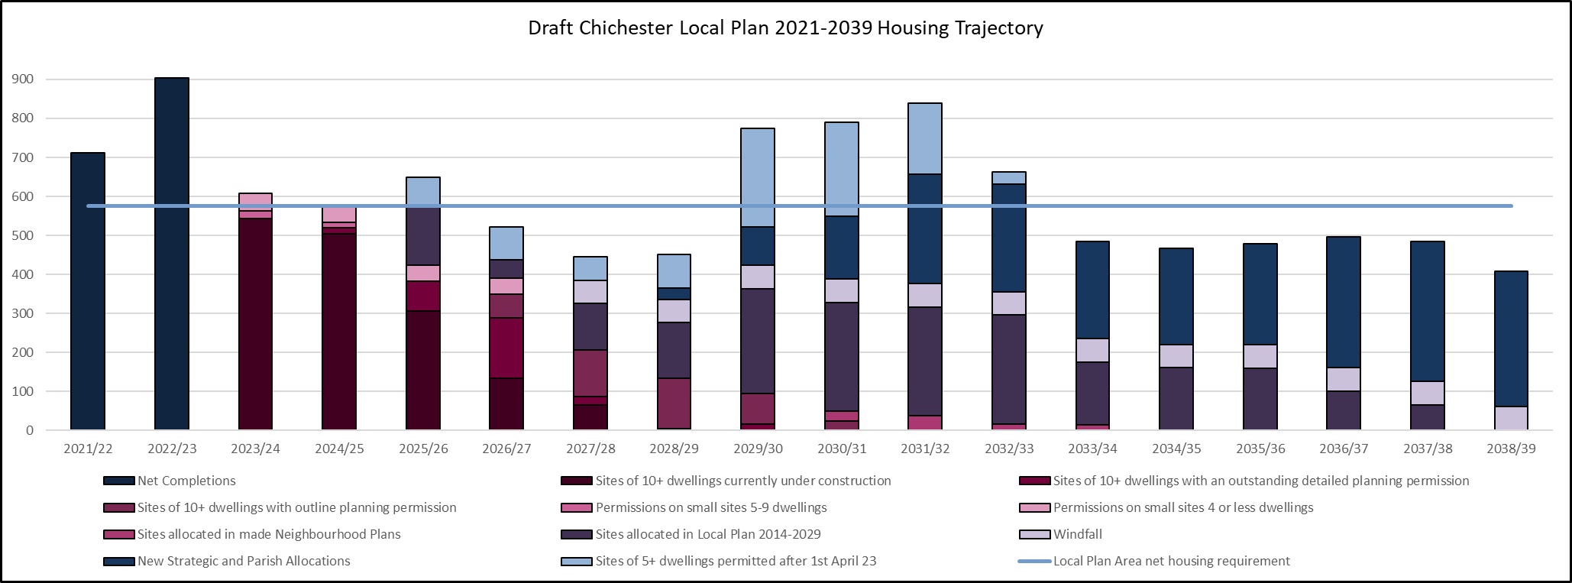

**Appendix 7**

Suggested Change – New Appendix F – Policies linked to Vision and Objectives

|  |  |  |  |  |  |  |  |  |
| --- | --- | --- | --- | --- | --- | --- | --- | --- |
|  | **Vision** | 1,2,4,5,6 | 3,11 | 4 | 6 | 2,7,8,9,10, 11,12,13,14 | 4,9,10 | 5,11,13 |
|  | **Strategic Objectives** | Objective 1: Climate Change -mitigation and adaptation | Objective 2: Natural Environment – protection and enhancement | Objective 3: Housing | Objective 4: Employment and Economy | Objective 5: Health and Wellbeing | Objective 6: Design and Heritage | Objective 7: Strategic Infrastructure |
| **Policies** | **CHAPTER 3: SPATIAL STRATEGY** | | | | | | | |
| S1 - Spatial Development Strategy | 1 |  | 3 | 4 |  |  |  |
| S2 - Settlement Hierarchy | 1 |  | 3 | 4 | 5 |  |  |
| **CHAPTER 4: CLIMATE CHANGE AND NATURAL ENVIRONMENT** | | | | | | | |
| NE1 - Stand Alone Renewable Energy | 1 |  |  |  |  |  |  |
| NE2 - Natural Landscape |  | 2 |  |  |  |  |  |
| NE3 - Landscape Gaps |  | 2 |  |  |  |  |  |
| NE4 - Strategic Wildlife Corridors |  | 2 |  |  |  |  |  |
| NE5 - Biodiversity | 1 | 2 |  |  |  |  |  |
| NE6 - Chichester’s Internationally and Nationally Designated Habitats |  | 2 |  |  |  |  |  |
| NE7 - Development and disturbance of birds in Chichester, Langstone and Pagham Harbour and Solent and Dorset Coast SPA |  | 2 |  |  |  |  |  |
| NE8 - Trees, Hedgerows and Woodlands |  | 2 |  |  |  |  |  |
| NE9 - Canals |  |  |  |  |  | 6 |  |
| NE10 - Development in the Countryside |  | 2 |  |  |  |  |  |
| NE11 - The Coast | 1 | 2 |  |  |  |  |  |
| NE12 - Development around the coast | 1 | 2 |  |  |  |  |  |
| NE13 -Chichester Harbour AONB |  | 2 |  |  |  |  |  |
| NE14 - Integrated coastal zone management for the Manhood Peninsula | 1 | 2 |  |  |  |  |  |
| NE15 - Flood Risk and water management | 1 | 2 |  |  |  |  |  |
| NE16 - Water Management and Water Quality | 1 | 2 |  |  |  |  | 7 |
| NE17 - Water Neutrality | 1 | 2 |  |  |  |  |  |
| NE18 - Source Protection Zones |  | 2 |  |  |  |  |  |
| NE19 - Nutrient Neutrality |  | 2 |  |  |  |  |  |
| NE20 - Pollution |  | 2 |  |  | 5 |  |  |
| NE21 - Lighting |  | 2 |  |  | 5 |  |  |
| NE22 - Air quality | 1 | 2 |  |  | 5 |  |  |
| NE23 - Noise |  |  |  |  | 5 |  |  |
| NE24 - Contaminated Land |  | 2 |  |  | 5 |  |  |
| **CHAPTER 5: HOUSING** | | | | | | | |
| H1 - Meeting Housing Needs |  |  | 3 |  |  |  |  |
| H2 - Strategic Locations/ Allocations |  |  | 3 |  |  |  |  |
| H3 - Parish Housing Requirements |  |  | 3 |  |  |  |  |
| H4 - Affordable housing |  |  | 3 |  |  |  |  |
| H5 - Housing Mix |  |  | 3 |  |  |  |  |
| H6 - Custom and Self Build |  |  | 3 |  |  |  |  |
| H7 - Rural Exception sites |  |  | 3 |  |  |  |  |
| H8 - Specialist housing |  |  | 3 |  |  |  |  |
| H9 - Housing for agricultural, horticultural and other rural workers |  |  | 3 | 4 |  |  |  |
| H10 - Accessible and Adaptable Homes |  |  | 3 |  |  |  |  |
| H11 - Meeting Gypsies, Travellers and Travelling Showpeople's Needs |  |  | 3 |  |  |  |  |
| H12 - Intensification sites |  |  | 3 |  |  |  |  |
| H13 - Accommodation for Gypsies, Travellers and Travelling Showpeople |  |  | 3 |  |  |  |  |
| H14 - G&T Site Design |  |  | 3 |  | 5 | 6 | 7 |
| **CHAPTER 6: PLACE-MAKING, HEALTH AND WELL-BEING** | | | | | | | |
| P1 - Design principles | 1 |  | 3 |  |  | 6 |  |
| P2 - Local character and distinctiveness |  |  |  |  |  | 6 |  |
| P3 - Density | 1 |  | 3 |  |  | 6 |  |
| P4 - Layout and access |  |  |  |  |  | 6 |  |
| P5 - Spaces and landscaping | 1 |  |  |  |  | 6 |  |
| P6 - Amenity |  |  | 3 |  | 5 | 6 |  |
| P7 - Alterations and extensions |  |  |  |  |  | 6 |  |
| P8 - Materials and detailing | 1 |  |  |  |  | 6 |  |
| P9 - The historic environment | 1 |  |  |  |  | 6 |  |
| P10 - Listed buildings |  |  |  |  |  | 6 |  |
| P11 - Conservation areas |  |  |  |  |  | 6 |  |
| P12 - Non-designated heritage assets |  |  |  |  |  | 6 |  |
| P13 - Registered Parks and Gardens |  |  |  |  |  | 6 |  |
| P14 - Green Infrastructure | 1 | 2 |  |  | 5 | 6 | 7 |
| P15 - Open Space, Sport and Recreation |  | 2 |  |  | 5 |  |  |
| P16 - Health and wellbeing |  |  |  |  | 5 |  |  |
| P17 - New and Existing Local and Community Facilities including Local Shops |  |  |  |  | 5 |  |  |
| **CHAPTER 7: EMPLOYMENT AND ECONOMY** | | | | | | | |
| E1 - Meeting Employment Land Needs |  |  | 3 |  |  |  |  |
| E2 - Employment development |  |  | 3 |  |  |  |  |
| E3 - Addressing horticultural needs |  |  | 3 |  |  |  |  |
| E4 - Horticultural development |  |  | 3 |  |  |  |  |
| E5 - Retail strategy and new development |  |  | 3 |  |  |  |  |
| E6 - Chichester City centre |  |  | 3 |  |  |  |  |
| E7 - Local centres and village parades |  |  | 3 |  |  |  |  |
| E8 - Built tourist and leisure development |  |  | 3 |  |  |  |  |
| E9 - Caravan and camping sites |  |  | 3 |  |  |  |  |
| E10 - Equestrian development |  |  | 3 |  |  |  |  |
| **CHAPTER 8: TRANSPORT AND ACCESSIBILITY** | | | | | | | |
| T1 - Transport infrastructure | 1 |  |  |  |  |  | 7 |
| T2 - Transport and development | 1 |  |  |  | 5 |  | 7 |
| T3 - Active Travel - Walking and Cycling Provision | 1 |  |  |  | 5 |  | 7 |
| T4 - Parking Provision |  |  |  |  |  |  | 7 |
| **CHAPTER 9: INFRASTRUCTURE** | | | | | | | |
| I1 - Infrastructure Provision | 1 |  |  |  |  |  | 7 |
| **CHAPTER 10: STRATEGIC AND AREA BASED POLICIES** | | | | | | | |
| A1 - Chichester City development principles |  |  |  | 4 | 5 | 6 |  |
| A2 - Chichester City - strategic housing location |  |  | 3 |  |  |  |  |
| A3, A4 and A5 - Southern Gateway |  |  | 3 | 4 |  |  |  |
| A6 - Land west of Chichester |  |  | 3 | 4 |  |  |  |
| A7 - Land at Shopwyke (Oving Parish) |  |  | 3 | 4 |  |  |  |
| A8 - Land east of Chichester |  |  | 3 | 4 |  |  |  |
| A9 - Land at Westhampnett/north east Chichester |  |  | 3 |  |  |  |  |
| A10 - Maudlin Farm |  |  | 3 |  |  |  |  |
| A11 - Highgrove Farm, Bosham |  |  | 3 |  |  |  |  |
| A12 - Chidham and Hambrook Parish |  |  | 3 |  |  |  |  |
| A13 - Southbourne BLD |  |  | 3 | 4 |  |  |  |
| A14 - Land west of Tangmere |  |  | 3 |  |  |  |  |
| A15 - Loxwood |  |  | 3 |  |  |  |  |
| A16 - Goodwood Motor Circuit and Airfield |  |  |  | 4 |  |  |  |
| A17 - Development within the Vicinity of Goodwood Motor Circuit and Airfield |  |  |  | 4 |  |  |  |
| A18 - Thorney Island |  | 2 |  |  |  |  |  |
| A19 - Land at Chichester Business Park |  |  |  | 4 |  |  |  |
| A20 - Employment land at Bognor Road |  |  |  | 4 |  |  |  |
| A21 - Land east of Rolls Royce |  |  |  | 4 |  |  |  |

1. Carried forward in this Local Plan (see Policy H2 Strategic Locations/ Allocations 2021 – 2039)
2. Carried forward in this Local Plan (see Policy H2 Strategic Locations/ Allocations 2021 – 2039) Site Allocations DPD 2014-2029)