**Chichester District Council**

**Council’s suggested modifications schedule**

Suggested changes to the Local Plan 2021 – 2039 Proposed Submission (2023)

**Appendix 9 – Chapter 8, Policy T1 and supporting text**

* 1. In 2021, National Highways confirmed that the A27 Chichester By-Pass major improvement scheme is included in the Road Investment Strategy Pipeline for the period 2025-2030 (RIS3). On 9 March 2023 it was confirmed by the Department for Transport that RIS3 pipeline schemes (which include the A27 Chichester Bypass) will be deferred to RIS4 (2030-35). ~~However, a~~At this stage, funding is not guaranteed and its inclusion or otherwise in the final RIS4~~3~~ programme will be confirmed at a later date and is dependent on an evaluation of National Highways option development work. Therefore, the council will continue to work with National Highways and WSCC as the Highway Authorities, to progress interim measures which will enable development to take place while a long-term strategic solution is progressed.
  2. In the first instance, development will be directed to the most sustainable locations where the need to travel is reduced or there are suitable alternatives to the car. Development will also be phased to align with future transport improvements planned to support development over the plan period.
  3. In order to ensure delivery of transport mitigation required to support the Local Plan, the Council will work closely with National Highways, West Sussex County Council Highways and relevant landowners. Where appropriate, to facilitate the delivery of necessary highway and sustainable transport mitigation, the council in partnership with National Highways and WSCC, will consider the use of compulsory powers.
  4. Increasing the capacity of the road network is key to supporting growth in the Local Plan. However, there is also a need to reduce demand for road transport to achieve net zero in greenhouse gas emissions by 2050 as highlighted in the council’s Climate Emergency Action Plan and Strategic Objective 1. In aiming to achieve the ambitions of the action plan, all development is expected to demonstrate how it will support four key objectives to create an integrated transport network which will alleviate pressure on the road network, improve highway safety, encourage sustainable travel behaviours and help reduce transport related impact on air quality, by:

1. Avoiding or reducing the need to travel by car;
2. Enabling access to sustainable means of travel, including public transport, walking and cycling;
3. Managing travel demand; and
4. Mitigating the impacts of travel by car.
   1. These ~~three~~ fourobjectives are central to the aims of Policies T1 and T2, which set out the strategic transport requirements for the Local Plan and more detailed development management criteria which will be applied when considering the transport impacts of proposals for new development.
   2. The district council has undertaken several transport studies of both the proposed development sites and strategic housing numbers set out in this Plan, and also a greater quantum of development, to understand the impacts on the highway network in the plan area and surrounding area. The introduction of Circular 1/22 (December 2022) has provided a clear and policy driven objective to reduce the need to travel by car and to enhance mode choice. This is in addition to, and potentially instead of, the improvements to the strategic road network identified in ~~T~~the evidence studies that are ~~have identified that a number of potential highway improvements will be~~ required to ~~mitigate~~ demonstrate how the impact of the development now planned in this Local Plan can be mitigated, particularly in relation to junction improvements on the A27 Chichester Bypass, as set out above. ~~There will also likely be a need to supplement physical highway improvements with sustainable transport initiatives.~~ The council ~~has~~ is working~~ed~~ with National Highways and the county council to identify a coordinated and deliverable package of transport measures and principles on which to identify further mitigation proposals, that will be considered through ~~the~~ a ‘monitor and manage’ approach to mitigate projected traffic impacts resulting from new housing and other development over the Plan period.
   3. The previous local plan identified a package of six major junction improvements on the A27 which were to designed to provide additional capacity for traffic movements. These were updated and added to in order to support the new Local Plan, the most significant addition being the need for the Stockbridge Link Road. The full cost of these A27 junction improvements cannot be funded through contributions from new development alone and no additional funding sources have been identified. One option considered with the Highway Authorities was to deliver improvements only to Fishbourne Roundabout with the Terminus Road Link, at an estimated cost between £9.5 and £12.9 million, and to Bognor Road Roundabout with the Vinnetrow Road Link at an estimated cost between £19.4 and £30.4 million. The remainder of the transport strategy would then be shaped by a monitor and manage approach. This would have left previously identified provisional junction improvements at Stockbridge Roundabout and Whyke and the Stockbridge Link Road (required to be delivered as a single package and costed between £57.23 and £82.79 million to deliver in full), unimplemented - until additional funding could be identified.
   4. In terms of the Portfield junction, the roundabout has had improvements implemented and there is opportunity for future mitigation if required. The Oving junction has also been subject to mitigation and designed to support bus priority, therefore there is little scope to further modify this junction.
   5. Since the original A27 schemes were developed the political, social, and economic environment has dramatically changed. There is now a very urgent need to achieve net zero, reduce emissions and act on climate change with the priorities of Government, their agencies and Local Authorities moving from providing for the private car to delivering sustainable transport, shared mobility and digital/technological solutions.
   6. Furthermore, travel behaviours have changed in recent years, particularly as a result of the Covid pandemic. The unprecedented increase in online shopping, same day, fast food and food/grocery deliveries and the rise in domestic tourism has resulted in significant changes to travel pattern behaviour and demand. Travel patterns and transport policy are therefore very different from when the junction improvement schemes were designed in 2013.

~~8.11 The schemes that are recommended to be provided within the Local Plan period, via developer contributions arising from housing growth, subject to the ongoing monitor and manage processes and funding are:~~

|  |  |
| --- | --- |
| ~~A27 junction improvements:~~ | * ~~Fishbourne Road roundabout and Terminus Road Link (A259)~~ * ~~Bognor Road Roundabout and Vinnetrow Road Link (A259)~~ |
| ~~Local Schemes~~ | * ~~Various local transport schemes identified within the WSCC Local Transport Plan~~ * ~~Other schemes forthcoming during the Local Transport Plan period~~ * ~~Travel demand management measures~~ |

* 1. For these reasons, the actual schemes to be delivered on the A27 and elsewhere will now be determined from updated evidence as part of the monitor and manage process. ~~This is a shift away from the previous approach of ‘predict and provide’ which forecasts the predicted growth in traffic and provides mitigation based on the forecast growth.~~ The ‘monitor and manage’ approach is based on identifying a package of potential highway improvements (including enhanced walking, cycling and public transport) which alongside schemes identified through the development management process, may be implemented following a monitoring process that will monitor the actual demand on the network and the requirement for the schemes. ~~The reason for this approach is that the full cost of the A27 junction improvements cannot be funded through contributions from new development alone and no additional funding sources have been identified. Fishbourne Roundabout with the Terminus Road Link is estimated at between £9.5 and £12.9 million, and Bognor Road Roundabout with the Vinnetrow Road Link is estimated at between £19.4 and £30.4 million.~~ This represents a shift away from the previous approach of 'predict and provide' which forecasts the predicted growth in traffic and provides mitigation based on the forecast growth.
  2. ~~8.13~~ As part ~~To oversee the delivery~~ of the monitor and manage process a ~~Traffic~~ Transport ~~and~~ Infrastructure Management Group (TIMG) has been ~~will be~~ set up, which includes ~~consisting of~~ representatives from Chichester District Council, West Sussex County Council and National Highways to develop the new evidence base which will better reflect

~~8.14~~ ~~Whilst is it recognised that based on the~~ current travel patterns, update forecasts of future transport needs and identify a coordinated and ~~forecasting, junction improvements are also required at Stockbridge Roundabout and Whyke Roundabout, the provisional mitigation schemes (converting the roundabouts to signalised crossroads) would ban right turn movements from the A27 to Chichester and the Manhood Peninsula. This would then trigger the requirement for the Stockbridge Link Road mitigation scheme, in order to replace right turn movements onto the Manhood Peninsula. This~~ viable package of transport ~~works would be between £57.23 and £82.79 million to deliver in full and would not be capable of being funded by development contributions alone. There have not been any external sources of funding identified that would be able to deliver the scheme. This, combined with concerns about the deliverability of the Link Road, means that it is unable to be delivered as part of the Local Plan mitigation~~ measures to support the plan. ~~However, if during the monitor and manage process, it is found that any alternate scheme could remove the need for the restricted movements, then these will be assessed by the TIMG and will inform any further review of the Plan.~~

~~8.15 In terms of the Portfield junction, the roundabout has had improvements implemented and there is an opportunity for future mitigation if required. The Oving junction has also been subject to mitigation and designed to support bus priority, therefore there is little scope to further modify this junction.~~

* 1. ~~8.16~~ The~~se~~ sustainable transport initiatives and highway improvement schemes ~~alongside a~~ identified through the monitor and manage process will replace the schemes previously identified to mitigate the effects of the 2015 Local Plan, other than specific localised schemes identified at the development management stage to mitigate the impact of a specific proposal.
  2. ~~8.17~~ In terms of public transport, the council will be working with Network Rail, train operators and local stakeholders to facilitate improvements to the accessibility of railway stations. The council also works closely with the county council and bus operators to improve services in and through the plan area.

|  |
| --- |
| Policy T1: Transport Infrastructure |
| Integrated transport measures will be developed to mitigate the impact of planned development on the highways network, improve highway safety and air quality, promote more sustainable travel patterns and encourage increased use of sustainable modes of travel, such as public transport, cycling and walking.  The council will work with National Highways, West Sussex County Council, other transport and service providers (including through the ~~Traffic~~ Transport ~~and~~ Infrastructure Management Group)and developers to provide a better integrated transport network and to improve accessibility to key services and facilities. All development is expected to demonstrate how it will support four key objectives to create an integrated transport network which will alleviate pressure on the road network, improve highway safety, encourage sustainable travel behaviours and help improve air quality, by:   * Avoiding or minimising ~~reducing~~ the need to travel by car; * Enabling access to sustainable means of travel, including public transport, walking and cycling; * Managing travel demand; and * Mitigating the impacts of travel by car.   All parties, (including applicants where relevant), are expected to support these objectives by:   1. Ensuring that new development is well located and designed to avoid or minimise the need for travel, encourages the use of sustainable modes of travel as an alternative to the private car and provides or contributes towards new or improved transport infrastructure; 2. Working with relevant providers to improve accessibility to key services and facilities and to ensure that new facilities are easily accessible by sustainable modes of travel; 3. Targeting investment to provide local travel options as an alternative to the car, focusing on the delivery of improved integrated bus and/or train services, and improved pedestrian and cycling networks, including the public rights of way network, based on the routes and projects identified in the Local Transport Plan, Local Cycling and Walking Infrastructure Plan (LCWIP) and the Infrastructure Delivery Plan; 4. Planning to achieve the timely delivery of transport infrastructure on the A27 and elsewhere on the network, needed to support new housing, employment and other development identified in this plan; 5. Phasing the delivery of new development to align with the provision of new transport infrastructure and the outcomes of monitoring travel demand. It may also be necessary to proactively phase development to take into account the monitoring and effectiveness of travel plans to encourage sustainable travel behaviour.; 6. Using demand management measures, such as travel plans, to manage travel demand and minimise the need for new or improved transport infrastructure as part of the monitor and manage process. 7. Delivering a coordinated package of infrastructure and other measures including sustainable transport improvements and ~~improvements to junctions on the A27 Chichester Bypass along with other small-scale~~ junction improvements on the A27 Bypass, within the city and elsewhere, as identified through the monitor and manage process. These will increase modal choice, reducing the need to travel by car, result in freeing/creating capacity on both ~~road capacity~~ strategic and local roads ~~reduce traffic congestion~~, improve safety and air quality, and improve access to Chichester city from surrounding areas.   Opportunities to secure funding to implement this package of improvements (in relation to criterion 7) will be maximised by working proactively with government agencies including National Highways and Homes England, other public sector organisations and private investors. Developer contributions from new development will also be sought from all new housing development in the south of the plan area that is not yet subject to planning permission, in accordance with the per dwelling contribution as set out in paragraphs 8.26~~0~~ to 8.27~~1~~.  The Community Infrastructure Levy may be used to contribute towards the cost of improvements to the local transport network. New development may also be required to deliver or contribute towards specific transport improvements directly related to the development.  The following routes are safeguarded (as shown in the Transport Study 2024~~23~~) to ensure that the A27 improvements can be delivered, unless it can be demonstrated that ~~they are~~ safeguarding is no longer required:   * A259 Cathedral Way/ Terminus Road Link * A259 Bognor Road/ Vinnetrow Road Link |

*The mitigation package*

* 1. Policy T1 Transport Infrastructure makes provision for a coordinated package of transport measures and infrastructure improvements including to junctions on the A27 Chichester Bypass, within the city and elsewhere that will increase modal choice, reduce the need to travel by car, improve safety and air quality, and improve access to Chichester city from surrounding areas. ~~road capacity, reduce traffic congestion and improve safety.~~
  2. The Transport Study (202~~3~~4)identified an indicative package of measures for the Fishbourne Roundabout costing up to ~~between~~ ~~£9,520,000 and~~ £12,900,000 and the Bognor Road Roundabout costing ~~between~~ ~~£19,390,000 and~~ up to £30,420,000. Indicative improvements to Whyke and Stockbridge junctions could also be modified to retain right hand turns, costing up to £13,100,000 and £14,610,000, respectively. The actual transport schemes to be delivered to mitigate the impact of the Plan on the A27, including the costs for these and the funding streams available, will be identified through the monitor and manage approach. However, until such time as alternative schemes are identified, the costings of the above indicative schemes will be used for the purpose of defining developer contributions, in so far as potential improvement to the Chichester Bypass itself.
  3. Delivery of the above indicative package of A27 junction improvements to mitigate the impact of this Plan (and the as yet unmitigated development brought forward through the 2014-2029 Local Plan) is costed at up to £71,030,000. That package of mitigation schemes is beyond the ability of the Plan to deliver through developer contributions and, in the absence of additional funding, is therefore currently unviable. With the introduction of Circular 1/22, creating additional highway capacity (including through smaller scale measures than those identified in the 2024 transport study) should be considered alongside sustainable mitigation measures such as active travel and public transport improvements. The council’s monitor and manage framework currently identifies £49,500,000 of local/sustainable transport measures that are suitable for consideration either in addition or as alternatives to enhancements to the strategic road network. This results in a ‘Total Funding Requirement’ of up to £120,530,000.

*Viability and apportionment*

* 1. The council’s viability assessment of the local plan has demonstrated that, taking account of other policy costs, £8,000 per dwelling (average) should represent the upper threshold of the ‘Target Contribution Level’ for development to contribute to the transport mitigation funding requirement in the south of the plan area.
  2. To ensure the financial contribution applied to development is fairly and reasonably related in scale and kind the council has developed an ‘Apportionment and Averaging Factor’, to be applied to the Target Contribution Level. The Apportionment and Averaging Factor is applied at ward level and adjusts the level of required contribution on the basis of the car ownership by ward (relative to number of bedrooms) and how many of those trips are likely to impact the A27 Chichester Bypass (using an analysis of the current transport model), whilst still maximising the level of contribution required.
  3. Apportionment will be based upon charging sectors set out on Map 8.1 (also shown on the policies map) and applies to all wards (and parts thereof) located to the south of the South Downs National Park.

Map 8.1 Charging sectors by Ward

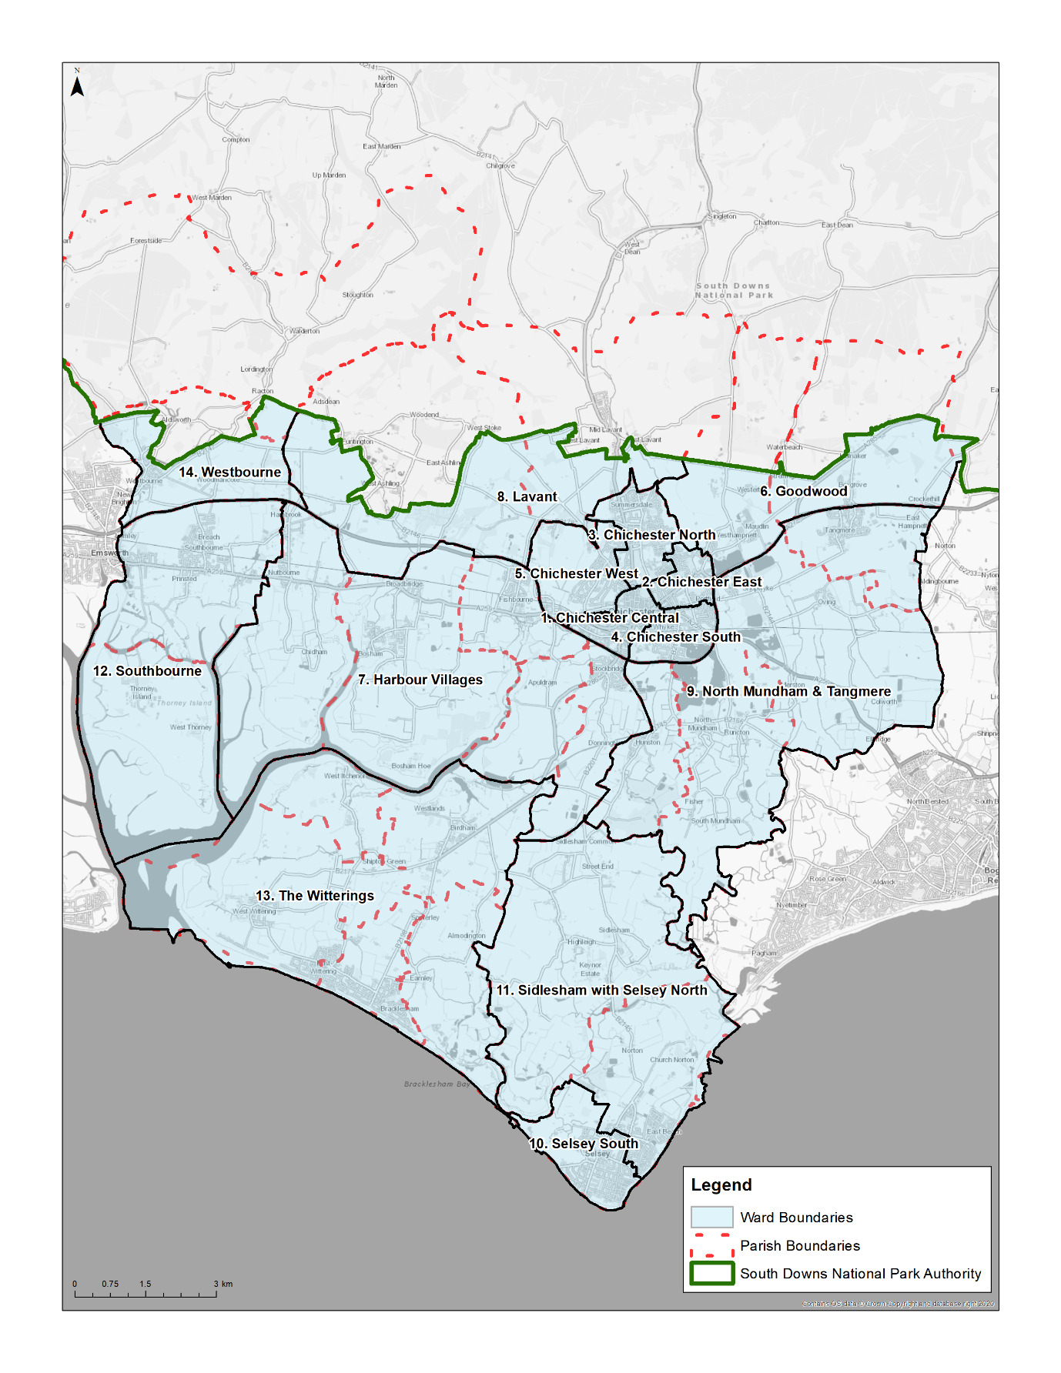

|  |  |  |  |  |  |
| --- | --- | --- | --- | --- | --- |
|  | | Number of Bedrooms | | | |
| 1 | 2 | 3 | 4+ |
| Charging Sector (ward) | 1. Chichester Central | 0.25 | 0.44 | 0.62 | 0.90 |
| 2. Chichester East | 0.29 | 0.55 | 0.76 | 0.99 |
| 3. Chichester North | 0.43 | 0.61 | 0.75 | 1.02 |
| 4. Chichester South | 0.36 | 0.57 | 0.78 | 1.05 |
| 5. Chichester West | 0.33 | 0.56 | 0.77 | 1.09 |
| 6. Goodwood | 0.36 | 0.51 | 0.61 | 0.77 |
| 7. Harbour Villages | 0.58 | 0.84 | 1.03 | 1.38 |
| 8. Lavant | 0.41 | 0.52 | 0.61 | 0.86 |
| 9. North Mundham & Tangmere | 0.66 | 0.90 | 1.15 | 1.52 |
| 10. Selsey South | 0.46 | 0.69 | 0.91 | 1.25 |
| 11. Sidlesham & Selsey North | 0.47 | 0.69 | 0.98 | 1.34 |
| 12. Southbourne | 0.18 | 0.27 | 0.34 | 0.45 |
| 13. The Witterings | 0.54 | 0.73 | 1.00 | 1.31 |
| 14. Westbourne | 0.20 | 0.30 | 0.39 | 0.50 |

Table 8.1: Apportionment and Averaging Factor

* 1. The Apportionment and Averaging Factors in the above table directly relate to the anticipated impact that development within each Sector (ward) will have on the A27, taking into account dwelling size. The resulting contribution levels seek to balance the need to secure sufficient funding to ensure that the impact of development in the plan can be mitigated as far as possible, with the need to ensure that development as a whole remains financially viable
  2. ~~8.20~~ This ~~sum~~ funding required will be met from financial contributions provided by the outstanding housing developments proposed in the south of the plan area (see Map 8.1 above) as set out below:

|  |
| --- |
| **A27 Mitigation contributions (applied to the south of the plan area only)** |
| Strategic development locations carried forward from 2015 Local Plan (without planning permission as at ~~November~~ April 202~~2~~4)   * West of Chichester SDL – Phase 2 = £1,803 per dwelling * Tangmere SDL = £5,914 per dwelling   All other housing development where there is a net increase in dwelling numbers~~,~~ will be required to make a financial contribution on the basis of the formula below, to be applied at the time of granting any permission:  Terminology:   * Charging Sector (Ward) – See Map 8.1 above * Apportionment and Averaging Factor – See Table 8.1 above * Target Contribution Level - £8,000 per dwelling  |  |  |  |  |  |  |  | | --- | --- | --- | --- | --- | --- | --- | | ~~Estimated cost of A27 works to Fishbourne Roundabout and Bognor Road Roundabout~~  Identify Charging Sector (ward) and housing mix |  | ~~Less contributions secured through committed (permitted) development~~  Multiply the Apportionment and Averaging Factor by the Target Contribution Level |  | ~~Divided by remaining supply to be permitted in southern Plan Area~~ |  | ~~Equals~~  Resultant contribution per dwelling (net increase) | |

* 1. ~~8.21~~ A worked example of the contribution to be calculated for ~~‘all other housing development’~~ for housing development proposal in Oving is provided below:

~~Estimated cost of works to Fishbourne Roundabout and Bognor Road Roundabout = £27,442,593 (higher cost of works £43,320,000 – receipts from committed development £15,877,407)~~

~~Supply of new dwellings in the south of the plan area up to 2039 = 3,551 dwellings~~

~~Per dwelling contribution = £27,442,593/ 3,551 = £7,728~~

|  |  |  |  |  |
| --- | --- | --- | --- | --- |
| Size of Dwelling | Charging Sector | Apportionment and Averaging Factor | Target Contribution Level | Contribution Per Dwelling |
| 1 Bed | 9 | 0.66 | £8,000 | £5,280 |
| 2 Bed | 0.90 | £7,200 |
| 3 Bed | 1.15 | £9,200 |
| 4+ Bed | 1.52 | £12,160 |

Table 8.2: Worked example of contribution calculation

~~8.22 The ‘estimated cost of A27 works to Fishbourne Roundabout and Bognor Road Roundabout’ will be based upon the most up to date estimate (through the Monitor and Manage process) at the time of granting any permission, to take into account adjustment for inflation and any other material changes to the cost of those works.~~ Contributions secured will be used ~~either~~ towards the transport infrastructure projects ~~identified junction infrastructure improvements, and/or other highway capacity improvements~~ identified through the ~~M~~monitor and ~~M~~manage process.

*Monitoring*

8.28 Equally as important as ensuring development maximises the available contributions toward mitigating its impact on the A27 Chichester Bypass and associated local highway network is that the level of contribution applied is relevant to the monitor and manage process at the time of application. The potential for future availability of other sources of funding, RIS, further modelling analysis and prioritisation of schemes are all matters for consideration of the monitor and manage process, through the TIMG. Should necessary changes to the Total Funding Requirement, Apportionment Factor or Average Factor be evidenced through the monitor and manage process, this will inform an annual review of the contribution and apportionment methodology and published on the council’s website.