| The names of the Local Authorites that have produced this document | Logo for Chichester District Council |
| --- | --- |

May 2024

**Chichester Local Plan 2021-2039**

**Statement of Common Ground between**

**Chichester District Council &**

**Havant Borough Council**

**Contents**

1. Introduction 2

2. List of parties involved 2

3. Relationship with other documents 3

4. Strategic geography 3

5. Respective planning documents – current status 3

Chichester District Council 3

Havant Borough Council 4

6. Strategic matters and record of agreement 4

7. Governance arrangements 13

8. Timetable for agreement, review and updating 13

9. Signatories 13

10. Appendix 1 Map of the Plan Areas 15

1. **Introduction**
   1. This Statement of Common Ground (SoCG) has been prepared by Chichester District Council and Havant Borough Council (‘the Councils’) in relation to both the Havant Borough ‘Building a Better Future Plan’ (BBFP) and the Chichester Local Plan 2021 - 2039 (excluding the South Downs National Park). It reflects the position between the two parties on a number of strategic matters and shared issues.
   2. This Statement ensures the requirements set out in the National Planning Policy Framework (NPPF) have been met. The NPPF states: ‘Local planning authorities are under a duty to cooperate with each other, and with other prescribed bodies, on strategic matters that cross administrative boundaries.’[1] The purpose of the Statement is to document the strategic cross boundary matters being considered and the progress made in cooperating to address them at the respective stages of the Councils’ plan making processes. It focuses on areas where there is agreement, and if appropriate those matters where work is ongoing to resolve differences. The Statement is intended to be ‘live’, updated as circumstances change, and agreement occurs on any outstanding issues. The Statement also forms part of the evidence to demonstrate compliance with the Duty to Cooperate during the preparation of the Chichester Local Plan 2021 - 2039.
2. **List of parties involved**
   1. This Statement has been prepared between Chichester District Council and Havant Borough Council.
3. **Relationship with other documents**
   1. This is an updated Statement prepared between CDC and HBC. It supersedes a previous Statement agreed between the two parties, dated February 2021.
   2. Where appropriate CDC have prepared separate Statements with other neighbouring authorities and prescribed bodies. All Statements have been published on the CDC website[2]
   3. Unless otherwise stated, all evidence documents referred to in this Statement have been published on the CDC website.
4. **Strategic geography**
   1. Although adjoining administrative areas, Chichester District falls within West Sussex and Havant Borough falls within Hampshire. The administrative boundary between the two local authorities also marks the boundary between the two counties. The South Downs National Park lies to the north with Chichester Harbour AONB (National Landscape) to the south. The main east-west strategic road, the A27 runs through both local authority areas. The location in relation to these key features is shown in the map at Appendix A.
   2. The administrative area covered by the Statement is identified in the map in Appendix 1.
5. **Respective planning documents – current status**

**Chichester District Council**

* 1. CDC’s current adopted Local Plan comprises the adopted Local Plan: Key Policies 2014-2029 (July 2015) and adopted Site Allocation Development Plan Document (DPD) (January 2019). CDC is at an advanced stage of preparing a new Local Plan (Chichester Local Plan 2021 - 2039) which will replace the Key Policies 2014-2029 and cover the period to 2039. A revised Site Allocation DPD is to be produced following adoption of the new Local Plan.
  2. Information on the stages that have taken place and the expected timetable for adoption of the new Chichester Local Plan is set out in Table 1 below.

**Table 1: Preparation of Chichester Local Plan Review**

|  |  |  |  |
| --- | --- | --- | --- |
| **Regulation 18 consultation** | **Regulation 19 consultation** | **Submission** | **Adoption date** |
| Issues and Options (June – August 2017)  Preferred Approach (December 2018 – February 2019) | 3 Feb – 17 March 2023 | Spring 2024 | Spring 2025 |

**Havant Borough Council**

* 1. HBC’s current adopted Local Plan comprises the Core Strategy (2011) and the Allocations Plan (2014). Following the withdrawal of the previous Local Plan from Examination in March 2022, HBC is producing a new Local Plan. The Council has since carried out a Regulation 18 consultation focused on key issues and is currently working towards a Regulation 18 consultation on a Draft Local Plan in Q4 of 2024.
  2. The Council has published an updated Local Development Scheme[3] which sets out the next key stages in the plan’s production.

1. **Strategic matters and record of agreement**
   1. The parties have had on-going dialogue over the course of a number of years, discussing a range of planning issues including strategic matters.
   2. The cross boundary strategic matters covered by this statement are:

* Housing need and distribution
* Transport
* Employment
* Nutrient Neutrality
* Wastewater Treatment
* Wildlife corridors
* Sites of International importance
* Gypsy and Travellers
  1. For the purposes of this Statement only the current position is recorded, together with any areas where agreement has not been reached or where there are other outstanding issues. The Duty to Cooperate Statement of Compliance provides a summary of the engagement that has taken place between CDC and HBC over the period of the preparation of the Chichester Local Plan.

**Housing need and distribution**

* 1. The following table summarises the local housing need for the two Councils and the housing figures proposed for each plan. Constraints, particularly the capacity of the A27 and the unaffordability of the full package of required highways mitigation, have led CDC to propose a housing figure below the LHN derived from the standard method. The proposed submission Chichester Local Plan plans for 575dpa comprising 535dpa in the southern plan area and 40dpa in the northern plan area. This results in an unmet need of 732 for the Chichester plan area over the plan period. Havant is in the early stages of plan preparation and is looking for sites for an LHN figure of 516 dwellings per year but acknowledges that this will be difficult alongside environmental constraints. A small part of the western part of the Chichester plan area, at Southbourne, falls within the Portsmouth housing market area.

| **Plan** | **Stage** | **Housing Need** |
| --- | --- | --- |
| **Chichester District[4]** | | |
| Chichester Local Plan 2021 - 2039 | Publication | LHN: 638dpa, Total 11,484  Proposed housing target: 575 dpa. Total target 10,350.  Projected supply as at 1 April 2024 10,752. (including 402 units now permitted beyond that set out in the Plan). Unmet need 732 (11,484-10,752). |
| **Havant Borough** | | |
| Building a Better Future (2025-40) | Regulation 18 | LHN 516 dpa  Proposed housing target: Not yet identified  Unmet need: 4,309 |

***Areas of agreement***

* 1. The parties note that CDC is currently not proposing to meet its LHN in full, due to constraints. Havant Borough Council has not objected to CDC’s local plan on that basis. Nonetheless, in the event that Chichester’s Local Plan examination finds that there is additional capacity to accommodate housing development, and Chichester’s housing need can then be met, it is agreed that the two parties will work together to explore whether there are cross boundary solutions to Havant's unmet need. Whilst Havant BC is still investigating site options for its emerging Plan, HBC undertook a comprehensive review of housing need and supply in October 2023 which indicates that there is likely to be unmet need arising from Havant in the region of 4,000 homes based on a plan period of 2022/23-2042/43. Respective parties have formally requested assistance from one another but are unable to assist each other at present given their respective housing supply positions.

**Transport**

* 1. CDC has undertaken several transport studies of both the proposed development sites and strategic housing numbers proposed in the Chichester Local Plan to understand the impacts on the highway network in the plan area and surrounding area. The studies have identified that a package of measures will be required to mitigate the impact of the development now planned in this Local Plan. These measures are likely to include improvements to the A27 roundabouts at Fishbourne and Bognor Road (which were identified as part of a mitigation package at the Preferred Approach stage) but detailed requirements will be determined through a Monitor and Manage approach
  2. The impact of the Chichester Local Plan and the Southbourne Broad Location for Development (BLD) on the A259 and relevant junctions in Havant is set out in a Technical Note (TN HCC01 v3, 29 January 2024) prepared by the Council’s highway consultants Stantec (Appendix 3) further to concerns raised by Hampshire County Council at Reg 19 consultation.

* 1. The Technical Note considers:
  + Flows on the A259 within Hampshire;
  + Reassignment of traffic resulting from Local Plan traffic and the addition of mitigation packages[5]; and
  + Impacts at the A259/North Street junction in Emsworth and the A27 Warblington Interchange.
  1. As set out in the Technical Note the strategic modelling (using the Chichester Area Transport Model (CATM)) outputs indicate that flows on the A259 increase when the Chichester Local Plan traffic is added, however, the flows fall back to at least the Reference Case traffic levels, if the Fishbourne Roundabout and/or Bognor Roundabout mitigation schemes and/or the full mitigation package are added into the modelling.
  2. The analysis of the reassignment of traffic indicates that the Local Plan traffic with the Fishbourne roundabout mitigation scheme decreases the amount of traffic on the A259 in Hampshire as traffic uses the A27 instead. The largest impact is seen in the westbound direction, mainly due to traffic which was using Appledram Lane South and turning left onto the A259, now joining the A27 at the Stockbridge junction and staying on the A27 towards Hampshire. The increase in flows at the Fishbourne junction has a knock-on impact with some additional trips using Emsworth Common Road towards Havant, from Chichester District.
  3. CATM has also been used to model the impacts of the Chichester Local Plan traffic on the A259/North Street junction in Emsworth and the A27 Warblington Interchange. The analysis indicates that both junctions operate within capacity for all scenarios and with minimal delays in both the AM and PM peaks.
  4. During the course of discussions with Hampshire County Council (HCC), reference was made by HCC to modelling outputs from a junction capacity assessment of the A27 Warblington Interchange for a development in Southbourne subject to a planning application which indicated different findings to those provided by the Local Plan modelling. The junction modelling identified overcapacity issues at the northern/western roundabout of the Warblington Interchange in the PM peak, whereas no capacity issues were identified in the Local Plan modelling. HCC stated that it would be beneficial for a comparison of the two assessments to be undertaken, to provide further evidence that the Chichester Local Plan would not exacerbate the existing situation.
  5. It is noted in the Technical Note that as the Local Plan modelling provides a strategic view of the cumulative impacts of development within the study area, particularly Chichester district, differences might be expected when compared to standalone modelling undertaken for a particular development using specific junction modelling software. Developers of sites identified in the Chichester Local Plan would still, however, be required to undertake their own Transport Assessment to identify local impacts and measures to mitigate them appropriately prior to planning consent.
  6. Further comparative analysis has, however, been undertaken to understand whether the Local Plan would put more trips at this location. This has indicated that there is the potential for the Local Plan traffic to exacerbate the existing capacity issues at the Warblington Interchange and for substantial flows to be added to the A259 Emsworth roundabout (if mitigation provided by the Fishbourne roundabout improvements, or suitable alternative measures identified through a monitor and manage process, are not implemented). The majority of additional trips will be as a result of the Southbourne development.
  7. The Technical Note has been shared with HCC and HBC.
  8. It is acknowledged that from the CATM modelling of additional trips there is the potential for development at Southbourne to exacerbate any existing capacity issues at the Warblington Interchange and to increase flows on the A259/North Street Roundabout. The impact on these junctions, and determination of any mitigation requirements, will require further investigation as part of detailed transport assessment work as development in Southbourne comes forward (as required by Chichester Local Plan Policy T2 (Transport and Development)). It is proposed that the delivery of the required transport infrastructure alongside development will be kept under review through a ‘monitor and manage’ approach, involving stakeholders, including HCC and HBC, in a Transport and Infrastructure Management Group (TIMG), which will oversee the governance, resourcing and prioritisation of this through the Plan Period.

***Areas of agreement:***

* 1. HBC is still preparing its Local Plan and has yet to identify a preferred spatial strategy and a pool of preferred growth locations. As such, these have yet to be tested alongside Chichester Borough Council’s development strategy. As such the additional impact of development on the highway network form Havant’s future development strategy is not fully known and mitigated. HBC recognises that a Reg.19 Local Plan will not be published for some time and that Chichester is not in a position to delay its Local Plan until HBC’s development strategy is clearer. Both parties agree that it will be necessary for further modelling through a Transport Assessment of specific planning application proposals at Southbourne Broad Location of Development to identify capacity issues and identify appropriate mitigation where appropriate taking into account HBC’s own growth strategy.
  2. It is further agreed that there is a need for collaborative working, primarily through the TIMG, to discuss cross-boundary transport issues associated with the A259. This is reflected in the updated CDC IDP to be published alongside the Local Plan when submitted.

***A259 Non-Motorised User link improvements between Chichester & Emsworth***

* 1. National Highways, in partnership with WSCC, is developing proposals to improve cycling and walking facilities along the A259 corridor between Chichester and Emsworth (the ‘Chem route’). The proposals have been subject to a feasibility study, public engagement and preliminary designs have been carried out by National Highways. The scheme is intended to encourage modal shift for shorter journeys and will be of benefit to existing residents and to future housing development proposed by the Chichester Local Plan in the A259 corridor. CDC support in principle the Chem route and are ready to engage with National Highways as the project progresses. The project is identified in the Chichester Local Plan IDP. Havant support in principle any measures that support a modal shift and will look to bring forward such measures on the network in its area, working with Hampshire County Council. The Havant LCWIP identifies a corridor which could extend this route into and beyond Emsworth (LCWIP route 270) – there may be potential to deliver this through the Havant Local Plan.

***Areas of agreement:***

* 1. The parties agree that the A259 Chichester to Emsworth proposals in West Sussex should connect with the cycle routes in the Havant LCWIP in order to provide a key sustainable transport route.

**Employment:**

* 1. Chichester District Council updated its Housing and Economic Development Needs Assessment in 2022. This indicated a need for around 22 to 23ha ha of employment land between 2021 and 2039, much of which can be met by existing commitments and allocations. Sufficient potential sites have been identified to accommodate the remaining requirement meaning Chichester is not looking towards Havant Borough Council to provide any unmet need for employment floorspace.
  2. Havant Borough Council has commissioned an Employment Land Review (ELR), building upon the [PfSH Economic, Employment and Commercial Needs Study](https://www.push.gov.uk/wp-content/uploads/2021/05/Economic-Employments-and-Commercial-Needs-including-logistics-Study-Final-Report-March-2021.pdf)[6]. This will confirm whether the Borough has sufficient employment land to meet its own development needs.

***Areas of agreement:***

* 1. CDC is not looking to Havant to meet any of its employment need. Havant Borough Council will keep Chichester District Council up to date on the progress of the ELR as it may need to formally request assistance from its neighbours to accommodate any unmet need. However, HBC recognises the advance stage of CDC’s plan production which may limit their ability to assist with any unmet need that arises.

**Nutrient Neutrality**

* 1. New development necessitates the provision of connections to the foul water drainage network and can increase surface water run-off. This can increase the amount of nutrients entering Solent European Sites. As a result, Natural England has advised that there is a likely significant effect on several of the Solent’s European Sites from development. Therefore, any new housing schemes and other proposals which include a net gain in overnight accommodation need to prevent any increase in nutrients into the harbour in order for them to be ‘nutrient neutral’.
  2. Havant Borough Council has confirmed that development draining to two wastewater treatment works in Havant borough; Budds Farm and Thornham would likely lead to a significant effect on the integrity of Solent European Sites. In the Chichester Plan Area, this applies to Lavant, Thornham, Bosham and Apuldram (Chichester) which drain into Chichester Harbour.
  3. Havant Borough Council has published a Position Statement and Mitigation Plan[7] for Nutrient Neutral Development which outlines the Council’s solution to addressing nutrients where it is not possible for development to achieve nutrient neutrality on site. The Review of the Warblington Farm Mitigation Option for Nutrient Neutral Development in the Havant Borough Report[8] confirms the scientific link between the likely significant effect from the development and the mitigation at Warblington, as required by the Habitats Regulations. It also confirms that Havant Borough Council’s mitigation option is suitable for development draining to Budds Farm and Thornham Wastewater Treatment Works. Mitigation at Warblington has a finite capacity but provides Havant borough with a short-term solution. As a HBC-led scheme, only developments in Havant Borough are currently eligible to use the scheme.
  4. Development in Chichester has been using a range of solutions to deliver nutrient mitigation including private schemes selling nutrient mitigation credits. A nutrient budget for the Local Plan has been prepared and considered as part of the Habitats Regulation Assessment of the Local Plan. The publication plan includes a policy requiring all relevant development to be nutrient neutral. Further mitigation solutions are being explored to ensure an ongoing supply, and CDC is preparing a bid to Round 2 of the Government’s Local Nutrient Mitigation Fund.
  5. HBC and CDC are both also continuing to work with the Partnership for South Hampshire (PfSH) and other affected authorities to coordinate a Solent wide solution in the medium to long term. This has included both Councils’ support for the appointment of a Strategic Environmental Planning team to coordinate progress on mitigation schemes.

***Areas of agreement:***

* 1. Both authorities require all relevant development to be nutrient neutral and a range of solutions is being progressed.

**Wastewater Treatment**

* 1. Southern Water is the statutory wastewater undertaker for both Chichester District and Havant Borough. The Councils share a common Wastewater Treatment Works (WwTW) at Thornham which services the Emsworth area (Havant Borough), and parts of the Chichester Plan area. The WwTW operates in accordance with environmental permits issued and enforced by the Environment Agency. These permits set the maximum volume of treated wastewater the company is permitted to discharge into the environment, as well as defining the standards of treatment that must be met in order to protect water quality objectives.
  2. The Chichester District Water Quality Assessment (August 2018) indicated that upgrades to Thornham would be needed by 2025. CDC has since been working with the Environment Agency and Southern Water, to keep information about remaining wastewater treatment capacity across the Chichester plan area under review. Latest work shows that additional capacity at Thornham WWTW is likely to be needed in the next 5 years. This differs from the conclusions of the PfSH IWMS Addendum (July 2020)[9] due to differences in the methodology. In November 2021 CDC agreed a Position Statement with Southern Water and the Environment Agency in relation to development within the Thornham WWTW catchment which is constrained due to the environmental capacity of the receiving water. The Position Statement is accompanied by monthly monitoring of additional permissions in the catchment. A separate statement of common ground is in place between CDC and Southern Water.
  3. A review of the evidence underpinning the Thornham Position Statement was commissioned by the Councils to assess remaining headroom at Thornham WWTW. This study found that the method used by CDC, which is based on 500 litres per household per day, was very precautionary and that the councils could consider using a slightly lower average figure for the waste water from new development, based on recent water use data from Southern Water.
  4. Southern Water published their Drainage and Wastewater Management Plan (DWMP) in June 2023. The DWMP sets out long term investment needs and will feed into Southern Water’s Business Planning process.
  5. Summary information for Thornham

|  |  |  |  |  |
| --- | --- | --- | --- | --- |
| **Additional capacity likely to be needed?** | **Environmental constraint to increasing permit?** | **Allocations in the Chichester Publication Local Plan** | **Existing solutions** | **Summary of investment needs identified in DWMP up to 2040 (IMPORTANT NOTE: these schemes are subject to business planning process and OFWAT approval and may therefore change)**  **See links for more detail** |
| Likely to need additional capacity in 5 years  Also infiltration issues.  Also serves development in Havant. | Y | Nutbourne and Hambrook A12  Southbourne BLD A13  Westbourne H3 | Infiltration reduction underway.  Permissions in the catchment are being monitored in conjunction with a Position Statement which will require no net increase in flows once existing permissions exceed remaining Q80 headroom. | <https://www.southernwater.co.uk/media/8671/awsinvestmentneeds-thornham.pdf>  2025-30 onwards:  Customer education to reduce blockages  Sewer rehabilitation and maintenance  Increase capacity to allow for planned new development by improving on TAL for nutrient removal  Use SuDs and storage in various locations to reduce storm overflows  Construct wetlands to reduce nitrates  Study into impacts on habitats  UV treatment  2030-35  Rainwater separation  2035-40  Increase biological treatment capacity to allow for planned new development if needed |

***Areas of agreement:***

* 1. It should be acknowledged that it is not within either of the Councils’ control to provide a solution to providing additional wastewater capacity. Nevertheless, both signatories remain committed to working together in partnership with Southern Water to find and secure solutions to deliver additional wastewater treatment capacity in step with development.

**Wildlife corridors**

* 1. The River Ems forms the boundary between Havant Borough and Chichester District. The pre submission Chichester Local Plan includes a new wildlife corridor on the eastern side of the River Ems. The western side of the River Ems is within Havant Borough. It is anticipated that the Havant Local Plan will recognise the importance of strategic wildlife corridors including the River Ems on the Havant – Chichester border.

***Areas of agreement***

* 1. Both parties recognise the importance of the River Ems as a corridor for wildlife.

**Sites of International importance**

* 1. Nutrient neutrality is discussed separately above. Both authorities are partners in the Bird Aware project to mitigate the impact of additional development on the Solent SPAs. Further details are available on the Bird Aware website at <https://solent.birdaware.org/home>

***Areas of agreement***

* 1. Both Councils will continue to work together, and with other relevant stakeholders, to protect sites of international importance.

**Gypsy and Traveller Accommodation**

* 1. The Chichester Gypsy and Traveller and Travelling Showpeople Accommodation Assessment (GTAA) (2022) identified a need for 158 gypsy and traveller pitches[10] and 40 travelling showpeople plots over the plan period. That figure encompasses the total level of need potentially related to travellers. Further analysis is being undertaken to establish the level of need within that figure which would fall within the revised definition of travellers within PPTS 2023. The Council propose to meet the gypsy and traveller pitch need through the intensification of a number of existing sites, making proportionate provision on strategic allocations and a requirement for provision on all other sites over 200 dwellings that may come forward over the plan period (provided a need is remaining at the time) and through the development of windfall sites when assessed against a criteria based policy.
  2. Plot provision for travelling showpeople will be made through the provision of additional plots on an existing site, making provision within the Southbourne Broad Location for Development and as part of the employment allocation south of Bognor Road, Chichester. Windfall sites will also need to come forward and will be assessed against a criteria based policy.
  3. Depending on the final need requirement which falls within the PPTS 2023 definition the council will potentially be able to meet the need for gypsies and travellers, though this is still being finalised. However, there will be a shortfall in terms of meeting the needs of travelling show people within the first five years post adoption, though it is expected that the need can be met over the remainder of the plan period.
  4. HBC is currently updating its Gypsy and Traveller Accommodation Assessment (GTAA), which will identify its own need for the plan period. The draft study confirms there is no net additional need arising from Havant Borough.

***Areas of Agreement***

* 1. Havant BC, and other neighbouring authorities, were asked, by a letter in December 2022, to consider whether they can assist in meeting this need.
  2. At present Havant BC is not in a position to assist with this unmet need. However, it is agreed that CDC and HBC will continue, through existing duty to cooperate arrangements, to work together to consider whether and how unmet Gypsy and Traveller and Travelling Showpeople needs can be met.

1. **Governance arrangements**
   1. In terms of governance arrangements, the two parties agree to:

* Keep a dialogue open on matters arising which are likely to have significant impacts and implications for the delivery of local plan policies
* To work together to achieve identified outcomes in relation to strategic matters
* To review and update this Statement in light of any material change in circumstance and
* To maintain positive principles of cooperation

1. **Timetable for agreement, review and updating**
   1. This statement has been informed by ongoing engagement between the two parties and the parties will continue to work together to address identified strategic matters. This Statement is intended to be a living document that can be reviewed and updated, informed by continued communication between the parties through meetings, statutory consultation at key plan making stages and electronic communication.
2. **Signatories**
   1. We confirm that the information in this Statement reflects the joint working to address identified strategic matters that has been undertaken between Chichester District Council and Havant Borough Council. The authorities will continue to work together to address cross boundary issues.

|  |  |
| --- | --- |
| Signed: | Signed: |
|  |  |
| Name: Cllr Bill Brisbane | Name: Alex Robinson |
|  |  |
| Position: Cabinet Member for Planning | Position: Executive Head of Place |
|  |  |
| Chichester District Council | Havant Borough Council |
|  |  |
| Date: 1st May 2024 | Date: 2nd May 2024 |

1. **Appendix 1 Map of the Plan Areas**

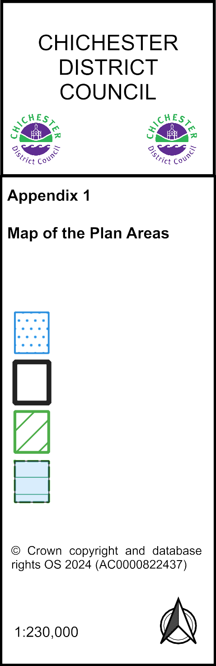

Legend

Chichester Local Plan Area

District Boundaries

South Downs National Park

Area of Outstanding

Natural Beauty

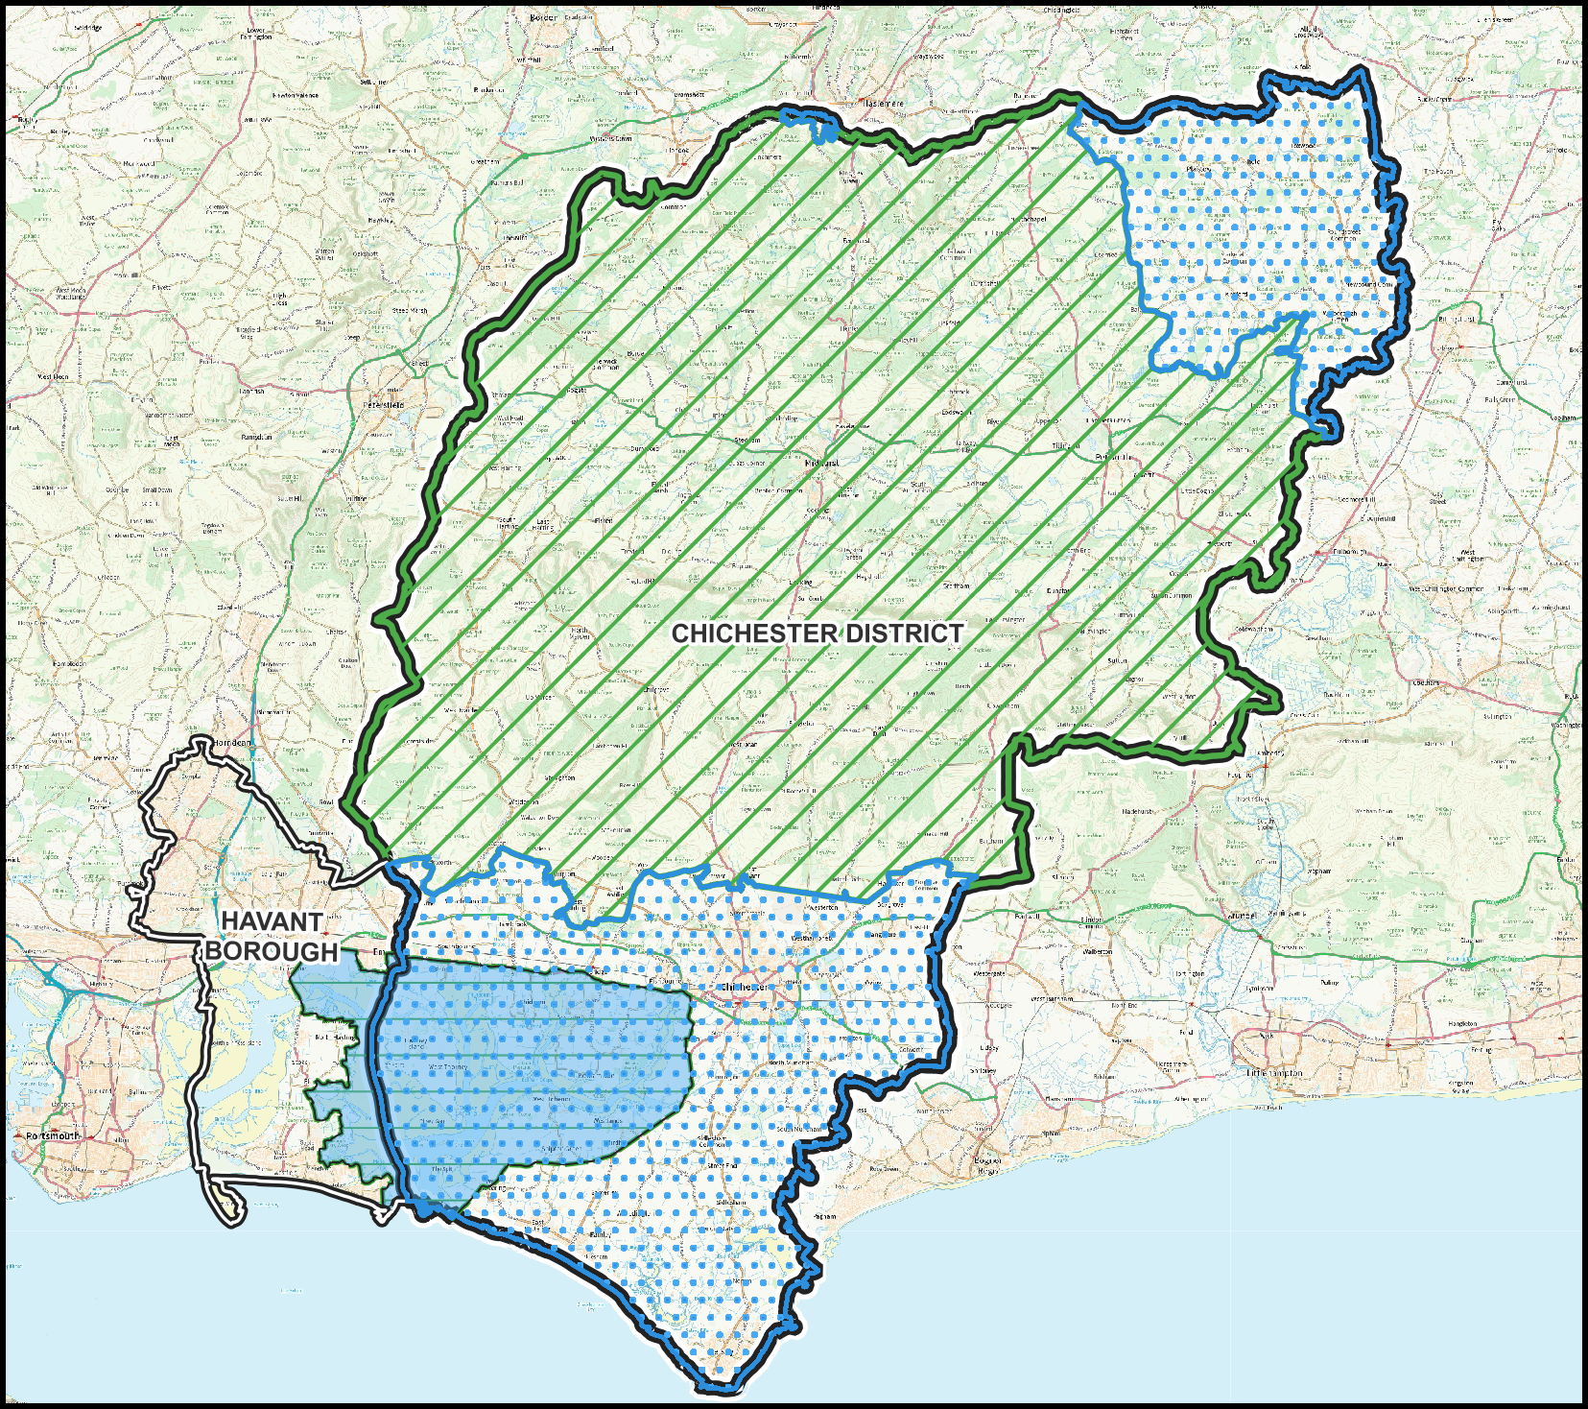

1. Paragraph 24, NPPF (2021)
2. Statements of Common Ground are published on the website at <https://www.chichester.gov.uk/dutytocooperate>
3. https://www.havant.gov.uk/planning-services/planning-policy/local-plan/local-development-scheme-lds
4. Note that Chichester housing need figures relate to the Chichester Plan Area i.e. the part of Chichester District which falls outside the South Downs National Park
5. The mitigation packages were the full mitigation package for the Local Plan (series of junction improvements along the A27, Stockbridge Link Road and mitigation within Chichester city) and just the Fishbourne roundabout and Bognor roundabout mitigation schemes
6. https://www.push.gov.uk/wp-content/uploads/2021/05/Economic-Employments-and-Commercial-Needs-including-logistics-Study-Final-Report-March-2021.pdf
7. https://www.havant.gov.uk/media/9586/download?inline
8. <https://www.havant.gov.uk/media/8323/download?inline> and its addendum https://www.havant.gov.uk/media/8837/download?inline
9. https://www.push.gov.uk/wp-content/uploads/2020/10/Wood-Technical-Note-July-2020.pdf
10. This includes the needs of both those who meet the Planning Policy for Travellers Sites (2015) definition of Traveller and those that do not.