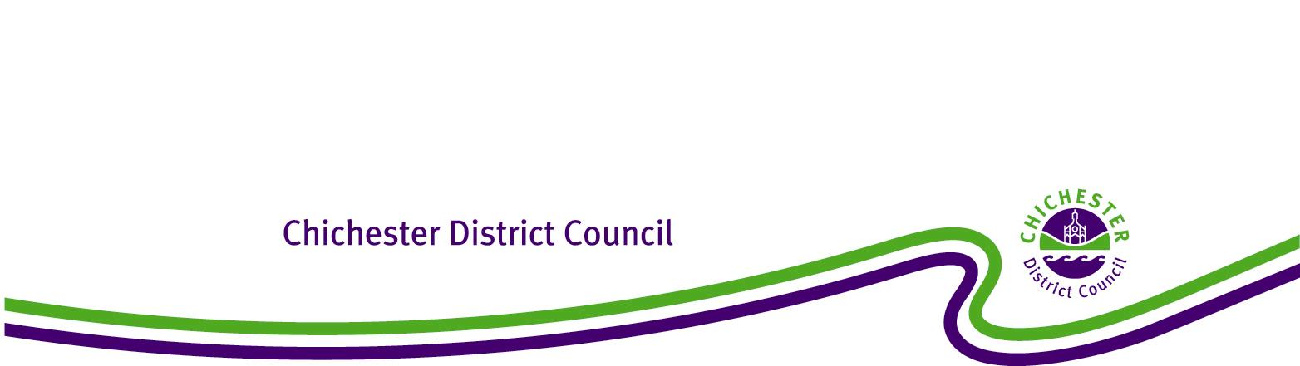

**Chichester District Council**

**Westbourne Neighbourhood Development Plan**

**The Neighbourhood Planning (General) Regulations 2012**

**Regulation 20: Publicising a Neighbourhood Development Plan**

**1. Introduction**

1.1 Under the Town and Country Planning Act 1990 (as amended), the Council has a statutory duty to assist communities in the preparation of Neighbourhood Plans and Orders to take plans through a process of examination, referendum and adoption. The Localism Act 2011 (Part 6 Chapter 3) sets out the local planning authority’s responsibilities for Neighbourhood Planning.

1.2 This report confirms that at the Full Council meeting on 21 September 2021, Chichester District Council resolved to ‘make’ the Westbourne Neighbourhood Plan 2017-2029 Post Examination Version June 2021. This means that the Westbourne Neighbourhood Plan has been brought into legal force and it forms part of the statutory development plan for Westbourne Parish. Consequently, decisions on whether or not to grant planning permission in Westbourne Parishwill need to be made in accordance with Westbourne Neighbourhood Plan 2017-2029 Post Examination Version June 2021, unless material considerations indicate otherwise.

**2. Background**

2.1 The neighbourhood plan area for Westbourne covers the whole of the Parish of Westbourne.

2.2 The Westbourne Neighbourhood Plan was examined by Jeremy Edge BSc (Hons) FRICS MRTPI who, in March 2021, recommended that the Westbourne Neighbourhood Plan 2017-2029 as modified by his recommendations should proceed to referendum. Following this the Examiner’s modifications were agreed by Westbourne Parish Council and Chichester District Council.

2.3 On 4 May 2021, the Decision Statement, a report that outlines all the Examiner’s modifications and confirms acceptance by all parties, was agreed by Cabinet.

2.4 On 29 July 2023, the Westbourne Neighbourhood Plan 2017-2029 Post Examination Version June 2021 successfully passed its referendum with 94% of the votes agreeing that Westbourne Neighbourhood Plan 2017-2029 Post Examination Version June 2021 be used in Development Management decision making.

2.5 On 21 September 2021 Chichester District Council resolved that the Westbourne Neighbourhood Plan 2017-2029 Post Examination Version June 2021, be ‘made’ and become part of the Development Plan for Westbourne Parish.

**3. Conclusion**

3.1 It is therefore confirmed that the Westbourne Neighbourhood Plan 2017-2029 Post Examination Version June 2021, complies with the legal requirements and basic conditions set out in the Localism Act 2011, and as a result of Full Council resolution of 21 September 2021 has been ‘made’.

3.2 In accordance with Regulation 20 of the 2012 Regulations, Chichester District Council has published the Westbourne Neighbourhood Plan 2017-2029 Post Examination Version June 2021 on its website and a hard copy can be examined at the Council Offices in Chichester during normal opening hours. The Council has also notified all persons who asked to be notified of the making of the plan and when and where it can be inspected.