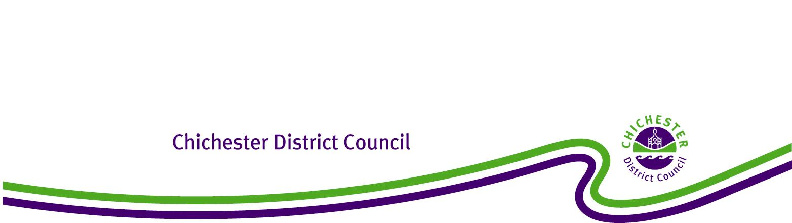

**Chichester District Council**

**Selsey Neighbourhood Development Plan**

**The Neighbourhood Planning (General) Regulations 2012**

**Regulation 20: Publicising a Neighbourhood Development Plan**

**1. Introduction**

1.1 Under the Town and Country Planning Act 1990 (as amended), the Council has a statutory duty to assist communities in the preparation of Neighbourhood Plans and Orders to take plans through a process of examination, referendum and adoption. The Localism Act 2011 (Part 6 Chapter 3) sets out the local planning authority’s responsibilities for Neighbourhood Planning.

1.2 This report confirms that at the Full Council meeting on 22 June 2021, Chichester District Council resolved to ‘make’ the Selsey Neighbourhood Plan 2014-2029 Referendum Issue May 2021. This means that the Selsey Neighbourhood Plan 2014-2029 Referendum Issue May 2021 has been brought into legal force and it forms part of the statutory development plan for Selsey Parish. Consequently, decisions on whether or not to grant planning permission in Selsey Parishwill need to be made in accordance with Selsey Neighbourhood Plan 2014-2029 Referendum Issue May 2021, unless material considerations indicate otherwise.

**2. Background**

2.1 The neighbourhood plan area for Selsey covers the whole of the Parish of Selsey.

2.2 The Selsey Neighbourhood Plan was examined by John Slater BA (Hons), DMS, MRTPI who, in October 2018, recommended that the Selsey Neighbourhood Plan 2014-2029 as modified by his recommendations should proceed to referendum. Following this the Examiner’s modifications were agreed by Selsey Town Council and Chichester District Council.

2.3 On 7 July 2020, the Decision Statement, a report that outlines all the Examiner’s modifications and confirms acceptance by all parties, was agreed by Cabinet.

2.4 On 6 May 2021, the Selsey Neighbourhood Plan 2014-2029 Referendum Issue May 2021 successfully passed its referendum with 79% of the votes agreeing that Selsey Neighbourhood Plan 2014-2029 Referendum Issue May 2021 be used in Development Management decision making.

2.5 On 22 June 2021 Chichester District Council resolved that the Selsey Neighbourhood Plan 2014-2029 Referendum Issue May 2021, be ‘made’ and become part of the Development Plan for Selsey Parish.

**3. Conclusion**

3.1 It is therefore confirmed that the Selsey Neighbourhood Plan 2014-2029 Referendum Issue May 2021, complies with the legal requirements and basic conditions set out in the Localism Act 2011, and as a result of Full Council resolution of 22 June 2021 has been ‘made’.

3.2 In accordance with Regulation 20 of the 2012 Regulations, Chichester District Council has published the Selsey Neighbourhood Plan 2014-2029 Referendum Issue May 2021on its website and a hard copy can be examined at the Council Offices in Chichester during normal opening hours. The Council has also notified all persons who asked to be notified of the making of the plan and when and where it can be inspected.