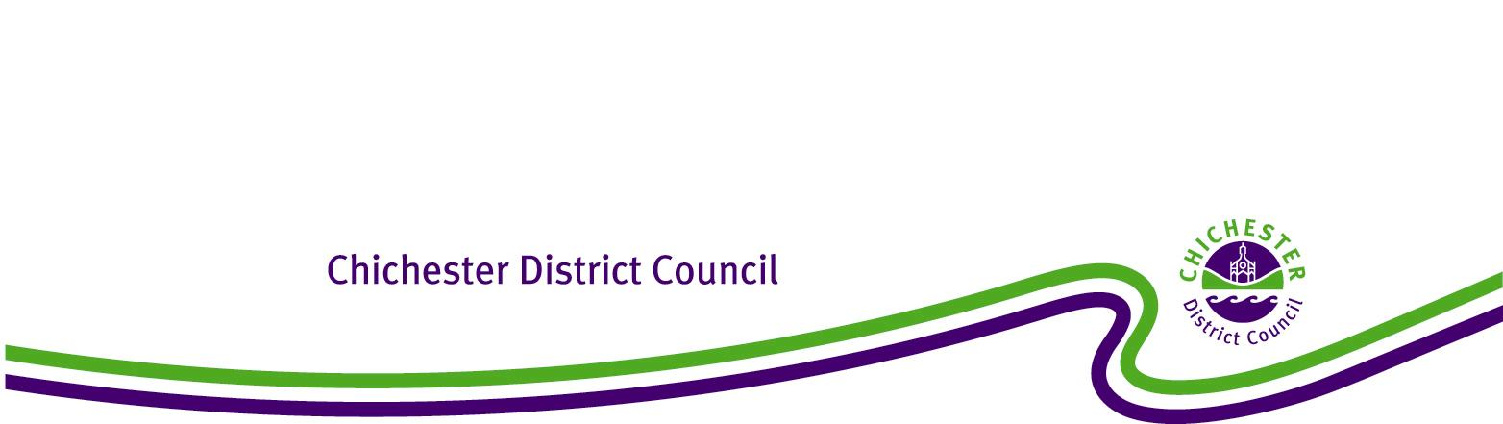

**Chichester District Council**

**Southbourne Modified Neighbourhood Development Plan**

**The Neighbourhood Planning (General) Regulations 2012**

**Regulation 20: Publicising a Neighbourhood Development Plan**

**1. Introduction**

1.1 Under the Town and Country Planning Act 1990 (as amended), the Council has a statutory duty to assist communities in the preparation of Neighbourhood Plans and Orders to take plans through a process of examination, referendum and adoption. The Localism Act 2011 (Part 6 Chapter 3) sets out the local planning authority’s responsibilities for Neighbourhood Planning.

1.2 This report confirms that at the Full Council meeting on 27 February 2024, Chichester District Council resolved to ‘make’ the Southbourne Modified Neighbourhood Plan 2014-2029 Referendum Modified Plan November 2023. This means that the Southbourne Modified Neighbourhood Plan has been brought into legal force and it now forms part of the statutory development plan for Southbourne Parish. Consequently, decisions on whether or not to grant planning permission in Southbourne Parishwill need to be made in accordance with Southbourne Modified Neighbourhood Plan 2014-2029 Referendum Modified Plan November 2023, unless material considerations indicate otherwise.

**2. Background**

2.1 The neighbourhood plan area for Southbourne covers the whole of the Parish of Southbourne.

2.2 The Southbourne Modified Neighbourhood Plan was examined by John Slater BA (Hons) M.A. DMS MRTPI who, in October 2023, recommended that the Southbourne Modified Neighbourhood Plan 2014-2029 as modified by his recommendations should proceed to referendum. Following this the Examiner’s modifications were agreed by Southbourne Parish Council and Chichester District Council.

2.3 On 5 December 2023, the Decision Statement, a report that outlines all the Examiner’s modifications and confirms acceptance by all parties, was agreed by Cabinet.

2.4 On 25 January 2024, the Southbourne Modified Neighbourhood Plan 2014-2029 Referendum Modified Plan November 2023 successfully passed its referendum with 89.8% of the votes agreeing that Southbourne Modified Neighbourhood Plan 2014-2029 Referendum Modified Plan November 2023 be used in Development Management decision making.

2.5 On 27 February Chichester District Council resolved that the Southbourne Modified Neighbourhood Plan 2014-2029 Referendum Modified Plan November 2023, be ‘made’ and become part of the Development Plan for Southbourne Parish.

**3. Conclusion**

3.1 It is therefore confirmed that the Southbourne Modified Neighbourhood Plan 2014-2029 Referendum Modified Plan November 2023, complies with the legal requirements and basic conditions set out in the Localism Act 2011, and as a result of Full Council resolution of 27 February 2024 has been ‘made’.

3.2 In accordance with Regulation 20 of the 2012 Regulations, Chichester District Council has published the Southbourne Modified Neighbourhood Plan 2014-2029 Referendum Modified Plan November 2023 on its website and a hard copy can be examined at the Council Offices in Chichester during normal opening hours. The Council has also notified all persons who asked to be notified of the making of the plan and when and where it can be inspected.