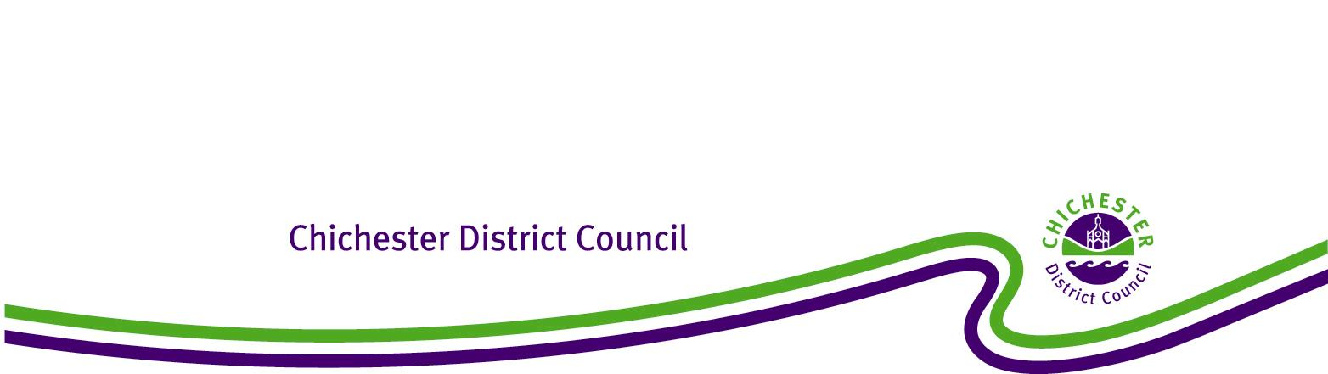

**Chichester District Council**

**Boxgrove Neighbourhood Development Plan**

**The Neighbourhood Planning (General) Regulations 2012**

**Regulation 20: Publicising a Neighbourhood Development Plan**

**1. Introduction**

1.1 Under the Town and Country Planning Act 1990 (as amended), the Council has a statutory duty to assist communities in the preparation of Neighbourhood Plans and Orders to take plans through a process of examination, referendum and adoption. The Localism Act 2011 (Part 6 Chapter 3) sets out the local planning authority’s responsibilities for Neighbourhood Planning.

1.2 This report confirms that at the Full Council meeting on 22 June 2021, Chichester District Council resolved to ‘make’ the Boxgrove Submission Neighbourhood Development Plan 2017-2029 Referendum Version. This means that the Boxgrove Submission Neighbourhood Development Plan 2017-2029 Referendum Version has been brought into legal force and it forms part of the statutory development plan for Boxgrove Parish. Consequently, decisions on whether or not to grant planning permission in Boxgrove Parishwill need to be made in accordance with the Boxgrove Submission Neighbourhood Development Plan 2017-2029 Referendum Version unless material considerations indicate otherwise.

**2. Background**

2.1 The neighbourhood plan area for Boxgrove covers the whole of the Parish of Boxgrove.

2.2 The Boxgrove Neighbourhood Plan was examined by Tony Burton MRTPI who, in January 2020, recommended that the Boxgrove Neighbourhood Plan 2017-2029 as modified by his recommendations should proceed to referendum. Following this the Examiner’s modifications were agreed by Boxgrove Parish Council and Chichester District Council.

2.3 On 7 July 2021, the Decision Statement, a report that outlines all the Examiner’s modifications and confirms acceptance by all parties, was agreed by Cabinet.

2.4 On 6 May 2021, the Boxgrove Submission Neighbourhood Development Plan 2017-2029 Referendum Version successfully passed its referendum with 89% of the votes agreeing that Boxgrove Submission Neighbourhood Development Plan 2017-2029 Referendum Version be used in Development Management decision making.

2.5 On 22 June 2021 Chichester District Council resolved that the Boxgrove Submission Neighbourhood Development Plan 2017-2029 Referendum Version be ‘made’ and become part of the Development Plan for Boxgrove Parish.

**3. Conclusion**

3.1 It is therefore confirmed that the Boxgrove Submission Neighbourhood Development Plan 2017-2029 Referendum Version complies with the legal requirements and basic conditions set out in the Localism Act 2011, and as a result of Full Council resolution of 22 June 2021 has been ‘made’.

3.2 In accordance with Regulation 20 of the 2012 Regulations, Chichester District Council has published the Boxgrove Submission Neighbourhood Development Plan 2017-2029 Referendum Version on its website and a hard copy can be examined at the Council Offices in Chichester during normal opening hours. The Council has also notified all persons who asked to be notified of the making of the plan and when and where it can be inspected.