Appendix 1: Chichester District Policy and Strategic Context

Policy/ Strategy/ Other Relevant Factors
Locality Description | 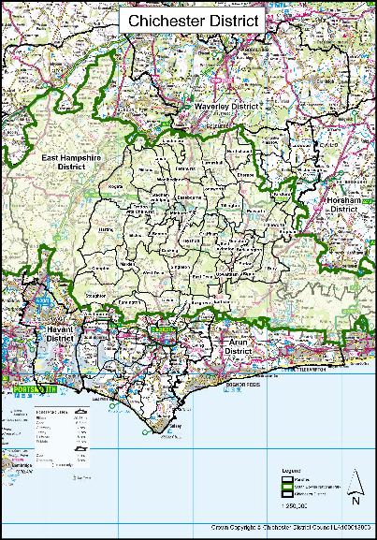  Chichester District covers an area of almost 800 km2 and is the largest of the seven districts and boroughs within West Sussex, stretching from the South Coast to the southern border of Waverley and East Hampshire in the north; and from Havant in the west to Arun and Horsham in the east. Over two-thirds of the district lies within the South Downs National Park.  There are 33 parish councils located within the Local Plan area, including six parishes which are also partly located within the South Downs National Park.  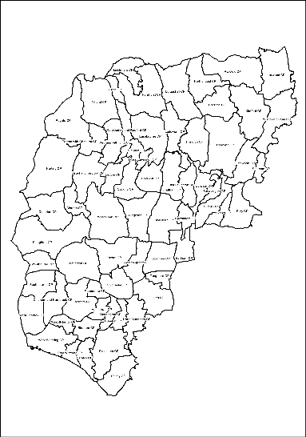  The district is dissected east to west by the A259, A27 and A272 cross routes, and north to south by the A286 through Midhurst and A285 through Petworth. North/south routes link with the A3 and the A29 towards the M25. East to west and north to south rail routes service Chichester, connecting with Southampton, Brighton, Horsham, Guildford, Gatwick Airport and London within the wider region.  The cathedral city of Chichester is the main settlement with a population of around 29,193 (Source: ONS Mid-Year Parish Population Estimates 2020) and is the principal location for the provision of higher education and shopping facilities. The city is renowned for its cathedral, its historic heritage and university and is the largest centre of employment in the plan area.  Outside Chichester city, there are four other significant settlements that accommodate a range of facilities and services:  - East Wittering and Bracklesham Parish has a population of around 4,899 (Source: ONS Mid-Year Parish Population Estimates 2020). Nearby beaches, especially those of West Wittering, are amongst the best in the Southeast.  - Selsey, at the tip of the Manhood Peninsula, is a town with a population of around 10,668 (Source: ONS Mid-Year Parish Population Estimates 2020). With one of the largest caravan parks in Europe, the population of the town more than doubles during the holiday season. It is also a focus for commercial activities such as horticulture, fishing and other marine related businesses.  - Southbourne, to the west of Chichester, has a population of around 6,820(Source: ONS Mid-Year Parish Population Estimates 2020) and has links to the nearby towns of Havant and Emsworth. Southbourne has several employment opportunities, a railway station, and a secondary school with a relatively modern leisure facility. The community facilities are dispersed throughout the settlement.  - Tangmere, to the east of Chichester city, is a settlement of some 3,158(4) people. It hosts a number of local businesses and has some dispersed community facilities including shops and a medical centre. However, it currently lacks many of the amenities and services normally associated with a settlement of its size.
Chichester District – Demography Source: Census 2021 | 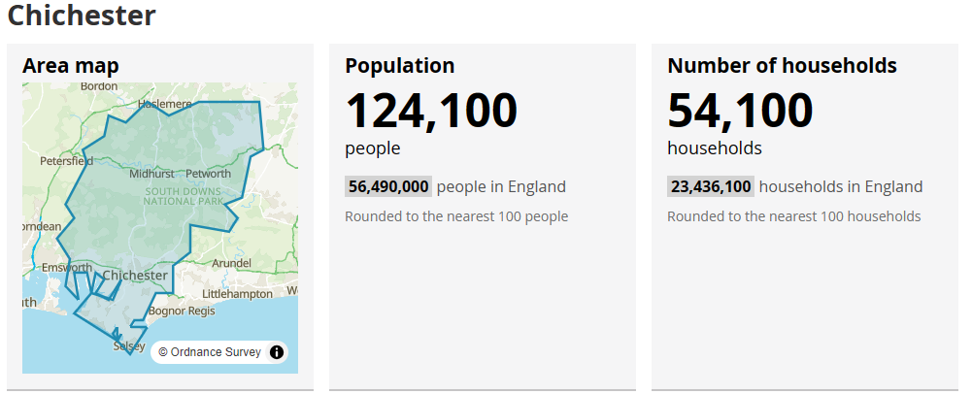  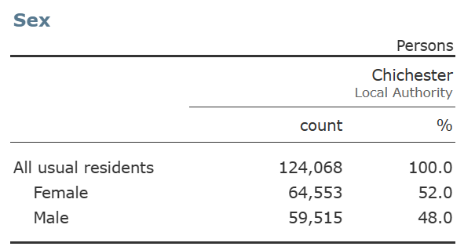  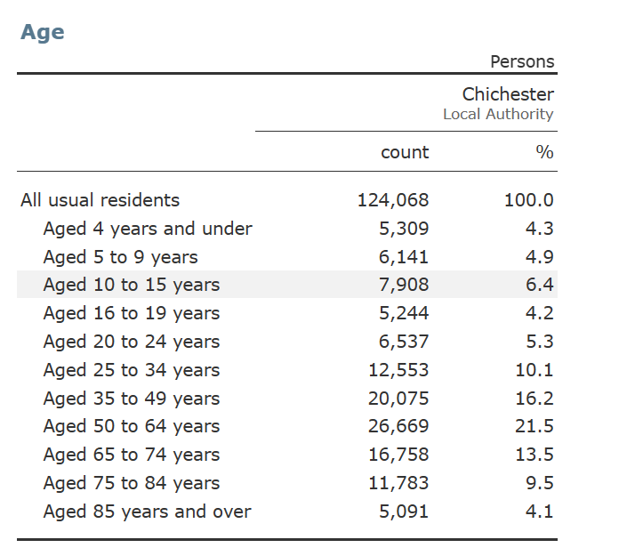  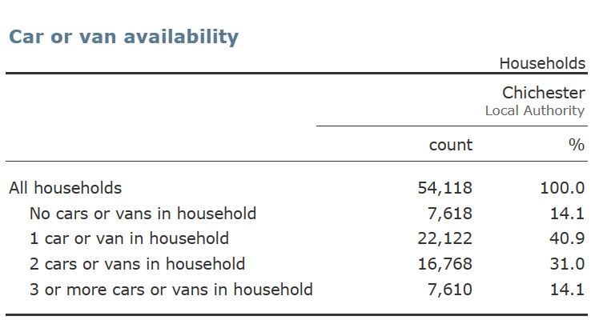
Study Area – Sub Areas | The study area follows the sub areas within the emerging Local Plan 2021 – 2039 Proposed Submission (Regulation 19) sub areas:  East-West corridor – Chichester city, east of the city, west of the city and includes the following parishes:  Westbourne (partly within SDNP), Funtington (partly within SDNP), Lavant (partly within SDNP), Westhampnett (partly within SDNP), Boxgrove (partly within SDNP), Eartham (mainly within SDNP), Southbourne, Chidham and Hambrook, Bosham, Fishbourne, Chichester City, Oving, Tangmere, Stoughton (mainly within SDNP), West Thorney (mainly barracks),  Manhood Peninsula – includes following parishes:  West Itchenor, West Wittering, Appledram, Birdham, East Wittering and Bracklesham, Earnley, Donnington, Hunston, Sidlesham, North Mundham, Selsey  North of the Plan area – includes following parishes:  Petworth (mainly within SDNP), Camelsdale and Hammer villages - within Linchmere Parish which is mainly within SDNP, Plaistow and Ifold (a small part is within SDNP) Kirdford (partly within SDNP), Wisborough Green (partly within SDNP), Loxwood, Ebernoe mainly within SDNP.  Note that the Local Plan does not cover the area within the South Downs National Park (SDNP) and some parishes are partly within the SDNP and partly within the Chichester Local Plan.
Estimated Sub Area Population, Source: ONS Parish Estimated Population 2020. | East-West Corridor – Chichester city, east of the city, west of the city  Parish Population ONS Parish 2020 Estimates  Westbourne 2287  Funtington 1545  Lavant 1800  Westhampnett 1075  Boxgrove 964  Eartham 115  Southbourne 6820  Bosham 2881  Chidham and Hanbrook 1860  Fishbourne 2557  Chichester City 29193  Oving 1647  Tangmere 3158  Sloughton 551  West Thorney 1209  Total 57,662  Manhood Peninsula  Parish Population ONS Parish 2020 Estimates  West Itchenor 308  West Wittering 2559  Appledram 211  Birdham 1625  East Wittering and Bracklesham 4889  Earnley 622  Donnington 2899  Hunston 1300  Siddlesham 1241  North Mundham 1613  Selsey 10668  Total 27935  North of the Plan area  Parish Population ONS Parish 2020 Estimates  1 3098  Linchmere – including Camelside and Hammer Villages 2309  Playstowe and Ifold 1995  Kirdford 1063  Wisborough Green 1419  Loxwood 1610  Ebernoe 212  Total 11706  The remaining population is within the South Downs National Park – Chichester Parishes  Parish Population ONS Parish 2020 Estimates  Barlavington 393  Bepton 226  Bignor 393  Bury 614  Cocking 468  Compton 381  Duncton 308  Easebourne 1957  Eastdene 196  East Lavington 302  Fittlewoth 1000  Graffham 491  Harting 1429  Heyshott 295  Linch 314  Lodsworth 628  Lurgashall 564  Marden 318  Midhurst 5341  Milland 909  Northchapel 843  Rogate 1631  Singleton 490  Stedham with Iping 820  Stopham 193  Sutton 393  Tillington 507  Trotton with Chithurst 346  Upwaltham 115  West Dean 426  West Lavington 268  Woolbeding with Redford 171  Elsted and Treyford 331  Fernhurst 2970  Total 26031
Chichester District Projected Population Estimates:  Source: ONS Sub National Population Projections Mid-Year 2018  Chichester Housing Development from Emerging Local Plan and South Downs National Park Local Plan Adopted 2 July (2014 – 2033) – Chichester Parishes. | The population data used in the modelling of existing and future needs for indoor sports facilities must be based on the Chichester district as-a-whole, and not just the District Council’s Local Plan area, and will need to cover that part of the District within the South Downs National Park.  ONS Sub National Population Projections Mid-Year 2018  2023 – Estimated 124, 285  2039 – Estimated 134,604  Total Projected = 10,319  Chichester Housing Development Emerging Local Plan  Plan Area  East-West Corridor Manhood Peninsula North Plan Area  Completions 1616 1346 193 77  Planning permissions 2791 2093 552 146  Sites allocated in Local Plan 2014-2029 2210 2200 0 10  Sites allocated in made Neighbourhood Plans 100 57 0 43  Windfall 796 562 182 52  New Strategic and Parish Allocations 2916 2578 0 338  Totals 10429 8836 927 666  Commitments only 6022 5397 182 443  Population Estimates based on a housing need in the emerging local plan 10,429 and an average household size of 2.29 (Source Census 2021 population 124,100 divided by total Census 2021 households 54,100) this would generate 23.882 residents living in these new dwellings.  South Downs National Park Local Plan Adopted 2 July 2019 (2014 – 2033) – Identified new housing developments in Chichester Parishes.  Parish Population ONS Parish 2020 Estimates South Downs Local Plan Housing Developments – number of Houses Average number of new houses New Population based on average Household Size (2.29)  Easebourne 1957 Allocation Policy SD66 16 – 20 Allocation Policy SD67 16 – 20 Allocation Policy SD68 16 - 20 18 18 18  Total 1957 54 124  Harting 1429 Allocated Policy SD86 6 – 8 Allocated Policy SD87 5 - 6 7 6  Total 1429 13 30  Midhurst 5341 Allocated Policy SD78 65 – 90 Allocated Policy SD79 50 – 70 Allocated Policy SD80 8 – 10 Allocated Policy SD81 – 20 Allocated Policy SD82 8 -12 77 60 9 10 10  Total 5341 166 380  Stedham with Iping 820 Allocated Policy SD88 - 16 16 37  Total 820 16 37  Chichester Parishes Total 249 571  Population Estimates based on housing need in the emerging Chichester District local plan 10,429 houses to 2039 and the South Downs National Park Local Plan Adopted 2 July 2019 (2013- 2033) 249 houses. Equates to 10.678 houses, based on the average household size of 2.29 (Source Census 2021 population 124,100 divided by total Census 2021 households 54,100) this would generate 24.453 residents living in these new dwellings. This excludes any additional new houses in the South Downs National Park between 2033 – 2039 that may be required in any new Local Plan after 2033.
Chichester District Council Corporate Plan 2022 - 2025 | 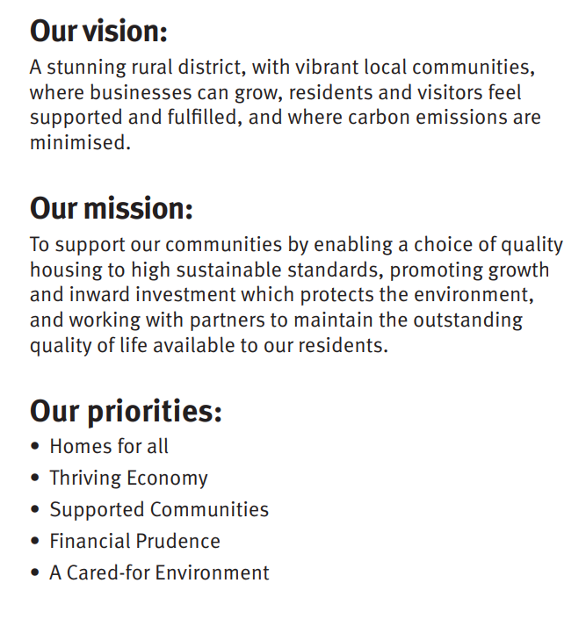  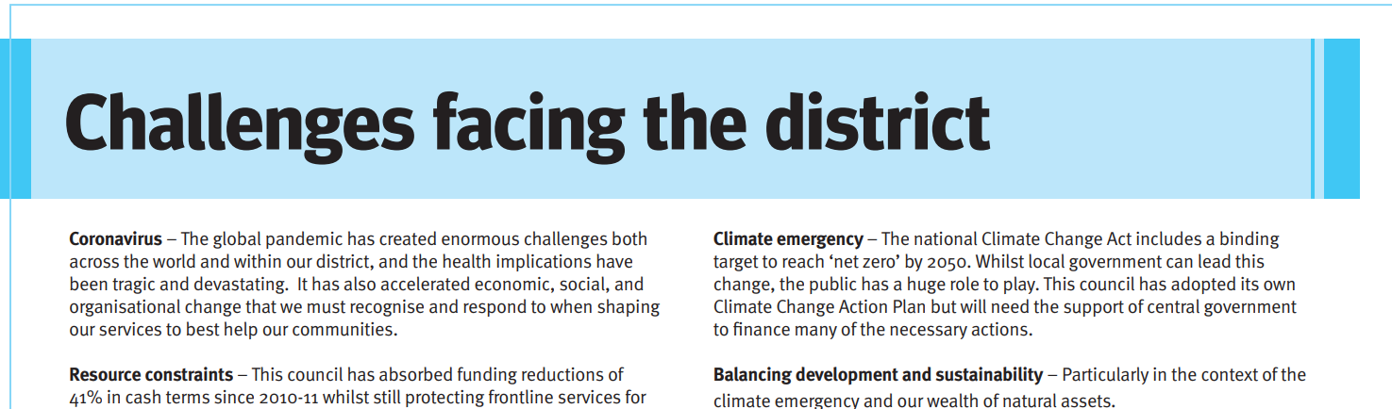  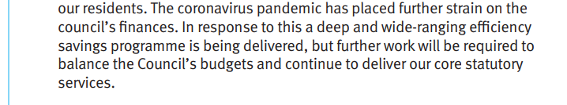    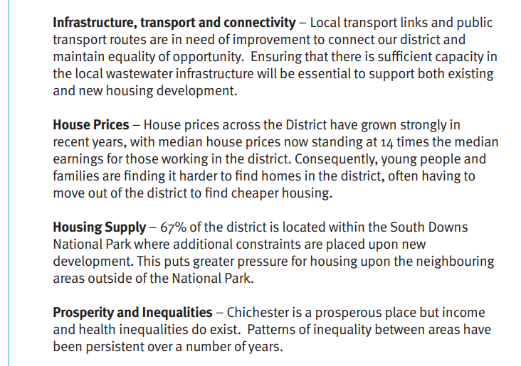  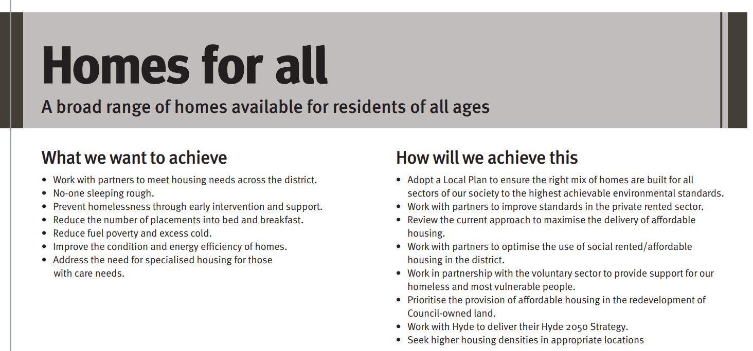  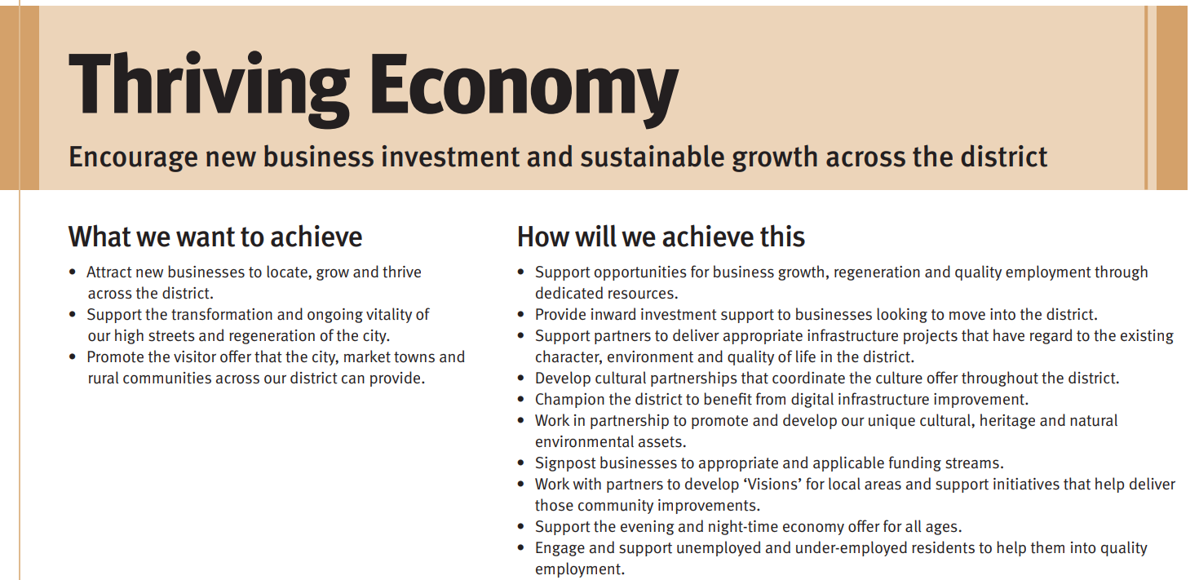  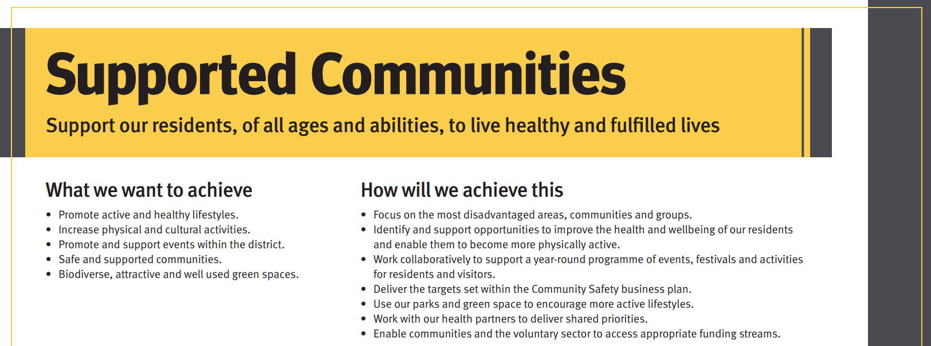  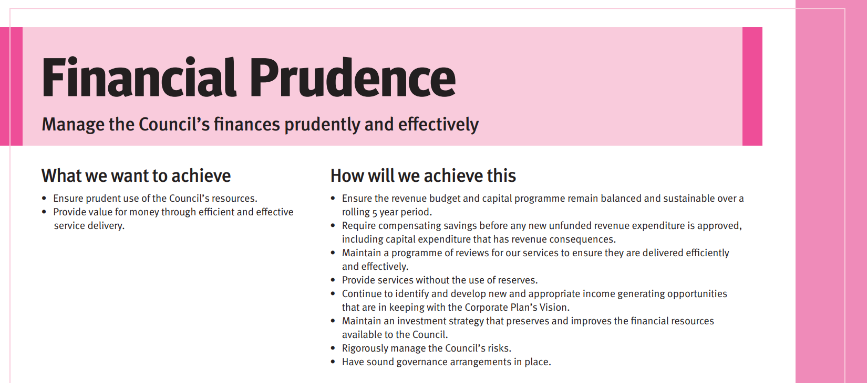
 | 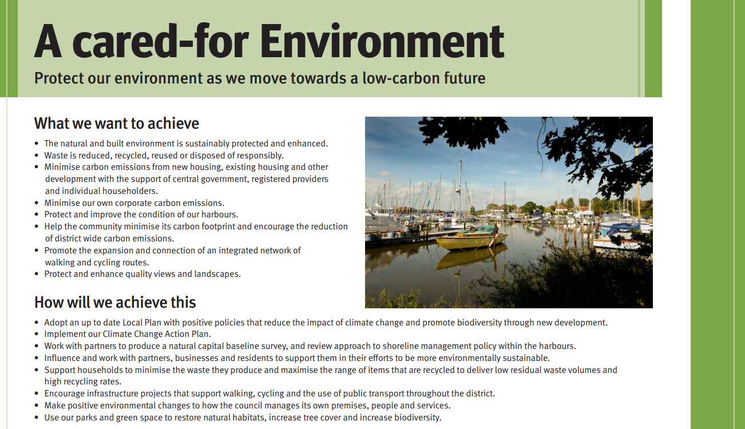
Chichester District – Deprivation (Source: Indices Multiple Deprivation 2019 and Census Data 2021) | Indices of Multiple Deprivation 2019  In 2019, 7.9% of the population was income-deprived, ranking Chichester as the 237th (from a total of 316) most income deprived local authority. The median housing affordability ratio is 13.67, the 4th highest in the southeast region. The district has a high level of home ownership.  Indices Multiple Deprivation 2019 – Chichester Neighbourhood Deprivation  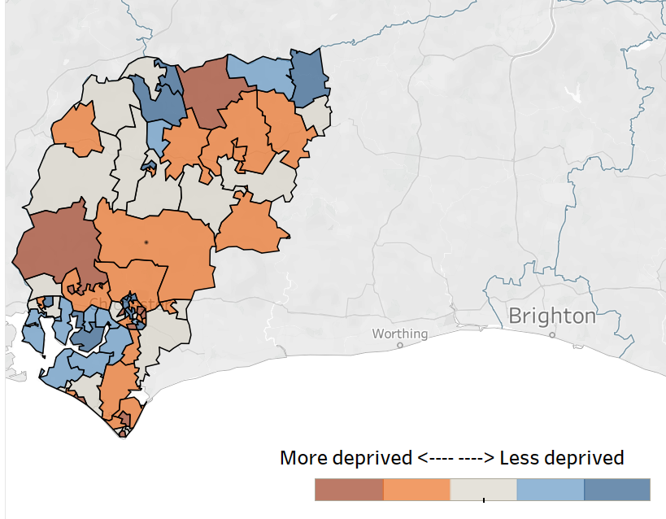  Census Data 2021  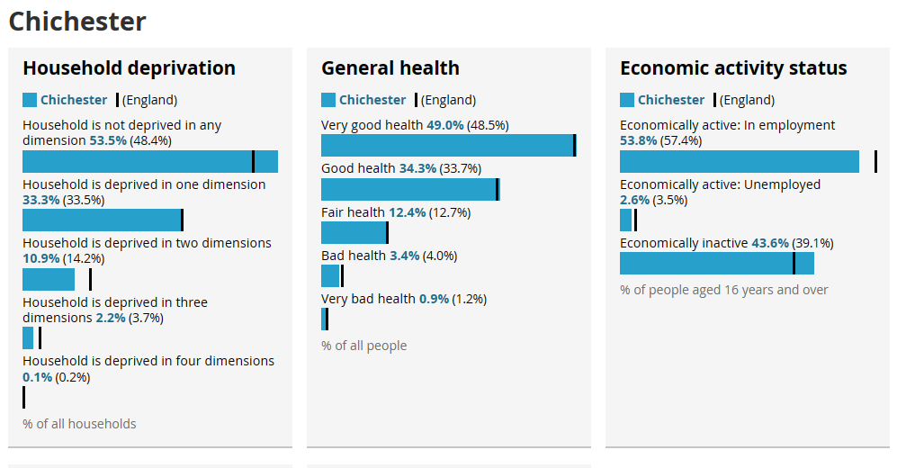
Adopted Chichester Local Plan: Key Polices 2014 - 2029 | The local plan only covers those areas in the district that do not fall within the South Downs National Park. There is a separate plan for the whole of the National Park, and this is produced by the South Downs National Park Authority.  The Vision includes:  Pursue a healthy lifestyle and benefit from a sense of well-being supported by good access to education, health, leisure, open space and nature, sports and other essential facilities.  Under objectives:  Health and Well-Being - Encourage healthy and active lifestyles for all. Encourage the development of quality, accessible and affordable sport and leisure facilities, parks, woodlands, cycle paths, networks of linked green spaces and community halls where people can pursue a healthy and active lifestyle with information and support.  Accessible health and wellbeing services - Improve access to health and well-being services, sport and leisure facilities, parks and green spaces and cultural pursuits. Work with partners to improve public transport and accessible transport links to the main settlements whilst ensuring services and facilities are provided close to people’s homes where possible.  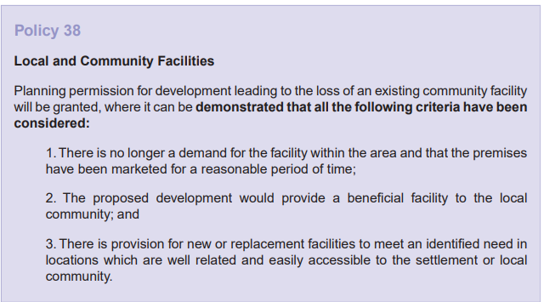  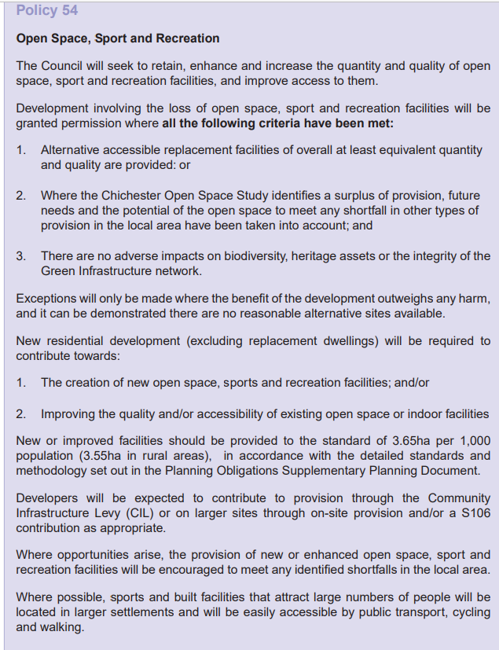
Chichester Emerging Local Plan – 2021 – 2039 (Regulation 19) | The emerging local plan only covers those areas in the district that do not fall within the South Downs National Park. There is a separate plan for the whole of the National Park, and this is produced by the South Downs National Park Authority.  The emerging local plan has three sub areas:  East West Corridor:  The emphasis of the Local Plan is on enhancing the role of Chichester city as the plan area's main centre, while also developing the role of key communities to its east and west. Chichester city is the focus for delivering housing and employment growth, as it is a key city and the main centre within the plan area. Due to this it is the most sustainable location, with a wide range of services and facilities. The main strategic sites are largely located in the East-West corridor.  Some strategic development sites in the East/West corridor are carried forward from the 2015 Local Plan, including Tangmere, Shopwhyke, Westhampnett/Northeast Chichester and West of Chichester. The new strategic housing sites in this area include Highgrove Farm, Bosham (245), East of Chichester (680), Maudlin Farm (265) and Southern Gateway (180).  An area of development has been identified at Southbourne for 1,050 homes. The detailed location of the development site, or sites, is yet to be decided, but this will be set out in either the local neighbourhood plan or through a new site allocation plan.  Strategic housing numbers have also been determined for Chichester City (270) and Chidham and Hambrook (300), which will be set out in either the local neighbourhood plans or through a new site allocation plan.  Small scale housing sites will be identified to help provide for the needs of local communities in Boxgrove (50), Fishbourne (30), Westbourne (30).  Meeting employment needs is important to support the economy of the plan area. The Local Plan carries forward employment space from the current Local Plan at West of Chichester, Chichester Business Park, Tangmere and Shopwhyke. The Kingsham Road employment site in the Site Allocation Development Plan Document 2014 - 2029 is also retained. In addition, a new employment site is proposed south of Bognor Road to provide 28,000 sqm of floorspace - while this is located within the Manhood area, it is close to Chichester. The land east of Rolls Royce is also safeguarded to allow future expansion of the existing site.  Nitrate neutrality is required for any development involving an overnight stay - both within homes and holiday accommodation - that discharges water into Chichester and Langstone Harbours. We have also produced a policy to protect wildlife corridors, which is the first time this type of initiative has been introduced in this area. This provides connectivity and passageways for wildlife through the landscape, especially between the coast and the South Downs.  Manhood Peninsula:  The Manhood Peninsula has a distinctive character and faces a specific set of planning challenges. These issues include significant areas at risk from coastal erosion and flooding; environmental designations; poor road accessibility; and traffic congestion.  The plan does not include any strategic housing allocations on the Manhood Peninsula. This is in recognition of recent speculative development and the ongoing constraints that the area faces. However, it does allow for 50 homes at North Mundham.  A new employment allocation on the land south of Bognor Road has also been included. While this is located within the Manhood Peninsula area, it is located close to Chichester.  The plan continues the designation of four Horticultural Development Areas around Tangmere, Runcton, Sidlesham and Almodington to support the horticultural industry. The land within the Runcton Horticultural Development Area is almost at capacity, and so the plan has extended it by a further 30 hectares of land.  The plan includes a suite of policies to ensure that coastal areas are protected from inappropriate development and that the unique environmental characteristics of the Manhood Peninsula coast are taken account of.  There is also a policy to protect wildlife corridors, which is the first time this type of initiative has been introduced in this area. This will provide connectivity and passageways for wildlife through the landscape, especially between the coast and the South Downs.  North of the Plan Area:  The north of the plan area covers those parts of Chichester District which lie north of the South Downs National Park boundary. This includes Loxwood Parish and most of the parishes of Kirdford, Plaistow and Ifold, and Wisborough Green. It also includes a small part of Lynchmere Parish, close to the Surrey border around the villages of Camelsdale and Hammer.  As part of the plan making process, there is a need to consider how many homes each area can accommodate. Higher housing numbers were considered at Loxwood, Kirdford, Wisborough Green and Plaistow and Ifold. However, this was ruled out due to the need to conserve the rural character of the area; its high-quality landscape; and, to minimise the impact on the historic environment.  Instead, the plan is suggesting that the following locations can accommodate a small number of homes through the neighbourhood planning process:  - Kirdford - 50 homes  - Wisborough Green - 75 homes  - Plaistow and Ifold - 25 homes  Loxwood is the least constrained village in the north of the plan area, and benefits from the most services and facilities, including healthcare. Due to this, it is proposed that 220 homes are delivered in Loxwood through the neighbourhood planning process.  Homes within the north of the plan area will need to demonstrate water neutrality through a mixture of water efficiency and offsetting. This is to limit the impact on the internationally designated Arun Valley sites, which are protected for their rare and protected habitats.  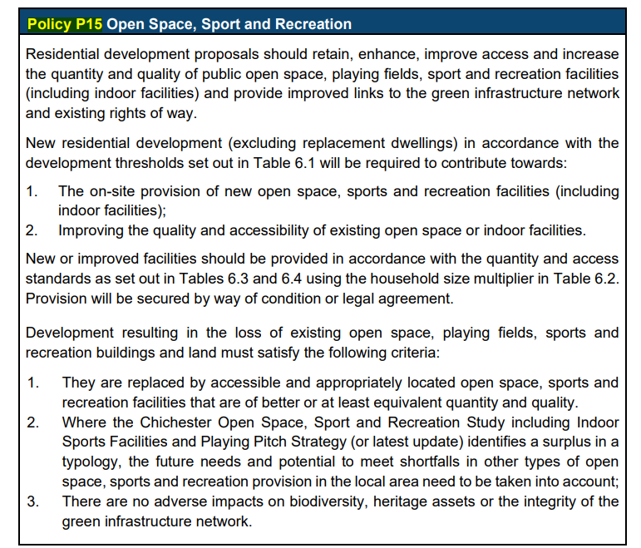  The table below shows the built sport and recreation facilities quantity and access standards required by developments that meet the thresholds for providing on-site facilities set out in hectares per 1000 population generated.  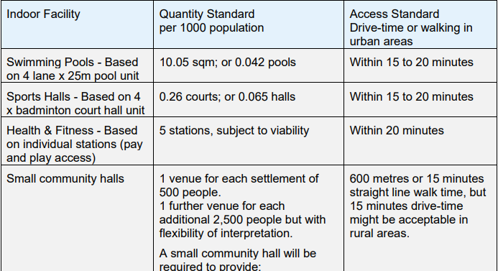  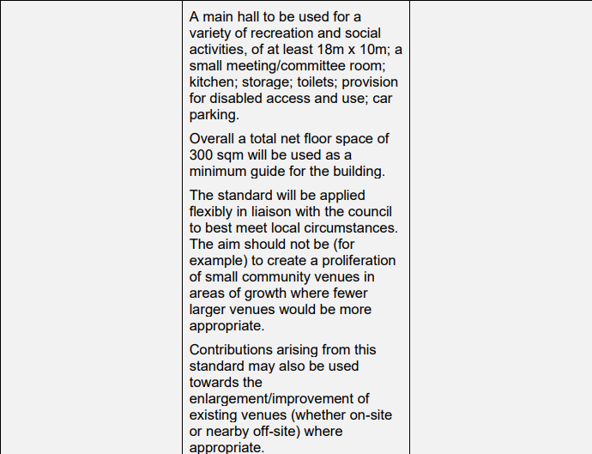
South Downs Local Plan Adopted July 2019 (2014 – 2033). | 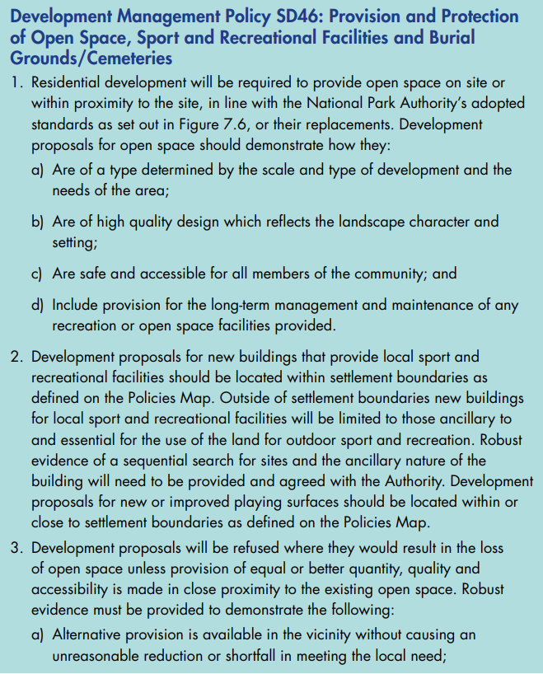  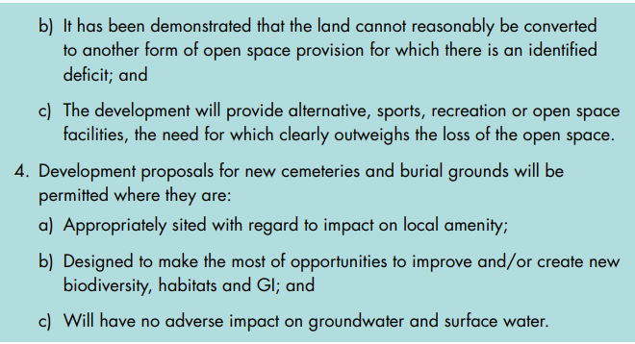  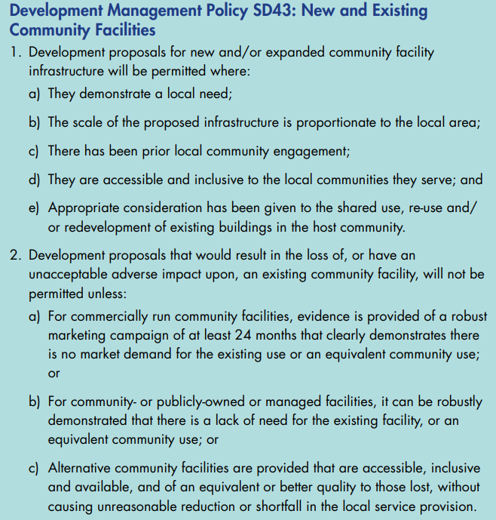
Neighbourhood Planning | Chichester District - Neighbourhood Plans that include sports and recreational facilities:  Kirdford Neighbourhood Plan - A major community social objective is to improve social integration in the village, provide sustainable recreation facilities and establish a social centre. A scheme to combine all Parish sports activities (releasing existing land for alternative use) and develop a new Village Hall/club house/community centre/medical day clinic/changing facilities and warden's flat, along with an element of new housing. The location is critical, as it places the social activity below the existing cluster of social housing in the village.  Southbourne Neighbourhood Plan Referendum will be held on 25 January 2024 - POLICY SB12: LAND FOR EXPANDING EDUCATION & RECREATIONAL USES The Neighbourhood Plan allocates land to the west of Bourne Community College, as shown on the Policies Map, for outdoor educational (Class F1(a)) and recreational uses (Class F2(c)), and for any ancillary buildings related to the recreation use.  Tangmere Neighbourhood Plan  Policy 2: Strategic Housing Development  ix. There will be a new Community Facility provided in the broad location shown on the Concept Plan to serve the existing and new communities and: a. will comprise rooms and facilities to service large community events, including amongst others a Youth Club, Community Kitchen, an Artisan Local Market, a café and a room suited to early years childcare service provision; and b. will include proposals for securing the satisfactory ongoing management of all the Tangmere Green Infrastructure Network within the site; x. Commercial uses on the site will be provided in the form of a small parade in the ‘Village Main Street’ to serve the convenience and local services needs of the existing and new residents and comprising a mix of units suited to A1-A5 and B1(a) uses (subject to marketing evidence), some or all of which may be delivered with dwellings on upper floors;  West Wittering Neighbourhood Plan –  Policy WW12 Community Facilities and Open Spaces  1. Parish owned Allotments – Community and leisure use  2. Memorial Hall  3. Sports Pavilion, Tennis Club and recreation ground Rookwood Rd – Sports use  4. Millennium Meadow including Cricket Pavilion – Sports and social use  5. Church of St Peter and St Paul – Community use  6. Church Room – Community use  7. Parochial Church School – Community use  8. St Peter’s Church – Community use  9. The Wittering – Tourism and community use  10. Sailing Club – Sports and Leisure use (also known as Snowhill Creek Moorings)  11. The Lamb Inn – Tourism and community use  12. Village Shop (Saya’s News) – Tourism and community use  13. Beach café – Tourism and community use  14. Elms Lane Tennis Club – Sports use  15. The Shore Inn – Tourism and community use  16. Marine Drive car park – Field used as a seasonal overflow carpark for visitors.  Proposals for the improvement or extension of the community facilities listed above and for the provision of new community facilities and open spaces that provide for everyday needs within West Wittering will be supported. Proposals that would result in the loss of existing community facilities and open spaces will only be acceptable if evidence is provided that they are no longer needed by the community or would be replaced by equivalent or better provision in terms of quantity and quality in a suitable location.  Wisborough Green Neighbourhood Plan - Support future plans to improve the current Sports Pavilion to modernise the facilities to meet the sporting and access for all requirements.
Your City – Your Vision – Chichester Tomorrow | Chichester City Centre – the focus of the vision  Thriving towns and cities have a central focal point – an area where residents, visitors and workers meet, relax, shop, do business, enjoy leisure activities, eat, drink, and socialise. It is therefore Chichester’s City Centre – the area within and adjacent to the city walls and ring road, extending eastwards to include St Pancras and the Hornet, northwards to include the Festival Theatre and University, westwards to include the College, and southwards to include the Canal Basin and Chichester Gate – which is the focus of the Vision.  The Vision will serve as a template against which to test new projects, policies and proposals emerging for the City Centre. The Vision will guide and influence future economic and planning policies for the City Centre, guide how future budgets and resources are allocated, and it will help attract inward investment. Fully researched and, following full consultation, enjoying overwhelming public support, this Vision will be the foundation to sustaining the vitality and viability of the City Centre for years to come.  ChiVision.v13.Final.5-12-17.pdf (chichester.gov.uk)
A Prosperous and Sustainable Economy – Economic Development Strategy for Chichester 2022 - 2024 | The priority areas of focus will be on the ongoing delivery of Inward Investment Delivery Plans to promote the district as open for business and on supporting the high street, horticulture, viticulture, and the visitor economy. Additionally, it specifically seeks to support sustainable businesses.  This economic development strategy also recommends a targeted approach to supporting indigenous businesses to grow, whilst encouraging inward investment.  It sets out that there is a need to attract and retain younger people; stresses the importance of education and training in raising aspirations and developing skills; and aims to promote better economic use of the district’s considerable natural and cultural assets.  https://www.chichester.gov.uk/media/37560/Economic-Development-Strategy-update-2022-2025/doc/Economic_Development_Strategy_update_2022-2025.docx?m=638048169553330000
Start Well, Live Well, Age Well: West Sussex Health and Wellbeing Strategy 2019 – 2024 | 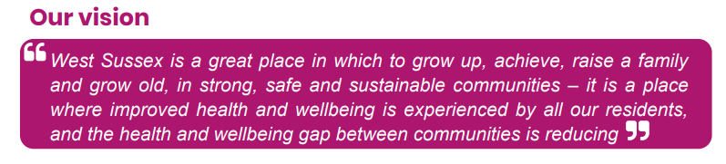  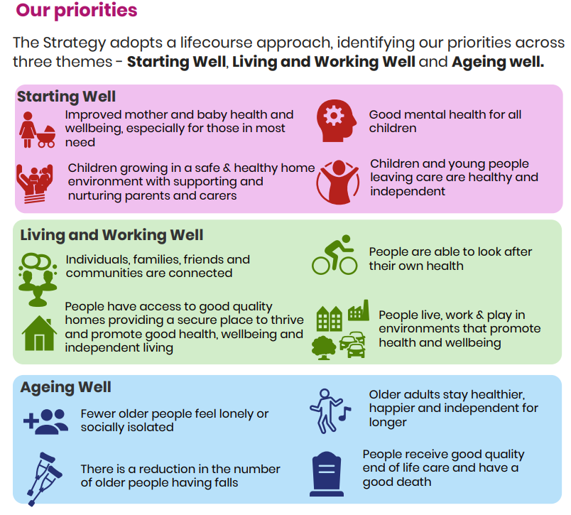  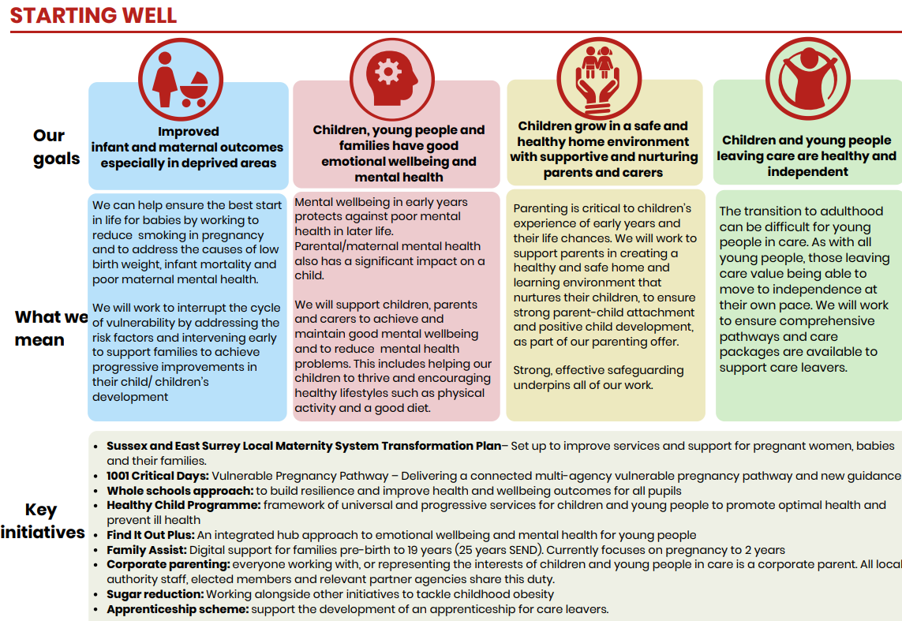  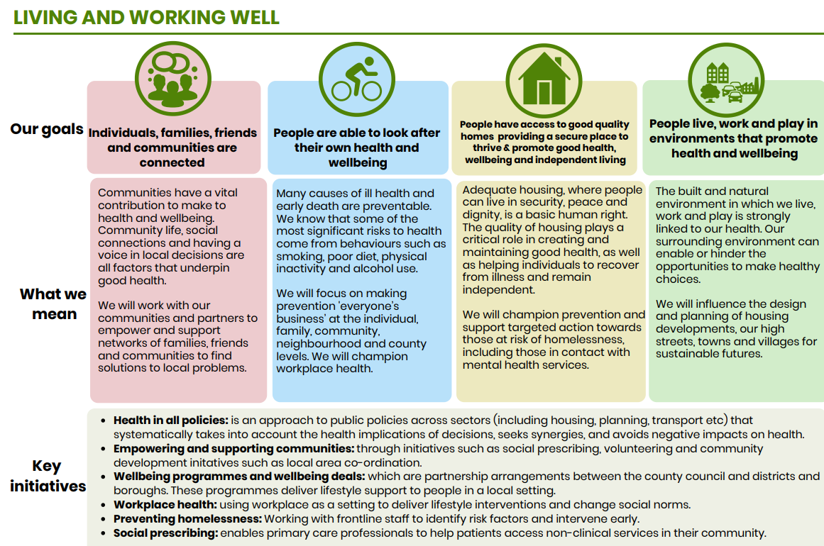  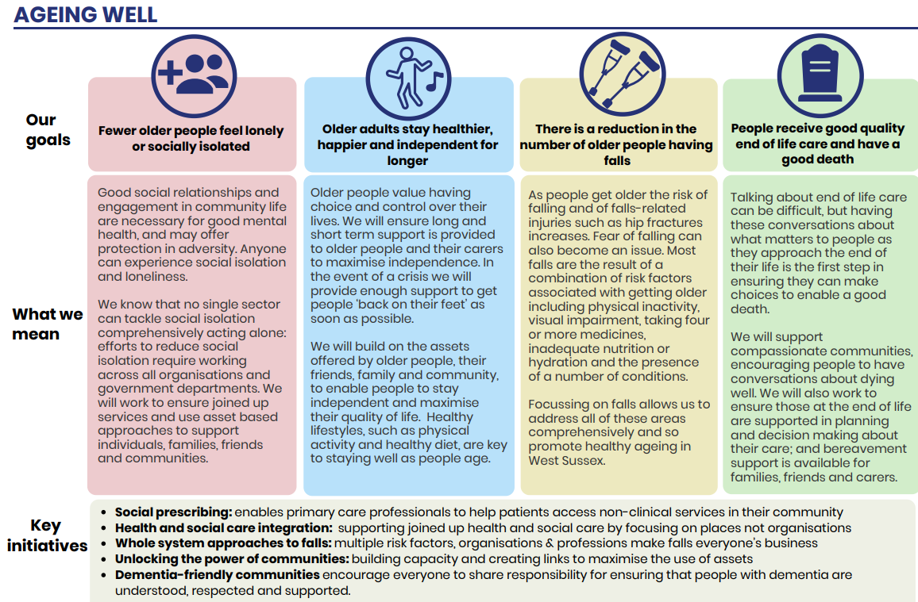
Chichester Wellbeing Service | All the District and Borough Councils in West Sussex are contracted by West Sussex County Council Public Health to deliver a Wellbeing service. The Wellbeing service is a universal service for adults of all ages designed to reduce the risk of cardiovascular disease, cancer, and type 2 diabetes. It targets areas of the district where deprivation has been identified, and population groups who are more likely to suffer poor health outcomes. Services focus on behaviour change and early intervention around the main causes of these diseases by supporting people to achieve a healthy weight, increase physical activity, stop smoking, reduce alcohol consumption, and reduce stress.  Throughout the pandemic the service adapted and continues to support people with their health and Wellbeing especially focusing on elements that have a greater impact on covid hospital admissions eg smoking, obesity and physical inactivity.
Sport England Active Lives Data (Participation 2019 – 2022) | Adult Active Lives Survey Nov 21/22  Levels of activity (Main - 3 categories) England West Sussex Chichester District LA  Inactive: less than 30 minutes a week 25.80% 24% 25.80%  Fairly active: 30-149 minutes per week 11.10% 11.20% 9.20%  Active: at least 150 minutes a week 63.10% 64.90% 65%  Adult Active Lives Survey Nov 20/21  Levels of activity (Main - 3 categories) England West Sussex Chichester District LA  Inactive: less than 30 minutes a week 27.20% 24.40% 19.60%  Fairly active: 30-149 minutes per week 11.50% 10.30% 10.60%  Active: at least 150 minutes a week 61.40% 65.20% 69.80%  Adult Active Lives Survey Nov 19/20  Levels of activity (Main - 3 categories) England West Sussex Chichester District LA  Inactive: less than 30 minutes a week 27.10% 25.90% 30.20%  Fairly active: 30-149 minutes per week 11.50% 11.40% 9.30%  Active: at least 150 minutes a week 61.40% 62.70% 60.60%  Adults Inactive less than 30 minutes a week in Chichester District has improved from 30.20% in 2019/2020 to 19.60% in 2022/2023. In 2023, Chichester Districts inactivity was the same as the England average 25.80% and slightly higher than West Sussex 24%. The Active at least 150 minutes a week was slightly higher 69.80% than the England average 63.10% and West Sussex 64.90%.  Sport and Physical activity Levels – Children and young People in Schools Years 1 – 11 No Chichester data available after 2019/2020.  Children and young People in Schools Years 1 - 11 Survey Nov 19/20  Levels of activity (Main - 3 categories) England West Sussex Chichester District LA  Less Active: less than 30 minutes per day 31% 26% 18%  Fairly active: 30-59 minutes per day 24% 26% 28%  Active: an average of 60 minutes per day across the week 45% 49% 53%  In 2019/2020 53% of children and young people in Chichester School Years 1 – 11 were active on average 60 minutes per day.  This is higher than West Sussex 49% and England 45%.  Chichester District Council Inactivity Map 2020/2021 LSOA  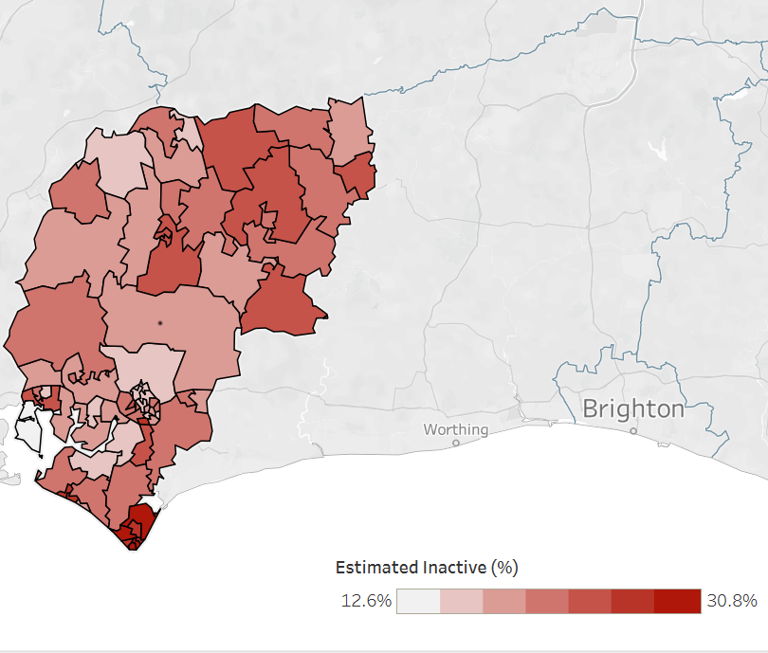
Active Sussex Strategy 2023 – 2028 – Getting Sussex moving | 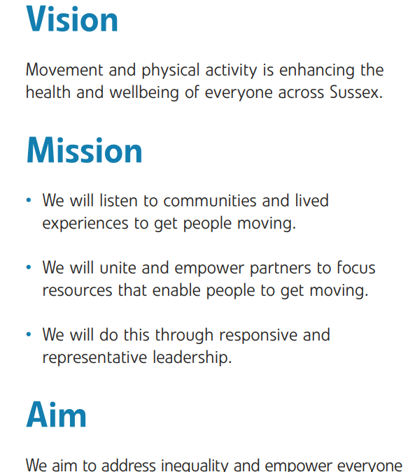  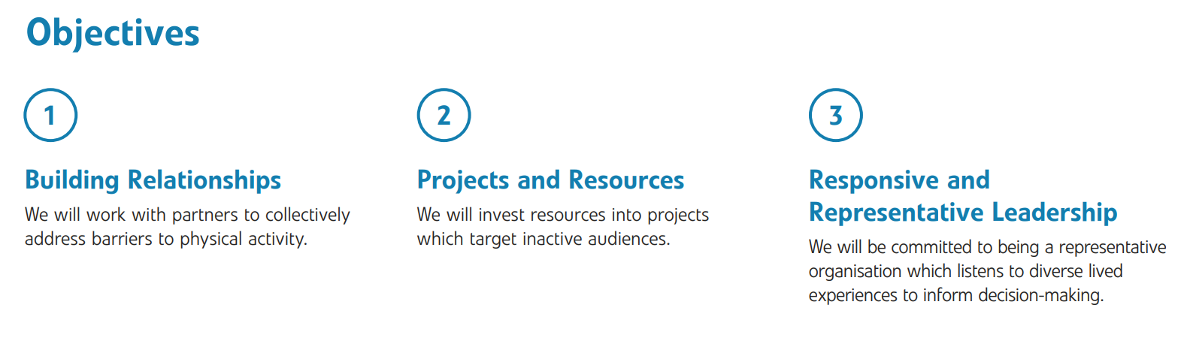  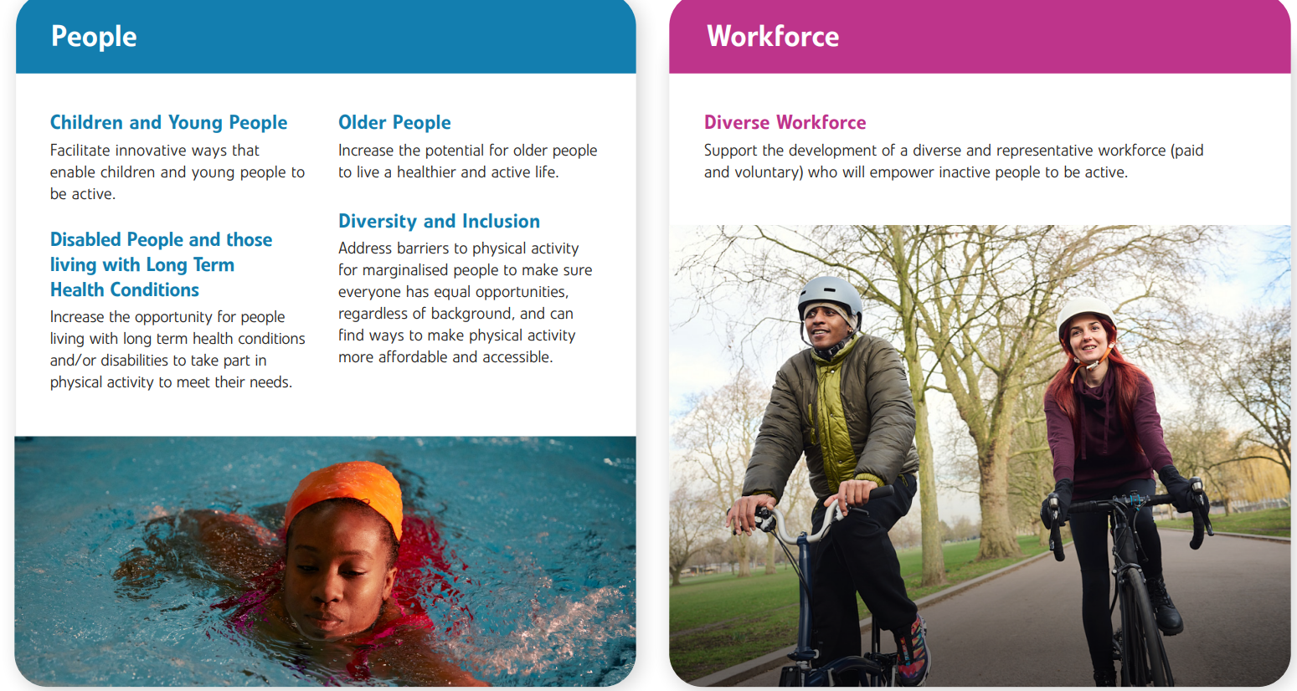  
Chichester Climate Change Action Plan | The council declared a climate emergency in July 2019. Local Plan policies are just one part of the local response to tackling this issue, ensuring that new developments in the plan area both mitigate climate change by contributing to a reduction in greenhouse gas emissions, and are adapted to the demands of a changing climate.  The council is also progressing and delivering a Climate Emergency Action Plan separately to the Local Plan process – the Action Plan seeks to deliver a 10% reduction in greenhouse gas emissions year on year from 2019 to 2025 (representing a 47% reduction overall), both for the Council’s own operations and for the whole district.  This is just the first step – a more challenging target will be set beyond that to contribute towards the Government objective of net zero by 2050.  All proposals for new development should be considered in the context of a climate emergency. In the Chichester plan area, the likelihood of sea level rise and increased risk of flooding is a key consideration, alongside other impacts such as higher temperatures, water scarcity and more extreme weather events. Flood risk will be considered using the council’s latest Strategic Flood Risk Assessment together with any more recent information from the Environment Agency. Targets for CO2 emissions, fabric energy efficiency, primary energy rates and building emissions rates for new and existing buildings are set through Building Regulations.

