Appendix 4: Chichester District - NGB Responses

NGB
England Indoor bowls Association | - Who are your key clubs and what do they deliver for your sport?  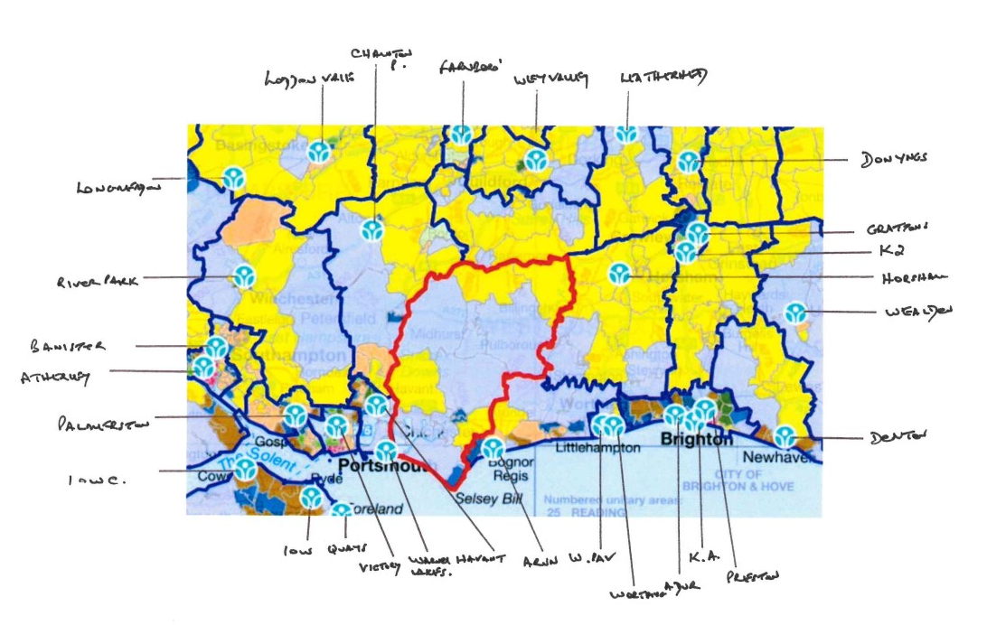  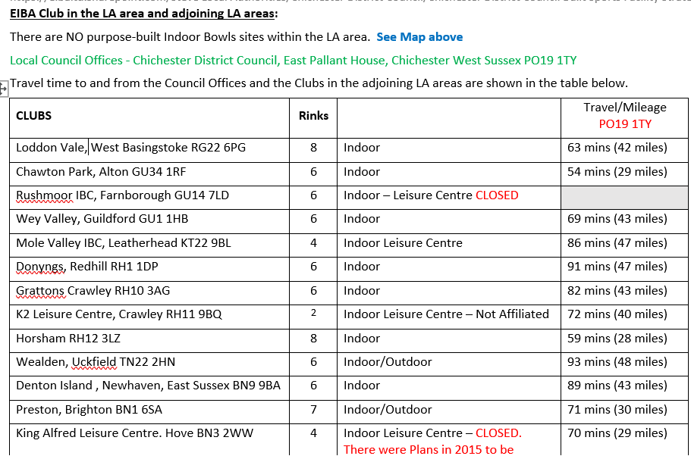  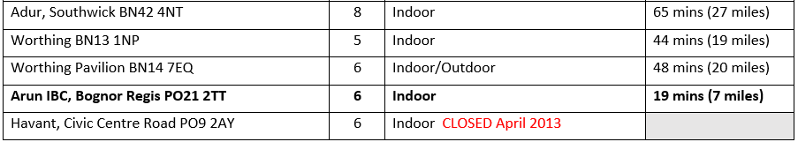  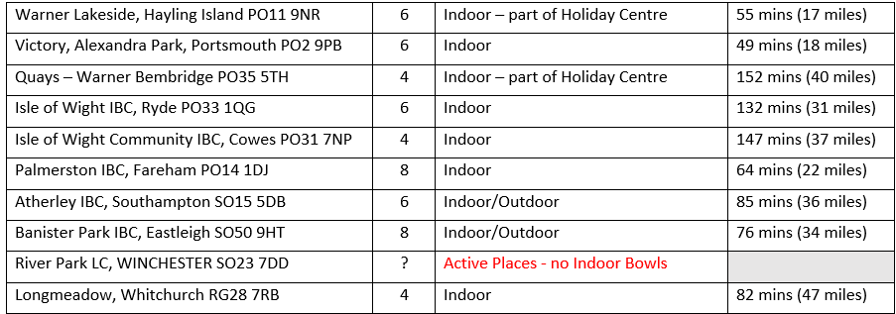  - What are your NGBs / Organisations current priorities in the Chichester District Council area?  Based on Mileage and Travel time for the LA Council Offices, there is only ONE Purpose Built Indoor Bowls site in adjoining areas within 30 minutes’ drive-time.  Chawton Park and Horsham may fall into this category depending upon a resident’s location in the LA area.  In pre-COVID times, when funding was not an issue, we would have sought to explore the possibility of an Indoor Bowls facility being provided in the LA area.  In the late 1980’s and 1990’s when Funding was readily available from Sport England and others, we saw many projects for Standalone Indoor Bowls facilities.  Since then, with funding for Capital Builds becoming extremely scarce, there have been very few new Standalone builds unless it has involved a relocation and selling of the existing site to fund the project.  Our recommendations where there was “Low Supply” AND “High Demand,” were as follows:  - Compliant Indoor Bowls Green in a Leisure Centre with at least four rinks.  - Indoor Bowls added to an existing Outdoor Bowls Club which has full Ancillary Services (Catering, Bar, Toilets, Changing Rooms) and has the land to build on.  - Indoor Bowls added to an existing Outdoor Sports Club which has full Ancillary Services (Catering, Bar, Toilets, Changing Rooms) and has the land to build on.  - Indoor Bowls within a building that could accommodate the Sport – with appropriate Lease, like Swindon Manor IBC have achieved.  - City of Birmingham IBC joined up with a Rugby Club, with S106 and Sport England monies.  Low Supply and High Demand – to ascertain whether there is “low supply and high demand,” we review:  - Locations of nearby existing Indoor Bowls facilities.  - Drive-time by Car from the proposed new build to existing Clubs.  - Whether the existing Clubs have the capacity to accommodate new members.  - Population figures and projections for the area surrounding the proposed new site.  - the new Clubs “Business Plan and Sports Development Plan,” to ascertain whether the new facility will be sustainable.  - the Design Plans for the new site, to ascertain if the facility will be attractive to new Indoor bowls participants and is not just a site which is “acceptable to the existing bowlers because they do not have any alternative.”  Market analysis  When you have determined the general location for your facility the catchment area should be defined and assessed. The following guidelines on catchment for indoor bowls centres must be interpreted in the light of local circumstances:  - Assume most users will live locally and not travel more than 20 minutes  - Assume 90% of users will travel by car, with the remainder by foot.  - As a guide, demand is calculated as one rink per 14,000-17,000 of total population  - A six-rink green, therefore, is required for a population of 85,000-100,000. This will be dependent upon the population profile of your area. To help you identify the population profile of your area, contact the EIBA.  - The number of rinks required can be related to the estimated number of members: assume 80-100 members per rink  We are currently reviewing the “Market Analysis” guidance as we feel that additional criteria/parameters are now appropriate:  - Travel time – consider an extension to 30 minutes. We anticipate that there will be regional variations, depending upon the current provision of Indoor Bowls sites.  - Means of travel – we consider that the provision of “public transport” will be relevant in some parts of the country – especially the rural areas.  - Members per rink ratio – this figure is still relevant, but we also need to factor in “spare rink capacity” for each session played, bearing in mind that then older population is not keen on travelling in the dark.  This review is being undertaken alongside a full review of the Design Guidance with Sport England.  - What might be required to support your priorities in the coming years?  See Answer to Q2 above.  - What long term plans or developments do you have in mind /in progress?  See Answer to Q2 above.  - Do you have access to funds to support your plans and developments across Chichester District Council area? If yes, please provide further details.  Regrettably, we do not have access to any funding.
England netball. | - Who are your key clubs and what do they deliver for your sport?  Chichester Netball Club, largest club in the area. They run all ages and two sessions with an Engand Netball Partnership Agreement for Back to Netball and Walking Netball in the community. The club compete from U9 -U17 in junior squads, alongside three adult teams who compete in the Chichester Netball League – Bishop Luffa School and University of Chichester.  Footloose Netball club – Westgate & Bishop Luffa School & University of Chichester  Six villages – Junior club – University of Chichester  Chichester University Netball club – running in the Dome at Bishop Otter Campus University of Chichester  Chichester Netball League, two division local England Netball registered league, also running in the Dome at the University of Chichester  Planet Netball Academy – Junior league ran by local volunteer – Bishop Luffa School  - What are your NGBs / Organisations current priorities in the Chichester District Council area?  Continue to support local clubs and leagues to deliver core netball. Support partnership agreements of Back to Netball and Walking Netball to boost community outreach, in partnership with Chichester Netball Club. Support prospective Walking Netball Club Kingfishers, who play at Westgate become an official Partnership Agreement club once their coach has completed the Walking Netball Host training course.  - What might be required to support your priorities in the coming years?  Increased court space, this has always been an issue in Chichester. Recently we supported Westgate putting netball court lines down in their hall. However, they are smaller than regulations, so can be used recreationally only, not for club games at local level or higher.  - What long term plans or developments do you have in mind/in progress?  Continue to grow the clubs and leagues, whilst growing Partnership Agreements to grow EN programmes. Launch NYCs in the area.  - Do you have access to funds to support your plans and developments across the Chichester District Council area? If yes, please provide further details.  Please contact England Netball Facilities manager for further discussions - charlotte.malyon@englandnetball.co.uk
Lawn tennis Association | - Who are your key clubs and what do they deliver for your sport?  Club All the clubs deliver  Aldingbourne LTC LTA Vision and Mission – and growing tennis and to see tennis opened up by making tennis relevant, accessible, welcoming, and enjoyable.  Chichester Rackets and Fitness Club  Crablands Tennis Club  Elms Lane Tennis Club  Fernhurst Tennis Club  Fishbourne Tennis Club  Graffham Tennis Club  Petworth Tennis Club  Rogate Tennis Club  Roman Landing Tennis Club  Rookwood Tennis Club  - What are your NGBs / Organisations current priorities in the Chichester District Council area?  LTA Vision and Mission – and growing tennis and to see tennis opened up by making tennis relevant, accessible, welcoming, and enjoyable.  https://www.lta.org.uk/about-us/what-we-do/mission-statement/  Parks Investment and Free Parks Tennis.  Floodlighting Venues.  Support the growth and addition of Padel.  Opening venues up to the community through pay and play.  Workforce Development.  Sustainability.  - What might be required to support your priorities in the coming years?  Partnership funding for venues to access to support facility development.  Workforce bursaries to help venues develop local workforce.  Planning support (lights/covers/padel projects)  Sustainability advice.
- What long term plans or developments do you have in mind/in progress?

Floodlighting/covering more courts.
Development and addition of more Padel courts.
Community accessibility – parks, venues, schools, leisure centre.
Taking tennis out of traditional settings and taking tennis to the heart of communities.
Accessing more schools where tennis courts are on site.
Local workforce development (linked to the University and secondary schools)
Sustainability.

- Do you have access to funds to support your plans and developments across the Chichester District Council area? If yes, please provide further details.
LTA Facility Funding.
Serves Programme.
Open Court Programme
Coach Development Fund.

Indoor Tennis Facilities:
To establish target locations for future community indoor tennis centres, the LTA modelled data from existing successful CITC’s. This helped to identify the demographic type, volume, and catchment size of a successful CITC. This modelling was applied across England, Scotland, and Wales to establish the areas of potential demand.

The key metrics established are:

- A target location must demonstrate a minimum threshold population of 70,000 within a 20-minute drive time of a target location. Of this population, at least 12,500 must identify as having an interest in playing tennis. Please note this drive time extends to 30 minutes for rural areas.
- Filtered for competition within the catchment to prioritise the addressing of indoor tennis provision gaps.

This methodology has enabled the LTA to identify seventy-two target locations for new indoor tennis venues in England. The target location closest to Chichester District is Horsham.
England Fencing | - Who are your key clubs and what do they deliver for your sport?  Chichester Fencing Club is an active club in Chichester providing training for all ages (pre-teen upwards) and all ability levels from novice to competitive fencer. Wheelchair users and those with mobility issues are also provided for. The club currently use Chichester high School for Girls.  - What are your NGBs / Organisations current priorities in the Chichester District Council area?  As a Body, we are aware that our Sport is under-represented in the general Population and are actively seeking to remedy that. Within our Region/County structure, Chichester is in Sussex in the South-East Region and, while the Region itself is quite active, it is possible that improvements could be made at County level. As the 'Capital City' of Sussex, Chichester would be a potential focal point for these improvements.  - What might be required to support your priorities in the coming years?  Availability of affordable venues is a persistent problem in the establishment and the continuance of community clubs. While we might be able to raise the profile of Fencing in an area and recruit a body of interested participants, any new club is likely to founder if the hire cost of the venue is high. Similarly, the increasing scarcity and rising costs of Venues capable of hosting a Fencing Tournament is reflected in a smaller Events Calendar with most of those remaining events taking place in the larger conurbations. In consideration of the above, any steps that could be taken to curb Venue-hire costs and to open up the availability of suitable venues apart from the purpose built 'Sports Centres' (community rooms, school sports facilities etc) would be beneficial.  - What long term plans or developments do you have in mind/in progress?  As mentioned, we are aware that our Sport is underrepresented, and our main drive is to improve that.  - Do you have access to funds to support your plans and developments across the Chichester District Council area? If yes, please provide further details.  We have no funds specifically earmarked for use in the Chichester District Council area.
British Gymnastics | - What are your WSP priorities? Please summarise, reference the document and the period it covers.  vision-brochure-leap-without-limits.pdf  A shared vision for gymnastics across all four home Nations  Leap Without Limits - A new vision for a new era  United Vision - An uplifting gymnastics experience for all  A Collective Purpose - Together we will ensure gymnastics is enjoyable, safe, and open to everyone.  5 Leaps to get us there.  - The Why Leap – Nurturing and celebrating the positive impact of gymnastics on individuals, communities, and wider society.  - The Empowerment Leap – Supporting everyone involved in gymnastics to play their part in making a positive difference.  - The Experience Leap – Making positive experiences and memories central to everything we do, at every stage, in every role.  - The Creative Leap – Encouraging and welcoming new ideas to support meaningful change.  - The Together Leap – Uniting the community, existing and new partners to maximise impact, learning and growth.  From the united vision British Gymnastics will produce its own strategy. To bring this to life, here are just six examples of the actions we will be taking:  Membership: Develop a new more relevant membership offer that provides value for all our members, and an improved membership system  Education: Implement a reformed and reimagined approach to supporting the learning and development of the gymnastics workforce, ensuring you feel valued and supported by British Gymnastics and the clubs and delivery environments you operate within  Community: Celebrate and recognise the contribution and stories of those in the gymnastics community on British Gymnastics channels and more widely, including further developing the British Gymnastics Awards as an annual platform for this  Reform: Deliver all the forty actions we have committed to in Reform ’25 over the next two years to create safe, positive, and fair experiences for all in gymnastics, including a major Safe Sport campaign.  Events: Work with our Technical Committees to agree a clearly defined and sustainable long-term national event programme for each discipline and develop new competitions and events at a recreational level.  Disability: Work to build international support for our ambition for gymnastics to become a Paralympic sport, with the aim of agreeing a plan and pathway for this to become a reality.  Six key impacts we want to see:  - More people enjoying the sport and its benefits, across all abilities, ages, and backgrounds, and as a gymnast, coach, club owner, official or fan  - Everyone is safe, supported and is able and confident to speak up, whatever their role or involvement in gymnastics.  - More inspirational moments that are seen, shared, and enjoyed by more people  - Our membership experience is a positive one, which meets your needs, is easy from start to finish. and being a member of British Gymnastics is something that provides you with both pride and value.  - You feel connected to British Gymnastics and trust us to be positive custodians of this incredible sport  - A united sport, where everyone is working together to ensure that collectively we deliver an uplifting gymnastics experience for all  OUR UNDERPINNING COMMITMENT: To be relentless in our pursuit of inclusion and accessibility.  - Does your sport have a facility strategy? Please summarise, reference the document and the period it covers.  British Gymnastics Facility Strategy  British Gymnastics Facility Development Priorities (for the period 2017 - 2021) outlined are:  - Support increased capacity within gymnastics through clubs, leisure providers and other delivery providers.  - Guide funding investment through the United Kingdom from British Gymnastics, Home Country Sports Councils, Local Authorities, and other potential funders.  - Maintain and improve the quality of facilities and equipment within existing delivery partners.]  - Develop insight, understanding and direction of how Facility Developments can contribute towards other BG Strategic Priorities.  - Is Chichester a priority area for your sport?  There is no geographic focus to the British Gymnastics Facility Strategy. Focus is based on need, suitability, and partners’ ability to support a project to successful completion.  - Does the facility strategy or WSP identify any capital or revenue spending relevant to this area?  The facility development team is available to support, develop and guide clubs, leisure providers and other partners to help achieve their facility requirements. Eligible British Gymnastics clubs can apply for Club Capital, a social investment impact loan. The £10m Club Capital fund offers unsecured loans of between £25,000 to £250,000 (up to £750,000 in exceptional circumstances) to enable clubs to move into new, or expand or safeguard existing, dedicated gymnastics facilities. Most loans will be over 4 years at an interest rate of 4%  Club Capital – Helping Communities Thrive  - Are there enough facilities / access to facilities for your sport in Chichester  There is a definite trend for gymnastics clubs to move into their own dedicated facilities. Nationally there have been 150 completed facility projects over 4-year cycle and BG expects this trend to continue and an increased number of clubs move their activities to dedicated spaces/facilities.  There is limited provision of access to facilities to gymnastic activities due to the lack of time within both dedicated and non-dedicated facilities and access to workforce. Most of the club’s report waiting list. Increasing inclusive access with a focus on ED&I is a priority to British Gymnastics.  - Are there any key facilities for your sport in in Chichester  Not at present  - What are the key clubs in in Chichester?  Partner Membership Facility  Chichester Gymnastics Academy 179 Dedicated  Westgate Gymnastics 213 Non-dedicated  Southbourne Gymnastics Club 255 Non-dedicated  The Academy of Gym 265 Dedicated  - Do you think there is potential for your sport to grow in in Chichester? Why is that?  Yes. There is some demand for more gymnastics opportunities with most clubs reporting waiting lists. A key part of British Gymnastics vision is to build capacity and capability in the community. We will support clubs and partners to move into dedicated facilities, offering more time and space for classes. British Gymnastics provides a range of products and programmes and expert assistance to support local delivery; gymnastic activities which look to successfully support the sport and all those in it to grow, develop and flourish.  The sport is experiencing challenges with availability of qualified coach workforce. Work on this will align to our strategic priorities and we welcome collaborative working to address the issue.  - What is the overall participation trend in your sport? Are there any innovations emerging in your sport?  The sport is experiencing a strong recovery post covid with member numbers tracking 5% under 2019.
Basketball England | Clubs and Demand  University Chichester - This year the Club has two men’s teams in BUCS, as well supporting IM Basketball programme for recreational players. The club has a women’s section but not competing this season. Home venue Chichester University  Chichester Knights Basketball Club – 2 men’s teams Solent Area Basketball League. Home Venue Chichester Free School.  Chichester Titans Basketball Club – 1 men’s team Solent Area Basketball League. Home venue Chichester Free School.  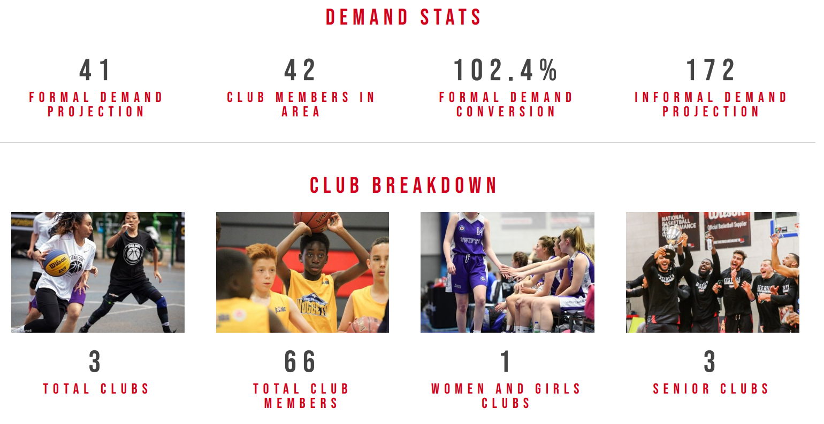  Supply:  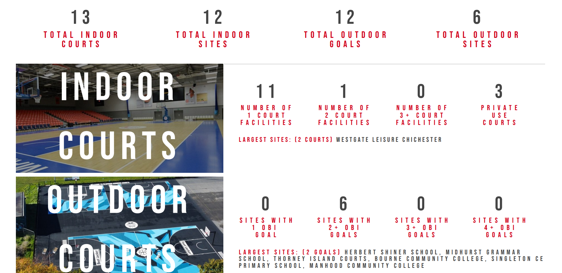  Supply and Demand Analysis  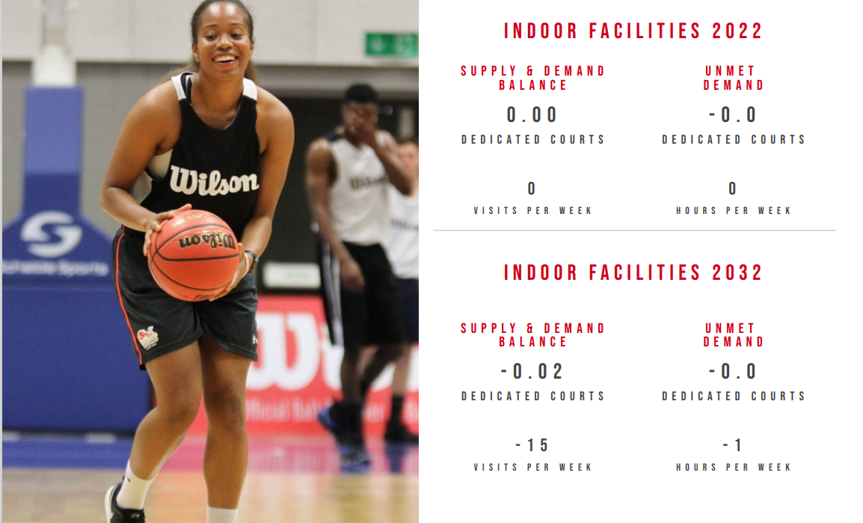  Strategic Ambition  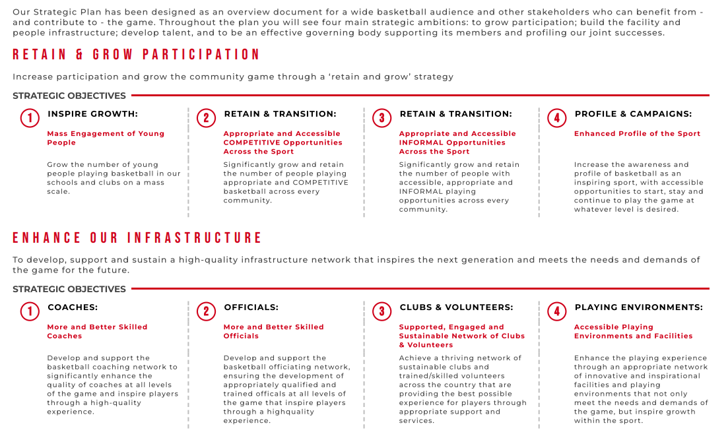
 | 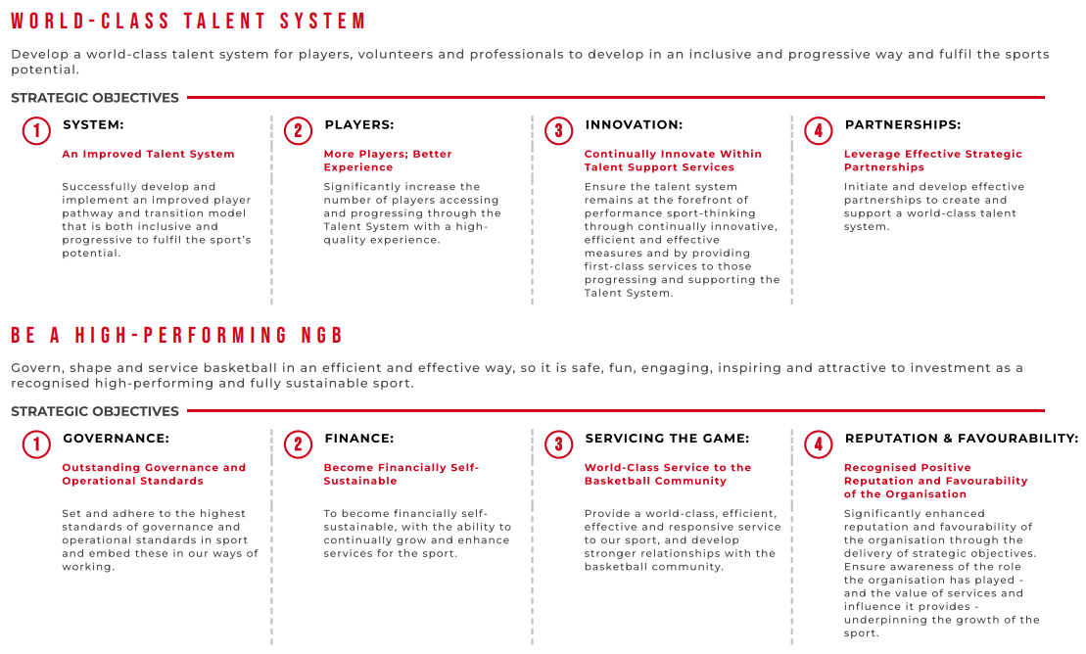
England Table Tennis | - Who are your key clubs and what do they deliver for your sport?  We currently have no Associated clubs and no Affiliated clubs in the Chichester LA. We do have sixty-five paid members who reside in the area. *  - What are your NGBs / Organisations current priorities in the Chichester District Council area?  There is currently enough provision for Table tennis in the area.  - What might be required to support your priorities in the coming years?  With the reduction in suitable indoor facilities and the increase in rental charges, facilities remain the single biggest issue for our clubs nationwide.  - What long term plans or developments do you have in mind/in progress?  Chichester sits in an area earmarked for future development especially in Junior and Women’s & Girls participation. This will require improved facility provision if this is to take place.  - Do you have access to funds to support your plans and developments across the Chichester District Council area? If yes, please provide further details.  We do not have any existing funding we are able to supply for facility development at present.  - NGB has not identified any clubs but has members in the area. North Mundham Village Hall provides table tennis facilities and is home to a table tennis league on Wednesdays,  - Fernhurst and Midhurst Table Tennis Club have four teams in the Haslemere and District Table Tennis League. Play at Fernhurst Village Hall.
Swim England | - There is a good supply of water space in the district  - Lots of private water provision  - The FPM may identify a small deficit in provision but because of the high level of private provision locally there is no rationale for increasing the amount of pay and play water space in the district  - Westgate LC pool facilities are a key priority – need to maintain this provision – yes to refurbishment or replacement if needed. Yes to putting a boom across the main pool so that it can be used for competition. If the swim club are not keen on this then the Council needs to decide whether to do it anyway. The boom will create a separate area of water that could be used for swim lessons if there is a business case for it. Could infill some of the depth. Boom would only need to be 1m wide.  - If they decide to replace Westgate LC, then you would not need anything bigger than an 8 lane 25m main pool, but 6 lane would suffice.  - Had a brief discussion about some of the private pool facilities. Oakwood school is an outdoor pool with a cover over. He was not sure whether Highfield and Brookham School pool is used by clubs. I said that it was only used by the school for private swim lessons for the community.  - Pool development in neighbouring boroughs. There is Portsmouth and the university pool. Arun District Council are well provided for but no new facilities as far as Swim England are aware. There is a masterplan with Homes England for Horsham and Crawley in relation to new housing provision in Ifield, including a sports hub with small community pool. However, this is some distance from the boundary with Chichester DC.  - Overall – Chichester is a low priority area for Swim England.
England Athletics | There are 0 outdoor synthetic 400m facilities located in Chichester Additionaly, there are 2 further facilities: Outdoor Grass 400m track - Seaford College : SE (APP) Facility reference: 1011383 CompactTrack - University of Chichester - Bishop Otter Campus (Private access only): SE (APP) Facility reference: 100887.  Chichester is reasonably we l served by the neighbouring competition facility at Portsmouth (Mountbatten Centre) Outdoor Competition Facilities: 40 minute drivetime.  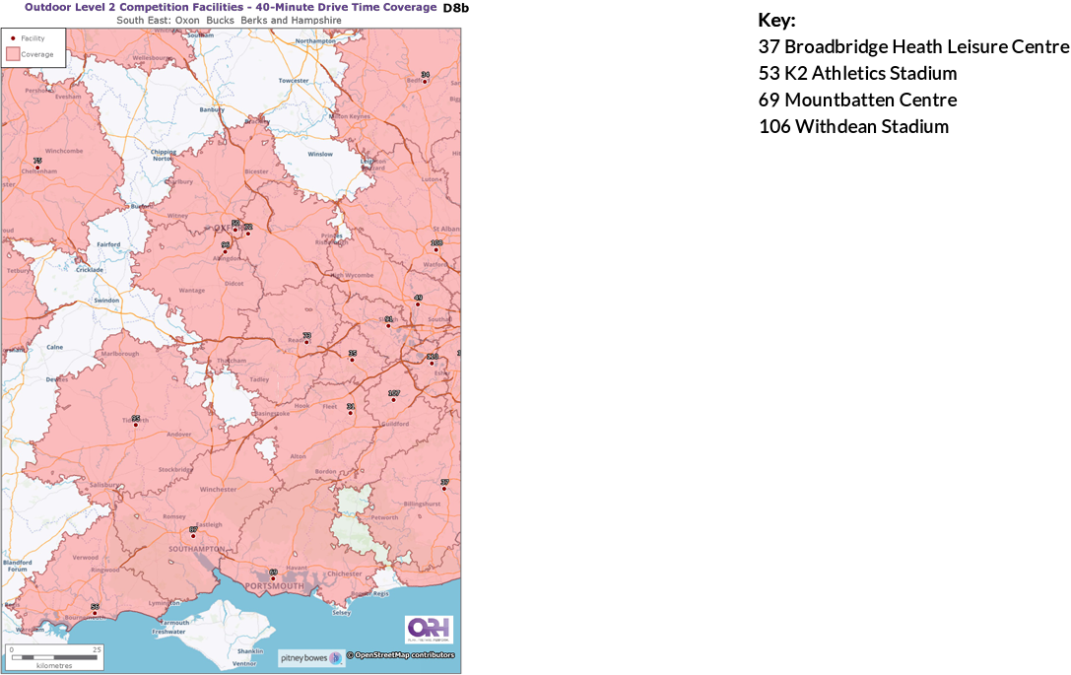  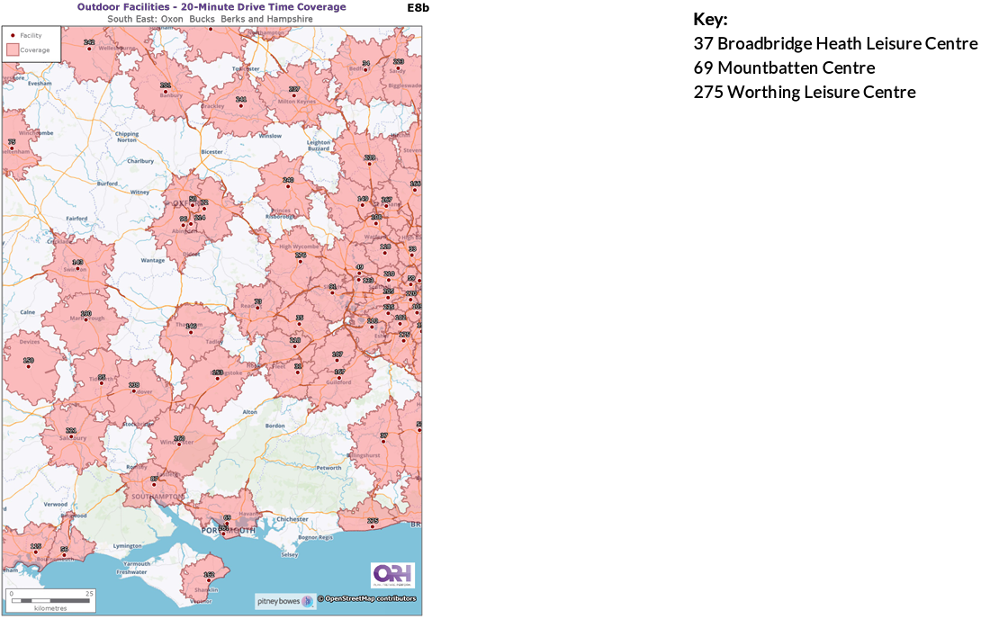  There are currently no formal, publicly accessible athletics/running facilities in Chichester and there are significant population catchments in the local authority that sit outside England Athletics' recommended 30minute drivetime (rural). Total Chichester population sitting outside EAs 30minute drivetime catchment = 105,658 / 86% (ORH report 2022) Preferred location(s): Chichester/Midhurst/Selsey/East & West Wittering.  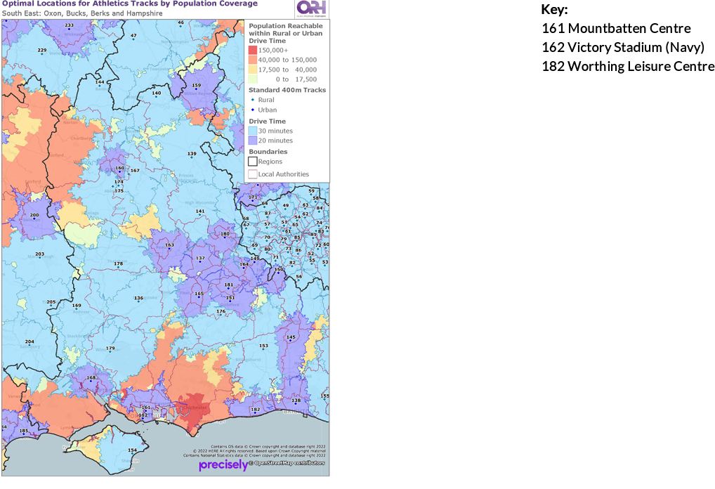  Sport England 30 minute Access Report:  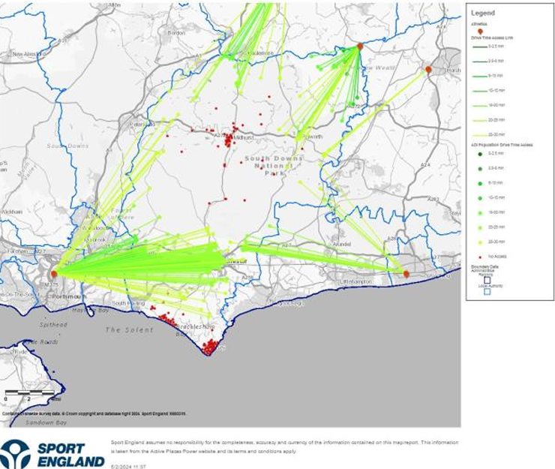  Club Name Category Region County Postcode 2023/24 (Inc. 15 Month)  Chichester Runners & AC Track and Field and Off Road South East Sussex PO19 1SB 131  Inspire Runners Chichester Off Track Only South East West Sussex PO19 1RJ 37  Midhurst Milers Off Track Only South East Sussex GU29 9HD 98  NewGen priority area  EAs mapping shows that there is demand for a NewGen facility(s) in the Chichester area. The type of NewGen facility should be shaped and assessed on local demand and insight  As a priority area EA has already provided seed funding and design support for the proposed NewGen track at Chichester College: 300m athletics training track 60m sprint straight Floodlighting Perimeter fencing

