Appendix 6: Chichester District – School Consultation Analysis

There were a total of 21 school that responded to the online survey. The schools are listed below. The map illustrates the location of the schools in relation to the district. The schools that responded covered an area of 603.7 km²:
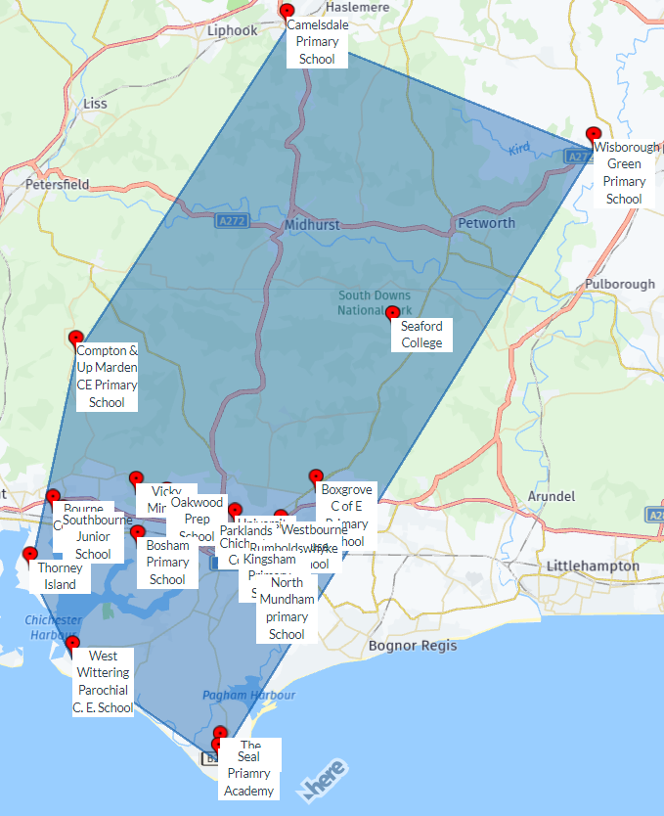
 | Name of school / college: | Postal Code:
 | Chichester College | PO19 1SB
 | Camelsdale Primary School | GU27 3RN
 | Oakwood Prep School | PO18 9AN
 | Bosham Primary School | PO18 8QF
 | Rumboldswhyke School | PO19 7UA
 | Thorney Island | PO10 8DJ
 | Compton & Up Marden CE Primary School | PO18 9EZ
 | Boxgrove C of E Primary School | PO18 0EE
 | Kingsham Primary School | PO19 8BN
 | Vicky Minton | PO18 8DR
 | Westbourne House School | PO20 2BH
 | University of Chichester | PO19 6PE
 | Southbourne Junior School | PO10 8JX
 | Seaford College | GU28 0NB
 | The Academy, Selsey | PO20 9EH
 | Bourne Community College | PO10 8PJ
 | Seal Priamry Academy | PO20 0BN
 | Parklands C P School | PO19 3AG
 | North Mundham primary School | PO20 1LA
 | Wisborough Green Primary School | RH14 0EE
 | West Wittering Parochial C. E. School | PO20 8AJ

School Type:

Age group of students:

Does your school / college have an indoor sports facility?

The schools / colleges that DO (green flags) and DO NOT (red flags) have an indoor facility are mapped below:

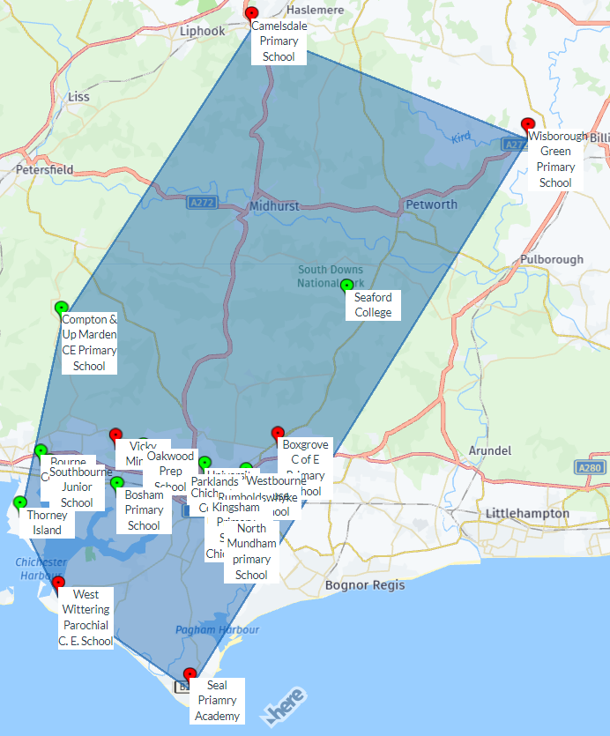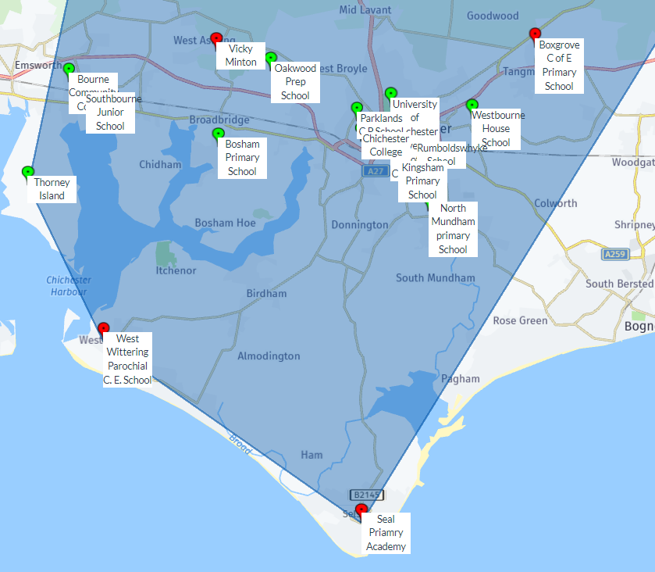
Please complete the following questions to record information about the sports facilities on your school site

Summary:

 |  | Facility Overview
Name of school / college | Post Code | Sports Hall | Swimming Pool | Squash Courts | Dance / Exercise Studios | Fitness Suites? | Indoor Tennis Court(s)? | Athletics Tracks
Chichester College | PO19 1SB | Yes | No | No | Yes | Yes | No | No
Camelsdale Primary School | GU27 3RN | No | No | No | No | No | No | No
Oakwood Prep School | PO18 9AN | Yes | Yes | No | No | No | No | No
Bosham Primary School | PO18 8QF | Yes | No | No | No | No | No | No
Rumboldswhyke School | PO19 7UA | Yes | No | No | No | No | No | No
Thorney Island | PO10 8DJ | Yes | No | No | No | No | No | No
Compton & Up Marden CE Primary School | PO18 9EZ | Yes | No | No | No | No | No | No
Boxgrove C of E Primary School | PO18 0EE | No | No | No | No | No | No | No
Kingsham Primary School | PO19 8BN | Yes | No | No | No | No | No | No
Vicky Minton | PO18 8DR | No | No | No | No | No | No | No
Westbourne House School | PO20 2BH | Yes | Yes | Yes | Yes | No | No | No
University of Chichester | PO19 6PE | Yes | No | No | Yes | Yes | No | Yes
Southbourne Junior School | PO10 8JX | Yes | No | No | No | No | No | No
Seaford College | GU28 0NB | Yes | Yes | No | Yes | Yes | Yes | No
The Academy, Selsey | PO20 0LY | Yes | No | No | No | No | No | No
Bourne Community College | PO10 8PJ | Yes | No | No | Yes | No | No | No
Seal Primary Academy | PO20 0BN | No | No | No | No | No | No | No
Parklands C P School | PO19 3AG | Yes | No | No | No | No | No | No
North Mundham primary School | PO20 1LA | Yes | No | No | No | No | No | No
Wisborough Green Primary School | RH14 0EE | No | No | No | No | No | No | No
West Wittering Parochial C. E. School | PO20 8AJ | No | No | No | No | No | No | No
Do you have this facility - Sports Hall?

Overview

The schools that have a sports hall supplied the following information:

Name of school / college | Quantity: | Is there community use of the hall ? | If there is community use, which teams / organisations use the facility, and what activities do they use it for? | Is there secured community use* of the sports hall | Is there 'pay and play' use of the facility?
Chichester College | 4 | Yes | Chichester City football, Sussex Laddies football, Chichester rugby club, Whyke United football, Chichester Baptist church table tennis, Kaman Martial arts. | Yes | Yes
Oakwood Prep School | 0 | No |  | Don't know | Yes
Bosham Primary School | 1 | No |  | No | No
Rumboldswhyke School | 1 | Yes | Assemblies, clubs and lunches | Don't know | No
Thorney Island | 1 | No |  | No | No
Compton & Up Marden CE Primary School | 1 | Yes | Film Club, private parties, The Octagon Parish | Yes | No
Kingsham Primary School | 2 | No |  | Yes | No
Vicky Minton | 0 | No |  | No | No
Westbourne House School | 4 | Yes | Chichester Badminton Club Various 5-aside football clubs Bognor Archery Club Various cricket clubs Occasional use by several netball clubs | Yes | No
University of Chichester | 4 | Yes | Community club bookings - typically activity groups and/or clubs | No | Yes
Southbourne Junior School | 1 | No |  | No | No
Seaford College | 7+ | Yes | Girl guides |  | No
The Academy, Selsey | 4 | Yes | Selsey FC (youth & mens) - football Sama Karate - karate Selsey badminton - badminton Hit & Miss - badminton Chris Williams dance - dance Walking football Selsey cricket club - cricket | Yes | No
Bourne Community College | 4 | Yes | Community use for Badminton and other indoor bookings | Don't know | Don't know
Parklands C P School | 1 | Yes | Fitness club, Band practice, Rugbytots | Yes | No
North Mundham primary School | 1 | Yes | Judo | No | Yes

Do you have this facility – Swimming pool?

Overview

The schools that have a swimming pool supplied the following information:

Name of school / college | If yes, what are the dimensions of the pool? | Is there organised use of the pool? | If there is community use, which teams / organisations use the facility, and what activities do they use it for? | Is there secured community use* of the sports hall | Is there 'pay and play' use of the facility?
Oakwood Prep School | 4m x 7m | Yes | Chichester swim school own the pool | Don't know | Don't know
Westbourne House School | 25 x 9m | Yes | Tangmere Primary School - Tuition BJ Sports - Tuition Arun Swimmers - Tuition Arun Swim School - Tuition Chichester Cormorants- Tuition West Dean Primary School - Tuition Medmerry Primary School - Tuition Portfield School - Tuition RNLI - Safety training | Yes | No
Seaford College | 45 x 60 | Yes | Girl guides | No | No
West Wittering Parochial C. E. School |  | Yes | Not used for community | No | No

Do you have this facility – Squash courts?

Overview

The schools that have a squash court supplied the following information:

Name of school / college | Quantity | Are they glass backed? | Is there organised use of the courts? | If there is community use, which team / organisations use the facility? | Is there secured community use* of the courts? | Is there 'pay and play' use of the facility
Westbourne House School | 2 | Yes | Yes | Yes - Westbourne Squash Club | Yes | No

Do you have this facility – Dance / Exercise Studios?

Overview

The schools that have a studio supplied the following information:

Name of school / college | Quantity | Is there organised use of the studios? | If there is community use, which team / organisations use the facility? | Is there secured community use* of the studios?* | Is there 'pay and play' use of the facility?‘
Chichester College | 1 | No |  | Yes | Yes
Westbourne House School | 1 | Yes |  | No | No
University of Chichester | 1 | No |  | No | Yes
Seaford College | 2 | Don't know |  | Don't know | No
Bourne Community College | 1 | Yes | Fitness classes through the Everyone Active leisure centre | Don't know | Don't know

Do you have this facility – Fitness Suite?

Overview

The schools that have a fitness suite supplied the following information:

Name of school / college | Is there organised use of the suite? | If there is community use, which team / organisations use the facility? | Is there secured community use* of the suite?* | Is there 'pay and play' use of the facility?‘
Chichester College | Yes | General Public | Yes | Yes
University of Chichester | Yes | No community use. used for staff and students primarily. External users under the supervision of staff/students use the facilty as part of the education process. | No | Yes
Seaford College | No |  | No | No

Do you have this facility – Tennis Court?

Overview

The only school/college that has an indoor tennis court is Seaford College, but they did not provide any information on quantity, quality or surface.

Do you have this facility – Athletics Track?

Overview

The only school/college that has an athletics track is Chichester College, but they did not provide any information on quantity, quality or surface.

Please state the main COMMUNITY users’ gender and age group:

Please state the main SCHOOL users’ gender and age group:(if you do not have a certain facility please select the N/A in the N/A column)

WEEKDAY USE by the SCHOOL:(please tick all that apply - if you do not have a specific facility please select N/A)

WEEKDAY USE by the COMMUNITY:(please tick all that apply - if you do not have a specific facility please select N/A)

WEEKEND USE by the SCHOOL:(please tick all that apply - if you do not have a specific facility please select N/A)

WEEKEND USE by the COMMUNITY:(please tick all that apply - if you do not have a specific facility please select N/A)

If there are sports facilities on the school site that are hired out, please provide the fees charged (please select N/A if the school does not have the type of facility specified)

Are there changing rooms available for the community when using the facilities?

If yes, how would you rate the changing facilities which serve the facility?

How would you rate the overall quality of your indoor sports facilities?

If there is currently no use of the sports facilities by the local community, would the school / college consider allowing community use in the future?

If no, what is the main reason?(please tick all that apply)

- no facilities onsite | - Don’t have authorisation | - We are located on a military base and other facilities are available.
- We don't have a facility that can be hired out | - We don't have the facilities
Are there any current plans to provide new sports facilities in the future?

Are there any current plans to provide sport facilities or improve existing school / college sports facilities in the future?

Are these facilities additional to current facilities provided, or are they new facilities to replace existing ones?

When will the project be completed?

How is the project being funded?(please tick all that apply)

Please use this space to record any other comments you wish to make:

School | Comments
Oakwood Prep School | Investment in sports facilities particularly astroturf is desperately needed
Boxgrove C of E Primary School | The school doesn't have a space onsite that is suitable to deliver the national curriculum for PE indoors. We use a classroom sized space for gathering the whole school together - this space is not large enough for a whole class PE lesson
University of Chichester | A consultant has already visited. We primarily support University education activities and University sport, however there is some hired community use in the available times when not used for university business. We have responded to 'sportshall' as the traditional sportshall facility. We also have a sports dome, which has additional 'indoor' facilities.
Southbourne Junior School | Bourne Community College and Everyone Active Leisure Centre is very close to us
Bourne Community College | Our space is shared with the leisure centre so we do not have the use of the sports hall for all curriculum time
Wisborough Green Primary School | We are a small Primary School with a tiny school hall as our only indoor facility that is used for everything including school lunches as a canteen. We did have a swimming pool but it is decommissioned as required so much work and upgrading that we cannot afford.

