Appendix 7: Chichester District - Sports Club Consultation Analysis

There were a total of 12 clubs that responded to the online survey. The clubs are listed below. The map illustrates the location of the clubs in relation to the district. The clubs that responded covered an area of 1082.6 km2:

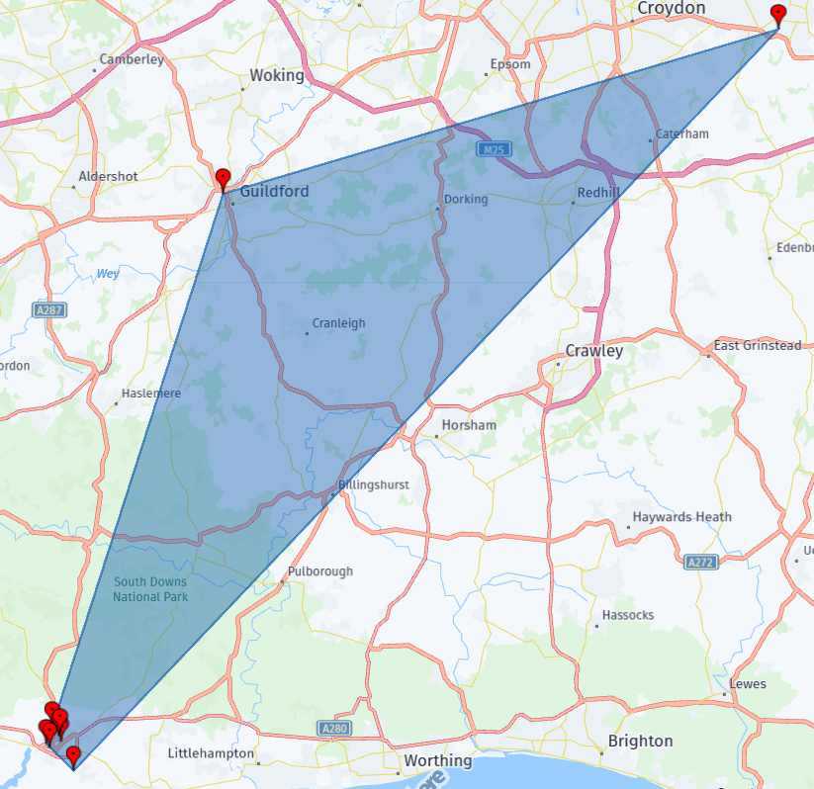

|  |  |  |  |
| --- | --- | --- | --- |
|  | **Club Name:** |  | **Postcode of club** |
|  | Chichester City Youth | Futsal | PO19 5DL |
|  | Chichester Bowling Club | Bowls | PO19 INS |
|  | Chichester Cormorants Swimming Club | Swimming | PO19 3HA |
|  | Chichester Aikido Club | Martial Arts | PO19 7XY |
|  | North Mundham Table Tennis Club | Table Tennis | PO20 1LA |
|  | Chichester Racquets & Fitness Club | Squash | PO19 6AR |
|  | Chichester racquets and Fitness Club | Tennis | PO19 6AR |
|  | Virtus Leisure | Tennis | BR6 9SA |
|  | Guildford Sabres Handball Club | Other | GU1 1AA |
|  | Chichester Netball League | Netball |  |
|  | Spirit Netball Chichester (previously Bears Netball) | Netball | PO19 6PE |
|  | Chichester Ronin Judo Club | Judo | PO19 7XY |
|  | Westgate Gymnastics | Gymnastics | PO19 1RJ |

**Please identify your clubs sport from the list below:**

**Name and postcode of your most used venue:**

|  |  |  |
| --- | --- | --- |
| **Club name** | **Venue** | **Postcode** |
| Chichester City Youth | University of Chichester | PO19 6PE |
| Chichester Bowling Club | Chichester Bowling Club | PO19 1NS |
| Chichester Cormorants Swimming Club | WEstgate Leisure Centre | PO19 1RJ |
| Chichester Aikido Club | Westgate Leisure centre | PO19 7XY |
| North Mundham Table Tennis Club | North Mundham Village Hall | PO20 1LA |
| Chichester Racquets & Fitness Club | Chichester Racquets & Fitness Club | PO19 6AR |
| Chichester racquets and Fitness Club | Chichester Racquets and Fitness CLub | PO19 6AR |
| Virtus Leisure | Bromley Tennis Centre | BR6 9SA |
| Guildford Sabres Handball Club | Chichester Uni Dome | PO19 6PE |
| Chichester Netball League | Chichester University | P019 6PR |
| Spirit Netball Chichester (previously Bears Netball) | University of Chichester | PO19 6PE |
| Chichester Ronin Judo Club | New Park Centre | PO19 7XY |
| Westgate Gymnastics | Westgate Leisure Centre | PO19 1RJ |

The locations of the clubs most used venues are mapped below:

**Please identify the number of active playing members in your club:**

Of the clubs that specified ‘other’ or ‘over 80’ their numbers are as below:

* 130
* 200-250
* 1600
* 16 teams with a minimum of 7 players per team
* 250-280

**Please specify how many paid coaches you have:**

The three clubs that ‘have 5 or over’ two they specified that all coaches are volunteers, with one club saying that they had 10 paid coaches.

**Please specify the number of volunteers in your club:**

Numbers of listed volunteers by the clubs are:

* 30
* approx 40
* 12

**Has the number of playing members increased over the last 5 years?**

**Is the number of club members likely to increase / decease over the next 5 years?**

**Please provide a reason for the increase / decrease:**

‘Other’ reasons for an increase/decrease in club numbers include:

* Covid reduced numbers now junior numbers are increasing
* More junior teams in the area
* Positive impact due to netball being televised more at the elite level
* We are a new junior club and attracting new players all of the time

**Is your club currently at full member capacity based on your current facility size?**

**Please tell us how many junior members you have aged 18 and under:**

**Please tell us the number of male and female members you have under the age of 18 and over the age of 18:**

**Does the facility you identify in Q3 fully suit your club's needs?**

**Please rate the facility or facilities you identified in Q3 as good, standard or poor.**

**Please tell us why you rated this facility good, standard or poor?**

**How many hours a week does your club use this facility?**

**Which days does your club use this facility?**

**Please tick all months your club uses this facility:Please tick all that apply**

**Please rate the relationship your club has with the facility owner/management:**

**How could this relationship be improved?**

**Please briefly provide us with your club's current and near future priorities e.g. increasing members, improving performance, etc.**

**Please use the space below for any other comments you may have:**

| **Club** | **Comment** |
| --- | --- |
| Chichester Cormorants Swimming Club | The facility is not suitable for a competitive swimming club, no 25m pool inadequate lane ropes, not enough pool time, no spectator area, not suitable for competitions, very high high rates. Pool often too hot, Sessions often cancelled due to pack of lifeguards. |
| Guildford Sabres Handball Club | The continued closure of the edge sports centre in Haslemere leaves us with only options of inside M25, Chichester, Haywards Heath or Southampton. Currently Chichester is the most cost competitive one and good for availability. |
| Chichester Netball League | The facilities and staff at the University are excellent but they don't have enough courts for the amount of teams we currently have |
| Spirit Netball Chichester (previously Bears Netball) | We are a very new club so growing in numbers and performance level. It is hard not being certain that the university timetable will allow us to continue our booking and parking is not great. But otherwise we are very happy. |
| Chichester Ronin Judo Club | We are happy with our current Dojo - However a more social area that could be adapted for Competition viewing would improve our community feel and ability to put bigger Area events on. |
| Westgate Gymnastics | We run our club independently but we also manage and run 4 hours of the Leisure centres classes for them. We do source a lot of equipment through our club and also source the coaches and mentor them which we use to also deliver the centres class for them. Although we are always replacing and buying things for both the classes to use - this is of course added to wear and tear to our costings.  We do oblige in doing this as the whole ethos of our club is to provide every child the experience of taking part in gymnastics. But sometimes it would be nice to have support when replacing the bigger apparatus rather than solely ourselves. We are looking to replace a beam in a few months but we will be purchasing this ourselves - although the centre will also be using it. |