Appendix 8: Chichester District - Parish/Town Council Consultation Analysis

The parish/town councils (22) that responded to the online survey are listed below; the map below illustrates the location of the parish/town councils in relation to the district of Chichester.

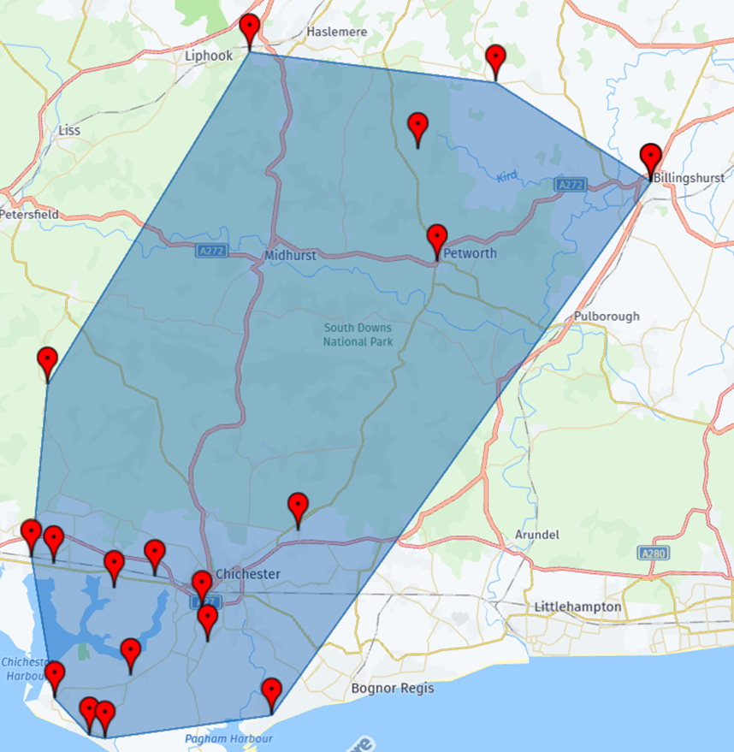

|  |  |  |
| --- | --- | --- |
|  | **Parish/Town Council Name** | **Postcode** |
|  | Birdham Parish Council | PO20 7HA |
|  | Bosham | PO18 8QF |
|  | Boxgrove | PO18 0EE |
|  | Chidham and Hambrook Parish Council | PO18 8FY |
|  | Donnington Parish Council | PO198RT |
|  | Earnley Parish Council | PO20 8DN |
|  | East Wittering Bracklesham | PO208HU |
|  | Ebernoe | GU28 9LE |
|  | Fishbourne | PO18 8BE |
|  | Funtington Parish | PO18 9HD |
|  | Hunston | PO20 1AW |
|  | Kirdford | RH14 4DE |
|  | Lynchmere | GU27 3QW |
|  | North Mundham | PO20 8DN |
|  | Petworth | GU28 0AP |
|  | Plaistow & Ifold Parish Council | RH14 0PX |
|  | Sidlesham Parish Council Parish Council | PO21 4QA |
|  | Southbourne | PO10 8HN |
|  | Stoughton Parish | PO18 9HD |
|  | West Itchenor | PO18 8FY |
|  | West Wittering Parish Council | PO20 8LT |
|  | Wisborough Green | RH14 0WT |

Of the 22 responses, 19 (83%) indicated that they have indoor sports facilities (including community halls). Whereas 5 (22%) said that they did not:

The tables below will look at and give a summary of the indoor sports facilities (including community halls) that each parish/town council has; including the number, location and quality of each of the facilities.

**Site 1:**

| **Parish/town council** | **Facility name** | **Parish/Community Halls (suitable for at least low impact physical activity)** | | **Sports Hall (3 badminton courts or more):** | | **Activity Hall (less than 3 badminton courts):** | | **Fitness Suites** | | **Changing rooms** | |
| --- | --- | --- | --- | --- | --- | --- | --- | --- | --- | --- | --- |
| **Number of facilities/ courts** | **Quality of facilities/ courts** | **Number of facilities/ courts** | **Quality of facilities/ courts** | **Number of facilities/ courts** | **Quality of facilities/ courts** | **Number of fitness stations** | **Quality of fitness stations** | **Number of changing rooms** | **Quality of changing rooms** |
| Birdham Parish Council | Birdham Village Hall | 1 | Unsatisfactory |  |  |  |  |  |  |  |  |
| Bosham | Bosham Village Hall | 1 | Satisfactory |  |  |  |  |  |  |  |  |
| Boxgrove | Boxgrove Village Hall | 1 | Satisfactory |  |  |  |  |  |  |  |  |
| Chidham and Hambrook Parish Council | Chidham Village Hall | 1 | Satisfactory |  |  |  |  |  |  |  |  |
| Donnington Parish Council | Donnington Parish Hall | 1 | Excellent | 1 | Good |  |  |  |  |  |  |
| East Wittering Bracklesham | Bracklesham Barn | 1 | Excellent |  |  |  | Excellent | 2 | Excellent | 2 | Excellent |
| Fishbourne | The Fishbourne Centre | 1 | Excellent |  |  |  |  |  |  |  |  |
| Funtington Parish | West Ashling Village Hall | 1 |  |  |  |  |  |  |  |  |  |
| Hunston | Hunston Village Hall | 1 | Satisfactory |  |  |  |  |  |  | 1 | Unsatisfactory |
| North Mundham | North Mundham Village Hall | 1 | Good |  |  |  |  |  |  |  |  |
| Plaistow & Ifold Parish Council | Winterton Hall | 1 | Good |  |  |  | Good |  |  |  |  |
| Sidlesham Parish Council Parish Council | Sidlesham Memorial Recreation Hall | 1 | Good |  |  |  |  |  |  | 2 | Good |
| Southbourne | No Details Given |  |  |  |  |  |  |  |  |  |  |
| Stoughton Parish | None - Just One Village Hall With No Sports | 1 | Unsatisfactory |  |  |  |  |  |  |  |  |
| West Itchenor | Itchenor Memorial Hall | 1 | Good |  |  |  |  |  |  |  |  |
| West Wittering Parish Council | No Details Given |  |  |  |  |  |  |  |  |  |  |
| Wisborough Green | Wisborough Green Village Hall | 1 | Good |  |  |  | Good |  |  |  |  |

**Site 2:**

| **Parish/town council** | **Facility name** | **Parish/Community Halls (suitable for at least low impact physical activity)** | | **Sports Hall (3 badminton courts or more):** | | **Activity Hall (less than 3 badminton courts):** | | **Fitness Suites** | | **Changing rooms** | |
| --- | --- | --- | --- | --- | --- | --- | --- | --- | --- | --- | --- |
| **Number of facilities/ courts** | **Quality of facilities/ courts** | **Number of facilities/ courts** | **Quality of facilities/ courts** | **Number of facilities/ courts** | **Quality of facilities/ courts** | **Number of fitness stations** | **Quality of fitness stations** | **Number of changing rooms** | **Quality of changing rooms** |
| Boxgrove | Boxgrove Pavilion |  |  |  |  |  |  |  |  | 1 | Unsatisfactory |
| East Wittering Bracklesham | Downview Hall | 1 | Excellent | 1 | Excellent | 2 | Excellent |  |  |  |  |
| North Mundham | Pavilion | 1 | Excellent |  |  |  |  | 2 | Satisfactory |  |  |
| Plaistow & Ifold Parish Council | Kelsey Hall | 1 | Excellent | 1 | Excellent |  |  |  |  |  |  |
| Wisborough Green | Scout Hut | 1 | Satisfactory |  |  |  |  |  |  |  |  |

**Site 3:**

|  |  |  |  |  |  |  |  |  |  |  |  |
| --- | --- | --- | --- | --- | --- | --- | --- | --- | --- | --- | --- |
| **Parish/town council** | **Facility name** | **Parish/Community Halls (suitable for at least low impact physical activity)** | | **Sports Hall (3 badminton courts or more):** | | **Activity Hall (less than 3 badminton courts):** | | **Fitness Suites** | | **Changing rooms** | |
| **Number of facilities/ courts** | **Quality of facilities/ courts** | **Number of facilities/ courts** | **Quality of facilities/ courts** | **Number of facilities/ courts** | **Quality of facilities/ courts** | **Number of fitness stations** | **Quality of fitness stations** | **Number of changing rooms** | **Quality of changing rooms** |
| East Wittering Bracklesham | East Wittering Village Hall | 1 | Satisfactory |  |  |  |  |  |  |  |  |
| Wisborough Green | Sports Pavilion | 1 | Unsatisfactory |  |  |  |  |  |  | 2 | Unsatisfactory |

**Site 4:**

|  |  |  |  |  |  |  |  |  |  |  |  |
| --- | --- | --- | --- | --- | --- | --- | --- | --- | --- | --- | --- |
| **Parish/town council** | **Facility name** | **Parish/Community Halls (suitable for at least low impact physical activity)** | | **Sports Hall (3 badminton courts or more):** | | **Activity Hall (less than 3 badminton courts):** | | **Fitness Suites** | | **Changing rooms** | |
| **Number of facilities/ courts** | **Quality of facilities/ courts** | **Number of facilities/ courts** | **Quality of facilities/ courts** | **Number of facilities/ courts** | **Quality of facilities/ courts** | **Number of fitness stations** | **Quality of fitness stations** | **Number of changing rooms** | **Quality of changing rooms** |
| East Wittering Bracklesham | United Reform Church | 1 | Good |  |  | 1 | Good |  |  |  |  |

**Please list below all changing facilities (for the above) in significant need of improvement**

|  |  |
| --- | --- |
| **Parish/town council** | **Comment** |
| Birdham Parish Council | No changing facilities available at Birdham |
| Boxgrove | Boxgrove Pavilion |
| East Wittering Bracklesham | None |
| Hunston | 1 set of changing rooms with archaic showers that dont function well |
| North Mundham | Home and Away Changing Rooms and a Referee Room |
| Plaistow & Ifold Parish Council | No changing facilities other than public toilets |

**Please use this box to comment on any potential facility developments within your Parish area**

| **Parish/town council** | **Comment** |
| --- | --- |
| Birdham Parish Council | Birdham would like to add allotments as an outdoor facility |
| Boxgrove | Boxgrove Pavilion has completed stage 1 of a renovation project and now needs funding for stage 2 |
| East Wittering Bracklesham | None |
| Funtington Parish | none |
| Hunston | The Parish Council will be looking at options to build a new community hall going forwards. |
| North Mundham | N/A |
| Sidlesham Parish Council Parish Council | Improvements to the football pitches at Sidlesham Memorial Recreational Ground and improvements to the Hall. |
| West Itchenor | No developments expected |
| Wisborough Green | Replacement sports pavilion required. Planning application with CDC but yet to be determined. |

**Please use this box to comment on any other information relating to the sports and leisure facilities/needs in your Parish area**

| **Parish/town council** | **Comment** |
| --- | --- |
| Birdham Parish Council | Bitrdham would like to add allotments, complete the all weather path (both of which encourage outdoor exercise) and install the active travel hub at the end of Church Lane with associated information board and bicycle parking to encourage cycling and walking. |
| Earnley Parish Council | The nearest sports and leisure facilities are within the adjoining parishes, these are private entities and are very expensive to join. The nearest affordable facilities in Chichester which is a 14 mile round trip and is not accessible. Neither options are accessible via public transport for residents in the parish. |
| East Wittering Bracklesham | As many people do not have the ability to travel into Chichester and with Harbour Way Country Club closing a local gym is needed |
| Ebernoe | There are facilities for Cricket and Stoolball in Ebernoe, |
| Fishbourne | There are numerous outdoor facilities: tennis, croquet, bowls, cricket and football. The football changing facilities could be improved. |
| Funtington Parish | Village Hall in poor repair |
| Kirdford | Current plan for a new sports pavilion (previous burned down). Also revamp of separate cricket pavilion. |
| Petworth | Here in Petworth we have been asking for additional sports and leisure facilities for many years. We have two small playgrounds (swings, slides, etc) and we have an outdoor sports ground which is used extensively by cricketers of all ages in the summer months, and by footballers of all ages in the winter months. We also have a private tennis club. For those who just want to enjoy time outdoors, our facilities are lacking. We would very much like to construct a Multi-Use Games Area for the community of all ages to use, which is located within the Petworth boundary. We would very much appreciate if this could be considered within your plans. Thank you. |
| Sidlesham Parish Council Parish Council | For the Sidlesham Memorial Recreational Hall and Grounds we are looking at new floodlights, heating within the hall and resurfacing of the car park area. |
| Wisborough Green | Additional sports playing pitches due to popularity of sport, particularly for children. |