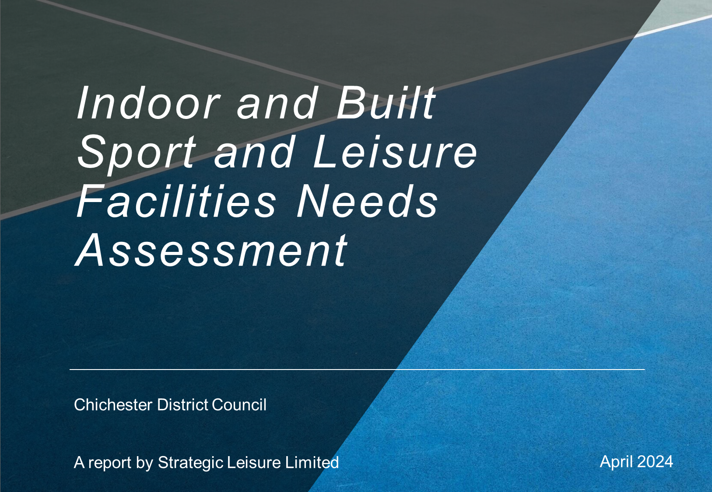
Table of Contents

Glossary of Terms i

1 Executive Summary 1
Recommendations 3
Overall Recommendations 3

2 Introduction and purpose 11

3 Methodology 1
Sports and Geographical Scope 1
Supply and Demand for built leisure facilities 6
Overview of the Facilities Planning Model (FPM) 6
Catchment Areas 7
Community Pay and Play Access 7

4 Chichester District Context 8
Introduction 8
Local population profile 8
Future development in the District 10
Key Demographics 14
Participation in Physical Activity 17
Physical activity - adults 18
Physical activity – children and young people 20

5 Strategic Policy and Context 22
Introduction 22
National Strategy 22
Regional and Local Strategies 27

6 Stage B - Existing Facility Provision 28
Introduction 28
Supply of Built Leisure Facilities in Chichester District 28
Operational Management of Chichester District Leisure Facilities 29
Assessment of Existing Sports Facility Provision 30
BSLNA Consultation 33
Schools’ Consultation 33
Objectives of Consultation 33
Sports Club Consultation 36
Objectives of Consultation 36
Parish Council Consultation 38
National Governing Boady Consultation (NGB) 40
Neighbouring Local Authorities 40
Assessment of Individual Built Leisure Facilities - Stage B 45

Sports Halls and Activity Halls - Assessment Summary Stage B 45
Provision in 2024 48
Sports Halls and Activity Halls - Quantity 48
Sports Halls and Activity Halls - Quality 60
Quality Ratings 60
New Activity Halls and Refurbishments since 2017 66
Sports Hall and Activity Hall Demand in 2024 67
Survey Responses (Education Institutions, Sports Clubs and Parish Councils) 67
National Governing Bodies (NGBs) 69
Facility Planning Model (FPM) Findings 72
Key Findings 72
Sports Halls and Activity Halls - Accessibility 73
Sports Hall and Activity Hall - Availability 77
Provision Requirements by 2039 78
Stage C 80

Swimming Pools - Assessment Summary Stage B 83
Swimming Pools - Provision in 2024 85
Swimming Pools - Quantity 85
Swimming Pools: Quality 92
Swimming Pool Demand in 2024 95
Consultation 95
Survey Responses (Education Institutions, Sports Clubs) 95
Sports Clubs (Swimming Clubs) 96
Parish and Town Councils 96
National Governing Bodies (NGBs) 96
Swim England 96
Facility Planning Model (FPM) Findings 98
Executive Summary 98
Swimming Pools - Accessibility 99
Swimming Pools: Availability 101
Provision Requirements by 2039 102
Stage C 103

Health and Fitness – Assessment Summary Stage B 107
Health and Fitness - Provision in 2024 109
Fitness Suites - Quantity 109
Fitness Suites: Quality 114
Fitness Suite Demand in 2024 116
Consultation 116
National Governing Bodies (NGBs) 117
Fitness Suites: Accessibility 117
Fitness Suites: Availability 119
Commercial Gyms 119
Outdoor Gyms 119
Provision Requirements by 2039 120

Fitness Studios 121
Fitness Studios: Quantity 121
Fitness Studios - Quality 125
Fitness Studios - Accessibility 126
Fitness Studios - Availability 128
Provision Requirements by 2039 128
Health and Fitness Stage C 128
Stage C 128

Other Sports and Facilities Stage B 130

Athletics - Assessment Summary Stage B 130
Provision in 2024 131
Athletics - Quantity 131
Athletics - Quality 134
Demand in 2024 134
Consultation 134
National Governing Bodies (NGBs) 136
Athletics - Accessibility 138
Athletics - Availability 138
Provision Requirements by 2039 138
Stage C 139

Indoor Bowls - Assessment Summary Stage B 139
Provision in 2024 140
Bowls - Quantity 140
Indoor Bowls - Quality 141
Demand in 2024 141
Consultation 141
NGB – England Indoor Bowls Association 142
Indoor Bowls - Accessibility 143
Indoor Bowls - Availability 143
Provision Requirements by 2039 143
Stage C 143

Squash - Assessment Summary Stage B 144
Provision in 2024 145
Squash - Quantity 145
Squash - Quality 148
Demand in 2024 148
Consultation 148
NGB – British Squash 149
Squash - Accessibility 149
Squash - Availability 151
Provision Requirements by 2039 151
Stage C 151

Indoor Tennis – Assessment Summary Stage B 151
Provision in 2024 152
Indoor Tennis – Quantity 152
Indoor Tennis – Quality 154
Demand in 2024 154
Consultation 154
National Governing Body – The Lawn Tennis Association 155
Outdoor/Indoor Tennis 155
Indoor Tennis 156
Tennis - Accessibility 156
Tennis - Availability 156
Provision Requirements by 2039 156
Stage C 157

Gymnastics – Assessment Summary Stage B 158
Provision in 2024 159
Gymnastics – Quantity 159
Gymnastics - Quality 160
Demand in 2024 160
Consultation 160
National Governing Body – British Gymnastics 161
Gymnastics - Accessibility 161
Gymnastics – Availability 162
Provision Requirements by 2039 162
Stage C 162

Martial Arts – Assessment Summary Stage B 162
Provision in 2024 164
Martial Arts – Quantity 164
Martial Arts – Quality 166
Demand in 2024 166
Consultation 166
Martial Arts - Accessibility 167
Martial Arts - Availability 167
Provision by 2039 167
Stage C 167

Boxing – Assessment Summary Stage B 168
Provision in 2024 169
Boxing – Quantity 169
Boxing - Quality 169
Demand in 2024 170
Consultation 170
National Governing Body – England Boxing 170
Boxing - Accessibility 170
Boxing – Availability 171
Provision Requirements by 2039 171
Stage C 171

Rifle Shooting – Assessment Summary Stage B 172
Provision in 2024 173
Rifle and Pistol Shooting – Quantity 173
Rifle and Pistol Shooting - Quality 173
Demand in 2024 173
Consultation 173
Survey Responses (Education Institutions, Sports Clubs, Parish and Town Councils) 173
National Governing Body – National Small-bore Rifle Association (NSRA) 174
Rifle and Pistol Shooting - Accessibility 174
Rifle and Pistol Shooting – Availability 174
Provision Requirements by 2039 175
Stage C 175

7 Recommendations – Stage D 176
Overall Recommendations 176

Tables

Table 1: Chichester District Population Breakdown by Parish Council 8
Table 2: Chichester District Emerging Local Plan - Total Housing Requirement and Supply 2021 – 2039 10
Table 3: Chichester District Strategic Development Locations for future housing growth 11
Table 4: South Down National Park Local Plan - Total Housing Requirement in Chichester Parishes 13
Table 5: Summary of Chichester District Demographic Profile 15
Table 6: Levels of Physical Activity - Adults 16+ years 18
Table 7: Levels of Physical Activity - Children and Young People 20
Table 8: Facility Types in Chichester (Active Places Power 2024 baseline data updated) 28
Table 9: Chichester District - Respondent Schools 34
Table 10: Additional Club Feedback - Chichester District Sports Club Survey 38
Table 11: Additional Feedback – Chichester District Parish and Town Council Survey 39
Table 12: Summary of Neighbouring Local Authority Consultation 40
Table 13: Sports halls Assessment Summary 45
Table 14: Supply of Sports Halls in Chichester District 50
Table 15: Summary of Sports Halls in Chichester District 53
Table 16: Supply of Activity Halls in Chichester District 54
Table 17: Summary of Activity Halls in Chichester District 59
Table 18: Quality rating scale (from Sport England guidance) 60
Table 19: Summary of the qualitative Assessment of Sports Halls in Chichester District 61
Table 20: Summary of the qualitative Assessment of Activity Halls in Chichester District 64
Table 21: Summary of activity hall refurbishment and new build projects since 2017 – Chichester District 66
Table 22: Summary of relevant Survey Responses – Education Institutions and Sports Clubs 67
Table 23: Feedback from National Governing Bodies of Sport – Chichester District 69
Table 24: Summary of School Sports Facilities – Community Use 77
Table 25: Sports Facility Calculator (SFC) – Chichester District Sports Halls 79
Table 26: Identified need for sports hall provision 81
Table 27: Key issues, Impacts, and Implications by Facility Type – Sports Halls 81
Table 28: Swimming Pools - Assessment Summary 83
Table 29: Supply of Swimming Pools in Chichester District 88
Table 30: Analysis of Swimming Pool Supply in Chichester District 91
Table 31: Strategic Size Swimming Pools in Chichester District 91
Table 32: Quality ratings 92
Table 33: Summary Qualitative Assessments of the Strategic Size Swimming Pools (the quality score is not just for the swimming pool) 93
Table 34: Education Institutions with pools who responded to survey 95
Table 35: Survey responses from Education Institutions with pools 95
Table 36: Summary of School Sports Facilities – Private/Community Use (Club/Sports Association) 101
Table 37: Sports Facility Calculator – Chichester District swimming 102
Table 38: Identified need for swimming pool provision 104
Table 39: Key Issues, Impacts, and Implications by Facility Type 104
Table 40: Summary of Facility Investment Priorities 105
Table 41: Health and Fitness - Assessment Summary 107
Table 42: Analysis of overall Fitness Suite Provision in The Chichester District 112
Table 43: Summary of Fitness Suite Size 112
Table 44: Fitness Suites in the Chichester District 113
Table 45: Quality ratings 115
Table 46: Summary Qualitative Assessments – Health and Fitness Facilities (Fitness suites only) 115
Table 47: Chichester District Council, Community Accessible and comparable priced fitness facilities 117
Table 48: Chichester District Council, community accessible and comparable priced facilities 120
Table 49: Fitness Studios in Chichester District 123
Table 50: Analysis of overall Studio Supply – the Chichester District 125
Table 51: Summary of Quality Assessments of Studios in the Chichester District 125
Table 52: Identified need for health and fitness provision 128
Table 53: Key Issues, Impacts, and Implications by Facility Type 129
Table 54: Summary of Facility Investment Priorities 129
Table 55: Athletics Tracks- Assessment Summary 130
Table 56: Athletics Clubs in the Chichester District 132
Table 57: Identified need for athletics provision 139
Table 58: Bowls Greens - Assessment Summary 139
Table 59: Bowls Clubs in the Chichester District 140
Table 60: Squash - Assessment Summary 144
Table 61: Squash Court Facilities in the Chichester District 145
Table 62: Qualitative assessment of squash courts – Chichester District 148
Table 63: Tennis - Assessment Summary 151
Table 64: Indoor Tennis Facilities in the Chichester District 154
Table 65: Indoor Tennis Courts – Quality Assessment 154
Table 66: Gymnastics – Assessment Summary 158
Table 67: Key Gymnastics Club in Chichester district and facilities used 159
Table 68: Martial Arts Assessment Summary 162
Table 69: Martial Arts Clubs using the Park Community Centre, Chichester 164
Table 70: Venues hired/used by Martial Arts Club – Chichester District 165
Table 71: Boxing – Assessment Summary 168
Table 72: Key Boxing Clubs in Chichester district and facilities used 169
Table 73: Rifle Shooting – Assessment Summary 172
Table 74: Key Rifle Shooting Clubs in Chichester district and facilities used 173

Maps

Map 1: Chichester District – Sub Areas and Parishes Map 2
Map 2: Chichester District – Strategic Development Locations 12
Map 3: Chichester District Council Inactivity Map 2020/2021 LSOA 19
Map 4: Sports Halls by Facility Access Type in Chichester District 52
Map 5: Activity Halls by Access Type Chichester District 58
Map 6: Sports Halls with Pay and Play or sports club/association use with a 20 minute drive and 10 minute walk catchment in Chichester District 75
Map 7: Activity Halls with Pay and Play or sports club/association use with a 20 minute drive and 10 minute walk catchment in Chichester District 76
Map 8: Swimming Pools by Access Type 87
Map 9: Swimming Pool with Pay and Play with 10 minute walk time and 20-minute public transport travel time catchment areas 100
Map 10: Fitness Suites in Chichester District by Facility Access Type 111
Map 11: Community access Fitness Suites within a 20-minute drive time and 10 minute walk catchment area 118
Map 12: Location of Studios in Chichester District by Access Type 122
Map 13: Studios community access with a 20 minute drive and 10 minute walk catchment 127
Map 14: Athletics Tracks in the Chichester District 133
Map 15: Proposed Athletics Track – Chichester College 135
Map 16: Optimal Locations for Athletics Track by Population Coverage – Chichester District 137
Map 17: Squash Courts by Facility Access Type in Chichester District 147
Map 18: Squash 20 minute drive and 10 minute walk catchments – Chichester District 150

Figures

Figure 1: Map of West Sussex illustrating Chichester District 11
Figure 2: ANOG Stages 4

Appendices

Appendix 1: Chichester District Policy and Strategic Context
Appendix 2: Chichester District Detailed Facilities Audit
Appendix 3: Chichester District Built Leisure Facilities Audits
Appendix 4: Chichester District NGB Responses
Appendix 5: Chichester District Neighbouring Authority Responses
Appendix 6: Chichester District Schools Consultation Analysis
Appendix 7: Chichester District Sports Club Consultation Analysis
Appendix 8: Chichester District Parish and Town Council Consultation Analysis
Appendix 9: Chichester District Stakeholder Consultation
Appendix 10: Chichester District Facility Planning Model (FPM) Sports Halls
Appendix 11: Chichester District Facility Planning Model (FPM) Swimming Pools
Appendix 12: Chichester District New/Refurbished Built Facility Projects Completed since 2017
Appendix 13: Chichester District Current Health and Fitness Demand 2024
Appendix 14: Chichester District Future Health and Fitness Demand 2039

Glossary of Terms

Terms | Explanation
Accessibility | Who can access the facility i.e. is it membership only, pay and play, clubs only, private, as well as the physical accessibility.
Affordable Fitness Facilities | These are fitness facilities which may be in the public, private or voluntary sectors, which offer similar prices as those operated by Chichester District Council; these facilities are therefore considered to be accessible, and potentially comparatively affordable, providing for at least some of the community, in a way that membership only facilities may not.
Assessing Needs and Opportunities Guidance (ANOG) | The Sport England guidance on preparing and developing needs assessments for built sports facilities, which provides the evidence to support a Local Plan.
Availability | When the facility is actually open e.g. dual use facilities are only available (generally) for community use when a school is NOT using them.
BSLNA | Built Sport and Leisure Needs Assessment
Catchment area | The area from which a facility draws usage; typically, this is 20 mins drivetime for swimming pools, fitness and sports halls.
Comfort Factor | A tool used in developing the BSLNA. If a swimming pool is over 70% full, it is getting too busy to actually be able to swim in it.
Community Use | A facility has community use if it is open for use by sports clubs/community groups and pay and play use (use by individuals in the community).
Community Use Agreement (CUA) | A CUA is a formal agreement between an education facility and a Local Authority (and sometimes also Sport England) for community use of a sports facility on an education site out of school hours.
Chichester District Council | Chichester District Council means the entirety of the geographic area for which Chichester District Council is responsible.
Facility Planning Model (FPM) | The FPM is a facility modelling toolkit, developed by Sport England to inform the current and future need for provision of sports halls and swimming pools
LPA | Local Planning Authority
National Planning Policy Framework (NPPF) | The NPPF sets out the Government’s planning policies and how they are expected to be applied. It covers both plan -making and development management.
Pay and Play | Sports facilities which are available for use by the general public; facilities can be booked by individuals or groups, without membership necessarily being required.
Peak Period | A tool used in developing the BSLNA; this helps estimate the capacity of a built facility i.e. how full is a facility during peak periods (the peak period for each facility is identified before the FPM is run)
Quality | Quality of the facility and ancillary provision e.g. changing, toilets.
Quantity | How many facilities – what, where, who manages.
School Lettings | A school open for lettings provides community access but these tend to just be for clubs/groups i.e., pre-organised groups as opposed to individual pay and play use.
SDNPA | South Downs National Park Authority
Sports Facility Calculator (SFC) | The SFC is a facility modelling toolkit, developed by Sport England to calculate the future need for provision ofsports halls, swimming pools and indoor bowls, based on a specified population increase in an identified location.  The Sports Facility Calculator (SFC) provides a quantitative estimate of future need, but unlike the FPM the SFC model analysis does not identify specific locations for future provision. That needs to be informed by the nature and location of future housing development (where locations are known), local geography and accessibility, and, critically, the location of existing facilities.  This is because future demand may have the potential to be addressed through facility extension, or refurbishment, as well as new locations. However, in the absence of any other future demand calculator, the SFC provides an indicator of the level of future provision needed. The SFC can be applied to the same facilities as those modelled in the FPM, but it is important to highlight that the SFC does not identify need, which can only be established by applying the information regarding demand from new housing to the findings and recommendations of the evidence in a Built Facility Strategy (BFS).
Strategic Size | Strategic size refers to either a sports hall of minimum 3 badminton courts, or a pool of a minimum 160 sqm. These are definitions used by Sport England in the FPM. Any sports hall less than 3 badminton court size is likely to be excluded from the FPM unless it is on an education site, where, if a main hall provides for community use, the smaller hall will be included in FPM modelling. SLL take account all halls in our supply and demand assessments.
Supply and Demand Assessment | The process of comparing facility supply against identified demand for provision.
vpwpp | Visits per week in the peak period

Executive Summary

- The purpose of this Built Sport and Leisure Needs Assessment (BSLNA) Study is to:

- Identify current and future built sport and leisure provision required to meet the needs of Chichester District residents. The outputs of this assessment will contribute to planning policy development of Chichester District Council’s emerging Local Plan (2021 – 2039) and a robust up to date evidence base.
- Review the current and future supply and demand for built sport and leisure facilities in Chichester District.
- Model the demand to assess the current and projected over/under supply of facilities using a recognised modelling technique that satisfies the requirements of Sport England e.g. Facilities Planning Model (FPM).
- Inform the development and delivery of built sports and leisure facilities across the district. The BSLNA focusses on facility provision in the context of the health and wellbeing of local communities.
- Provide conclusions and recommendations on policy and proposed development.

- At the request of Chichester District Council and in accordance with National Planning Policy Framework (NPPF) transitional arrangements, the emerging Local Plan will be examined under the September 2023 version on the NPPF. This study has therefore been undertaken in accordance with the requirements of the September 2023 version of the NPPF and not the latest version which was updated 19 December 2023.

- This study is also undertaken in accordance with Planning Policy Guidance 17 July 2021 (PPG17) and Sport England’s Assessing Needs and Opportunities Guidance 2014 (ANOG) as set out in Figure 1 (ANOG).

- The Sport England Assessing Needs and Opportunities Guidance (ANOG) no longer requires the application of the standards for built facilities as applied in the previous Chichester Indoor Sports Facilities Assessment July 2018. The application of standards is seen to be too simplistic a tool to look at in isolation, without considering proximity to similar facilities in neighbouring areas and authorities, the geography and rurality of a district, and what is needed for public space to become accessible.

- The BSLNA includes a quantitative, qualitative, accessibility and availability analysis of the following facilities which are owned by the public (including education), private and third sectors:

- Swimming pools – indoor and outdoor (lidos);
- Sports halls and appropriate school and local community facilities;
- Activity Halls;
- Health and fitness facilities i.e. fitness suites and studios;
- Indoor bowls;
- Facilities catering for martial arts, boxing, indoor rifle/pistol shooting
- Indoor tennis; and
- Athletics facilities.

- The BSLNA provides robust and up to date evidence to support the policies of Chichester’s emerging Local Plan (2021 – 2039) and underpins future policies for provision. Recommendations from the BSLNA will inform the Vision, Strategic Objectives and Neighbourhood/Site Allocations of the emerging Local Plan. The BSLNA will ensure the continued provision of an appropriate level of sustainable built sport and leisure assets to meet the needs of the population of Chichester District both now and over the Local Plan period.

- The context for the assessment and its consequent recommendations set out below includes the demographic profile of the district, relevant national and local policy and strategy. Key to informing need for future provision is that:

- The population of Chichester District is projected to increase from 123,297 in 2020 (latest ONS dataset which gives a breakdown by parish) to 134,604 in 2039. Plans for appropriate new open space, sport, and leisure infrastructure will to be required, together with improved quality and access to existing provision to meet the needs of the growing population.
- In 2021 the number of people aged 65 accounted for 27% of the Chichester District population and this is expected to rise to 35.8% by 2039. This will put pressure on health and caring services, particularly in rural areas where access to transport, services and everyday activities is difficult.
- There is a lack of opportunity for young people to move into or remain in the Local Plan area because the housing stock is dominated by larger, more expensive properties.
- 25.8% of adults in the Chichester District are inactive; this is higher than for the West Sussex region (24%) but comparable with the England average (25.8%). Inactivity levels of adults in the Chichester District had been significantly higher in 2019/20 at 30.2%, then reduced down to 19.6% during the Covid Pandemic, but appear to be beginning to rise again.
- Only 9.2% of adults in the Chichester District are fairly active; this is lower than both regional (11.2%) and national (11.1%) averages. However, the percentage of adults in the Chichester District who are active and participate in at least 150 minutes of exercise a week is comparable to the West Sussex region and better than the national average.
- Activity levels for children and young people in the Chichester District are very positive with only 18% less active (less than 30 minutes of exercise a day); this is significantly lower than for regional (26%) and national (31%) averages. It should be noted however that no data for Chichester is available after 2019/20.
- 22.5% of reception pupils (4/5 years) in the Chichester District are classified as overweight/obese. This is comparable to the England average. By the time pupils reach Year 6 (10/11 years), 36.3% are classified as overweight/obese. This is better than the England average of 37.8%.
- Chichester District is the least densely populated of the South East’s 64 local authority areas. This reflects the rural nature of the district. 67% of the district is also located within the South Downs National Park where additional constraints are placed upon new development.
- Approximately 13% of households in the Chichester District have no access to a car. This is lower than for West Sussex (16%) and England averages (23%). However, for those without a vehicle, access to services is a challenge, particularly if living in rural areas outside of the East West Corridor sub area of the Chichester District Council Local Plan.
- Residents of the district have good life expectancy; for males this is 80.1 years and 84.5 years for females. This is in line with South East averages and slightly higher than the national averages.
- Chichester is a prosperous area but income and health inequalities do exist. There are no Lower Layer Super Output Areas (LSOAs) within Chichester district in the 20% most deprived nationally.
- Chichester Local Community Network Area priorities (April 2023) include access to services, particularly transport in rural areas; reducing social isolation, particularly for young people and older people; and addressing the health impact of the cost of living crisis.

Recommendations

- Based on the detailed assessment, the following recommendations are made for both the overall future approach to indoor and built sport and leisure provision and the specific types of provision needed in the future.

Overall Recommendations

Recommendation 1 (R1)

The existing levels of community accessible (including pay and play) sports hall, swimming pool and fitness provision in the district are retained as a minimum, but these need not necessarily be the same facilities as at present.

(PROTECT)

Recommendation 2 (R2)

Chichester District Council and all its partners identify the level of capital funding required to address the identified investment needs for sports facilities, and investigate all available sources for capital funding, on a partnership basis. To support this process, it is recommended to Active Sussex.

(PROVIDE)

Recommendation 3 (R3)

Chichester District Council and its partners prioritise investment in the development of high-quality community sports facilities/spaces. Increasing available capacity and therefore opportunities to take part in regular physical activity, in the local community, will contribute to improved health and wellbeing, increased participation and better community cohesion.

(PROVIDE AND ENHANCE)

Recommendation 4 (R4)

Where appropriate, Chichester District Council and its partners seek to secure developer contributions from strategic developments that could contribute towards the development/refurbishment of strategic facilities, additional and safe walking, running, and cycling routes, and where possible to open up other informal, multipurpose places and spaces where people can be active.

(PROVIDE AND PROTECT)

Recommendation 5 (R5)

There should be on-going monitoring of this Strategy through its implementation, but as a minimum, progress should be reviewed and refreshed every five years. On-going monitoring should include partnership working with neighbouring local authorities to keep aware of facility changes and developments.

(PROTECT)

Recommendations for specific facility types by 2039

Recommendation 6 Sports Halls and Activity Halls

Facility Type | Facility Need by 2039 | Location
Sports Halls and Activity Halls | Recommendation 6a (R6a)  Provision of new and refurbishment/replacement of existing ageing facilities – potentially through planning obligations  (PROVIDE) | Westgate Leisure Centre (6 badminton court hall); the replacement of this facility has significant potential linked to location with high demand and proximity to areas of high deprivation within the district where need is greatest.  Any replacement sports hall on site should be designed to accommodate indoors sports at both recreational and club/competition level.  Refurbishment of activity halls and/or associated changing accommodation at Birdham Village Hall, Hunston Village Hall, Stoughton Parish Hall, and Boxgrove Pavilion  Where new housing developments generate 500 or more people, a needs assessment will be undertaken by the Council to determine what small scale activity halls/spaces are required if any, proportionate to the size of development, taking into consideration the geography and rurality of an area, and proximity to other similar existing provision within the catchment area,
 | Recommendation 6b (R6b) Introduction of formal Community Use Agreements to improve and extend community access at educational sites where facilities are currently hired out to sports clubs/organisations.  (PROVIDE AND ENHANCE) | Highfield and Brookham School, located within the SDNP. This could be linked to school’s long term plans to rebuild the dryside sports facilities on site.  Bishop Luffa C of E School  Chichester High School  Midhurst Rother College  Seaford College  The Academy Selsey  University of Chichester (Bishop Otter Campus)  Westbourne House Boarding School
 | Recommendation 6c (R6c) Introduction of formal Community Use Agreements (CUAs) as a planning requirement for all new/replacement sports facility applications on educational sites.  (PROVIDE AND ENHANCE) | District wide

Recommendation 7 Swimming Pools

Facility Type | Facility Need by 2039 | Location
Swimming Pools | Retention and further modernisation of Westgate Leisure Centre has the greatest importance. Potentially increase in pool scale on replacement. | Westgate Leisure Centre, Chichester
 | In the short term, increasing opening hours at both Westgate pools would help to alleviate capacity challenges.
 | Consider if there is any reduction in supply of swimming pools in neighbouring authorities which will reduce access for Chichester residents and increase unmet demand.
 | Consider if there is any projected population growth in Chichester in the future, particularly in one area or on the borders of the district.

Recommendation 8 a - b Fitness Suites and Studios

- There is no identified need for additional fitness suite provision within the Chichester District.

Facility Type | Facility Need by 2039 | Location
Fitness Suites | Recommendation 8a (R8) Retain existing level of fitness suite provision.  (PROTECT) | District wide
Studios | Recommendation 8b (R8) Invest in additional studio provision or multi-purpose space which can be used for group exercise amongst other activities as the population grows. | Identified Strategic Development Locations for new housing – Chichester District Council Local Plan 2021 – 2039, and the South Downs National Park Local Plan (2019 – 2033) where a sustainable business case can be evidenced, and no other similar provision exists within the immediate catchment area.

Recommendation 9 (R9) Athletics

Facility Type | Facility Need by 2039 | Location
Athletics | Recommendation 9 (R9) Support provision of a NewGen track at Chichester College to serve the local community.  (PROVIDE) | Chichester College preferred location or alternatively Midhurst, Selsey, East and West Wittering.

Recommendation 10 (R10) Indoor Tennis

- There is no evidence identified for a new dedicated indoor tennis facility.

Facility Type | Facility Need by 2039 | Location
Indoor Tennis | Recommendation 10 (R10) Chichester District Council should progress and conclude negotiations with Chichester Racquets and Fitness Club regarding the provision of a permanent indoor tennis hall to replace the temporary seasonal cover currently used on site, subject to a sustainable business case and in return for secured community pay and play access to some of the tennis courts at the club including those catering for Padel and Pickleball.  (PROVIDE) | Chichester Racquets and Fitness Club

Indoor Bowls

- There is no evidence identified as to the need for a new indoor bowls facility.

Squash

- There is no evidence identified as to the need for additional squash court provision.

Recommendation 11 (R11) Gymnastics

- There is no evidence identified as to the need for additional specialist gymnastics facilities.

Facility Type | Facility Need by 2039 | Location
Gymnastics | Recommendation 11 (R11) Existing levels of community accessible gymnastics provision should be retained and support given to facilitating club-led development of dedicated gymnastics facilities to help increase capacity.  (PROTECT AND ENHANCE) | East-West Corridor demand and population densities are high.  Westgate Gymnastics Club (Westgate Leisure Centre) and Southbourne Gymnastics Club (Bourne Leisure Centre) currently using non-dedicated facilities.

Recommendation 12 (R12) Martial Arts

- There is no identified need for additional provision of new specialist Martial Arts facilities in the Chichester District.

Facility Type | Facility Need by 2039 | Location
Martial Arts | Recommendation 12 (R12) Existing levels of community accessible martial arts facilities should be retained and extended where possible, utilising existing non-dedicated spaces for hire, to support the growth of the sport within the district.  (PROTECT AND ENHANCE) | South Downs National Park – Midhurst Rother College, the Grange Community and Leisure Centre  North of the Plan Sub Area

Recommendation 13 (R13) Boxing

- There is no identified need for a new dedicated boxing facility within the Chichester District.

Facility Type | Facility Need by 2039 | Location
Boxing | Recommendation 13 (R13) Existing levels of boxing facilities should be retained and support given to facilitating club led development of community accessible boxing facilities to help support the growth of the sport within the district  (PROTECT AND ENHANCE) | District wide

Recommendation 14 (R14) Rifle Shooting

- There is no identified need for additional provision of specialist rifle shooting in the Chichester District.

Facility Type | Facility Need by 2039 | Location
Rifle Shooting | Recommendation 14 (R14) Existing levels of community accessible rifle shooting facilities should be retained and support given to facilitating club led development of outdoor rifle shooting facilities to help increase capacity.  (PROTECT AND ENHANCE) | Chichester Rifle and Shooting Club – Chichester City

Introduction and purpose

  - Chichester District Council started the Local Plan review in June 2017. This is a review of the current Local Plan adopted in 2014 and will set out the vision for the future development of the district to 2039.

  - The current Local Plan highlights the important contribution that sport and leisure can make to the health and wellbeing of communities (Policy 54) and refers to indoor sports facilities as including swimming pools, leisure centres, and sports facilities provided in community centres and schools.

  - The National Planning Policy Framework (NPPF) September 2023 requires Local Planning Authorities to set out policies to enable communities to access high quality open spaces an opportunities for sport and recreation. It requires Local Planning Authorities to base their planning policies on robust and up to date assessments of the needs for sport and recreation facilities and opportunities for new provision.

Figure 1: Map of West Sussex illustrating Chichester District

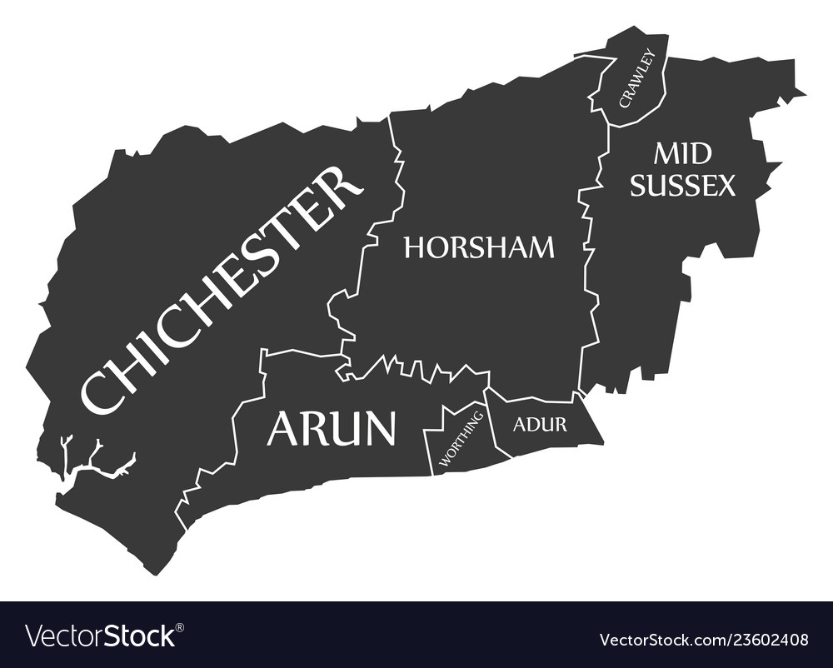

  - This study has been undertaken in accordance with the requirements of the September 2023 NPPF, Planning Policy Guidance 17 July 2021 (PPG17) and Sport England’s Assessing Needs and Opportunities Guidance 2014 (ANOG) throughout.

  - The Sport England Assessing Needs and Opportunities Guidance (ANOG) no longer requires the application of the standards for built facilities as applied in the previous Chichester Indoor Sports Facilities Assessment July 2018. The application of standards is seen to be too simplistic a tool to look at in isolation, without considering proximity to similar facilities in neighbouring areas and authorities, the geography and rurality of a district, and what is needed for public space to become accessible.

  - This BSLNA provides robust and up-to-date evidence to support the policies in the Chichester District Council’s emerging Local Plan (2021 – 2039) and underpins future priorities for provision. Recommendations from the BSLNA will inform the Vision, Objectives and Neighbourhood/site allocations of the emerging Local Plan. The BSLNA will ensure the continued provision of an appropriate level of sustainable built sport and leisure assets to meet the needs of the population now and over the Local Plan period.

  - The purpose of this BSLNA is to:

- Identify current and future built sport and leisure provision required to meet the needs of Chichester District residents. The outputs of this assessment will contribute to planning policy development of the emerging Local Plan and a robust up to date evidence base.
- Review the current and future supply and demand for built sport and leisure facilities in Chichester District.
- Model the demand to assess the current and projected over/under supply of facilities using a recognised modelling technique that satisfies the requirements of Sport England e.g. Facilities Planning Model (FPM).
- Inform the development and delivery of built sports and leisure facilities across the district. The BSLNA focusses on facility provision in the context of the health and wellbeing of local communities.
- Provide conclusions and recommendations on policy and proposed development.

Methodology

  - The BSLNA has been developed using the Sport England Assessing Needs and Opportunities Guidance, as set out in Figure 1 (ANOG), published in 2014. This recommends an approach to undertaking a robust assessment of need for facilities to meet the requirements of the NPPF (September 2023).

Sports and Geographical Scope

  - The BSLNA assesses indoor facility provision within the following sub areas of the Chichester District Council’s Local Plan:

- the East-West Corridor (Chichester City, east of the City, West of the city);
- the Manhood Peninsula; and
- the North of the Plan Area (the north east of the district and Hammer/Camelsdale)

  - The BSLNA also incorporates and assessment of indoor facility provision within the South Downs National Park, which accounts for 67% of Chichester District’s geographical area. The South Downs National Park Authority (SDNPA) has its own Local Plan (2014 – 2033, adopted in 2019) and is responsible for all planning decisions relating to the National Park. However, the BSLNA recognises that residents living within and outside the National Park boundary will use indoor facilities nearest to where they live and not based on Local Plan boundary lines. There are also some parish councils that sit both within the South Downs National Park and Chichester District Council Local Plan areas. The BSLNA therefore includes the whole district, whilst recognising that there may be additional planning restrictions affecting the South Downs National Park.

Map 1: Chichester District – Sub Areas and Parishes Map

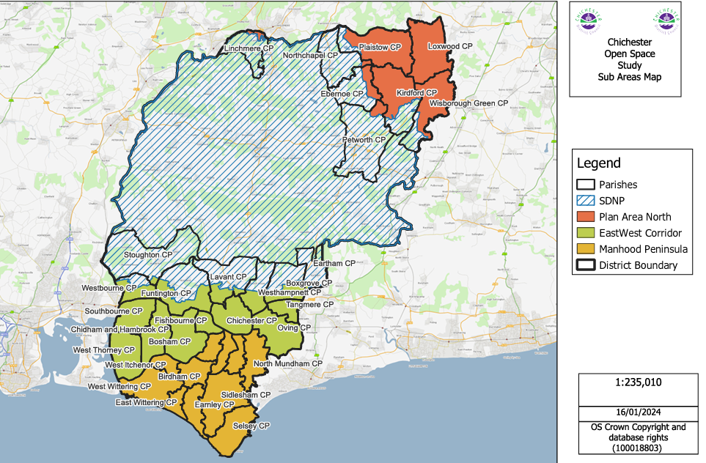
  - Chichester District covers an area of almost 800 km2 and is the largest of the seven districts and boroughs within West Sussex, stretching from the South Coast to the southern border of Waverley and East Hampshire in the north; and from Havant in the west to Arun and Horsham in the east. Over two-thirds of the district lies within the South Downs National Park.

  - The cathedral city of Chichester is the main settlement with a population of around 29,193 and is the principal location for the provision of higher education and shopping facilities. The city is renowned for its cathedral, its historic heritage and university and is the largest centre of employment in the plan area.

  - Outside Chichester city, there are four other significant settlements that accommodate a range of facilities and services:

- East Wittering and Bracklesham Parish has a population of around 4,899. Nearby beaches, especially those of West Wittering, are amongst the best in the Southeast.

- Selsey, at the tip of the Manhood Peninsula, is a town with a population of around 10,668. With one of the largest caravan parks in Europe, the population of the town more than doubles during the holiday season. It is also a focus for commercial activities such as horticulture, fishing and other marine related businesses.

- Southbourne, to the west of Chichester, has a population of around 6,820 and has links to the nearby towns of Havant and Emsworth. Southbourne has several employment opportunities, a railway station, and a secondary school with a relatively modern leisure facility. The community facilities are dispersed throughout the settlement.

- Tangmere, to the east of Chichester city, is a settlement of some 3,158 people. It hosts a number of local businesses and has some dispersed community facilities including shops and a medical centre. However, it currently lacks many of the amenities and services normally associated with a settlement of its size.

  - There are 33 parish councils located within the Local Plan area, including six parishes which are also partly located within the South Downs National Park.

  - The district is dissected east to west by the A259, A27 and A272 cross routes, and north to south by the A286 through Midhurst and A285 through Petworth. North/south routes link with the A3 and the A29 towards the M25. East to west and north to south rail routes service Chichester, connecting with Southampton, Brighton, Horsham, Guildford, Gatwick Airport and London within the wider region.
  - The district’s main sport and leisure facilities are located within the built up areas of the East-West corridor. As the district is mainly rural in nature, access by public and private transport to these facilities can be challenging for those living in North of the Plan Area, the Manhood Peninsula and east of the Corridor.
Figure 2: ANOG Stages
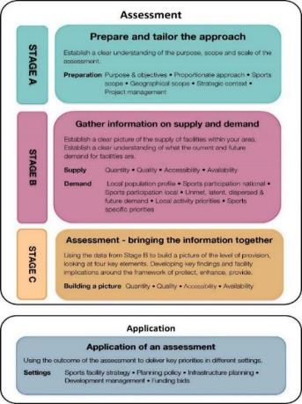
  - The BSLNA includes a Sport England Facility Planning Model (FPM) assessment for both swimming pool and sports hall provision, to look at existing and future facility needs, nature, and location, as well as more detailed spatial analysis.

  - The BSLNA follows the advice set out in paragraph A12 of the ANOG. It states that it is for the local authority to decide what facilities to include in an assessment. However, given their importance, any assessment must include swimming pools and sports halls.

  - The BSLNA includes a quantitative, qualitative, accessibility and availability analysis of the following facilities which are owned by the public (including education), private and third sectors:

- Swimming pools – indoor and outdoor;
- Sports halls and appropriate school and local community facilities;
- Activity Halls;
- Health and fitness facilities i.e. fitness suites and studios;
- Indoor bowls;
- Facilities catering for martial arts, boxing, indoor rifle/pistol shooting
- Indoor tennis; and
- Athletics facilities.

In line with ANOG, the methodology used to develop the BSLNA includes:

- Review of local strategic planning and policy context (Appendix 1)
- Review of the borough’s demographic profile and population growth to understand the significance and impact of this in specific areas
- Site visits to quality audit all identified indoor sites (access was not possible at some sites as documented in Appendix 3)
- Stakeholder consultation (face to face/online meetings)
- Online surveys to schools, sports clubs and parish/town councils (surveys closed for analysis on 5 January 2024)
- Assessment of built leisure facility supply and demand
- Identification of spatial requirements
- Analysis of school, sports club and parish/town council survey feedback (Appendices 6, 7 and 8)
- Analysis of Standard Facility Planning Model (FPM) runs covering current and future provision (sports halls and swimming pools) (Appendices 10 and 11)
- Feedback from stakeholder consultation
- Assessment of all findings and identification of need - current and future built leisure facility provision (what, where)
- Options for addressing and delivering need – spatial analysis, partnerships etc
- Conclusions and Recommendations
- Action Plan

  - It is important to highlight from the outset that this BSLNA is not just about formal sports facility provision, but also looks at opportunities for increased use of informal places and spaces. For example, community halls can be used for sport and physical activity even if they are not purpose designed nor marked for such use. Informal places and spaces can often provide an introductory experience of sport and physical activity, or a more accessible option for those who are older, have difficulty travelling or who have commitments which make it hard for them to travel to formal facilities.

  - Users of sport and leisure facilities do not necessarily recognise administrative boundaries and will use facilities that are convenient and/or provide a quality/value for money experience. Residents within Chichester District may therefore also travel into the adjacent districts and boroughs of Havant, East Hampshire, Waverley, Horsham and Arun to access sport and leisure facilities. The availability of facilities in neighbouring boroughs can and does influence sports facility usage patterns, as does access to private transport and availability of public transport.

  - Similarly, residents will not recognise Local Plan boundaries that exist within a district when choosing a leisure facility for the same reasons outlined in 3.3

Supply and Demand for built leisure facilities

  - The main tools used to inform the assessment of supply and demand are set out below:

- the facility audit (Appendix 2 taken directly from Active Places and used as the baseline data checked and challenged through the site visits);
- quality site visits (Appendix 3);
- demand information gathered through the consultation, surveys and site visits; and
- the Sport England Facility Planning Model (FPM) – this is only used for sports halls of 3 court size and above and swimming pools larger than 160 sq. m.

  - The demand (current and future) for facilities other than sports halls and swimming pools is assessed using National Governing Body (NGB) standards if they are available, plus a combination of local factors e.g. how many existing facilities there are, what is the identified demand from schools, clubs, the community etc, what is available immediately outside the authority boundaries to which people may find it easier to travel.

Overview of the Facilities Planning Model (FPM)

The Facilities Planning Model (FPM) is a computer-based supply/demand model, which has been developed by Edinburgh University in conjunction with Sport Scotland and Sport England since the 1980’s. The model is a tool to help to assess the strategic provision of community sports facilities in an area. It is currently applicable for use in assessing the provision of sports halls, swimming pools, indoor bowls centres and artificial grass pitches.

Use of FPM: Sport England uses the FPM as one of its principal tools in helping to assess the strategic need for certain community sports facilities. The FPM has been developed as a means of:

- assessing requirements for different types of community sports facilities on a local, regional or national scale;
- helping local authorities to determine an adequate level of sports facility provision to meet their local needs;
- helping to identify strategic gaps in the provision of sports facilities; and
- comparing alternative options for planned provision, taking account of changes in demand and supply. This includes testing the impact of opening, relocating and closing facilities, and the likely impact of population changes on the needs for sports facilities.

Its current use is limited to those sports facility types for which Sport England holds substantial demand data, i.e. swimming pools, sports halls, indoor bowls and artificial grass pitches.

The report sets out the findings under seven headings and includes data tables and maps. The headings are defined at the start and include total supply; total demand; supply and demand balance; satisfied/met demand; unmet demand; used capacity (how full the pools are); and local share of pools. Each heading is followed by a commentary on the findings. The purpose of the report is to provide the Chichester District with an updated evidence base for sports halls and swimming pools, which the Council can use to inform its strategic planning for the future provision of these facility types. The full FPM sports hall report and appendices are set out in Appendix 10.

Catchment Areas

  - Catchment areas for different types of facilities provide a means of identifying areas currently not served by existing built leisure facilities. It is recognised that catchment areas vary from person to person, day to day, hour to hour, and are also very different in rural and urban areas. This problem is overcome by accepting the concept of ‘effective catchment,’ defined as the distance travelled by around 75-80% of users. The maps in this assessment reflect the catchment areas for facility provision in the Chichester District. The study uses a 20-minute public transport travel time and a 10 minute walk time as a catchment area for sports facilities (these catchment areas are within guidance parameters suggested by Sport England, were agreed prior to the mapping being undertaken with Chichester District Council and align with the ambition to reduce car use).

Community Pay and Play Access

  - It is important to highlight that community use, and specifically pay and play access is the focus of the BSLNA. Community use applies to clubs, the public and community associations / groups; pay and play community access refers to the public.

  - The latter is really important because those who are inactive are highly unlikely to join a club to use a facility; therefore, it is only by ensuring there is sufficient pay and play community access to formal and informal facilities, that participation is likely to increase. There is also a link between good quality places and spaces in which to be physically active and levels of participation.

  - Community use provided for clubs is also very important, given that club members are also part of the overall community, but these individuals are more likely to be active already.

Chichester District Context

Introduction

- An important element of developing the picture of demand is gaining an understanding of the population characterisation in the Chichester District. It is fundamental to understand the make-up of the population, and in particular what is the demographic profile in age, gender, social class, disability and health as this can impact on the type of built leisure assets required.

Local population profile

- The current and future population profile of Chichester District and the locations of growth are important to understand in relation to planning for the future provision of sport and physical activity.

- The current population of Chichester district is 123,297. Table 1 provides a breakdown of the population by parish council. By 2039, the population is estimated to increase to 134,604 with an estimated 35.8% of the population aged 65 and over. An ageing population of this scale presents challenges for health and caring services, particularly in rural areas where access to transport, services and everyday activities is difficult.

Table 1: Chichester District Population Breakdown by Parish Council

Parish | Population ONS Parish 2020 Estimates | Parish | Population ONS Parish 2020 Estimates
East-West Corridor – Chichester City, East of the City, West of the City
Westbourne | 2287 | Chidham and Hambrook | 1860
Funtington | 1545 | Fishbourne | 2557
Lavant | 1800 | Chichester City | 29193
Westhampnett | 1075 | Oving | 1647
Boxgrove | 964 | Tangmere | 3158
Eartham | 115 | Stoughton | 551
Southbourne | 6820 | West Thorney | 1209
Bosham | 2881 | Total | 57,662
Manhood Peninsula
West Itchenor | 308 | Donnington | 2899
West Wittering | 2559 | Hunston | 1300
Appledram | 211 | Sidlesham | 1241
Birdham | 1625 | North Mundham | 1613
East Wittering and Bracklesham | 4889 | Selsey | 10668
Earnley | 622 | Total | 27,935
North or Area Plan
Petworth | 3098 | Wisborough Green | 1419
Linchmere – including Camelsdaleand Hammer Villages | 2309 | Loxwood | 1610
Plaistowand Ifold | 1995 | Ebernoe | 212
Kirdford | 1063 | Total | 11,706
Within the South Downs National Park – Chichester Parishes
Barlavington | 393 | Marden | 381
Bepton | 226 | Midhurst | 5341
Bignor | 393 | Milland | 909
Bury | 614 | Northchapel | 843
Cocking | 468 | Rogate | 1631
Compton | 381 | Singleton | 490
Duncton | 308 | Stedham with Iping | 820
Easebourne | 1957 | Stopham | 193
East Dene | 196 | Sutton | 393
East Lavington | 302 | Tillington | 507
Fittlewoth | 1000 | Trotton with Chithurst | 346
Graffham | 491 | Upwaltham | 115
Harting | 1429 | West Dean | 426
Heyshott | 295 | West Lavington | 268
Linch | 314 | Woolbeding with Redford | 171
Lodsworth | 628 | Elsted and Treyford | 231
Lurgashall | 564 | Fernhurst | 2970
 |  | Total | 25,994

Future development in the District

- The spatial development strategy for Chichester District’s emerging Local Plan builds upon the previous Local Plan, seeking to disperse development across the Local Plan area by:

- focussing housing growth on Chichester City and within the east-west corridor;
- reinforcing the role of the Manhood Peninsula as a home to existing communities, tourism and agricultural enterprise; and
- where opportunities arise, supporting the village and rural communities in the North of the Plan area.

- Table 2 provides a breakdown of an additional housing requirement of 10,350 for the emerging Local Plan and a housing supply figure of 10,429, of which 6,022 are commitments only and still have their impact to be addressed. This updates the current Local Plan’s figures (2016 – 2036) of 13,679 dwellings of which 4,774 had already had their impact addressed, leaving 8,935 still to be addressed.

Table 2: Chichester District Emerging Local Plan - Total Housing Requirement and Supply 2021 – 2039

 |  |  | Notes
Total housing requirement 2021-2039 |  | 10,350 | B 575 dpa, constrained figure below OAN of 638 due to highway impact
Net housing completions 2021-2023 | 1616
Planning permissions as 1 April 2023 | 2791
‘Commitments’ |  | 4407 | NB. These sources of supply has addressed its impact through CIL/S106
Adopted LP allocations to be delivered 2021-2039 | 2210
Neighbourhood Plan allocations 2021-2039 | 100
Windfall allowance 2021-2039 | 796
Proposed strategic allocations 2021-2039 | 2668
Proposed parish numbers | 248
Supply still subject to CIL/S106 |  | 6022 | NB. These sources of supply have yet to address their impact through CIL/S106*
 |  |  | Buffer no longer applied due to constrained figure
Total Supply 2021 - 2039 |  | 10,429

- The emerging Local Plan identifies the following Strategic Development Locations for future housing growth.

Table 3: Chichester District Strategic Development Locations for future housing growth

Strategic Development Location | Site and approximate number of dwellings
Within or adjacent to the sub-regional centre of Chichester City | Shopwyke (Policy A7) – 585 dwellings  West of Chichester (Policy A6) – 1,600 dwellings  Westhampnett/Maudlin Farm (Policy A9 and Policy A10) – 500 homes and 265 dwellings  East of Chichester (Policy A8) – 860 dwellings  Southern Gateway (Policy A4 and Policy A5) – 110 and 70 dwellings  Chichester City (Policy A2) – minimum 270 dwellings  Land South of Bognor Road (Employment) (Policy A20) – 5 plots for travelling show people
At the following settlement hubs | Southbourne (Policy A13) – 1,050 dwellings  Tangmere (Policy A14) – 1,300 dwellings west of Tangmere
At the following service villages | Bosham (Policy A11) – 245 dwellings at Highgrove Farm  Hambrook/Nutbourne (Policy A12) – 300 dwellings at Chidham and Hambrook  Loxwood (Policy A15) – minimum 220 dwellings

Map 2: Chichester District – Strategic Development Locations

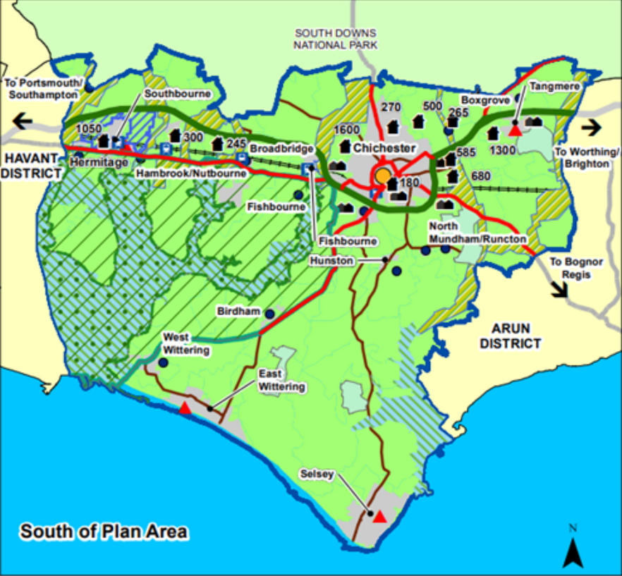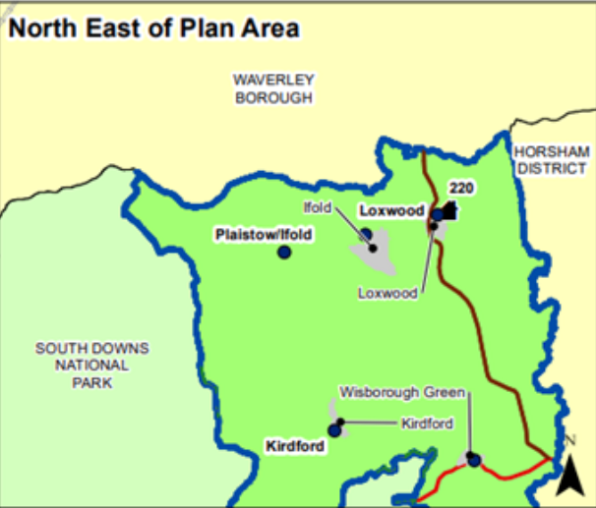

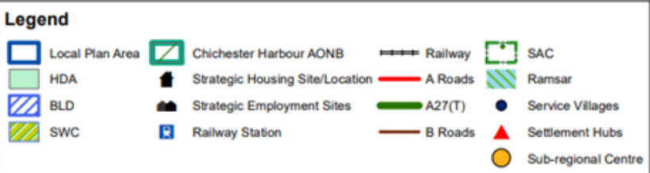
- The South Downs National Park Local Plan adopted in July 2019 (covering the period 2019 – 2033), identifies the following new housing developments in Chichester parishes.

Table 4: South Down National Park Local Plan - Total Housing Requirement in Chichester Parishes

Parish | Population ONS Parish 2020 Estimates | South Downs Local Plan Housing Developments – number of Houses | Average number of new houses
Easebourne | 1957 | Allocation Policy SD66 16 – 20  Allocation Policy SD67 16 – 20  Allocation Policy SD68 16 - 20 | 18  18  18
Total | 1957 |  | 54
Harting | 1429 | Allocated Policy SD86 6 – 8  Allocated Policy SD87 5 - 6 | 7  6
Total | 1429 |  | 13
Midhurst | 5341 | Allocated Policy SD78 65 – 90  Allocated Policy SD79 50 – 70  Allocated Policy SD80 8 – 10  Allocated Policy SD81 – 20  Allocated Policy SD82 8 -12 | 77  60  9  10  10
Total | 5341 |  | 166
Stedham with Iping | 820 | Allocated Policy SD88 - 16 | 16
Total | 820 |  | 16
Chichester Parishes Total |  |  | 249

- The SDNPA has recently commenced a review of its Local Plan and is at the evidence gathering stage of the process. An assessment has been made on future needs for Housing and Economic Development Needs (HEDNA) which has produced a housing need number of 350 homes a year between 2024 and 2042 (equivalent of 6,300 homes) for the whole of the South Downs National Park. This may not necessarily be the same number that SDNPA will use for the updated South Downs Local Plan as constraints relating to the National Park and other issues such as flooding risk will need to be taken into account.

- The following Chichester Neighbourhood Plans make reference to the proposed development/improvement of sport and recreational facilities:

- Kirdford Neighbourhood Plan (North of Plan Area) - A major community social objective is to improve social integration in the village, provide sustainable recreation facilities and establish a social centre. A scheme to combine all Parish sports activities (releasing existing land for alternative use) and develop a new Village Hall/club house/community centre/medical day clinic/changing facilities and warden's flat, along with an element of new housing. The location is critical, as it places the social activity below the existing cluster of social housing in the village.

- Tangmere Neighbourhood Plan (East – West Corridor and Strategic Development Location for new housing) - There will be a new Community Facility provided to serve the existing and new communities and:

- will comprise rooms and facilities to service large community events, including amongst others a Youth Club, Community Kitchen, an Artisan Local Market, a café and a room suited to early years childcare service provision; and
- will include proposals for securing the satisfactory ongoing management of all the Tangmere Green Infrastructure Network within the sit.; Commercial uses on the site will be provided in the form of a small parade in the ‘Village Main Street’ to serve the convenience and local services needs of the existing and new residents and comprising a mix of units suited to A1-A5 and B1(a) uses (subject to marketing evidence), some or all of which may be delivered with dwellings on upper floors.

- West Wittering Neighbourhood Plan (Manhood Peninsula) – Proposals for the improvement or extension of the existing 16 community facilities and for the provision of new community facilities and open spaces that provide for everyday needs within West Wittering, will be supported. Proposals that would result in the loss of existing community facilities and open spaces will only be acceptable if evidence is provided that they are no longer needed by the community or would be replaced by equivalent or better provision in terms of quantity and quality in a suitable location.

- Wisborough Green Neighbourhood Plan (North of Plan Area) - Support future plans to improve the current Sports Pavilion to modernise the facilities to meet the sporting and access for all requirements.

Key Demographics

- Table 5 provides a summary of key demographic information relating to Chichester district. Unless otherwise stated, all demographic data in this table is sourced: West Sussex JSNA, Public Health Fingertips, West Susses Health4Families Local Health Profile, ONS, Nomis and Census 2021.

- Chichester is an affluent district but income and health inequalities do exist. Often affluent areas are located directly next to pockets of deprivation. Some of the most deprived parishes in Chichester are located on the Manhood Peninsula and in rural locations close to Petworth.

- In general, residents in Chichester district experience good health and life expectancy. Obesity levels for children and young people are relatively low as is the case with adults. The West Sussex Joint Health and Wellbeing Strategy 2019 - 2024 identifies the following key priorities for Chichester, reflecting the growing ageing population of the district, and the growing need to support those with low level mental health conditions, recognising that people with mental health problems are more likely to smoke, drink and exercise less:

- Promoting and developing a dementia friendly district
- Encouraging and supporting people to adopt healthy lifestyles.
- Coordinating and promoting services that help people with low level mental health conditions
- Protecting and supporting the most vulnerable in society

- The district is predominantly rural with the main built up areas and services provided within the East-West Corridor. Access to services for those living in rural areas is therefore a key issue; this is exacerbated by an ageing population and reliance on public transport for those without access to a car (13%). Social isolation can also affect those living in rural communities, affecting the mental health of both young and old.

Table 5: Summary of Chichester District Demographic Profile

Demographic Profile
Poverty | Approximately 11% (1,960) of children aged 0 – 15 years in the Chichester District are from low income families.  The proportion of the population of Chichester District experiencing deprivation relating to low income is 7.9%. However, only 8.2% of those aged 60 and over experience income deprivation. This is relatively low compared to West Sussex.  The neighbourhood with the lowest average household income is Selsey (£34,300 per household). The highest average income is Ilford and Wisborough Green.
Deprivation | Chichester District is characterised as relatively affluent. Nationally it ranks 237th most deprived out of 316 lower tier authorities and has no LSOAs within the top 20% most deprived. It has 3 LSOAs within the top 30%, all of which sit within its main settlement, Chichester city.  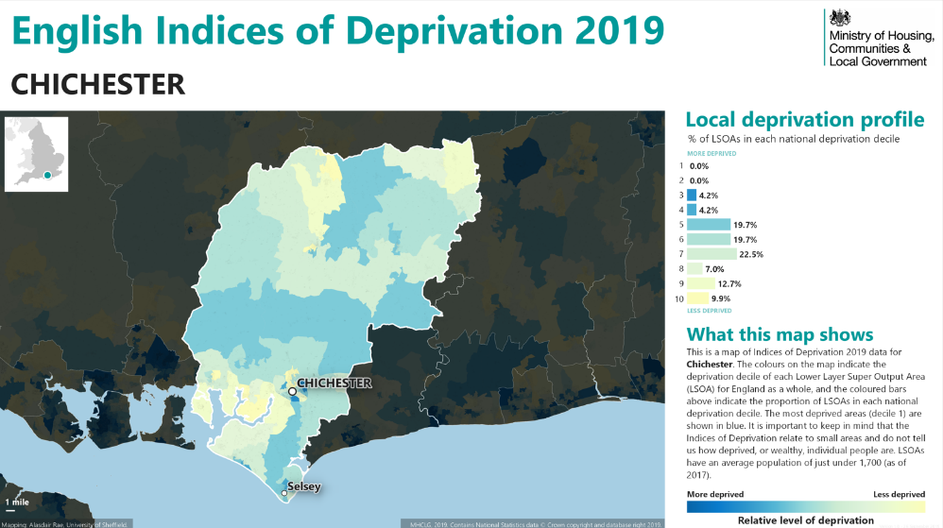  Beyond the overall picture, however, there is poverty within the district, and particular challenges which arise from rurality, such as high costs of living including costs for household fuel and the costs of transportation.  The most deprived parishes in Chichester as expressed by Indices of Multiple Deprivation (IMD 4.5 – 6.0) are East Wittering, Hunston, Eartham, Sidlesham, Lodsworth, Lurgashall, Barlavington, Stoughton, and Selsey.  When looking at the Income Deprivation Affecting Children Index (IDACI), higher rates of deprivation are found in the following MSOAs (over 5,000 people): Central Chichester; College Lane & Oaklands; Easebourne & Petworth; Selsey; Tangmere, North Mundhamn & Hunston; and Wittering & Birdham.  4.2% of small areas within Chichester are among the most deprived 10% areas within West Sussex.  In the Chichester Parliamentary Constituency 5,324 households are defined as being fuel poor.  Social mobility is about ensuring that young people have the same opportunities to succeed in life regardless of who they are or where they live. Chichester has the lowest rank for early years in West Sussex (275th of 324 local authorities in England).
Health | 22.5% of reception pupils (4/5 years) in Chichester are classified as overweight/obese. This is comparable to the England average. By the time pupils reach Year 6 (10/11 years), 36.3% are classified as overweight/obese. This is better than the England average of 37.8%.  56.5% of adults in Chichester are classified as overweight or obese. This is better than the regional (56.5%) and England averages (60.3%)  Chichester’s Excess Winter Death index is 42 per 1,000 households. This is higher than the region (30.2) and England (31.1).  West Sussex JSNA identifies mental health as a key priority across the county, particularly for children (8% of children aged 5 – 16 were estimated to have a mental health condition in West Sussex).
Life Expectancy | Residents of the district have good life expectancy; for males this is 80.1 years and 84.5 years for females. This is in line with the south east averages. Life expectancy is 3.1 years lower for men and 2.5 years lower for women in the most deprived areas of Chichester than in the least deprived.
Housing | Chichester district is the least densely populated of the South East’s 64 local authority areas. This reflects the rural nature of the district. 67% of the district is also located within the South Downs National Park where additional constraints are placed upon new development.  There has been an increase in private rented housing from 14.9% in 2011 to 18.1% in 2021.  Chichester households who own their own home has decreased from 67.2% in 2011 to 65.4% in 2021.
Car Ownership | Approximately 13% of households in Chichester District have no access to a car. This is lower than for West Sussex (16%) and England averages (23%). However, for those without a vehicle, access to services is a challenge, particularly if living in rural areas outside of the East West Corridor.
Employment | 4.1% of residents are unemployed; this is higher than the south east (3.4%) and UK (3.8%)

Participation in Physical Activity

- Sport England’s Active Lives Survey has replaced the previous Active People Survey. It provides an assessment of levels of physical activity across the country at a local authority, regional and national level (survey is sent to those aged 19+). The annual survey results can be used to identify general patterns and trends in participation.

- The following definitions for different levels of activity are used by Sport England:

- Inactive: a person doing less than 30 minutes of moderate intensity activity per week
- Fairly active: a person doing being 30-149 minutes of moderate intensity activity per week
- Active: a person doing 150+ minutes of moderate intensity physical activity per week

- Moderate intensity is defined as activity which causes an individual to raise their breathing rate. The Chief Medial Officer’s guidelines recommend that adults should be active daily and achieve a total of 150 minutes of moderate intensity exercise in a week, in bouts lasting for at least 10 minutes (2010/11 recommendations).

- Table 6 displays the most recently published Active Lives data for Chichester District and compares activity rates between West Sussex and England.

Physical activity - adults

Table 6: Levels of Physical Activity - Adults 16+ years

Adult Active Lives Survey Nov 21/22
Levels of activity (Main - 3 categories) | England | West Sussex | Chichester District LA
Inactive: less than 30 minutes a week | 25.80% | 24% | 25.80%
Fairly active: 30-149 minutes per week | 11.10% | 11.20% | 9.20%
Active: at least 150 minutes a week | 63.10% | 64.90% | 65%

- 25.8% of adults in Chichester are inactive; this is higher than for the West Sussex region (24%) but comparable with the England average (25.8%). Inactivity levels of adults in Chichester had been significantly higher in 2019/20 at 30.2%, then reduced down to 19.6% during the Covid Pandemic, but appear to be beginning to rise again.

- Only 9.2% of adults in Chichester are fairly active; this is lower than both regional (11.2%) and national (11.1%) averages. However, the percentage of adults in Chichester who are active and participate in at least 150 minutes of exercise a week is comparable to the West Sussex region and better than the national average.

- Map 3 shows levels of adult inactivity across the district at LSOA level and clearly shows that inactivity levels are not equally distributed across the district but are worse in some areas, particularly Selsey and The Witterings.

Map 3: Chichester District Council Inactivity Map 2020/2021 LSOA

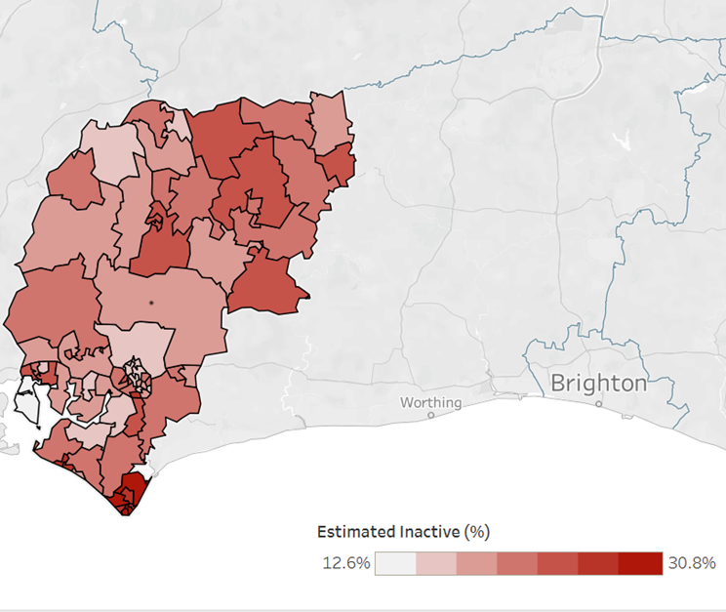

Physical activity – children and young people

- Sport England’s Children and Young People’s Survey has replaced the previous Active People Survey. It provides an assessment of levels of physical activity across the country at a local authority, regional and national level. The annual survey results can be used to identify general patterns and trends in participation.

- Physically active is defined here as doing more than 60 mins of physical activity per day.

- The following definitions for different levels of activity are used by Sport England for children and young people:

- Active: an average of 60 minutes or more of physical activity a day
- Fairly active: an average of 30 – 59 minutes of physical activity a day
- Less active: an average of less than 30 minutes a day of physical activity

- Table 7 displays the most recently published Active Lives data for children and young people for Chichester District and compares activity rates between West Sussex and England.

Table 7: Levels of Physical Activity - Children and Young People

Children and young People in Schools Years 1 - 11 Survey Nov 19/20*
Levels of activity (Main - 3 categories) | England | West Sussex | Chichester District LA
Less Active: less than 30 minutes per day | 31% | 26% | 18%
Fairly active: 30-59 minutes per day | 24% | 26% | 28%
Active: an average of 60 minutes per day across the week | 45% | 49% | 53%

*N.B. No data available for Chichester District after 2019/20

- Participation rates for children and young people in the Chichester District show that activity levels for children and young people in Chichester District are very positive with only 18% less active (less than 30 minutes of exercise a day); this is significantly lower than for regional (26%) and national (31%) averages.

- In 2019/20 53% of children and young people in Chichester District schools Years 1 – 11 were active on average 60 minutes a day. This is higher than West Sussex (49%) and England (45%).

- The positive physical activity level data also reflects the relatively low obesity levels of children and young people across Chichester District.

Strategic Policy and Context

Introduction

National Planning Policy Guidance (NPPG) Open space, sports and recreation facilities, public rights of way and local green space

  - The NPPG guides authorities and developers to refer to Sport England’s guidance on how to assess the need for sports and recreation facilities (Paragraph: 002 Reference ID: 37-002-20140306, Revision date: 06 03 2014).

  - The BSLNA reflects and supports the delivery of the relevant planning, sport and strategic policy priorities at local level. To ensure the assessment takes account of relevant national, regional and local policies and priorities, a range of strategies, policies and plans were reviewed.

National Strategy

  - The following strategies provide national level strategic guidance and direction in relation to the development of sport, physical activity and health and wellbeing measures. These strategies are detailed in Appendix 1. The improvement of the existing sport and leisure facilities in Chichester District are informed by, and will contribute towards, a number of national policy objectives as summarised below:

National Planning Policy Framework (NPPF) ( September 2023 version)

  - At the request of Chichester District Council and in accordance with National Planning Policy Framework (NPPF) transitional arrangements, the emerging Local Plan will be examined under the September 2023 version on the NPPF. This study has therefore been undertaken in accordance with the requirements of the September 2023 version of the NPPF and not the latest version which was updated 19 December 2023.

  - The NPPF sets out the Government’s planning policies for England. The version published in September 2023 replaced the previous version dated July 2021. The NPPF provides the framework that must be considered in the preparation of local plans and is a material consideration in determining planning decisions. The NPPF states that planning policies should be based on robust and up-to-date assessments of the need for open space, sport and recreation facilities and opportunities for new provision. The NPPF sets out government’s planning policies for England and how these are expected to be applied. The NPPF highlights the purpose of the planning system in terms of contributing to the achievement of “sustainable development”, and defines the three dimensions of this – economic, social and environmental – which are interdependent and need to be pursued in mutually supportive ways.

  - The September 2023 version of the NPPF retains the broad policy approach of the previous version, albeit with a stronger emphasis upon housing delivery. The policy wording for sport and recreation is largely unchanged. Paragraph 98 of the NPPF states that planning policies should be based on robust and up-to-date assessments of the need for open space, sport and recreation facilities and opportunities for new provision.

  - Paragraph 99 of the September 2023 NPPF specifies that:

Existing open space, sports and recreational buildings and land, including playing fields, should not be built on unless:

An assessment has been undertaken which has clearly shown the open space, buildings or land to be surplus to requirements; or the loss resulting from the proposed development would be replaced by equivalent or better provision in terms of quantity and quality in a suitable location; or the development is for alternative sports and recreational provision, the benefits of which clearly outweigh the loss of the current or former use.

  - The September 2023 NPPF has increased emphasis in relation to health and wellbeing. For example, the increased importance of planning policies and decisions to aim to achieve healthy, inclusive and safe places (para. 93 – in particular 93c) and NPPF para. 93a – planning positively for provision and use of community facilities (including sports venues) and 93b – take into account local strategies to improve health, social and cultural wellbeing for all sections of the community.

  - Sport England is a statutory consultee on all planning applications affecting playing fields used in the last 5 years, and a consultee on other applications: it looks to improve the quality, access and management of sports facilities as well as investing in new facilities to meet unsatisfied demand. Sport England requires local authorities to have an up-to date assessment of sports facility needs and an associated strategy including a recommendation that the evidence base is regularly reviewed to keep it up to date and renewed at least every five years.

  - The key drivers for the production of the strategy as advocated by Sport England are to protect, enhance and provide sports facilities, as follows:

- Protect
  - To provide evidence to inform policy and specifically to support Site Allocations and Development Management Policies which will protect sports facilities and their use by the community, irrespective of ownership;
- Enhance
  - To ensure that sports facilities are effectively managed and maintained and that best uses are made of existing resources - whether facilities, expertise and/or personnel to improve and enhance existing provision – particularly in the light of pressure on Local authority budgets; and
- Provide
  - To provide evidence to help secure external funding for new facilities and enhancements (if on the Infrastructure List) and Section 106 agreements. Sport England and the Local authority can then use the strategies developed and the guidance provided in making key planning decisions regarding facility developments in the area.

Get Active: A strategy for the future of sport and physical activity. Department for Culture Media and Sport August 2023

Our vision is to make sport and physical activity accessible, resilient, fun, and fair, for now and the years to come – for the benefit of individuals and the country.

  - The government wants to help build a healthier nation by tackling high levels of inactivity, and by making sure that the sport and physical activity sector thrives for future generations.

  - The 3 core priorities of this strategy, and what it means for the country, are:

- Being unapologetically ambitious in making the nation more active, whether in government or in the sport sector:
- Ensuring everyone is focused on increasing physical activity, meaning fewer inactive children, and narrowing the gap on inactivity where groups are not being reached, with visible progress across the country by 2030.
- Focusing on evidence, data, and metrics
- Setting the future direction for facilities and spaces where people can be active.

- Making sport and physical activity more inclusive and welcoming for all so that everyone can have confidence that there is a place for them in sport.
- Helping the sector to be welcoming to all.
- Improving how issues and concerns are dealt with in the sector.

- Moving towards a more sustainable sector that is more financially resilient and robust.
- Supporting the sector to access additional, alternative forms of investment.
- Working towards a more environmentally sustainable sector.

Sport England – ‘Uniting the Movement’ 2021

  - Sport England’s vision is that everyone in England feels able to take part in sport or physical activity, regardless of age, background, or ability. Sport England has three key objectives in the new 10-year strategy:

        - Advocating for Movement, Sport and Physical Activity.
    - Joining Forces on Five Big Issues.
    - Creating the Catalysts for Change
  - The ‘Five Big Issues’ are defined as:

    - Recover and Reinvent
- Recovering from the biggest crisis in a generation and reinventing as a vibrant, relevant and sustainable network of organisations providing sport and physical activity opportunities that meet the needs of different people.

    - Connecting Communities
- Focusing on sport and physical activity’s ability to make better places to live and bring people together.

    - Positive Experiences for Children and Young People
- An unrelenting focus on positive experiences for all children and young people as the foundations for a long and healthy life.

    - Connecting with Health and Wellbeing
- Strengthening the connections between sport, physical activity, health and wellbeing, so more people can feel the benefits of, and advocate for, an active life.

    - Active Environments
- Creating and protecting the places and spaces that make it easier for people to be active.

  - National Governing Bodies (NGBs) also have their own strategy documents that set out their sport’s national strategic priorities. An overview of these is provided in Appendix 4 of this report.

Everybody Active, Every Day Public Health England (PHE)

  - This framework sets out a national, evidence-based approach to support all sectors to embed physical activity into the fabric of daily life and make it an easy, cost-effective and ‘normal’ choice in every community in England.

  - Public Health England wants to drive a step change in the public’s health. Tackling physical inactivity is a key part of making this step change to reduce the burden of preventable death, disease and disability, and support people and their communities to achieve their potential.

  - To deliver this vision requires action across four areas at national and local level:

- Active society: creating a social movement
- Moving professionals: activating networks of expertise
- Active lives: creating the right environments
- Moving at scale: scaling up interventions that make us active

  - The 2018 and 2021 reviews of everybody active, every day recognised these specific challenges:

- Tacking inequalities; this is important in the Chichester District where those living in more deprived areas are more likely to experience a range of inequalities, including health.
- Creating an active society; given the ageing population in the Chichester District, it is a priority to create the conditions and opportunities where people can be more active as part of everyday life to help stay healthier into old age and reduce the burden on the NHS.
- Creating an active environment. The growth areas in the Chichester District provide an opportunity to create active environments facilitating everyday physical activity and linking existing and new communities.

Chief Medical Officer (CMO) UK Physical Activity Guidelines (2011; updated 2016, and again in 2019)

Department for Health and Social Care

  - Physical activity includes all forms of activity, such as everyday walking or Squash to get from A to B, active play, work-related activity, active recreation (such as working out in a gym), dancing, gardening or playing active games, as well as organised and competitive sport. The CMO provides physical activity guidance for five different age groups within the population.

- Moderate activity
- Causes participant to get warmer and breathe harder and their hearts to beat faster, but they should still be able to carry on a conversation.

- Vigorous activity
- Causes participant to get warmer and breathe much harder and their hearts to beat rapidly, making it more difficult to carry on a conversation

- Strengthening activity
- Physical activities that strengthen muscle and bone involve using body weight or working against a resistance

- Shorter sessions of activity
- The evidence shows that the benefits of physical activity can be achieved through sessions of 10 minutes or more of moderate to vigorous intensity activity. This duration is sufficient to improve cardiovascular fitness and lessen some risk factors for heart disease and type 2 diabetes. Although more research is required, there is also some evidence that sessions of vigorous intensity activity less than 10 minutes may be beneficial to health.
- Shorter sessions of physical activity offer an easier starting point for people who have been in active for some time, and for those who have busy lives and find it hard to prioritise activity.

Regional and Local Strategies

  - Other key regional and local strategies are detailed in Appendix 1.

Stage B - Existing Facility Provision

Introduction

  - The current level and nature of indoor built leisure facility provision in Chichester has been assessed across the district, incorporating those facilities both within the Chichester District Council Local Plan area and South Downs National Park Local Plan area. The district has an extensive range of formal sports facilities and an extensive network of community halls and education-based provision.

  - The BSLNA will model the following housing and population growth scenario as a basis for calculating future need for sport and leisure facility provision in the District to 2039:

Total of 10,678 new dwellings across the Chichester District 2021 – 2039 (Chichester District Council Local Plan area and South Downs National Park Local Plan area) and a population growth of 24,559 (additional dwellings x 2.3 national average population per dwelling).

Supply of Built Leisure Facilities in Chichester District

  - Table 8 summarises the existing built leisure facility provision across Chichester District.

Table 8: Facility Types in Chichester (Active Places Power 2024 baseline data updated)

Facility Type | Chichester District
Sports Hall (3+ badminton courts) | 14
Activity Halls | 25
Swimming Pools – diving, learning/teaching/training, leisure pool, lido and main/general | 26
Health and Fitness Suites | 18
Studios | 21
Squash Courts | 13
Indoor Bowls | 0
Indoor Tennis | 2
Athletics | 2

N.B Full details of all facilities and their quality audits (where possible to undertake) are included in Appendices 2 and 3.

Operational Management of Chichester District Leisure Facilities

  - Chichester District Council’s leisure facilities are managed under contract by Everyone Active. This 10 year contract is due to end 1 May 2026. There is a 5 year extension option built into the contract. However, the Council has confirmed that it intends to go back out to the market with a new contract commencing on 1st May 2026.

  - There are 3 main leisure centres included within the contract:

- Westgate Leisure Centre – located within the cathedral city of Chichester. This facility was opened in 1987 and has over the years seen a number of its facilities updated. The leisure centre includes a 33.3m main pool, sports hall, health and fitness suite, spa, cafe, exercise studio and ancillary facilities. Wessex County Council’s Wellbeing Service is based in the centre. In 2016, Everyone Active invested £1.5 million into a refurbishment which included a gym extension, Hot Yoga Studio (now a Fortis Studio for group fitness), indoor cycling studio, café refurbishment, treatment/consulting rooms and new reception. Investment was also made into energy efficient plant and lighting. More recently a Toning Suite was installed in May 2021. The leisure centre is now 36 years old and is the oldest leisure facility within the Council’s portfolio. The average lifespan for a leisure centre is 35 – 40 years and although there has been continuous investment in facilities on site over the years, the building’s major plant, structure and foundations will be reaching the end of its useful life.

- The Grange Community and Leisure Centre – located in Midhurst, within the South Downs National Park. Opened in March 2014, this community hub operates in partnership with West SussexCounty Council who operate a library and registrar’s office on the same site. Sport and leisure facilities include a 4 badminton court and 2 badminton court sports hall, 2 squash courts, health and fitness suite, studio, spa, café and ancillary facilities.

- Bourne Leisure Centre – located in Southbourne. Opened in July 2004 in partnership with Bourne Community College, the facility is a dual use site, used by the college and community and offering a sports hall, health and fitness suite, studio, multipurpose room, small sided 3G pitch and school hall (managed under a separate agreement) and ancillary facilities.

  - The contract includes a requirement to increase participation in sport across the district. Everyone Active employs a Sport Development Team made up of 2 full time equivalent posts to deliver a sport development programme including diversionary outreach activities. There is also an Active For Health Coordinator to deliver health and wellbeing initiatives including exercise referrals.

Assessment of Existing Sports Facility Provision

  - This section sets out the Stage B, C and D information required by the ANOG process. It provides a detailed picture of existing facilities in the Chichester District:

- Quantity: how many of each type there are?
- Quality: their age and condition?
- Accessibility: who owns and operates the facilities, facility location and catchment areas?
- Availability: whether the facilities are available to all residents, and whether there is pay and play access?

  - Given the inter-related nature of these four key areas, Section 5 covers each facility type in turn, and assesses it in terms of the above, then pulls together all the data collected to provide an overall summary of each facility type, current and future provision i.e. supply and demand analysis.

  - Each individual facility type section is structured as follows:

- Summary of Provision
- Stage B
- Provision in 2024
- Quantity
- Quality

Quality Audits and Site Visits (these inform the demand assessment)

The quality audits comprise an independent visual assessment of the quality and condition of the facilities; results are recorded on the ANOG assessment sheet, developed by Sport England, and scored, based on the Sport England system set out below. Details of the individual audits undertaken are included in Appendix 3. The audit scores are based on a numerical value, detailed on each assessment sheet, as follows:

Quality Audit Scoring System

Key | Rating
>80% | Excellent
60% - 80% | Good
40% - 59% | Average
20%-39% | Poor
<20% | Very Poor

A facility scoring highly in terms of visual quality and condition (good – excellent) is likely to require less investment than one which in a poorer visual condition (average – very poor). The combination of the scores, results in the facility rating, and identification of investment need (significant, moderate etc.). It is important to highlight that in undertaking the quality assessments, each element of the facility e.g. sports hall, pool etc is given a qualitative assessment, and the overall facility is also given an overall qualitative mark. Therefore, a sports hall can be of poor quality, but the overall facility score could be good.

- Demand in 2024
- Survey Responses (Education Institutions, Sports Clubs, Parish Councils)
- Consultation (National Governing Bodies)

There are two main tools used to inform the assessment of supply and demand, as well as the facility audit (Appendix 2 taken directly from Active Places and used as the baseline data 2024, showing updates/amendments as a direct result of site audits and consultation), quality site visits (Appendix 3), and the demand information gathered through the consultation. These tools are summarised below:

The Sport England Facility Planning Model (FPM) – this is only used for sports halls of 3 court size and above and swimming pools larger than 160 sq. m.

The Facilities Planning Model (FPM) is a computer-based supply/demand model, which has been developed by Edinburgh University in conjunction with Sport Scotland and Sport England since the 1980’s. The model is a tool to help to assess the strategic provision of community sports facilities in an area. It is currently applicable for use in assessing the provision of sports halls, swimming pools, indoor bowls centres and artificial grass pitches.

Use of FPM: Sport England uses the FPM as one of its principal tools in helping to assess the strategic need for certain community sports facilities. The FPM has been developed as a means of:

- assessing requirements for different types of community sports facilities on a local, regional or national scale;
- helping local authorities to determine an adequate level of sports facility provision to meet their local needs;
- helping to identify strategic gaps in the provision of sports facilities; and
- comparing alternative options for planned provision, taking account of changes in demand and supply. This includes testing the impact of opening, relocating and closing facilities, and the likely impact of population changes on the needs for sports facilities.

Its current use is limited to those sports’ facility types for which Sport England holds substantial demand data, i.e. swimming pools, sports halls, indoor bowls and artificial grass pitches.

The report sets out the findings under seven headings and includes data tables and maps. The headings are defined at the start and include total supply; total demand; supply and demand balance; satisfied/met demand; unmet demand; used capacity (how full the pools are); and local share of pools. Each heading is followed by a commentary on the findings.

The purpose of the report is to provide the Chichester District with an updated evidence base for sports halls and swimming pools, which the Council can use to inform its strategic planning for the future provision of these facility types. The full FPM reports and appendices are set out in Appendix 10 and 11.

For Chichester District, the 2023 National Run FPMs are used for Sports Halls and Swimming Pools with a population of 125,107 taken from the ONS 2018 subnational population projections. The geographical distribution of the residents, and therefore demand uses the 2021 Census output areas. The assessment is travel time based and therefore extend beyond local authority boundaries and Local Plan boundaries, and therefore the findings for neighbouring local authorities and the South Downs National Park are included.

The demand (current and future) for facilities other than sports halls and swimming pools is assessed using National Governing Body (NGB) standards if they are available, plus a combination of local factors e.g. how many existing facilities there are, what is the identified demand from schools, clubs, the community etc, what is available immediately outside the authority boundaries to which people may find it easier to travel.

- Accessibility
- Accessibility means the ability both to get to a facility, and to be able to get into it i.e., membership and activity pricing
- Catchment areas for different types of facilities provide a means of identifying areas currently not served by existing built leisure facilities. It is recognised that catchment areas vary from person to person, day to day, hour to hour, and are also very different in rural and urban areas. This problem is overcome by accepting the concept of ‘effective catchment,’ defined as the distance travelled by around 75-80% of users. The maps in this section reflect the catchment areas for facility provision in the Chichester District. The study uses a 20-minute public transport travel time and a 10-minute walk time as a catchment area for sports facilities (these catchment areas are within guidance parameters suggested by Sport England and align with the Chichester District Council’s ambitions to reduce car use).

- Availability
- Availability of a facility is about opening times and programming.

- Provision Requirements by 2039
- Demand in 2039 (this is compared to the findings in 2024, and where applicable i.e. for sports halls and pools, a standard demand assessment (the Facility Planning Model (FPM)) as summarised)

- Stage C
- What does this mean for specific facility provision in Chichester District? (This analysis identifies current and future built leisure needs in the Chichester District).

- Stage D
- Recommendations- these are summarised in one section at the end of the report

The agreed overall Action Plan reflecting the BSLNA and its findings are set out in a separate document; the Action Plan addresses identified needs and gaps in built leisure provision.

N.B. It is important to highlight that there are facilities such as e.g. saunas, steam rooms etc which are not specifically assessed in this report but could form part of an overall offer in a leisure facility.

BSLNA Consultation

  - Consultation has been undertaken with clubs, schools, parish councils, neighbouring Boroughs, National Governing Bodies (NGBs) and key stakeholders to inform the BSLNA, across all facility types. The feedback is summarised below and highlighted where appropriate in each individual facility type assessment.

  - Schools, clubs and parish and town councils were consulted via an online survey. All key schools and club contact details were provided by Chichester District Council. Parish and town council were contacted directly by Chichester District Council. Clubs’ needs are also identified via consultation with NGBs.

  - Neighbouring Boroughs were contacted by email and information collected through this medium and through face-to-face meetings, combined with SLL’s own knowledge about existing and planned leisure facilities from recent work in relevant areas.

  - NGBs were all contacted by email and asked a series of questions to identify the information required. The consultation responses are set out in the following analysis, as relevant.

  - Stakeholders identified by Chichester District Council were all contacted by email to request a meeting – online or where possible, face to face. The list of responding stakeholders in included at Appendix 9. Feedback from these stakeholders is reflected in the supply and demand analysis.

Schools’ Consultation

Objectives of Consultation

  - All schools including Special Educational Needs (SEN) and independent schools in Chichester District were contacted by email on 7 December 2023 and asked to complete a survey by the closing date of 5 January 2024 about their existing sports facilities (quality and quantity), their plans/aspirations for future provision, and the extent and nature of community use of the facilities (accessibility and availability). Those schools that had not yet responded were sent a reminder on 20 December 2023. 21 schools responded to the survey; a summary of the responses is included in Appendix 6. Schools with community assets that did not respond to the survey were contacted by telephone and/or visited as part of the facility quality audits.

  - Schools were contacted to inform the analysis (extent of provision, access and use), and were offered a meeting as part of the qualitative site visit. All site visits therefore involved on-site consultation with a member of staff.

  - During site visits, some schools, particularly smaller primary and junior schools, expressed a desire to introduce or increase community access for both sporting and non-sporting use, but highlighted safeguarding, health and safety, and financial reasons for not pursuing this. Some schools stated that there would be an additional insurance cost incurred which deterred them from for allowing public use of their facilities.
  - The cost of providing lifeguard cover and paying the caretaker for opening and closing facilities out of hours were also cited as financial disincentives to community access of school sports facilities.

  - Appendix 6 sets out the detailed feedback received from the 21 schools completing the online survey. The respondent schools are:

Table 9: Chichester District - Respondent Schools

Name of Respondent School
Chichester College | Boxgrove C of E Primary School | The Academy, Selsey
Camelsdale Primary School | Kingsham Primary School | Bourne Community College
Oakwood Prep School | Vicky Minton | Seal Primary Academy
Bosham Primary School | Westbourne House School | Parklands C P School
Rumboldswhyke School | University of Chichester | North Mundham primary School
Thorney Island | Southbourne Junior School | Wisborough Green Primary School
Compton & Up Marden CE Primary School | Seaford College | West Wittering Parochial C. E. School

  - The key findings from the online school survey are:

- The majority of respondent schools are local authority maintained schools; this may reflect the relatively high number of primary and junior schools that responded to the survey. 18% of respondent schools are Academies; this is important because levels of community use have in general been adversely impacted in England by the introduction of Academies.
- The majority of schools that responded are located within the urban area of the East-West Corridor of the Chichester district Council Local Plan area.
- The majority of schools have indoor sports facilities.
- The majority of respondent schools have sports halls; most of these are used by organised groups i.e. not community pay and play access; it is community pay and play access that has the most impact on inactivity. Chichester College and Bourne Community College both have secured community pay and play access agreements in place for use of their sports hall and other sports facilities on site. Although the University of Chichester responded to the survey saying that if offers pay and play access, a site visit and meeting with the manager confirmed that they only accept advanced bookings by clubs.
- Only 4 respondent schools have a pool facility; 3 of these schools are private and all 4 schools offer no pay and play community access, although Westbourne school does make its pool available to other local schools in the area for swim lessons.
- Westbourne House School is the only respondent school with squash court facilities; these are hired out to Westbourne Squash Club. Although the school states that there is a secured Community Use Agreement in place for use of the facilities, this is not the case.
- Some schools have a studio facility; usage arrangements are as for sports halls. Both Chichester College and Bourne Leisure Centre have formal Community Use Agreements in place for use of their studios.
- Only Chichester College, Seaford College, Bourne Community College and the University of Chichester have health and fitness suites on site; Chichester college has community pay and play access with the fitness suite open at specific times during the day between 6am and 9.45pm term time and at all times during the school holidays.
- Seaford College has indicated that it has an indoor tennis court, however no information has been supplied regarding the quantity, quality or surface and the site audit completed for this study identified no such purpose built facility. The college has 6 outdoor tennis courts and the assumption is that this was submitted in error by the college, or that the indoor sports hall has line markings for tennis.
- In terms of weekday and weekend usage of sports facilities by the schools, the sports hall facilities are used the most frequently.
- Community use of school sports facilities is mainly during weekday evenings outside of school hours due to daytime use of the facilities by the schools and ensuring the safeguarding of pupils on site.
- There is significant variation when school respondents are asked to rate the overall quality of their indoor facilities; this may reflect the fact that there are a mix of local authority and private school facilities responding to the survey.
- Of those schools who do not currently open their facilities to community use, over 40% indicated that they would be interested in doing this in future.
- 22% of schools give the following main reasons for not considering community use:
- The school/college does not want this
- Operating hours
- Already lots of school/college use (before/after school clubs)
- No facilities onsite
- The school is located on a military base and other facilities are available.

- Of those schools who do not currently open their facilities to community use, the following said that they would consider this in the future:
- Chichester College (said in error – the college already provides pay and play and club community access)
- Bosham Primary School – has no indoor sport or recreational facilities on site
- Westbourne House School (said in error – the school already provides club access)
- University of Chichester (said in error – the university already provides club access)
- The Academy, Selsey – has a sports hall and studio on site
- Parklands C P School – has no indoor sport or recreational facilities on site
- North Mundham Primary School – has no indoor sport or recreational facilities on site
- Wisborough Green Primary School (this school only has a covered outdoor lido which has been decommissioned since 2020 and needs replacing)

Sports Club Consultation

Objectives of Consultation

  - All key sports clubs in the district were contacted by email (using the contact list supplied by Chichester District Council) and asked to complete a survey about their existing sports facilities (quality and quantity), their plans/aspirations for future provision and development, existing participation levels, future aspirations and needs. The leisure facility managers at Westgate Leisure Centre, The Grange Community and Leisure Centre, Bourne Leisure Centre, Chichester College, and Chichester University also kindly forwarded a link to the survey to their database of sports club hirers. The survey was sent out on 7 December 2023, with a closure date of 5 January 2024. All clubs who had not yet responded to the survey were sent a reminder on 20 December 2023. 12 sports clubs responded to the online survey. To mitigate the relatively low response, key clubs were contacted by phone and emailed week commencing 30 January 2024 and relevant NGBs were contacted and asked to supply supporting club data were possible.

  - The 12 respondent clubs represent the following sports:

- Futsal
- Bowls
- Swimming
- Martial Arts - 2
- Table Tennis
- Squash
- Tennis
- Handball
- Netball – 2
- Gymnastics
N.B. Virtus Leisure also responded to the survey but were removed as they are a tennis coaching company operating on a regional basis and not a sports club.

  - Between them, these clubs use the following facilities. With the exception of North Mundham Village Hall, all facilities are located within Chichester city:

- University of Chichester (Bishop Otter Campus)
- Chichester Bowling Club
- Westgate Leisure Centre
- North Mundham Village Hall
- Chichester Racquets and Fitness Club
- New Park Centre
  - Key points raised by the respondent sports clubs:

- 35% of respondent clubs have 80 or more active playing members with Chichester Racquet and Fitness Club having the largest number (1600)
- A quarter of the respondent clubs have over 5 paid coaches; one of these clubs has 10 paid coaches (Westgate Gymnastics Club)
- The majority of respondent clubs confirm that the number of playing members has increased over the last 5 years and 80% believe that the number of club members will increase in the next 5 years. Reasons given for the anticipated increase include the positive return to sport following Covid, more junior teams in the area, and in the case of netball, the positive impact of the televising of the sport at elite level
- 30% of respondents have over 5 volunteers assisting the club; 2 clubs have 30 plus volunteers
- 70% of respondents say that their club is not currently at full capacity
- Over 50% of respondent clubs have approximately 10 female members with Westgate Gymnastics and Chichester Racquet and Fitness Club each having over 100 female members under 18. Chichester Netball League and Chichester Racquet and Fitness Club have over 100 female members over the age of 18.
- 50% of respondent clubs feel that the facility they use suits their club needs, 40% do not
- The majority of respondent clubs rate their facility as good. The most popular reasons given for this include good availability and good communication with the venue. For those that rate their facility as poor, the main reason given is the cost of hire
- 50% of respondent clubs are very satisfied with their relationship with the facility management/owner; 30% are somewhat dissatisfied.
- When asked how the relationship could be improved, better communication, lower cost of hire and better availability are cited as the main opportunities

  - Priorities for clubs include:

- Increasing membership
- Increasing the number of volunteers
- Reduce hire costs
- Improve their financial situation

  - Additional feedback from respondent clubs is summarised below:

Table 10: Additional Club Feedback - Chichester District Sports Club Survey

Additional Club Feedback
Theme | illustrative feedback
Suitability of Facility for Club Needs | The facility is not suitable for a competitive swimming club, no 25m pool, inadequate lane ropes, not enough pool time, no spectator area, not suitable for competitions, very high rates. Pool often too hot, Sessions often cancelled due to lack of lifeguards (Chichester Cormorants Swimming Club)
 | We are happy with our current Dojo - However a more social area that could be adapted for Competition viewing would improve our community feel and ability to put bigger Area events on (Chichester Ronin Judo Club)
Availability and certainty over continuity of bookings | The continued closure of the Edge Sports Centre in Haslemere leaves us only with the following options of inside M25: Chichester, Haywards Heath or Southampton. Currently Chichester is the most cost competitive one and good for availability (Guildford Sabres Handball Club).
 | The facilities and staff at the University are excellent but they don't have enough courts for the number of teams we currently have (Chichester Netball League)
 | We are a very new club so growing in numbers and performance level. It is hard not being certain that the university timetable will allow us to continue our booking and parking is not great. But otherwise we are very happy (Spirit Netball Chichester).
Staffing and equipment costs | We run our club independently but we also manage and run 4 hours of the Leisure centres classes for them. We do source a lot of equipment through our club and also source the coaches and mentor them which we use to also deliver the centres class for them. Although we are always replacing and buying things for both the classes to use - this is of course added to wear and tear to our costings.  We do oblige in doing this as the whole ethos of our club is to provide every child the experience of taking part in gymnastics. But sometimes it would be nice to have support when replacing the bigger apparatus rather than solely by ourselves. We are looking to replace a beam in a few months but we will be purchasing this ourselves - although the centre will also be using it (Westgate Gymnastics Club).

Parish Council Consultation

  - All parish councils in Chichester District were contacted by email by Chichester District Council and asked to complete an online survey regarding the number, quality and location of indoor sports facilities within their parish boundary. The survey was sent out on 7 December 2023 with a deadline date of 5 January 2024. Those parish councils who had not responded to the survey were sent a reminder on 20 December 2023.

  - A total of 22 parish councils responded to the survey and the following key points were raised:

- 83% confirm that they have indoor sports facilities (including community halls) within their parish boundary
- 15 parishes have 1 facility which is either a village or parish hall; 5 of those parishes have 2 facilities, 2 of the parishes have 3 facilities, and East Wittering and Bracklesham Parish Council has 4 facilities.
- The majority of parishes regard the quality of their hall as satisfactory, good or excellent. Only Birdham Village Hall, Wisborough Green Sports Pavilion and Stoughton Parish hall are described as unsatisfactory.
- There are no halls of sports hall size (3 badminton courts). All are 1 badminton court size or less.
- There are no parish council’s offering fitness suite facilities in their halls.
- Only 3 parish councils say that their hall provides changing accommodation on site. These sites are Bracklesham Barn, Hunston Village Hall, Sidlesham Memorial Recreation Hall, Wisborough Green Sports Pavilion and Boxgrove Pavilion. The majority of these changing facilities are described as unsatisfactory in quality.

  - The parish councils provided the following additional comments relating to sport and leisure facilities and needs in their area:

Table 11: Additional Feedback – Chichester District Parish and Town Council Survey

Parish/town council | Comment
Birdham Parish Council | Birdham would like to add allotments, complete the all-weather pitch (both of which encourage outdoor exercise) and install the active travel hub at the end of Church Lane with associated information board and bicycle parking to encourage cycling and walking.
Earnley Parish Council | The nearest sports and leisure facilities are within the adjoining parishes, these are private entities and are very expensive to join. The nearest affordable facilities are in Chichester which is a 14 mile round trip and is not accessible. Neither options are accessible via public transport for residents in the parish.
East Wittering Bracklesham | As many people do not have the ability to travel into Chichester and with Harbour Way Country Club closing, a local gym is needed
Ebernoe | There are facilities for Cricket and Stoolball in Ebernoe,
Fishbourne | There are numerous outdoor facilities: tennis, croquet, bowls, cricket and football. The football changing facilities could be improved.
Funtington Parish | Village Hall in poor repair
Kirdford | Current plan for a new sports pavilion (previous burned down). Also revamp of separate cricket pavilion.
Petworth | Here in Petworth we have been asking for additional sports and leisure facilities for many years. We have two small playgrounds (swings, slides, etc) and we have an outdoor sports ground which is used extensively by cricketers of all ages in the summer months, and by footballers of all ages in the winter months. We also have a private tennis club. For those who just want to enjoy time outdoors, our facilities are lacking. We would very much like to construct a Multi-Use Games Area for the community of all ages to use, located within the Petworth boundary. We would very much appreciate if this could be considered within your plans. Thank you.
Sidlesham Parish Council Parish Council | For the Sidlesham Memorial Recreational Hall and Grounds we are looking at new floodlights, heating within the hall and resurfacing of the car park area.
Wisborough Green | Additional sports playing pitches due to popularity of sport, particularly for children.

National Governing Body Consultation (NGB)

  - NGBs who responded to the consultation include:

  - Feedback from each NGB is included in the relevant facility type assessment and in Appendix 4.

Neighbouring Local Authorities

  - In determining the nature, level and location of sports provision required across the Chichester district for the future, it is important to be aware of how neighbouring local authorities are planning for the future. Given that communities use sports facilities in areas other than where they live, the development of new or improved provision can impact significantly on both participation levels and capacity cross boundary.

  - Havant Borough Council, East Hampshire District Council, Waverley Borough Council, Horsham District Council and Arun District Council were all invited to online consultation meetings. Havant Borough Council, Arun District Council and East Hampshire District Council responded as summarised below. Information on the remaining districts is provided through Strategic Leisure Limited’s (SLL) own knowledge of these geographical areas.

Table 12: Summary of Neighbouring Local Authority Consultation

Organisation Name | Summary Feedback | Key Implications for Chichester District Council
Havant Borough Council | Significant Indoor Facility Developments in your District  We are working towards an extension of Waterlooville Leisure Centre over the next 12-24 months. Concept options include addition of 2x covered padel tennis courts, small sided 3g football pitch, remodelling of health and fitness zones to provide 2x new studios (1 low intensity and dual use with community health and wellbeing initiatives and one high intensity studio), enlargement of fitness suite by circa 30 stations incorporating modern fitness trends. This links to the major housing development at Berewood (West of Waterlooville Development) circa 2000 homes, from which s106 funds are being committed to the project.  Replacement of the ageing Havant Leisure Centre in full, is a priority of our indoor built facilities strategy. This realistically is 5 years plus away and we are starting by developing an Active Wellbeing Strategy for the borough over the next 12 months.  Major Housing Development Planned  Havant Borough Council is undertaking a local plan review, The ‘Building a Better Future Plan’ will be the Local Plan for Havant Borough. The new Local Plan will run until 2042. New housing needs for Havant are currently estimated at 516 per year. Between 2023 and 2040 (19 years) there will be a need for 9,804 new houses.  Are you aware of any facilities used by your borough council’s residents/groups for training or competition?  None that I am aware of cross the border into Chichester district, but several do cross into Portsmouth.  Indoor Built Facility Strategy completed in November 2018. download (havant.gov.uk) | Extension at Waterlooville Leisure Centre within next 2 years linking to new housing development at Berewood (2000 homes)  Additional 30 stations for health and fitness suite and 2x new studios  Replacement of Havant Lesure Centre in approximately 5 years  Any leisure travel out of the district tends to be to the west i.e. Portsmouth
Arun District Council | Significant Indoor Facility Developments within Arun District Council  Freedom Leisure operating 4 sites under contract to Arun DC (2 x wet & dry @ Littlehampton and Bognor Regis) and the other 2 are community or dryside sites including a theatre.  Cost at Freedom sites at Arun are typically £52.50/month compared with £37 at Everyone Active Chichester sites (more competition in Chichester).  Felpham LC Bognor Regis built 1974 (with 8 x lane swimming pool built in 1994). Dryside has dual use agreement with onsite school.  Littlehampton LC new leisure centre opened in Spring 2019 cost £16m (4 x court sports hall, 8-lane pool, learner pool, 85-station gym and 2 x studios) Littlehampton LC has 3,200 members.  There was another wetside facility in Bognor Regis called Arena LC but it closed in 2022 (not sure who owns or operated the latter).  Does Arun District Council have an indoor facilities strategy? If so, what stage is it at and what were the key findings regarding swimming pools, sports halls, health and fitness suites and fitness studios?  KKP undertook a ISBFS for Arun District Council in 2019. Identified a need for 7 more badminton courts by 2036. New changing facilities required at Arun LC. There will be a need for 4 x lane swimming pool by 2028 and 5 lanes by 2036. 18% of swimming demand is exported to other local authorities. On this basis there is need for an additional and new facilities to accommodate increases in demand generated from new populations resulting from housing growth. Housing development information not known by Arun District Council officer interviewed.  Link to ISBFS for Arun District Council:  https://www.arun.gov.uk/download.cfm?doc=docm93jijm4n19212.pdf&ver=20922 | Recently built Littlehampton LC (2019) includes 8 lane 25m pool, large gym, 4 court sports hall, and 2x studios.  Indoor Sport and Built Facility Strategy identifies need for an additional 4 lane swimming pool by 2028 and 5 lanes by 2036.  The lower membership costs in Chichester compared to Arun reflects the level of health and fitness competition in the Chichester area.  18% of swimming demand exported to other local authorities in 2019. This will increase with projected housing growth in the district. New Littlehampton LC pool will cater in part for this demand.
East Hampshire District Council | Significant Indoor Facility Developments in your district  Alton Sports Centre (Opened in January 2020) Cost £20m  - 6 lane 25m pool  - Teaching pool  - Sports Hall  - 130 station Gym  - Spin Studio, Group Ex Studio and Mind and Body Studio  - Squash  - Spa  - Climbing Wall  - Soft Play  - Café  Alton Sports Centre | Gym, Swim & Fitness Classes | Everyone Active  Whitehill and Bordon Leisure Centre (Opened in December 2020) Cost £10m  - 6 lane 25m pool  - Teaching pool  - 80 station Gym  - Spin Studio  - Group Ex Studio  Whitehill & Bordon Leisure Centre | Gym & Swim | Everyone Active  Major Housing Developments  - Following approval of the outline planning permission (planning application reference 55562/005/OUT) for up to 800 new homes, community facilities and supporting infrastructure, the second phase Reserved Matters planning application has been submitted to East Hampshire District Council.  Land East of Horndean | (landeasthorndean.co.uk)  - Whitehill and Bordon  This is a complex, £1bn, multi-partner, 15-year collaborative and transformational place-making programme which seeks to:  - Transform the town from ‘garrison town to green, healthy and connected town’ by 2036.  - Deliver some 3,350 new homes; 3,350 jobs and create nearly 100,000sqm of new commercial, retail, and leisure floor space.  - Deliver a new town centre with a high-quality leisure and retail offer coupled with new schools, leisure centre, health facilities & public service hub.  - Deliver a new relief road, undertake improvements to the existing A325 and develop sustainable transport projects that will encourage less car use and more walking and cycling in the town.  - Protect and enhance around 150 hectares of green space through the provision of two SANGs (suitable alternative natural green spaces) at Bordon Enclosure and Hogmoor Enclosure.  - Deliver new community facilities and critically support the community through the transformation process including the population increase from 14,000 to 22,000 by 2030.  - Deliver an Enterprise Zone site to attract investment from digital technology businesses, in partnership with the Enterprise M3 Local Enterprise Partnership and sites at Basing View and Longcross.  Does East Hampshire District Council have an indoor facilities strategy?  This has just been completed by Continuum and the final report is being reviewed by the community’s team and will be published on the council’s website later this year.  - The available supply of sports halls for community use is greater than the demand  - There has been a good record of investment in new facilities and modernisation of the older sites. However, the age of some sites will make them less attractive in the future and costly to maintain, for example, Taro Leisure Centre sports hall is over 30 years old.  - The educational sector is the main provider of sports halls. This means that there are only the two public leisure centre sports halls and one educational site open during off-peak times. Continuing community use is dependent on each educational establishment’s policy towards making their sports halls available, and the over-reliance on educational sector facilities is a concern.  - The available supply of swimming pools for community use is greater than the demand.  - There are no areas of the District where there is enough unmet demand that could be met to justify the provision of a new swimming pool.  - It is expected that pool sites are operating at a comfortable level at peak times with plenty of spare capacity for the future. | New Alton and Whitehill and Bordon Leisure Centres are within a 20 minute drive catchment for Chichester District residents living in the South Downs National Park area, providing good quality pay and play community accessible wet and dryside facilities for Chichester District residents living within the catchment area of these new leisure centres.  2x 6 lane 25m pools and teaching pools provide swim lesson and competitive swimming opportunities for Chichester residents living in the north of the district.  Whitehill and Bordon Leisure Centre to cater for new housing growth in the area.  Lack of off peak community accessible sports halls in East Hampshire and the age and condition of Taro Leisure Centre sports hall may create additional demand for use of the Grange Community and Leisure Centre sports hall as this is the nearest pay and play community sports hall.  New pools in Whitehall and Bordon and Alton have capacity to cater for exported demand from Chichester District.
Horsham District Council  Information from Built Facility Strategy January 2019 | No reply to request for information; information is based on SLL’s knowledge of recent work with the borough council.  Population of Horsham district is expected to grow from 135,000 (in 2017) to 150,000 by 2031.  Closest town to neighbouring Chichester local authority is Billingshurst in the west of Horsham district. Billingshurst Leisure Centre has a wet and dry facility, 4-court sports hall and 4-lane 25m swimming pool. It is located on a school site. It is owned by the local authority.  The BFS concludes:  - The demand for sports halls to 2031 can be met from within existing supply.  - Badminton England has a need for a new Badminton Performance Centre (now addressed through the Bridge Leisure Centre)  - There is potential to better use some informal halls such as community centres to meet activity demand, particularly in rural areas  - Many sports halls are on education sites and, because only two sites are the subject of formal Community Use Agreements, continued community access is not guaranteed  - Some facilities, particularly squash courts, and sports halls on education sites, are aging and will require replacement or refurbishment in the long term (10 -15 years).  - This includes the sports hall at Billingshurst Leisure Centre that forms part of the Council’s community offer  - There is an under supply of facilities for swimming that equates to 260.42sqm of water space (just over a 4 lane, 25m pool), most of which relates to the new housing developments in and around Horsham Town  - There is an evidenced demand for additional gymnastics and trampolining provision  - There is an evidenced demand for improved cycling facilities within the district, including off road tracks  - There will be a small shortfall (77) in affordable and community accessible fitness stations within fitness suites to meet the needs of the growing population by 2031  - There is a desire on the part of Netball England for indoor netball facilities but this has not been mirrored through the views of local clubs | Sports Hall at Billingshurst LC in need of refurbishment/replacement in next 10 – 15 years.  Current and future under supply of swimming pool provision (4 lane 25m pool) particularly around Horsham Town and the south/border with Crawley.  No additional/new leisure facility provision planned.
Waverley Borough Council  Information taken from Waverley 2017 - 2027 Indoor Leisure Facilities Strategy | No reply to request for information  The report from 2017 acknowledged: Significant investment into leisure facilities including a new Godalming leisure centre at £5.8 million, the refurbishment of Cranleigh (£1.7million), Farnham (£3.5 million) and Haslemere more recently at £4.1 million.  Due to the projected increase in population in the borough over the next 20 years it was deemed necessary to develop a strategy that would consider the need and availability of indoor leisure facilities in order to plan the future demand. Knight Kavanagh and Page Ltd (KKP) were appointed to carry out a needs assessment analysis and produce an Indoor Leisure Facilities Strategy for the next 10 years.  The needs assessment report indicates no shortfall for water space or sports halls in the immediate area. Forthcoming developments in the Cranleigh area could lead to additional demand of up to two lanes by 2032, according to Sport England’s Sports Facilities Calculator. | No new leisure facilities planned due to previous levels of investment in leisure facilities in Waverley.  Haslemere and Cranleigh leisure centres are within a 20 minute drive catchment of Chichester District residents living in the North of the Plan area and the north part of the South Downs National Park.

Assessment of Individual Built Leisure Facilities - Stage B

Sports Halls and Activity Halls - Assessment Summary Stage B

Sports halls are identified as 3+ court badminton halls (strategic size) and provide formal facilities for team sports such as netball, volleyball, basketball etc.

Activity halls are smaller halls normally of 1 badminton court size; they may/may not be marked out for badminton but can cater for some sports and physical activity.

  - The assessment identifies:

Table 13: Sports halls Assessment Summary

Facility Type- Sports Halls | Key Points
Quantity | The supply assessment identifies that there is a good range of sports halls across the district.  Chichester District has a total of 14 sports halls across 12 sites (refer to Map 4) with 6 located within the city of Chichester, 2 in Midhurst and the remaining sports halls are evenly distributed across the district. There is no provision in the north east of the district.  There are 25 activity halls across 22 sites (refer to Map 5). These are fairly evenly distributed across the district and reflects the smaller localised catchment for which the majority serve, often located in smaller village halls and community centres. Only 1 hall is available for pay and play community access and 15 available to hire by local sports clubs/associations, 11 of which are located in purpose built stand-alone community halls/village halls and 4 on education sites.  Tables 14 and 16 provides details of all sports halls and activity halls across the district.  There are 4 community pay and play sports halls; 2 are on education sites with secured community access and therefore the halls are only available for pay and play community use outside of off peak periods. There are 8 sports halls with community access to sports clubs/associations.  There is a heavy reliance on sports hall provision on education sites within the district with 11 of the 14 sports halls located on education sites. 5 of the sports halls are on academy owned sites with 4 of these hired out to community sports clubs/associations. However, the are no secured Community Use Agreements in place with these Academies. this is important because levels of community use have in general been adversely impacted in England by the introduction of Academies.  Supply and Demand in 2023  - A high proportion of Chichester District’s demand for sports halls is met, which is similar to the national average.  - However, the distribution of sports halls across the district does not align with demand.  - Two sports halls (Westgate Leisure Centre and The Academy, Selsey) are estimated to be uncomfortably full at peak times while others are under-utilised.  - The total sport hall space in Chichester District included in the FPM equates to 48.7 badminton courts. However, only 35.5 courts are available during the weekly peak period.  - The education sector provides 51% of the available capacity in the district in the weekly peak period and has scope to increase capacity if required.  - The resident population generates demand for 9,838 visits in the weekly period which equates to 33.4 badminton courts with a comfort factor included.  - The available supply of sports halls for community use is therefore greater than demand.  - The 3 public sports halls provide 49% of the available capacity in the Chichester District in the weekly peak period.  - 91% of demand for sports halls from Chichester District residents is met in 2023.  - 81% of Chichester District’s satisfied demand is met at sports halls within the district, with 19% exported and met at sports halls outside the district.  - 26% of Chichester District residents are within a 20 minute walk of a sports hall. This is lower than neighbouring authorities and regional and national averages.  - Unmet demand is low and is the equivalent of 3 badminton courts. Nearly all unmet demand (98%) is from residents who live too far from a sports hall and is not due to lack of capacity.  - There is wide variation in the estimated used capacity of the individual sport hall sites, ranging from 11% to 100%. Westgate Leisure Centre and The Academy, Selsey, are estimated to be uncomfortably full (more than 80% utilised).
Quality | The sports halls in the Chichester District are in relatively good condition and there has been a good record of investment in new facilities and modernisation of older sites A total of 12 out of the 14 sports halls in the district were built or refurbished within the last 25 years, with the average age of sports halls in the district being 19 years.  For those sports clubs who responded to the survey, there was minimal criticism regarding the quality of sports hall provision.  The oldest sports halls are located at Highfield and Brookham School, Bishop Luffa C of E School, and the University of Chichester and consideration should be given to refurbishing/replacing these facilities within the next 10 – 15 years. Highfield and Brookham School is located within the South Downs National Park and therefore the responsibility of the planning authority to refurbish/replace in this area. Bishop Luffa C of E School and the University of Chichester provide community club access but only have in place unsecured community use arrangements with local sports clubs.  Highfield and Brookham School has identified the need to replace its sports hall in the medium/long term and therefore the SDNPA should consider negotiating a formal CUA as part of any future planning permission.  Westgate Leisure Centre sports hall was originally built in 1987 and refurbished in 2005. As this is a heavily used facility and one of only 2 community pay and play sports halls in the district offering off peak use community use, consideration will need to be given to refurbishing or replacing this facility in the medium term.  .  The activity halls in Chichester vary significantly in quality, reflecting the variable age of the facilities. Bourne Community College, Chichester High School and East Wittering Community Primary School all have activity halls over 40 years old in age that have not been refurbished.  There are other activity halls of a similar age that have been refurbished in the last 25 years, located at Easebourne C of E Primary School, Fernhurst Village Hall, Kelsey Hall, and New Park Community Centre.  Qualitative issues identified through the Parish and Town Council survey relating to Birdham Village Hall, Hunston Village Hall, Stoughton Parish Hall, and Boxgrove Pavilion.  There has also been significant investment in the past 5 years by Chichester District Council in developing new and refurbished halls over and above those identified in the Sport England Places Power Database. These have included new community halls in areas of strategic housing growth e.g. Havenstoke Park, Shopwyke, and Westhampnett.
Accessibility | A large proportion of the East West Corridor is within a 20 minute drive catchment of both Chichester District Sports Halls and those sports halls in neighbouring Havant and Arun. Those areas outside a 20 minute drive catchment in the East West Corridor are in and around the sparsely populated coastal areas of West Thorney and Thorney Island.  According to the Sports Hall FPM, demand is highest along the East West corridor (A27) and greatest in Chichester City Centre where there are 6 sports hall, with the greatest densities of demand immediately east and north of the Westgate Leisure Centre. The sports halls in the city are therefore well located. There areas of highest deprivation in the district are both located within the city, where Chichester High School is located, and Portfield, located within walking distance of the University of Chichester.  The majority of the Manhood Peninsula is served by those sports halls located in the city of Chichester or those located in neighbouring Arun and Havant. Those areas not within a 20 minute catchment are around the coastal areas of West Wittering and Bracklesham Bay which are sparsely populated areas.  The whole of the South Downs National Park is within a 20 minute drive time catchment of a sports hall. Midhurst Rother College, The Grange Community and Leisure Centre, and Seaford College catchments extend to most of the South Downs National Park with the exception of areas in the far north east and south west, but these areas are all within 20 minute drive catchments of neighbouring local authority sports halls.  The North of the Plan area has no sports halls but is within a 20 minute drive catchment of sports halls within the South Downs National Park and those located in Horsham and Waverley District Councils.  There are sports halls in all of the neighbouring local authorities, close to Chichester District borders.  Although the percentage of households without a car is relatively low (13%) compared to West Sussex and England, there are pockets of deprivation, particularly in more rural parts of the District, where access to sports halls and more importantly, locally accessible activity halls will play an important part in delivering physical and mental wellbeing for residents. Similarly, Chichester District’s population is ageing and as people grow older, reliance on using private transport becomes more difficult.  89% of journeys to sports halls in Chichester District are by car, which is higher than the regional and national average.
Availability | There is a high level of accessible sports hall and activity hall provision in the Chichester District. However, the majority are on education sites and only provide for sports club/association use (usually outside of school hours).  Of those 9 educational institutions (all secondary and higher education) that do offer community sports club use, only Bourne Leisure Centre and Chichester College have formal Community Use Agreements (CUAs) in place and offer community pay and play access. The remaining 7 sites have no CUAs in place, which means that there is no secured use of sports facilities on these education sites.  The limited access to sports facilities on education sites means two main things:  - Participation in the district is very heavily reliant on public provision within and outside the district  - There are a large number of assets in the district which do not benefit the wider community nor contribute to a reduction in health inequalities
Demand in 2039 | By 2039 there is a need for an additional 7.5 badminton courts according to the SFC calculation. This takes into account the current over supply of badminton courts identified in 2023. This requirement excludes the current community use by sports clubs of sports halls at Chichester University, Bishop Luffa C of E Schools and Westbourne House Boarding School which would reduce this deficit.

Provision in 2024

Sports Halls and Activity Halls - Quantity

  - The supply analysis identifies that there is a good range of sports halls across the Chichester District with a total of 14 sports halls located across 12 sites that are of strategic size (3+ badminton courts). Table 14 details all the sports halls in the district. A total of 4 of these offer pay and play community access. It should be noted however, that Bourne Leisure Centre Sports Hall and Chichester College Sports Hall are located on education sites and therefore the halls are only available for pay and play community use after 3pm weekdays, all day Saturday and Sunday, and school holidays. Both sites have secured Community Use Agreements in place with Chichester District Council.

  - Westgate Leisure Centre has a 6 court pay and play sports hall, which was refurbished in 2005 and is the largest sports hall in the district. However it is operating at capacity and is estimated to be full at peak times.

  - A total of 11 out of the 14 sports halls in the district are located on education sites.

  - 6 of the sports halls are located within the city of Chichester; Chichester High School, Chichester College and Westgate Leisure Centre sports halls are located close to each other to the south west of Chichester city centre; Chichester University sports halls are located to the north east of the city centre. The rest are evenly distributed across the district with 2 in Midhurst. There is no provision in the north east of the district.

  - Chichester District Council own 3 of the sports halls, located at Bourne Leisure Centre, The Grange Community and Leisure Centre and Westgate Leisure Centre. All are operated under contract by a commercial operator, Everyone Active and offer pay and play community access.

  - Academies own 5 of the sports hall sites, with 4 of these letting out their sports facilities to sports clubs and associations, namely Bishop Luffa C of E School, Chichester High School, Midhurst Rother College and The Academy, Selsey. None of these schools have formal Community Use Agreements in place.

  - A total of 2 of the sports halls are for private use. This includes the 5 court sports hall at the Tim Peak Sport and Conference Centre, which is leased to Chichester Olympic Gymnastics Club for a period of 10 years (expires in 2027). The club has a been based at the site since 2010. The other private sports hall is located at Highfield and Brookham School, located within the SDNP.

  - The sports halls in education settings have different hours of access for community use, outside of education use. Some schools and colleges proactively manage venues for wider community use, predominantly by sports clubs and community groups. Other schools and colleges let their sports halls on a responsive basis to sports clubs or community groups, for a term or even shorter lettings.

  - There are 8 sports halls with community access available for sports clubs. 2 of these sports halls are located at the University of Chichester (Bishop Otter Campus). The University of Chichester has one 4 badminton court sports hall and a standalone Sport Dome facility which is the equivalent of a 4 badminton court sports hall. The Sports Dome has a tensile roof and steel frame. It is described as an indoor tennis facility by Sport England and is marked out for 4 tennis courts and other sports including netball, basketball, volleyball, futsal and handball. When consulted, the university explained that the Sports Dome is only used for teaching tennis (PE course) and that the floor is not conducive to competitive tennis, however it is used for a range of other sports by both students and the local community. The facility has therefore been included in the sports hall section of this report. There is no secured community access to the university sports hall or Sports Dome.

  - The majority of sports hall facilities are located within the East-West Corridor. 3 sports hall facilities are located within the South Downs National Park, and 1 sports hall is located within the Manhood Peninsula.

Table 14: Supply of Sports Halls in Chichester District

Site Name | Post Code | Facility Type | Number Badminton Courts | Access Type | Ownership Type | Management Type | Pay and Play | Strategic Size Sports Hall i.e. 3+ courts pay and Play | Year Built | Year Refurbished
Bishop Luffa C of E School | PO19 3HP | Sports Hall | 4 | Sports Club/Community Association | Academies | School/College/University (in house) |  |  | 2000 | N/A
Bourne Leisure Centre | PO10 8PG | Sports Hall | 4 | Pay and Play | Local Authority | Commercial Management | √ | √ | 2003 | N/A
Chichester College Sports Centre | PO19 1SB | Sports Hall | 4 | Pay and Play | Further Education | School/College/University (in house) | √ | √ | 2004 | N/A
Chichester High School | PO19 8EB | Sports Hall | 4 | Sports Club/Community Association | Academies | School/College/University (in house) |  |  | 2008 | N/A
Chichester High School (Tim Peake Sports Centre) | PO19 8GW | Sports Hall | 5 | Private | Academies | School/College/University (in house) |  |  | 2008 | N/A
Highfield and Brookham School | GU30 7LQ | Sports Hall | 3 | Private | Other Independent School | School/College/University (in house) |  |  | 1892 | 1950
Midhurst Rother College | GU29 9DT | Sports Hall | 4 | Sports Club/Community Association | Academies | School/College/University (in house) |  |  | 2006 | N/A
Seaford College | GU28 0NB | Sports Hall | 4 | Sports Club/Community Association | Other Independent School | School/College/University (in house) |  |  | 1978 | 2015
The Academy Selsey | PO20 9EH | Sports Hall | 4 | Sports Club/Community Association | Academies | School/College/University (in house) |  |  | 2009 | N/A
The Grange Community & Leisure Centre | GU29 9HD | Sports Hall | 4 | Pay and Play | Local Authority | Commercial Management | √ | √ | 2014 | N/A
University of Chichester (Bishop Otter Campus) | PO19 6PE | Sports hall | 4 | Sports Club/Community Association | Higher Education Institution | School/College/University (in house) |  |  | 2000 | N/A
University of Chichester (Bishop Otter Campus) | PO19 6PE | Sports Dome | 4 | Sports Club/Community Association | Higher Education Institution | School/College/University (in house) |  |  | 2014 | N/A
Westbourne House Boarding School | PO20 2BH | Sports Hall | 3 | Sports Club/Community Association | Other Independent School | School/College/University (in house) |  |  | 1988 | 2021
Westgate Leisure Centre | PO19 1RJ | Sports Hall | 6 | Pay and Play | Local Authority | Commercial Management | √ | √ | 1987 | 2005

Map 4: Sports Halls by Facility Access Type in Chichester District

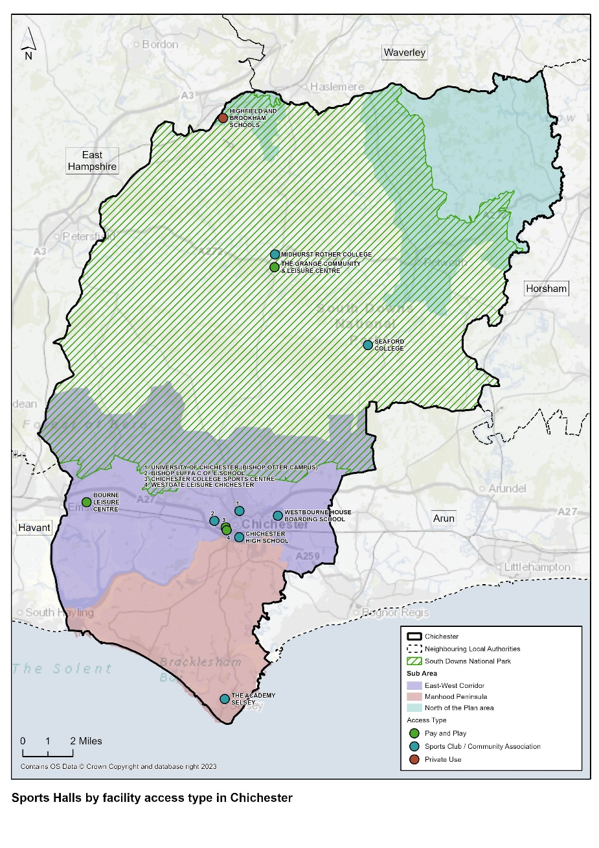
Table 15: Summary of Sports Halls in Chichester District

Summary Point | Total
Total number of Sports Halls (all strategic size i.e. 3 courts +) | 14
Total Number of Sites | 12
Sports halls with community pay and play access (strategic size 3+ courts) | 4  - Bourne Leisure Centre  - Chichester College Sports Centre  - The Grange Community and Sport Centre  - Westgate Leisure Centre
Sports halls with community access available for use by sports clubs and groups (strategic size 3+ courts) | 8  - Bishop Luffa C of E School  - Chichester High School  - Midhurst Rother College  - Seaford College  - The Academy Selsey  - University of Chichester (Bishop Otter Campus) x 2  - Westbourne House Boarding School
Sports halls available for use by registered members (strategic size 3+ courts) | 0
Sports halls available for private use only (strategic size 3+ courts) | 2  - Chichester High School (Tim Peak Sport and Conference Centre)  - Highfield and Brookham School
Sports halls on education sites and managed by schools or colleges | 11  - Bishop Luffa C of E School  - Chichester College Sports Centre  - Chichester High School  - Chichester High School (Tim Peake Sport and Conference Centre)  - Highfield and Brookham School  - Midhurst Rother College  - Seaford College  - The Academy Selsey  - University of Chichester (Bishop Otter Campus) x 2  - Westbourne House Boarding School
Sports halls managed by Everyone Active on behalf of Chichester District Council | 3  - Bourne Leisure Centre  - The Grange Community and Leisure Centre  - Westgate Leisure Centre
Sports halls managed by a Community Organisation | 0

  - There are a total of 25 activity halls across 22 sites. These are fairly evenly distributed across the district and reflects the smaller localised catchment for which the majority serve, often located in smaller village halls and community centres. Table 16 details all the activity halls in the district. Activity halls often cater for more than sport and physical activity but provide for wider community use sessions such as dance classes, arts/craft events and programmes, birthday parties, social gatherings and meetings.

  - There is only 1 activity hall which is available for pay and play community use. This is a 2 badminton court hall located in The Grange Community and Leisure Centre.

  - There are 15 activity halls which are available to hire by local sports clubs/community associations; 11 of these are purpose built standalone facilities (mainly community centres or village halls) and 4 are halls within education buildings.

  - There are 8 activity halls which are for private use only; these are all located within school, college or university facilities and are used by students only. 2 of these halls are located at the University of Chichester.

  - A total of 1 activity hall is 2 badminton courts in size; 19 activity halls are 1 badminton court in size; and 5 are less than 1 badminton court in size.

Table 16: Supply of Activity Halls in Chichester District

Site Name | Post Code | Facility Type | Number Badminton Courts | Access Type | Ownership Type | Management Type | Pay and Play | Year Built | Year Refurbished
Bishop Luffa C of E School | PO19 3HP | Activity Hall | 1 | Private Use | Academies | School/College/University (in house) |  | 1962 | N/A
Bourne Community College | PO10 8PJ | Activity Hall | 1 | Private Use | Community School | School/College/University (in house) |  | 1975 | N/A
Boxgrove Village Hall and Community Centre | PO18 0EE | Activity Hall | 0 | Sports Club/community Association | Community Organisation | Local Authority (in house) |  | 2010 | N/A
Bracklesham Barn | PO20 8HU | Activity Hall | 0 | Sports Club/Community Association | Local Authority | Community Organisation |  | 2008 | N/A
Chichester High School | PO19 8EB | Activity Hall | 1 | Sports Club/Community Association | Academies | School/College/University (in house) |  | 1927 | N/A
Chichester High School | PO19 8EB | Activity Hall | 1 | Sports Club/Community Association | Academies | School/College/University (in house) |  | 1927 | N/A
Chidham Parochial Primary School | PO18 8TH | Activity Hall | 1 | Sports Club/Community Association | Voluntary Controlled School | School/College/University (in house) |  | 2005 | N/A
Down View Park | PO20 8NS | Activity Hall | 1 | Sports Club/Community Association | Local Authority | Sport Club |  | 2018 | N/A
Easebourne C of E Primary | GU29 9AG | Activity Hall | 1 | Private Use | Voluntary Controlled School | School/College/University (in house) |  | 1969 | 2013
East Wittering Community Primary School | PO20 8NH | Activity Hall | 1 | Private Use | Community School | School/College/University (in house) |  | 1980 | N/A
Fernhurst Village Hall | GU27 3EH | Activity Hall | 1 | Sports Club/Community Association | Community Organisation | Community Organisation |  | 1909 | 2009
Hampers Green Community Centre | GU28 9NL | Activity Hall | 0 | Sports Club/Community Association Use | Local Authority | Local Authority (in house) |  | 2001 | N/A
Kelsey Hall | RH14 0UD | Activity Hall | 0 | Sports Club/Community Association | Community Organisation | Community Organisation |  | 1978 | 2002
Lodsworth Recreation Ground | GU28 9BY | Activity Hall | 1 | Sports Club/Community Association | Community Organisation | Community Organisation |  | 2001 | N/A
New Park Community Centre | PO19 7XY | Activity Hall | 1 | Sports Club/Community Association Use | Local Authority | Community Organisation |  | 2011 | N/A
New Park Community Centre | PO19 7XY | Activity Hall | 1 | Sports Club/Community Association Use | Local Authority | Community Organisation |  | 1887 | Not Known
Oakwood School | PO18 9AN | Activity Hall | 1 | Private Use | Other Independent School | School/College/University (in house) |  | 1990 | N/A
Selsey Centre | PO20 0SE | Activity Hall | 1 | Sports Club/Community Association | Local Authority | Local Authority (in house) |  | 2007 | N/A
Sidlesham Primary School | PO20 7NL | Activity Hall | 1 | Sports Club/Community Association | Community School | School/College/University (in house) |  | 2003 | N/A
Sidlesham Recreation Ground | PO20 7RD | Activity Hall | 0 | Sports Club/Community Association | Local Authority | Sport Club |  | 2022 | N/A
St Anthony’s School | PO19 5PA | Activity Hall | 1 | Private | Community Special School | School/College/University (in house) |  | 2005 | N/A
The Grange Community & Leisure Centre | GU29 9HD | Activity Hall | 2 | Pay and Play | Local Authority | Commercial Management | Ö | 2014 | N/A
The March C of E Primary School | PO18 0NU | Activity Hall | 1 | Private Use | Voluntary Aided School | School/College/University (in house) |  | 1990 | N/A
University of Chichester (Bishop Otter Campus) | PO19 6PE | Activity Hall | 1 | Private Use | Higher Education Use | School/College/University (in house) |  | 2000 | N/A
University of Chichester (Bishop Otter Campus) | PO19 6PE | Activity Hall | 1 | Private Use | Higher Education Use | School/College/University (in house) |  | Not Known | N/A

Map 5: Activity Halls by Access Type Chichester District

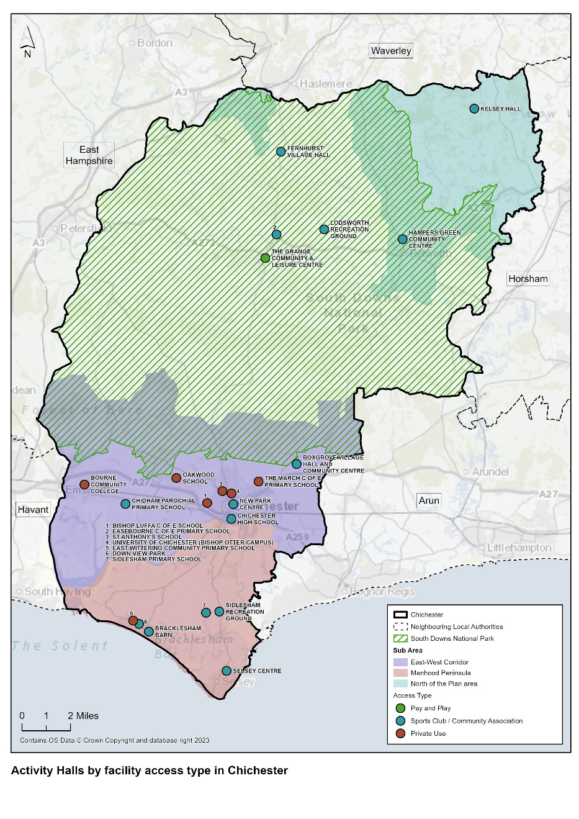
Table 17: Summary of Activity Halls in Chichester District

Summary Point | Total
Total Number of Activity Halls | 25
Total Number of Sites | 22
Activity Halls for private use only on educational sites | 8  - Bourne Community College  - Easebourne C of E Primary School  - East Wittering Community Primary School  - Oakwood School  - The March C of E Primary School  - University of Chichester (Bishop Otter Campus) x 2  - St Anthony’s School
Activity halls with community access available for use by clubs and groups | 15  - Boxgrove Village Hall and Community Centre  - Bracklesham Barn  - Chichester High School x 2  - Chidham Parochial Primary School  - Down View Park  - Fernhurst Village Hall  - Hampers Green Community Centre  - Kelsey Hall  - Lodsworth Recreation Ground  - New Park Community Centre x 2  - Selsey Centre  - Sidlesham Primary School  - Sidlesham Recreation Ground
Activity halls on education sites with community access available for use by clubs and groups | 3  - Chichester High School x 2  - Chidham Parochial Primary School
Activity Halls with community pay and play use | 1  - The Grange Community and Leisure Centre

Sports Halls and Activity Halls - Quality

  - Detailed quality assessments were undertaken on all of Chichester District’s indoor sports facilities (December 2023 – Jan 2024) by way of a site visit and visual assessment of the facilities. Each quality assessment looks at the age and condition of the facility, whether it is physically accessible, and if it is fit for purpose,

  - The individual sports hall/activity hall quality assessments are provided in Appendix 3 and are summarised in Table 19 and Table 20. It was not possible to access some of the schools and community centres/village halls and therefore data was collected for these via the internet and online survey. The quality scores are explained in paras 6.7 – 6.9 and Table 18. It is important to note that:

- A facility scoring highly in terms of visual quality and condition (good – excellent) is likely to require less investment than one which is in a poorer visual condition (average – very poor). The combination of the scores, results in the facility rating, and identification of investment need (significant, moderate etc.).

- It is important to highlight that in undertaking the quality assessments, each element of the facility e.g. sports hall, pool etc is given a qualitative assessment, and the overall facility is also given an overall qualitative mark. Therefore, a sports hall can be of poor quality, but the overall facility score could be good. (Overall scores for each facility are included in Appendix 3).

Quality Ratings

Table 18: Quality rating scale (from Sport England guidance)

Percentage | Rating
>80% | Excellent
60% - 80% | Good
40% - 59% | Average
20%-39% | Poor
<20% | Very Poor

  - The sports halls in the Chichester District are in relatively good condition and there has been a good record of investment in new facilities and modernisation of older sites. A total of 12 out of the 14 sports halls in the district were built or refurbished within the last 25 years, with the average age of sports halls in the district being 19 years. The average lifespan of a community sports hall is circa 35 – 40 years.

  - Consideration should be given to planning towards the refurbishment/replacement of sports halls at Highfield and Brookham School, Bishop Luffa C of E School, and the University of Chichester within the next 10 – 15 years. Bishop Luffa C of E School and the University of Chichester provide community club access but only have in place unsecured community use arrangements with local sports clubs.

  - The oldest sports hall is located at Highfield and Brookham School and was built in approximately 1950 and is used exclusively by pupils. The school has identified this as in need of refurbishment and is part of a long term plan for development at the school. However, it is unclear whether the school would be receptive to opening up the sports hall to community use following refurbishment.

Table 19: Summary of the qualitative Assessment of Sports Halls in Chichester District

Facility Name | Quality Score | Commentary
Bishop Luffa C of E School | 75% | Good quality facilities hired out to clubs and local organisations 7 days a week. No formal Community Use Agreement in place.  Full disability access and good car parking available on site.
Bourne Leisure Centre | 79% | Formal dual use agreement in place with CDC. Facility is approximately 20 years old and is on the same site as Bourne Community College. The school has links with local sports clubs e.g. judo, karate, badminton, fencing, gymnastics and yoga.  Dedicated changing and toilets for the public.  Sports hall is in excellent condition. The site has dedicated changing and toilets for the general public which helps maintain separation from pupils during the day and allows daytime public use of gym and studios. 764 members of the centre.
Chichester College Sports Centre | 61% | The site benefits from having a sports centre reception for serving the community.  The sports hall is in good condition but has long term leak to the roof resulting from when PV panels were installed 10 years ago.  Dedicated changing and toilets for the public. There is a lift to the first floor.  The college has priority use of the sports hall until 3pm weekdays. Used by community including local gymnastics club  The climbing wall in the sports hall is heavily used 5 days out of 7, by schools, clubs, scouts etc.  The gym is open for public use at certain times of the day between 6am and 10pm depending on the curriculum.  Key clubs which hire the sports hall include Kamon Martial Arts, Sussex Performance Football Centre, Badminton, table tennis and a number of one off bookings.  The college has a formal Community Use Agreement in Place. The gym has 600 members and there are 200 students who live on campus and have access to the sports facilities included in their accommodation charge.
Chichester High School | 71% | 4. court Sports hall within the former Girls School is in good condition and hired out to local sports clubs but predominantly basketball. There is no formal Community Use Agreement in place. However, Active Sussex is working with the school through the Sport England Opening School Facilities Fund to help open up their sports facilities to community use during evenings, weekends and holidays, and this is moving in a positive direction.  The Tim Peak Sports and Conference Centre was established when the girls’ and boys’ schools merged in 2016. A separate 5 courts sports hall is housed in this building and is leased exclusively to Chichester Olympic Gymnastics Club on a 10 year lease. The condition of this sports hall is good. Used also by the school for gymnastics.
Highfield and Brookham School | 57% | This is a private boarding school for children aged 9 – 13 years. Isolated rural location so reliance on car.  Sports facilities are housed in a separate building. The 3 court sports hall and squash court are older in age (built in the 1950’s) than the pool facility and are in need of refurbishment. Private use only.  There is disability changing and shower accommodation in the sports building.  There is a long term ambition of the school to rebuild the sports complex and retain the existing pool. Unlikely to keep squash court if they do this.  The school does hire out some of its facilities for community use on a restricted basis outside of school hours e.g. the school runs a private swim lesson programme for public (1000 users) and their external astroturf pitch is hired out to external clubs – Liphook FC and Hazelmere Hockey Club are key hirers. Safeguarding issues because of having boarders on site.
Midhurst Rother College | 79% | Sports hall, health and fitness suite and climbing wall all located in separate adjacent building to the main college site. Built approximately 15 years ago.  Sports hall is in good condition and benefits from full disability access throughout, good public transport links and good parking.  Sports hall is let to community clubs outside of college hours. Health and fitness suite is used by pupils only. There is a climbing wall located in a purpose built room and is used by students during the day and Chichester Climbing Club outside college hours.  There is no Community Use Agreement in place.
Seaford College | 84% | Private college in rural location on private estate. Sports hall built in 1975 and in good condition offering community sports club use. Gym refurbished in 2017 and in excellent condition.
The Academy Selsey | 75% | Sport hall in good condition and hired out to community clubs/organisations but not at weekends. Academy school and part of The Kemnal Academies Trust. No formal Community Use Agreement.
The Grange Community & Leisure Centre | 89% | The community hub building is approximately 10 years old and in excellent condition. Everyone Active manages the whole building, which incorporates a library and registrar’s office.  The sports hall is in excellent condition and used for badminton, walking football, long mat bowls (club use this facility out of season), no strings badminton, stoolball, gymnastics. Full disability access including 2 Sport England Changing Places toilets.
University of Chichester (Bishop Otter Campus) | 56% | The sports hall and Sports Dome are both in good condition and are let out to the local community sports clubs, mainly on a seasonal basis. Sports Dome is used by Chichester Netball League, Chichester Basketball Club, triathlon, handball, and the Chelsea Football Foundation.  The Sports Dome lacks adequate temperature control and floor surface issues through design and maintenance issues have inhibited usage. Floor surface issues have been resolved through the installation of a DYNAMIK Flexi-Beam Plus Sprung System Finished in a Sports Seamless Polyurethane Playing Surface installed 2022).  The two ground floor changing facilities were fully refurbished in the summer of 2023 and now provide inclusive changing and shower facilities for individuals and teams.  There is no Community Use Agreement in place but the University offers indoor sports facility access to a range of community clubs and events subject to mutually beneficial arrangements.
Westbourne House Boarding School | 93% | The 4 badminton court sports hall is in excellent condition (refurbished in 2021) as are all the sports facilities at school. Limited allocation to community use in the form of block and no formal Community Use Agreement in place. Will consider requests for use to fit in around the school’s programme of activity.
Westgate Leisure Centre | 65% | The pay and play community use sports hall with sprung wood floor is in excellent condition. Maintaining required temperature continues to be an issue. Full disability access on site (including a Sport England Changing Places toilet/change) following a disability audit undertaken a few years ago. There is good car parking provision adjacent to the leisure centre.  There has been investment in the site in recent years but the wet changing rooms do need refurbishing.

  - The activity halls in Chichester vary significantly in terms of quality, reflecting the variable age of the facilities. Bourne Community College, Chichester High School and East Wittering Community Primary School all have activity halls over 40 years old in age that have not been refurbished. There are other activity halls of a similar age that have been refurbished in the last 25 years, located at Easebourne C of E Primary School, Fernhurst Village Hall, Kelsey Hall, and New Park Community Centre.

  - Some of the quality scores for halls are affected, not so much by the quality of the activity hall itself but by the limitations of the building which it is located in i.e. older buildings often have poor disability access or a high street location with poor parking because the facility originally served just the immediate community without reliance on use of a car.

  - The parish and town Council survey identified the following quality issues relating to following sites:

- Birdham Village Hall – main hall in unsatisfactory condition and in need of refurbishment
- Hunston Village Hall – changing room in need of refurbishment
- Stoughton Parish Hall – main hall in unsatisfactory condition and in need of refurbishment
- Boxgrove Pavilion – changing room in need of refurbishment
- Wisborough Green Sports Pavilion – in unsatisfactory condition (to be addressed. See Table 21)

Table 20: Summary of the qualitative Assessment of Activity Halls in Chichester District

Facility Name | Quality Score | Commentary
Birdham Village Hall | - | Unsatisfactory condition and in need of refurbishment – identified from Parish and Town Council Survey
Bishop Luffa C of E School | 75% | As per Table 19. Activity hall of good quality.
Bourne Community College | 61% | The activity hall is one the Bourne College school site and separate to the dual use leisure centre. This facility is managed by Everyone Active alongside the dual use leisure centre facilities as part of the CUA with the college. It is not clear why this hall is therefore identified separately to Bourne Leisure Centre on the Sport England Active Power database.  The hall is in average condition and used for badminton, children’s football training, karate etc.
Boxgrove Village Hall/pavilion and Community Centre | 79% | The activity hall is in excellent condition and hired out to sports clubs/community associations. No pay and play access available. The hall is well signposted with good car parking. Changing room in need of refurbishment.
Bracklesham Barn | 79% | The activity hall is in good condition and has a sprung wooden floor, marked out for badminton. Refurbished since 2017. Changing rooms are provided behind the stage.  The hall has a capacity for 100 people. Sound system is provided in the room. Modern wooden vaulted ceiling. Used for Pilates, Kick Boxing, Badminton, table tennis, short mat bowls, roller skating and yoga. Full disability access, good signposting and car parking provision on site. Changing Places toilet/changing room recently added.
Chichester High School | 71% | As per Table 19. 2 activity halls, both rated as of good quality.
Chidham Parochial Primary School | 61% | The hall is in good condition and hired out to local community groups e.g. scouts. There is very limited parking available on site but close to public transport.
Down View Park | 96% | Local authority owned community centre. Activity hall is in excellent condition with full disability access, badminton court and shower facilities.
Easebourne C of E Primary | 59% | 1 badminton court size activity hall used by the school. The school does not promote the activity hall for community use and has no regular club lets.
East Wittering Community Primary School | 50% | The hall is in average condition and primarily used by the school only. There is also an outdoor lido on site
Fernhurst Village Hall | 46% | The activity hall is one badminton court size and is in average condition. The hall is run by a registered charity and is located in a building dating back to 1909. The activity hall includes a stage and is available for hire by a range of community groups. There is a large kitchen and meeting room on site.  There is a disabled toilet and automatic front doors to the building.
Hampers Green Community Centre | 46% | The activity hall is in average condition, used for functions, parties, exercise classes etc. There is a kitchen on site and partial disabled access.
Hunston Village Hall | - | Changing room in need of refurbishment – identified from Parish and Town Council Survey
Kelsey Hall | 75% | The activity hall is in excellent condition, built in 1978 and used by community groups including yoga, Zumba, children’s groups.  It was extended in 2002 to provide additional storage. There is parking for 25 cars. There is a small meeting room, kitchen and disabled toilet in addition to the main activity hall. Serves the immediate local community.
Lodsworth Recreation Ground | 71% | The activity hall is in good condition and is marked out for badminton. Built in 2000.  There is a stage at one end 8m x 12m. There is a second small hall/meeting room and commercial kitchen.  The hall is hired for theatre productions, parties, meetings, social everts etc. There are disabled toilets on site.
New Park Community Centre | 80% | The Community Centre consists of 2 buildings; the original Victorian school building and a new Jubilee Hall extension that was constructed in 2011. One of the activity halls (Jubilee Hall) is located in the Jubilee Hall and is used by various community groups including Pilates, yoga, Slimming World, dance Groups, birthday parties etc. The hall is in good condition.  There is a purpose built Dojo within the same building, which was financed in part by Sport England.  There is a second activity hall located in the school building; this is the called the Old Dojo and is much older in age but in good condition and includes a small viewing gallery. Capacity for up to 120 people. Used for dance, sports activities, community events and training/adult learning.  There is full disability access in the new extension and partial access in the school building. Limited car parking. Cafe on site.
Oakwood School | 71% | The private school has an activity hall which is of good quality
Selsey Centre | 96% | Facility built in 2007. Owned by Chichester District Council and operated by the Town Council. Activity Hall is in excellent condition with a sprung wooden floor and is hired out to a range of community organisations including dance, Pilates, dog training, Slimming World, Art Club, Indoor Kids Football and Tao Dragons Martial Arts. The facility is currently closed until March 2024 whilst building works take place to increase toilet provision and the installation of a Sport England Changing Places Toilet. Hirers are using the Town Hall in the interim.
Sidlesham Primary School | 57% | Activity hall is in average condition with full disability access, some car parking and served by public transport. Hired out to sports clubs and community associations.
Sidlesham Recreation Ground | 50% | Activity hall with stage and integral bar. Facility also has 2 smaller halls and kitchen. Operated by Sidlesham Community Association.
St Anthony’s School | 55% | Activity hall in good condition and hired out for community use. The pool on site used to be hired out to the community but this has stopped due to priority given to pupil usage for swim lessons.
Stoughton Parish Hall | - | Main hall in unsatisfactory condition and in need of refurbishment – identified from Parish and Town Council Survey
The Grange Community & Leisure Centre | 89% | The Grange has 2 activity halls used for a range of activities including falls prevention, Better Balance classes, Dementia Hub, NHS Fundin Services, MIND etc. All facilities on site are in excellent condition reflecting the age of the facility (built in 2014).
The March C of E Primary School | 57% | Activity hall in average condition and 1 badminton court size. For private use only. There is full disability access and good parking. Not served by public transport.
University of Chichester (Bishop Otter Campus) | 56% | Activity Hall 1 is in relatively poor condition, partly used as a storage area and incorporating an indoor climbing wall along one wall, used to teach students how to teach climbing. The second activity hall is in average condition and again used only by students for activities including table tennis, dance and dodgeball.
Wisborough Green Sports Pavilion | - | Pavilion in unsatisfactory condition – as identified in Parish and Town Council Survey.

New Activity Halls and Refurbishments since 2017

  - Appendix 12 provides a summary of new and refurbished built facility projects undertaken within the Chichester District since 2017. Some of the facilities identified below are not included in the Sport England Active Places Database and are therefore not referenced above. Table 21 provides a summary of projects specifically relating to activity halls.

Table 21: Summary of activity hall refurbishment and new build projects since 2017 – Chichester District

Parish | Project
Chichester City | - Conversion of Graylingwell Chapel into Community Centre  - Chichester Boys Club Improvements  - Improvements to 5th Chichester Scout Hut  - Improvements to Regnum Guide Hall  - New clubhouse incorporating indoor shooting range for Chichester Bowmen. Location adjacent to Oaklands Park  - New community hall, Havenstoke Park – part of Chichester Community Development Trust, hall available for hire and used for exercise classes, dance theatre, kids’ classes etc  - New pavilion, Keepers Green
Chidham and Hambrook | - New community building on land adjoining Scant Road, West Hambrook  - Refurbishment of Chidham and Hambrook Village Hall
Donnington | - Extension to Village Hall
East Wittering & Bracklesham | - Down View Hall improvements containing multi sports including badminton, shower facilities etc  - Improvements to Bracklesham Barn Community Centre
Fishbourne | - Improvements to Fishbourne Community Centre
Loxwood | - Sports Pavilion Extension and Renovation
Oving | - Shopwyke Strategic Development area - new community hall as part of new housing development of 585 homes
Southbourne | - Village Hall Improvements and improvements to sports pavilion
Tangmere | - Tangmere Centre improvements
Westbourne | - St John’s parish hall improvements
Westhampnett | - New community hall
Wisborough Green | - Village Hall improvements – phase 1 completed  - Architect and planning fees to progress improvements or rebuild of sports pavilion

Sports Hall and Activity Hall Demand in 2024

Survey Responses (Education Institutions, Sports Clubs and Parish Councils)

  - Detailed analysis is provided of education institution, sports club and parish council feedback in paragraphs 6.10 – 6.28.

Table 22: Summary of relevant Survey Responses – Education Institutions and Sports Clubs

Consultee Group | Summary Feedback
Education Institutions | - Only 5 out of the 16 respondent education institutions with a sports hall said that they had a formal community use agreement (CUA) in place. This means that there is very limited secured use of education facilities in the district; an education institution could choose at any time not to allow access to clubs.  - Access to education-based sports facilities are limited to sports clubs/community groups. This does not facilitate increased participation levels by those who are inactive.  - The majority of respondent schools rated the quality of their sports hall changing facilities as poor or average. There is therefore a need to improve ancillary accommodation across school sites to help improve the overall experience for community clubs hiring the sports hall.  - Boxgrove C of E Primary expressed a need for space on its site for delivery of indoor PE lessons.  - The University of Chichester, when consulted, confirmed that: ‘There is no Community Use Agreement in place but the University offers indoor sports facility access to a range of community clubs and events subject to mutually beneficial arrangements. This remains to position and we work well with the local community and access to our facilities in the available hours where we are not teaching or providing facilities for student recreational and competitive sport.  - Many activity halls on education sites, particularly primary school are used for multiple functions including school lunches, assemblies as well as indoor physical activity.
Sports Clubs | - The majority of sports clubs hire sports facilities within the East-West Corridor and specifically in the city of Chichester. This reflects the fact that this is the main urban area within the district.  - The majority of sports clubs feel that the facilities they hire suit their club needs most of the time and rate these facilities as good.  - Increasing club membership and the number of volunteers are seen as key priorities, followed by reduced hire costs and improving the club’s financial situation.  - A request for support in replacing larger sports hall equipment (specifically gymnastics) was raised by a club in reference to Westgate Leisure Centre sports hall.
Parish Councils | - The majority of parish council provide at least 1 activity hall within their parish boundary.  - The majority of activity halls are described as being of good or excellent quality, with only Birdham Village Hall, Stoughton Village Hall, and Wisborough Green Sports Pavilion described as unsatisfactory.  - Hunston Village Hall, Boxgrove Pavilion and Wisborough Green Sports Pavilion changing rooms are also described as unsatisfactory.  - Hunston Parish Council is looking at options to build a new community hall going forwards.  - Replacement sports Pavilion Wisborough Green Parish needed. Planning application is with Chichester District Council but yet to be determined.  - Potential refurbishment of Sidlesham Memorial Recreation Ground Hall.  - No sport and leisure facilities within Earnley Parish Council and nearest facilities are private and expensive to join. Affordable facilities are located a long distance away.  - Plans to rebuild Kirdford sports pavilion (previous one burned down)

National Governing Bodies (NGBs)

  - Consultation was undertaken with NGBs to identify their views on the need for sports hall provision in Chichester District. The views of NGBs (representing sports hall sports) who responded are included in Appendix 4. Based on the feedback provided, the following priorities have been identified:

Table 23: Feedback from National Governing Bodies of Sport – Chichester District

NGB | Feedback
England Netball | England Netball current priorities for the Chichester District Council area are to continue to support local clubs and leagues to deliver core netball. Support partnership agreements of Back to Netball and Walking Netball to boost community outreach, in partnership with Chichester Netball Club. Support prospective Walking Netball Club Kingfishers, who play at Westgate become an official Partnership Agreement club once their coach has completed the Walking Netball Host training course.  Key clubs in the district are as follows:  - Chichester Netball Club is the largest club in the area. They run all ages and two sessions with an England Netball Partnership Agreement for Back to Netball and Walking Netball in the community. The club compete from U9 -U17 in junior squads, alongside three adult teams who compete in the Chichester Netball League – Bishop Luffa School and University of Chichester.  - Footloose Netball Club– Westgate & Bishop Luffa School & University of Chichester  - Six villages – Junior club – University of Chichester  - Chichester University Netball club – running in the Dome at Bishop Otter Campus University of Chichester  - Chichester Netball League, two division local England Netball registered league, also running in the Dome at the University of Chichester  - Planet Netball Academy – Junior league ran by local volunteer – Bishop Luffa School  What might be needed to support England Netball priorities in future includes:  - Increased courts space. This has always been an issue in Chichester.  - England Netball recently supported Westgate Leisure Centre putting netball court lines down in the sports hall. However, they are smaller than regulations, so can be used recreationally only, not for club games at a local or higher level
England Fencing | England Fencing current priorities are to address the under-representation of the sport in the general population. Within our Region/County structure, Chichester is in Sussex in the South-East Region and, while the Region itself is quite active, it is possible that improvements could be made at County level. As the 'Capital City' of Sussex, Chichester would be a potential focal point for these improvements.  Key clubs in the Chichester district are Chichester Fencing Club, providing training for all ages (pre-teen upwards) and all ability levels from novice to competitive fencer. Wheelchair users and those with mobility issues are also provided for. The club currently use Chichester high School for Girls.  What might be needed to support England Fencing priorities in future include:  - Availability of affordable venues is a persistent problem in the establishment and the continuance of community clubs. While we might be able to raise the profile of Fencing in an area and recruit a body of interested participants, any new club is likely to founder if the hire cost of the venue is high.  - Similarly, the increasing scarcity and rising costs of Venues capable of hosting a Fencing Tournament is reflected in a smaller Events Calendar with most of those remaining events taking place in the larger conurbations.  - In consideration of the above, any steps that could be taken to curb Venue-hire costs and to open up the availability of suitable venues apart from the purpose built 'Sports Centres' (community rooms, school sports facilities etc) would be beneficial.
British Gymnastics | There is no geographical focus in the British Gymnastics Strategy. Focus is based on need, suitability, and partners’ ability to support a project to successful completion. The British Gymnastics Facility Strategy priorities for the period 2017 – 2021 are:  - Support increased capacity within gymnastics through clubs, leisure providers and other delivery providers.  - Guide funding investment through the United Kingdom from British Gymnastics, Home Country Sports Councils, Local Authorities, and other potential funders.  - Maintain and improve the quality of facilities and equipment within existing delivery partners.  - Develop insight, understanding and direction of how Facility Developments can contribute towards other BG Strategic Priorities.  England Gymnastics does not respond regarding the level of facility provision available in the Chichester District for gymnastics but comments that there is a definite trend for gymnastics clubs to move into their own dedicated facilities. Nationally there have been 150 completed facility projects over 4-year cycle and BG expects this trend to continue and an increased number of clubs move their activities to dedicated spaces/facilities. There is limited provision of access to facilities to gymnastic activities due to the lack of time within both dedicated and non-dedicated facilities and access to workforce. Most of the club’s report waiting list. Increasing inclusive access with a focus on ED&I is a priority to British Gymnastics.  No key facilities are identified in Chichester District for gymnastics.  Key clubs in Chichester District are:  Chichester Gymnastics Academy – 179 members – dedicated facility  Westgate Gymnastics – 213 members – non-dedicated facility  Southbourne Gymnastics Club – 255 members – non-dedicated facility  The Academy of Gym – 265 members – dedicated facility  The sport is experiencing a strong recovery post Covid with member numbers tracking at 5% under 2019. There is some demand for more gymnastics opportunities in Chichester with most clubs reporting waiting lists. We will support clubs and partners to move into dedicated facilities.
Basketball England | Key clubs in the Chichester district include:  - University of Chichester. This year the Club has two men’s teams in BUCS, as well supporting IM Basketball programme for recreational players. The club has a women’s section but not competing this season. Home venue Chichester University.  - Chichester Knights Basketball Club – 2 men’s teams Solent Area Basketball League. Home Venue Chichester Free School.  - Chichester Titans Basketball Club – 1 men’s team Solent Area Basketball League. Home venue Chichester Free School.  There are a total of 12 indoor sites for basketball in the Chichester District offering a total of 13 indoor courts. The largest indoor site is at Westgate Leisure Centre (2 courts). Basketball England identified no under supply of basketball courts in the district by 2032.  Basketball England’s key priorities are to:  - Increase participation and grow the community game through a retain and grow strategy.  - Develop, support and sustain a high quality infrastructure network that inspires the next generation and meets the needs and demands of the game in the future – through accessible playing environments and facilities.  - Develop a world class talent system for players, volunteers and professionals to develop in an inclusive and progressive way and fulfil the sports potential.  - Govern, shape and service basketball in an efficient and effective way, so it is safe, fun, engaging, inspiring and attractive to investment as a recognised high performing and fully sustainable sport.
England Table Tennis | We currently have no Associated Clubs and no Affiliated clubs in the Chichester local authority. We do have 65 paid members who reside in the area.  There is currently enough provision for table tennis in the area.  With the reduction in suitable indoor facilities and the increase in rental charges, facilities remain the single biggest issue for our clubs nationwide.  Chichester sits in an area earmarked for future development especially in Junior and Women’s & Girls participation. This will require improved facility provision if this is to take place.  We do not have any existing funding we are able to supply for facility development at present.  NGB has not identified any clubs but has members in the area. North Mundham Village Hall provides table tennis facilities and is home to a table tennis league on Wednesdays  Fernhurst and Midhurst Table Tennis Club have four teams in the Haslemere and District Table Tennis League. Play Fernhurst Village Hall.

Facility Planning Model (FPM) Findings

The FPM study is a quantitative, accessibility and spatial assessment of the supply, demand, and access to sports halls.

As agreed with Chichester District Council, the FPM National Standard Run provides a baseline assessment of provision in Chichester District in 2023.

Key Findings

The key findings in 2023 are as follows:

- A high proportion of Chichester District’s demand for sports halls is met, which is similar to the national average.
- However, the distribution of sports halls across the district does not align with demand.
- Two sports halls (Westgate Leisure Centre and The Academy, Selsey) are estimated to be uncomfortably full at peak times while others are under-utilised.
- The total sport hall space in Chichester District included in the FPM equates to 48.7 badminton courts. However, only 35.5 courts are available during the weekly peak period.
- The education sector provides 51% of the available capacity in the district in the weekly peak period and has scope to increase capacity if required.
- The resident population generates demand for 9,838 visits in the weekly period which equates to 33.4 badminton courts with a comfort factor included.
- The available supply of sports halls for community use is therefore greater than demand.
- The 3 public sports halls provide 49% of the available capacity in the Chichester District in the weekly peak period.
- 91% of demand for sports halls from Chichester District residents is met in 2023.
- 81% of Chichester District’s satisfied demand is met at sports halls within the district, with 19% exported and met at sports halls outside the district.
- 26% of Chichester District residents are within a 20 minute walk of a sports hall. This is lower than neighbouring authorities and regional and national averages.
- Unmet demand is low and is the equivalent of 3 badminton courts. Nearly all unmet demand (98%) is from residents who live too far from a sports hall and is not due to lack of capacity.
- There is wide variation in the estimated used capacity of the individual sport hall sites, ranging from 11% to 100%. Westgate Leisure Centre and The Academy, Selsey, are estimated to be uncomfortably full (more than 80% utilised).
- There is no scope to increase capacity at peak times at Westgate Leisure Centre. However, Chichester College Sports Centre and Chichester High School are both close to Westgate Leisure Centre and have spare capacity. It may be possible to work with these sites to meet some of the demand that currently goes to Westgate Leisure Centre. Chichester High School has a 4 court sports hall and 2 activity halls that were built in 2008 and would therefore be the best site to target.
- The Academy Selsey has a 4 court sports hall built in 2009 but is only available for community use 54% of the weekly peak period. There is scope to extend this by up to 21 hours per week. This would reduce used capacity to a comfortable level and also meet unmet demand in the area and improve local access to sports halls.
- There is wide variation in local share across the district, with residents in the South Downs National Park area being able to reach plenty of supply and residents in the south not having sufficient supply.

N.B. Facilities excluded from the FPM National Standard Run are those sports halls deemed to be private, too small, closed or lack of information available, particularly relating to hours of use. It should be noted that the University of Chichester and Bishop Luffa C of E School sports halls have been excluded as identified as private. Highfield and Brookham School sports hall is also identified as available for community use.

Sports Halls and Activity Halls - Accessibility

  - Map 6 presents a 20 minute drive catchment and 10 minute walk catchment for all sports halls within and outside the Chichester District boundary. The map presents a varied picture which reflects in part the urban and rural geography of the district. A large proportion of the East West Corridor is within a 20 minute drive catchment of both Chichester District Sports Halls and those sports halls in neighbouring Havant and Arun. Those areas outside a 20 minute drive catchment in the East West Corridor are in and around the sparsely populated coastal areas of West Thorney and Thorney Island.

  - According to the Sports Hall FPM, demand for sports halls is highest along the East West corridor (A27) and greatest in Chichester City Centre where there are 6 sports hall, with the greatest densities of demand immediately east and north of the Westgate Leisure Centre. The sports halls in the city are therefore well located. The areas of highest deprivation in the district are both located within the city, where Chichester High School is located, and Portfield, located within walking distance of the University of Chichester.

  - The majority of the Manhood Peninsula is served by The Academy in Selsey, those sports halls located in the city of Chichester or those located in neighbouring Arun and Havant. Outside of the city of Chichester, Selsey has the highest demand for sports halls. The Academy is only available for community use by sports clubs outside of school hours and there is no secured Community Use Agreement in place with the school. Those areas not within a 20 minute catchment are around the coastal areas of West Wittering and Bracklesham Bay which are sparsely populated areas. The catchment area reflects the limited road network within the Manhood Peninsula. This is particularly noticeable in and around the town of Selsey, where there is one main road in and out of the town.

  - The whole of the South Downs National Park is within a 20 minute drive time catchment of a sports hall. Midhurst Rother College, The Grange Community and Leisure Centre, and Seaford College catchments extend to most of the South Downs National Park with the exception of areas in the far north east and south west, but these areas are all within 20 minute drive catchments of neighbouring local authority sports halls.

  - The North of the Plan area has no sports halls but is within a 20 minute drive catchment of sports halls within the South Downs National Park and those located in Horsham and Waverley District Councils.

  - The Chichester Sports Hall 20 minute drive catchment areas extend into all neighbouring local authority areas, but to a lesser extent in Horsham. There are sports halls in all of the neighbouring local authorities close to the Chichester District borders.

  - Map 7 presents a 20 minute drive catchment and 10 minute walk catchment for all activity halls within and outside the Chichester District administrative boundary. The map presents a very similar picture to that of sports halls. However, the main difference is that the North of the Plan area is almost entirely within a 20 minute drive catchment of Chichester activity halls. This is essentially due to the location of Kelsey Hall and Hampers Green Community Centre.

  - 89% of journeys to sports halls in the district are made by car which is higher than the regional and national average. This corresponds with the low number of households in Chichester District, (13% ) with no access to a car; this compares to an average of 16% in West Sussex and 23% in England. The percentage of the population without access to private transport is important, because it influences travel patterns to sports halls. If there is a high percentage of the population without access to a car, then a network of locally accessible sports halls for residents who either walk or use public transport to travel to a sports hall becomes much more important. Although the percentage of residents in Chichester District without access to a car is relatively low compared to West Sussex and England averages, there are pockets of deprivation, particularly in more rural parts of the District, where access to sports halls and more importantly, locally accessible activity halls will play an important part in delivering physical and mental wellbeing for residents. Similarly, Chichester District’s population is ageing and as people grow older, reliance on using private transport becomes more difficult.

  - Only 6% of journeys to sports halls are made on foot and 5% by public transport; this again reflects the rural nature of the district and reliance on car travel.

Map 6: Sports Halls with Pay and Play or sports club/association use with a 20 minute drive and 10 minute walk catchment in Chichester District
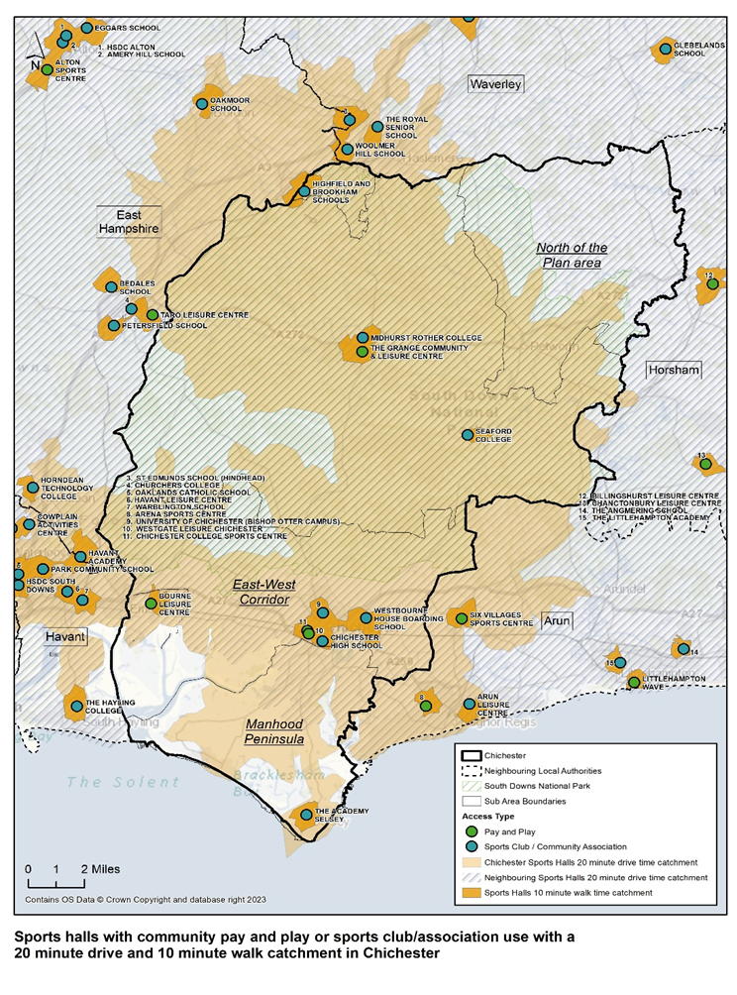
Map 7: Activity Halls with Pay and Play or sports club/association use with a 20 minute drive and 10 minute walk catchment in Chichester District
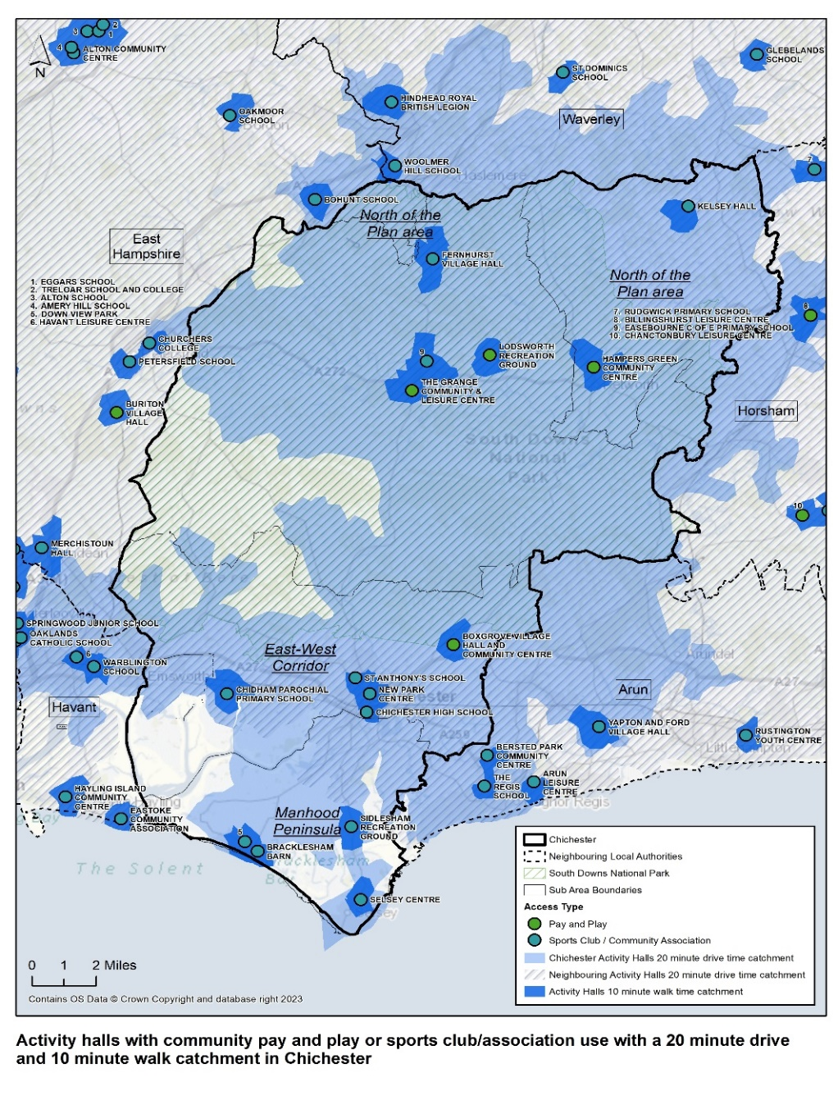

Sports Hall and Activity Hall - Availability

  - Tables 14 and 16, together with Maps 4 and 5 highlight that there is a high level of sports hall and activity hall provision in the Chichester District. However, the majority are on education sites and only provide for sports club/association use (usually outside of school hours).

  - Taking these sites out of the equation in terms of community access significantly reduces the number of sports halls and activity halls available. There is little impact on availability as the education facilities are principally available for sports clubs and groups, not pay and play access. Accessibility is also not impacted by excluding the education facilities as these are not accessible for pay and play use.

  - Whilst a community accessible pay and play sports hall would typically be open from 7am – 10pm weekdays and 9am – 6pm weekends, a facility on an education site, if open to community use is more likely to be open from 5pm – 9pm weekdays and 9am – 5pm weekends as demonstrated in Table 24. Opening hours for community halls vary significantly depending on how they are operated but they would typically not be open for as many hours as a community accessible sports hall.

  - Schools with community access (pay and play and sports clubs and community groups) were consulted with as part of this study and key information was provided relating to access arrangements and programmes of use.

Table 24: Summary of School Sports Facilities – Community Use

School | Access arrangements and Programme of Use
Bishop Luffa C of E School | School exclusive use of sports facilities 9am – 5pm weekdays. Community access outside of these times and Saturday and Sunday.
Chichester College | College has exclusive use of sports hall until 3pm weekdays. Pay and play use outside of these times. The gym and health and fitness suite are available for community pay and play throughout the day between the hours of 6am and 10pm at set times to fit around the college curriculum. The climbing wall in the sports hall is heavily used 5 days out of 7, particularly by school groups, and local clubs. The college also operate climbing walls at other venues including Bognar Arena, Hayling Secondary School and Midhurst College.
Chichester High School | School sports facilities used by the school 9am – 5pm weekdays and available for hire by sports clubs 5pm – 10pm weekdays and Saturday 8.30am – 10pm. There are limited community lets at present (predominantly basketball). However, Active Sussex is working with the school through the Sport England Opening School Facilities Fund to help open up their sports facilities to community use during evenings, weekends and holidays, and this is moving in a positive direction.
Chidham Parochial Primary School | School sports facilities used by the school 8am – 5pm weekdays. Community Club use only available weekdays 6pm – 9pm. Activity hall hired out by sports and community associations e.g. scouts
Midhurst Rother College | Community access to the sports facilities 5pm – 10pm Mod – Thurs, 2pm – 10pm Friday, and 7am – 4pm weekends. Health and Fitness Suite is for pupils only. Sports Hall and studio used by a range of local sports clubs and organisations. Chichester Climbing Club use the climbing wall outside of college hours.
Seaford College | Limited access for community club use at weekends only 9am – 5pm. School has exclusive use of all sports facilities at other times. There is no community access to the pool. No details of clubs provided.
Sidlesham Primary School | Activity hall available for club use outside of school hours. No details provided of community lets.
The Academy Selsey | Community use of the sports hall and activity hall 5pm – 10pm weekdays. No weekend usage. Block bookings only. No details provided of community lets.
University of Chichester (Bishop Otter Campus) | Activity Halls and gym are for student use only. All other facilities are used by students 8.30am – 5pm weekdays and the Student Union uses the facilities 5pm – 10pm Monday and Tuesday evenings. Community lets Wed, Thurs and Friday evenings. Saturday and Sunday is a mix of student and external community lets.  The Dome, which includes a 40m sprint track is predominantly used by Chichester netball league, Chichester Basketball, triathlon clubs and Chelsea Foundation. The University uses the Dome for teaching tennis but use Chichester Racquets and Fitness Club for tennis competition due to the Dome’s sprung floor.  Sports hall used by BUCS teams e.g. Basketball.  Outdoor J track is used by Chichester Runners and Athletics Club by juniors on Mon and Wed evenings in summer (April to Sept).
Westbourne House Boarding School | Facilities used by school Monday to Friday 8.30am – 6pm and Saturdays and 9am – 6pm Saturdays. Limited community club use. Westbourne Squash Club uses the squash courts and Bognor Badminton Club use the sports hall but no other external clubs mentioned.

Provision Requirements by 2039

  - The Sports Facility Calculator is a facility modelling toolkit, developed by Sport England to calculate the future need for provision of sports halls, swimming pools and indoor bowls, based on a specified population increase in an identified location.

  - The Sports Facility Calculator (SFC) provides a quantitative estimate of future need, but unlike the FPM the SFC model analysis does not identify specific locations for future provision. That needs to be informed by the nature and location of future housing development (where locations are known), local geography and accessibility, and, critically, the location of existing facilities.

  - This is because future demand may have the potential to be addressed through facility extension, or refurbishment, as well as new locations. However, in the absence of any other future demand calculator, the SFC provides an indicator of the level of future provision needed. The SFC can be applied to the same facilities as those modelled in the FPM, but it is important to highlight that the SFC does not identify need, which can only be established by applying the information regarding demand from new housing to the findings and recommendations of the evidence in a Built Facility Strategy (BFS).

  - Using the Sports Facility Calculator (SFC) it is possible to estimate overall future demand for provision of sports halls in Chichester District, based on the following population growth scenario for Chichester District:

Total of 10,678 new dwellings across the Chichester District 2021 – 2039 (Chichester District Council Local Plan area and South Downs National Park Local Plan area) and a population growth of 24,559 (additional dwellings x 2.3 national average population per dwelling).

Table 25: Sports Facility Calculator (SFC) – Chichester District Sports Halls

 | (A)  Current over-supply of Badminton Courts 2023 | (B)  Unmet demand for Badminton Courts 2023 | (C)  Future Demand for Additional Badminton Courts by 2039 | (D)  Total over-supply (-) /under-supply of Badminton Courts by 2039
Population increase 24,559 | 2.1 | 3.0 | 6.6 | - 7.5

N.B. Calculation uses population of 125,102 for Chichester District as used by Sport England in their Facility Planning Model for Sports Halls. This ensures that future demand/supply calculations directly correlate to the baseline calculations for current supply/demand and population figures used for these.

  - The SFC identifies an under provision of 7.5 badminton court by 2039 in the Chichester District. It should be noted however that the baseline calculations as taken from the Sport England Facility Planning Model excludes the sports halls at Chichester University, Bishop Luffa C of E School and Westbourne House Boarding School which are available for community use by sports clubs. Were these facilities included within the calculation then this would reduce the deficit in badminton court provision by 2039.

  - The education sector is the main provider of sports halls in the district but the public leisure centres do meet over half of the used capacity in the District. Continuing community use at the educational sites is important but it is dependent on establishing policy towards making their sports halls available. At present, there are only 2 secured Community Use Agreements in place across the district. These are with Chichester College and Bourne College. It is important that the District Council works with those educational establishments who currently let out their sports hall facilities to sports club use and establish formal Community Use Agreements going forward and where possible, increase availability for community use.

  - Westgate Leisure Centre and The Academy at Selsey are estimated to be at capacity at peak times. Both Chichester College Sports Centre and Chichester High School have spare capacity. It may be possible to work with these sites, together with the University of Chichester, to meet some of this current and anticipated future demand. They are all located within the city of Chichester and within the East – West Corridor catchment where the majority of future housing growth will be focussed.

  - The Academy in Selsey could extend its opening hours by up to 21 hours per week. This would increase the capacity and also meet unmet demand in the area and improve access to sports halls in the Manhood Peninsula.

Summary

By 2039 there is a need for an additional 7.5 badminton courts according to the SFC calculation. This takes into account the current over supply of badminton courts identified in 2023. This requirement excludes the current community use by sports clubs of sports halls at Chichester University, Bishop Luffa C of E Schools and Westbourne House Boarding School which would reduce this deficit.

Based on the evidence developed for this assessment, it is unlikely that there is this level of additional need for badminton courts because 15 courts are already being used by the wider community at Chichester University, Bishop Luffa C of E Schools and Westbourne House Boarding School. It is considered that supply actually meets demand.

Stage C

  - There are a number of key factors in Chichester District which impact on both current and future need for all types of built leisure provision. These are set out below in the sports hall section of the assessment but equally apply to all other facility types covered in covered in this report:

  - Changing demographics
  - Population growth
  - Housing development on strategic sites/areas identified for residential development in the Chichester District Council Local Plan area as identified in Table 3 including:
- Shopwyke
- West of Chichester
- Westhampnett/Maudlin Farm
- East of Chichester
- Southern Gateway
- Chichester City
- Southbourne
- Tangmere
- Bosham
- Hambrook/Nutbourne
- Loxwood
  - Reducing Health Inequalities – There are some very specific factors to which the provision of quality, affordable and accessible sports facilities can contribute:
- Encouraging a more active lifestyle;
- Maintaining an active lifestyle;
- Improved mental health;

  - Maintaining and growing participation levels in sport and physical activity to contribute to more active lifestyles

  - The identified need for sports hall provision is summarised in Table 26.

Table 26: Identified need for sports hall provision

Facility Type | 2023 | 2039
Sports Halls | An over provision of 2.1 badminton courts | 7.5 badminton courts (equivalent to 1.875 x 4 sports halls of 4 badminton court size), but this excludes the fact that 15 courts are already in community use but are excluded from the FPM calculations.

Table 27: Key issues, Impacts, and Implications by Facility Type – Sports Halls

Facility Type | Key Issues | Impact/Implications
Sport Halls | Under supply of sports halls to meet future demand | Increased demand as a result of population growth cannot be accommodated
 | Heavy reliance on sports hall provision on educational sites with no secured Community Use Agreements | Lack of control from Chichester district Council over supply of sports hall facilities.  Access to sports halls could be withdrawn at any time by the educational establishment.  12 sports halls on educational sites but only 2 of these have secured Community Use Agreements.
 | Westgate Leisure Centre sports hall are estimated to be full at peak times and has no scope to increase capacity | The facility is located in an area of high demand and is the only pay and play sports hall available in the city of Chichester. Potential to work with neighbouring sports halls at Chichester College, Chichester High School and the University to meet some of the demand.
 | The Academy in Selsey is in an area of high demand but is only available for community use for 54% of the weekly peak period. | There is scope to extend the opening hours by 21 hours per week to increase capacity.
 | The age of Westgate Leisure Centre | The Westgate Leisure Centre was built in 1987 and refurbished in 2005. The sports hall will need refurbishing/replacing in the medium term as this is a heavily used facility operating at capacity. This should be considered in conjunction with the refurbishment/replacement of the overall site which is reaching the end of its useful life.
Activity Halls | Improvements to the main hall and/or changing rooms at Birdham Village Hall, Hunston Village Hall, Stoughton Parish Hall, and Boxgrove Pavilion | Need to maintain these important local facilities which provide a valuable service/role to local communities

  - Given supply meets demand for sports halls in the district but there is significant provision of sports halls on education sites without secured community access, , there is a need to:

  - Maintain and extend existing community access of sports halls on educational sites and secure access where possible through the introduction of Community Use Agreements.
  - Seek to open up community access for pay and play, not just sports club access to existing sports halls on education sites.
  - Extend existing community access arrangements, particularly in areas of high demand for sports hall use in the city of Chichester, Selsey and Tangmere. Chichester District Council should focus specifically on Chichester College Sports Centre, The University of Chichester, Chichester High School, Westbourne House Boarding School and the Academy Selsey.
  - Any planning applications for new or refurbished sports halls in the district should be subject to a formal Community Use Agreement being agreed. Community use should seek to include pay and play access and not just sports club access.

  - Residents in the South Downs National Park are able to reach plenty of sports hall supply and are served by 2 sports hall facilities in Midhurst. There is no sports hall provision in the North of the Plan area, however residents in this area are within a 20 minute drive catchment of leisure facilities in neighbouring Horsham and Waverley. There is good sports hall provision in neighbouring authorities close to the Chichester District borders. There is also new or planned investment in sports hall provision at Littlehampton Leisure Centre, Alton Leisure Centre and Havant Leisure Centre.

  - Westgate Leisure Centre is the largest and busiest sports hall in the district and one of only 3 pay and play sports halls available. The building is reaching the end of its useful life and it is important that the sports hall is refurbished/replaced in the medium term to be able to meet customer demand and expectations.

Swimming Pools - Assessment Summary Stage B

  - Swimming pools (strategic size) are identified as a minimum of 160 sq. m of water space, suitable for a range of aquatic activities.

  - The assessment identifies:

Table 28: Swimming Pools - Assessment Summary

Facility Type- Swimming Pools | Key Points
Quantity | There are 26 swimming pools across 21 sites. 15 of these pools are located on school sites with restricted or private only access. 9 of the school pools are outdoor lidos and only open for 2 months of the year.  There are 6 strategic size main pools, but only 1 with pay and play access – Westgate Leisure Centre.  The main pool at the Westgate Leisure Centre is the non-standard size – 33.3m x 13m and lack of spectator seating. This precludes the swimming club from hosting its own Club Championship and Open Meets at this venue.  Tables 29 and 31 details all swimming pools in area sq.m  The key findings from the supply, demand and access assessment (FPM 2023):  - The total water space in Chichester is 1,203 sqm of water. When scaled against the amount available during the weekly peak period, this reduces to 1,080 sqm.  - The resident population generates demand for 7,784 visits in the weekly peak period, which equates to 1,280 sqm of water with a comfort factor included. The visits demanded amount to less than Chichester’s available supply. However, with a comfort factor applied, more water space is required than is currently available in the district.  - Of the demand for swimming pools from Chichester residents, 81% is met in 2023.  - Of Chichester’s satisfied demand, 35% is exported and met at swimming pools outside the district.  - Unmet demand totals 238 sqm of water.  - Westgate Leisure Centre is estimated to be the most utilised site, at 74% of capacity used at peak times.  - Chichester exports 1,221 more visits than it imports in the weekly peak period.  - Chichester has a local share value of 0.95, meaning that there is not quite sufficient suitable provision to meet demand.  - Chichester has 10 sqm of water per 1,000 population. This is the second lowest in the study area and is lower than the regional average of 13 sqm of water and the national average of 12 sqm of water.  All the unmet demand is from residents who are too far from a swimming pool and is not due to lack of capacity.  Unmet demand is highest in Selsey, but there is not enough unmet demand to justify the provision of a new swimming pool.
Quality | The Westgate Leisure Centre is nearly 40 years old originally built in 1987, the swimming pools at Westgate were refurbished in 2005, however, the swimming pools and plant are now looking tired and showing signs of age. There have been issues with condensation, fluctuating pool temperatures and falling debris from the roof.  The quality of the other pools in the district, especially those located at the independent private schools is better, possibly due to lower demand and usage.  It should be noted that the average lifespan of a public leisure facility is 35 years.
Accessibility | There are two facilities in Chichester, although only one offering publicly accessible swimming – Westgate Leisure Centre.  Westgate Leisure Centre and Nuffield Health are in the city of Chichester, both to the southwest of the city centre, located near the railway station.  Champneys Forest Mere and Highfield and Brookham School are in the northwest of the District, in the South Downs National Park and on the border with East Hampshire DC  There is an uneven distribution of swimming pools in the district. Nevertheless, there is accessible swimming pool provision in the Chichester city where demand is highest.  According to the Swimming Pool FPM 2023, Chichester relies on swimming pools in neighbouring local authority areas to meet 35% of its satisfied demand.  The following five public leisure centres in neighbouring local authority areas close to Chichester District boundary are:  - Haslemere Leisure Centre, in the north – Waverley Borough Council  - Taro Leisure Centre, in the northwest – East Hants DC  - Billingshurst Leisure Centre, in the northeast – Horsham DC  - Havant Leisure Centre, in the southwest – Havant BC  - Arun Leisure Centre, in the southeast – Arun DC  Only 12% of Chichester’s residents are within a 20-minute walk of a swimming pool due to the rural nature of the district. However, deprivation in Chichester is low and access to a car is high. Most of the journeys to swimming pools are estimated to be by car.
Availability | Only the pools at the Westgate Leisure Centre in Chichester are publicly accessible and currently accommodate a full range of swimming activities.
Demand in 2039 | Between 2023 and 2039, there is an increase in demand for swimming pool provision.  - Between 2020 and 2039, there is a projected 9% increase in Chichester ’s population  - Chichester ’s current demand for swimming pools not currently being met equates to -200 sq. m of water space against a supply (allowing for a comfort factor) of 1,080 sq. m of water space i.e. an under-supply of 200 sq. m of water space (for context, 25mx 8m 4-lane pool is circa 200 sq. m of water space). This is based on demand for 1,280 sq m of water space and supply being 1,080 sq m of water space.  - In addition, there is the equivalent of 238 sq. m of unmet demand  - By 2039 there is also additional demand for swimming pool provision of 251.27 sq. m  - In total, by 2039 there is a need for an additional 689.27 sq m of water space.  - A further factor to consider is the age of Westgate Swimming Pool which is likely to need replacing in the medium to long term. This is particularly important given it provides 47% of the available swimming capacity in the district and is the only publicly accessible pool with a learner pool.  - In considering the need for future swimming pool provision, 689.27 sq. m equates to just over 1.5 swimming pools of 25m x 8 lane size.  - Swim England’s view is that when Westgate is replaced the pool size could be increased to 8 lanes; this would address some of the existing under-supply and obviously address the issue of improved facility quality. Other factors to consider is that there is new swimming provision being provided in neighbouring boroughs e.g. Havant in the future, and there are other pools in the district which can be accessed. The local geography also means other pools can be accessed by private transport. It is, however, critical to ensure that there is accessible swimming provision in the district for those without access to private transport, to ensure they have the opportunity to be physically active.  Given there is an under-supply (689.27 sq. m) of community accessible swimming pools in the district by 2039, there is a need to:  - Retain and further modernise Westgate Leisure Centre. Potentially increase in pool scale on replacement.  - In the short term, increasing opening hours at both Westgate pools would help to alleviate capacity challenges. Chichester District Council is currently in the process of reviewing opening hours.  - Consider if there is any reduction in supply of swimming pools in neighbouring authorities will reduce access for Chichester residents and increase unmet demand.  - Consider if there is any projected population growth in Chichester District in the future, particularly in one area or on the borders of the district.

Swimming Pools - Provision in 2024

Swimming Pools - Quantity

  - There are 25 swimming pools in the Chichester District across 21 sites. These pools are shown in Appendix 2, Table 29 and Map 8.

  - Since the last review in 2018, the 3 swimming pools located at the Oasis holiday park in Selsey have been added to the list of swimming pools available in Chichester district. However, three of the lidos on the school sites at Littlegreen, Tangmere and Wisborough closed during Covid and have been reported as “unlikely to reopen due to the significant investment required”. Therefore, the status of these facilities has changed since the last review and are not included in the supply analysis.

  - There are 15 swimming pools located on school sites, 9 of these are lidos (outdoor pools) and 7 of these are for private use only. There are 6 indoor swimming pools on school sites (including those who have built a cover over what was previously an outdoor pool e.g. Great Ballard School).

  - A total of 7 out of the 25 swimming pools in the district are community and/or pay and play accessible swimming pools. A total of 2 of the 8 ‘accessible’ swimming pools are owned by the local authority at the Westgate Leisure Centre. The Westgate Leisure Centre also has a small 7m x 7m splash pad and flume.

  - A total of 2 of the 3 pools at the Oasis holiday park are available to the community albeit outside of the peak holiday season and are subject to short notice closure depending on how busy the holiday park is. There is an outdoor pool (lido), but this is for private use only. The main pool is not available for hire by swimming clubs or private swim schools; the primary purpose for the swimming pools is to serve the people staying at the holiday park. The pools are therefore categorised as registered membership only.

  - The main pool at the Oasis holiday park is 25m x 12m, however, stepped entry from the side of the swimming and ‘bubble seating’ around the internal edges of the swimming pool, means that only two lanes can be used for lane swimming reducing the available water space to 25m x 4m.

  - The remaining five pools ‘accessible’ to sports clubs and/or community association groups are located on school sites at East Wittering Primary, Great Ballard School, Highfield and Brookham, Oakwood and Westbourne House Boarding School.

Map 8: Swimming Pools by Access Type
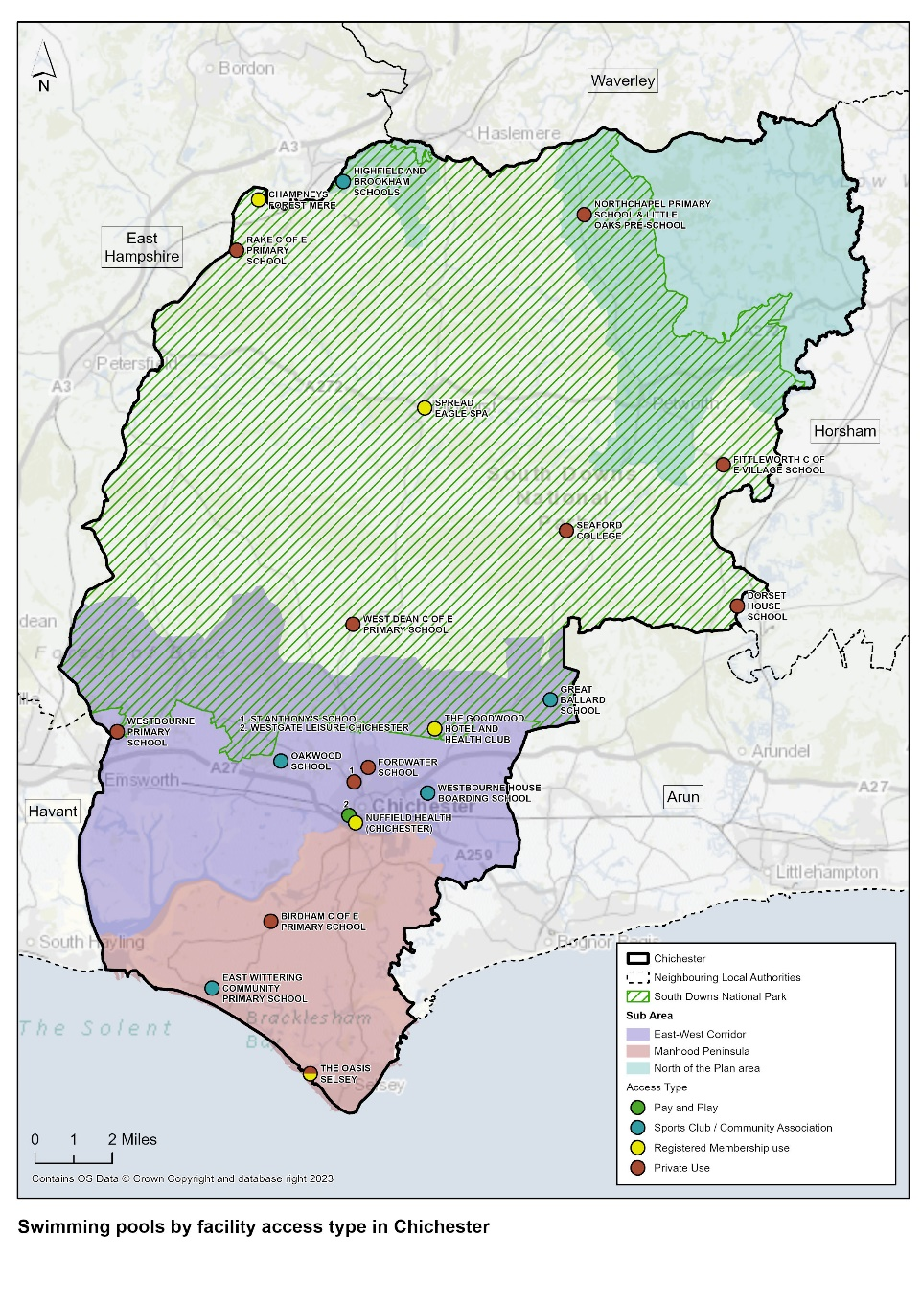
  - Tables 29 and 30 provide further analysis of the swimming pool supply in Chichester District.

Table 29: Supply of Swimming Pools in Chichester District

Site Name | Post Code | Facility Type | Facility Sub Type | Lanes | Area Sq.m | Access Type | Ownership Type | Management Type | Year Built | Year Refurbished
Birdham Primary School | PO20 7HB | Swimming Pool | Lido | 0 | 86 sq.m | Private Use | Community School | School/College/ University (in house) | 1965 | n/a
Champneys Forest Mere | GU30 7JQ | Swimming Pool | Main/General | 0 | 250 sq.m | Registered Membership use | Commercial | Commercial Management | 1997 | n/a
Champneys Forest Mere | GU30 7JQ | Swimming Pool | Lido | 0 | 105 sq.m | Registered Membership use | Commercial | Commercial Management | 1997 | n/a
Dorset House School | RH20 1PB | Swimming Pool | Lido | 0 | 75 sq.m | Private Use | Other Independent School | School/College/ University (in house) | 2007 | n/a
East Wittering Community Primary School | PO20 8NH | Swimming Pool | Lido | 0 | 120 sq.m | Sports Club / Community Association | Community School | School/College/ University (in house) | 1949 | n/a
Fittleworth C Of E Village School | RH20 1JB | Swimming Pool | Lido | 0 | 50 sq.m | Private Use | Voluntary Controlled School | School/College/ University (in house) | 1992 | 2015
Fordwater School | PO19 6PP | Swimming Pool | Learner/ Teaching/ Training | 0 | 54 sq.m | Private Use | Other Independent School | School/College/ University (in house) | 2000 | 2010
Great Ballard School | PO18 0LR | Swimming Pool | Lido | 0 | 107 sq.m | Sports Club / Community Association | Other Independent School | School/College/ University (in house) | 1961 | n/a
Highfield And Brookham School | GU30 7LQ | Swimming Pool | Main/General | 5 | 160 sq.m | Sports Club / Community Association | Other Independent School | School/College/ University (in house) | 2004 | n/a
Northchapel Primary School & Little Oaks Pre-School | GU28 9JA | Swimming Pool | Lido | 0 | 50 sq. | Private Use | Community School | School/College/ University (in house) | 1999 | n/a
Nuffield Health (Chichester) | PO19 8EL | Swimming Pool | Main/General | 0 | 240 sq.m | Registered Membership use | Commercial | Commercial Management | 2003 | n/a
Oakwood School | PO18 9AN | Swimming Pool | Main/General | 6 | 90 sq.m | Sports Club / Community Association | Other Independent School | School/College/ University (in house) | 1990 | 2018
Oasis, Selsey | PO20 9BJ | Swimming Pool | Main/General | 2 | 100 sq.m | Registered Membership use | Commercial | Commercial Management | Not Known | Not Known
Oasis, Selsey | PO20 9BJ | Swimming Pool | Leisure Pool | 0 | Approx. 200 sq.m | Registered Membership use | Commercial | Commercial Management | Not Known | Not Known
Oasis, Selsey | PO20 9BJ | Swimming Pool | Lido | 0 | 120 sq.m | Private Use | Commercial | Commercial Management | Not Known | Not Known
Rake C Of E Primary School | GU33 7JH | Swimming Pool | Lido | 0 | 50 sq.m | Private Use | Voluntary Controlled School | School/College/ University (in house) | 1970 | n/a
Seaford College | GU28 0NB | Swimming Pool | Main/General | 4 | 170 sq.m | Private Use | Other Independent School | School/College/ University (in house) | 2000 | 2015
Spread Eagle Spa | GU29 9NH | Swimming Pool | Leisure Pool | 0 | 70 sq.m | Registered Membership use | Commercial | Commercial Management | 1997 | n/a
St Anthony's School | PO19 5PA | Swimming Pool | Learner/ Teaching/ Training | 0 | 67 sq.m | Private Use | Community Special School | School/College/ University (in house) | 1975 | 2005
The Goodwood Hotel and Health Club | PO18 0QB | Swimming Pool | Learner/ Teaching/ Training | 2 | 126 sq.m | Registered Membership use | Commercial | Commercial Management | 1989 | 2007
West Dean C Of E Primary School | PO18 0RJ | Swimming Pool | Lido | 0 | 40 sq.m | Private Use | Voluntary Controlled School | School/College/ University (in house) | 1990 | n/a
Westbourne House Boarding School | PO20 2BH | Swimming Pool | Main/General | 4 | 225 sq.m | Sports Club / Community Association | Other Independent School | School/College/ University (in house) | 1995 | 2001
Westbourne Primary School | PO10 8TG | Swimming Pool | Lido | 0 | 72 sq.m | Private Use | Community School | School/College/ University (in house) | 1980 | 2001
Westgate Leisure Chichester | PO19 1RJ | Swimming Pool | Main/General | 6 | 433 sq.m | Pay and Play | Local Authority | Commercial Management | 1987 | 2005
Westgate Leisure Chichester | PO19 1RJ | Swimming Pool | Learner/ Teaching/ Training | 0 | 120 sq.m | Pay and Play | Local Authority | Commercial Management | 1987 | 2005

Table 30: Analysis of Swimming Pool Supply in Chichester District

 | No of Pools | No of sites
Total Number of Pools | 26 | 21
Community Use Swimming Pools (pay and play and sports clubs/community associations) | 10 | 7
Main Pools | 8 | 8
Learner Pools | 4 | 4
Diving Pools | 0 | 0
Leisure pools | 2 | 2
Education Sector (Sports Clubs and Associations) | 5 | 5
Private Sector/Other | 14 | 13
Lido | 11 | 11

Table 31: Strategic Size Swimming Pools in Chichester District

Facility | Ownership | Strategic Size | Access Type | Operator
Westgate Leisure Centre | Local Authority (CDC) | Main Pool 433 sq.m (6 lane: 33.3m x 13m) | Pay & Play | Everyone Active (EA) on behalf of CDC
Highfield & Brookham School | Independent School | Main Pool 160 sq.m (5 lane: 20m x 8m) | Sports Clubs/ Community Associations | The School
Seaford College | Independent School | Main Pool 170 sq.m (4 lane: 17m x 10m) | Private | The School
Westbourne House Boarding House | Independent School | Main Pool 225 sq.m (4 lane: 25m x 9m) | Sports Clubs/ Community Associations | The School
Champneys, Mere | Commercial Management | Main Pool 250 sq.m (25m x 10m) | Registered Membership | Commercial
Nuffield Health & Fitness | Commercial Management | Main Pool 240 sq.m (20m x 12m) | Registered Membership | Commercial Nuffield Health

  - There are 6 strategic size swimming pools in the Chichester District, one with ‘pay and play’ access – Westgate Leisure Centre in Chichester operated by Everyone Active on behalf of Chichester District Council.

Swimming Pools: Quality

  - Detailed quality assessments were undertaken on all of Chichester ’s indoor sports facilities (December 2023 and January 2024) by way of a site visit and visual assessment of the facilities. Each quality assessment looks at the age and condition of the facility, whether it is physically accessible, and if it is fit for purpose.

  - The individual swimming pool quality assessments are provided in Appendix 3 and are summarised in Table 33. It was not possible to visit some schools therefore, data was collected for these schools via the internet and online survey. The quality scores are explained in paragraphs 6.7 – 6.9 and for each facility in Appendix 3 and Table 32.

- A facility scoring highly in terms of visual quality and condition (good – excellent) is likely to require less investment than one which in a poorer visual condition (average – very poor). The combination of the scores, results in the facility rating, and identification of investment need (significant, moderate etc.).

- It is important to highlight that in undertaking the quality assessments, each element of the facility e.g. sports hall, pool etc is given a qualitative assessment, and the overall facility is also given an overall qualitative mark. Therefore, a sports hall, pool etc can be of poor quality, but the overall facility score could be good. Overall scores for each facility are included in Appendix 3.

Table 32: Quality ratings

Key | Rating
>80% | Excellent
60% - 80% | Good
40% - 59% | Average
20%-39% | Poor
<20% | Very Poor

  - There is only one council-owned swimming pool facility in the district - Westgate Leisure Centre which was built in 1987. The facility was refurbished in 2005 with the swimming pool changing rooms last refurbished in 2007. The changing rooms are now in need of further refurbishment. Netting has been installed above the pools to prevent debris falling in the pools.

Table 33: Summary Qualitative Assessments of the Strategic Size Swimming Pools (the quality score is not just for the swimming pool)

Facility | Overall Quantitative Score for Facility % | Qualitative Score for Swimming Pool | Need for Investment- Overall Facility
Westgate Leisure Centre | 65% | The main pool, and learner pool are in average condition, having been rebuilt in 1987. There is stepped access into the learner pool. Issues with failing plant are not uncommon.  The pools offer a balanced programme of child and adult swim lessons, and casual swimming. All sessions have to be pre-booked post Covid. There is disability access and toilet facilities.  The main swimming pool is 33.3m x 13m. The non-standard length prohibits the use of the pool for short course (25m) competition under Swim England regulations but does offer a facility suitable for water polo.  The main pool is also hired out by Chichester Cormorants Swim Club for training however Club Championships or Open Meets cannot be hosted at Westgate LC because there is no spectator seating, and the adaptations (submersible turning boards) used to reduce the length of the pool from 33.3m to 25m is not compliant with Swim England competition rules. | Moderate
Highfield and Brookham School | 57% | The main pool is 5 lane 20m x 8m. It was built in 2005. It is located at a private (independent) school.  The school runs a successful learn to swim programme with 1,000 participants. There is a separate entrance, changing and parking for the general public to comply with safeguarding requirements.  The swimming facility is in good condition. | Moderate
Seaford College | 84% | The main pool is 4 lane 17m x 10m.  The school is a private (independent) school, located on a large rural estate in the Downs National Park. The pool is used by the pupils of the school on a private basis.  The pool was built in 2000. It was refurbished in 2015 with the changing rooms refurbished in 2019.  The swimming facility is in good condition. | Minimal
Westbourne House Boarding House | 93% | The main pool is 4 lane 25m x 9m.  The school is a private (independent) preparatory school. The pool was built in 1995 and the facility was refurbished in 2001. The changing facilities were upgraded in 2015.  There is some club and community association use in the evenings and at weekends. The pool is also used by local primary schools and a learn to swim school.  The swimming facility is in excellent condition. | Minimal
Champneys, Mere | 77% | The main pool is 25m x 10m. The pool is located at a high-end hotel and spa venue for registered membership use only (although day passes can be purchased).  The swimming facility is in excellent condition. | Minimal
Nuffield Health & Fitness | 87% | The main pool is 20m x 12m.  Nuffield Health is a registered members club. The pool was built in 2003. The changing rooms have been refurbished.  The club is located in the city centre; free parking is available for limited period.  A learn to swim programme is hosted at the club, which non-club members can access.  The swimming facility is in excellent condition. | Minimal

  - The overall quality of the swimming pools in the district varies from average at the Westgate Leisure Centre to excellent at the two registered members’ facilities at Champneys and Nuffield Health & Fitness. The three other strategic size pools are located on private (independent) school sites and range from good to excellent condition.

  - The use of the main pool at Westgate Leisure Centre by Chichester Cormorants Swimming Club (CCSC) cannot be maximised due to the non-standard dimensions of the main pool and the lack of spectator seating to allow the club to generate secondary income from Club Championships and Open Meetings. CCSC host their own Club Championships and Open Meetings at either Arun Leisure Centre in Bognor Regis or Mountbatten Centre in Portsmouth.

  - There has been discussion about installing a permanent 1m structure (boom) at the 25m mark in the main pool at Westgate LC to create a standard short course distance pool (and creating a separate area of water approximately 7m x 13m suitable for learn to swim lessons), however this was deemed cost prohibitive by CDC, Instead the club use submersible turning boards which may be adequate for training but do not meet Swim England standards for competition venues.

  - It should be noted that the average lifespan of a public leisure centre (including a pool) is 30-35 years.

Swimming Pool Demand in 2024

Consultation

Survey Responses (Education Institutions, Sports Clubs)

  - Detailed analysis is provided of education institution and sports club feedback in paragraphs 6.10 – 6.28.

Table 34: Education Institutions with pools who responded to survey

Name of school / college: | Postal Code: | Swimming Pool
Oakwood Prep School | PO18 9AN | Yes – sports club/community association
Westbourne House Boarding School | PO20 2BH | Yes – sports club/community association
Seaford College | GU28 0NB | Yes – private use
West Wittering Parochial C. E. School | PO20 8AJ | Yes – private use

  - The following information was supplied by the schools:

Table 35: Survey responses from Education Institutions with pools

Name of school / college | If yes, what are the dimensions of the pool? | Is there organised use of the pool? | If there is community use, which teams / organisations use the facility, and what activities do they use it for? | Is there secured community use* of the sports hall | Is there 'pay and play' use of the facility?
Oakwood Prep School | 15m x 6m | Yes | Chichester swim school own the pool | Not known | Not known
Westbourne House School | 25 x 9m | Yes | Tangmere Primary School - Tuition BJ Sports - Tuition Arun Swimmers - Tuition Arun Swim School - Tuition Chichester Cormorants- Tuition West Dean Primary School - Tuition Medmerry Primary School - Tuition Portfield School - Tuition RNLI - Safety training | Yes | No
Seaford College | 17 x 10 | Yes | Girl guides | No | No
West Wittering Parochial C. E. School |  | Yes | Not used for community | No | No

Sports Clubs (Swimming Clubs)

  - There is only one swimming club in the district – Chichester Cormorants Swim Club (CCSC). The club uses the Westgate Leisure Centre swimming facilities.

  - CCSC expressed the following concerns regarding the swimming facilities at the Westgate Leisure Centre:

‘The facility is not suitable for a competitive swimming club, no 25m pool, inadequate lane ropes, not enough pools time, no spectator area, not suitable for competitions, very high rates. Pool often too hot, sessions often cancelled due to lack of lifeguards.’

Parish and Town Councils

  - There was no feedback from parish and town councils in respect of swimming provision within the district.

National Governing Bodies (NGBs)

Swim England

  - Consultation was undertaken with National Governing Bodies (NGBs) to identify their views on the need for swimming pool provision in the district. The views of the NGB (representing aquatic sports) which responded is included in Appendix 4.

  - Based on the feedback provided by Swim England, the following has been identified:

- There is a good supply of water space in the district
- Lots of private water provision
- The FPM may identify a small deficit in provision; however, the FPM excludes water space at The Oasis Selsey, together with lidos and private provision and therefore there is no rationale for increasing the amount of pay and play water provision in the district

  - Swim England has identified the following priorities:

- Westgate LC Pool facilities are a key priority – need to maintain this provision
- Refurbishment, or replacement would be considered if needed
- Putting a *boom across the main pool so that it can be used for competition
- (*If the swim club is not keen on this then the Council needs to decide whether to do it anyway).
- The boom will create a separate area of water that could be used for swim lessons if there is a business case for it.
- Could infill some of the depth. Boom would only need to be 1m wide.

  - Key clubs in Chichester District are:

- Chichester Cormorants Swimming Club

  - Swim England’s medium/long term plans for the neighbouring areas:

- Pool development in neighbouring boroughs. There is provision by Portsmouth City Council (PCC) and the new (opened 2023) university pool. PCC is also aiming to develop a new pool to replace an older pool closed during Covid. Arun District Council is well provided for but no new facilities as far as Swim England are aware.

- There is a masterplan with Homes England for Horsham and Crawley in relation to new housing provision in Ifield, including a sports hub with small community pool. However, this is some distance from the boundary with Chichester District Council.

  - Swim England confirmed that if it is decided to replace Westgate Leisure Centre, then a main pool no bigger than an 8-lane 25m would be required but a 6-lane would suffice.

  - Overall Chichester district is a low priority area for Swim England in terms of investment in swimming because there is sufficient public swimming provision, and easy access to pools in neighbouring boroughs for competitive use.

Facility Planning Model (FPM) Findings

The FPM study is a quantitative, accessibility and spatial assessment of the supply, demand, and access to swimming pools.

As agreed with Chichester District Council, the FPM modelling runs provide:

- Standard assessment of the current supply and demand for provision of swimming pools in the Chichester District in 2023.

Executive Summary

  - The key element to be taken from the FPM report is that Chichester has an adequate supply of swimming pools to meet most of its demand, but it is partially reliant on the commercial sector and neighbouring local authorities for over a third of its met demand.
  - As there is only one public leisure centre, which is the oldest and largest site in the district, it will be important that Westgate Leisure Centre remains open. The centre provides 47% of the available capacity in Chichester and is the only site with a learner pool.

The key findings in 2023 from the supply, demand and access assessment are as follows:

  - The total water space in Chichester is 1,203 sqm of water. When scaled against the amount available during the weekly peak period, this reduces to 1,080 sqm.
  - The swimming pool stock in Chichester is ageing and there is a need for modernisation.
  - The resident population generates demand for 7,784 visits in the weekly peak period, which equates to 1,280 sqm of water with a comfort factor included. The visits demanded amount to less than Chichester’s available supply. However, with a comfort factor applied, more water space is required than is currently available in the district.
  - Of the demand for swimming pools from Chichester residents, 81% is met in 2023.
  - Of Chichester’s satisfied demand, 35% is exported and met at swimming pools outside the district.
  - Only 12% of Chichester’s residents are within a 20-minute walk of a swimming pool.
  - Unmet demand totals 238 sqm of water.
  - Westgate Leisure Centre is estimated to be the most utilised site, at 74% of capacity used at peak times.
  - Chichester exports 1,221 more visits than it imports in the weekly peak period.
  - Chichester has a local share value of 0.95, meaning that there is not quite sufficient suitable provision to meet demand.
  - Chichester has 10 sqm of water per 1,000 population. This is the second lowest in the study area and is lower than the regional average of 13 sqm of water and the national average of 12 sqm of water.

NB Facilities excluded from the FPM National Standard Run are those swimming pools to be outdoor pools, principal pool too small, private use, closed or there is a lack of information, particularly relating to hours of use. It should be noted that Westbourne House Boarding School and Oakwood School have been excluded from this FPM run although these have subsequently been identified as available for sports club/community association use (not private use only). The Oasis, Selsey, also has water space that has been excluded from the FPM run.

Swimming Pools - Accessibility

  - The drive time catchment area is based on 20 minute drive time. It is important to ensure that pools are as accessible as possible to those walking or using public transport.

  - Map 9 shows both the 20-minute public transport travel time and the 10-minute walk time catchment areas for all publicly accessible swimming pools in the Chichester district. The map illustrates that the majority of the district falls within a 20-minute drive time of a publicly accessible swimming pool.

  - According to the Swimming Pool FPM, demand for swimming is pools is highest in the A27 corridor area of Chichester. Demand is greatest in Chichester city centre, with the greatest densities of demand per square kilometre are 37sqm of water east of Westgate Leisure Centre and Nuffield Health and 30 sqm of water north of Westgate Leisure Centre and Nuffield Health.

  - In the Manhood area of the District, there are two clusters of higher demand in Selsey, and in East Wittering and Bracklesham. Demand is very low and dispersed in the National Park area of the District, with large areas where there is no demand.

  - Map 9 also shows the 10-minute walk time catchment area for all publicly accessible swimming pools in the Chichester district. As there is only one facility in Chichester offering publicly accessible swimming, it is not surprising that the map illustrates that a large proportion of the district is currently unable to access a pool within a 10-minute walk time. Approximately 12% of the district is within a 10-minute walk time catchment area.

  - Residents southwest of the city centre can access the most swimming pools within a 10- minute walk because they are close to Westgate Leisure Centre and Nuffield Health. Some residents on the border with Waverley are within a 10-minute walk of Haslemere Leisure Centre. However, not all residents in these areas will walk to a swimming pool and some will travel further.

  - It is estimated that 90% of journeys to swimming pools by Chichester residents are by car. Only 5% of journeys to swimming pools are made on foot and 5% by public transport; this again reflects the rural nature of the district and reliance on car travel.

  - The relative affluence of the district means that car ownership is high and so most people are able to travel to Westgate Leisure Centre or other facilities in neighbouring local authorities. Support needs to be focussed on those without private transport, and those who cannot afford public transport and are also inactive to ensure they do not lose out on opportunity to access swimming and other activities.

  - There are clearly opportunities to look at the geographical spread of swimming provision in neighbouring authorities. This is particularly noticeable to the north and north-east of the district bordering Waverley Borough Council and Horsham District Council local authorities (including South Down National Park) to the southeast (Arun District Council) and to the west (East Hampshire and Havant District Councils).

Map 9: Swimming Pool with Pay and Play with 10 minute walk time and 20-minute public transport travel time catchment areas

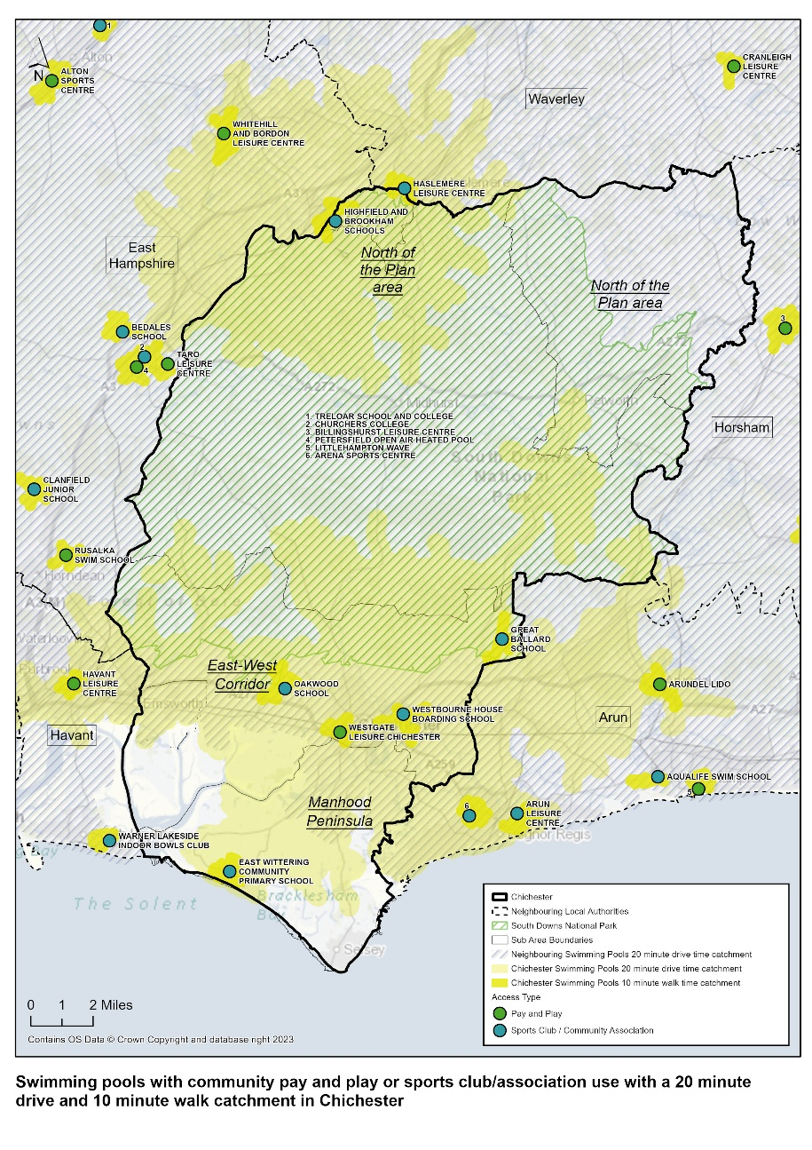

Swimming Pools: Availability

  - Only the pools at Westgate Leisure Centre in the district are publicly accessible, currently accommodating a full range of swimming activities including learn to swim, public recreational swimming, lane swimming, fitness swimming and swimming development through the Chichester Cormorants Swimming Club.

  - The Westgate Leisure Centre provides 47% of the available capacity in the district and is the only publicly accessible site with a learner pool.

  - In terms of increasing community access to pools in the Chichester district, the FPM suggests that there is scope for the opening hours of the pools at Westgate Leisure Centre to be extended at the weekly peak period, which would increase the capacity of the site at peak times and reduce the used capacity to a more comfortable level. The pools programmes should be reviewed in conjunction with the leisure operator to look at opportunities available to increase available capacity.

  - Three of the other five strategic size swimming pools in the district are located on independent private school sites, and only two out of the three offer sports club/community association access. There is little impact on availability as the education facilities are principally available for sports clubs and groups, not pay and play access. Accessibility is also not impacted by excluding the education facilities as these are not accessible for pay and play use.

  - The remaining two strategic size swimming pools are at Champneys Forest, Mere and Nuffield Health, Chichester which are registered membership use only. These are both high end membership facilities so will neither be available nor accessible (on affordability grounds) to everyone in the district.

  - Schools with community access (sports clubs and community groups) were consulted with as part of this study and key information was provided relating to access arrangements and programmes of use.

Table 36: Summary of School Sports Facilities – Private/Community Use (Club/Sports Association)

School | Access arrangements and Programme of Use
Seaford College | Private school use only
Westbourne House Boarding School | Facilities used by school Monday to Friday and Saturdays. Limited community club use. A local learn to swim school and primary school hire out the school pool.  Whilst the school prioritises its fee-paying pupils and parents, the bursar confirmed the school is keen to hire its facilities during ‘non-school’ hours to create an alternative funding stream
Highfield and Brookham School | The school runs a successful learn to swim programme with 1,000 participants. There is a separate entrance, changing and parking for the general public to comply with safeguarding requirements.
*Oakwood Prep School | School exclusive use of sports facilities weekdays. Community access outside of these times and Saturday and Sunday.

*Not of a strategic size pool but included as a swimming pool on a school site

Provision Requirements by 2039

  - Using the Sports Facility Calculator (SFC) it is possible to estimate overall future demand for provision of swimming pools in Chichester district, based on the following population growth scenario for Chichester District:

Total of 10,678 new dwellings across the Chichester District 2021 – 2039 (Chichester District Council Local Plan area and South Downs National Park Local Plan area) and a population growth of 24,559 (additional dwellings x 2.3 national average population per dwelling).

Table 37: Sports Facility Calculator – Chichester District swimming

 | (A)  Current under-supply of Swimming 2023 | (B)  Unmet demand for Swimming 2023 | (C)  Future Demand for Additional Swimming by 2039 | (D)  Total over-supply (-) /under-supply of Swimming by 2039
Population increase 24,559 | -200 sq m | 238 sq. m | 251.27 sq m | 689.27 sq. m

N.B. Calculation uses population of 125,102 for Chichester District as used by Sport England in their Facility Planning Model for Sports Halls. This ensures that future demand/supply calculations directly correlate to the baseline calculations for current supply/demand and population figures used for these.

  - The SFC identifies an under provision of 689.27 by 2039 in the Chichester District.

  - Demand for swimming pool provision increases from 2023 to 2039.

- Between 2020 and 2039, there is a projected 9% increase in Chichester ’s population
- Chichester ’s current demand for swimming pools not currently being met equates to -200 sq. m of water space against a supply (allowing for a comfort factor) of 1,080 sq. m of water space i.e. an under-supply of 200 sq. m of water space (for context, 25mx 8m 4-lane pool is circa 200 sq. m of water space). This is based on demand for 1,280 sq m of water space and supply being 1,080 sq m of water space.
- In addition, there is the equivalent of 238 sq. m of unmet demand
- By 2039 there is also additional demand for swimming pool provision of 251.27 sq. m
- In total, by 2039 there is a need for an additional 689.27 sq m of water space.
- A further factor to consider is the age of Westgate Swimming Pool which is likely to need replacing in the medium to long term. This is particularly important given it provides 47% of the available swimming capacity in the district and is the only publicly accessible pool with a learner pool.
- In considering the need for future swimming pool provision, 689.27 sq. m equates to just over 1.5 swimming pools of 25m x 8 lane size.
- Swim England’s view is that when Westgate is replaced the pool size could be increased to 8 lanes; this would address some of the existing under-supply and obviously address the issue of improved facility quality. Other factors to consider is that there is new swimming provision being provided in neighbouring boroughs e.g. Havant in the future, and there are other pools in the district which can be accessed. The local geography also means other pools can be accessed by private transport. It is, however, critical to ensure that there is accessible swimming provision in the district for those without access to private transport, to ensure they have the opportunity to be physically active.

Stage C

  - There are a number of key factors in Chichester District which impact on both current and future need for all types of built leisure provision. These are set out below but equally apply to swimming and all other facility types covered in covered in this report:

- Changing demographics
- Population growth
- Housing development on strategic sites/areas identified for residential development in the Local Plan area as identified in Table 3 including:
- Shopwyke
- West of Chichester
- Westhampnett/Maudlin Farm
- East of Chichester
- Southern Gateway
- Chichester City
- Southbourne
- Tangmere
- Bosham
- Hambrook/Nutbourne
- Loxwood

- Reducing Health Inequalities – There are some very specific factors to which the provision of quality, affordable and accessible sports facilities can contribute:
- Encouraging a more active lifestyle;
- Maintaining an active lifestyle;
- Improved mental health;

- Maintaining and growing participation levels in sport and physical activity to contribute to more active lifestyles

  - The identified need for additional swimming pool provision is summarised in Table 38.

Table 38: Identified need for swimming pool provision

Facility Type | 2023 | 2039
Swimming Pools | 438 sq. m (equivalent to just over 1 x 25m x 8 lane pool) | 689.27 sq. m (from SFC)

Table 39: Key Issues, Impacts, and Implications by Facility Type

Facility Type | Key Issues | Impact/Implications
Swimming Pools | Under supply of swimming provision to meet future demand | Increased demand as a result of population growth cannot be accommodated
 | Due to the rural nature of the district there is an uneven distribution of swimming pools across the district. There are large areas across the Chichester district that are not within a 10-minute walk catchment of a community accessible swimming pool facility – known as unmet demand. | Demand is highest in Chichester city centre, which is where Westgate Leisure Centre is located.  The unmet demand is low values per square kilometre.
 | The proportion of Chichester’s demand that is met is lower than the regional and national averages. | Chichester relies on swimming pools in the neighbouring local authority areas to meet 35% of its satisfied demand. Therefore, any future changes to provision in these areas could impact Chichester’s residents.
 | The rural nature of the district means that only a small proportion of residents are within walking distance of a swimming pool. But deprivation in Chichester is low and access to a car is high | Most of the journeys to swimming pools are estimated to be by car.
 | In 2023 the unmet demand is from residents who are too far from a swimming pool and is not due to lack of capacity - highest in Selsey. | There is not enough unmet demand to justify the provision of a new swimming pool.
 | The overall estimated used capacity of the swimming pools in Chichester is low, but Westgate Leisure Centre is estimated to be operating at an uncomfortable level at peak times. However, it is not available for community use for the full peak period. | The opening hours of both pools could be extended by 4.5 hours in weekly peak period, which would increase the capacity of the site at peak times and reduce the used capacity to a more comfortable level.
 | Deterioration of Westgate Leisure Centre | The leisure centre was built in 1987 and was refurbished in 2005. The original design and fit-out (including the energy inefficient plant) will need replacing/refurbishing in the short term as this is a heavily used facility operating at capacity.  The inclusion of a permanent boom to reduce the size of the 33m length to create a 25m standard pool would allow for swimming development through clubs, short course competition and training as well as maintaining a pool suitable for lane and fitness swimming etc. The remaining space i.e. 6mx12m could be used for providing a learner pool suitable for other aquatic activities such as swimming lessons, adult and child and fun family-based activities.  During refurbishment /replacement spectator seating near the swimming pools would create a venue suitable for club championship and open meeting club competition.

  - The identified priorities for investment in swimming pool provision are:

Table 40: Summary of Facility Investment Priorities

Facility Type | Priority for Future Provision | Location
Swimming Pools | There is an uneven distribution of swimming pools across the district. However, demand is highest in Chichester city centre, which is where Westgate Leisure Centre is located. Given the age of the Westgate Leisure Centre, there is a need to recognise that replacement will need to happen in the medium to long term.  Retention and further modernisation of Westgate Leisure Centre has the greatest importance. Potentially increase in pool scale on replacement.  In the short term, increasing opening hours at both Westgate pools would help to alleviate capacity challenges.  Consider if there is any reduction in supply of swimming pools in neighbouring authorities will reduce access for Chichester residents and increase unmet demand.  Consider if there is any projected population growth in Chichester in the future, particularly in one area or on the borders of the district. | Westgate Leisure Centre  Neighbouring local authorities  All areas within the district

  - Given there is a future estimated under-supply of swimming pool in the district, there is a need to:

- Maintain and extend existing community access of swimming pools on educational sites and secure access where possible through the introduction of Community Use Agreements.
- Seek to open up community access for pay and play, not just sports club access to existing swimming pools on education sites.
- Any planning applications for new or refurbished swimming pools in the district should be subject to a formal Community Use Agreement being agreed.
- Community use should seek to include pay and play access and not just sports club access.

  - Residents in the South Downs National Park are able to reach swimming pool supply served by Billingshurst Leisure Centre. Residents in the North of the Plan area are able to access swimming pools at Highfield and Brookham School, and the Herons Leisure Centre at Haslemere. Elsewhere residents in this area are within a 20 minute drive catchment of leisure facilities in neighbouring Horsham and Waverley. There is good swimming pool provision in neighbouring authorities close to the Chichester District borders. There is also new or planned investment in swimming pool provision at Littlehampton Leisure Centre, Alton Leisure Centre and Havant Leisure Centre.

  - Westgate Leisure Centre is the largest and busiest pool in the district and the only pay and play swimming facility available. The building is reaching the end of its useful life and it is important that the leisure centre/swimming pools are refurbished/replaced in the short/medium term to be able to meet customer demand and expectations.

Health and Fitness – Assessment Summary Stage B

  - The assessment identifies:

Table 41: Health and Fitness - Assessment Summary

Facility Type- Health and Fitness Facilities | Key Points
Quantity | Fitness Suites  There are 18 fitness suites in Chichester District. In total, the fitness suites provide 748 fitness stations as set out in Table 44 and Map 10. There is a good amount of fitness suite provision in Chichester District.  Current demand for fitness suites is calculated by taking into account all local authority, community accessible and comparable priced facilities providing 20 or more fitness stations as follows:  - Bourne Leisure Centre  - Chichester College Sports Centre  - Chichester Racquet and Fitness Club  - Nuffield Health (Chichester)  - Optimus Gym (Chichester)  - The Grange Community and Leisure Centre  - The Gym Group  - The Oasis, Selsey  - Westgate Leisure Centre  The total number of fitness stations across these facilities is 616. Demand is calculated based on the FIA penetration rate which is 2022 calculates demand at 444 fitness stations against a supply of 616. This equates to an over-supply of 172 fitness stations. Current demand for fitness suite provision is set out in detail in Appendix 13.
Studios

There are 21 studios in the Chichester District across 16 sites.

Studios are typically used for group exercise classes; if demand for these classes outstrips available capacity this is a sign that additional studio space is needed.

Typically, new physical activity facilities would include a minimum of two, usually three studios to enable concurrent programming of aerobic -type classes and Pilates/yoga (in a separate studio), and a dedicated group cycling studio. All these types of group exercise are income generating and important to offer as part of an overall fitness membership.

There is no evidence to demonstrate an under-supply or over-supply of studios. However there are 21 studios in the Chichester District and 18 of these are community accessible. It will be important to ensure there is investment in additional studio provision, or multi-purpose space, which can be used for group exercise amongst other activities as the population grows.

Quality | Fitness Suites  The quality of fitness suites in the districtranges from average to excellent. Those fitness suites that are of average quality tend to be located on educational sites.  The quality of commercial facilities ranges from good to excellent.
Studios

The quality of the studios in the district range from good to excellent.

Accessibility | Fitness Suites  The majority of the Chichester District is within a 20 minute drive catchment of a fitness suite located within the district. Those areas not within a 20 minute catchment (North of the Plan area, and the far east and west of the South Downs National Park) are within a 20 minute drive of fitness suites in neighbouring authorities.  The city of Chichester is particularly well catered for in terms of fitness suites, with most areas within a 10 minute walk of a facility, with higher population densities attracting commercial operators.
Studios

Studios in the district reflect a similar catchment to fitness suites. The majority of studios are located within the urban East West Corridor in and around the City of Chichester. Those located within the South Downs National Park are mainly located in and around the main town of Midhurst. Those areas not within a 20 minute drive of a studio (North of the Plan area and east of the South Downs National Park) are within a 20 minute drive of studios in neighbouring authorities.

Availability | Fitness Suites  The commercial fitness sector (private and registered membership) provides 382 (49%) of the 778 stations in the Chichester District. A total of 200 (26%) are provided by the local authority and managed by Everyone Active, 154 (20%) are located on educational sites and the remaining fitness suites (5%) are located within sports club/pavilion locations.
Studios

Provision of studios is similar to that of fitness suites; studios tend not to be stand-alone but are part of an overall fitness offer, usually requiring membership. Some studios also provide pay and play access.

Demand in 2039 | Future demand for fitness suites is calculated by taking account all local authority, community accessible and comparable priced facilities offering 20 or more fitness stations as follows:  - Bourne Leisure Centre  - Chichester College Sports Centre  - Chichester Racquet and Fitness Club  - Nuffield Health (Chichester)  - Optimus Gym (Chichester)  - The Grange Community and Leisure Centre  - The Gym Group  - The Oasis, Selsey  - Westgate Leisure Centre  The total fitness number of stations across these facilities is 616. Demand is calculated based on the FIA penetration rate (2022) which in 2039, calculates demand at 489 fitness stations against a supply of 616. This equates to an over-supply of 127 fitness stations. This suggests that, although the population of Chichester District is set to increase between 2024 and 2039, the current level of fitness station provision in the district can accommodate the resulting increase in demand from the estimated population growth.  Typically, studios are provided alongside fitness suites. Demand for group exercise classes is likely to increase as population in the Chichester District grows. It will therefore be important to ensure there is investment in additional studio provision, or multi-purpose space, which can be used for group exercise amongst other activities as the population grows.

Health and Fitness - Provision in 2024

Fitness Suites - Quantity

  - A station is a piece of static fitness equipment; health and fitness centres with over 20 stations are generally able to make a more attractive offer to both members and pay and play users. The 2022 state of UK Industry report reveals that the membership penetration rate is 14.6%, so approximately one in every 7 people over the age of 16 in the UK is a member of a gym.

  - There are 18 fitness suites in Chichester District. In total, the fitness suites provide 748 fitness stations. There is a good amount of fitness suite provision in Chichester District. All fitness suite facilities require some form of payment/membership payment before use, and an induction is required, although there is some pay and play access available at the local authority owned facilities.

  - The majority of community accessible fitness suite provision is within the Chichester District Council Local Plan area in the urban East West Corridor. There is also some provision within the South Downs National Park area in and around the town of Midhurst.
  - There are 3 pay and play fitness suites, all owned by Chichester District Council and managed by Everyone Active. These pay and play fitness suites provide a total of 245 fitness stations which is approximately 33% of the total number of fitness stations available within the district. The Westgate Leisure Centre also includes an Active Wellbeing Suite, offering power assisted equipment for gentle exercise, which was opened in 2020. The toning suite targets the older population and those recovering from long term illness. The room provides approximately 15 pieces of equipment.

  - There are 3 private fitness suites, all located on educational sites where sports club/association use is available for other sports facilities on site.

  - There are 10 registered membership fitness suites providing approximately 61% of the total number of fitness stations in the district. A total of 6 of these are owned by commercial companies including Nuffield Health and The Gym Group. Most commercially operated fitness suites require registered membership and operate pre-registered, pre-paid/DD membership schemes.

  - There is also a relatively new commercially operated fitness suite located at The Oasis holiday park in Selsey. This site used to be owned by Bunn Leisure but was bought by Cove UK in 2019. The American company has since invested a significant amount of money in leisure facilities on site including a new Technogym fitness suite. Although the facilities are primarily for holiday park guests and those who own holiday accommodation on site, there is a monthly membership available to local residents during limited opening times. The park and facilities are also closed annually out of season during January and February of each year.

  - The largest fitness suites (100 – 150 fitness stations) are all located within the City of Chichester as this is the urban centre for the district and attracts sufficient footfall to support commercial gym facilities of this size. There are no fitness suites in the Chichester District with over 150+ fitness stations.

  - The majority of fitness suites in the district (7) are relatively small providing 29 or less stations.

  - All existing fitness suites in the district are detailed in Appendix 2 and Table 44. Map 10 shows the supply and location of fitness suites in Chichester District by different access type.

Map 10: Fitness Suites in Chichester District by Facility Access Type

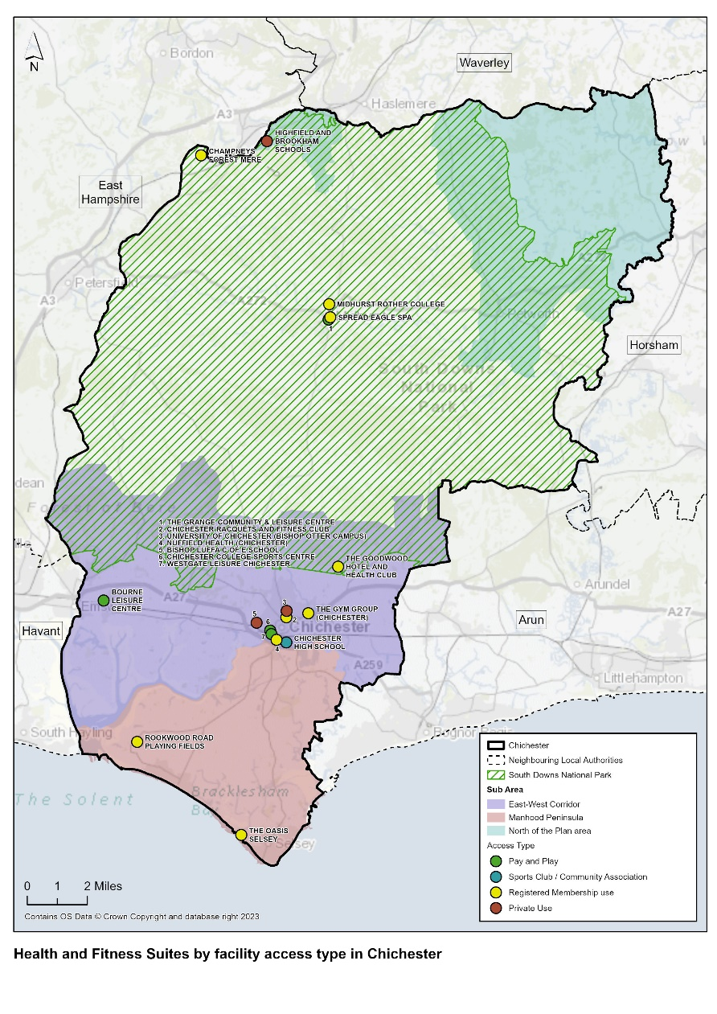

  - Analysis of the overall supply of fitness suites is summarised in Table 42 and 43:

Table 42: Analysis of overall Fitness Suite Provision in The Chichester District

Total Fitness Suites | 18
Total Fitness Stations | 778
Pay and Play Fitness Suites | 3
Pay and Play / No. of Fitness Stations | 245
Registered Membership Fitness Suites | 11
Registered Membership no. of Fitness Stations | 484
Private use Fitness Suites | 3
Private use no. of Fitness Stations | 72
Sports Club/Community Association Suites | 1
Sports Club/Community Association No. of Fitness Stations | 22
Education-based Fitness Suites offering community use | 4

Table 43: Summary of Fitness Suite Size

Number of Fitness Stations | No. Fitness Suite Sites
150+ | 0
100 - 149 | 2
50 - 99 | 3
30 - 49 | 6
29 or less | 7

Table 44: Fitness Suites in the Chichester District

Site Name | Post Code | Facility Type | Stations | Access Type | Ownership Type | Management Type | Pay and Play Community use (ü) | Year Built | Refurbished
Bishop Luffa C of E School | PO19 3HP | Health and Fitness Gym | 15 | Private | Academies | School/College/University (In house) |  | 2009 | N/A
Bourne Leisure Centre | PO10 8PG | Health and Fitness Gym | 30 | Pay and Play | Local Authority | Commercial Management | √ | 2003 | 2015
Champneys Forest Mere | GU30 7JQ | Health and Fitness Gym | 22 | Registered Membership Use | Commercial | Commercial Management |  | 1997 | 2008
Chichester College Sports Centre | PO19 1SB | Health and Fitness Gym | 45 | Registered Membership Use | Further Education | School/College/University (In house) |  | 2004 | 2018
Chichester High School | PO19 8EB | Health and Fitness Gym | 22 | Sports Club/Community Association | Academies | School/College/University (In house) |  | 2008 | 2003
Chichester Racquets and Fitness Club | PO19 6AR | Health and Fitness Gym | 34 | Registered Membership Use | Sports Club | Sports Club |  | 1995 | 2012
Midhurst Rother College | GU29 9DT | Health and Fitness Gym | 15 | Registered Membership Use | Academies | School/College/University (In house) |  | 2013 | N/A
Nuffield Health (Chichester) | PO19 8EL | Health and Fitness Gym | 105 | Registered Membership Use | Commercial | Commercial Management |  | 2003 | 2007
Optimus Gym (Chichester) | PO19 8ZZ | Health and Fitness Gym | 30 | Registered Membership Use | Commercial | Commercial Management |  | 2021 | N/A
Rookwood Road Playing Fields | PO20 8LT | Health and Fitness Gym | 8 | Registered Membership Use | Local Authority | Commercial Management |  | 2017 | N/A
Seaford College | GU28 0NB | Health and Fitness Gym | 31 | Private | Other Independent School | School/College/University (In house) |  | 2017 | N/A
Spread Eagle Spa | GU29 9NH | Health and Fitness Gym | 15 | Registered Membership Use | Commercial | Commercial Management |  | 1997 | 2006
The Goodwood Hotel and Health Club | PO18 0QB | Health and Fitness Gym | 30 | Registered Membership Use | Commercial | Commercial Management |  | 1989 | 2013
The Grange Community and Leisure Centre | GU29 9HD | Health and Fitness Gym | 50 | Pay and Play | Local Authority | Commercial Management | √ | 2014 | N/A
The Gym Group (Chichester) | PO19 7YH | Health and Fitness Gym | 100 | Registered Membership Use | Commercial | Commercial Management |  | 2020 | N/A
The Oasis Selsey | PO20 9BJ | Health and Fitness Gym | 80 | Registered Membership Use | Commercial | Commercial Management |  | 2019 | N/A
University of Chichester (Bishop Otter Campus) | PO19 6PE | Health and Fitness Gym | 26 | Private | Higher Education | School/College/University (In House) |  | 2000 | 2008
Westgate Leisure Chichester | PO19 1RJ | Health and Fitness Gym | 120 | Pay and Play | Local Authority | Commercial Management | √ | 2000 | 2012

Fitness Suites: Quality

  - Quality assessments have been undertaken at health and fitness facilities where access was possible. These quality audits are summarised in Appendix 3 and Table 45. Where it was unfortunately not possible to access facilities or obtain desktop visual information online, no quantitative score has been assigned.

  - The quality of health and fitness facilities in the Chichester District ranges from average to excellent.

  - The visual check highlights that overall, the quality of the commercial facilities is good or excellent as is generally the case. All have up to date fitness stations, are well-designed and planned facilities, with good quality changing facilities. The quality of local authority owned fitness suites in Chichester District is also comparable with those of commercially owned facilities such as Nuffield Health and The Gym Group, reflecting the competitiveness of the lucrative health and fitness market and the need for leisure operators to maintain high quality facilities to attract and retain custom.

  - Those fitness suites that are of average quality are mainly located on educational sites (Seaford college is the exception to this but is a private school). The University of Chichester is in the process of undertaking a refurbishment programme through to the end of Summer 2024. This includes an extension to their fitness suite and provision of new equipment, which will improve the quality rating of the facility.

  - The fitness suite is only available to students. External users under the supervision of staff/students use the facility as part of the education process. There is no indication that this arrangement will change following the refurbishment. The two ground floor changing rooms were refurbished in Summer 2023 and now provide inclusive changing and shower facilities for individuals and teams using the indoor and outdoor sports facilities on site.

  - It is important to note that:

  - A facility scoring highly in terms of visual quality and condition (good – excellent) is likely to require less investment than one which in a poorer visual condition (average – very poor). The combination of the scores, results in the facility rating, and identification of investment need (significant, moderate etc.).

  - It is important to highlight that in undertaking the quality assessments, each element of the facility e.g. sports hall, pool etc is given a qualitative assessment, and the overall facility is also given an overall qualitative mark. Therefore, a sports hall can be of poor quality, but the overall facility score could be good.

Table 45: Quality ratings

Key | Rating
>80% | Excellent
60% - 80% | Good
40% - 59% | Average
20%-39% | Poor
<20% | Very Poor

Table 46: Summary Qualitative Assessments – Health and Fitness Facilities (Fitness suites only)

Site Name | Overall Quantitative Score for Facility % | Qualitative Score for Health and Fitness Suite | Need for Investment- Overall Facility
Bishop Luffa C of E School | 75% | Good | Moderate
Bourne Leisure Centre | 79% | Good | Minimal
Champneys Forest Mere | 77% | Good | Minimal
Chichester College Sports Centre | 61% | Average | Moderate
Chichester High School | 71% | Average | Moderate
Chichester Racquets and Fitness Club | 79% | Good | Moderate
Midhurst Rother College | 79% | Average | Minimal
Nuffield Health (Chichester) | 87% | Good | Minimal
Optimus Gym (Chichester) | 75% | Good | Minimal
Rookwood Road Playing Fields |  | Unable to Access or view online
Seaford College | 84% | Excellent | Minimal
Spread Eagle Spa | 59% | Average | Moderate
The Goodwood Hotel and Health Club | 83% | Excellent | Minimal
The Grange Community and Leisure Centre | 89% | Good | Minimal
The Gym Group (Chichester) | 86% | Excellent | Minimal
The Oasis Selsey | 70% | Excellent | Minimal
University of Chichester (Bishop Otter Campus) | 56% | Average | Moderate
Westgate Leisure Chichester | 65% | Excellent | Moderate

Fitness Suite Demand in 2024

Consultation

Survey Responses (Education Institutions, Sports Clubs, Parish/Town Councils)

  - Detained analysis is provided of education institution and sports club feedback in paragraphs 6.10 – 6.28.

  - No specific issues about fitness suites or studios are identified through consultation other than a reference by East Wittering and Bracklesham Parish Council regarding the closure of the Harbour Way Country Club and therefore a need for a local gym in the area. Relatively few schools who responded to the survey had fitness suites or studios on site.

National Governing Bodies (NGBs)

  - There is no specific NGB feedback on fitness suites and studios.

  - Current demand for fitness suites is calculated by taking into account all local authority, community accessible and comparable priced fitness facilities providing 20 stations and above as follows:

Table 47: Chichester District Council, Community Accessible and comparable priced fitness facilities

Bourne Leisure Centre
Chichester College Sports Centre
Chichester Racquet and Fitness Club
Nuffield Health (Chichester)
Optimus Gym (Chichester)
The Grange Community and Leisure Centre
The Gym Group
The Oasis, Selsey
Westgate Leisure Centre

  - The total number of fitness stations across these facilities is 616. Demand is calculated based on the FIA penetration rate (14.6% in 2022) calculates demand at 448 fitness stations against a supply of 616. This equates to an over-supply of 168 fitness stations. Current demand for fitness suite provision is set out in detail in Appendix 13.

Fitness Suites: Accessibility

  - Map 11 shows that the majority of the Chichester District is within a 20 minute drive catchment of a fitness suite located within the district. Those areas not within a 20 minute catchment (North of the Plan area, and the far east and west of the South Downs National Park) are within a 20 minute drive of fitness suites in neighbouring authorities.

  - The City of Chichester is particularly well catered for in terms of fitness suites with most areas within a 10 minute walk of a facility, reflecting the higher population density and attractiveness to commercial operators.

Map 11: Community access Fitness Suites within a 20-minute drive time and 10 minute walk catchment area

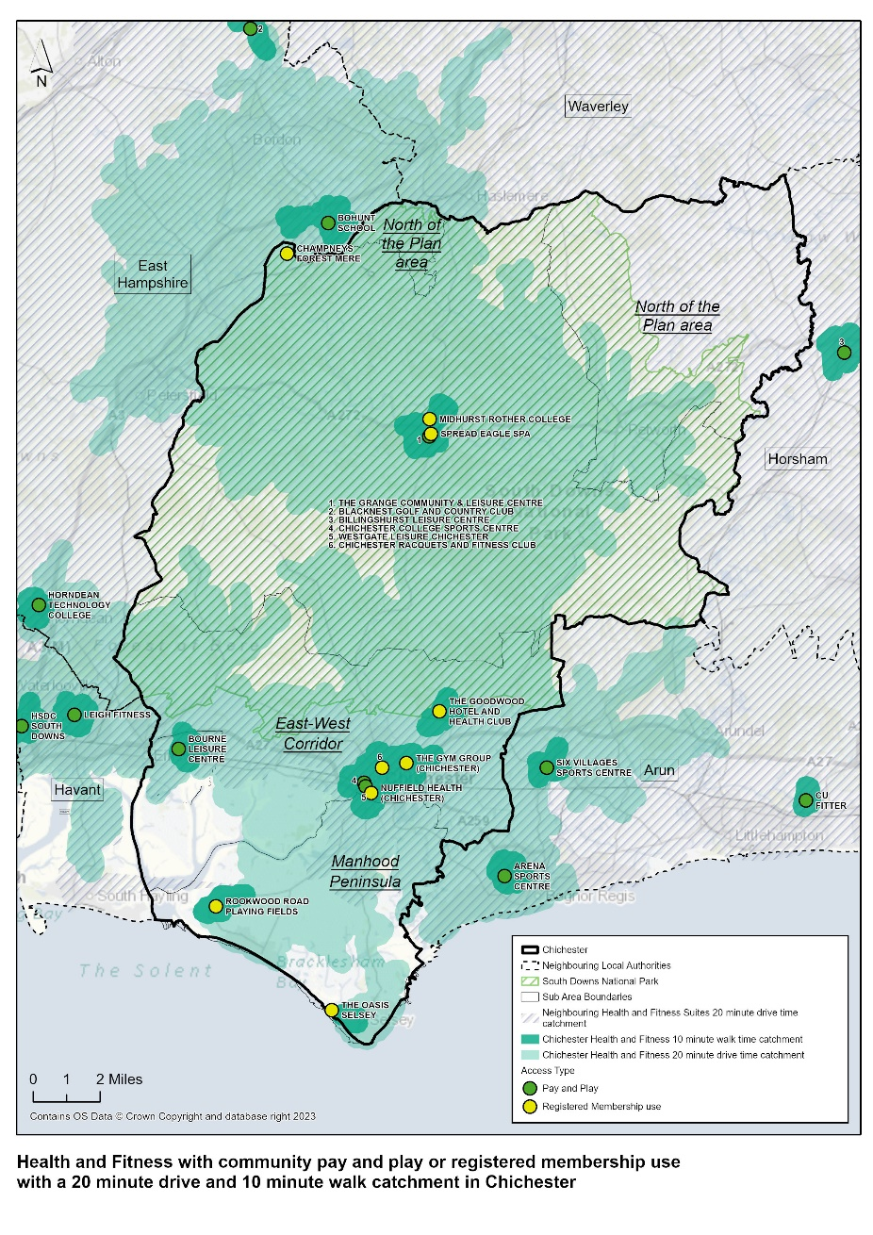

Fitness Suites: Availability

  - The commercial fitness sector (private and registered membership) provides 382 (49%) of the 778 stations in the Chichester District. A total of 200 (26%) are provided by the local authority and managed by Everyone Active, 154 (20%) are located on educational sites and the remaining fitness suites (5%) are located within sports club/pavilion locations.

Commercial Gyms

  - Only 6 out of the 17 sites in the district provide a commercial fitness offer. However, 3 of these sites (Nuffield Health, The Gym Group, and The Oasis Selsey) offer the highest number of fitness stations. The Gym Group (Chichester) is the only budget gym in the district with memberships starting at £15.99 a month. Budget gym providers target areas where there is a significant number of young people e.g. urban areas where there are universities /colleges, offering low-cost membership rates. This is the case with The Gym Group (Chichester) which is located in a retail park close to Chichester University and Chichester College. Budget gyms are a growing trend in the UK; they offer a gym and little else, are staffed on a very lean basis and do not provide the range of facilities found in a community leisure centre.

  - Budget gyms are an important offer in areas of deprivation, and for young people in general, because they can facilitate low-cost access to fitness provision. Budget gyms are competition for community fitness facilities; it is important in any one area to have a balanced offer which includes both.

  - The fitness suite at The Oasis holiday park in Selsey is unusual in that registered membership is available to local residents, but only during off peak periods and excluding weekends and school holidays. The holiday park is also closed during January and February of each year. The offer is therefore very restrictive in terms of community access. However, it is convenient in terms of location for people living in Selsey and negates the need to travel 20 minutes into the next nearest gym in the city of Chichester.

  - There are also some gyms which do not provide fitness stations but offer weight training areas and potentially other facilities e.g. CrossFit Chichester, Fitbox Fitness Studios. These are not shown on Map 10.

Outdoor Gyms

  - There are a number of outdoor/green gyms in and around the Chichester District. These include but are not limited to:

- Sidlesham Memorial Playing Field
- Florence Park
- Oaklands Park
- Whyke Oval
- West Wittering Recreation Centre, Rookwood Park
- The Common on Monk’s Hill, Westbourne
- Swanfield Park, Chichester
- Bracklesham Bay

  - The ability to be active outdoors has become even more important post pandemic; provision of outdoor/green gyms will continue to grow in importance as more people choose to be active outside. For those who prefer a more formal or structured activity, the provision of green/outdoor gyms offers opportunity for a gym workout, outdoors, often for free or at minimal cost.

  - There is no methodology for assessing the need for green/outdoor gyms. However, increasing numbers of people are choosing to be active outdoors provision and therefore a green/outdoor gym can be an important element in an active environment, alongside walking and cycling routes, children’s play areas and multi-use games areas (MUGAs).

  - Provision of green/outdoor gyms should be a consideration in all new residential developments as part of an active environment; this approach would make access to fitness equipment more accessible for those without access to private transport.

Provision Requirements by 2039

  - Future demand for fitness suites is calculated by taking into account all local authority, community accessible and comparable priced facilities providing 20 stations and above as follows:

Table 48: Chichester District Council, community accessible and comparable priced facilities

Bourne Leisure Centre
Chichester College Sports Centre
Chichester Racquet and Fitness Club
Nuffield Health (Chichester)
Optimus Gym (Chichester)
The Grange Community and Leisure Centre
The Gym Group
The Oasis, Selsey
Westgate Leisure Centre

  - The total fitness number of stations across these facilities is 616. Demand is calculated based on the FIA penetration rate (14.6% in 2022) which in 2039, calculates demand at 489 fitness stations against a supply of 616. This equates to an over-supply of 127 fitness stations. This suggests that, although the population of Chichester District is set to increase between 2024 and 2039, the current level of fitness station provision in the district can accommodate the resulting increase in demand from the estimated population growth.

  - Future demand for fitness suite provision is set out in detail in Appendix 14.

Fitness Studios

  - Studios provide a space in which a range of aerobic, fitness and dance classes plus activities such as yoga and Pilates, can take place as well as martial arts, and Indoor Bowls. Studios are typically used for group exercise classes; if demand for these classes outstrips available capacity this is a sign that additional studio space is needed.

  - Typically, new physical activity facilities would include a minimum of two, usually three studios to enable concurrent programming of aerobic -type classes and Pilates/yoga (in a separate studio), and a dedicated group cycling studio. All these types of group exercise are income generating and important to offer as part of an overall fitness membership.

  - Although requiring some specialist equipment for martial arts and boxing, it is also possible to do a form of these activities in an informal space such as a community hall. Informal halls can also accommodate a range of fitness and dance classes. Informal halls are discussed in the Sports Hall and activity hall section of this assessment.

  - The studios assessed in this report are multi-purpose studios (no specific size), not those with fixed equipment, or only one use e.g., spinning.

  - Many informal community hall facilities are used by dance schools, and the smaller halls often available on education sites have significant potential to be used for fitness classes as do community halls.

Fitness Studios: Quantity

  - There are 21 studios in the Chichester District across 16 sites. These are provided as part of a health and fitness offer within facilities. Map 12 shows the location of studios across the Chichester District, and the overall provision of studios in the Chichester District is summarised in Appendix 2, and Table 49.

  - A total of 18 studios are community accessible, with 6 offering pay and play use, 8 offering registered membership use, and 4 offering sports club/community association use. There is no evidence to demonstrate an under-supply or over-supply of studios. However, it will be important to ensure there is investment in additional studio provision, or multi-purpose space, which can be used for group exercise amongst other activities as the population grows.
Map 12: Location of Studios in Chichester District by Access Type

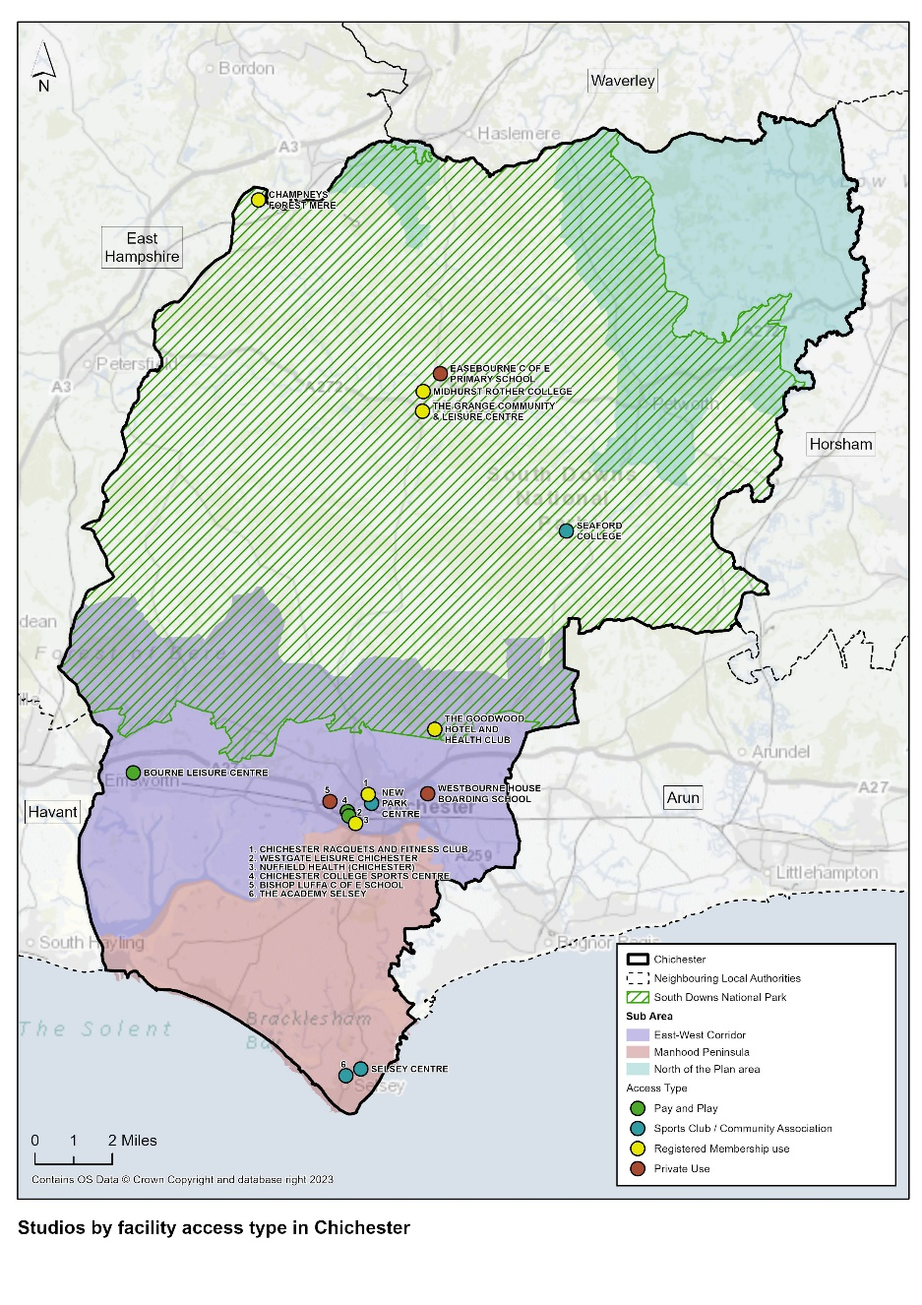
Table 49: Fitness Studios in Chichester District

Site Name | Post Code | Facility Type | Access Type | Ownership Type | Management Type | Pay and Play Community use (ü) | Year Built | Refurbished
Bishop Luffa C of E School | PO19 3HP | Studio | Private Use | Academies | School/College/University (in house) |  | 2009 | N/A
Bourne Leisure Centre | PO10 8PG | Studio | Pay and Play | Local Authority | Commercial Management | √ | 2003 | N/A
Bourne Leisure Centre | PO10 8PG | Studio | Pay and Play | Local Authority | Commercial Management | √ | 2016 | N/A
Champneys Forest Mere | GU30 7JQ | Studio | Registered Membership use | Commercial | Commercial Management |  | 1997 | 2006
Champneys Forest Mere | GU30 7JQ | Studio | Registered Membership use | Commercial | Commercial Management |  | 1997 | N/A
Chichester College Sports Centre | PO19 1SB | Studio | Pay and Play | Further Education | School/College/University (in house) | √ | 2004 | N/A
Chichester Racquets and Fitness Club | PO19 6AR | Studio | Registered Membership use | Sports Club | Sports Club |  | 2006 | N/A
Easebourne C of E Primary School | GU29 9AG | Studio | Private Use | Voluntary Controlled School | School/College/University (in house) |  | 1990 | N/A
Midhurst Rother College | GU29 9DT | Studio | Registered Membership use | Academies | School/College/University (in house) |  | 2012 | N/A
New Park Community Centre | PO19 7XY | Studio | Sports Club/Community Association Use | Local Authority | Community Association |  | 1887 | Not Known
Nuffield Health (Chichester) | PO19 8EL | Studio | Registered Membership use | Commercial | Commercial Management |  | 2003 | N/A
Nuffield Health (Chichester) | PO19 8EL | Studio | Registered Membership use | Commercial | Commercial Management |  | 2003 | N/A
Seaford College | GU28 0NB | Studio | Sports Club / Community Association | Other Independent School | School/College/University (in house) |  | 2000 | N/A
Selsey Centre | PO20 0SE | Studio | Sports Club / Community Association | Local Authority | Local Authority (in house) |  | 2007 | N/A
The Academy Selsey | PO20 9EH | Studio | Sports Club / Community Association | Academies | School/College/University (in house) |  | 2002 | 2018
The Goodward Hotel and Health Club | PO18 0QB | Studio | Registered Membership use | Commercial | Commercial Management |  | 2002 | N/A
The Grange Community and Leisure Centre | GU29 9HD | Studio | Registered Membership use | Local Authority | Commercial Management |  | 2014 | N/A
Westbourne House Boarding School | PO20 2BH | Studio | Private Use | Other Independent School | School/College/University (in house) |  | 2008 | N/A
Westgate Leisure Centre | PO19 1RJ | Studio | Pay and Play | Local Authority | Commercial Management | √ | 1987 | 2003
Westgate Leisure Centre | PO19 1RJ | Studio | Pay and Play | Local Authority | Commercial Management | √ | 2003 | N/A
Westgate Leisure Centre | PO19 1RJ | Studio | Pay and Play | Local Authority | Commercial Management | √ | 2003 | N/A

  - The analysis of the overall studio supply in the Chichester District is as follows:

Table 50: Analysis of overall Studio Supply – the Chichester District

Total Studios | 21
Total number of sites with studios | 16
Pay and Play Community Access Studios | 6
Commercial Sector Studios | 5
Education Sector Studios | 7
Sports Club/Community Association Studios | 1
Local Authority Studios | 8

Fitness Studios - Quality

  - Detailed quality assessments have been undertaken on all studios in the Chichester District. Unfortunately, it was not possible to undertake personal detailed quality audits on all existing facilities, as commercial operators often do not want these to be undertaken, and access to schools was difficult. Therefore, a visual check of these has been undertaken online and has been combined with knowledge of the commercial sector nationally.

  - These are summarised in Appendices 2 and Table 51.

Table 51: Summary of Quality Assessments of Studios in the Chichester District

Site Name | Overall Quantitative Score for Facility % | Qualitative Score for Health and Fitness Studios | Need for Investment- Overall Facility
Bishop Luffa C of E School | 75% | Good | Moderate
Bourne Leisure Centre | 79% | Excellent | Minimal
Champneys Forest Mere | 77% | Excellent | Minimal
Chichester College Sports Centre | 61% | Good | Moderate
Chichester Racquets and Fitness Club | 79% | Good | Moderate
Easebourne C of E Primary School | 59% | Good | Moderate
Midhurst Rother College | 79% | Good | Minimal
New Park Community Centre | 80% | Good | Minima
Nuffield Health (Chichester) | 87% | Excellent | Minimal
Seaford College | 84% | Good | Minimal
Selsey Centre | 96% | Excellent | Minimal
The Academy Selsey | 75% | Good | Minimal
The Goodward Hotel and Health Club | 83% | Good | Minimal
The Grange Community and Leisure Centre | 89% | Excellent | Minimal
Westbourne House Boarding School | 93% | Excellent | Minimal
Westgate Leisure Centre | 65% | Excellent | Moderate

  - The quality of studios ranges from good to excellent. The majority of studios are located in facilities which have obtained a high overall quantitative score and require minimal investment.

Fitness Studios - Accessibility

  - There is a total of 6 studios located within the South Downs National Park Local Plan area and the remaining 14 studios located within the Chichester District Council Local Plan area. The majority of studios are located within the urban East West Corridor in and around the City of Chichester. Those located within the South Downs National Park are mainly located in and around the main town of Midhurst.

  - Map 13 shows that studios are unevenly dispersed across the Chichester District, reflecting the rural and coastal nature of the area. Both Champneys Forest Mere and Seaford College are located in remote rural settings where car travel to the facilities is essential. The are 2 studios located in the town of Selsey on the southern tip of the Manhood Peninsula. Most studios, other than those on education sites, are part of an overall fitness offer incorporating health and fitness suites, spin studios etc. As demonstrated in Map 13, the vast majority of residents in the Chichester District currently have access to a studio within a 20 minute drive catchment. This includes studios outside of the Chichester District boundary.

Map 13: Studios community access with a 20 minute drive and 10 minute walk catchment

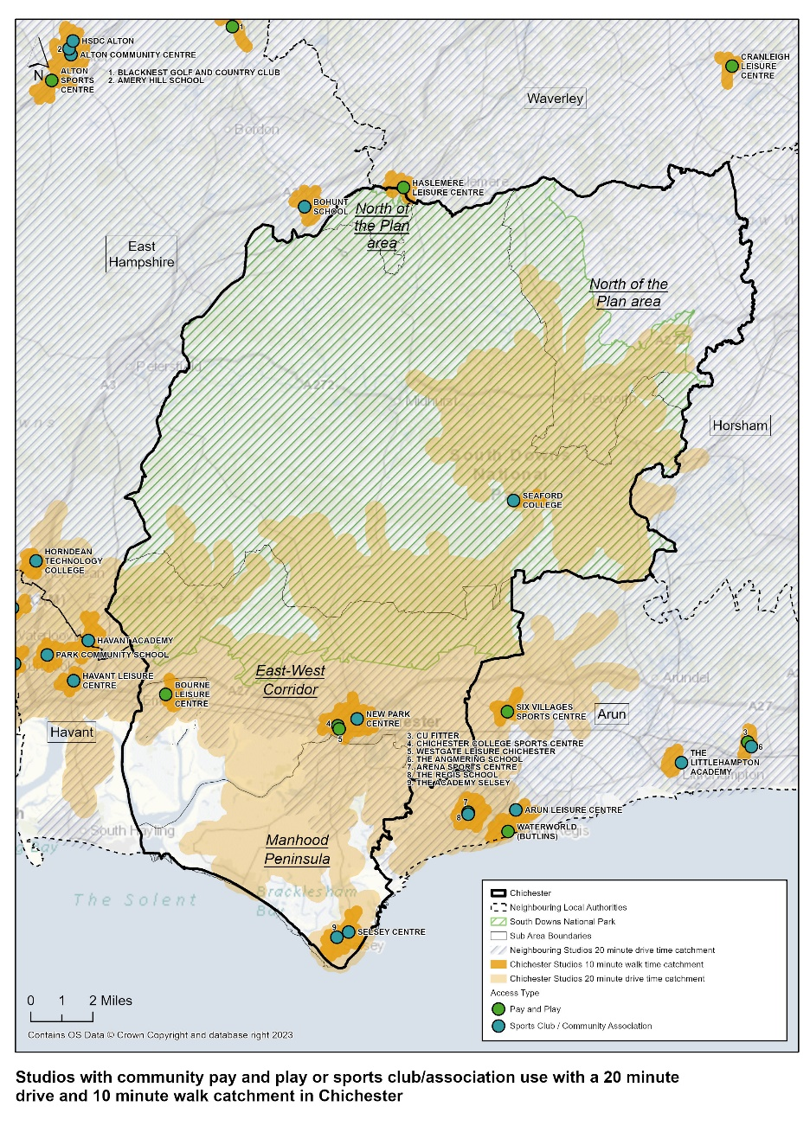
  - It is also important to ensure that studios are as accessible as possible to those walking or using public transport. Map 13 demonstrates the 10-minute walking catchment areas for each of the community accessible studios in the district. It shows the majority of studios are easily accessible by foot to those residents living in and around the key conurbations of the City of Chichester, Bourne, Selsey and Midhurst. This reflects the need for health and fitness facilities to be located close to areas of higher population, where there is sufficient footfall and available disposable income.

Fitness Studios - Availability

  - A total of 8 studios in the district are owned by Chichester District Council with 6 of these operated under contract by Everyone Active. A total of 7 studios are located on education owned sites and 5 located on commercially owned sites. The remaining studio is located on a sports club owned site.

  - 18 studios are available for community use (pay and play, registered membership use, or sports club/community association access); 8 require membership prior to use and 3 are for private use only.

Provision Requirements by 2039

  - There is no methodology for assessing whether there is sufficiency of current or future provision of studios. Typically, studios would be provided alongside a fitness suite, unless possibly on an education site where stand-alone dance studios are sometimes available. Population growth will increase demand for the range of activities provided in studios so there will be a need for additional provision of this facility type.

Health and Fitness Stage C

Stage C

  - The identified need for additional health and fitness provision is summarised in Table 52.

Table 52: Identified need for health and fitness provision

Facility Type | 2024 | 2039
Fitness Suites | 616 fitness stations | 489 fitness stations (over-supply of 127 stations)

Table 53: Key Issues, Impacts, and Implications by Facility Type

Facility Type | Key Issues | Impact/Implications
Health and Fitness Facilities | Over-supply of fitness stations to meet current and future demand | Existing provision can meet current demand.  Increased demand as a result of estimated population growth can be accommodated by existing levels of provision.
 | No additional health and fitness suites are required to be built for community use.
 | No methodology for assessing current and future demand for studio space. However, population growth in the District will increase demand for the range of activities provided in studios | Planning obligation monies should be directed towards development of new studio facilities in areas of new residential development.

  - The vast majority of the Chichester District residents currently have access to a studio within a 20 minute drive catchment. The majority of residents living in the key conurbations of the City of Chichester, Selsey, Bourne, and Midhurst have access to a studio within a 10 minute walk catchment. This reflects the need for fitness facilities to be located in areas of higher population, where there is sufficient footfall and disposable income.

  - On the basis of identified need for additional health and fitness provision, priorities for investment are:

Table 54: Summary of Facility Investment Priorities

Facility Type | Priority for Future Provision | Location
Health and fitness | - No identified need for new fitness suites to meet current and future demand  - New studio space to meet future anticipated demand | N/A  Strategic Development sites identified within the Chichester District Council Emerging Local Plan where a sustainable business case can be evidenced, and no other similar provision exists within the immediate catchment area.

Other Sports and Facilities Stage B

  - There are a range of other sports provided for in the Chichester District. These include:

- Athletics
- Indoor Bowls
- Squash
- Gymnastics
- Indoor Tennis
- Martial Arts
- Boxing

  - These activities provide important opportunities for participation in physical activity. Assessment of the need for these sports/activities is set out below.

Athletics - Assessment Summary Stage B

  - The assessment identifies:

Table 55: Athletics Tracks- Assessment Summary

Facility Type – Athletics Tracks | Key Points
Quantity | There are 2 outdoor athletics facilities within the Chichester District:  - 6 lane 400m permanent grass track with 8 lane finishing straight located at Seaford College.  - Compact 150m synthetic surface J Track located at Chichester University.  There is one indoor athletics facility which is a 40m length sprint lane located within the Sports Dome facility at Chichester University.  There is no traditional 400m all-weather athletics track or entry level accessible/affordable mini oval track within the Chichester District which encourages all age groups to participate in athletics and gain new skills.
Quality | The indoor and outdoor athletics facilities are in good condition. However, Seaford College is a grass track facility which prevents year round high levels of usage. There is also no floodlighting.  The size of the J Track facility at the University of Chichester restricts the type and level of usage. There is also no floodlighting on site. Storage on site is adequate.
Accessibility | The Seaford College grass track is a private facility situated in a remote rural location within the South Downs National Park.  The University of Chichester indoor and outdoor athletics facilities are centrally located in the City of Chichester and easily accessible by foot, car and public transport. However, the facilities are predominantly used by university students with only occasional use by external clubs.
Availability | There is no public access to the grass track facility at Seaford College.  There is limited sports club access to the athletics facilities at the University of Chichester.
Demand in 2039 | England Athletics has evidenced that there is demand for a NewGen track

Provision in 2024

Athletics - Quantity

  - There are two outdoor athletics facilities within the district:

- Seaford College Athletics Track – Standard oval 6 lane 400m permanent grass track with 8 lane 100m final straight. The facility includes field event facilities, no floodlighting and no spectator accommodation. There is accompanying changing accommodation. The athletics track was built in 1978 and refurbished in 2005.

- University of Chichester (Bishop Otter Campus) Athletics track – Compact 8 lane 150m synthetic surface track (‘J’ sprint section) including long jump and triple jump facility. Changing accommodation and disability access. No floodlighting or spectator accommodation. The facility was built in 2013 in the north of the campus on the top field close to the main car park.

  - There is one indoor athletics facility within the district:

- University of Chichester (Bishop Otter Campus) Indoor Sprint Lane - located within the University Sport Dome. 1.2m wide and 40m in length with a 2.5m length start line and finish line. The layout fits the space available and does not allow for the recommended minimum run offs.

  - The athletics track at Seaford College is predominantly for private use by school pupils. The athletics facilities at the University of Chichester are used predominantly by univesity students for teaching purposes, however, the facilities are available for hire by external groups and Chichester Runners and Athletics Club do occassionally hire the J Track in the summer on Monday and Wedneday evenings for junior training.
  - The indoor sprint lane is also occassionally hired by Chichester Triathlon Club.

  - The previous Indoor Sports Facilities Assessment undertaken in 2018 identified the need for a 400m athletics track in the Chichester District and that this should be provided at the University of Chichester Bishop Otter Campus through the extension of the exisitng J Track. This would provide a sub-regional specialist facility for teaching, training, club and competition activities including indoor training facilities (sprint, jumps, throwing cage) and Sport Performance Centre. This was in response to a previous Feasibility Study which had been undertaken in partnership with Chichester District Council and Chichester Runners and Athletics Club (CRAC). The need for an athletics track was supported by England Athletics.

  - England Athletics continues to support the need for an athletics track within the Chichester District as outlined in paragraph 6.212 of this report. However, the location of this facility has since changed, with CRAC now working in partnership with England Athletics and Chichester College to build a NewGen MiniTrack (https://www.englandathletics.org/clubs-and-facilities/facilities/newgen-tracks/) on the college site. This will be a 300m training track with an all weather polymeric surface, marked out for three 900mm wide lanes. Two corners will be banked like a standard 200m indoor track. The other corner will be the same as a standard 400m track. There will be a separate 60m 3 x 1.2m sprint straight and an all weather warm up area, suitable for high jump.

  - England Athletics identify the following athletics clubs in the district:

Table 56: Athletics Clubs in the Chichester District

Club Name | Category | Athletes 2023/24
Chichester Runners and Athletics Club | Track and Field and Off Track | 131
Inspire Runners Chichester | Off Track only | 37
Midhurst Milers | Off track Only | 98

  - Map 14 shows the location of athletics facilities within the Chichester district.

Map 14: Athletics Tracks in the Chichester District

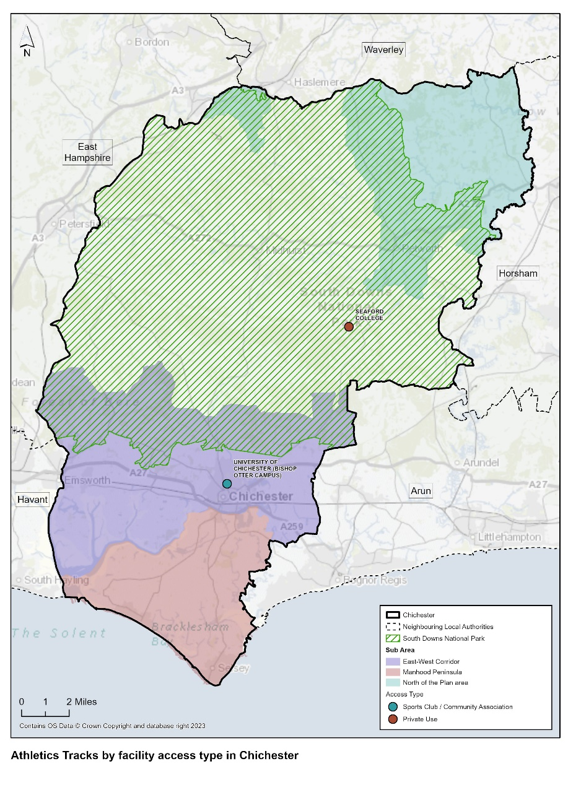

Athletics - Quality

  - The athletics track at Seaford College is in good condition, with the grass marked out on a seasonal basis for college athletics training and sports days. The grass area is flat and associated field event facilities are provided for long jump, high jump, hammer and discuss. There is a changing pavilion adjacent to the track. The track is not UKA TrackMark accredited and there is no floodlighting.

  - The compact J track at the University of Chichester (Bishop Otter Campus) is in good condition although the adjacent pavilion is adequate but lack space and storage. The track is used for sprints and hurdles. There is no floodlighting. There is a long jump facility located adjacent to the 100m straight. Field events take place at a separate location on the university campus. The indoor 40m sprint lane located within the Sports Dome is in good condition.

Demand in 2024

Consultation

Survey Responses (Education Institutions, Sports Clubs, Parish and Town Councils)

  - The University of Chichester (Professor Mike Lauder, Director Institute of Applied Sciences) commented that:

‘There are no current short or medium term plans for the University to prioritise the completion of the 400m track, although the 100m J-track and jumps provision remains in use. This does however remain an aspiration.’

  - Jim Garland, Chairman of Chichester Runners and Athletics Club commented that:

A 400m running track in Chichester would be lovely, however our experience is that it probably just isn’t going to happen, ever. We did have high hopes that the university 150m J track would one day be extended to a full 400m, even if as a 3 lane training track, however, the University have no plans to do this any time soon. Meanwhile, junior and senior athletes are winter training on footpaths and pavements which is far from ideal.

Chichester Runners & AC in partnership with Chichester College are therefore building a 3 lane 300m all-weather training track, with construction scheduled to start this May. Due to site constraints, it is a departure from the standard World Athletics 300m track, with the tighter bends being banked as a 200m indoor track. The layout and approach have been reviewed by England Athletics Technical Committee who are very enthusiastic about this project.

A substantial part of the funding is now in place (capital cost £300k, funding secured £250k) and we will be proceeding with the construction of the track base (a high-spec tarmac path) in summer 2024, subject to Chichester District Council renewing the planning permission that was originally granted in Nov 2020. £5k received from England Athletics.

Map 15: Proposed Athletics Track – Chichester College

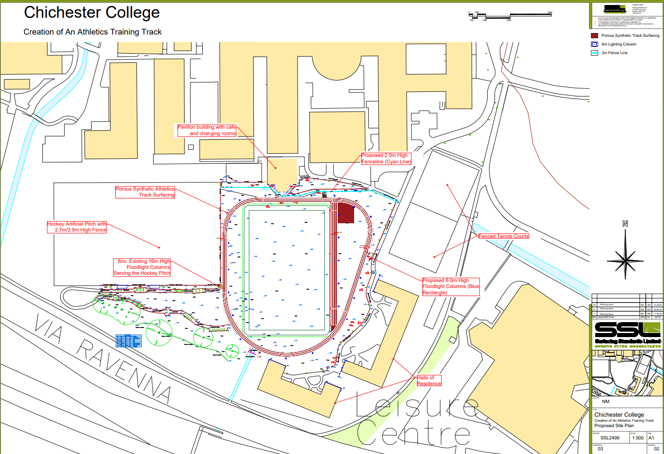

  - No comments were received via the sports club, school and parish council surveys regarding athletics provision.

National Governing Bodies (NGBs)

  - England Athletics responded in detail regarding athletics provision in the district. This is detailed in Appendix 4. A summary of their feedback is set out below:

England Athletics (EA)

Priorities

- Chichester has been identified by England Athletics as a priority area for a NewGen track facility.
- Chichester is one of 50 local authority areas in England that has been identified as a priority area for the development of a NewGen track.
- The following link provides more details of the strategy for NewGen tracks - New:Gen Tracks - England Athletics
- There is potential seed funding and design support for a NewGen facility in Chichester.
- There are no outdoor synthetics 400m facilities in the Chichester District. Additionally, there are 2 further facilities:
- Outdoor Grass 400m track – Seaford College: SE(APP) Facility reference: 1011383
- Compact Track – University of Chichester – Bishop Otter Campus: SE (APP) Facility reference: 1008877

- Chichester is reasonably well served by the neighbouring competition facility at Portsmouth (Mountbatten Centre). This has a 40 minute drivetime catchment and serving the south and west of the Chichester District including the whole of Chichester City. The competition facility at Broadbridge Health Leisure Centre serves the far east and north east of the district including Petworth, leaving a central north south band within the Chichester District which is not covered by a competition facility 40 minute drive catchment.
- However, there are currently no formal, publicly accessible athletics/running facilities in the Chichester District and there are significant population catchments in the district that sit outside England Athletics recommended 30 minute drivetime (rural). The total Chichester district population sitting outside England Athletics’ 30 minute drivetime catchment is 105,658 (ORH report 2022). See Map 16 provided by England Athletics.
- Preferred location for formal publicly accessible athletics/running facility: Chichester, Midhurst, Selsey, East and West Wittering.
- England Athletics mapping shows that there is demand for a NewGen facility in the Chichester area
- As a priority area, England Athletics has already provided seed funding and design support for the proposed NewGen track at Chichester College: a 300m athletics training track, 60m sprint straight, floodlighting and perimeter fencing.

Map 16: Optimal Locations for Athletics Track by Population Coverage – Chichester District

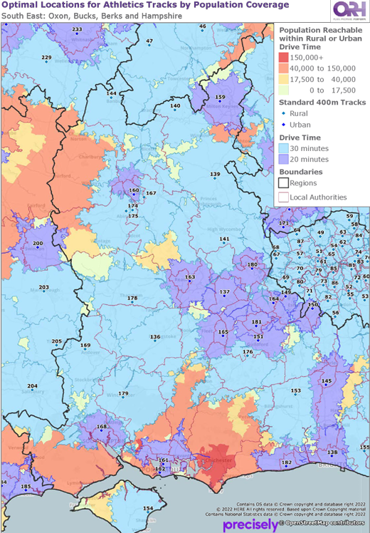
Key:

161 Mountbatten Centre
162 Victory Stadium (Navy)
182 Worthing Leisure Centre

Athletics - Accessibility

  - The athletics track at Seaford College is a private facility used only by the school for athletics training, college sports days etc. Seaford College itself is located in a rural location, south of Petworth and within the South Downs National Park Local Plan area. Private transport is essential for accessing the site.

  - The existing J track and indoor sprint track at the University of Chichester (Bishop Otter Campus) are centrally located within the City of Chichester and therefore serve the main urban East West sub area of the Chichester District Council Local Plan. The J track and indoor sprint lane are not located close to each other on site. The J track is located on the northern edge of the campus close to the main car park. The indoor sprint lane is located approximately 5 minutes’ walk away to the south of the campus within the Sports Dome facility. Although car parking is available on the campus site, car parking is chargeable and spaces are limited as used by students, staff and visitors. Public transport does however serve the campus and the site is easily accessible by foot.

Athletics - Availability

  - The J track and indoor sprint lane at The University of Chichester is primarily used by university students for teaching purposes, as not designed/suitable for competition. There is very limited use of the facilities by external sports clubs, other than occasional lettings to CRAC and Chichester Triathlon Club.

Provision Requirements by 2039

  - While it is not possible to undertake a detailed supply and demand assessment of athletics facilities (due to the lack of an agreed method for measuring capacity and demand), England Athletics mapping has evidenced that there is demand for a formal publicly accessible outdoor athletics/running facility in the Chichester area and has therefore provided seed funding and design support for the proposed NewGen track at Chichester College, working in partnership with the College and Chichester Running and Athletics Club.

  - Chichester District Council should support the delivery of the NewGen track at Chichester College, including the renewal of planning permission subject to a secured community use agreement for the facility. A planning application was submitted (24/00377/FUL) on 19.02.24.

  - The majority of the Chichester District is within a 40 minute drive catchment of competition facilities at the Mountbatten Centre (Portsmouth) and Broadbridge Health Leisure Centre and therefore no formal outdoor competition track is required for the district.

Stage C

  - The identified need for future athletics provision is summarised in Table 57.

Table 57: Identified need for athletics provision

Facility Type | 2024 | 2039
Athletics Tracks | The key priority for England Athletics is to:  PROVIDE  - A publicly accessible athletics/running facility in the Chichester area  - A NewGen track facility at Chichester College site | The key priority for England Athletics is to:  PROTECT  - The NewGen track at Chichester College site, subject to completion of the project

Indoor Bowls - Assessment Summary Stage B

  - The assessment identifies:

Table 58: Bowls Greens - Assessment Summary

Facility Type – Bowling Greens | Key Points
Quantity | There are no purpose built indoor bowls facilities within the Chichester District.  There are 3 outdoor green bowls facilities and 2 short mat bowls clubs operating from school/village hall sites.
Quality | All existing bowling greens are of a standard quality.
Accessibility | There is reasonable access to outdoor bowls club in the south of the district with Fishbourne and Chichester Bowls Clubs located within the East West sub area and Crablands Bowls and Tennis Club located in the Manhood Peninsula. There are no outdoor clubs located in the North of the Area sub area or the South Downs National Park local Plan area.
Availability | All 3 outdoor bowls clubs operate on a membership basis. The facilities are used for training and competition, plus events.  There are no indoor bowling facilities in the district, but also no evidence if need for this type of facility.
Demand in 2039 | No additional bowling greens needed by 2039.

Provision in 2024

Bowls - Quantity

  - There are no indoor bowling facilities in the district. The nearest indoor bowls facility is located at Arun Indoor Bowls Club, located 7 miles (19 minutes) from the City of Chichester.

  - There are 6 outdoor bowling clubs and 2 short mat bowls clubs in district as shown in Table 59. Southbourne Bowls Club offers both outdoor bowls and short mat bowls.

Table 59: Bowls Clubs in the Chichester District

Bowling Club | Facilities
Chichester Bowls Club | Club for male and female adults and juniors – 120 members.  Lawn bowling club and wooden pavilion is open from mid-April until the end of September.  Six rink grass green.  Nearest car park is the Chichester Festival Theatre Car park
Crablands Bowls and Tennis Club | Offering green and short mat bowls. There is a club room and activity hall.  6 rink bowling green available mid-April to end of Sept.  Short mat bowls can accommodate 4 rinks.  There is also all weather and grass tennis courts on site.  Club caters for male and female adults and juniors.
Fishbourne Bowling Club | Shares the site with other sports clubs. Includes a community centre, cricket and football pitches, croquet lawn, multi-sport court and children’s play area. Disabled facilities on site.  Club caters for male and female adults and juniors.  6 rink bowls green built in 1995. Clubhouse built in 2001, part funded by Chichester District Council.
Hunston Short Mat Bowls Club | Located in Hunston Village Hall.  Meets every Tuesday evening.
Midhurst Bowls Club | Provides a 5 rink green, and pavilion with changing facilities.  Caters for male and female, offering friendly fixtures and club competition and tournaments throughout the season.  Coaching available to members.
Petworth Bowls Club | 6 rink lawn bowling club catering for all male and female adult and junior players.  Catering for all abilities and offering internal competition, local friendly fixtures, league and county standard bowls.  Modern outdoor surface and clubhouse facilities.
Selsey Carpet Bowls Club | Located at Medmerry Primary School Hall, Selsey.  The club meets Wednesday and Thursday evenings or Sunday mornings.
Southbourne Bowls Club | Small members club for male and female adult players,.  6 rink green available and also offers short mat bowls.  Club friendly fixtures and county and national competition offered. The club plays in the West Sussex Bowls League, Brooks Motors League and West Sussex Short Mat League.  The club also offers winter bowling outdoors.  Casual bowling available on Tuesday evenings and Sunday afternoons if no fixture is schedules.

  - Chichester Bowls Club facilities are located at Priory Park, Chichester. This park site is managed by Chichester District Council. The park is home to both Chichester Bowling Club and Chichester Priory Park Cricket Club. Crablands Bowls and Tennis Club is a private club located in Crablands area of Selsey. Fishbourne Bowling Club is located at Fishbourne Playing Fields, owned and operated by the Fishbourne Playing Fields Association.

  - Fishbourne and Chichester bowling clubs are both located within the East West sub area of the Chichester District Council Local Plan and Crablands Bowls Club is located within the Manhood Peninsula sub area of the Chichester District Council Local Plan. Midhurst Bowls Club and Petworth Bowls Club are both located within the South Downs National Park Local Plan area. There are no outdoor bowls clubs located in the North of the Plan sub area of the Chichester District Council Local Plan.

Indoor Bowls - Quality

  - The quality of the 6 bowling clubs’ facilities is standard.

Demand in 2024

Consultation

Survey Responses (Education Institutions, Sports Clubs)

  - Detained analysis is provided of education institution, sports club and parish council feedback in paragraphs 6.10 – 6.28.

  - The only feedback was received from Chichester Bowls Club who responded to the sports club survey. A summary of the information they provided is listed below:

- The club has approximately 61 – 70 members, 3 paid coaches and over 5 volunteer coaches.
- The number of members is likely to increase.
- The club is not operating at capacity.
- Comments are made about the poor quality of their existing wooden pavilion and that it is no longer fit for purpose. Their website makes reference to this and that they are trying to raise funds for a new building which would include bar and kitchen facilities, improved changing accommodation, lockers and storage, and space for post-match meals.
- The club highlights the need for better communication with the facility owners/management.

NGB – England Indoor Bowls Association

  - Consultation was undertaken with the England Indoor Bowls Association to identify their views on the need for indoor bowls provision within the Chichester District. The NGB’s response is detailed in Appendix 4 and summarised below:

- Based on mileage and travel time from the local authority council offices, there is one purpose built indoor bowls site in adjoining areas within a 30 minute drive time. This is located at Arun Indoor Bowls Club, Bognor Regis.
- Chawton Park (Alton) and Horsham bowls Club may also fall into this category depending upon a resident’s location within the local authority area.
- In pre-Covid times, when funding was not an issue, we would have sought to explore the possibility of an Indoor Bowls Facility being provided in the local authority area.
- Since then, with funding for capital builds becoming extremely scarce, there have been very few new standalone builds unless they involve relocation and selling of the existing site to fund the project.
- The NGB is currently reviewing its ‘market analysis’ guidance and feel that the additional criteria/parameters are now appropriate:
- Travel time – consider an extension to 30 minutes. We anticipate that there will be regional variations, depending upon the current provision of Indoor Bowls sites.
- Means of travel – we consider that the provision of “public transport” will be relevant in some parts of the country – especially the rural areas.
- Members per rink ratio (one rink per 14,000 – 17,000 of total population) – this figure is still relevant, but we also need to factor in “spare rink capacity” for each session played, bearing in mind that then older population is not keen on travelling in the dark.

- The NGB has no access to any funding to support the provision of new capital builds.

Indoor Bowls - Accessibility

  - There is reasonable access to outdoor bowls club in the south of the district with Fishbourne and Chichester Bowls Clubs located within the East West sub area and Crablands Bowls and Tennis Club located in the Manhood Peninsula. There are also 2 bowls clubs located within the South Downs National Park, serving the more rural parts of the district. There are no outdoor clubs located in the North of the Area sub area.

Indoor Bowls - Availability

  - The 6 outdoor bowls clubs all operate on a membership basis. The facilities are used for training and competition, plus events.

  - No need has been identified for indoor bowling facilities in the district.

Provision Requirements by 2039

  - There is no evidence of need for additional outdoor bowling greens in the district.

Stage C

  - There is no identified need for additional provision of indoor or outdoor bowling facilities.

Squash - Assessment Summary Stage B

  - The assessment identifies:

Table 60: Squash - Assessment Summary

Facility Type – Squash Facilities | Key Points
Quantity | There are 13 squash courts in the district across 6 sites.  5 of the courts are for registered membership use, 2 are for community pay and play use, 3 are for private use, and 3 are for sports club/association use.  Both community pay and play squash courts are provided at The Grange community and Leisure Centre which is owned by the local authority and operated by Everyone Active.  Chichester Racquets and Fitness Club provides 5 courts; the highest number of courts compared to other sites in the district. These are all registered membership use only.
Quality | All the squash courts are in either good or excellent condition, with the exception of Highfield and Brookham School squash court, which is the oldest court in the district and in average condition.
Accessibility | The majority of the district is within a 20 minute drive time of a squash court with the exception of parts of the Manhood Peninsula, including Selsey, Bracklesham, Church Norton, West Wittering, and Thorney Island.
Availability | There are 2 pay and play community accessible squash courts available in the Chichester District. Both are glass backed courts and provided at The Grange Community and Leisure Centre, operated by Everyone Active and located within the South Downs National Park. A further 8 courts provide community access through registered membership or sports club/association use across the district.
Demand in 2039 | Although there is no specific methodology for assessing the current and future demand for squash courts, England Squash normally recommends a ratio of 1 court per 10,000 population.  This equates to 12 courts in the Chichester District and therefore the district currently exceeds this requirement by 1 court.  Competitive squash across the country is predominantly now played in clubs, from a club facility; demand for community access squash courts has reduced in recent years. Participation is still growing, but through the club base where juniors can be supported and coached from an early age.  There is no identified current or future demand for additional squash facilities in the district.

Provision in 2024

Squash - Quantity

  - There are a total of 13 squash courts in the district located across 6 sites as shown in table 61:

  - Five squash courts are for private use only and these are located at Baker Barracks (MOD site), Highfield and Brookham School, and Westbourne House Boarding School.

  - There are only 2 community pay and play squash facilities; these are both glass backed and located at The Grange Community and Leisure Centre in South Downs National Park Local Plan area.

  - The Chichester Racquets and Fitness Club is a registered membership club in the City of Chichester, offering the highest number of courts (5) with one of these being glass backed.

  - A total of 5 out of the 13 courts in the district are glass backed.

  - 5 of the courts are for registered membership use, 3 are for private use, 3 are for sports club/association use, and 2 are community pay and play courts.

Table 61: Squash Court Facilities in the Chichester District

Site Name | Post Code | Facility Type | Sub Type | Courts | Access Type | Ownership Type | Management Type | Pay and Play Community use (ü) | Year Built | Refurbished
Baker Barracks | PO10 8DH | Squash Courts | Normal | 2 | Private | MOD | MOD |  | 2006 | N/A
Chichester Racquets and Fitness Club | PO19 6AR | Squash Courts | Normal | 4 | Registered Membership Use | Sports Club | Sports Club |  | 1964 | 2005
Chichester Racquets and Fitness Club | PO19 6AR | Squash Courts | Glass Backed | 1 | Registered Membership Use | Sports Club | Sports Club |  | 2000 | N/A
Highfield and Brookham School | GU30 7LQ | Squash Courts | Normal | 1 | Private | Other independent School | School/College/University (in house) |  | 1975 | N/A
Loxwood Sports Association | RH14 0SX | Squash Courts | Normal | 1 | Sports Club/Community Association | Community Organisation | Community Organisation |  | 1981 | N/A
The Grange Community and Leisure Centre | GU29 9HD | Squash Courts | Glass Backed | 2 | Pay and Play | Local Authority | Commercial Management | √ | 2014 | N/A
Westbourne House Boarding School | PO20 2BH | Squash courts | Glass Backed | 2 | Sports Club/Community Association | Other independent School | School/College/University (In house) |  | 1988 | Not known

Map 17: Squash Courts by Facility Access Type in Chichester District

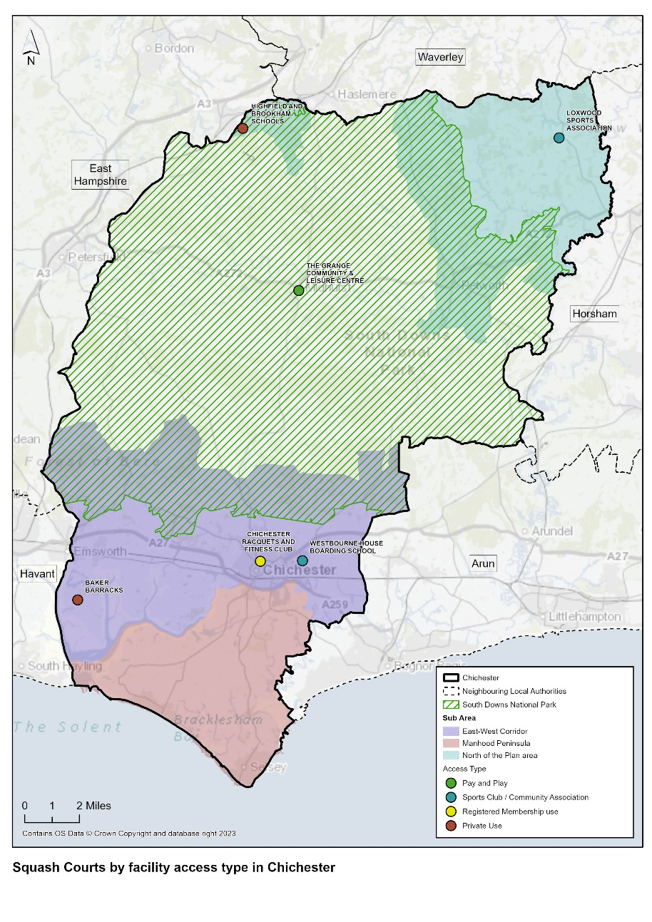

Squash - Quality

  - A quality assessment was undertaken of squash court provision in the district as shown in table 62.

Table 62: Qualitative assessment of squash courts – Chichester District

 |  | Overall Quantitative Score for Facility % | Qualitative Score for Squash Courts | Need for Investment- Overall Facility
Baker Barracks |  | Not accessible as MOD site restrictions
Chichester Racquets and Fitness Club |  | 79% | Good | Moderate
Chichester Racquets and Fitness Club |  | 79% | Good | Moderate
Highfield and Brookham School |  | 57% | Good | Moderate
Loxwood Sports Association |  | 54% | Average | Moderate
The Grange Community and Leisure Centre |  | 89% | Excellent | Minimal
Westbourne House Boarding School |  | 93% | Excellent | Minimal

  - The quality of squash court provision is generally good or excellent in the district, with the exception of the 1 court facility at Highfield and Brookham School, which was built in 1975 is of average quality and for pupil use only.

Demand in 2024

Consultation

Survey Responses (Education Institutions, Sports Clubs, Parish and Town Councils)

  - Detained analysis is provided of education institution and sports club feedback in paragraphs 6.10 – 6.28. There was no specific feedback regarding squash provision.

  - Westbourne House Boarding School confirmed that its squash courts are hired out to Westbourne Squash Club.

  - Highfield and Brookham School indicated during the site audit that they have long term plans to replace their indoor leisure facilities (excluding the pool) and but may decide to exclude a squash court facility due to the lack of use by the school.

NGB – British Squash

  - No consultation feedback has been received.

Squash - Accessibility

  - Squash courts are more specialist facilities, so there are generally fewer of them in any one area. The squash courts in the Chichester District are provided by a range of organisations including local authority, MOD, sports club, community organisation and schools.

  - Map 17 shows the 20 minute drive and 10 minute walk catchments for community accessible squash courts in the district. The map shows that the majority of the district is within a 20 minute drive catchment of a community accessible squash court, with the exception of parts of the Manhood Peninsula, including Selsey, Bracklesham, Church Norton, West Wittering, and Thorney Island. Other areas outside a 20 minute drive catchment are within a 20 minute drive catchment of squash facilities in neighbouring authorities.

Map 18: Squash 20 minute drive and 10 minute walk catchments – Chichester District
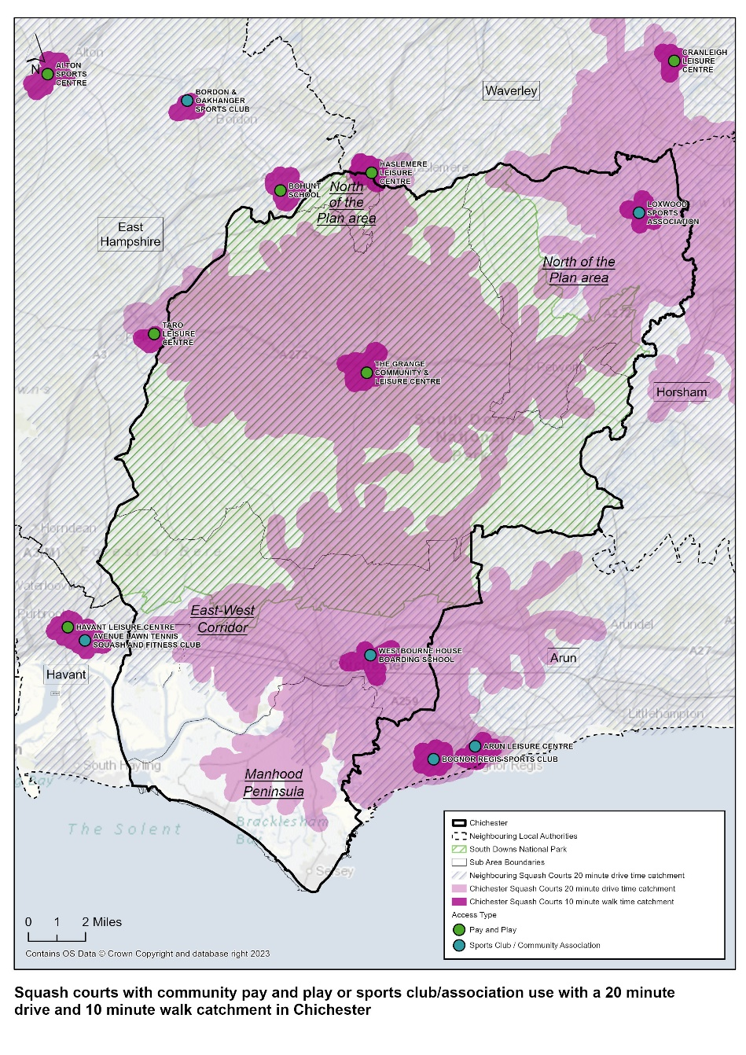

Squash - Availability

  - There are 2 pay and play community accessible squash courts available in the Chichester District. Both are glass backed courts and provided at The Grange Community and Leisure Centre, operated by Everyone Active and located within the South Downs National Park. A further 8 courts provide community access through registered membership or sports club/association use across the district.

Provision Requirements by 2039

  - Although there is no specific methodology for assessing the current and future demand for squash courts, England Squash normally recommends a ratio of 1 court per 10,000 population. This equates to 12 courts in the Chichester District and therefore the district currently exceeds this requirement by 1 court. Although 3 of the courts included in the calculation are for private use only, there are also 2 community pay and play courts also included in the same calculation.

  - Competitive squash across the country is predominantly now played in clubs, from a club facility; demand for community access squash courts has reduced in recent years. Participation is still growing, but through the club base where juniors can be supported and coached from an early age.

  - There is no identified need for additional squash facilities in the district.

Stage C

  - There is no identified need for additional provision of specialist Squash facilities.

Indoor Tennis – Assessment Summary Stage B

  - The assessment identifies:

Table 63: Tennis - Assessment Summary

Facility Type – Tennis Courts | Key Points
Quantity | There is 1 indoor tennis facility within the district.  Chichester Racquet and Fitness Club has 3 outdoor hard courts that are covered on a seasonal basis through the use of a temporary ‘bubble’ structure.  There are 90 outdoor tennis courts across the district. 75 of these are publicly accessible with a similar number of local authority, sports club and educationally owned courts. 15 outdoor courts are private and located on education sites.  There are currently only 2 Padel tennis courts in the district and these are located on a sports club site in the city of Chichester.
Quality | The indoor tennis facility at Chichester Racquet and Fitness Club is of average quality due to the condition of the temporary ‘bubble’ cover.  The University confirmed that the Sports Dome floor/court specification is not conducive to competitive tennis and that the university students therefore use the courts at Chichester Racquet and Fitness Club for competitive tennis.
Accessibility | Both indoor tennis facilities are located in the City of Chichester and easily accessible by foot, public transport and car.  However, Chichester Racquet and Fitness Club is a registered members club and therefore offers no pay and play community tennis. The tennis facilities are however, hired by Chichester University for tennis competitions.
Availability | Indoor tennis provision is only available at Chichester Racquets and Fitness Club from October to April of each year.  The Club is open Monday – Thursday 6.30am – 10pm, Friday 6.30am – 11pm, Saturday 8am – 8pm and Sunday 9am – 7pm. All courts are used for a variety of activities including junior and adult tennis coaching, social tennis, club championships, tennis events and tournaments.  The tennis courts are not available for hire by external tennis clubs or for external tennis coaching.
Demand in 2039 | There is no identified need for a Community Indoor Tennis Centre within the district.  However, Chichester District Council should progress and conclude negotiations with Chichester Racquets and Fitness Club regarding the provision of a permanent indoor tennis hall to replace the temporary seasonal cover currently used on site, subject to a sustainable business case and in return for secured community pay and play access to some of the tennis courts at the club including those catering for Padel and Pickleball.  There is no identified need for additional provision of outdoor tennis courts, but ensuring tennis can be played on any new multi-use games areas (MUGAs) would be sensible to anticipate any growth in demand.

Provision in 2024

Indoor Tennis – Quantity

  - There is 1 indoor tennis facility in the district, listed in Table 64.

  - The Chichester Racquets and Fitness Club (CRAFC) has 4 outdoor artificial clay courts, 3 outdoor hard courts, and an additional 3 hard courts that are covered with a temporary ‘bubble’ structure seasonally from October through to April. There are also 2 padel tennis courts on site built in 2019.
  - All courts are floodlit. The Club also manage the neighbouring 7 public tennis courts in Oaklands Park on behalf of Chichester District Council. These courts can be booked online through the LTA ClubSpark portal. Three of the public tennis courts are floodlit.

  - The Chichester University Sports Dome has already been included in the sports hall section of the report as its used for multi sports; it is not a purpose-built tennis facility. The Dome is marked out for tennis and the university use it for recreational tennis and for the purposes of teaching students who are going to teach the sport, but it is used by the community for a range of sports.

  - The Sport Dome facility which is the equivalent of a 4 badminton court sports hall. It has a tensile roof and steel frame. It is described as an indoor tennis facility by Sport England and is marked out for 4 tennis courts and other sports including netball, basketball, volleyball, futsal and handball. When consulted, the university explained that the Sports Dome is only used for teaching tennis (PE course) and that the floor is not conducive to competitive tennis, however it is used for a range of other sports by both students and the local community. The facility has therefore been included in the sports hall section of this report.

  - There is no secured community access to the Sports Dome.

  - There are a total of 90 outdoor tennis courts in the Chichester District. A total 15 are private and on educational sites and 75 are publicly accessible. Of those that are publicly accessible, 21 are local authority owned and mainly located in parks and recreation grounds, 5 are commercially owned, 19 are sports club owned and 20 are owned by educational establishments. 65% of tennis courts were built after the year 2000 with 34% known to have been refurbished since 2010. There is a fairly even distribution of outdoor courts across the district, with the highest proportion located within the City of Chichester and urban East West sub area of the Chichester District Council Local Plan.

  - Padel tennis is a relatively new sport which is growing in popularity amongst all age groups as it is both quick and easy to pick up. The growth and roll out of Padel tennis is seen as one of the LTA’s key priorities both nationally and in the Chichester District Council area as the sport is seen as an introductory pathway into mainstream tennis. At present there are only 2 Padel tennis courts available in the Chichester District Council area.

  - Other padel tennis courts can be found in Sussex:

- The West Worthing Club – 2 new floodlit and covered Padel courts
- The Triangle in Burgess Hill – 1 Padel courts
- Withdean Sports Complex – 1 pop up court
- Rye Lawn Tennis and Squash Club – 2 Padel courts
- Crowborough Tennis and Squash Club – 2 new Padel courts

  - The Triangle and Withdean Sports Complex are both local authority owned pay and play community accessible facilities managed by commercial operators. The remaining courts are located on sports club sites and operate on a registered membership basis.
Table 64: Indoor Tennis Facilities in the Chichester District

Site Name | Post Code | Facility Type | Sub Type | Courts | Access Type | Ownership Type | Management Type | Pay and Play Community use (ü) | Year Built | Refurbished
Chichester Racquets and Fitness Club | PO19 6AR | Indoor Tennis Centre | Airhall (Seasonal) | 3 | Registered Membership Use | Sports Club | Sports Club |  | 1993 | 2010

Indoor Tennis – Quality

  - Indoor quality assessment have been carried out of the 2 indoor tennis facilities as shown in Table 65.

Table 65: Indoor Tennis Courts – Quality Assessment

Site Name | Overall Quantitative Score for Facility % | Qualitative Score for Health and Fitness Suite | Need for Investment- Overall Facility
Chichester Racquets and Fitness Club | 79% | Average | Moderate

  - The covered outdoor tennis courts at the CRAFC are regarded as of average quality. Investment needed in the court cover itself which, according to the Club, is open to abuse due to its proximity to College Lane (public highway).

Demand in 2024

Consultation

Survey Responses (Education Institutions, Sports Clubs, Parish and Town Councils)

  - Detained analysis is provided of education institution, sports club and parish and town council feedback in paragraphs 6.10 – 6.28. The following comments were made:

- Seaford College responded saying that it has an indoor tennis court on site but this was not identified during a site audit of the facility and the assumption is that the facility they are referring to is their sports hall which is marked out for tennis.
- Fishbourne Parish Council refers to having numerous outdoor facilities including tennis, croquet, bowls, cricket and football.
- Petworth Parish Council commented that it has a private tennis club. This offers outdoor tennis provision.

Chichester Racquets and Fitness Club (CRAFC)

  - The previous Chichester District Council Built and Indoor Sport and Leisure Needs Assessment (2018) commented that the Council were in negotiations with CRAFC over the management of the community tennis courts at Oaklands Park, secured community use of designated courts and the potential of receiving planning permission for a permanent indoor tennis structure on the site of these courts.

  - The Council has confirmed that they are still in discussion with CRAFC regarding the public courts at Oaklands Park. The Club still has plans for a permanent indoor tennis facility incorporating Padel and Pickleball courts but no final plans have been agreed, no planning permission obtained and no funding identified.

National Governing Body – The Lawn Tennis Association

  - The LTA’s priorities for tennis both nationally and in the Chichester District area are that of ‘growing tennis and to see tennis opened up by making tennis relevant, accessible, welcoming and enjoyable.’

Outdoor/Indoor Tennis

  - To do this they are focussing on:

- Parks investment and free parks tennis ( Park Tennis Project (lta.org.uk))
- Floodlighting/covering more courts
- Support the growth and addition of Padel Tennis courts
- Opening venues up to the community through pay and play
- Community accessibility – parks, venues, schools, leisure centres
- Taking tennis out of traditional settings and into the heart of communities
- Accessing more schools where tennis courts are on site
- Workforce development
- Sustainability

Indoor Tennis

  - To establish target locations for future community indoor tennis centres, the LTA modelled data from existing successful CITC’s. This helped to identify the demographic type, volume, and catchment size of a successful CITC. This modelling was applied across England, Scotland, and Wales to establish the areas of potential demand.

  - The key metrics established are:

- A target location must demonstrate a minimum threshold population of 70,000 within a 20-minute drive time of a target location. Of this population, at least 12,500 must identify as having an interest in playing tennis. Please note this drive time extends to 30 minutes for rural areas.
- Filtered for competition within the catchment to prioritise the addressing of indoor tennis provision gaps.

  - This methodology has enabled the LTA to identify 72 target locations for new indoor tennis venues in England. The target location closest to Chichester District is Horsham.

Tennis - Accessibility

  - All indoor tennis courts in the district are situated across 1 site, which located in the city of Chichester. The site is easily accessible by car, foot and public transport.

  - The 3 seasonal indoor tennis courts at CRAFC are only available on a registered membership basis as are the other facilities on site.

Tennis - Availability

  - The temporary ‘bubble’ roof covering the 3 outdoor tennis courts at the CRAFC is in situ from October to April of each year. The registered members club opening hours varies; Monday – Thursday 6.30am – 10pm, Friday 6.30am – 11pm, Saturday 8am – 8pm and Sunday 9am – 7pm. All courts are used for a variety of activities including junior and adult tennis coaching, social tennis, club championships, tennis events and tournaments.

Provision Requirements by 2039

  - The LTA’s methodology for determining locations for future community indoor tennis centres (CITC) has identified Horsham as its preferred location for a new facility, closest to the Chichester District. This therefore suggests that the LTA does not see Chichester itself as having the right demographic type, volume and catchment size to suit a facility of this type.

  - However, consideration should be given to other key factors affecting current indoor tennis provision within the district.
  - Taking the above into consideration and the current condition of the temporary ‘bubble’ court cover at CRAFC, there is the opportunity for Chichester District Council and CRAFC to work together to progress and conclude negotiations for a permanent indoor tennis hall on the CRAFC site to replace the temporary seasonal cover, subject to a sustainable business case and in return for secured community pay and play use of some of the courts on site including Padel and Pickleball.

  - There is no identified need for additional outdoor tennis courts in the district. However, given population growth demand may increase for this facility type. It would be sensible to ensure that tennis can be played on any new multi-use games areas (MUGAs) developed in areas of housing growth.

Stage C

  - The LTA has confirmed that there is no identified need for a Community Indoor Tennis Centre within the district. However, Chichester District Council should progress and conclude negotiations with Chichester Racquets and Fitness Club regarding the provision of a permanent indoor tennis hall to replace the temporary seasonal cover currently used on site, subject to a sustainable business case and in return for secured community pay and play access to some of the tennis courts at the club including those catering for Padel and Pickleball.

  - There is no identified need for additional provision of outdoor tennis courts, but ensuring tennis can be played on any new multi-use games areas (MUGAs) would be sensible to anticipate any growth in demand.

Gymnastics – Assessment Summary Stage B

  - The assessment identifies:

Table 66: Gymnastics – Assessment Summary

Facility Type – Gymnastics | Key Points
Quantity | There is no purpose built specialist gymnastics facility in the district.  There are 4 key gymnastics clubs; 2 lease facilities and have dedicated use; 2 use local authority sports halls on a regular hire arrangement.
Quality | The gymnastics facilities leased or hired by clubs in the district are either good or excellent in quality.
Accessibility | 3 out of the 4 main gymnastics clubs in the district are located in the city of Chichester where there is a higher population. The fourth club is located in Southbourne.  There is very limited provision in the South Downs National Park, or North of the Plan and Manhood Peninsula sub areas of the Chichester District Council Local Plan, reflecting in part the rural geography of the district. Gymnastics sessions have been provided at the Grange Community and Leisure Centre in Midhurst. There is also a Victory Gymnastics Club operating from the Former Herbert Shiner School, Petworth.
Availability | Gymnastics is a specialist activity; demand is likely to grow as the population increases in the district. A lack of capacity however has not been identified in the district. 2 of the 4 main gymnastics clubs in the district now operate from dedicated facilities and have capacity to grow.
Demand in 2039 | There is no specific methodology for assessing the need for gymnastics provision, neither facilities nor clubs.  British Gymnastics does not identify the need for a purpose built specialist gymnastics facility within the district.  However, existing levels of provision should be retained and support given to facilitating club-led development of dedicated gymnastics facilities to help increase capacity as the population in the district grows.  Utilisation of existing sports hall and activity hall facilities in more rural parts of the district, particularly within the South Downs National Park, North of the Plan sub area and the Manhood Peninsula sub area of the Chichester District Council Local Plan should be supported to help increase access to opportunities to take part in gymnastics in these areas.

Provision in 2024

Gymnastics – Quantity

  - There are no purpose built specialist gymnastics facility in the district. Table 67 details the key gymnastics clubs in the district and the facilities that they currently use.

Table 67: Key Gymnastics Club in Chichester district and facilities used

Gymnastics Club | Membership | Facility Address | Basis of use
Chichester Olympic Gymnastics Academy | 179 | The Tim Peake Sports and Conference Centre (Chichester High School Campus), Chichester | Dedicated
Westgate Gymnastics | 213 | Westgate Leisure Centre, Chichester | Non-dedicated
Southbourne Gymnastics Club | 255 | Bourne Leisure Centre, Southbourne | Non-dedicated
The Academy of Gym | 265 | Unit 5, Cedar Trade Park, Chichester | Dedicated

  - Chichester Gymnastics Academy leases the Tim Peake Sports and Conference Centre, located on the Chichester High School campus in the city of Chichester. When the Chichester High School for Boys merged with the adjacent girl’s school in 2016, the newly formed Chichester High School no longer required full time use of the 2 sports halls on site. The school therefore agreed a 10 year lease (commencing 2017) of the Tim Peake Sports and Conference Centre with the Chichester Gymnastics Academy, who has been based at the school since 2010. The lease includes use of the sports hall by the school for gymnastics at agreed times. The school retains responsibility for the building with the Academy responsible for all equipment on site. The Academy cater for recreational and competitive gymnastics for children and adults aged 3 years and over.

  - Westgate Gymnastics Club use Westgate Leisure Centre sports hall and offers recreational and competitive gymnasts for boys and girls aged 4 – 16 years. Non-dedicated use of the sports hall requires the club to set up and take down the gymnastics equipment at the beginning and end of each let. The equipment is stored on site.

  - Southbourne Gymnastics Club use the sports hall at Bourne Leisure Centre dual use facility, which is owned by the local authority and managed by Everyone Active. The club caters for recreational and competitive gymnastics for 4 – 16 year olds.

  - The Academy of Gym leases a business unit on Cedar Trade Park in Chichester. This allows the club to offer a variety of daytime, evening and weekend classes for children aged 2.5 years and over.
  - The above clubs provide a range of gymnastics disciplines including artistic, rhythmic, and trampolining from beginner levels through to elite competitive squads.

  - There are also smaller gymnastics clubs not listed by British Gymnastics including the Victory Gymnastics Club, who uses the Former Herbert Shiner School in Petworth. The Grange Community and Leisure Centre has also previously provided gymnastics sessions for 5 – 11 year olds through the British Gymnastics ‘Rise into Gymnastics’ programme and award scheme.

Gymnastics - Quality

  - The sports halls at Bourne Leisure Centre and Westgate Leisure centre are both of excellent quality. The Tim Peake Sports and Conference Centre sports hall and Academy of Gym facilities were not accessible at the time of the site audits. However, from online research both facilities would be described as of good quality.

Demand in 2024

Consultation

Survey Responses (Education Institutions, Sports Clubs, Parish and Town Councils)

  - Detailed analysis is provided of education institution, sports club and parish and town council feedback in paragraphs 6.10 – 6.28.

  - Westgate Gymnastics Club responded to the Sports Club Survey and provided the following feedback:

We run our club independently but we also manage and run 4 hours of the Leisure centres classes for them. We do source a lot of equipment through our club and also source the coaches and mentor them which we use to also deliver the centres class for them. Although we are always replacing and buying things for both the classes to use - this is of course added to wear and tear to our costings.

We do oblige in doing this as the whole ethos of our club is to provide every child the experience of taking part in gymnastics. But sometimes it would be nice to have support when replacing the bigger apparatus rather than solely ourselves. We are looking to replace a beam in a few months but we will be purchasing this ourselves - although the centre will also be using it.

  - It should be noted that Westgate Leisure Centre does allow Westgate Gymnastics Club to store all gymnastics equipment free of charge and assists the club in setting up and putting away of equipment before and after each let.

  - No other feedback was received.

National Governing Body – British Gymnastics

  - British Gymnastics refers to its new ‘Leap Without Limits’ vision for the sport, with the collective purpose of ensuring that gymnastics is enjoyable, safe, and open to everyone.’ The NGB’s facility strategy (2017 – 2021) is now out of date but identified the following priorities:

- Support increased capacity within gymnastics through clubs, leisure providers and other delivery providers.
- Guide funding investment through the United Kingdom from British Gymnastics, Home Country Sports Councils, Local Authorities, and other potential funders.
- Maintain and improve the quality of facilities and equipment within existing delivery partners.
- Develop insight, understanding and direction of how Facility Developments can contribute towards other BG Strategic Priorities.

  - British Gymnastics has no geographical focus and therefore does not identify Chichester as a priority area. Any focus is based on need, suitability, and partners’ ability to support a project to successful completion.

  - British Gymnastics does not identify any key facilities for the sport in Chichester District. It does however feel that there is potential for the sport to grow in the district, as most clubs nationally report waiting lists. Since British Gymnastics vision is to build capacity in the community, they will support clubs and partners wishing to move into dedicated facilities, offering more time and space for classes. Eligible British Gymnastics Clubs can apply for Club Capital, a social investment impact loan of between £25,000 and £250,000 to enable clubs to move into new or expand or safeguard existing dedicated gymnastics facilities.

Gymnastics - Accessibility

  - Gymnastics is a specialist activity and therefore the catchment area is greater. 3 of the gymnastics clubs in the district are located within the city of Chichester where there is a higher population. The fourth gymnastics club is located in Southbourne. There is very limited provision in the South Downs National Park, or North of the Plan and Manhood Peninsula sub areas of the Chichester District Council Local Plan, reflecting in part the rural geography of the district.

  - The Academy of Gym had previously operated from Westgate Leisure Centre, Chidham and Bognor but has moved into dedicated facilities to allow the club to expand. It is now able to offer daytime classes including Tag Tots (for pre-school children), Parent and Toddler playtime sessions and gymnastics for Home Education children.

  - Some of the clubs have links with local schools e.g. Southbourne Gymnastics Club has links with local primary schools in Southbourne and Selsey.

Gymnastics – Availability

  - All clubs in the district operate on a registered membership basis, which may incorporate British Gymnastics insurance cover to take part in training and competition.

Provision Requirements by 2039

  - There is no specific methodology for assessing the need for gymnastics provision, neither facilities nor clubs. British Gymnastics does not identify the need for a new purpose built specialist gymnastics facility in the district.

Stage C

  - There is no identified need for additional provision of specialist gymnastics in the Chichester District. However, existing levels of provision should be retained and support given to facilitating club-led development of dedicated gymnastics facilities to help increase capacity.

  - Utilisation of existing sports hall and activity hall facilities in more rural parts of the district, particularly within the South Downs National Park, North of the Plan sub area and the Manhood Peninsula sub area of the Chichester District Council Local Plan should be supported to help increase access to opportunities to take part in gymnastics.

Martial Arts – Assessment Summary Stage B

  - The assessment identifies:

Table 68: Martial Arts Assessment Summary

Facility Type – Martial Arts | Key Points
Quantity | There is one purpose built Dojo facility within the Chichester District. This is located at the New Park Centre in the city of Chichester. This was part funded by Sport England and is designed to meet Olympic standards for Martial Arts activities, coaching and competition.  There are a wide range of clubs within the district catering for different Martial Art disciplines.
Quality | The quality of the Dojo at the New Park Centre is excellent, having been constructed in 2011. It has full disability access, changing, storage and a small, tiered viewing gallery.  Chichester Ronin Judo Club commented that the facility could be improved by having a social area that could be adapted for competition viewing, and that this could attract bigger events to the site.  It was not possible to visit all venues hired or leased by Martial Arts organisations. However, of the 5 venues that were visited, all were of good or excellent quality.
Accessibility | All the Martial Arts Clubs in the district operate on a Registered Membership basis. There is no pay and play Martial Arts provision in the district; this reflects the way the sport operates nationally.  The Dojo at the New Park Centre is owned by Chichester District Council and operated by the New Park Community and Arts Association. The facility is located in the centre of Chichester City, with good access by foot and by public transport, but with poor car parking provision. The facility serves the urban East West Corridor.  The Chichester City area is relatively well served by Martial Arts Clubs. There is more limited provision within the Manhood Peninsula sub area, South Downs National Park and North of the Plan sub area, reflecting the rural nature of these areas and lower population densities.  Midhurst Rother College is hired by 2 of the 4 Martial Arts clubs operating in the South Downs National Park. Midhurst Rother College is an academy with no secured community use agreement in place. There are however Martial Arts Clubs located in Haselmere, Petersfield and Horsham, within a 20 minute drive catchment of the South Downs National Park and North of the Plan sub area.
Availability | The Dojo facility at NPC is available to hire 8am – 10pm Monday to Saturday and 9am – 10pm Sundays. The majority of Martial Arts clubs hire the facility weekday evenings.  The Dojo is also used by non-Martial Arts organisations, particularly during off peak hours for activities such as including Arabesque School of Performing Arts, Kickstar Sports, Women’s Only Boxing, yoga and 50 plus keep fit.
Demand in 2039 | There is no specific methodology for assessing the need for Martial Arts provision, neither facilities nor clubs. No need has been identified for a new purpose built Martial Arts facility in the district.  However, existing levels of provision should be retained and extended where possible, particularly in the South Downs National Park and North of the Area sub area. This could be achieved through negotiating secured community access to the sports facilities at Midhurst Rother College and/or supporting Martial Arts provision at the other existing local community spaces for hire including the Grange Community and Leisure Centre.

Provision in 2024

Martial Arts – Quantity

  - There is one purpose built Dojo facility within the Chichester District. This is located at the New Park Centre (NPC) in the city of Chichester. The NPC has been in existence since 1974 and is housed in a converted Victorian School Building. The Dojo is located in an adjacent separate new building constructed in 2011 and called the Jubilee Hall. The Dojo was part funded by Sport England and is designed to meet Olympic standards for Martial Arts activities, coaching courses, and competitions. The Dojo has capacity for approximately 40 people on the matted area and the room includes a tiered viewing gallery, changing rooms and storage areas.

  - The New Park Centre also has an old Dojo facility within the converted Victorian building. This is a newly decorated multi-purpose hall with small viewing gallery. The room is also used for Martial Arts activities as well as adult learning, dance/sports activities, community events and music and drama classes.

  - There are a wide variety of Martial Arts clubs in the district, with the following clubs using the New Park Centre facilities:

Table 69: Martial Arts Clubs using the Park Community Centre, Chichester

Club | Room
Aikido Circle Black Belt Academy | New Dojo
Chichester Aikido Club | New Dojo
Chichester Aikido Club (5 – 17 yrs) | New Dojo
Chichester Karate Club | New Dojo
Chichester Junior Karate Club | New Dojo
Chichester Ronin Judo Club | New Dojo
Chichester Ronin Juniors Judo Club | New Dojo
Golden Flower Tai Chi Club | Jubilee Hall
Goryukai Aikido Yoshinkan | New Dojo
Tao Dragons Martial Arts | Old Dojo
Matt Fiddes Martial Arts | Old Dojo
  - Martial Arts Clubs also hire or lease a variety of other venues across the district as shown in Table 70. These venues include leisure centre studios, village halls, educational establishments and in a couple of cases, clubs have leased and converted industrial units. One of the Martial Arts Clubs holds sessions outdoors in Priory Park, Chichester. The clubs cover a range of different Martial Arts disciplines.

Table 70: Venues hired/used by Martial Arts Club – Chichester District

Club | Venue | Ownership
Manhood Peninsula
Selsey Taekwondo | Selsey Centre | Local Authority
Aro Fitness Kickboxing & Martial Arts | Unit 2, Sherrington Mews, Selsey | Private
Aro Fitness Kickboxing & Martial Arts | Bracklesham Barn | Local Authority
Aro Fitness Kickboxing & Martial Arts | Westbourne Club, Emsworth | Local Authority
Chichester City
Golden Flower Tai Chi Club | Hambrook Village Hall | Local Authority
Aro Fitness Kickboxing & Martial Arts | Donnington Parish Hall | Local Authority
Chichester Aikido Club | Westgate Leisure Centre | Local Authority
Chichester Mad Hatters Brazilian Jiu Jitzu & MMA | Unit 4, Terminus Industrial Centre, Chichester | Private
Zheng Dao Lo Martial Arts Academy | Westgate Leisure Centre | Local Authority
Sussex Tai Chi | St Peters Place Church Hall, Fishbourne | Chichester Diocese
Sussex Tai Chi | Priory Park, Chichester | Local Authority
Kamon Martial Arts | Chichester College | Further Education
One Jiu Jitsu Chichester | Unit 3, Summersdale Retail Park, Chichester | Private
South Downs National Park
South Downs Taekwondo | Midhurst Rother College | Academy
Renshinkan Karate | Midhurst Rother College | Academy
Sussex Tai Chi | Cowdray Hall | Private
Matt Fiddes Martial Arts | Bury Village Hall | Local Authority

Martial Arts – Quality

  - The Dojo facility at the NPC is in excellent condition. Jubilee Hall itself has full disability access, tiered viewing gallery, changing rooms and storage.

  - The quality of facilities hired or leased by Martial Arts organisations elsewhere in the district varies according to the venue being used. However, of those venues that were site audited (Midhurst Rother College, Chichester College, Westgate Leisure Centre, Bracklesham Barn, and the Selsey Centre) the quality scores are either good or excellent.

Demand in 2024

Consultation

Survey Responses (Education Institutions, Sports Clubs, Parish and Town Councils)

  - Detailed analysis is provided of education institution, sports club and parish and town council feedback in paragraphs 6.10 – 6.28.

  - Chichester Aikido Club and Chichester Ronin Judo Club responded to the Sports Club Survey. A summary of their responses is as follows:

- Chichester Aikido Club – has approximately 60 members and has capacity to grow the club. All their coaches are volunteer coaches. They feel that the Westgate Leisure Centre that they hire is of good quality because it offers good availability and good communication.

- Chichester Ronin Judo Club – has approximately 80 members (25 juniors) and 12 volunteer coaches. The number of members is anticipated to increase as a result of post Covid desire by people to get fitter. The Club rates the New Park Dojo as of good quality but made the following comment:

‘We are happy with our current Dojo - However a more social area that could be adapted for Competition viewing would improve our community feel and ability to put bigger Area events on.’

  - No responses were received from NGBs representing Martial Arts.

Martial Arts - Accessibility

  - The Dojo facility at the NPC is owned by Chichester District Council but managed by an independent charity called the New Park Community and Arts Association. The NPC is located in the centre of Chichester City, with good access by foot and by public transport, but with poor car parking provision. The facility’s main catchment is the urban East West Corridor.

  - The Chichester City area is well served by Martial Arts Clubs. There is more limited provision within the Manhood Peninsula sub area, South Downs National Park and North of the Plan sub area reflecting the rural nature of these areas and lower population densities. Provision within the Manhood Peninsula is delivered mainly by one club, Aro Fitness Kickboxing and Martial Arts Club. Midhurst Rother College is hired by 2 of the 4 Martial Arts clubs operating in the South Downs National Park. Midhurst Rother College is an academy with no secured community use agreement in place. There are however Martial Arts Clubs located in Haselmere, Petersfield and Horsham, within a 20 minute drive catchment of the South Downs National Park and North of the Plan sub area.

  - All Martial Arts clubs in the district operate on a registered membership basis. The Dojo at NPC is available to hire by local sports clubs/associations. There is no pay and play community accessible Martial Arts provision in the district; this reflects the way the sport operates nationally.

Martial Arts - Availability

  - The Dojo facility at NPC is available to hire 8am – 10pm Monday to Saturday and 9am – 10pm Sundays. The majority of Martial Arts clubs hire the facility weekday evenings. The Dojo is also used by non-Martial Arts organisations, particularly during off peak hours for activities such as including Arabesque School of Performing Arts, Kickstar Sports, Women’s Only Boxing, yoga and 50 plus keep fit.

Provision by 2039

  - There is no specific methodology for assessing the need for Martial Arts provision, neither facilities nor clubs. No need has been identified for a new purpose built Martial Arts facility in the district.

Stage C

  - There is no identified need for additional provision of new specialist Martial Arts facilities in the Chichester District. However, existing levels of provision should be retained and extended where possible, particularly in the South Downs National Park and North of the Area sub area. This could be achieved through negotiating secured community access to the sports facilities at Midhurst Rother College and/or supporting Martial Arts provision at the Grange Community and Leisure Centre and other existing local community spaces for hire.

Boxing – Assessment Summary Stage B

  - The assessment identifies:

Table 71: Boxing – Assessment Summary

Facility Type – Boxing | Key Points
Quantity | There is no purpose-built specialist boxing facility in the district.  There is 1 boxing club in the district – Chichester Boys Club, located at a Youth Centre in Chichester;  There is 1 other club - Bognor Amateur Boxing Club, located in Bognor Regis (which is in Arun DC) on the first floor of a leased building at VK Gym.
Quality | The boxing facility used by Bognor ABC is in very good in quality, although there is no lift to access the boxing gym on the 1st floor that restricts wheelchair access.
Accessibility | 1 out of the 2 boxing clubs is located within the Chichester district in the city of Chichester where there is a higher population. The other club is located to the southeast in Bognor, Arun District Council.  There is very limited provision in the South Downs National Park, or North of the Chichester District Council Local Plan, reflecting in part, the rural geography of the district.
Availability | Boxing is a specialist activity; demand is likely to grow as the population increases in the district. A lack of capacity however has not been identified in the district. The club in the district does not operate from a dedicated facility and may not have capacity to grow.  At Bognor ABC the club operates from a gym with dedicated use of the first floor. The number of people using the latter fluctuates from 50 – 70 per week.
Demand in 2039 | There is no specific methodology for assessing the need for boxing provision, neither facilities nor clubs.  England Boxing does not identify the need for a purpose-built specialist boxing facility within the district.  However, existing levels of provision should be retained, and support given to facilitating club-led development of dedicated boxing facilities to help increase capacity as the population in the district grows.  Bognor ABC welcome “all people” and the club has a focus on promoting neurodiversity within the club.  Utilisation of existing sports hall and activity hall facilities in more rural parts of the district, particularly within the South Downs National Park, North sub area of the Chichester District Council Local Plan should be supported to help increase access to opportunities to take part in boxing in these areas.

Provision in 2024

Boxing – Quantity

  - There is no purpose-built specialist boxing facility in the district. Table 72 details the key boxing club in the district and the other club just outside the district within Arun District Council.

Table 72: Key Boxing Clubs in Chichester district and facilities used

Boxing Club | Membership | Facility Address | Basis of use
Chichester Boys Club | Unknown | Chichester Boys Club, Little London, Chichester | Non-dedicated
*Bognor Amateur Boxing Club | Unknown but 50 – 70 attend per week | VK Gym, Bognor Regis | Dedicated first floor use

* Located southeast of Chichester within the district of Arun DC.

  - Chichester Boys Club use the local authority owned Youth Centre at Little London, Chichester and only has non-dedicated use of the activity hall. This requires the club to set up and take down any boxing equipment at the beginning and end of each let. The equipment is stored on site.

  - Bognor Amateur Club use the first floor of VK Gym, which is privately owned. The club caters for recreational and competitive boxing for juniors and seniors.

  - Chichester Boys Club provide a range of boxing disciplines, training and fitness.

  - Bognor ABC also provide a range of boxing disciplines including training from beginner levels through to open competition shows.

Boxing - Quality

  - The Youth Centre at Little London, Chichester is not a specific gym equipped for boxing. The venue was not accessible at the time of the site audit.

  - The first-floor boxing and gym facilities at VK Gym was also not accessible at the time of the site audits. However, from online research the VK Gym facility would be described as of very good quality.

Demand in 2024

Consultation

Survey Responses (Education Institutions, Sports Clubs, Parish and Town Councils)

  - Detailed analysis is provided of education institution, sports club and parish and town council feedback in paragraphs 6.10 – 6.28.

  - Chichester Boys Club neither responded to the survey nor replied to any requests for further information.

  - Bognor Amateur Boxing Club did respond to follow-up contact and provided the following feedback:

A community gym which offers pay and play. The number of people fluctuates from 50-70 per week. All people are welcome. The club has young people with ADHD, autism etc too accessing the facility. The club is of very good quality. Located on the first floor with no lift that restricts wheelchair access. There is specific boxing equipment. Good signage to the club.

  - No other feedback was received.

National Governing Body – England Boxing

  - No feedback was received from England Boxing.

Boxing - Accessibility

  - Boxing is a specialist activity and therefore the catchment area is greater. The only boxing club in the district is located within the city of Chichester where there is a higher population.

  - The other boxing club is located in the southeast at Bognor Regis within Arun District Council. There is very limited provision in the South Downs National Park, and North of the Chichester District Council Local Plan, reflecting in part the rural geography of the district.

  - Chichester Boys Club is located at Little London near Priory Park in Chichester and is open for beginners on Mondays and Thursdays between 6/30 – 7/30pm and for seniors between 7/30 – 9/00pm. The club operates on a pay and play basis and is open to all.

  - Bognor Amateur Boxing Club is located at VK Gym, Bognor and is open on Tuesday and Thursday evenings and in the mornings on weekends. All sessions are either supervised and/or coached.

Boxing – Availability

  - Only Bognor Regis ABC operate on a registered membership basis, which may incorporate England Boxing insurance cover to take part in training and competition.

Provision Requirements by 2039

  - There is no specific methodology for assessing the need for boxing provision, neither facilities nor clubs. England Boxing does not identify the need for a new purpose-built specialist boxing facility in the district.

Stage C

  - There is no identified need for additional provision of specialist boxing in the Chichester District. However, existing levels of provision should be retained, and support given to facilitating club-led development of boxing facilities to help increase capacity.

  - Researchers have concluded that physical exercise is effective in decreasing stereotypic behaviours in individuals with autism and ADHD. Boxing is proven to improve confidence and focus. It also helps with sleep, quicker reaction times and better memoryThe sessions are purely based around skills, both physical and social. Working in small groups, it’s about building confidence and aspirations and learning new disciplines. It’s also part of us, helping our community see that everyone has a place and a part to play.

  - Utilisation of existing sports hall and activity hall facilities in more rural parts of the district, particularly within the South Downs National Park, North of the Plan sub area of the Chichester District Council Local Plan should be supported to help increase access to opportunities to take part in boxing.

Rifle Shooting – Assessment Summary Stage B

  - The assessment identifies:

Table 73: Rifle Shooting – Assessment Summary

Facility Type – Rifle Shooting | Key Points
Quantity | There is a purpose-built specialist rifle shooting facility in the district.  There is 1 rifle shooting club in the district – Chichester Rifle and Pistol Club, located at a The Range, Wellington Road in Chichester.
Quality | The rifle shooting facility is leased from Chichester DC by the club. The club has an ageing infrastructure and may benefit from upgrading, especially with more energy efficient measures.
Accessibility | Chichester Rifle and Pistol Club is located in Chichester city and therefore access to the indoor facility is good.  Elsewhere within the district there is very limited provision for indoor rifle shooting in the South Downs National Park, or North of the Chichester District Council Local Plan, reflecting in part, the rural geography of the district.  The outdoor rifle range at Fittleworth has recently closed, and the club would benefit from access to, or provision of, additional outdoor shooting ranges to provide 50 metres and 100 yards disciplines, which may be more practical than trying to extend the current facility at Wellington Road.
Availability | Rifle Shooting is a specialist activity; demand is likely to grow as the population increases in the district. A lack of capacity however has not been identified in the district. The club in the district operates from a dedicated facility and may not have capacity to grow. The opportunity for an outdoor range is an area where the club is lacking opportunity. Some Club members are researching alternatives. 50m and 100-yard classes are an important part of the National competition leagues and the Club has a strong core of experienced members at this level, two of whom also shoot for Great Britain.
Demand in 2039 | There is no specific methodology for assessing the need for rifle shooting provision, neither facilities nor clubs.  It is unclear whether the National Small-bore Rifle Association (NSRA) identifies the need for another purpose-built specialist rifle shooting facility within the district.  However, existing levels of provision should be retained, and support given to facilitating club-led development of dedicated rifle shooting facilities to help increase capacity as the population in the district grows.  Chichester Rifle and Pistol Club welcome “all people” and the current membership of approximately 100 members includes men, women and juniors.

Provision in 2024

Rifle and Pistol Shooting – Quantity

  - There is a purpose-built specialist shooting range in the district. Table 74 details of the indoor rifle club in the district.

Table 74: Key Rifle Shooting Clubs in Chichester district and facilities used

Rifle Shooting Club | Membership | Facility Address | Basis of use
Chichester Rifle and Pistol Club | Approximately 100 members | The Range, Wellington Road, Chichester. PO19 6BB | Dedicated

  - Chichester Rifle and Pistol Club trains at the range at Wellington Road, Chichester.

  - Chichester Rifle and Pistol Club has NSRA Approved instructors who train members in the safe handling of firearms for target shooting.

Rifle and Pistol Shooting - Quality

  - The Rifle Range at Wellington Road, Chichester was not accessible at the time of the site audit.

  - The club is a non-profit organisation and the spokesperson for the club said the club has a financially cautious approach to asset acquisition. The armoury is stocked with older rifles, many of which have been donated. Some club rifles would benefit from being upgraded to more contemporary models in time.

  - The quality of instruction within the club and at the range was said to be very good - all members are trained to shoot to County and National competitor standard.

Demand in 2024

Consultation

Survey Responses (Education Institutions, Sports Clubs, Parish and Town Councils)

  - Detailed analysis is provided of education institution, sports club and parish and town council feedback in paragraphs 6.10 – 6.28.
  - Chichester Rifle and Pistol Club did respond to follow-up contact and provided the following feedback:

Facility Upgrades: The recent hike in energy prices has resulted in the Club reviewing its energy consumption. Lighting, heating and ventilation systems are under consideration. These ageing infrastructure items would benefit from upgrading to newer, more energy efficient solutions.

Administration Improvements: The club still relies on cash payments and paper accounting as opposed to chip and pin or digital point of sale terminals. We are researching options, but the main challenge is to keep costs proportionally low to match the clubs’ limited finances.

Equipment: The club is a non-profit organisation and has a financially cautious approach to asset acquisition. The armoury is stocked with older rifles, many of which have been donated. Some club rifles would benefit from being upgraded to more contemporary models in time.

Additional Facilities: Since the recent closure of a local outdoor range at Fittleworth, the Club would benefit from access to, or provision of additional outdoor shooting ranges to provide 50 metres and 100 yards disciplines. It may be impractical to extend the current facility. (No feasibility study has been undertaken, but it is an area where the club is lacking opportunity). Some Club members are researching alternatives. 50m and 100 yard classes are an important part of the National competition leagues and the Club has a strong core of experienced members at this level, two of whom also shoot for Great Britain.

  - No other feedback was received.

National Governing Body – National Small-bore Rifle Association (NSRA)

  - No feedback was received from NSRA.

Rifle and Pistol Shooting - Accessibility

  - Rifle shooting is a specialist activity and therefore the catchment area is greater. The only indoor rifle shooting club in the district is located within the city of Chichester where there is a higher population.

  - Chichester Rifle and Pistol Club is located at Wellington Road in Chichester and is open accessible for people aged over 12 and of all abilities.

Rifle and Pistol Shooting – Availability

  - Chichester Rifle and Pistol Club operates on a membership basis, which includes NSRA insurance cover to take part in training and competition.

Provision Requirements by 2039

  - There is no specific methodology for assessing the need for rifle shooting provision, neither facilities nor clubs. NSRA does not identify the need for a new purpose-built specialist boxing facility in the district.

Stage C

  - There is no identified need for additional provision of specialist rifle shooting in the Chichester District. However, existing levels of provision should be retained, and support given to facilitating club-led development at the Range to help increase capacity to help increase access to opportunities to take part in rifle shooting.

Recommendations – Stage D

- Based on the assessment set out in Section 5 the following recommendations are made for both the overall future approach to provision and the specific types of provision needed in the future.

Overall Recommendations

Recommendation 1 (R1)

The existing levels of community accessible (including pay and play) sports hall, swimming pool and fitness provision in the district are retained as a minimum, but these need not necessarily be the same facilities as at present.

(PROTECT)

Recommendation 2 (R2)

Chichester District Council and all its partners identify the level of capital funding required to address the identified investment needs for sports facilities, and investigate all available sources for capital funding, on a partnership basis. To support this process, it is recommended to Active Sussex.

(PROVIDE)

Recommendation 3 (R3)

Chichester District Council and its partners prioritise investment in the development of high-quality community sports facilities/spaces. Increasing available capacity and therefore opportunities to take part in regular physical activity, in the local community, will contribute to improved health and wellbeing, increased participation and better community cohesion.

(PROVIDE AND ENHANCE)

Recommendation 4 (R4)

Where appropriate, Chichester District Council and its partners seek to secure developer contributions from strategic developments that could contribute towards the development/refurbishment of strategic facilities, additional and safe walking, running, and cycling routes, and where possible to open up other informal, multipurpose places and spaces where people can be active.

(PROVIDE AND PROTECT)

Recommendation 5 (R5)

There should be on-going monitoring of this Strategy through its implementation, but as a minimum, progress should be reviewed and refreshed every five years. On-going monitoring should include partnership working with neighbouring local authorities to keep aware of facility changes and developments.

(PROTECT)

Recommendations for specific facility types by 2039

Recommendation 6a - c (R6) Sports Halls and Activity Halls

Facility Type | Facility Need by 2039 | Location
Sports Halls and Activity Halls | Recommendation 6a (R6a)  Provision of new and refurbishment/replacement of existing ageing facilities – potentially through planning obligations  (PROVIDE) | Westgate Leisure Centre (6 badminton court hall); the replacement of this facility has significant potential linked to location with high demand and proximity to areas of high deprivation within the district where need is greatest. Any replacement sports hall on site should be deigned to accommodate indoor sports at both recreational and club/competition level.  Refurbishment of activity halls and/or associated changing accommodation at Birdham Village Hall, Hunston Village Hall, Stoughton Parish Hall, and Boxgrove Pavilion  Where new housing developments generate 500 or more people, a needs assessment will be undertaken by the Council to determine what small scale activity halls/spaces are required if any, proportionate to the size of development, taking into consideration the geography and rurality of an area, and proximity to other similar existing provision within the catchment area,
 | Recommendation 6b (R6b) Introduction of formal Community Use Agreements to improve and extend community access at educational sites where facilities are currently hired out to sports clubs/organisations.  (PROVIDE AND ENHANCE) | Highfield and Brookham School, located within the SDNP. This could be linked to school’s long term plans to rebuild the dryside sports facilities on site.  - Bishop Luffa C of E School  - Chichester High School  - Midhurst Rother College  - Seaford College  - The Academy Selsey  - University of Chichester (Bishop Otter Campus)  - Westbourne House Boarding School
 | Recommendation 6c (R6c) Introduction of formal Community Use Agreements (CUAs) as a planning requirement for all new/replacement sports facility applications on educational sites.  (PROVIDE AND ENHANCE) | District wide

Recommendation 7 (R7) Swimming Pools

Facility Type | Facility Need by 2039 | Location
Swimming Pools | Retention and further modernisation, plus potentially increase in pool scale, of Westgate Leisure Centre. This is the priority given it provides 47% of all swimming pool capacity in the district, and the only publicly accessible learner pool.  In the short term, increasing opening hours at both Westgate pools would help to alleviate capacity challenges.  Consider if there is any reduction in supply of swimming pools in neighbouring authorities will reduce access for Chichester residents and increase unmet demand.  Consider if there is any projected population growth in Chichester in the future, particularly in one area or on the borders of the district. | Westgate Leisure Centre, Chichester

Recommendation 8 (R8) Fitness Suites and Studios

- There is no identified need for additional fitness suite provision within the Chichester District.

Facility Type | Facility Need by 2039 | Location
Studios | Recommendation 8 (R8) Invest in additional studio provision or multi-purpose space which can be used for group exercise amongst other activities as the population grows.  (PROVIDE) | Identified Strategic Development Locations for new housing – Chichester District Council Local Plan 2021 – 2039, and the South Downs National Park Local Plan (2019 – 2033) ) where a sustainable business case can be evidenced, and no other similar provision exists within the immediate catchment area.

Recommendation 9 (R9) Athletics

Facility Type | Facility Need by 2039 | Location
Athletics | Recommendation 9 (R9) Support provision of a NewGen track at Chichester College to serve the local community.  (PROVIDE) | Chichester College preferred location or alternatively Midhurst, Selsey, East and West Wittering.

Recommendation 10 (R10) Indoor Tennis

- There is no evidence identified for a new dedicated indoor tennis facility.

Facility Type | Facility Need by 2039 | Location
Indoor Tennis | Recommendation 10 (R10) Chichester District Council should progress and conclude negotiations with Chichester Racquets and Fitness Club regarding the provision of a permanent indoor tennis hall to replace the temporary seasonal cover currently used on site, subject to a sustainable business case and in return for secured community pay and play access to some of the tennis courts at the club including those catering for Padel and Pickleball.  (PROVIDE) | Chichester Racquets and Fitness Club

Indoor Bowls

- There is no evidence identified for a new indoor bowls facility.

Squash

- There is no evidence identified for additional squash court provision.

Recommendation 11 (R11) Gymnastics

- There is no evidence identified for additional specialist gymnastics facilities.

Facility Type | Facility Need by 2039 | Location
Gymnastics | Recommendation 11 (R11) Existing levels of community accessible gymnastics provision should be retained and support given to facilitating club-led development of dedicated gymnastics facilities to help increase capacity.  (PROTECT AND ENHANCE) | East-West Corridor demand and population densities are high.  Westgate Gymnastics Club (Westgate Leisure Centre) and Southbourne Gymnastics Club (Bourne Leisure Centre) currently using non-dedicated facilities.

Recommendation 12 (R12) Martial Arts

- There is no identified need for additional provision of new specialist Martial Arts facilities in the Chichester District.

Facility Type | Facility Need by 2039 | Location
Martial Arts | Recommendation 12 (R12) Existing levels of community accessible martial arts facilities should be retained and extended where possible, utilising existing non-dedicated spaces for hire, to support the growth of the sport within the district.  (PROTECT AND ENHANCE) | South Downs National Park – Midhurst Rother College, the Grange Community and Leisure Centre  North of the Plan Sub Area

Recommendation 13 (R13) Boxing

- There is no identified need for a new dedicated boxing facility within the Chichester District.

Facility Type | Facility Need by 2039 | Location
Boxing | Recommendation 13 (R13) Existing levels of boxing facilities should be retained and support given to facilitating club led development of community accessible boxing facilities to help support the growth of the sport within the district  (PROTECT AND ENHANCE) | District wide

Recommendation 14 (R14) Rifle Shooting

- There is no identified need for additional provision of specialist rifle shooting in the Chichester District.

Facility Type | Facility Need by 2039 | Location
Rifle Shooting | Recommendation 14 (R14) Existing levels of community accessible rifle shooting facilities should be retained and support given to facilitating club led development of outdoor rifle shooting facilities to help increase capacity.  (PROTECT AND ENHANCE | Chichester Rifle and Shooting Club – Chichester City

Disclaimer

Forecasts and recommendations in any proposal, report, appendices, or letter produced by SLL or their sub-consultants are made in good faith and on the basis of the information before the Company at the time. Their achievement must depend, among other things, on effective co-operation of the Client and the Client’s staff. In any consequence, no statement in any proposal, report, appendix, or letter is to be deemed to be in any circumstances a representation, undertaking, warranty or contractual condition.

© Strategic Leisure Limited 2024

Source: ONS Parish Population Estimates for mid-2011 to mid-2020 based on best fitting of output areas
Source: ONS Sub National Population Projections Mid-Year 2018
Source: Census 2021
Source: ONS Sub National Population Projections Mid-Year 2018
Source: Sport England Active Lives Survey Nov 2021/22
Source: Sport England Active Lives Survey Nov 19/20
Source Chichester LCN JSNA Data Pack April 2023
Source: Census 2021
Source: ONS, Expectancy at Birth (published Sept 2021)
Source: ONS Parish Population Estimates for Mid 2011 to Mid-2020 based on best fitting of output areas
Source: ONS Parish Population Estimates for Mid 2011 to mid-2020 based on best fitting of output areas
Source: ONS Parish Population Estimates for Mid 2011 to mid-2020 based on best fitting of output areas
Source: ONS Parish Population Estimates for Mid 2011 to mid-2020 based on best fitting of output areas
Source: ONS Parish Population Estimates for Mid 2011 to mid-2020 based on best fitting of output areas
Source: ONS Parish Population Estimates for Mid 2011 to mid-2020 based on best fitting of output areas
Source: ONS Mid-Year Subnational population projections 2018
Source: Index of Multiple Deprivation 2019
Source: Active Lives November 2021 –November 2022
Source: Sport England Small Area Estimates 2021 - 22
Source: Active Lives November 2019 – November 2020
Source: An evidence-based approach to physical activity (2014), reviewed 2021
Source: Sport England FPM Sport Halls Chichester District 2023
Source: Census 2021 Chichester LA
Source: Neurodiversity & Send | Community Boxing | Training Cave

