**Chichester Local Plan 2021 - 2039**

**Retail and Town Centres**

**Background Paper**

**[www.chichester.gov.uk](http://www.chichester.gov.uk/) May 2024**

**Contents**

1. Introduction 3

2. National Policy 3

3. Economic Context 5

4. Monitoring of retail floorspace 7

6. What does the evidence base indicate? 9

7. Policy Approach 12

# **Introduction**

* 1. This report provides analysis of retail and town centre issues in terms of how they relate to the Chichester Local Plan 2021-2039: Proposed Submission (the Local Plan). It sets out an explanation in relation to need levels with respect to retail, hospitality and other main town centre uses and how those needs are addressed in the Local Plan. It also explains how the policy framework in relation to these issues responds to the requirements of national policy and the issues facing the relevant sectors within the plan area.
  2. The background papers and related evidence are available on the council website at [www.chichester.gov.uk/localplanexaminationlibrary](https://www.chichester.gov.uk/localplanexaminationlibrary). This background paper may be reviewed and updates issued during the examination of the Local Plan.

# **National Policy**

* 1. National policy encompasses government strategy documents and national policy and guidance in the form of the National Planning Policy Framework (NPPF) and Planning Practice Guidance (PPG).

*Government strategy for regenerating town centres*

* 1. In July 2021, the government published the Build Back Better High Streets strategy which sets out a long-term plan ‘to support the evolution of high streets into thriving places to work, visit and live’. The vision has five key priorities framed around: 1. Breathing new life into empty buildings; 2. Supporting high street businesses; 3. Improving the public realm; 4. Creating safe and clean spaces; and 5. Celebrating pride in local communities.
  2. This strategy stresses the importance of flexibility in the planning system and enabling high streets to adapt to support a mix of activity and businesses. This sets the context for the reasoning behind the changes to the use classes order and the new permitted development rights (below).

*National planning policy and guidance*

* 1. The most recent version of the NPPF was published in December 2023 following the Levelling-up and Regeneration Bill: reforms to national planning policy consultation which took place at the end of 2022/early 2023. The retail section of the NPPF remains as the previous version, and takes a positive approach to centres’ growth, management, and adaption, however, under paragraph 230, plans that have reached regulation 19 of the Town and Country Planning (Local Planning) (England) Regulations 2012 (pre-submission) stage on or before the 19 March 2024 will be examined under the relevant previous section of the Framework. This means that the changes to the NPPF are not applicable to the council’s approach. All references to the NPPF are related to the 2021 version which should be used as the basis for the examination of the plan.
  2. Paragraph 86 sets out a checklist of what planning policies should include and retains the sequential test and the impact tests for determining planning applications.
  3. Paragraph 86 of the NPPF requires that planning policies should (in summary):

a) Define a hierarchy of town centres and promote their long-term vitality and viability;

b) Define the extent of town centres and primary shopping areas;

c) Retain and enhance existing markets and, where appropriate create new ones;

d) Allocate suitable sites in town centres looking ahead at least ten years;

e) Where suitable sites are not available in town centres, allocate sites outside in order of sequential preference;

f) Encourage residential development on suitable sites.

* 1. Paragraph 87 requires that local planning authorities should apply a sequential test to planning applications for main town centre uses which are neither in an existing centre nor in accordance with an up-to-date plan. Paragraph 90 sets out the requirement for an impact test in respect of retail and leisure applications outside of town centres and provides a size threshold for when this requirement is activated. This paragraph also allows the Local Plan to set a local floorspace threshold where the figure specified in the NPPF is considered inappropriate.
  2. The town centres and retail section of the PPG was extensively updated in 2019 and has a greater focus on enabling centres to adapt to changes in shopping and leisure patterns and formats (even before Covid). It notes the benefit of developing a town centre strategy and that a wide range of complementary uses can help to support the vitality of town centres, including residential. It also provides more detailed guidance about how the sequential and impact tests should be used for decision-making purposes.
  3. There is no longer a formal requirement for local plans to designate primary and secondary retail frontages. However, the PPG does state that LPAs may, *“where appropriate, also wish to define primary and secondary retail frontages where their use can be justified in supporting the vitality and viability of particular centres.”*
  4. Other important pieces of guidance within the PPG are that where it is not possible to accommodate all forecast needs for main town centre uses in a town centre, planning authorities should plan positively to identify the most appropriate alternative strategy for meeting the need, having regard to the sequential and impact tests. This should ensure that any proposed main town centre uses which are not in an existing town centre are in the best locations to support the vitality and vibrancy of town centres, and that no likely significant adverse impacts on existing town centres arise, as set out in paragraph 90 of the NPPF.
  5. In plan-making, the sequential approach requires a thorough assessment of the suitability, viability and availability of locations for main town centre uses. It requires clearly explained reasoning if more central opportunities to locate main town centre uses are rejected.
  6. In terms of the impact test, the PPG states that in relation to plan making, if plan policies are based on meeting the assessed need for town centre uses in accordance with the sequential approach, issues of adverse impact should not arise. The impact test may however be useful in determining whether proposals in certain locations would impact on existing, committed and planned public and private investment, or on the role of particular centres.

*Changes to the Use Classes Order (UCO)*

* 1. The Use Classes Order was updated in September 2020. A range of use classes (including the former A classes relevant to retail uses, B1, and parts of D1 and D2) have been consolidated into a new Use Class E (Commercial, Business and Service). This means that planning permission is not required to move between any of these uses.
  2. However, the new UCO does provide greater protection for local convenience stores by separating them from Use Class E and putting them in Use Class F2 (provided they do not exceed 280sqm (net sales area) mostly selling essential goods including food and drink at least 1km from another similar shop).

*New permitted development rights*

* 1. The new Use Class E has a new permitted development right (Class MA of Part 3, Schedule 2), which came into force on 1 August 2021. This allows any uses in Class E to be converted to housing subject to a prior approval application (in which the local planning authority can only assess a limited number of issues).
  2. There are a number of relevant restrictions, for example it does not apply within an Area of Outstanding Natural Beauty (AONB) and is limited to buildings of less than 1,500 sq.m. It does, however, apply to buildings in conservation areas, but prior approval allows specific consideration to be given to the change of use of any ground floor space on the character and sustainability of the conservation area.

# **Economic Context**

* 1. Historic national trends indicate that consumer expenditure has grown consistently in real terms. This growth has fuelled demand for new retail floorspace. Since the last recession expenditure growth has been much slower and the demand for retail floorspace has reduced. This has been exacerbated by other impacts such as the growth in online retailing, Brexit and the pandemic, all of which has culminated in some significant weakening of the retail sector and a challenging situation for the high street, with significant businesses ceasing to trade and vacancies increasing markedly, though with significant variation between different retail locations.
  2. While the full ramifications of the pandemic for the high street have yet to be fully established, including issues such as the extent to which office workers are likely to fully return to town/city centres, it does now seem possible to begin to understand some of the signals concerning the health of the high street post the pandemic. Nationally, the signs are that the town/city centres and the high street are recovering relatively well, and there does not appear to be evidence of an existential threat to their role and function. The Centre for Cities (CfCs) research in 2022[1] shows that nationally, off-line spending on groceries, food and drink and fashion had all essentially recovered to pre-pandemic levels.
  3. In addition, the CfCs found that the health of high streets tended to reflect the affluence and strength of the local economy, rather than act as a driver of that strength. This factor was also more important than the impact of other factors such as internet shopping. The CfCs also found little evidence for city/town centre spending and facilities being decentralised and redirected to more suburban locations. For the hospitality sector, CfCs found that the recovery had been stronger in centres compared with suburban locations.
  4. CfCs did find that office workers had not fully returned to town/city centres, and this was impacting on those areas which were heavily dependent on office workers for their customer base, predominantly in London.
  5. A main recommendation from the CfCs in terms of tackling the health of city/town centres and the high street was the need to maintain an affluent customer base, particularly a strong, high wage local economy, and hence that should be the focus for policy-making, and then the rest would naturally follow. While keen to emphasise the need for flexibility and adaptation, CfCs are concerned about losses of commercial floorspace in town/city centres to residential, and emphasise the need to retain employment floorspace in these locations. CfCs acknowledge the need for an attractive physical environment, but consider that spending power and footfall are the most important factors. They also note that policy-makers should not rely too heavily on retail in town/city centres, owing to the fragility of that sector.
  6. So overall, while the economic context for city/town centres and the high street is challenging, neither appear to be in terminal decline, and both still appear to fulfil key functions which are not likely to disappear, though clearly they need to adapt to new lifestyle patterns and the economic context generally. This is important as the evidence in relation to the centres and shopping areas within the plan area are generally reflective of this position, namely that the situation is challenging, but the plan area so far has been resilient in the face of these challenges.

# **Monitoring of retail floorspace**

* 1. The council undertakes regular monitoring of the primary and secondary shopping frontages, as per Policy 27 Chichester Centre Retail in the adopted Local Plan: Key Policies 2014-2029. The policy set thresholds controlling the percentage of A1 and non-A1 uses in the city centre, in order to ensure that the city centre retained and maintained its viability and vitality. The target is to ensure that no more than 25% of the primary frontages are in non-retail use, and not more than 75% of the secondary frontages are in non-retail use.
  2. The changes to the UCOs has meant that Policy 27 and the application of thresholds has been rendered out of date; however, it is still considered useful to monitor within the frontages such that the council has an understanding of the retail trends and changes that are taking place in the primary shopping area.
  3. The graph below sets out how the level of retail occupancy in both the primary and secondary frontages has remained stable, despite the challenging economic context facing bricks and mortar retail in recent years. This is also considered to be reflective of the well-established nature of both the primary and secondary frontages within the city centre.

1. **Responses to Regulation 18 consultation**
   1. The council consulted on the Regulation 18 Preferred Approach plan between December 2018 and February 2019. The key strategic policy in relation to retail and town centres at the Preferred Approach (PA) stage was Policy S9 Retail Hierarchy and Sequential Approach. This received a limited number of representations during the consultation, including some objections. Some of the key issues raised were as follows:

* Need to identify local retail parades which are distinct from local centres.
* Concern that reducing primary shopping frontage shrinks range of retail offering.
* Impact of online shopping on the health of the peripheral retail areas.
* That there should be greater flexibility and an expansion of the offer.
* Need to look beyond the traditional interpretation of retail.
* Overstock of bricks and mortar shopping (Chichester BID)
* Too much emphasis on restaurants and not enough on shops.
* Concerns about and resistance to out-of-town retailing, owing to the impact on the city centre.
  1. Overall there probably isn’t a clear picture emerging from these comments, as some respondents seems to think there is insufficient emphasis on retail, and some too much. Fundamental concerns did not seem to have been identified in relation to the policy as it was then drafted.
  2. Policy S10 Local Centres, Local and Village Parades received even fewer comments, although a few objections. No fundamental concerns were raised, but there was a recommendation to clarify the role of village parades, clarify the wording of the policy generally, and to consider the relationship with Policy S9.
  3. There were only 6 responses to Policy DM11 Town Centre Development, which covered the issues of primary and secondary frontages, new retail development and re-use of redundant floorspace. These included limited comments concerning the frontages themselves, with only minor amendments requested. There was also reference to the need to prevent out of town retail and encouraging more use of the upper floors for residential development. There was also concern about the detrimental impact of increasing numbers of coffee shops and food establishments on the city centre and the need for more emphasis on retail.
  4. The Preferred Approach also includes Policy DM12 Edge and Out of Centre Retail Sites. This policy sought to protect city centre retail areas from displacement of retail stores to out of centre locations. This policy was supported by a few respondents at Regulation 18 stage, primarily on the basis that they wanted to ensure that city centre retail was protected.

# **What does the evidence base indicate?**

*Convenience retail*

* 1. 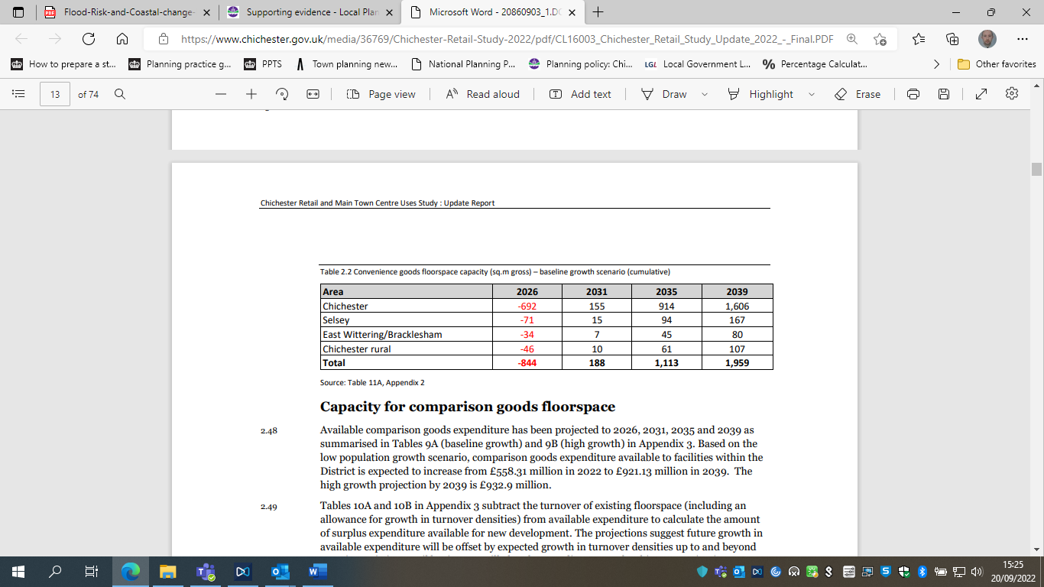The Retail Study 2022 (EE02) states that surplus expenditure up to 2039 indicates that there is capacity for additional convenience goods floorspace in the district[2] comprising 1,959 sq.m gross based on the baseline growth scenario, or 2,658 sq.m gross based on the high growth scenario.
  2. Consequently, the level of need which should be accommodated for the 10 years referred to in the NPPF is 1,113 sq.m.

*Comparison retail*

* 1. 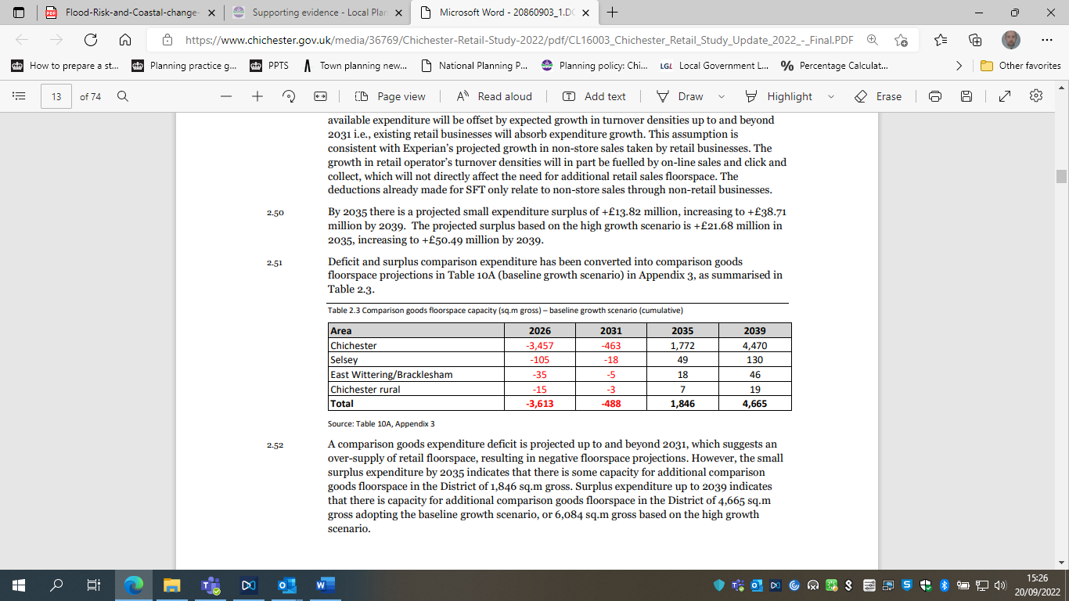A comparison goods expenditure deficit is projected up to and beyond 2031, which suggests an over-supply of retail floorspace, resulting in negative floorspace projections. However, the small surplus expenditure by 2035 indicates that there is some capacity for additional comparison goods floorspace of 1,846 sq.m gross. Surplus expenditure up to 2039 indicates that there is capacity for additional comparison goods floorspace of 4,665 sq.m gross adopting the baseline growth scenario, or 6,084 sq.m gross based on the high growth scenario.
  2. The need to be accommodated over the 10-year period referred to in the NPPF is 1,846 sq.m.

*Food and Beverage*

* 1. 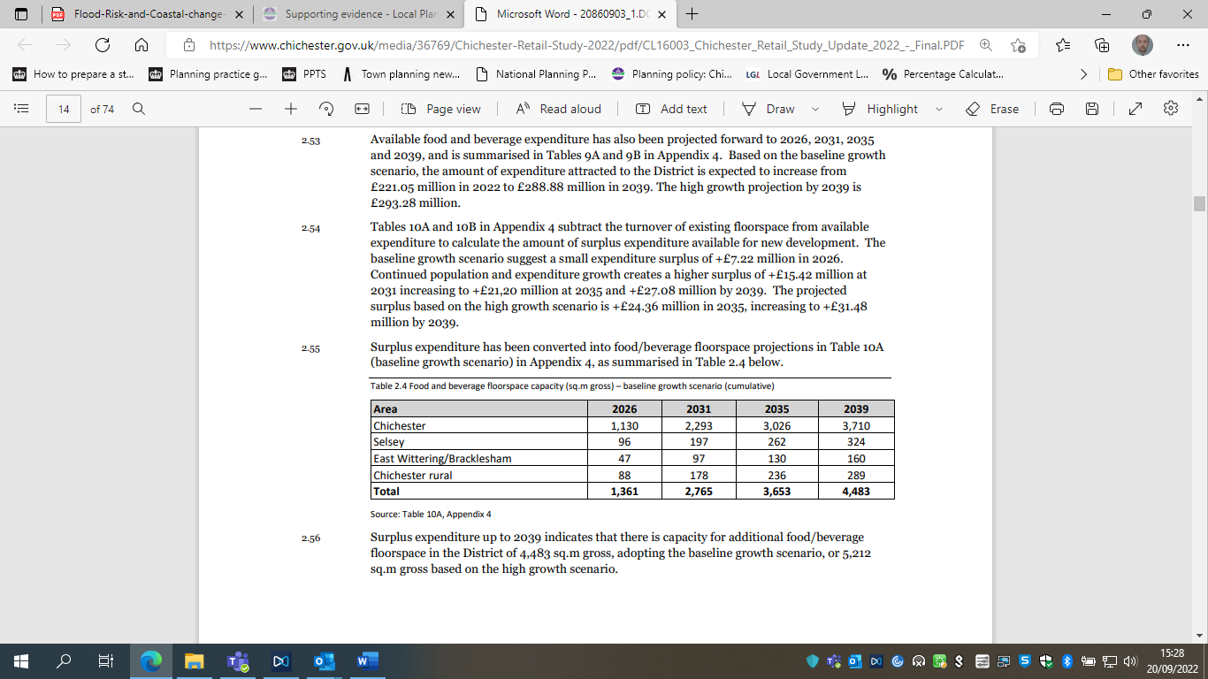Surplus expenditure up to 2039 indicates that there is capacity for additional food/beverage floorspace of 4,483 sq.m gross, adopting the baseline growth scenario, or 5,212 sq.m gross based on the high growth scenario.
  2. The amount to be accommodated over the 10 year period is 3,653 sq.m.

*Other leisure uses*

* 1. The Retail Study 2022 (EE02) sets out that there is scope to expand the leisure offer within the District, indicating potential scope for approximately 5,400 sq.m of new commercial leisure and cultural floorspace by 2039. It states that there is theoretical capacity for a medium sized multiplex cinema (6 to 8 screens) in Chichester, however, it notes that the longer-term impact of the Covid-19 pandemic on the number of cinema trips may reduce this theoretical capacity.
  2. In addition, there is a potential quantitative capacity for additional cultural facilities, and the Study recommends that the development strategy needs to be flexible to respond to emerging opportunities for attractive new facilities of this kind. There could also be potential for between 4 to 5 additional health and fitness facilities in the plan area up to 2039, depending on the degree to which participation rates increase in the future.
  3. The Study notes that across the country vacant retail space in town centres has provided new opportunities for leisure uses. Vacated premises have been reconfigured and reused for family entertainment activities including trampolines, climbing, escape rooms, ice and roller skating and indoor golf etc. The Study considers that these leisure innovations are likely to continue and a flexible approach is required to respond to such opportunities.

*Overall requirements*

* 1. The table below sets out the overall gross floorspace needs over the plan period as set out in the Retail Study 2022 (EE02). However, it will be important to consider this in light of the significant amount of floorspace currently vacant, which is considered in more detail below.

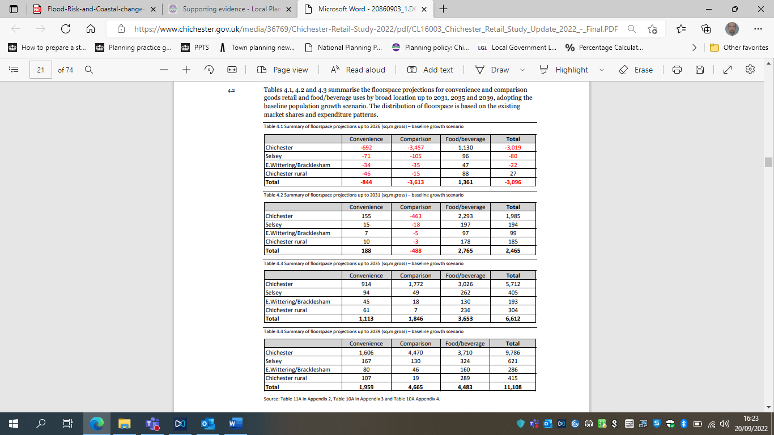

* 1. When combining the need from the 3 different components set out above, the requirement for the first 10 years of the plan period is taken to be 6,600 sqm (as per table 4.3 above).
  2. However, this need figure must be put into the context of the available floorspace. The Retail Study 2022 (EE02) explains that Goad Plan data suggested that Chichester city centre had retail floorspace of about 58,700 sq.m gross in 2017. Food and beverage uses and other non-retail services (within the previous class A categories) was around 26,400 sq.m gross**,** with about 4,700 sq.m gross vacant floorspace. This data for 2017 suggested retail uses occupied about two thirds of the floorspace in the city centre within shop premises.
  3. The Study states that, overall, the amount of vacant floorspace in the city centre may have increased from 4,700 sq.m to about 11,500 sq.m. The proportion of occupied retail floorspace could have reduced from 58,700 sq.m gross in 2017 to about 52,000 sq.m gross in 2021. A further 4,400 sq.m gross reduction in retail floorspace by 2026, would represent a 19% reduction from the 2017 position.
  4. The Study concludes that it should be assumed that half the current vacant floorspace could be suitable for reoccupation. On this basis, the following needs could be accommodated by existing floorspace:
* Chichester city centre - 5,700 sq.m gross
* Selsey - 500 sq.m gross
* East Wittering/Bracklesham - 200 sq.m gross
  1. This means that the level of supply available already is around 6,500 sq.m, just 100 sq.m short of the 10 year requirement referred to above.
  2. The long-term 2039 projection for the plan areas would reduce from approximately 11,100 sq.m gross to 4,700 sq.m. On this basis the study concludes that “*there is no pressing need to identify major new allocations for retail and food/beverage development, particularly up to 2031.”*
  3. The short-term projections to 2026 suggest there is likely to be limited demand to reoccupy vacant floorspace, particularly in Chichester city centre. However, the need to retain retail floorspace in the medium and longer term (up to 2031, 2035 and 2039) is still important, as it will be needed over the next 10 years.
  4. While existing floorspace can meet the needs over the first 10 years of the plan period, inevitably some new convenience goods floorspace will be required to serve new residential developments in the form of local/neighbourhood centres. Some of the projected food/beverage floorspace will also be provided in these neighbourhood centres. Therefore, further space will inevitably come forward in order to supplement the supply figures referred to above. However, the precise amounts of new floorspace cannot be clearly established at this precise point in time.
  5. The study highlights that the retention or expansion of comparison goods retail floorspace within Chichester city centre is not a short or medium-term priority and a more flexible approach to accommodate food/beverage uses and other non-retail uses should be considered, however, the new E use class means that there will inevitably be considerable flexibility within the town centre to respond to market demand.

# **Policy Approach**

* 1. Following the consultation on the Regulation 18 plan and the receipt of the 2022 Retail Study, the relevant policies were updated for the Regulation 19 Proposed Submission plan. This consolidated the four relevant policies into three. These are discussed in detail below.

Policy E5 – Retail strategy and new development

* 1. Policy E5 addresses the retail strategy and new development, this encompasses establishing the retail and hospitality needs for the plan area, the hierarchy of centres and how the plan seeks to handle uses proposed outside of existing centres.

*Meeting the need for floorspace*

* 1. The level of need for new floorspace specified in the policy is reflective of the findings of the Retail Study 2022 (EE02) which finds that approximately 6,600 sq.m of floorspace should be provided up to 2035 (the first ten years of the plan period post adoption in line with the requirements of the NPPF).
  2. As has already been set out above, existing vacant floorspace is already available in order to meet the needs set out in the Retail Study for the 10-year period. There will also be scope for additional retail floorspace to come forward via a number of mechanisms. Policies A3 and A4 relate to Southern Gateway and seek to support the inclusion of retail and hospitality uses within the regeneration area as its redevelopment progresses. This is particularly important as it will help to enhance the vitality and viability of the city centre as a whole. The East of Chichester site, Tangmere, West of Chichester and the Southbourne broad location for development will provide other opportunities for additional local retail and hospitality uses. The neighbourhood planning process also provides a mechanism for local needs to be addressed in an area specific way.

*Hierarchy of Centres*

* 1. The NPPF requires that policies should define a network and hierarchy of town centres and promote their long-term vitality and viability. This is done via Policy E5, which identifies Chichester city centre as the top of the hierarchy, and Selsey and East Wittering as secondary, local centres. This has been based on the scale, character and role of the centres; all of which are considered to be clearly established. This is reinforced by the Retail Study 2018 (EE04). The Retail Study 2018 states that at that time there were 433 retail units in Chichester, while Selsey and East Wittering had 83 and 69 retail units respectively. These two top rungs of the hierarchy also essentially reflect their respective positions within the settlement hierarchy.
  2. Previously the Preferred Approach had included a range of ‘village centres’ (encompassing Bracklesham, Southbourne, Tangmere, Bosham and Westbourne). However, in a separate policy (S10 at that time), those village centres were identified as local and village parades, which is also reflective of how they were described in the Retail Study 2018 (EE04). This description is considered to be a fair reflection of these areas, and is important in light of the description of what constitutes a town centre in the glossary of the NPPF:

*‘****Town centre****: Area defined on the local authority’s policies map, including the primary shopping area and areas predominantly occupied by main town centre uses within or adjacent to the primary shopping area. References to town centres or centres apply to city centres, town centres, district centres and local centres but exclude small parades of shops of purely neighbourhood significance. Unless they are identified as centres in the development plan, existing out-of-centre developments, comprising or including main town centre uses, do not constitute town centres.’*

* 1. This definition within the NPPF appears to suggest that neither village centres nor local or village parades should be identified as part of the hierarchy of town centres, as they do not fit with that description. In addition, the description seems to suggest that the point of the town centre designation is as a focus for main town centre uses, whereas the village centres/parades within the plan area are more of a cluster of small-scale local uses, sometimes without a clear geographical focus, and would not be appropriate locations to which the full range of main town centre uses should be directed. Consequently, the policy only focuses on the larger centres, which is considered to be the most appropriate response to the content of the NPPF. Nevertheless, it is still important to protect against the loss of the facilities within these smaller settlements, and this protection is provided via the community facilities Policy P17 New and Existing Local and Community Facilities including Local Shops.
  2. The hierarchy of town centres is defined on the policies map. The Chichester city centre boundary (defined as town centre on the policies map) has been slightly amended in order to include the bus station. This is considered appropriate as that site falls within the Southern Gateway allocation area and is the closest part of that site to the existing town centre boundary. The Retail Study 2022 (EE02) states the main town centre uses which would come forward as part of that development should be north of the railway line, as close as possible to the town centre boundary (as it then was). Given that the bus station is the closest part of the regeneration area and hence should be the main focus for town centre uses in any redevelopment and given its close proximity to the existing town centre boundary, it is considered appropriate to bring this site into the town centre boundary.
  3. The other two town centre boundaries within the plan area, namely Selsey and East Wittering, have already been established via the made Selsey Neighbourhood Plan and in the case of East Wittering the existing Site Allocation Plan Development Plan Document (DPD), which is being saved. The boundaries of both centres are not proposed to be amended at this point but could be reviewed if that is deemed appropriate as part of either a future neighbourhood plan or the next Site Allocation DPD.
  4. The rest of this section of the policy sets out the sequential approach to the location of main town centre uses, as per the requirements of the NPPF, which seeks to ensure that the national policy in relation to the sequential test is satisfied. The policy acknowledges the small-scale rural uses exemption in relation to the sequential test, and also applies this to similar scale uses in other contexts, as it also seems logical that locally orientated uses can be provided within settlements, as they will provide a valuable service to local communities and are unlikely to be compete with established centres.
  5. The final element of this part of the policy sets out the thresholds in relation to the impact assessment. The NPPF sets out a general floorspace threshold for when this requirement is activated, however, there is the option for the Local Plan to set lower thresholds if that is deemed to be appropriate. The policy adopts the NPPF minimum impact threshold of 2,500 sq.m in relation to Chichester itself. However, a lower threshold is proposed for the local centres (over 500 sq.m gross).
  6. The lower threshold for the local centres is justified within the Retail Study 2018 (EE04) and reinforced by the updated floorspace projections in the 2022 Study, which suggests that a blanket threshold across the plan area is inappropriate and explains that these lower ranked centres are smaller and weaker than Chichester and hence are vulnerable to the impacts of small-scale development. It is logical therefore that a lower threshold is required for these centres. The Retail Study recommends setting a threshold of 500 sq.m.

*Uses outside of designated centres*

* 1. In essence this final part of the policy integrates some of the existing policy requirements of Policy 28 Edge and Out of Centre sites – Chichester in the current Local Plan with some new requirements. Newly proposed clause 4 (the site should not be required for employment or housing) is important to ensure that appropriate sites for employment or housing are retained (given the need for both are more pressing in the plan area than the need for retail). The final requirement seeks to ensure detrimental impacts are avoided to neighbouring properties as the potential exists for main town centre uses to have an impact on neighbouring residential properties if placed in close proximity.

**Policy E6 – Chichester City Centre**

* 1. This policy sets out the primary shopping area within the plan area as required by the NPPF. It also sets out a policy framework which allows the city centre to diversify to respond to changes in retail and leisure demands and ensure a suitable mix of uses, in order to ensure long-term vitality and viability of the city centre.

*Primary shopping area*

* 1. As has been referred to above, Chichester sits at the top of the retail (and settlement) hierarchy, and is the main focus of retail, hospitality, cultural and leisure uses within the plan area. The NPPF indicates that first preference for retail uses should be the primary shopping area, with other main town centre uses in the town centre boundary. The Retail Study 2022 (EE02) disputes the need to define a primary shopping area, due to the changes to the UCO and the introduction of Class E, as well as the changes to the sequential and impact assessments, however it remains a requirement of national policy. There are clear benefits for the city centre as the protection of the relevant uses within the primary shopping area is important for maintaining the vitality and viability of the city centre, as well as ensuring there is a necessary supply of floorspace for meeting future retail and hospitality needs.

*Retail frontages*

* 1. The policy identifies primary and secondary frontages within the primary shopping area. It is acknowledged that there is no requirement to do so in the NPPF or PPG. However, as has been stated above, the PPG does set out that this is an option, and it allows an element of control over uses within these frontages to maintain vitality and viability. The primary frontage contains the highest proportion of retail uses, while the secondary frontages allow for greater diversity. The primary frontage also focuses on national retailers, with the secondary frontage involving a wide array of independent retailers, which is considered to be an important part of the character of Chichester. Moreover, this distinction is considered to be reflective of the fundamental spatial principles underpinning the city centre, with a core retail area essentially focused on the main four streets, particularly the pedestrianised areas, with secondary frontages on the periphery of these streets and associated side streets.

*Re-use of upper level floorspace*

* 1. This element of the policy seeks to ensure that upper floors are properly utilised in an appropriate manner. This is considered to be consistent with section 11 of the NPPF (Making Effective Use of Land), in terms of helping to focus as much development as possible on brownfield land and also delivering multiple benefits from land. The policy seeks to reflect the requirements in the NPPF for this positive approach to still be balanced against the need ensure safe and healthy living conditions (para 123).

*Retail development outside of the primary shopping area*

* 1. This section of the policy looks to support the protection of the primary shopping area by seeking to ensure that retail development proposed outside of the primary shopping area has as acceptable impact both on the primary shopping area and the area where the new development is proposed. This is reflective of the variety of different types of retailing and their associated impacts, combined with the sensitive nature of the town centre in terms of its historic character. There is also a significant amount of residential development outside of the primary shopping area but within the town centre boundary, which could be difficult to reconcile with large-scale retail proposals outside of the primary shopping area.

*Defining the primary shopping area*

* 1. This section sets out how the primary shopping area has been defined, and the compares the proposed policy area with that set out in the current Local Plan. The primary and secondary shopping frontages as set out in the adopted Local Plan are shown below in Figure 1.

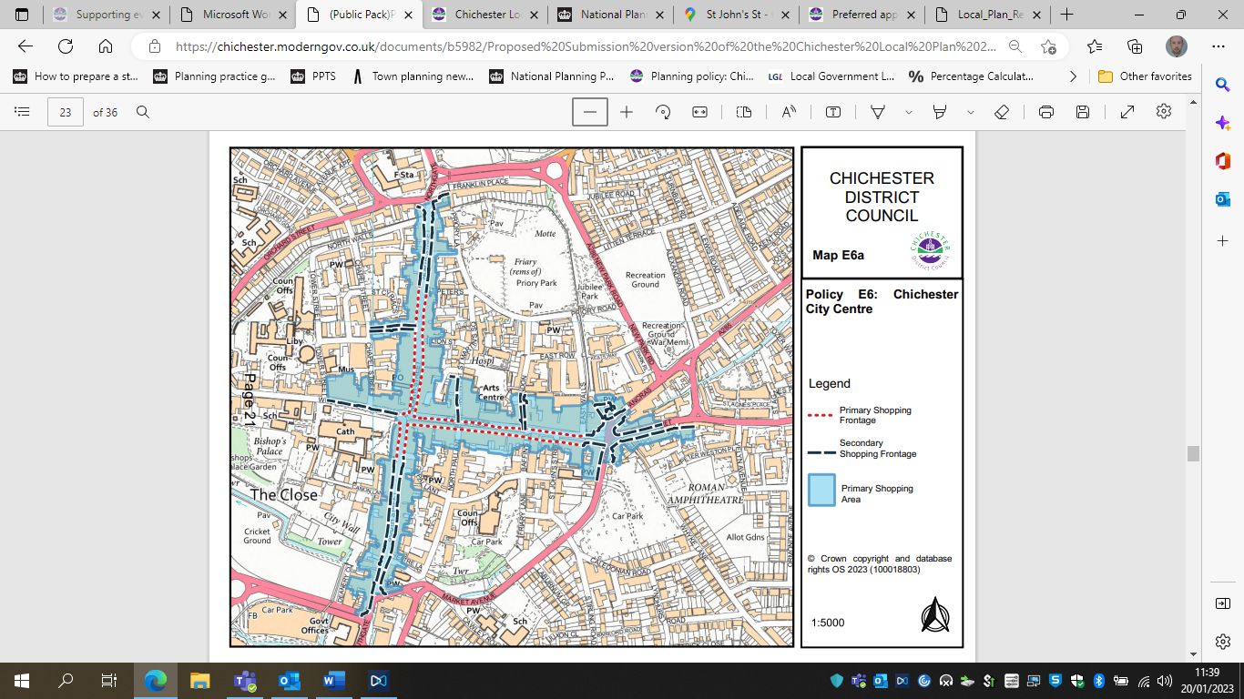

Figure 1: Primary and secondary shopping frontages in the adopted Local Plan

* 1. The new primary shopping area has been defined to reflect and encompass the adopted (and proposed) primary and secondary shopping frontages, with a few amendments which are set out below. The primary shopping area is shown outlined in blue in Figure 2. The proposed shopping frontages are shown in blue and red and show the extent to which the primary shopping frontage is proposed to be contracted and tightened, and the secondary frontage extended, to allow to flexibility and diversity of uses.

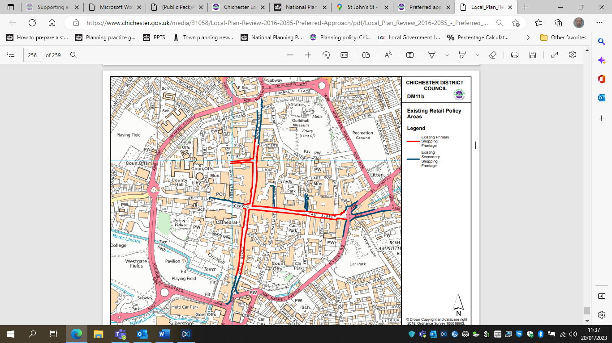

Figure 2: Proposed primary shopping area and frontages in the Local Plan Proposed Submission

* 1. The changes reflect the recommendations made in the 2018 Retail Study (EE04), which is considered to remain relevant, and which are as follows:
* 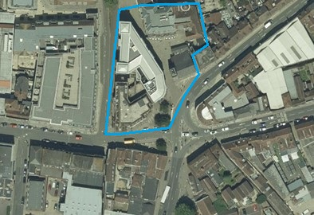The area in The Square, off St Pancras (just off the eastern end of the primary shopping area) to be included as secondary retail frontage, to include the café/restaurants and art gallery. The approximate area is shown in blue below.

* 1-4 Eastgate Square, which is currently defined as primary retail frontage, to be re-defined as secondary retail frontage, because it predominantly comprises service uses. This is the row of buildings immediately to the south of the site referred to above.
* The secondary retail frontage to be extended along Market Road to include the currency exchange and Coral betting office unit (as it is currently). This is also encompassed by the image above, at the very bottom on the aerial photo.
* Removal of two dwellings at the end of the secondary retail frontage along Little London.
* The secondary retail frontage is to be extended to include the retail units on the corner of North Street and Oaklands Way, and those in the small shopping precinct. This comprises the northern part of the primary shopping area, and is shown in the figure below.
* 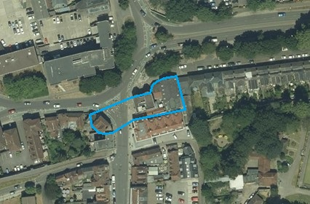The secondary retail frontage is to be extended to include the commercial units on the corner of North Street and Northgate (i.e. 3-5 North Street). The approximate area of this change is shown below.
* Most of South Street is changed from primary to secondary retail frontage, essentially from the end of the pedestrianised area. This is reflective of the higher proportion of hospitality units along that street vis-à-vis the rest of the primary shopping area (approximate area amended is shown in blue below).

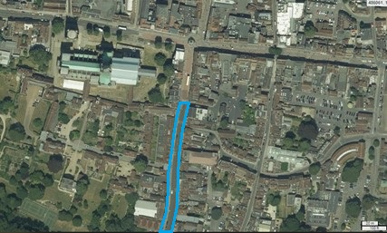

* Crane Street is also to be converted from primary to secondary frontage, which is reflective of the higher proportion of hospitality uses along this street when compared with the primary frontage (the approximate area in question is shown in blue below).

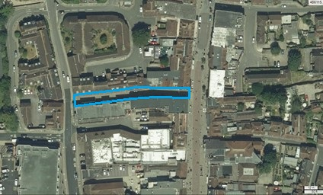

**Policy E7 – Local Centres**

* 1. This policy relates to the designated local centres of Selsey and East Wittering. These centres have been designated already via the made Selsey Neighbourhood Plan and existing Site Allocation DPD (which is to be saved). The boundaries of these local centres are more tightly drawn meaning that in the local centre and the shopping area become essentially synonymous. There is no requirement for this policy to define primary shopping areas within local centres.

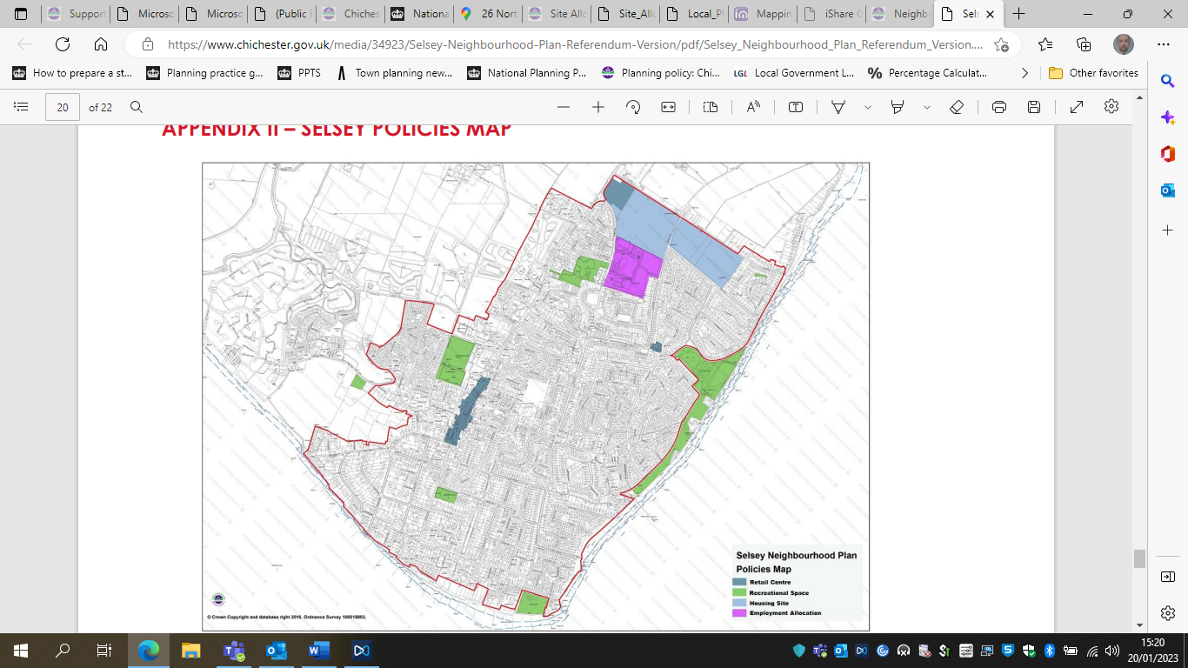

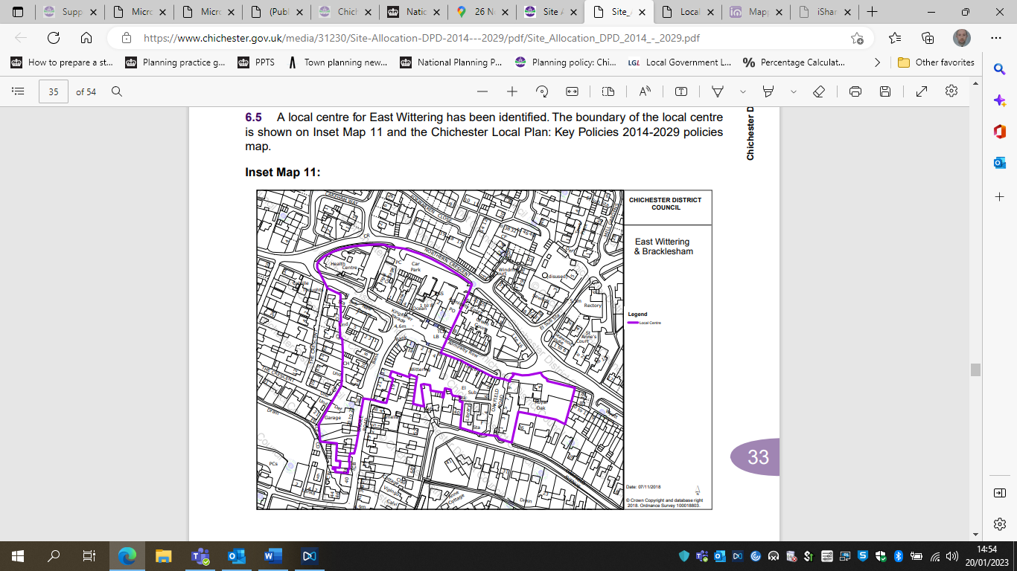

* 1. Policy E7 is in many respects very closely related to Policy E6. The focus of the policy is to direct main town centre uses to within the local centre boundary and protecting those uses within that area. The policy seeks to ensure that only smaller scale main town centre uses are provided within these two centres, which is reflective of the smaller scale of these centres compared with Chichester, both in terms of their expanse, the size of the settlements, and also the scale of the built form. The policy also places an emphasis on seeking to support small and independent businesses, which is reflective of a key characteristic of these existing centres and an important feature of their local distinctiveness.
  2. As with the Chichester City Centre policy there is also an emphasis on maximising the use of brownfield land and multiple uses of urban land by encouraging use of the upper floors within these areas for residential, leisure, commercial and community uses.

1. [Cities-Outlook-2022-2.pdf (centreforcities.org)](https://www.centreforcities.org/wp-content/uploads/2022/01/Cities-Outlook-2022-2.pdf)
2. While the Study refers to the district, earlier versions of the 2022 Study clarify that the study area is the retail catchment of these centres. This is set out in more detail in the 2018 Study.