Chichester Local Plan 2021 - 2039


Gypsy and Traveller and Travelling Showpeople
Background Paper

www.chichester.gov.uk May 2024

Contents
1. Introduction 3
2. National Policy Context 3
3. Local Policy Context 6
4. Preferred Approach/Regulation 18 Consultation 6
5. Latest evidence and strategy for meeting needs 7
6. Travelling Showpeople 21
7. Conclusion 25
Appendices 27
Appendix 1 - List of pending applications and appeals 27
Appendix 2 – site sieving 29
Appendix 3 – Officer site assessments 41
Appendix 4 – RAG Assessment of ‘call for sites’ submissions 77
Appendix 5 – Gypsy and traveller and travelling showpeople windfall analysis 91
Appendix 6 – travelling showpeople site area analysis 99

1. Introduction
  - This background paper provides analysis of gypsy and traveller and travelling showpeople issues in relation to the Chichester Local Plan 2021-2039: Proposed Submission. It explains the level of need in the plan area, primarily in relation to the latest Gypsy and Traveller and Travelling Showpeople Accommodation Assessment (GTAA) (H02). Furthermore, it explains the strategy for how to address the needs identified. In so doing it also considers the implications of the changes made to Planning Policy for Traveller Sites (PPTS) in 2023.

  - The background paper focuses of gypsies and travellers and travelling showpeople, however, the council is mindful of the provisions set out in the Housing and Planning Act (2016) which include a more general duty under Section 8 of the 1985 Housing Act for a periodical review concerning the needs of people residing in or resorting to their district with respect to the provision of sites on which caravans can be stationed, or places on inland waterways where houseboats can be moored. The council has commissioned a specific report in relation to this wider need, which forms part of the evidence base submitted in support of the new Local Plan, and hence when the evidence base is considered collectively the council meets the full range of its various legal and policy requirements in relation to all caravan and houseboat dwellers.

  - The background papers and related evidence are available on the council website at www.chichester.gov.uk/localplanexaminationlibrary. This background paper may be reviewed and updates issued during the examination of the Local Plan.

National Policy Context
  - The key planning policy document underpinning the consideration of gypsy and traveller and travelling showpeople issues is Planning Policy for Traveller Sites (PPTS). At the time the Reg.19 consultation took place the relevant version was that published in 2015, however, that was superseded by a slightly amended version in December 2023. The change to PPTS 2023 relates to the definition of gypsies and travellers in a planning context, and this issue will be covered in more detail below. The amendment in 2023 doesn’t change the main body of the guidance, and the key requirements in terms of strategic issues are as follows:

- Local Planning Authorities (LPA)s need to make their own assessment of need. (para 4)
- LPAs should set pitch targets for gypsies and travellers and plot targets for travelling showpeople (as defined in Annex 1 of PPTS) which address the likely permanent and transit site accommodation needs of travellers in their area, working collaboratively with neighbouring local planning authorities. (para 9)
- The LPA needs sufficient deliverable pitches to meet its 5 year need, and sufficient developable pitches for 6 – 10 years, and where possible 11 – 15 years. (para 10)
- Relate the number of pitches or plots to the circumstances of the specific size and location of the site and the surrounding population’s size and density. (para 10)
- Protect local amenity and environment. (para 10)
- Criteria should be set to guide land supply allocations where there is identified need. Where there is no identified need, criteria-based policies should be included to provide a basis for decisions in case applications nevertheless come forward. Criteria based policies should be fair and should facilitate the traditional and nomadic life of travellers while respecting the interests of the settled community. (para 11)
- LPAs should ensure that traveller sites are sustainable economically, socially and environmentally:
- promote peaceful and integrated co-existence between the site and the local community;
- promote, in collaboration with commissioners of health services, access to appropriate health services;
- ensure that children can attend school on a regular basis;
- provide a settled base that reduces both the need for long-distance travelling and possible environmental damage caused by unauthorised encampment;
- provide for proper consideration of the effect of local environmental quality (such as noise and air quality) on the health and well-being of any travellers that may locate there or on others as a result of new development;
- avoid placing undue pressure on local infrastructure and services;
- do not locate sites in areas at high risk of flooding, including functional floodplains, given the particular vulnerability of caravans;
- reflect the extent to which traditional lifestyles (whereby some travellers live and work from the same location thereby omitting many travel to work journeys) can contribute to sustainability; (all para 13)
- When assessing the suitability of sites in rural or semi-rural settings, LPAs should ensure that the scale of such sites does not dominate the nearest settled community. (para 14)

  - There are also a number of requirements which are more pertinent to the development management context, but which are nevertheless very relevant for policy drafting with respect to the Local Plan and how individual sites should be provided and designed:

- LPAs should very strictly limit new traveller site development in open countryside that is away from existing settlements or outside areas allocated in the development plan. Local planning authorities should ensure that sites in rural areas respect the scale of, and do not dominate, the nearest settled community, and avoid placing an undue pressure on the local infrastructure. (para 25)
- When considering applications, LPAs should attach weight to the following matters: a) effective use of previously developed (brownfield), untidy or derelict land b) sites being well planned or soft landscaped in such a way as to positively enhance the environment and increase its openness c) promoting opportunities for healthy lifestyles, such as ensuring adequate landscaping and play areas for children d) not enclosing a site with so much hard landscaping, high walls or fences, that the impression may be given that the site and its occupants are deliberately isolated from the rest of the community. (para 26)
- If an LPA cannot demonstrate an up–to-date 5 year supply of deliverable sites, this should be a significant material consideration in any subsequent planning decision when considering applications for the grant of temporary planning permission. (para 27)
  - In terms of the NPPF, this does include references to gypsy and traveller provision, with Paragraph 62 (now 63) referring to meeting the needs of travellers. However, this does not entail any specific requirements, and in any case that reference is probably much less significant now that the definition of travellers within PPTS has been amended to again include those who have permanently ceased to travel.
Amendments to PPTS 2023
  - As has been referred to above, PPTS was amended in December 2023 to broaden out the definition of travellers to again include those who have permanently ceased to travel (as was the case prior to the 2015 amendment). At the time of the Reg.19 consultation the definition excluded the word permanently, this meant that only those who had temporarily ceased to travel were covered by the definition, meaning that it was uncertain how the needs of individuals of traveller origin who had ceased to travel should be addressed. Previously there have been arguments made that all traveller needs should effectively be treated the same (i.e. all needs identified within the GTAA should be met in the same manner, whether the need in question met the PPTS definition or not), especially in light of the Lisa Smith judgement; others have argued that non-PPTS definition need should just be met via general housing provision rather than specific traveller pitches. In order to adopt a circumspect approach, the council had been attempting to work on the basis of the former interpretation at the time of the Regulation 19 consultation.

  - However, the consultants who prepared the GTAA (Opinion Research Services - ORS) have now reviewed their data in light of the amended definition within PPTS 2023, and established that the change in the definition makes virtually no difference to the need level vis-à-vis that which was previously established in relation to PPTS 2015. Therefore, the position is now much clearer than at the time of the Regulation 19 consultation, namely that ORS have established the PPTS 2023 level of need, while the other need found in the GTAA relates to caravan dwellers only, not gypsies and travellers, and therefore that wider need falls to be considered as part of general housing need.

Local Policy Context
  - The current/adopted Local Plan contains a policy on gypsy and traveller and travelling showpeople need (policy 36). This sets out the level of need for pitches/plots in the plan area at that time, based on the GTAA from 2013. The need at that time amounted to 59 pitches of which 37 pitches were required before 2017. There was also a need for 18 plots for Travelling Showpeople, of which 11 were required before 2017.

  - The adopted plan did not set out a specific strategy for meeting that need, rather, as is often the case, this was deferred to a subsequent specific Gypsy and Traveller and Travelling Showpeople Allocation DPD. That DPD was commenced, with consultants Adams Hendry commissioned to produce it, however, it has effectively been overtaken and hence subsumed into the new Local Plan. The process of producing the specific gypsy and traveller DPD involved a call for sites and site assessment process, which has been used to inform the production of the strategy pertaining to the new Local Plan, which is covered in more detail below. The policy in the adopted plan also contained a set of criteria for the consideration of sites on a case-by-case basis.

Preferred Approach/Regulation 18 Consultation
  - At the Preferred Approach/Regulation 18 (PA) stage the proposed policy framework at that time was very similar to the adopted Local Plan. The level of need was identified in the policy, based on the 2018 GTAA. The level of need, as reflected in the policy had increased from 59 in the adopted Local Plan to 91 pitches, with 66 needed in the first 5 years. In relation to travelling showpeople, the need level had again increased, from 18 in the adopted Local Plan, to 28 in the PA, with 18 required in the first 5 years.

  - The PA strategic policy (S7) included a set of priorities for how new sites should be provided, focusing on the intensification of existing sites in the first instanced, followed by the expansion of such sites as a secondary option. At that time specific provision of new sites was deferred to a specific Gypsy and Traveller and Travelling Showpeople DPD.

  - The PA also included a criteria-based policy (DM5) within the Development Management section, setting out how new sites would be assessed, which would have applied to both the allocation of sites, and also the determination of relevant planning applications on a case-by-case basis.

  - With regard to the representations received in relation to the PA, objections were limited, just 4 were received. These raised concerns about the need not being met and an overly restrictive approach to the consideration of site options. There were also concerns raised regarding the size of encampments and overconcentration of pitches in particular locations, especially Westbourne. Concerns were also raised regarding the findings of the GTAA, to the effect that it was overstating the level of need by including individuals who don’t meet the definition of travellers within PPTS. 2 objections were also received in relation to the development management criteria-based policy, though these essentially re-stated the objections received in relation to the strategic policy.

Latest evidence and strategy for meeting needs
  - The next section sets out the latest evidence in relation to the level of need, and the strategy for meeting that need, including the associated evidence base. As will be apparent from the sections below, the need level has been fully updated, including in relation to the recent amendments to PPTS, and every effort has been made to adopt the most positive strategy which is realistically available in order to meet the level of need.
Gypsies and Travellers
  - Turning firstly to gypsies and travellers, this section addresses the issues associated with need and supply of gypsies and traveller pitches, and how that relates to the amended definition within PPTS 2023. Travelling Showpeople are addressed separately in the next section.
Need level
5.3 The council commissioned an updated GTAA from specialist consultants ORS in 2022, who are one of the main providers of such assessments in the country. This was fully up-to-date at the time of the Reg.19 consultation, but clearly the amendments to PPTS in 2023 as referred to above needed to be addressed. Consequently, as has been referred to above, ORS have subsequently updated their figures in light of the amendments to PPTS 2023 and established that it makes virtually no difference to the level of need. The changes are set out in their letter to the council dated 16 April (Examination Library reference H02), and amount to 4 pitches of need moving from the non-PPTS definition section to the PPTS compliant section.
5.4 The need level in terms of how it pertains to the Local Plan is set out below. For the first 5 year period the council is using the first 5 year need period as set out in the GTAA, but rolled forward from 2022 to 2024 in recognition that the Local Plan is expected to be adopted in 2024/25, however, the first 5 year period also incorporates the requirement from the 2022 – 2024 period, and so is effectively a 7 year period. This is to ensure that the first 5 year period of the plan includes all the 5 year need from the GTAA.

Table 1 – level of gypsy and traveller need over the plan period (assuming adoption in 2024/25).
 | 2024 - 29 | 2029 – 34 | 2034 – 2039 | Total
Households who meet the PPTS 2023 definition. | 95 | 17 | 18 | 130
Households whose status is unknown but may meet the PPTS 2023 definition. | 2 | 1 | 1 | 4
People living in caravans but established in the GTAA as not meeting the PPTS 2023 definition. | 16 | 4 | 4 | 24
Total | 113 | 22 | 23 | 158

5.5 Given this large need, finding sufficient supply in order to meet this need is inevitably extremely challenging.
Supply
5.6 A clear priority for the Local Plan, as set out in national policy, is to meet the need level identified, particularly for the first 5 years. It’s also a requirement to meet the need for the first 10 years. Consequently, there are various supply components which could be utilised to achieve this. These are considered to be as follows:
- Consents subsequent to the base date of the new Local Plan
- Vacant pitches
- Intensification/expansion of existing authorised sites
- Allocations of pitches on new sites and as part of other strategic allocations
- Windfall in order to meet any residual needs.
Consents post 2021
5.7 The inclusion of this component within the supply replicates the approach taken to housing in relation to the new Local Plan (and any other Local Plan for that matter). The table below sets out the number of consents since April 2021 (at the time of writing April 2024):

Table 2 – consents post Local Plan base date.

Application ref: | Address | Description | No. of additional pitches | Decision date
20/01330/FUL | Land Adjacent To Melita Nursery Chalk Lane Sidlesham | Change of use of land to travellers caravan site consisting of 2 no. pitches each containing 1 no. mobile home and ancillary development (re-submission of 19/02876/FUL). | 2 | 11-May-21
21/00322/FUL | Land South Of Telephone Exchange Selsey Road Sidlesham | increase number of gypsy-traveller pitches from 3 to 4 including | 1 | 31-Aug-21
19/03043/FUL | Field South Of Green Lane Piggeries Ham Road Sidlesham | Change of use of land as private gypsy and traveller caravan site (variation of condition 2 of planning permission SI/14/04058/COU (APP/L3815/W/3019459- to make the temporary permission permanent). | 1 | 07-Sep-21
21/03138/FUL | Land and Buildings South of Little Willow, Hunston Road | Change of use of land to private gypsy and traveller caravan site consisting of 1 no. mobile home, 1 no. touring caravan, 1 no. utility dayroom and associated development (alternative scheme following refusal of application 20/03163/FUL). | 1 | 07-Feb-22
21/02905/FUL | Land Adjacent To Plot A Pond Farm North Newells Lane West Ashling | he use of land as a travellers caravan site consisting of 2 no. pitches and associated development. | 2 | 09-Jun-22
21/01714/FUL | Plot A Pond Farm Newells Lane West Ashling | 1 no. additional travellers caravan pitch consisting of 1 no. mobile home and 1 no. touring caravan and associated works, within red line of existing consent CH/19/02880/FUL. | 1 | 10-Jun-22
19/02579/FUL | Land North West Of Newbridge Farm Salthill Road Fishbourne | 19/02579/FUL is for 4 pitches while 20/02009/FUL is for 3. | 4 | 15-Jul-22
19/03112/FUL | Melita Nursery Chalk Lane Sidlesham | Change of use of land to rear of dwelling for siting of residential caravans for 7 no. pitch Gypsy Traveller site with associated development (hard standing fencing and 3 no. utility buildings). | 7 | 28-Jul-22
20/00047/FUL | Hopedene Common Road Hambrook Westbourne | Change use of land to a single private gypsy pitch with associated hardstanding and day room. | 1 | 07-Oct-22
20/00785/FUL | Meadow View Stables Monks Hill Westbourne | Change of use of land for use as extension to Gypsy caravan site for the stationing of 6 additional caravans, including 3 pitches, | 3 | 21-Feb-23
19/00445/FUL (Appeal 19/3271433), | Land South East Of Tower View Nursery West Ashling Road Hambrook Funtington | elocation of 2 no. existing travelling show people plots plus provision of hard standing for the storage and maintenance of equipment and machinery, 6 no. new pitches for gypsies and travellers including retention of hard standing. | 6 | 14-Jun-23
20/03164/FUL | Land East Of Monk Hill Monks Hill Westbourne | Change of use of land to 1 no. private gypsy and traveller caravan site consisting of 1 no. mobile home, 1 no. touring caravan, 1 no. utility dayroom | 1 | 09-Aug-23
23/01477/FUL, | 3 & 4 Melita Nursery Chalk Lane Sidlesham | Change of use of land to a travellers caravan site with stationing of 3 no. additional caravans, erection of 3 no. utility buildings with parking for 1 no. touring caravan, | 3 | 30-Aug-23
23/01476/FUL | Land South Of Telephone Exchange Selsey Road Sidlesham | Stationing of 4 no. additional caravans for gypsy-traveller families along with associated utility building, hard standing and landscaping. | 4 | 08-Sep-23
21/00051/FUL (Appeal 21/3311285). | The Stables, Cemetery Lane, Woodmancote, Westbourne | Increase number of permitted caravans from 1 no. static and 1 no. tourer to 2 no. static and 2 no. tourers and retention of stable block | 1 | 19-Oct-23
23/00086/FUL, | Land Adjacent To Melita Nursery Chalk Lane Sidlesham | Change of use of land to a travellers caravan site consisting of a 4 no. pitches and associated development. | 4 | 23-Oct-23
23/01845/FUL | Land to the West of Newells Farm Newells Lane West Ashling | Stationing of caravans for residential purposes, hardstanding and utility/dayrooms ancillary to 3 no. pitches | 3 | 17-April-23 (resolution to grant at committee)
23/02463/FUL | Field West of Beachlands Nursery, Newells Lane, West Ashling, | Change of use of land for the stationing of 4 no. static caravans and 4 no. touring caravans for residential purposes, together with the formation of hardstanding and associated landscaping. | 4 | 17-April-23 (resolution to grant at committee)
23/02460/FUL | Old Allotment Site Newells Lane West Ashling West Sussex | Use of land for the stationing of 1 no. caravan/mobile home for residential purposes, together with the formation of hardstanding. | 1 | 17-April-23 (resolution to grant at committee)
23/02464/FUL | Field West of Beachlands Nursery, Newells Lane, West Ashling, | Change of use of land for the stationing of 1 no. static caravan and 1 no. touring caravan for residential purposes, 1.no day room, | 1 | 17-Apr-23 (resolution to grant at committee)
23/02575/FUL | Field West of Beachlands Nursery, Newells Lane, West Ashling, | Use of land for the stationing of 2 caravans for residential purposes, together with the formation of hardstanding | 1 | 17-Apr-23 (resolution to grant at committee)
Total |  |  | 52

5.8 This will be kept updated and could be higher by the time of the hearings, as there are a number of pending applications and appeals, as set out in Appendix 1 below. This amounts to 6 pitches of possible additional supply in the near future, though clearly the outcome of these applications and appeals is currently uncertain. This level of pending supply is much lower than was the case at the time of the Regulation 19 consultation. The reduction in this pending supply figure is reflective of the fact that many of those listed at the time of the Regulation 19 consultation have now been consented and hence now form part of the supply.

Vacant pitches
5.9 Vacant pitches which benefit from planning permission are considered to be supply which is deliverable within the first 5 years. Moreover, the definition of deliverable in the NPPF states that:
“Deliverable: To be considered deliverable, sites for housing should be available now, offer a suitable location for development now, and be achievable with a realistic prospect that housing will be delivered on the site within five years. In particular:
a) sites which do not involve major development and have planning permission, and all sites with detailed planning permission, should be considered deliverable until permission expires, unless there is clear evidence that homes will not be delivered within five years (for example because they are no longer viable, there is no longer a demand for the type of units or sites have long term phasing plans).”
5.10 Consented pitches which are vacant or unimplemented are considered to be akin to a consented but unconstructed housing site, and hence should be considered to be deliverable as there is currently no clear evidence that they will not be delivered within 5 years. Moreover, given the well-established shortage of pitches it seems reasonable to presume that they will be brought into use in due course.

Table 3 - Vacant and unimplemented pitches comprise 7 pitches
Site | No. of pitches | Commentary
10 Oaklands, Tower View Nursery North | 2 | Need for 2 identified in the GTAA on this site.
Land West of Harwood | 5 | Aerial photos clearly show that development of the pitches initially commenced.

5.11 The GTAA does identify a number of other vacant pitches, but these are generally consented pitches which appear not to have been developed yet, and hence these have not been included in the vacant pitches component of supply as they are already present in the consents post 2021 element.
Allocations
5.12 This section effectively brings together 4 different work-streams. Firstly, there is intensification of existing sites. Secondly, there are sites which came forward as part of the call for sites process in early 2021. Thirdly, there is a proposed traveller site which was promoted via the Housing and Economic Land Availability Assessment (HELAA) (H09). Finally, there is the option of including gypsy and traveller pitches within the strategic housing allocations within the new Local Plan. As these sites came forward at different times and via different processes their initial assessment was somewhat different, but in the later stages these sources have been integrated, and this report provides a comprehensive assessment of their suitability for the supply of additional pitches.

Intensification
5.13 This is effectively a form of allocation, as in order to be utilised as supply it is necessary to assess the suitability of existing authorised sites for incorporating additional pitches, establish their capacity, and set out a policy in submission Local Plan which supports additional pitches on those sites.
5.14 In order to pursue this source of supply the council commissioned a Pitch Deliverability Assessment (PDA) (H04) from consultants Opinion Research Services (ORS – who, as referred to above also produced the GTAA). While the study shows potentially significant amounts of supply, further analysis illustrates that the reality is likely to be lower. Partly this is owing to some of the capacity being replaced by consents and hence moving to a different part of the supply (Melita Nursery being the main site in this regard). The other main reason is the more detailed site analysis undertaken by officers and consultants Adams Hendry, which illustrates that most of the sites have limited scope for intensification.
5.15 A more detailed explanation of the approach which has been taken to intensification sites is as follows:
- There was an initial sieve of sites conducted at the outset of the PDA process. This is explained in the PDA report produced by ORS. In essence, this involved sieving out sites with what were considered to be overriding constraints which would mean that it was not likely to be acceptable in planning terms to provide additional pitches on those sites.
- This was followed by the production of the PDA report, which assessed the potential to provide pitches on the sites which had made it through the initial sieving process. This process involved more consideration of site characteristics and circumstances, and in many respects established the availability and achievability potential of those sites to provide pitches.
- However, the council considered that additional analysis was then needed in order to establish a capacity which was consistent with the site design policy within the submission Local Plan, and in order to give more consideration to suitability. This involved two elements. Firstly, an additional sieving process was utilised, which involved considering the following factors:
- sites which were already in the planning system, as generally it was considered most appropriate that the applications in question run their course; sites which had previously been refused were generally not considered further (unless there were reasons for a potentially different outcome, for example a lower number of pitches);
- where the site was clearly already at the maximum reasonable capacity;
- where there was no need identified at the site itself, as the presumption is that intensification is only suitable to provide for need generated by the existing site occupants;
- the site is no longer in use as a gypsy and traveller site.
The outcomes of this sieving process are set out in Appendix 2 of this document. The second stage of the process was that sites were subject to detailed capacity work by consultants Adams Hendry, which forms part of the Local Plan evidence base. In essence, the detailed capacity work entailed using an agreed pitch size (which accords with the site design policy within the submission Local Plan) and then establishing how many pitches would fit onto the available space in a potentially acceptable manner and taking account of relevant constraints.
- The final stage in the process is that each of the sites which have made it through the initial sieving process have been assessed by the council in light of the findings in the PDA and the Adams Hendry report. These detailed assessments are set out in Appendix 3 of this document.

5.16 In light of this extensive analysis, the only sites which are considered to be suitable for additional pitches at present are:
- Greenacre, (Land adjacent to Westbourne Gypsy Site), Cemetery Lane: potentially, another 4 pitches will fit on the site, and while the council is very reluctant to further consolidate this already very large cluster; given that the GTAA and PDA identify that the intended occupants are living ‘doubled up’ on the neighbouring public site, in presumably what is a cramped situation, it is considered most appropriate to allow their need to be met on this neighbouring site. This is considered most appropriate given the individual circumstances and won’t actually significantly increase the occupation within the cluster, as the prospective occupants are already there.
- Tower View Nurseries: Potentially 2 additional pitches could be provided vis-à-vis consented provision. Again, while the council is very reluctant to consolidate this cluster, the existing consents slightly underutilise the land in question. The actual occupation appears to be more intensive than the consents allow. Therefore, it is considered that intensification which accords with the council’s site design policy is the best compromise and would hopefully improve the existing situation. Moreover, given that the existing permissions underutilise the site it would be unrealistic to expect that no further pitches are provided on the site.
- Land at Lakeside Barn: This site has a need for 4 pitches, and there is a reasonable prospect these can be provided on the site as there is a lot of space available.
- Sunrise: There is scope for one 1 additional pitch to be provided at the back of the site, though this would need to be provided in a suitable manner i.e. so that it does not block the public right of way running along the side of the site. While the GTAA 2022 concludes that the site occupants did not meet the PPTS 2015 definition, the subsequent ORS review of the available data in light of the amendments made to PPTS 2023 concludes that the site occupants do meet the amended definition. For clarification, the 1 additional pitch considered to be deliverable is with respect to the 1 pitch consented at the time the Regulation 19 plan was drafted, meaning a total of 2 pitches on the site. Representations submitted as part of the Regulation 19 consultation suggest that an additional mobile home may have been placed at the rear of the site since the capacity work was undertaken, in the area where the additional pitch under consideration would be provided, and that this does not have the benefit of planning permission. If an additional mobile home is to be consented at the rear of the site then this would in itself count as supply and mean that the need would be met, and this site would need to be deleted from the list of sites in policy H12.

5.17 This gives a total of 11 pitches which could be generated via intensification. Given that these are allocations, pertaining to existing sites, and the PDA establishes that they are available, it is considered that these are deliverable sites which can count as supply within the first 5 years.
Call for sites and HELAA
5.18 In addition to the PDA, the council also conducted a call for sites in 2021 as part of the process of preparing a specific Gypsy and Traveller DPD. The DPD has now effectively been subsumed within the new Local Plan. Consequently, it is considered that these sites also need to be assessed as part of the new Local Plan, with a view to seeking to establish if any sites could be allocated at this stage.
5.19 While these sites flow from a different process to the PDA, in effect they are quite similar, as most of the sites promoted entail the intensification or expansion of existing sites. These sites have been assessed by Adams Hendry as part of the initial Gypsy and Traveller DPD process using a RAG assessment system, which is set out in full in appendix 4.
5.20 One gypsy and traveller site was also promoted through the HELAA process. This site was given an initial appraisal as part of the HELAA process and then also considered in more detail using the Adams Hendry RAG assessment.
5.21 As with the intensification sites, a further review of sites promoted through the call for sites has been carried out by officers and Adams Hendry. These sites have been sieved in a very similar manner to the intensification sites referred to above, as set out in Appendix 2. The only additional consideration is that the council has sought to limit any potential allocations pertaining to existing large encampments to just limited intensification/infill, as further expansion of those sites is considered likely to lead to further domination of the settled community along with further encroachment onto the countryside.
5.22 As with the intensification sites there has been more detailed assessment by Adams Hendry in order to establish a realistic capacity in light of the site characteristics and constraints. As with the intensification sites, each site which has made it through the sieving process has also been assessed by officers in order to determine their suitability for allocation within the new Local Plan, as set out in Appendix 3.
5.23 The key outcomes of this process are as follows:
- HBI0028 – Pinks Four, Birdham: promoted through the HELAA for 8 pitches. The Adams Hendry capacity work confirms that this appears a reasonable assumption in terms of likely site yield. However, owing to concerns regarding the site access this site is not considered suitable for allocation at present, though if further information is provided by the site promoter in order to demonstrate that the access is suitable then the site could be considered for allocation in the future.
- Bi04 - Cherry West Meadow, Birdham: promoted for 12 pitches, however, AH analysis suggests that at most only 3 net additional pitches would fit on the site (in a manner which would accord with the site design policy), though it would appear that 1 pitch would be more realistic. Given that the provision of 3 pitches appears to require considerable re-organisation of the site and clearance of vegetation there appear to be no guarantees that this would be achievable or acceptable in planning terms and therefore only 1 additional pitch has been assumed to be deliverable at this stage.
- HU01 - Land south of Little Willows, Hunston Road: promoted for 3 pitches. While the site can easily accommodate that number of pitches in spatial terms, given that a single pitch on the site was previously refused planning permission, ultimately it is considered that the site is not suitable for allocation.
- WE01 - The Stables, Bracklesham Lane, the site is promoted for 2 additional pitches, and while 2 pitches may fit into the available space on the site, it is very tight and it is not necessarily possible to satisfactorily accommodate 2 pitches while still having sufficient vehicle turning space and without impacting upon existing hedging along the edge of the site. Consequently, only 1 additional pitch is considered appropriate at this juncture in terms of future yield, unless it can be demonstrated that 2 pitches can be satisfactorily accommodated. However, the site is vulnerable to future flood risk as set out in the latest version of the Strategic Flood Risk Assessment (2023). While the site could be deemed unsuitable for allocation on that basis, when considering the high level of need, and the future flood risk being a considerable time away (between 75 – 100 years), it is considered that temporary or personal permission could be utilised in order to provide for fairly long-standing occupation of the site, but which can respond to flood risks in the future by reconsidering this issue when consents need to be renewed.
5.24 This gives a total of only 2 additional pitches at this stage. These 2 pitches considered to be available now, and consequently are considered to be deliverable sites, which can count as supply within the first 5 years.
Strategic housing allocations
5.25 An option for the provision of pitches which is becoming increasingly common is making provision for traveller pitches on the strategic housing allocations. Examples of this are Basingstoke and Deane, Guildford and Runnymede. In the case of Basingstoke the Inspector stated the following:
“The Council also indicated at the Hearings that in its experience, large sites, such as Peak Copse, are not successful in management terms; and that smaller sites tend to integrate better with the settled community. I agree with the Council that the positive preparation of small G&T sites within the four largest greenfield allocations, to be established at the outset, is a sustainable approach which is also justified in terms of management and integration of G&T provision with the settled community.”
5.26 Given the very high need within the plan area and hence the need to utilise all reasonable supply options it is considered that the approach of assigning traveller pitches to the strategic housing allocations should be employed. It is presumed that this approach should only be applied to new allocations, not those being carried forward from the current Local Plan, as those have already been masterplanned and permission is either already in place (at least in outline form) or there is a resolution to grant, which would make it inappropriate to seek to retrospectively apply this requirement. This leaves only a very limited number of options, namely Land East of Chichester and Maudlin Farm. The broad location in Southbourne would also need to include a pitch requirement. At Regulation 19 stage, it was assumed that pitches would also be provided on the Highgrove Farm site, however, with that site now having received planning permission with no pitches included, it has to be presumed that no pitches will come forward on that site.
5.27 Based on experience, travellers generally prefer to live in family units (and that also tends to be easier to integrate with the settled community), and hence it is considered likely that a cluster of around 3 - 4 pitches is most appropriate. On a smaller allocation like Maudlin Farm 1 cluster might well be most appropriate, whereas for the larger sites 2 or 3 clusters spread around the site could be achievable. Consequently, a provisional dispersal of pitches could be along the following lines:
- Land East of Chichester – 9 pitches
- Maudlin Farm – 3 pitches
- Southbourne broad location for development – 12 pitches
5.28 Southern Gateway has not been assigned pitches, given that it is an urban site, and is impacted by flood risk concerns, consequently, the site area is likely to be limited and the form of development is likely to be fairly high density, which would not be compatible with the provision of traveller pitches.
5.29 The approach set out above would be quite a conservative approach, and suggests a potential supply of 24 pitches. A drawback with this approach is that the pitches are likely to come forward later in the plan period and hence in all likelihood none could be counted within the first 5 years.
Windfall
5.30 PPTS is silent on whether windfall can be included as supply. Nevertheless, when considering housing supply generally, windfall is nearly always included as a component of housing supply, and can form quite a large component if both large and small site windfall is included. Therefore, it seems logical that windfall can also form part of gypsy and traveller supply, provided that, as with housing, there is compelling evidence that this will provide a reliable source of supply.
5.31 Moreover, windfall supply was allowed to be included in relation to the Darlington Local Plan, including within the first 5 years. The Inspector stated the following:
“157. Since the assessment was undertaken, planning permissions have been granted for a total of 7 additional pitches on 3 sites. The Council provided evidence during the examination of plans to create a total of 33 additional pitches on extensions to the two Council owned sites in the next few years. There is compelling evidence that windfalls will continue to come forward, both through small extensions to existing private sites and proposals for new private sites. Historically, the average rate of windfall provision has been 4 additional pitches per year. Whilst this rate may not continue, it is not unreasonable to assume that around 30 additional pitches will be created on windfall sites in the next 15 years in the context of policy H9 which sets out a positive, criteria-based approach that is consistent with national policy.
158.Overall, therefore, there is likely to be a sufficient supply of additional pitches for gypsies and travellers (around 70 pitches between 2021 and 2036) to ensure that identified needs can be met.
159.The five year requirement is for 13 additional pitches. This can be met at the current time through opportunities to use vacant and potential pitches on existing sites, the outstanding planning permissions, and through additional windfalls that are expected to come forward. A planning application for 25 additional pitches on the proposed extension to one of the Council owned sites is due to be submitted shortly meaning that it will contribute to an ongoing five year supply.”
5.32 Officers have done analysis of windfall. The data available demonstrates that consents for traveller pitches comprises 114 pitches between 2012-13 and 2023-24, rolling that forward would mean that average windfall would be at least 9 pitches per annum, or could be as high as 10 if rounded up. This means that windfall could actually be sufficient to meet virtually all of the council’s need over the plan period. However, it is considered that solely relying on windfall would not be appropriate or consistent with the requirements of PPTS (as clearly the emphasis should be on a plan-led approach). Consequently, the council’s position has been to do everything which is reasonably possible in order to meet the need in a manner which is consistent with PPTS, and only rely on windfall in order to meet any residual need.
Anomalies
5.33 It is proposed that it would be reasonable to assume that in the case of a few sites they can accommodate the need identified without the provision of extra pitches elsewhere:
- Hawthorns, Clayton Lane: this is quite an unconventional site, as it involves a large bungalow, which appears to be considered to be a day room in planning terms, and a large number of caravans. The site does not really constitute a traditional arrangement of pitches, nor would it be possible to incorporate additional pitches within the current site confines in a conventional manner. The need pertaining to the site within the GTAA could probably be met by allowing additional caravans within the curtilage of the site. That is probably going to be the most pragmatic way of meeting that need (for 2 pitches). This would accord with the PDA, which states that the landowner believes that they can meet their current need on the site (2 pitches), though that future need would be more difficult, however, that future need appears to have subsequently fallen away as that is not recorded in the GTAA data.
- Land South of the Stables, GTAA shows a need for 2 pitches, but 7 are given over to “storage”, and hence it seems reasonable to assume that 2 of those will be made available as accommodation for the need identified.

Bringing it all together
5.34 The main priority in the first instance is trying to achieve a 5 year supply of pitches. A reasonable but positive approach to supply would be:
- 52 pitches from post 2021 consents
- 7 vacant/unimplemented pitches.
- 13 pitches from intensification/expansion sites.
- The potential to provide 47 pitches from windfall (assuming that the previous average continues).
5.35 Setting aside the windfall allowance post the adoption of the new Local Plan, that would comprise 72 pitches, this means that the PPTS 2023 5 year need requirement has already been nearly met (in relative terms), and meeting the remainder should easily be achievable via windfall sites. Indeed, the level of windfall has the potential to easily exceed the need requirement. However, it is not presumed that the PPTS 2023 figure would be exceeded on the basis of additional windfall consents coming forward, rather, once the need has been met, it is expected that windfall consents would be granted on a much more limited basis.
5.36 For the remainder of the plan period there would also be approximately 24 pitches of supply available via the strategic housing allocations, which would count towards the long-term need. Moreover, that would be sufficient to meet most of the PPTS 2023 need level for the rest of the plan period (i.e. years 6 – 15), which stands at 35 pitches. The remainder can easily be met by windfall.

Travelling Showpeople

Need

6.1 The level of travelling showpeople need has been assessed in the GTAA in the same way as for gypsies and travellers. The time periods from the GTAA have also been transferred into the Local Plan in the same way as for gypsies and travellers (as has been set out in the relevant section above).

Table 4 – level of travelling showpeople need over the plan period (assuming adoption in 2024/25).
 | 2024 - 29 | 2029 – 34 | 2034 – 2039 | Total
Households who meet the PPTS 2023 definition | 24 | 4 | 5 | 33
Households whose status is unknown but may meet the PPTS 2023 definition | 2 | 2 | 3 | 7
Travelling showpeople established in the GTAA as not meeting the PPTS 2023 definition. | 0 | 0 | 0 | 0
Total | 26 | 6 | 8 | 40

6.2 As with gypsies and travellers, the level of travelling showpeople need is high and very challenging for the council to meet. To put the level of need into context, this would involve almost doubling the number of plots within the plan area over the next 15 years. In particular, the need during the first 5 years is very difficult to address, especially as the supply options are very limited.

6.3 In relation to the amendment to PPTS, ORS have confirmed that they do not consider that the figures set out in the GTAA 2022 will change in light of the amendments to PPTS in 2023, as none of the travelling showpeople failed to meet the 2015 definition, hence there is no need to now consider whether they would fall within the amended definition. Given that everyone interviewed has met the definition of travellers, the assumption is that all of the need identified should be met, consequently, the apportionment of the unknown category to the PPTS category has not been undertaken (unlike with gypsies and travellers where the assumption is that 68% of the unknown need falls within the PPTS 2023 definition).
Supply

6.4 It is probably pertinent to note in the first instance that travelling showpeople sites are generally more difficult to provide than gypsy and traveller pitches as they tend to require far more space. More specifically, the council has worked on the assumption that around 320 sqm is appropriate for a gypsy and traveller pitch, whereas the GTAA suggests that an appropriate plot size for travelling showpeople is around 2000 sqm. However, further research by the council indicates that this picture is more nuanced, and that the average plot size in the plan area is 1500 sqm. This is further complicated by some large yards containing some smaller units of accommodation within them (please see Appendix 6). Consequently, there doesn’t appear to be a clear pattern in this regard. In addition, travelling showpeople yards involve storage of large machinery, with associated maintenance requirements, which further complicates matters in terms of providing sites, as this can be difficult to reconcile with landscape and residential amenity considerations.

Consents post-2021

6.5 4 plots have been consented since the base date of the new Local Plan (April 2021). As has been set out in the gypsy and traveller section, these are considered to be supply which is deducted from the need figure for the first 5 years post adoption.

Application ref: | Address | No. of additional pitches | Decision date
22/00406/FUL | Land Adjacent To Plot 8 Priors Leaze Lane Hambrook Chidham | 2 | 26-May-23
22/02136/FUL | Mans Rest Bracklesham Lane Bracklesham | 1 | 30-Jun-23
23/00601/FUL | Zsaras Yard, Highleigh Road, Sidlesham, Chichester West Sussex | 1 | 08-Jun-23

Intensification

6.6 The analysis above concerning plot sizes is important as it illustrates the difficulty in establishing clear parameters for an intensification approach in the same way as for gypsy and traveller pitches. Consequently, travelling showpeople plots generally haven’t been considered for intensification in the same was as for gypsies and travellers as set out above.

6.7 However, there were 2 sites promoted through the call for sites, which are essentially intensification sites and have been assessed in order to establish whether they can provide any supply. Of these 2 sites, one was sieved out as it was already subject to a refusal of planning permission. The other site, Five Paddocks Barn/Mans Rest, was assessed in detail along with the gypsy and traveller pitches referred to above, as set out in Appendix 3.

6.8 Five Paddocks Farm/Mans Rest is a very difficult site to assess, and the decisions regarding the suitability and capacity of the site are finely balanced. On the one hand the site does not appear to afford the space to accommodate additional plots of a size which would accord with standard expectations in terms of the required site area. Moreover, there clearly doesn’t seem to be space to provide in an acceptable manner the 6 plots being promoted. There are also concerns regarding flood risk in relation to this site, particularly future flood risk. Conversely, there is a need for 2 plots in relation to the site, and no alternative sites appear to be available. In addition, it is clear that some of the plots on the site are already smaller than the average size referred to above. Consequently, there does appear to be space to provide for 2 plots of a similar size to those already consented in this location. Therefore, on balance, given that there is an identified need, and a lack of alternatives, it does appear most appropriate to allocate the site for 2 additional plots (not including the recent planning permission granted at the site - 22/02136/FUL). The location of these is shown in Appendix I of the submission Local Plan.
6.9 Nevertheless, as with The Stables site referred to above, future flood risk affects this site. While the site could be deemed unsuitable for allocation on that basis, when considering the high level of need, and the future flood risk identified being towards the end of the 100 year period used in the Strategic Flood Risk Assessment, it is considered that temporary or personal permissions could be utilised in order to provide for fairly long-standing occupation of the site, but in a manner which can respond to flood risks in the future by reconsidering this issue when consents need to be renewed.
Strategic housing allocations

6.10 In light of the lack of short-term supply available it would appear important to consider whether travelling showpeople plots can be provided on the strategic allocations. This is theoretically possible, however, there are some significant constraints to what can be achieved. Firstly, the nature of the strategic allocations, as they are generally essentially housing-led, with no significant employment element. As has been referred to above, the nature of showpeople sites, especially for the scale of need pertaining to the plan area, is that they need a significant storage element, likely to comprise large yards and storage buildings. Consequently, they are unlikely to be highly compatible with a predominantly housing-led site, either from a placemaking or compatibility of uses perspective, except perhaps on very large strategic allocations where they could be assigned a more spacious section of the site somewhat detached from the main area of housing.
6.11 The second problem is geographical, as the vast majority of need flows from the Priors Leaze Lane site in Southbourne parish. It is presumed that showpeople need to be near their machinery/equipment (from a security perspective and also in terms of sustainability). Consequently, allocations on sites in Chichester are unlikely to be appropriate geographically vis-à-vis the current site.
6.12 The above seems to inevitably suggest that the main opportunity in terms of providing travelling showpeople plots via allocations is the Southbourne BLD. This is most appropriate geographically, as part of the BLD area is very close to the Priors Leaze site (the eastern edge of the BLD lies just to the west of the Priors Leaze site). In addition, as the largest new allocation, with the potential to provide a mix of uses, it has the greatest scope to provide travelling showpeople plots in terms of compatibility with other uses and in terms of sufficient space being available.
6.13 Currently, the level of need flowing from the Priors Leaze Lane site is 12 plots, and hence that has been assigned to the Soutbourne BLD as a policy requirement.
6.14 Furthermore, there is a large amount of undeveloped land around the existing Priors Leaze site, and hence it seems logical that there would also be some potential intensification/expansion of that site, particularly with a flexible release policy (in the form of policy H13 within the submission Local Plan). However, it is difficult to put a figure on that, especially as specific sites haven’t been promoted. Following the principle which is applied in a housing context, it is considered that any plots provided in the Priors Leaze/Southbourne area via the flexible release policy should be subtracted from the Southbourne BLD requirement.
6.15 An exception to the above is the need which is being generated by the fully occupied Coles Yard site on the edge of Chichester, which it is considered could be met on the Bognor Road employment site. More specifically, as the Coles Yard site is already located within an existing employment area then there seems to be no reason why the additional need flowing from that site couldn’t be met on a similar site. In addition, the Bognor Road site is very well located in relation to Coles Yard, as it is situated just to the south-east of the site. Consequently, a requirement for the provision of 5 plots has been applied to that allocation.
Windfall
6.16 Analysis of windfall demonstrates that historically there has been a notable supply of plots, with 29 having been consented between 2012-13 and 2023-24. That would be an average of at least 2.4 plots per annum. If that average were to be applied to the plan period, then that would be 36 plots which could potentially come forward via windfall.
6.17 Some of this windfall is likely to come forward in the parish of Southbourne, owing to the large site already located there, and that would be subtracted from the number of plots proposed on the BLD. However, in the past 10 years only around 30% of windfall has come forward in Southbourne. That would suggest that there would only be a modest reduction in the number of plots provided on the BLD amounting to 3-4 plots.

Bringing it all together
6.18 It does not appear possible for the council to meet the 5 year need for travelling showpeople plots. There are 4 consents permitted since the base date of plan period to be counted and no vacant plots which could be counted. There is the potential to allocate 2 plots at Five Paddocks Barn/Mans Rest. That means only 6 plots could be counted towards the total 5-year need of 24.
6.19 The council has followed the duty to cooperate process in order to establish whether any of those plots can be provided elsewhere (please see Duty to Cooperate Statement of Compliance ref: SD06). However, no plots have been identified as being available. Consequently, it is presumed that the residual need from the first 5-year period needs to be rolled forward and met over the rest of the plan period.
6.20 In terms of the longer-term supply, the council is proposing to allocate 12 plots on the Southbourne BLD, and 5 on the Bognor Road employment allocation. This would take total supply to 23 plots.
6.21 The final supply component which appears to be available is windfall. Historic delivery rates in this regard show that there has been a notable level of supply over the past 12 years, at an average of 2.4 plots per annum. If that were to be applied to the plan period then that would be 36 plots of windfall. If combined with the other supply mechanisms referred to above then that would mean that the total supply achievable would be 65. However, it is considered that a certain amount of that windfall would be at Prior Leaze Lane and hence would need to be subtracted from the Southbourne BLD requirement. As set out above, were 4 of that 12 on the Southbourne BLD to be subtracted from the level of supply then that would reduce potential supply to 61 plots. Moreover, as has been referred to above in relation to gypsies and travellers, it is presumed that windfall will only come forward as a residual supply mechanism in order to plug gaps in relation to the planned solutions in the form of allocations.
6.22 Ultimately, overall, there is sufficient supply available to meet the level of need over the plan period, and while there would be a shortfall in the first 5 years post adoption, that can be made up over the remainder of the plan period.

Conclusion
7.1 This background paper sets out the extensive work which the council has undertaken to both robustly establish the level of need for gypsy and traveller and travelling showpeople pitches/plots, and also in order to meet that need. The council has a recently completed GTAA, and the need level has been updated in order to reflect recent changes to national policy. The council has also gone to great lengths to produce an extensive and sophisticated strategy for meeting the level of need, which is underpinned by a call for sites, intensification study, capacity appraisal and the analysis set out in this background paper.
7.2 The high level of need is very challenging for the council to meet. However, in relation to gypsy and traveller need, the council is able to meet its requirements, both in relation to the 5-year need and the remainder of the plan period. In relation to travelling showpeople, the relatively high level of short-term need, and very limited supply options, mean that it is not possible to meet the 5 year need, however, that shortfall, and the remainder of the need, can be met over the remainder of the plan period.
7.3 Through the duty to co-operate process no other authorities have confirmed that they are able to accommodate any of the council’s need. In addition, this issue has been addressed in the SA (Appendix III), which concluded that there are no reasonable alternatives to the strategy set out above.

Appendices

Appendix 1 - List of pending applications and appeals
Gypsy and Traveller Applications
Application ref: | Address | Description | No. of additional pitches
22/02047/FUL | Bridgefoot Meadows Glasshouse Lane Kirdford | Change of use of agricultural land to provide 1 no. Gypsy/Traveller pitch consisting of a static mobile home, parking for 1 no. tourer and 2 no. vehicles, with the laying of hardstanding and associated works. | 1
23/02753/FUL | Melita Nursery Chalk Lane Sidlesham | Change of use of land to 2 no. pitch gypsy/traveller site comprising the siting of 1 static caravan, 1 touring caravan, and erection of 1 no. dayroom per pitch. | 2

Gypsy and Traveller Appeals
Application ref: | Address | Description | No. of additional pitches
23/01064/FUL | Land South Of Tranjoeen Bracklesham Lane Bracklesham Bay | Change of use of land as a travellers caravan site consisting of 3 no. pitches and associated development. | 3

Travelling showpeople applications
Application ref: | Address | Description | No. of additional pitches
23/02921/FUL | Land East Of Rownberts Woodmancote Lane Woodmancote Emsworth | Change of use of land for the sitting of 1 no. showman's mobile home with storage of associated vehicles and equipment. | 1

Travelling showpeople appeals
Application ref: | Address | Description | No. of additional pitches
22/02444/FUL | 1 Maple Field South Of Tranjoeen Bracklesham Lane Bracklesham Bay | Use of land as a single private travelling showperson's site | 1
23/01504/FUL | Land South Of 1 Field Maple Bracklesham Lane Chichester Bracklesham | Change of use of land as proposed single travelling showperson site. | 1

Appendix 2 – site sieving
Appendix 2A - Pitch Deliverability Assessment: sieving process in order to inform Adams Hendry capacity work
Excluded sites/sieved out
Ref | Site Address | Parish | PDA Capacity | Reason(s) for Exclusion | Commentary
PDA 3 | The Hawthorns, Clayton Lane, Bracklesham Bay | East Wittering/ Bracklesham | 3 | No scope to provide additional pitches in a manner which would comply with the proposed methodology for pitch provision. | This is quite an unusual site. It comprises a large bungalow (which appears to be officially effectively a day room), with an area of hardstanding to the front which is full of caravans. The site does not appear to be laid out in accordance with traditional conventions regarding pitch provision and there does not appear to be scope to provide additional pitches on the site in a conventional manner without demolishing the existing bungalow, which does not appear to be realistic. Therefore, it would not be suitable for testing using the proposed methodology, and may require a more bespoke approach.
PDA 4 | Merston Phesantry (The Vardoe and Treetops), Bognor Road, Merston | Oving | 0 | No need/availability. | The PDA states that the owner of Merston Phesantry and the Vardoe said he does not want or need any further pitches. The site is occupied by non-PPTS definition travellers.
PDA 5 | The Willows, Clayton Lane, Bracklesham Bay | East Wittering/Bracklesham | 1 | No need on the site. | While a need was identified in the PDA, the subsequent GTAA identified no need.
PDA 6 | Melita Nurseries | Sidlesham | 1 | Planning permission granted | Granted 21 January 2022.
PDA 14 | Maytrees | Southbourne | 2 | No need on the site and clearly full. | While the PDA identifies a need for 2 pitches, the subsequent GTAA identifies a need of 0. In addition, the site is clearly full and has not additional capacity.
PDA 18 | Plot B, Pond Farm, Newells Lane, West Ashling | Chidham and Hambrook | 1 | No need on the site. Site availability is also unknown. | While a need was identified in the PDA, the subsequent GTAA identified no need. Furthermore, the PDA states that it has not been possible to contact the site owner, meaning that the availability of the site in terms of providing additional pitches is not known.
PDA 20 | Land south of Green Orchards, Inlands Road, Nutbourne | Southbourne | 0 | The site is no longer a gypsy and traveller site. | Consent has now been granted for the redevelopment of the site for housing - 21/03665/FUL.
PDA 21 | The Paddock, Lane at Hopedene | Westbourne | 7 | Lack of clarity regarding site capacity. | This is quite a large site and while there is need being generated by the site, it is not clearly exactly whereabouts on the site it is coming from, making it impossible to assess with certainty. More specifically, some of the pitches on the site a very crowded, others much less so. If the need pertains to the crowded pitches, then there is unlikely to be space on those pitches, whereas the less crowded pitches probably have more capacity, but it would be guesswork to make that assessment based on the information available. Furthermore, the PDA concludes that: However, at this stage it has not been possible to determine how many  additional pitches could be accommodated on the site.  Finally, it should be noted that this site is occupied by non-PPTS definition travellers.
PDA 23 | Littleacre, Keynor Lane, Sidlesham | Sidlesham | 2 | No need identified in the new GTAA. Existing consent appears to set the site capacity. | The PDA is quite unclear regarding this site, it both identifies need, while also suggesting that the site owner is willing to make 2 pitches available as future supply. However, the GTAA now identifies no additional need on the site, and the existing consent appears to fill the site, meaning that on the face of it there is no need nor scope for intensification (14/00884/FUL). However, it could be argued that there is spare capacity on the site which could count as future supply.
PDA 27 | Meadow View Stable | Westbourne | 3 | Site was at appeal (20/00785/FUL) when the Reg.19 plan was drafted. Appeal subsequently allowed. | GTAA now only identifies need for 1 additional pitch.
PDA 29 | Land south of the Stables, Scant Road East | Funtington | 1 | Uncertainty regarding need and availability of site. | 7 pitches currently in use as storage according to GTAA, which means most of the site either isn’t available or can be brought back into use in order to meet the need identified (2 pitches).
PDA 31 | Pond Cottage, Plot A Pond Farm, Newells Lane, West Ashling | Chidham and Hambrook | 1 | Additional pitch needed presumably granted via 21/01714/FUL. | Consent granted in June 2022, and hence after the PDA and after the baseline information was collected for the new GTAA.

Sites included for further consideration
Ref | Site Address | Parish | PDA Capacity | Reason(s) for Inclusion/testing
PDA7 & PDA11 | Tower View Nurseries North and South, West  Ashling Road | Funtington | 1 on PDA 7, and 1 on PDA 11 | The Council is concerned about these sites, owing to them forming part of a large concentration of pitches. In addition, these sites don’t appear to be occupied in accordance with the existing consents, though those do appear to underutilise the site. The GTAA also does indicate that there is need on the site. Consequently, on balance it is considered that the site is worthy of additional analysis, and assigning a number of additional pitches could have the benefit of regularising in a more appropriate way the current situation on the site. Assessing the sites would at least help to clarify their potential capacity vis-à-vis how they are currently being occupied.
PDA10 | Connors, Scant Road East, West Ashling | Funtington | 6 | There is a previous refusal on the site concerning an increase in the number of caravans (19/02662/FUL). However, this was for a clearly a very cramped site, and was only refused on the basis of lack of information and hence it is considered that there may be merit in at least assessing whether a smaller increase in capacity would be appropriate. In addition, the site is generating need, which reinforces the view that on balance the site is worthy of at least being tested in order to establish if the need which is being generated can be met on site.
PDA12 | Sunrise / Applecross (Adjacent to Southbourne  Farm Shop), Southbourne | Southbourne | 2 | GTAA differs from the PDA in concluding that the occupants do not meet the definition. However, as the Council needs to address the needs of all travellers the site has still been assessed. The GTAA does identify need on the site. There has been a recent planning application on the site (19/00251/FUL), which was withdrawn, and it is understood that blocking of a public Right of Way next to the site was one of the main concerns with the application, and hopefully by assessing the site in more detail it will be possible to ascertain whether there is room to provide additional accommodation without blocking the ROW.
PDA17 | Kia Ora Nurseries / Land East of Nutbourne Park | Southbourne | N/A | The site is undeveloped/unimplemented, and it is believed that the permission has lapsed. Given that consent is no longer in place the site would not be appropriate to count as a deliverable site, but given that permission has previously been granted on the site then it could be considered to be developable, and given that there appears to be space for more than the 2 pitches consented it was considered appropriate to test whether there was any additional capacity.
PDA19 | Land at Lakeside Barn, Hunston Road | Hunston | 4 | This site has been tested for completeness but as includes a large paddock, there is clearly sufficient space for some additional pitches in order to meet the identified needs for the site.
PDA24 | Land West of Harwood, Cemetery Lane, Woodmancote | Westbourne | N/A | The site is consented, and a start has presumably been made given the evidence of hardstanding on the site. Consequently, it isn’t currently generating any need, and is considered to be supply of 5 pitches. The site has been tested in order to establish whether there is any capacity in order to provide additional pitches.
PDA25 | Oakfield (Land east of Tower View Nursery) | Funtington | 2 | The GTAA echoes the PDA in terms of identifying a need for 2 pitches in relation to this site. There does not appear to be space on the site for additional pitches, but given that the site is generating need the site has been tested in order to check that assumption.
PDA33 | Plot J, Pond Farm, Newels Lane, West Ashling | Chidham and Hambrook | 2 | The site is located within a Local Wildlife Site, and hence in general terms is unacceptable in principle. However, as consent has already been granted in this area, and there is an area of hardstanding, it is considered that it is prudent to check whether there is any additional capacity in relation to just the hardstanding area. The need identified for the site is 2 pitches, and it appears highly unlikely that can be met on the hardstanding area, but this has been tested in order to check that assumption.
PDA34 | Greenacre, Cemetery Lane, Woodmancote | Westbourne | 4 | There is a need for 4 pitches established via the PDA and GTAA. Ordinarily the Council would not like to consolidate this large existing cluster of pitches, but given that the prospective occupants appear to already be doubled up on the adjacent public site, they are already in the area and as the proposed site is likely to be much more spacious, and would meet an identified need, it is considered appropriate to test the site in order to check that it has sufficient capacity to meet the need identified.

Appendix 2B - Call for sites: sieving process in order to inform Adams Hendry capacity work
Excluded sites/sieved out
Ref | Site Address | Parish | Proposed Capacity | Reason(s) for Exclusion | Commentary
BI01 | Plot B, Land to the rear of Premier Business Park | Birdham | 1 | Enforcement action upheld at appeal – impact on AONB. | Appeal decision to uphold enforcement notice (Feb and May 2017). Planning application 21/00923/FUL (decline to determine, May 2021).
BI02 | Plot C, Land to the rear of Premier Business Park, Main Road | Birdham | 1 | Enforcement action upheld at appeal – impact on AONB. | Appeal decision to uphold enforcement notice (Feb and May 2017). Planning application 21/00924/FUL (decline to determine, May 2021).
BI03 | Plot A, Land to the rear of Premier Business Park, Main Road | Birdham | 1 | Enforcement action upheld at appeal – impact on AONB. | Appeal decision to uphold enforcement notice (Feb and May 2017). Planning application 21/00977/FUL (decline to determine, May 2021).
C01 | Land north west of Newbridge Farm, Salthill Road | Chichester | 4 | Consented for 4 pitches. | Planning applications 19/02579/FUL (4 no. pitches – not determined) and 20/02009/FUL (3 no. pitches - refused) refer. Appeals allowed May 2022. Consequently, it is presumed that no further assessment of the site is needed.
CH01 | Land adjacent Plot A, Pond Farm, Newells Lane | Chidham & Hambrook | 2 | Consented for 2 pitches | Planning application 21/02905/FUL refers. Consequently, it is presumed that no further assessment of the site is needed.
CH02 | Land at Plot A, Pond Farm, Newells Lane | Chidham & Hambrook | 1 | Consented for 1 pitch | Planning application 21/01714/FUL refers. Consequently, it is presumed that no further assessment of the site is needed.
CH03 | Land adjacent Paddock View, Drift Lane | Chidham & Hambrook | 4 | Planning refusal - impact on SAC, SPA and ecology. Wholly within Local Wildlife Site. | Planning application 21/01712/FUL (refused Feb 2022), no appeal lodged. The application was for only 2 pitches.
CH04 | Land east of Paddock View, Drift Lane | Chidham & Hambrook | 2 | Planning refusal - impact on SAC, SPA and ecology.  Wholly within Local Wildlife Site | Planning application 21/02052/FUL (refused Feb 2022), no appeal lodged. The application was for only 1 pitch.
CH05 | Pond Farm North, Newells Lane | Chidham & Hambrook | 3 | Wholly within Local Wildlife Site. | No planning history identified. 12/00458/COU (Plot J allowed at appeal). 18/01225/FUL (Plot K refusal – encroachment into countryside along bridleway).
CH06 | Newells Lane | Chidham & Hambrook | 3 | Planning refusal – unsustainable location, dominance/coalescence, impact on SPA, SAC and RAMSAR. | Planning application 20/03306/FUL (refused June 2021 – appeal in progress).
WE01 | The Stables, Cemetery Lane | Westbourne | 6 | Planning refusal – dominance/coalescence, impact on SPA;  Contaminated land | Planning application 21/00051/FUL (increase number of permitted caravans from 1 no. static and 1 no. tourer to 2 no. static and 2 no. tourers and retention of stable block - refused May 2022). Appeal lodged (December 2022). The application/appeal only relates to part of the site, but given that part of the site has been determined as being unacceptable it does not seem tenable to consider allocating the whole site.
WE02 | Land west of Harwood, Cemetery Lane, Westbourne | Westbourne | 20 | Planning refusal – decision cites harm to the character of the countryside, unsustainable location. | Planning application 12/00910/FUL (refused May 2012, appeal dismissed Oct 2012). 7 chalets for tourism purposes. Given that decision, it would then seem untenable to allocate the site for considerably more gypsy and traveller pitches.
WE03 | Hopedene, Common Road, Westbourne | Westbourne | 1 | Consented for 1 pitch | Planning application 20/00047/FUL refers (refused Jan 2021, appeal allowed Oct 2022. Consequently, it is presumed that no further assessment is needed.
WE04 | Cemetery Lane South, Westbourne | Westbourne | 4 | Planning refusal - dominance/coalescence;  Contaminated land  Medium risk of surface water flooding. | Planning applications 15/00381/FUL (refused July 2015) and 14/03139/FUL (refused Dec 2014). This site is effectively part of a large unauthorised site, which has already been refused planning permission twice. Consequently, the planning history suggests that allocating the site for traveller pitches would be untenable.
WE05 | Land at Monks Hill, Westbourne | Westbourne | 1 | Planning refusal – dominance/impact on community balance, urbanising, impact on SPA | Planning application 20/03164/FUL refers (refused Aug 21, appeal in progress). 22/01943/FUL (pending consideration).  Given that the proposal has already been refused it does not appear appropriate to consider the site for allocation, and the current application and appeal will determine the suitability of the site.
WE06 | Cemetery Lane North, Westbourne | Westbourne | 4 | Planning refusal – dominance, coalescence;  Contaminated land. | Planning application 15/00381/FUL (refused Dec 2014). This site is effectively part of a large unauthorised site, which has already been refused planning permission twice. Consequently, the planning history suggests that allocating the site for traveller pitches would be untenable.

Sites included for further consideration
Ref | Site Address | Parish | Proposed Capacity | Reason(s) for Inclusion/commentary
BI04 | Cherry West Meadow | Birdham | 12 | Given that permission has previously been granted on the site for one pitch, and there clearly appears to be space for some additional accommodation, it is considered that the site is worthy of further consideration.
EWB03 | The Stables, Bracklesham Lane, Bracklesham | East Wittering & Bracklesham | 2 | Given that permission has previously been granted on the site for one pitch, and there clearly appears to be space for some additional accommodation it is considered that the site is worthy of further consideration.
HBI0028 | Pinks Four, Bell Lane | Birdham | 8 | The site has been promoted via the HELAA and no obvious overriding constraints appear to have been identified as part of the assessment associated with that process. Consequently, it is considered worthy of further consideration.
HU01 | Land south of Little Willows, Hunston Road | Hunston | 3 | Permission has been granted for a site immediately to the north of the site, and hence this suggest that the principle of development is likely to be acceptable in this location. Part of the site falls within a Local Wildlife Site. Ordinarily sites falling within that designation have been excluded from further assessment, but in this case on a very small part of the site. Therefore, the site is considered to be worthy of further consideration, but on the proviso that development would need to be kept out of the Local Wildlife Site, and a buffer is also likely to be required.

Appendix 2C – sieving of promoted travelling showpeople sites (call for sites)
Ref | Site Address | Parish | Proposed Capacity | Reason(s) for Exclusion/Inclusion | Commentary
EWB01 | Land south of Tranjoeen, Bracklesham Lane, Bracklesham | East Wittering & Bracklesham | 4 | Planning refusal – unsustainable location, impact on rural character and ecology/SPA;  Partially within Flood Zone 2 and 3.  Given the previous refusal, the site is not considered to be suitable for additional consideration at this stage. | Planning application 21/03213/FUL refers (single travelling showpersons site refused May 2022). 22/02444/FUL also refers (single travelling showpersons site pending consideration).  While the previous refusal makes reference to the site being within a flood zone, this presumably only relates to a small part of the site on the eastern edge.
EWB02 | Five Paddocks Farm and Mans Rest, Bracklesham Lane | East Wittering & Bracklesham | 5 | Given the previous consents granted at the site, and the obvious available space for more plots, the site is considered worthy of further consideration in order to establish its capacity. Flood risk is a definite concern with the site, but given the scarcity of alternatives, the site is still considered worthy of additional consideration in the event that the flood risk concerns can be addressed, for example via a rolling temporary permission. | There are 5 travelling showpersons plots consented (14/03861/FUL, 15/03539/FUL, 16/02434/FUL, 19/01582/FUL and 20/02299/FUL), with a further plot in a pending application (22/02136/FUL).  The site is considered at risk of flooding in the future, but this mainly only pertains to the access and it is close to 100 years before the flood risk is likely to increase significantly. Consequently, on balance, it is considered that the flood risk doesn’t necessarily constitute an overriding constraint, though this will require further consideration.

Appendix 3 – Officer site assessments
- Tower View Nurseries North and South, West Ashling Road
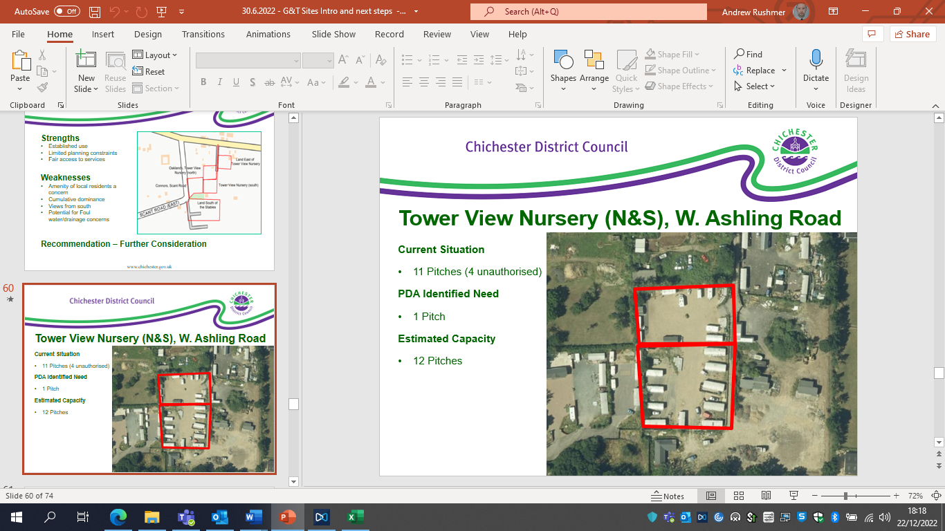
Site description
The site is part of a large cluster of pitches to the south of West Ashling Road. Funtington is located just to the north, and West Ashling to the north-east. The A27 is located just to the south. This site comprises two sites with a separate planning history, but which appear to be essentially one component of this much larger cluster and are in the same ownership. The site appears to be occupied by caravans in quite a high density formation, and is characterised by a high degree of hardstanding.
Planning history
This site has consent for 7 pitches across the two combined sites; Permission 06/03403/FUL is for 4 pitches on the southern part of the site, whilst 08/03702/FUL is for 3 pitches on the northern part of the site.
Need Level
The GTAA splits the sites in two, with 2 pitches being required in relation to the northern sites (1 current need, 1 5-year need), while for the southern site it’s 4 pitches which are needed.
Commentary in relation to the Pitch Deliverability Assessment (PDA)
The PDA identifies few concerns with the site itself, though does note the concerns regarding the scale of the encampment in general in terms of the domination of the settled community. Some environmental concerns are identified, and also some issues with the access.
Commentary in relation to the Capacity Study (CS)
The CS notes that the site is not currently laid out as per the permission on the site. The result is that the permissions entail under-utilisation of the site in terms of density, while the actual current occupation appears to be characterised by an overly high density. The CS identifies some potential capacity, but only for 1 additional pitch within the site compared with current permissions. So while 7 pitches are consented on the site, the overall capacity would appear to be 8.
Commentary in relation to the new Local Plan
The site is situated within a large existing cluster of pitches, and consequently the landscape impact is unlikely to be significant. There also appears to be virtually no vegetation on the site and hence no clearance of trees or hedgerows would be required.
A key constraint is clearly the Strategic Wildlife Corridor (SWC) as referred to in the CS. This cuts across the site, and clearly it would be important to ensure that no future proposal would impact upon the SWC. However, given that the need relates to the site and there is a shortage of sites there are not likely to be any sequentially preferable sites. In addition, given the condition of the current site, reconfiguring it in order to comply with the site design policy actually may create an opportunity for biodiversity enhancement.
There are no specific flood risks associated with the site, this includes from groundwater, as shown in the SFRA Level 1.
The new pitches on the site would need to comply with the new site design policy in relation to gypsy and traveller pitches, and this would probably improve the condition of the site and deliver a better standard of accommodation.
Commentary in relation to Planning Policy for Traveller Sites (PPTS)
A key consideration in relation to PPTS is the requirement to meet identified needs, and there is currently a high need associated with this site. Consequently, as a general principle, from a need perspective it is likely to be beneficial to meet as much of the need as possible on this site. However, as has been set out above, the CS establishes that there is insufficient capacity in order to meet the needs on the site in an acceptable manner.
PPTS refers to the importance of ensuring peaceful and integrated co-existence between the site and the local community, and also ensuring that the scale of sites does not dominate the nearest settled community. The Council is very mindful of these requirements, and in general terms would not wish to support the expansion of existing large encampments. However, in this case, as the proposed occupants are already on the site, and overall, the level of occupation of the site would be reduced compared with the current high density of occupation, arguably this is not really an intensification or expansion of the current site, rather a reconfiguration to bring the site in line with the new policy. Moreover, 1 additional pitch within the confines of the existing encampment, for need which is already on the site, it unlikely to materially impact upon the nearby settlement community.
PPTS also encourages the effective use of brownfield land, and as a consented site, that would appear to imply that this is brownfield land and hence it should be used effectively rather than left underutilised.
Conclusion
The decision in relation to this site is considered to be very finely balanced. On the one hand, the concerns about the scale of the current encampment is a very important consideration, and the Council does consider that there is already an overconcentration pitches this location.
However, this must be balanced against meeting identified needs, and in this case the prospective occupants are already part of this cluster and one additional consented pitch within the existing confines of the site is unlikely to have any material impact on the scale of the cluster, especially as it would appear to reduce the density of occupation which currently characterises the site.
Consequently, on balance, it is considered that the site in question can be expected to be suitable for very limited intensification for 1 additional pitch vis-à-vis the 7 pitches already consented. This is predicated on the site be laid out in a manner which accords with the new site design policy and in so doing improving upon the current situation.

- Connors, Scant Road East, West Ashling
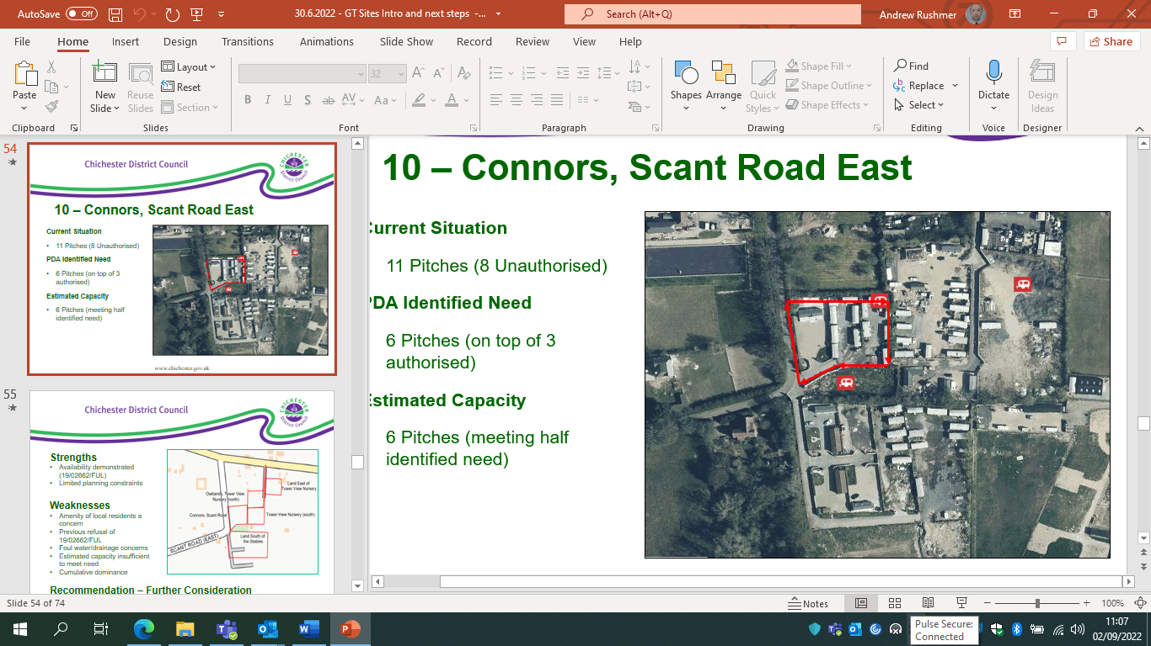
Site description
The site is part of a large cluster of pitches to the south of West Ashling Road. Funtington is located just to the north, and West Ashling to the north-east. The A27 is located just to the south. This site is next to the Tower View Nurseries North/South site referred to above. Currently there appears to be one pitch on the site laid out in a fairly conventional manner, but with caravans arranged in a much more high-density arrangement on the remainder of the site.
Planning History
08/00611/FUL - Use of land for extended settled gypsy accommodation comprising 3 no. mobile homes, 3 no. touring caravans and 3 no. utility blocks.
19/02662/FUL - Use of land for extended settled gypsy accommodation comprising 3 no. mobile homes, 3 no. touring caravans and 3 no. utility blocks - Variation on Conditions 2 and 4 of planning permission FU/08/00611/FUL - to increase the number of caravans to 12, including 11 no. static caravans/mobile homes.
Need level
There is currently a need for 1 pitch on the site and 2 more in the first 5 years.
Commentary in relation to the Pitch Deliverability Assessment (PDA)
The PDA identifies few concerns with the site itself, though does note the concerns regarding the scale of the Tower View Nurseries encampment generally in terms of the domination of the settled community. Some environmental concerns are identified.
Commentary in relation to the Capacity Study (CS)
Generally, the site assessment process has sieved out sites where permission for intensification has already been refused, and it is noted that there has been a recent refusal on the site. However, having looked at the site layout plan proposed that appeared to be effectively seeking to regularise the very high-density arrangement on the eastern side of the site, which is materially different from what would be expected if the site were to comply with the site design policy. In addition, the application which was refused appeared to essentially only be the basis of lack of information. Consequently, overall, consideration of a capacity based on the site design policy is considered appropriate.
The CS establishes that there is space on the site for 5 pitches in a manner which would accord with the site design policy. However, that would entail the re-configuration of the established pitch on the site, which does not appear realistic, and hence actually only the pitches on the eastern side of the site are considered to be achievable, meaning a net increase of only 1 pitch on the site.
Commentary in relation to the new Local Plan
The site is situated within a large existing cluster of pitches, and consequently the landscape impact is unlikely to be significant. There also appears to be virtually no vegetation on the site and hence no clearance of trees or hedgerows would be required.
A key constraint is clearly the Strategic Wildlife Corridor (SWC) as referred to in the CS. This cuts across a small part of the site, and clearly it would be important to ensure that no future proposal would have a detrimental impact upon the SWC. However, given that the need relates to the site and there is a shortage of sites there are not likely to be any sequentially preferable sites. In addition, given the condition of the current site, reconfiguring it in order to comply with the site design policy actually may create an opportunity for biodiversity enhancement.
There are no specific flood risks associated with the site, including from groundwater, as shown in the SFRA Level 1. However, it is noted that in relation to the most recent planning application there was concern in relation to pollution of groundwater protection zones, and that will remain a pertinent consideration in light of the relevant policy in the new Local Plan.
The pitches on the site would need to comply with the new site design policy in relation to gypsy and traveller pitches, and this would probably improve the condition of the site and deliver a better standard of accommodation.
Commentary in relation to Planning Policy for Traveller Sites (PPTS)
A key consideration in relation to PPTS is the requirement to meet identified needs, and there is need associated with this site. Consequently, as a general principle, from a need perspective it is likely to be beneficial to meet as much of the need as possible on this site. However, as has been set out above, the commentary above explains that there is insufficient capacity in order to meet the needs on the site in an acceptable manner.
PPTS refers to the importance of ensuring peaceful and integrated co-existence between the site and the local community, and also ensuring that the scale of sites does not dominate the nearest settled community. The Council is very mindful of these requirements, and in general terms would not wish to support the expansion of existing large encampments. However, in this case, as the proposed occupants are already on the site, and overall, the level of occupation of the site would be reduced compared with the current high density of occupation, arguably this is not really an intensification or expansion of the current site, rather a reconfiguration to bring the site in line with the new policy. Moreover, 1 additional pitch within the confines of the existing encampment, for need which is already on the site, it unlikely to materially impact upon the nearby settlement community.
PPTS also encourages the effective use of brownfield land, and as a consented site, that would appear to imply that this is brownfield land and hence it should be used effectively rather than left underutilised.
Conclusion
The decision in relation to this site is considered to be very finely balanced. On the one hand, the concerns about the scale of the current encampment is a very important consideration, and the Council does consider that there is already an overconcentration pitches this location.
However, this must be balanced against meeting identified needs, and in this case the prospective occupants are already part of this cluster and one additional consented pitch within the confines of the existing site is unlikely to have any material impact on the scale of the cluster, especially as it would appear to reduce the density of occupation which currently characterises the site.
Consequently, on balance, it is considered that the site in question can be expected to be suitable for very limited intensification for 1 additional pitch vis-à-vis the 3 pitches already consented. This is predicated on the site be laid out in a manner which accords with the new site design policy and in so doing improving upon the current situation.
- Oakfield (Land East of Tower View Nursery), West Ashling Road
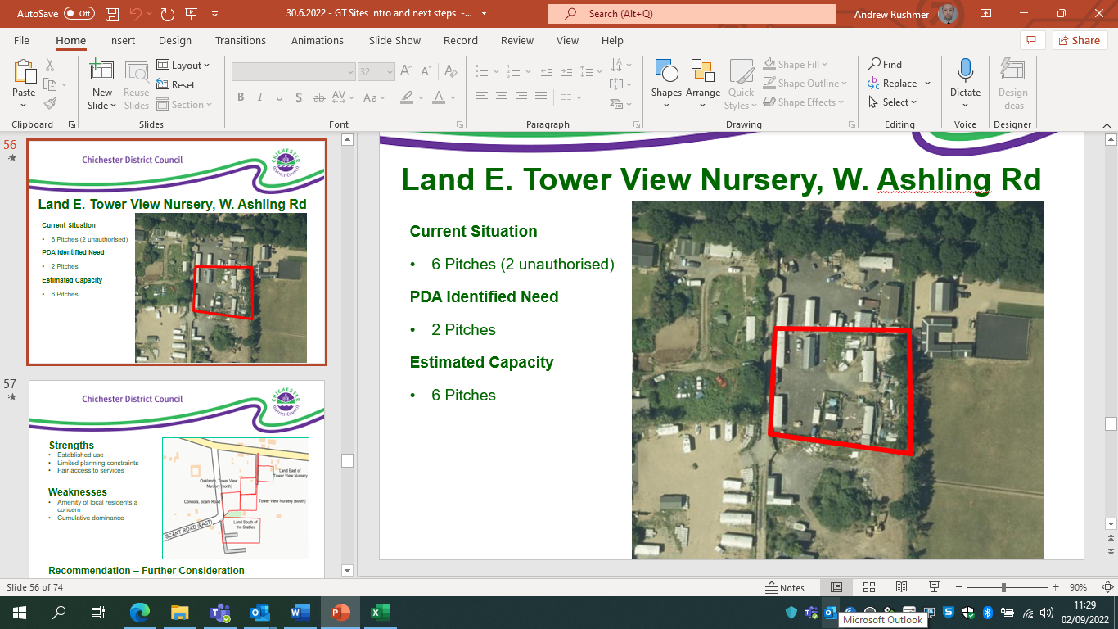
Site description
The site is part of a large cluster of pitches to the south of West Ashling Road. Funtington is located just to the north, and West Ashling to the north-east. The A27 is located just to the south. This site is next to the Tower View Nurseries North/South site referred to above. Currently there appears to be two pitches on the site laid out in a fairly conventional manner, with hardstanding covering the remainder of the site which appears to be used as two additional pitches.
Planning history
14/01267/FUL - Provision of four mobile home pitches for occupation by gypsy/travellers (as defined in Planning Policy for Traveller Sites) and erection of three timber-clad utility buildings.
Need level
The PDA and GTAA both identify a need for two pitches, though the timing is slightly different. The more recent GTAA specifies that one pitch is needed immediately and 1 in the next 5 years.
Commentary in relation to the Pitch Deliverability Assessment (PDA)
The PDA identifies few concerns with the site itself, though does note the concerns regarding the scale of the Tower View Nurseries encampment generally in terms of the domination of the settled community. Some environmental concerns are identified.
Commentary in relation to the Capacity Study (CS)
The PDA appears to suggest that the 2 additional pitches needed can be accommodated on the site, and hence this has been tested via the CS. The CS confirms that there is not scope for additional pitches.
Consequently it is considered that there is no merit in considering the site in light of the new Local Plan or PPTS.
Conclusion
There is clearly not capacity for additional pitches on the site vis-à-vis the 4 already consented.

- Sunrise / Applecross (Adjacent to Southbourne Farm Shop), Southbourne
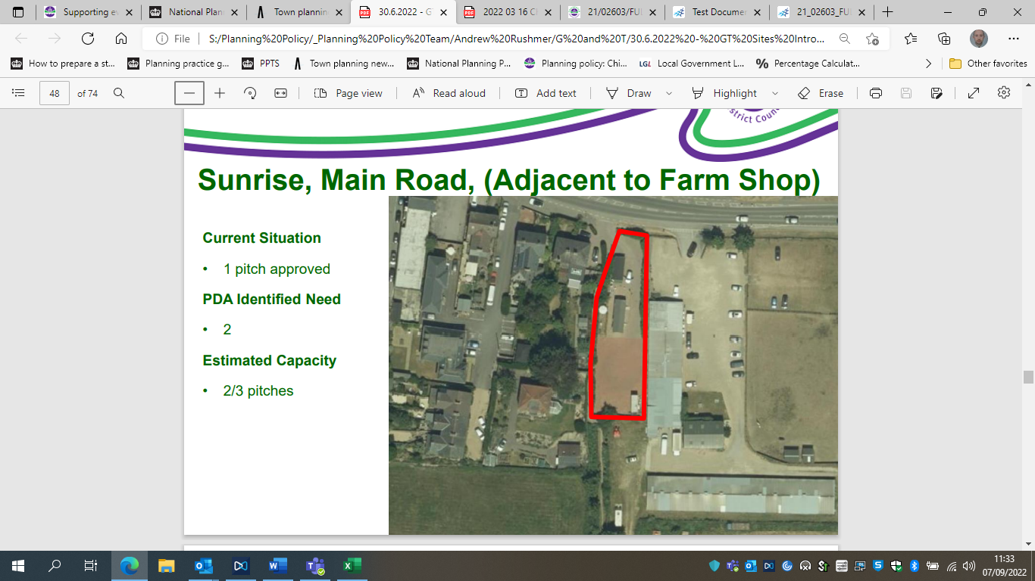
Site description
The site is located adjacent to the 259 on the edge of Southbourne, in a gap between a row of residential properties and a farm shop. There is a hedgerow along the frontage with the road, and a public Right of Way (RoW) running along the side of the site.
Planning history
The original planning permission is 09/04908/FUL, and appears to be for just one pitch. A subsequent application for another pitch was withdrawn (19/00251/FUL).
Need level
2 pitches are needed, 1 immediately, and 1 in the first 5 years. The site is being occupied by non-travellers (as set out in the GTAA), but their needs still have to be met and hence the site capacity has been tested in the same way as other sites.
Commentary in relation to the Pitch Deliverability Assessment (PDA)
The main issues which are identified in respect of the PDA is that the site is located within the AONB and that the public RoW has been ‘informally’ redirected, and this issue appears to have been a significant problem in relation to the recent application referred to above.
Commentary in relation to the Capacity Study (CS)
The CS demonstrates that there is sufficient space for 1 additional pitch at the rear of the site regardless of whether the original or re-directed route of the RoW is assumed.
Commentary in relation to the new Local Plan
Given the location of the site within the AONB the impact on the natural landscape is clearly an important consideration. However, given that the additional pitch would be within the confines of the existing site, with other buildings all around it, the landscape impact and effect on the openness of the AONB is likely to be minimal. The area at the back of the pitch is also already given over to hardstanding and hence is not likely to necessitate the loss of trees or vegetation.
The site is not at significant risk of flooding. 3% is potentially at risk of surface flooding, but such as small risk does not impact upon the principle of the development. The site is potentially at risk of groundwater flooding, like most sites in the southern plan area. However, in relation to the exception test criteria, this site is highly likely to be the most sustainable option for meeting the need identified, as the site itself is in a sustainable location and the site allows for the need to be met on the site on which it is being generated. In addition, groundwater is generally not a difficult flood risk to mitigate, and the main risk is typically associated with basements, which clearly won’t be the case with a traveller site, indeed, the caravans will be stationed above ground level.
The new pitch on the site would need to comply with the new site design policy in relation to gypsy and traveller pitches.
Commentary in relation to Planning Policy for Traveller Sites (PPTS)
As the site is occupied by non-travellers PPTS is technically not relevant. However, in light of the Lisa Smith judgement it may be prudent to still consider the site in light of the relevant considerations. A key consideration in relation to PPTS is the requirement to meet identified needs, and there is currently a need associated with this site. Consequently, as a general principle, from a need perspective it is likely to be beneficial to meet as much of the need as possible on this site. However, as has been set out above, the CS establishes that there is insufficient capacity in order to meet the needs on the site in an acceptable manner.
PPTS also encourages the effective use of brownfield land, and as an area of hardstanding within a consented site, that would appear to imply that this is brownfield land and hence it should be used effectively rather than left underutilised.
Conclusion
Given that there is need pertaining to the site and there is clearly space for 1 additional pitch at the rear of the site it appears reasonable to assume that the site could be intensified for the provision of 1 additional pitch. However, it would be important to ensure that the public RoW issue is resolved, and the CS indicates that there is space for an additional pitch even if the original line of the RoW needs to be restored. This is predicated on the site be laid out in a manner which accords with the new site design policy.
- Kia Ora Nurseries/Land East of Nutbourne Park
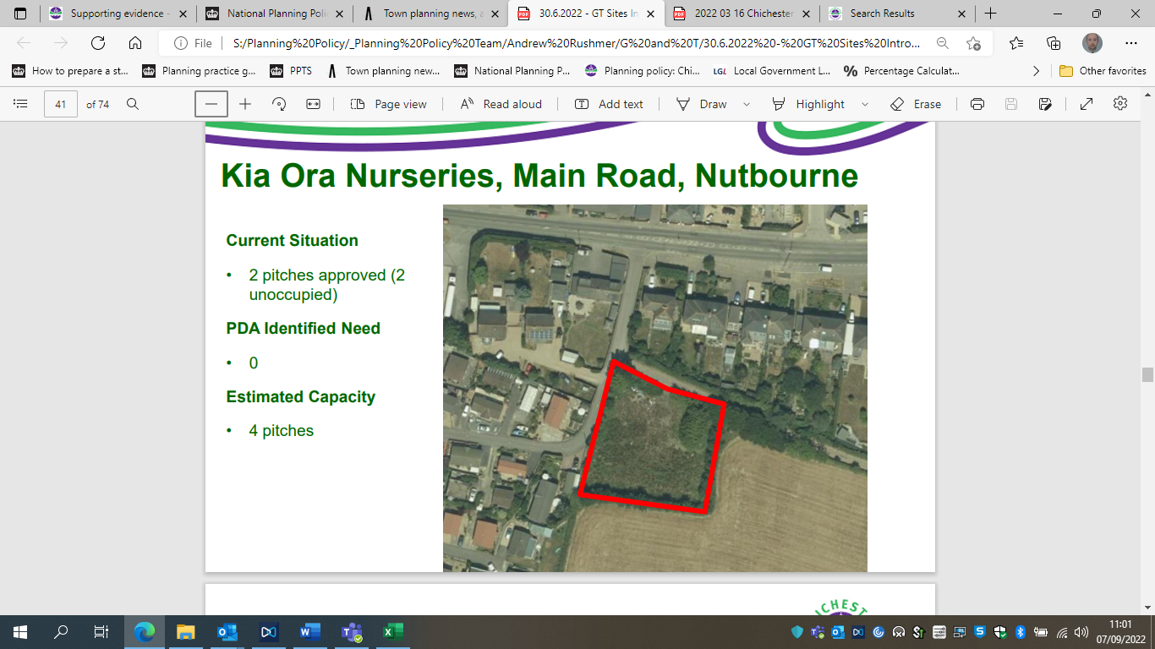
Site description
The application site consists of a roughly square and flat plot of land, which apparently previously contained a small agricultural building. The site boundaries are defined by tall hedging and trees. Access to the A259 is by means of the same access as that to the Nutbourne Caravan Park. The site is described in the planning application for two pitches in 2012 as being overgrown and untidy. Residential properties flank the site to the north and west, with an arable field to the south and east.
Planning history
Consent granted in 2012 on appeal for 2 pitches (12/02077/FUL). Permission has now lapsed.
Need level
None as the site has not been developed or occupied. The site has been assessed with a view to maximises potential sources of supply.
Commentary in relation to Pitch Deliverability Assessment (PDA)
Only a very limited commentary is provided, which is reflective of the fact that the site is unimplemented. The PDA notes the location of the site within the AONB. However, given that consent has already been granted this is presumably not an overriding constraint.
Commentary in relation to Capacity Study (CS)
The CS establishes that it is not possible to fit additional pitches onto the site in a manner which would accord with the site design policy. Consequently, the site has not been subject to any further consideration.
It should also be noted that the site is identified in the new SFRA as being susceptible to groundwater flooding (affecting 36% of the site), which would undermine the principle of development and could actually reduce capacity.
Conclusion
While the principle of pitches on this site has been established via the previous consent, this has now lapsed and the CS demonstrates that it is not possible to increase the potential capacity of the site for additional pitches. Given that consent was granted almost 10 years ago and has never come forward it is unlikely to be valid as a source of supply, particularly for the first 5 years of the plan period.

- Land at Lakeside Barn
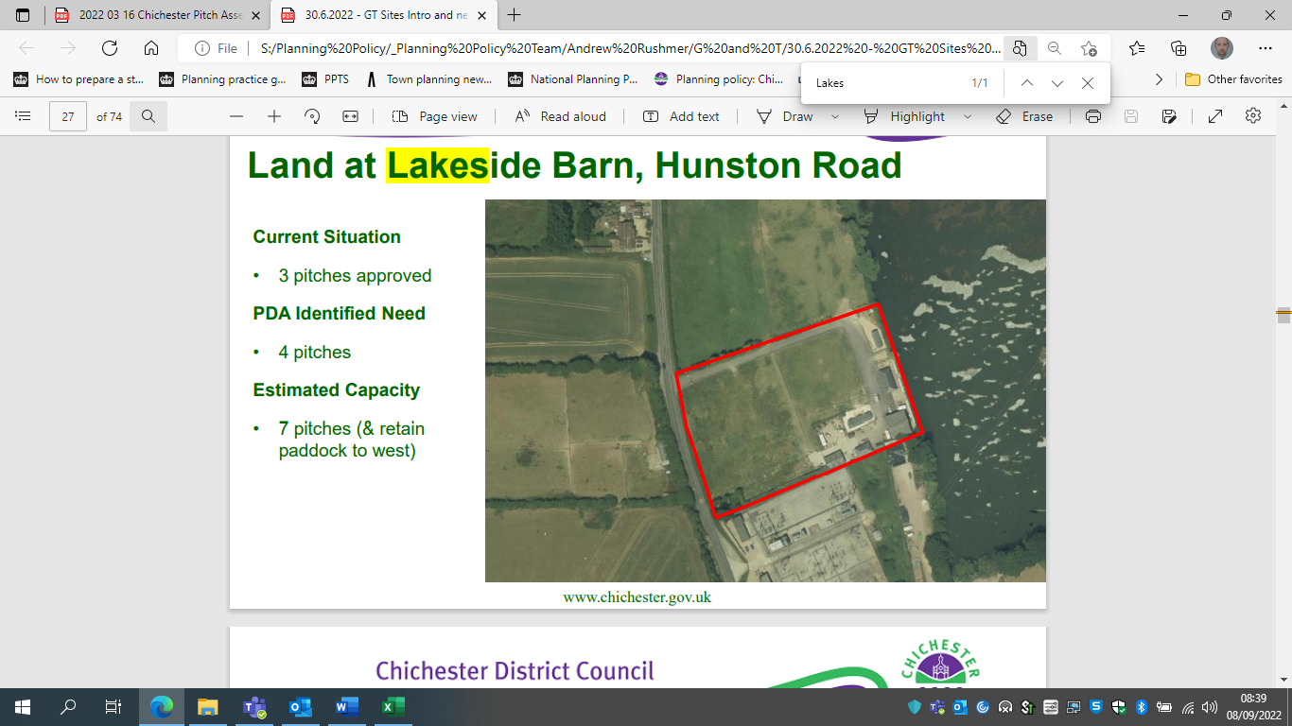
Site description
The site is located on the western side of West Trout Lake and the east off Hunston Road (B2145). The site is bounded by a large electricity sub-station to the south of the paddocks to the north. The site is accessed from a gated entrance at the northwest corner of the site, with a long part gravelled, part metalled road, leading to a car part servicing 3 mobile homes. The majority of the site is used as a paddock, and there a number of outbuildings on the edge of the site.
Planning history
This site has an existing consent for 3 pitches (13/03158/FUL). The description refers to the site as being for settled accommodation. However, the GTAA lists the site occupants as meeting the PPTS definition.
Need level
The GTAA that there is an immediate need for 4 pitches in relation to the site.
Commentary in relation to the Pitch Deliverability Assessment (PDA)
The PDA identifies the site as being within Flood Zone 2. However, the site has been screened as part of the Strategic Flood Risk Assessment process and established as being entirely within Flood Zone 1 and is also not particularly susceptible to other sources of flooding (4% of the site is at risk of surface water flooding). The site is potentially at risk of groundwater flooding, like most sites in the southern plan area. However, in relation to the exception test criteria, this site is highly likely to be the most sustainable option for meeting the need identified as the site allows for the need to be met on the site on which it is being generated. There is also a bus stop just to the south-west of the site. In addition, groundwater is generally not a difficult flood risk to mitigate, and the main risk is typically associated with basements, which clearly won’t be the case with a traveller site, indeed, the caravans will be stationed above ground level.
Commentary in relation to the Capacity Study (CS)
The CS confirms what is fairly obvious from the site plan, namely that there is amble space for the additional pitches needed to be provided on the site.
Commentary in relation to the new Local Plan (LP)
Landscape impact is a concern to a certain extent, and the Council would be concerned about any encroachment into the countryside. However, it would appear that there are likely to be ways in which additional pitches could be provided in a manner which would consolidate the existing cluster of pitches, which is considered to mitigate the concerns regarding landscape impact.
A key constraint is the Local Wildlife Site, however, this only skirts around the edge of the site and there are already buildings within the designated area. Any new pitches would appear to inevitably end up being located further away from the Local Wildlife Site than some of the current buildings and there is amble space for buffering even if that were considered to be needed.
Biodiversity net gain would need to be achieved, and it would appear that sufficient space would be left over for this to be potentially achievable on-site. The provision of the 4 pitches would also not appear to result in the need for any significant clearance of trees and vegetation.
The new pitches on the site would need to comply with the new site design policy in relation to gypsy and traveller pitches. Moreover, it will be important to ensure that the site does not become excessively large, and hence there are likely to be limits to much additional intensification of the site will be appropriate.
Commentary in relation to Planning Policy for Traveller Sites (PPTS)
A key consideration in relation to PPTS is the requirement to meet identified needs, and there is currently a need associated with this site. Consequently, as a general principle, from a need perspective it is likely to be beneficial to meet as much of the need as possible on this site.
PPTS emphasises the need for Local Authorities to very strictly limit new traveller site development in open countryside that is away from existing settlements or outside areas allocated in the development plan. This is quite a rural site, which would be a concern in that regard if consent had not already been granted, but given that the principle has already been established, the nature of the location does not appear to be an overriding constraint.
PPTS also requires that sites must not dominate the nearest settled community. There are a number of residential properties to the north east, but the site is not immediately next to them. It is considered that 4 additional pitches would be unlikely to dominate the nearest settled community, though were this site to be significantly intensified/expanded then this could be concerning in terms of the impact on the settled community in the vicinity.
Conclusion
Given that there is immediate need derived from the site and amble space for additional pitches it is considered relatively straightforward to recommend that the site is suitable for additional pitches in order to meet identified needs.

- Land West of Harwood
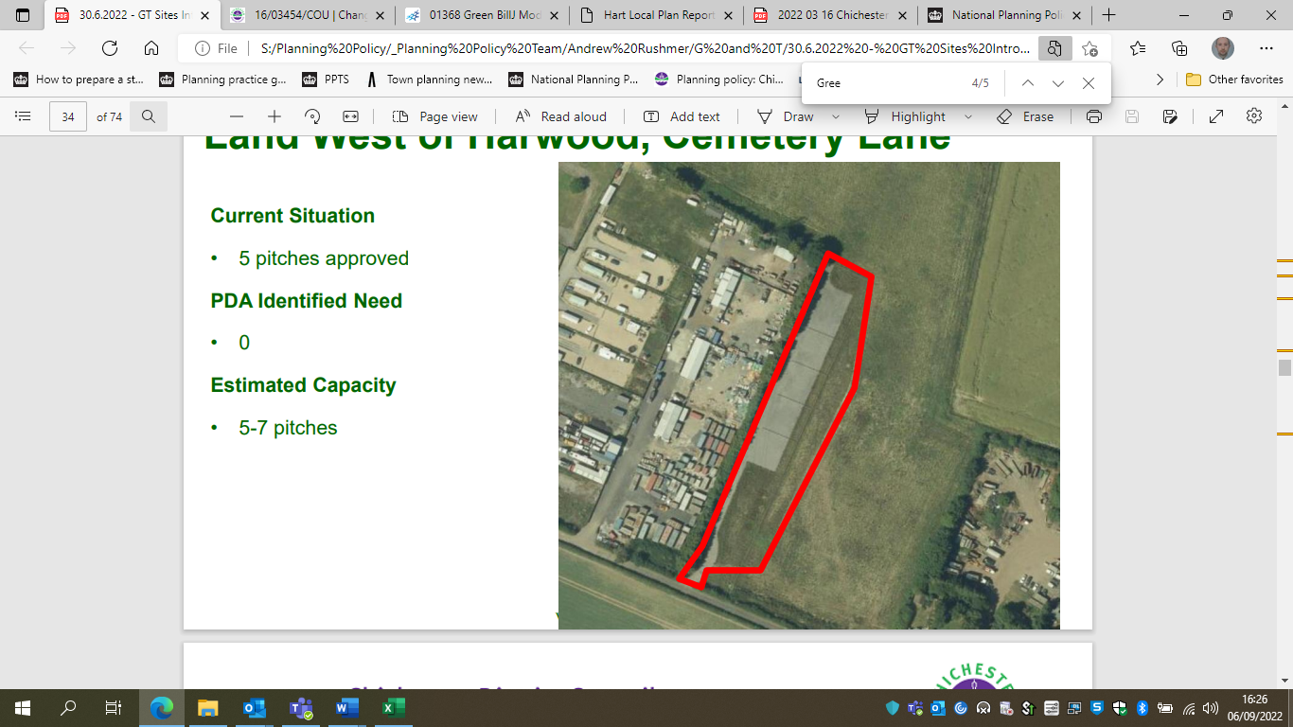
Site description
The site lies on the northern side of Cemetery Lane. The general area is mainly open farmland but, to the east along Cemetery Lane, beyond an open field, is a ribbon of residential development behind which is an agricultural contractor’s site. To the west is a travelling show person’s plot (Ten Acres) and beyond this is a Council owned gypsy site with 17 permanent and 2 transit pitches. On the southern side of Cemetery Lane, slightly to the east of that gypsy site, is a cemetery with a small chapel and a dwelling. The western part of Cemetery Lane between Foxbury Lane and the gypsy site is metalled. Further to the east it is unmade until just before it meets South Lane.
The site itself, which is part of a larger field of rough pasture in the appellant’s ownership, is bounded by tall conifers on the western boundary with The Old Army Camp and there is a high native species hedge along the southern boundary with Cemetery Lane. An electricity power line crosses the southern part of the site on a roughly north-south line.
Planning history
Permission was granted on appeal for 5 pitches 2016 - WE/14/01217/FUL.
Need Level
None as the site is not currently occupied, nor does the prospective occupants appear to have been identified (in which case it might have been possible to establish whether any additional need may have been likely in connection with the site).
Commentary in relation to the Pitch Deliverability Assessment (PDA)
The PDA provides only a limited assessment of the site, largely owing to the fact that while it appears to have been implemented, it hasn’t been fully developed or occupied. There are no significant problems identified with the site.
Commentary in relation to the Capacity Study (CS)
This site was tested in order to check whether there was any additional capacity available on the site, however, the CS clearly indicates that there is no potential to provide additional pitches on the site in an acceptable manner. Consequently, the site has not been subject to any additional consideration.
Conclusion
It is clear from the capacity study that there is no capacity to provide additional pitches on the site in an acceptable manner, vis-à-vis the 5 consented.

- Plot J, Pond Farm, Newells Lane, West Ashling
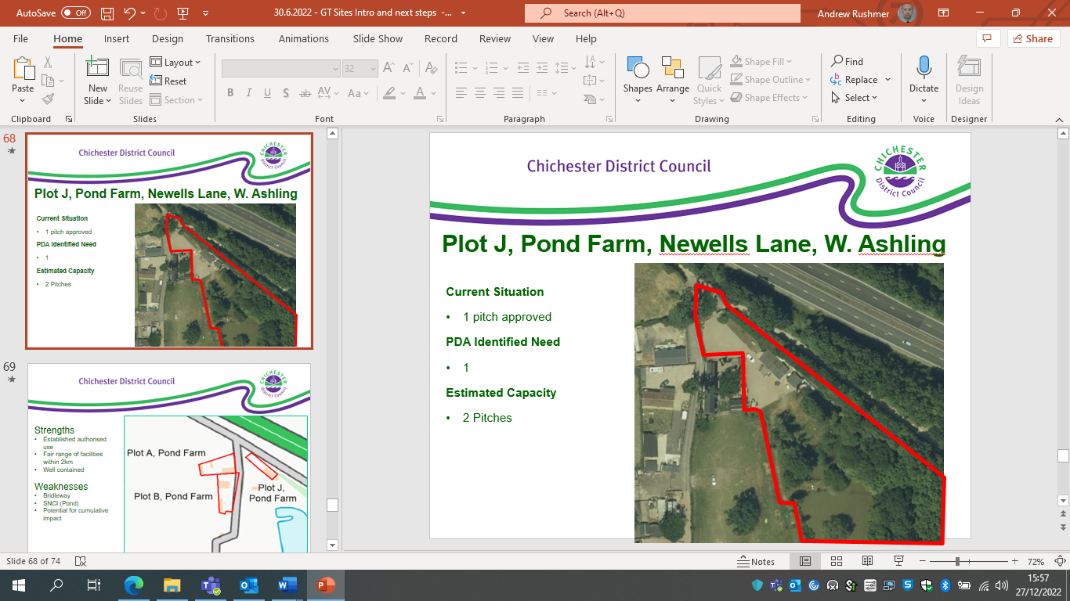
Site description
The site lies within an area of land south of the A27, adjoining Newells Lane to the east and Drift Lane to the south. The site falls within Site of Nature Conservation Importance (SNCI). The site is one of a cluster of traveller pitches within what is collectively known as Pond Farm. The site is known as Plot J, and while the site itself is fairly large, it is presumed that only the existing area of hardstanding is a reasonable option in terms of providing an opportunity for additional pitches, as the rest of the site needs to be protected owing to it ecological importance.
Planning history
A temporary permission was originally granted on appeal, 12/00458/COU, and then later made permanent - 16/02894/FUL.
Need Level
The GTAA records that the level of need associated with the site is 3 pitches, flowing from in-migration. The PDA reports a slightly lower level of need, only 2 pitches, of which only 1 was current need.
Commentary in relation to the Pitch Deliverability Assessment (PDA)
The PDA identifies various concerns regarding the site, particularly the environmental concerns regarding ecology, noise impacts in relation to the adjacent A27 (in respect of which there is no noise barrier), impact on the countryside and highways impacts. The PDA concludes that the owner of the site considers that sufficient land is available in order to meet the need levels associated with the site.
Commentary in relation to the Capacity Study (CS)
The CS demonstrates that there is insufficient space within the hardstanding area in order to provide for additional pitches. Consequently, the site has not been subjection to any additional consideration.
Conclusion
Owing to the environmental sensitivity of the site, it is considered that only the existing hardstanding area has any potential for being an acceptable location for additional pitches. The CS has established that it is not possible to provide additional pitches in that location in an acceptable manner.

- Greenacre
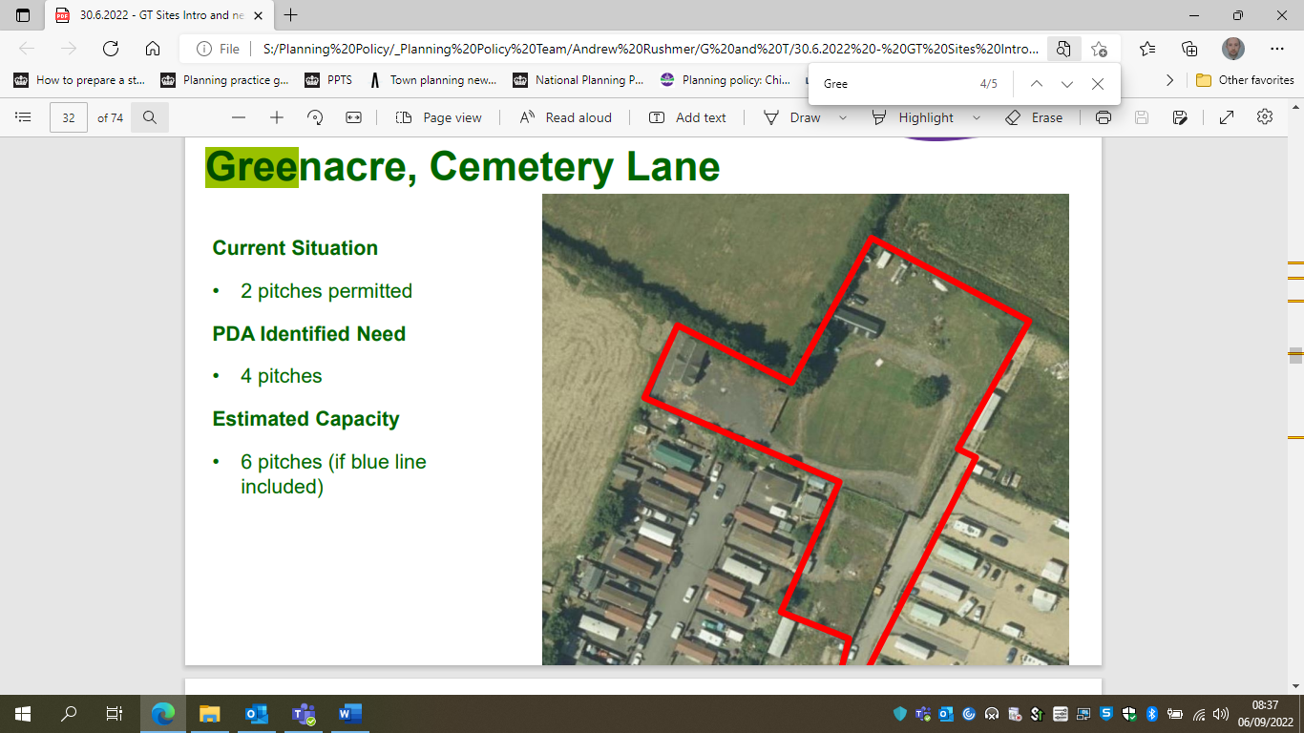
Site description
The application site is located within the Parish of Westbourne, to the east of the village. To the south of the site is the WSCC Gypsy and Travellers site, with open countryside beyond. To the north and west is open agricultural land, on which are a number of trees that offer some screening of the site. To the east is the remaining part of the land known as the Old Army Camp.
Access is achieved via an existing track which leads into the site from Cemetery Lane, currently serving an existing travelling showpersons site and the rest of the brownfield site. Much of the current site is given over to grazing for horses, though with elements of hardstanding. A post and rail fence defines the northern boundary.
Planning history
The site has planning permission for two pitches (16/03454/COU), with the rest of the site given over to paddock.
Need Level
4 in immediate need.
Commentary in relation to the Pitch Deliverability Assessment (PDA)
The PDA identified few concerns regarding the site in terms of constraints or potential detrimental impacts. There is limited access to public transport, but given that this is already an authorised site, and there a large number of other authorised pitches in the vicinity, this is not considered likely to be an overriding constraint. The PDA indicates that the need in relation to this site relates to adult children of the site owners living on the neighbouring public site. Consequently, this site provides an important opportunity to address that need and provide them with more spacious accommodation.
Commentary in relation to the Capacity Study (CS)
The CS clearly demonstrates that there is ample space to provide additional pitches on the site, up to 6. However, the CS does highlight that delivering that level uplift in full would lead to conflict with the Strategic Wildlife Corridor (SWC) along the western side of the site. It would certainly be important to protect the integrity of the SWC and hence pitches in that location should be avoided. That would reduce the level of capacity to only 4, all of which would be outside of the SWC.
Commentary in relation to the new Local Plan (LP) and Neighbourhood Plan
Landscape impact/development in the countryside is a concern to a certain extent, and the council would be concerned about any encroachment into the countryside. However, the site would appear to effectively involve the squaring-off of an existing cluster of pitches, which is considered to mitigate the concerns regarding landscape impact.
A key constraint is clearly the Strategic Wildlife Corridor as referred to above. The CS establishes that there is space available outside of the corridor for 4 pitches, and it is considered that only those 4 pitches are acceptable in relation to the SWC. The additional two pitches on the western side would appear to require the hedgerow to be removed which would clearly be detrimental to the SWC and hence unacceptable.
Biodiversity net gain would need to be achieved, and it would appear that sufficient space would be left over for this to be potentially achievable on-site. The provision of the 4 pitches on the eastern side would also not appear to result in the need for any significant clearance of trees and vegetation.
There are no significant flood risks associated with the site, only a very small amount of surface water flooding (2% of the site is affected). The site is potentially at risk of groundwater flooding, like most sites in the southern plan area. However, in relation to the exception test criteria, this site is highly likely to be the most sustainable option for meeting the need identified, as the site allows for the need from the adjacent public site to be consolidated on this site and potentially free up space for those who cannot afford to buy their own pitch. In addition, groundwater is generally not a difficult flood risk to mitigate, and the main risk is typically associated with basements, which clearly won’t be the case with a traveller site, indeed, the caravans will be stationed above ground level.
The new pitches on the site would need to comply with the new site design policy in relation to gypsy and traveller pitches.
The community balance policy in the Westbourne Neighbourhood Plan is also recognised, and this is interpreted as meaning that in general terms the intensification of this large cluster would not be acceptable. The current cluster of pitches is already likely to be considered an over-concentration, and this will need to be balanced against the needs of the occupants and lack of alternative provision available for them. In addition, the intensification of this site would relate well to some of the provisions of the community balance. The occupants are already on the neighbouring public site and so have a local connection. In addition, relocating them to this site is likely to provide them with more amenity space than is currently the case.
Commentary in relation to Planning Policy for Traveller Sites (PPTS)
A key consideration in relation to PPTS is the requirement to meet identified needs. In the case of this site, it has been established through the GTAA that there is need in relation to this site flowing from the neighbouring public site (adult children in need of their own pitches). Consequently, it is considered that as a general principle it would be important for these needs to be met, and the proposed location has been identified as deliverable, and would appear to be the most suitable option available for their accommodation.
Conversely, PPTS refers to the importance of ensuring peaceful and integrated co-existence between the site and the local community, and also ensuring that the scale of sites does not dominate the nearest settled community. The council is very mindful of these requirements, and in general terms would not wish to support the expansion of existing large encampments. However, in this case, as the proposed occupants are already on the neighbouring site, and the proposal would involve development within the confines of the existing planning permission area, it is considered unlikely to have a material detrimental impact on the local community through increases in the level of occupation or scale of the site. Moreover, as the proposed occupants are ‘doubled up’ on an existing site and in need of accommodation, their personal circumstances would be likely to weigh in favour of any future planning application pertaining to the site.
Conclusion
The decision in relation to this site is considered to be very finely balanced. On the one hand the NP policy regarding community balance is a very important consideration, and the council does consider that there is already an overconcentration pitches this location.
However, this must be balanced against meeting identified needs, and in this case the prospective occupants are already part of this cluster, and hence arguably meeting their needs on a more spacious site is just a more appropriate method of accommodating the existing site occupants, rather than being an expansion of the cluster. In addition, there does not appear likely to be any significant harm flowing from the intensification of this site.
Consequently, on balance, it is considered that the site in question can be expected to be suitable for intensification in order to meet the identified need pertaining to it.

- The Stables, Bracklesham Lane, Bracklesham
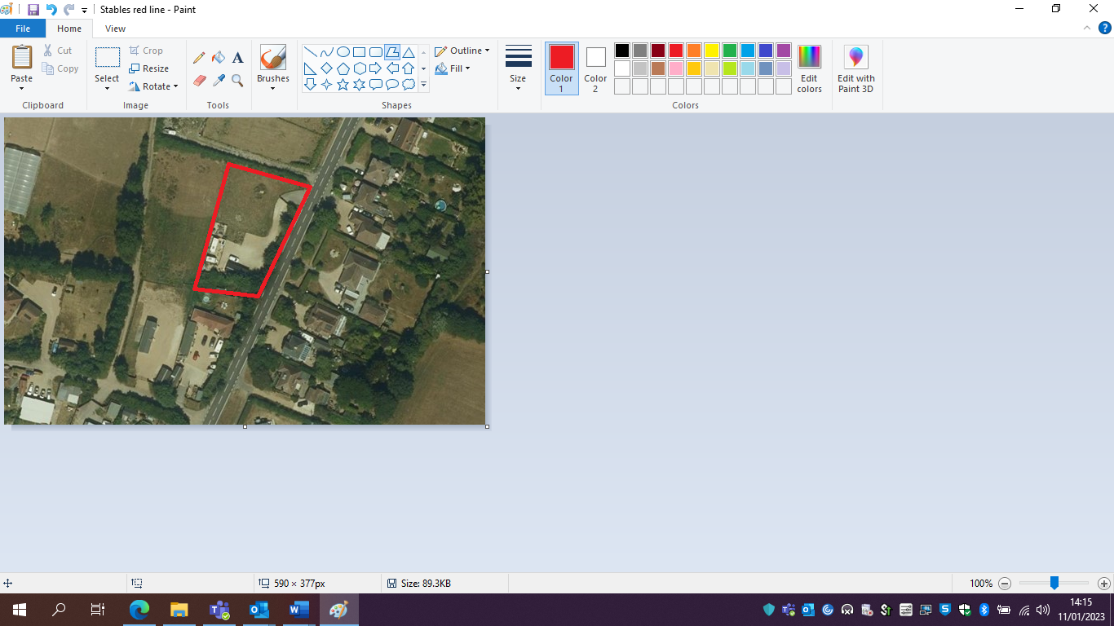
Site Description
The site is located within a semi-rural location and opposite a ribbon of residential properties positioned to the east of Bracklesham Lane (also known as the B2198). There is also further scattered residential development located to the south of the site, in Clayton Lane, together with the siting of two further gypsy sites. To the north is situated a row of travelling showpeople plots (which are also considered as part of this assessment). Open flat countryside is evident to the north and west of the appeal site. The site is adjacent to Bracklesham Lane, with considerable vegetation along the frontage. The site is predominantly grassland but with a hard surfaced area for the stationing of caravans, car parking and recreational space. The site is an established traveller pitch, including a large day/utility building.
Planning history
Permission for the use of the site as a gypsy and traveller pitch was granted retrospectively on appeal in 2010 (09/07501/FUL). Subsequently, a variation to the permission, for a larger utility/day room, was also granted on appeal, (17/03152/FUL).
Need level
The site is listed within the GTAA as being undetermined (refusal to be interviewed), and hence no need has been established in relation to the site, which is not necessarily to say that there is no need associated with the site.
Commentary in relation to the call for sites site assessment (CfSSA)
The CfSSA does not identify any significant concerns regarding the site. The site receives an amber scores in the RAG assessment for habitat designations, however, this appears to be a concern/score which relates to the need for all development near the coast in this area and can be addressed as part of any future planning application (by complying with the general policy requirements in this regard). There is an amber score for the relationship with the surrounding area and neighbouring properties, however, no overriding concerns appear to have been identified in the commentary, just the need for some more screening. The site receives an amber score for infrastructure and utilities, but again, no significant concerns appear to have been identified in the commentary.
Commentary in relation to the Capacity Study (CS)
The CS concludes that there is theoretically space for 2 pitches in the undeveloped area to the north of the existing pitch. However, that would appear to mean that the additional pitches would be very hard up to the northern boundary, which could impact upon the hedgerow in that location. It is also not clear from the capacity exercise whether sufficient space would be afforded for vehicle turning or the additional screening referred to in the RAG assessment.
Consequently, while there does appear to be space in theory for 2 pitches, this seems to be quite tight and hence only 1 pitch is considered sufficiently likely to be acceptable at this stage. There may be the potential to provide an additional pitch, but that would need to be demonstrated via a planning application.
Commentary in relation to the new Local Plan (LP)
Landscape impact/encroachment into the countryside would be a significant concern, however, it appears the additional accommodation proposed would effectively be limited infill within an existing row of pitches/plots. As has already been referred to above, the provision of two proposed pitches would appear to put pressure on the hedgerow along the northern boundary and if its retention were to be jeopardised that would appear to create a conflict with the new Local Plan.
The site is not within a current flood risk zone in terms of fluvial, tidal flooding or surface water flooding. However, part of the site is within a future flood risk zone as per the new Strategic Flood Risk Assessment, including the existing access and egress pertaining to the site, though this would not be until approximately 100 years into the future based on current climate change allowances. The site is potentially at risk of groundwater flooding, like most sites in the southern plan area. However, groundwater is generally not a difficult flood risk to mitigate, and the main risk is typically associated with basements, which clearly won’t be the case with a traveller site, indeed, the caravans will be stationed above ground level. Nevertheless, overall, flood risk is a significant concern pertaining to the site owing to the future flood risk identified with respect to the site.
There would be various policy requirements in relation to environmental designations along the coastline, however, these can be addressed via planning applications.
The new pitches on the site would need to comply with the new site design policy in relation to gypsy and traveller pitches.
Commentary in relation to Planning Policy for Traveller Sites (PPTS)
There is no specific established need associated with the site, so the contribution towards meeting needs is a general one as opposed to being specific to this site. PPTS seeks to restrict development in open countryside, and ensure that there is no domination of the settled community in terms of scale. In terms of the open countryside aspect of this requirement, the site is not particularly rural, and given that consent has already been granted for this site and a number of other pitches/plots in the immediate vicinity, the rural nature of the site isn’t likely to be an overriding constraint. This site is part of a growing cluster of gypsy and traveller pitches and travelling showpeople plots, and consequently the scale of this in relation to the settled community is becoming a concern. However, the scale of this cluster is significantly less than some of the existing very large encampments in the district around Westbourne and West Ashling, though the council certainly wouldn’t want to see it expanded to become anywhere near as large as those existing encampments.
Paragraph 13 (g) of the PPTS sets out a clear objective not to locate gypsy and traveller sites in areas at high risk of flooding, given the particular vulnerability of caravans. Consequently, the future flood risk pertaining to this location is a significant concern. In addition, it may well serve to limit future expansion of this cluster and hence reduce the likelihood of it dominating the nearest settled population.
So overall, the scale of this cluster could certainly become concerning if any significant expansion were to take place, however, infilling within it is less concerning. As a counterpoint to the above, as the site is consented, intensifying the use of the site would be consistent with the requirement to make effective use of land.
Conclusion
The site has been promoted for 2 pitches However, the provision of 2 pitches would appear to be very tight, and it is difficult to be confident that 2 additional pitches could be provided in an acceptable manner, and consequently, intensification for only 1 additional pitch is considered most appropriate.
The is also concern regarding future flood risk with respect to this site as part of it, including the access falls within a future flood risk zone, consequently, it is considered that it would not be appropriate for a permanent permission, given the highly vulnerable nature of caravans, and hence future consents would be most appropriately limited to temporary or personal permissions.
The cumulative growth of this wider cluster of pitches and plots is becoming concerning, and will need to be carefully managed in order to ensure that it doesn’t become excessively large.

- Land South of Little Willows
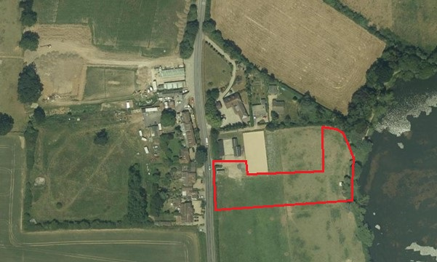
Site description
The site forms undeveloped grassland within a flat coastal plain. The land is undeveloped, rural and exposed due to its flat topography. The land is currently grazed by horses and there is a stables and menage to the north. To the east lies lakes. There are neighbouring properties to the north and west. To the north lies the access that serves Little Willow, Partney and Saladin. The west, east and north boundaries are defined natural vegetation.
Planning history
There is a previous refusal on the site for a single pitch (20/03163/FUL).
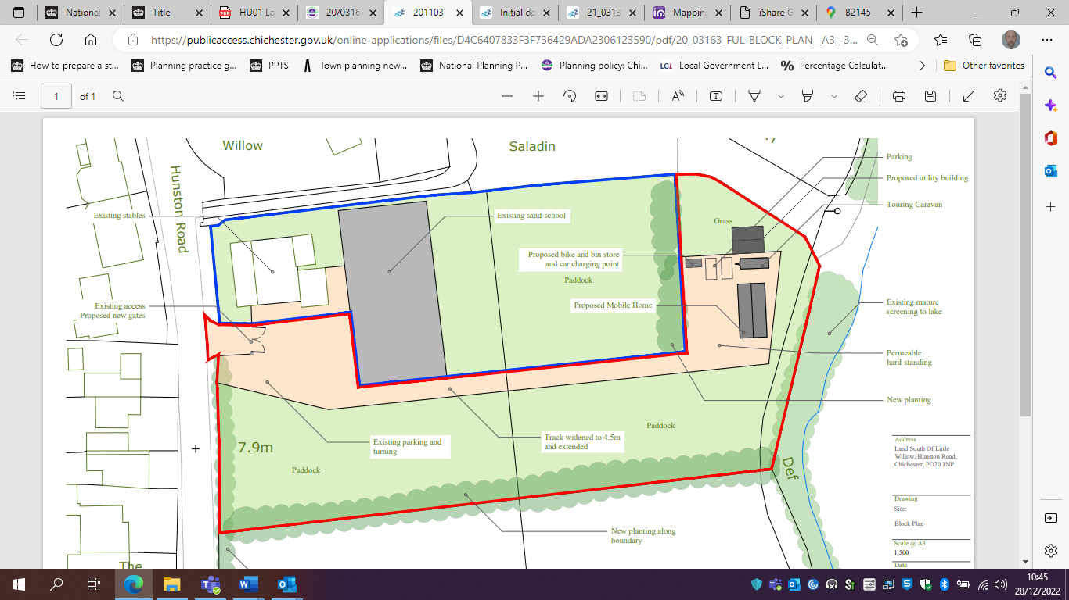
This application was refused for the following reasons:
- The proposal by reason of its; siting, layout, driveway siting and length, reliance on hardstanding would result in a development that would appear noticeably urban to a degree that would be visually harmful to the prevailing open and undeveloped character that would represent an unacceptable and unjustified encroachment into the rural area, segregating a wider parcel of currently undeveloped Greenfield land and eroding the open, flat and rural character of the site and surroundings.
- By virtue of the siting, layout, dominance of hardstanding, driveway, means of enclosure and the lack of soft landscaping, amenity space and the likely reliance on hardstanding, the proposal would result in a poorly designed layout which would be harmful to the future occupiers. This would result in an environment that would be unacceptable for future occupiers.
- The other reasons for refusal were general reasons pertaining to lack of information regarding the impact on nearby ecological designations along the coast and would have been capable of being addressed.
A subsequent application for a single pitch was approved, this involved bringing the pitch more within the existing cluster of equestrian related buildings (21/03138/FUL).
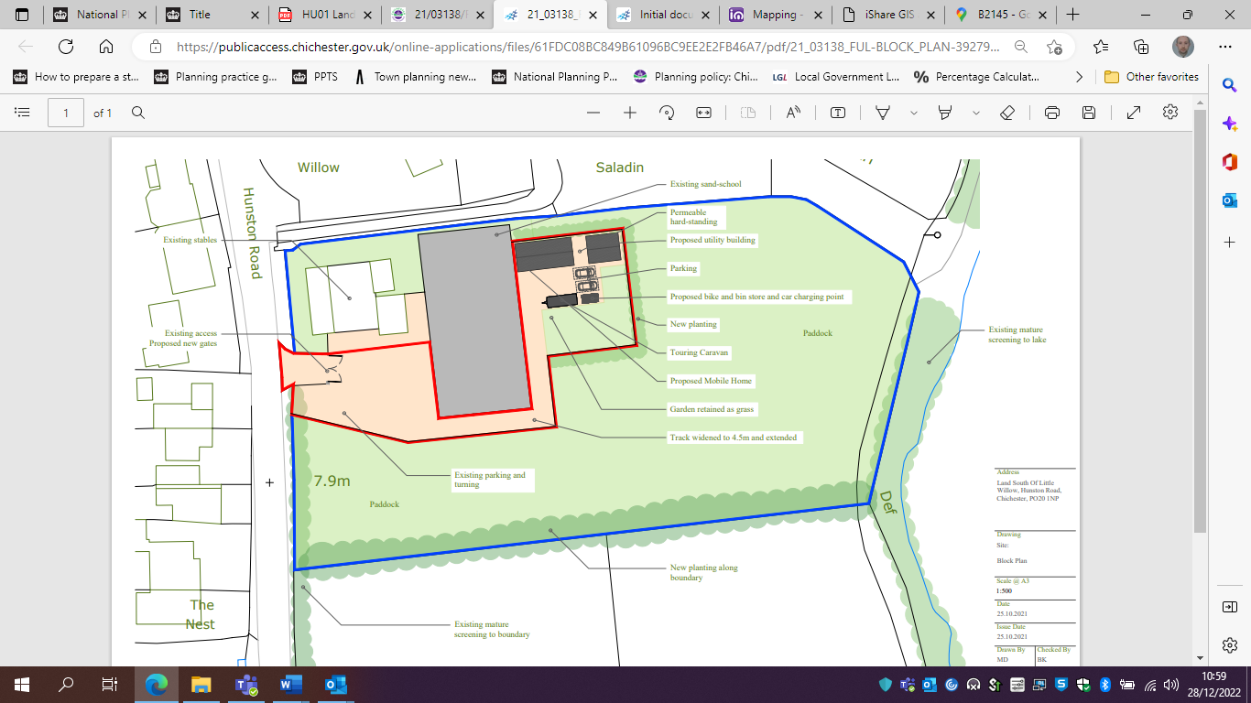
Need Level
The GTAA doesn’t record any need in relation to the site.
Commentary in relation to the call for sites site assessment (CfSSA)
The site receives a red for ecological impacts as it contains part of Local Wildlife Site (LWS). Any site which is wholly within a LWS has generally been sieved out, however, in this instance the LWS only encompasses the very edge of the site and there would be plenty of space to provide some pitches without impacting on the LWS and while also maintaining a healthy buffer.
The site receives an amber score in relation to the impact upon the character of the area and relationship with neighbouring properties. However, the commentary appears to suggest that this could be mitigated by additional screening. The site also receives an amber score in relation to infrastructure and utilities, but the commentary does not identify any overriding constraints in this regard.
Commentary in relation to the Capacity Study (CS)
The CS has established that there is theoretically sufficient space for 7 pitches within the site area. However, it acknowledges that there are constraints in relation to the LWS which might lower the realistic capacity of the site, probably by 2 pitches.
Commentary in relation to the new Local Plan (LP)
Based on the planning application at the site which was previously refused (20/03163/FUL), the key issues in relation to reconciling the potential allocation of the site with the new Local Plan would be in relation to the impact on the character of the area/development in the countryside. Given that one pitch was considered to be contrary to the current adopted Local Plan policy it would seem very difficult to reconcile 3 or more pitches with the relevant policies in the new Local Plan, as they contain essentially the same requirements.
The previous refusal referred to the unacceptable nature of the design of the proposed pitch and the consequent unacceptable standard of amenity for residents. It is considered likely that ensuring adherence with the new site design policy would imply that such concerns could theoretically be addressed. Though conversely, a greater number of pitches is likely to entail greater amounts of hardstanding etc. which would suggest that it could well still be difficult to overcome the previous reason for refusal in this regard.
Commentary in relation to Planning Policy for Traveller Sites (PPTS)
There is no specific need associated with the site, so the contribution towards meeting needs is a general one as opposed to being specific to this site. Nevertheless, the contribution of 3 – 5 pitches would certainly be a meaningful contribution towards meeting the level of need identified.
PPTS seeks to restrict development in open countryside, and ensure that there is no domination of the settled community in terms of scale. In terms of the open countryside aspect of this requirement, the site is fairly rural, though given that consent has already been granted immediately to the north the rural nature of the site isn’t necessarily an overriding constraint, though as has been noted above, the rural nature of the site does create significant problems in terms of the impact of any proposal on the character of the area. There is an existing pitch consented immediately to the north, and the Lakeside Barn site in close proximity to the south, and consequently the number of pitches in this locality in relation to the settled community could easily escalate and become a significant concern, especially as there is a large expanse of land between this site and the Lakeside Barn site, all of which could theoretically be subject to applications for pitches.
Conclusion
The decision as to whether to allocate this site is considered to be finely balanced. Given the level of need and the meaningful contribution this site could make towards meeting this need, there are strong grounds for allocating the site. However, ultimately the key consideration is deemed to be the relationship with the previous refusal pertaining to the site. It is vital that a consistent approach is taken, and to refuse 1 pitch in that location owing to the impact on the character of the area, but then allocate 3 pitches would appear highly inconsistent and hence on balance it is concluded that this site should not be allocated.
In addition, allocating this site could create the potential for a sizeable number of pitches in this location, as there is a relatively large area of paddocks in this vicinity, which could all be suitable in theory for pitches. Consequently, over time there would be the potential for a large number of pitches to be provided in this location, which could ultimately dominate the settled community. This is essentially a precedent argument in some respects, and hence is not the overriding rationale for the conclusion set out above; in this regard the previous refusal is considered to be the key arbiter in the decision-making process.

- Cherry West Meadow/Cowdry Nursey
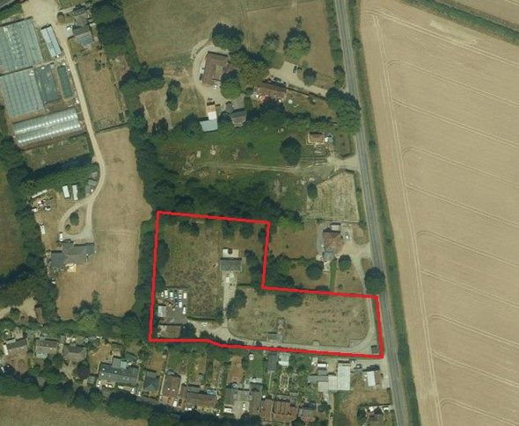
Site description
The site is on the edge of Birdham, and forms part of the former Cowdry Nursery. There is a consented traveller pitch located in the centre of the site, set back somewhat from Siddlesham Lane. Within the site there is an area which appears to be given over to the storage of motor vehicles. There is also a significant amount of trees and vegetation within the site area. The surrounding land uses are residential to the south, north and west, and the other land uses in the vicinity are agriculture and horticulture. There is a public footpath just to the south of the site, linking it with the main part of the village.
Planning history
The site has consent for one pitch, granted at appeal (11/05313/FUL).
Need level
The site falls within the undetermined category, and it appears that it has not been possible to interview the site occupants, meaning that no need has been identified in relation to the site, though that is not to say that there is no need pertaining to the site. Based on the information provided by the applicant (who appears to be the occupant of the site) at the time of the planning application in 2011, there may well be no current need flowing from the site, as the information provided at that time suggest that the occupants are a mature couple, with only one daughter who was already grown up at that time and travelling elsewhere.
Commentary in relation to the call for sites site assessment (CfSSA)
The RAG assessment does not identify any overriding constraints to the provision of more pitches on the site. The appear to some issues regarding contaminated land, but it is likely these could be overcome as part of any future planning application process, subject to the provision of sufficient information. There also appear to be some ecological constraints, and while these wouldn’t necessary be overriding constraints they could impact upon capacity and would require ecological information and mitigation measures to be addressed as part of any future planning application. The site is not particularly good in accessibility terms, however, the main part of the village is accessible via the public right of way to the south of the site, and given that consent has already been granted for one pitch, this is not likely to be an overriding constraint.
Commentary in relation to the Capacity Study (CS)
The site has been promoted for 12 pitches, and the CS clearly shows that such a yield in terms of additional pitches would be completely inappropriate. The CS shows that the site does have the potential to yield 3 additional pitches (on top of the existing pitch already consented). However, it is clearly from the analysis conducted that the provision of three additional pitches would be difficult to deliver in terms of reconciling that with the existing pitch already on the site, and without requiring significant vegetation clearance. Consequently, only one additional pitch appears likely to be realistic.
Commentary in relation to the new Local Plan (LP)
The main issues are likely to be in relation to landscape impact, development in the countryside and impact upon vegetation. It does not appear possible to provide a significant number of additional pitches at the rear of the site without creating a conflict with the policies referred to above, though a single pitch on the eastern side adjacent to Siddlesham Lane would be less likely to be problematic.
Extensive clearance of vegetation could also be problematic from an ecological perspective and in terms of being able to achieve the necessary level of biodiversity net gain.
The new pitches on the site would need to comply with the new site design policy in relation to gypsy and traveller pitches.
The site is potentially at risk of groundwater flooding, like most sites in the southern plan area. However, in relation to the exception test criteria, this site is likely to be the most sustainable option for meeting the need identified, as there are no other sites available, and the site itself is in a relatively sustainable location. In addition, groundwater is generally not a difficult flood risk to mitigate, and the main risk is typically associated with basements, which clearly won’t be the case with a traveller site, indeed, the caravans will be stationed above ground level.
Commentary in relation to Planning Policy for Traveller Sites (PPTS)
There is no specific need associated with the site, so the contribution towards meeting needs is a general one as opposed to being specific to this site. Nevertheless, the proposed contribution of 12 pitches proposed would certainly be a very meaningful contribution towards meeting the level of need identified, though as has been stated above, that appears to be out of the question in reality. The maximum realistic capacity of 3 additional pitches would also be a meaningful contribution, though those benefits are considered to be outweighed by the detrimental impact upon the environment and character of the area, which has been referred to above, and this is an issue which is also covered by PPTS, which seeks to restrict the impact of new pitches on the character of the countryside.
PPTS seeks to ensure that there is no domination of the settled community in terms of scale. The provision of the 12 pitches proposed could have the effect. However, 3 pitches, or the more realistic 1 additional pitch would appear very unlikely to have that outcome.
Conclusion
For the reasons set out above, it would appear that the 12 pitches promoted would be completely unacceptable. The capacity study has shown that 3 additional pitches (on top of the pitch already consented) is achievable in purely spatial terms. However, that would create significant problems in terms of having to reconfigure the site and in terms of having detrimental impacts upon the character of the area and loss of vegetation. Therefore, 1 additional pitch on the open part of the site (which appears to be a paddock) adjacent to Siddlesham Lane seems to be the most realistic yield which could be relied upon the come forward in an acceptable manner.

- Pinks Four, Birdham
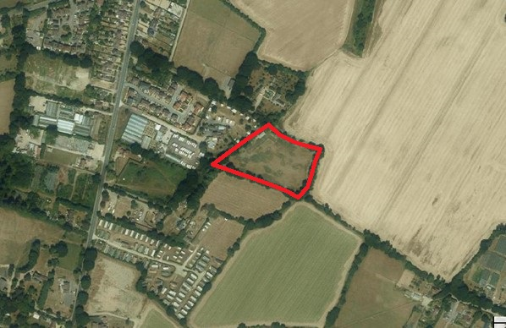
Site description
The HELAA describes the site as a parcel of land to the immediate south-east of Birdham village, adjacent to a recently completed residential estate and caravan park. The site is approximately 200m from the settlement boundary and is accessed via Pinks Lane.
In essence the site appears to be a small paddock, with trees around the perimeter of the site, jutting out into a large arable field. The site is accessed via Bell Lane, and the access is lined by mature trees (which are subject to a TPO).
Planning history
Planning permission was previously refused for stables (97/01927/FUL) and granted for a replacement extension to an existing railway carriage and replacement septic tank (retrospective application 13/03100/FUL).
Need level
None, as the site is not currently a gypsy and traveller site.
Commentary in relation to HELAA assessment and call for sites site assessment (CfSSA)
The HELAA consideration of the site is as follows:
“The site is well related to the settlement and facilities and is therefore considered potentially suitable, subject to detailed consideration on matters including access and landscaping.”
Turning to consider the site in relation to the CfSSA criteria, generally the site receives a reasonably good range of scores, though the access is a significant concern.
There are some surface water flooding issues pertaining to the site, but only on the very edge of the site, and hence unlikely to constitute an overriding constraint. There appear to some issues regarding contaminated land, but it is likely these could be overcome as part of any future planning application process, subject to the provision of sufficient information. There also appear to be some ecological constraints, and while these wouldn’t necessary be overriding constraints they could impact upon capacity and would require ecological information and mitigation measures to be addressed as part of any future planning application.
The main concern in relation to the site pertains to the access. While it is positive that there is an existing access, this is narrow and lined with very mature trees with low hanging branches. These trees are subject to TPOs, which accentuates the need to ensure that the access arrangements do not have a detrimental impact on them. There are also drainage ditches running along the edge of the lane, and it’s not obvious how satisfactory passing places could be provided in order to cater for the likely traffic which would be generated by 8 pitches. This is a big concern and it is considered that the site is only suitable for allocation if this issue is satisfactorily addressed via additional information, and that it can be demonstrated that the access arrangements will be both safe, and not have a detrimental impact on the trees or drainage.
Commentary in relation to the Capacity Study (CS)
The CS notes the constraints around the access, in respect of the trees at least, though does not consider that this is an insurmountable obstacle. The CS has established that the 8 pitches promoted can be satisfactorily accommodated on the site, indeed there is theoretically space for more. However, crucially, the 8 pitches promoted allows amble space to protect the existing trees and vegetation on the site perimeter of the site itself, which is an important consideration. On that basis the CS effectively considers that 8 pitches are likely to be the most appropriate yield in terms of the number of pitches.
Commentary in relation to the new Local Plan (LP)
Key issues in this regard are likely to be in relation to landscape impact, development in the countryside and impact upon vegetation. Provided the trees around the edge of the site are retained and satisfactorily protected then there does appear to be a reasonable prospect that the use of the site for pitches could be acceptable in some respects, as that would minimise the landscape impact. It is also pertinent that there is a large caravan park to the south of the site, which is likely to have a more significant impact than the allocation of this site for 8 pitches.
The key issue in relation to the Local Plan probably relates to the access as referred to above, as the Local Plan requires the provision of an access that is safe for all users. This may be possible, but that cannot be guaranteed (at least in terms of being achievable in an acceptable manner), as the existing access is very narrow and an allocation for 8 pitches would potentially significantly increase the use of the existing access and involve some fairly large vehicles using the lane. Consequently, it is considered that it needs to be demonstrated that this requirement can be met before the site is allocated. Not only would the access need to be safe, but in making it safe it would need to be demonstrated that this would not have a detrimental impact on the trees lining the lane.
Extensive clearance of vegetation would be problematic from an ecological perspective and in terms of being able to achieve the necessary level of biodiversity net gain. However, it appears that the pitches can be provided within the site itself without necessarily having a detrimental impact on biodiversity, subject to suitable mitigation measures being put in place. However, the impact on the trees lining the lane is less clear cut as has been referred to above.
The new pitches on the site would need to comply with the new site design policy in relation to gypsy and traveller pitches.
Commentary in relation to Planning Policy for Traveller Sites (PPTS)
There is no specific need associated with the site, so the contribution towards meeting needs is a general one as opposed to being specific to this site. Nevertheless, the contribution of 8 pitches would certainly be a very meaningful contribution towards meeting the level of need identified.
PPTS seeks to restrict development in open countryside, and ensure that there is no domination of the settled community in terms of scale. In terms of the open countryside aspect of this requirement, while the site is outside of the main built-up area of the village, it is not particularly rural and hence the semi-rural nature of the site doesn’t appear likely to be an overriding constraint. However, there is still the question as to whether the number of pitches proposed would dominate the settled community. The site is on the edge of a small residential area, which is an off-shoot from the main village. However, it would be set back from the main residential area and 8 pitches would not be significant in scale relative to the number of houses in the vicinity.
The site also appears likely to help promote good integration with the settled community, as it is close to existing residential properties, but is not of a scale or proximity which could create a conflict between the two communities.
Conclusion
In many respects this is considered to be a good site for traveller pitches, as the site is in a reasonably sustainable location, is relatively well related to the settled community, and the mature vegetation around the perimeter will help minimise the landscape impacts. The provision of 8 pitches would also make a meaningful contribution towards meeting the council’s needs.
However, the access is a significant concern. While the CS considers that this is not necessarily an insurmountable problem, ultimately the access is very narrow, lined by mature trees and drainage ditches, and working on the assumption that passing places are needed there is no guarantee that those could be provided in an acceptable manner. Therefore, on balance it is considered that the site promoter should demonstrate that the access would be likely to be acceptable in highways terms, without having a detrimental impact on the trees, before the site can be safely allocated.

- Five Paddocks Farm/Mans Rest
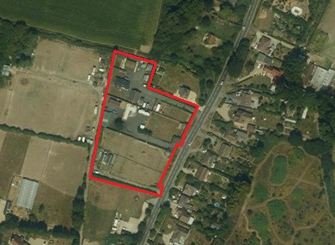
Site description
The site comprises a group of existing travelling showpeople plots adjacent to Bracklesham Lane just to the north of East Wittering. The existing plots are on the western side of the site, with the eastern side fairly open, though behind call evergreen hedging. There are 3 existing site accesses. In terms of surrounding land uses, there are residential properties lining the road on the eastern side of the site, and a house immediately to the north. To the south are a small cluster of gypsy and traveller pitches and the land to the west appears to be paddocks. Compared with the aerial photo above, additional development appears to have taken place at the southern end of the site.
Planning history
Within the general site area there is currently consent for 5 travelling showpersons plots (14/03861/FUL, 15/03539/FUL, 16/02434/FUL, 19/01582/FUL and 20/02299/FUL), with a pending application for an additional mobile home on the Mans Rest plot (22/02136/FUL).
Need Level
The GTAA identifies a need for 2 plots stemming from the site, one immediately and 1 in the next 5 years.
Commentary in relation to Call for Sites Site Assessment (CfSSA)
The CfSSA only identifies one significant concern in relation to the site, which is flood risk, and clearly this is a particularly significant issue given the vulnerability of caravans/mobile homes in this regard. The current flood risk only covers a small part of the site on the northern edge. However, future flood risk in relation to climate change is much more extensive, covering half of the site. In addition, this raises question marks regarding the safety of access and egress.
Commentary in relation to capacity
This site has not been assessed as part of the capacity study pertaining to gypsy and traveller sites, as travelling showpeople sites have different spatial requirements. Officers have researched the size of travelling showpeople plots, which has established that owing to the need for storage space, the typical size is approximately 1,500 sqm, while the GTAA suggests a figure of 2,000 sqm. However, it is clear from this site that some of the plots are considerably smaller than that, though some are more comparable with the average size of plot (this is set out in Appendix 3A). This is not altogether surprising as the research carried out by the council does show that in some instances while the overall yard can be quite large, there can be significantly smaller plots within that.
Overall, the capacity of the wider site for additional plots is very unclear. The site is promoted for 6 additional plots, though that is considered to be very unlikely to be acceptable, owing to the limited amount of space available.
There is a reasonable prospect that the vacant land in relation to application 19/01582/FUL could be suitable for an additional plot, as it is almost exactly the same size as the site area already permitted and would presumably be able to utilise the same access.
The plot to the north has a reasonable amount of vacant space, which is of a similar size as the consented plot referred to above. However, that seems to be potentially impacted to a greater extent by a future flood risk zone, which makes it more difficult to allocate.
Indeed, the site generally is subject to future flood risk owing to significant parts of the site, and the access and egress, being within or affected by the future flood risk zones. However, it is presumed that if additional plots are granted on a temporary or personal basis, which would ensure that occupation ceases prior to the future flood risk taking effect, then this would address the concerns regarding allocation and would mean there is no need for a sequential or exception test, though these would be required if a permanent permission were to be sought.
Commentary in relation to the new Local Plan
An important issue is clearly flood risk, and this has already been covered to a certain extent above. In addition, the site is potentially at risk of groundwater flooding, like most sites in the southern plan area. Nevertheless it is considered that this sites still warrants consideration as in relation to the exception test criteria, this site is highly likely to be the most sustainable option for meeting the need identified, as the site itself is in a relatively sustainable location, close to East Wittering/Bracklesham, right next to a bus stop, and the site allows for the need to be met on the site on which it is being generated. In addition, much of the area which appears to be available for intensification appears to be outside of the climate change flood risk area, though access and egress would appear to be affected as has been referred to above. Ultimately, the flood risk will need to be addressed as part of any future planning application, probably via a specific flood risk assessment. In addition, with respect to the groundwater risk, this is generally not a difficult flood risk to mitigate, and the main risk is typically associated with basements, which clearly won’t be the case with a traveller site, indeed, the caravans will be stationed above ground level.
Another important consideration will be landscape impact/development in the countryside. However, as this is an established travelling showpeople site with extensive, mature, dense vegetation along the frontage then there seems to be a reasonable prospect that the proposal would not be unacceptable in this regard. The policy requirements in relation to the environmental designations would incur certain requirements to be fulfilled in relation to those policies, but that can be addressed via any future application.
Commentary in relation to Planning Policy for Traveller Sites (PPTS)
There is some need associated with the site, which is short-term need, and hence meeting that need would help achieve compliance with the PPTS requirements in this regard, which is particularly pertinent given the lack of alternative options for travelling showpeople accommodation.
PPTS seeks to restrict development in open countryside, and ensure that there is no domination of the settled community in terms of scale. In terms of the open countryside aspect of this requirement, while the site is outside of the main built-up area of the village, it is not particularly rural and hence the semi-rural nature of the site doesn’t appear likely to be an overriding constraint. However, there is still the question as to whether the number of plots proposed would dominate the settled community. The site is part of a small residential area, which is a small area of ribbon development to the north of the main settlement, though with a large tourist caravan park to the south. The site is also part of a slightly larger cluster of traveller accommodation, as there are 3 fairly small gypsy and traveller sites to the south. On balance it is considered that the limited intensification of the existing site within its current confines would be unlikely to lead to the domination of the settled community. However, the expansion of the site would be much more concerning.
Paragraph 13 (g) of the PPTS sets out a clear objective not to locate gypsy and traveller sites in areas at high risk of flooding, given the particular vulnerability of caravans. This issue has already been covered above.
Conclusion
This is a very difficult site to assess, and the decisions regarding the suitability and capacity of the site are finely balanced. On the one hand the site does not appear to afford the space to accommodate additional plots of a size which would accord with the higher expectations in terms of the required site area, which is considered to be 1500-2000 sqm. Moreover, there clearly doesn’t seem to be space to provide the 6 plots being promoted. There are also concerns regarding flood risk in relation to this site, particularly future flood risk.
Conversely, there is a need for 2 plots in relation to the site, and no alternative sites appear to be available. In addition, it is clear that some of the plots on the site are already smaller than the average size referred to above, and it is not uncommon for the plots areas within a yard to vary somewhat in terms of size. Consequently, there does appear to be space to provide for 2 plots of a similar size to those already consented in this location. Therefore, on balance, given that there is an identified need, and a lack of alternatives, it does appear most appropriate to allocate the site for 2 additional plots (not including the site currently subject to a planning application - 22/02136/FUL).
The is also concern regarding future flood risk with respect to this site as part of it falls within a future flood risk zone, and the access and egress to the site would also be effected by future flood risk. Consequently, it is considered that it would not be appropriate for a permanent permission(s), given the highly vulnerable nature of caravans, and hence future consents would be most appropriately limited to temporary or personal permissions.

Appendix 3A – site area analysis in relation to Five Paddocks Farm and Mans Rest

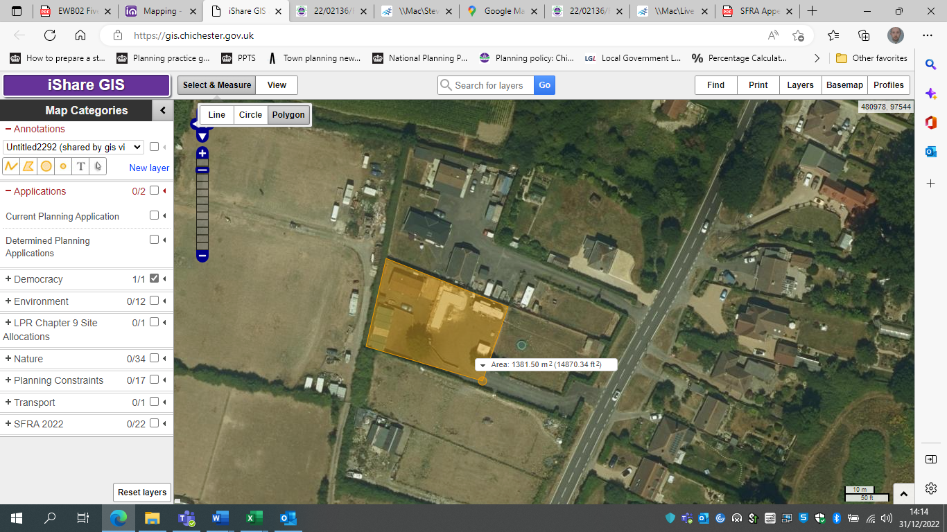
Existing site within the Five Paddocks Farm/Mans Rest area, encompassing potentially two plots. The vacant area immediately to the east next to the road is considered to have sufficient space to accommodate an additional plot as set out below.

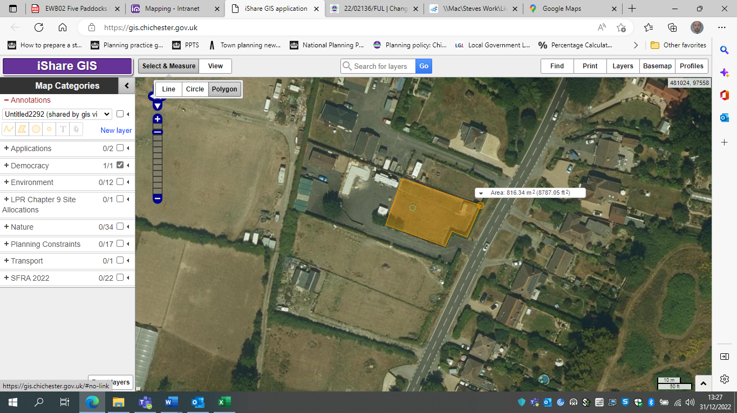
This map shows a vacant area within the Five Paddocks Farm and Mans Rest site which is broadly comparable with the site area of other plots within the site. This forms part of the area identified within Appendix I within the Submission Local Plan where an additional plot could be located.

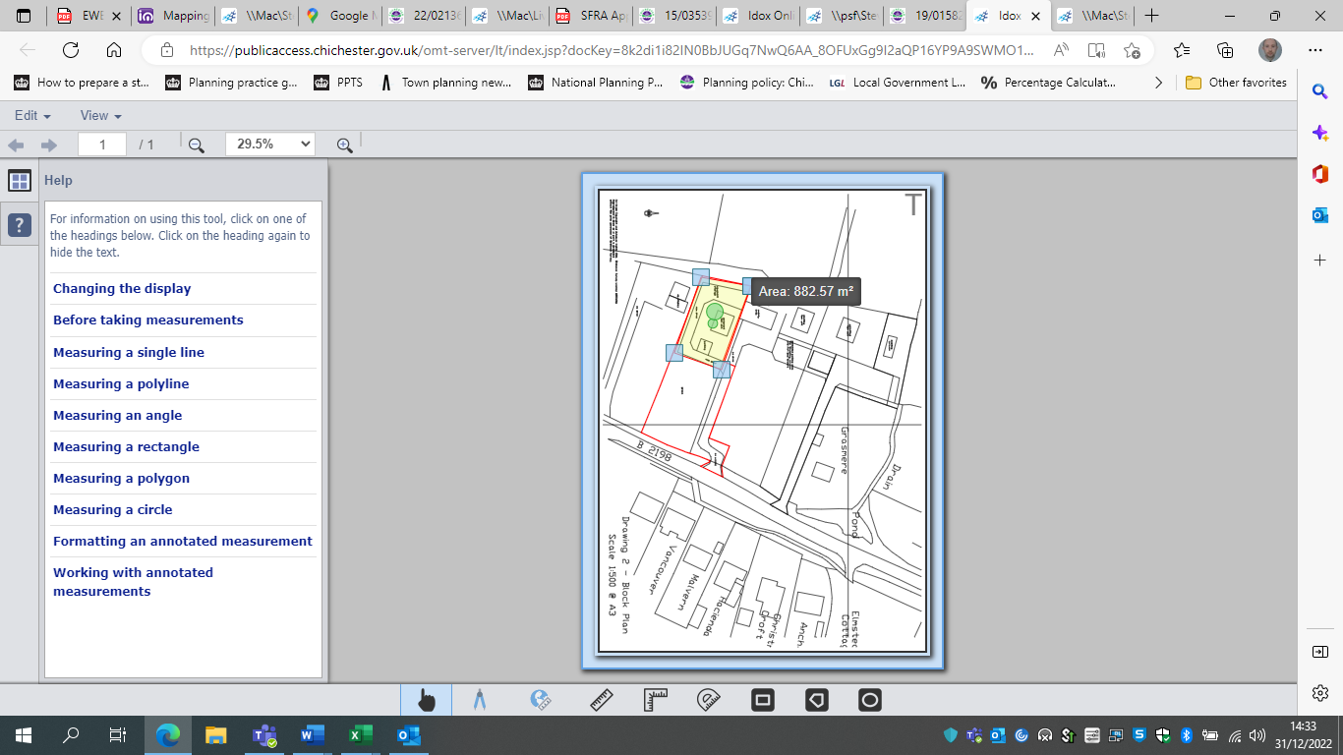
This map shows the site area consented at Five Paddock Barn - 19/01582/FUL, as can be seen in the image below, there is a similar size area immediately to the east, which indicates that there is space for another plot within the wider site area.

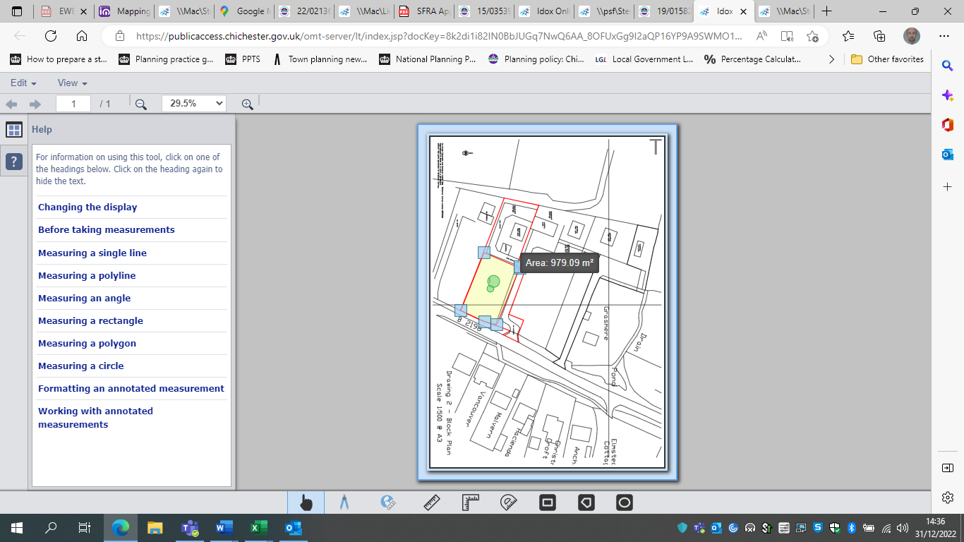
As per the description above, this is a vacant area within the Five Paddocks Farm site where an additional plot could be located, and is identified as such within Appendix I of the Submission Local Plan.

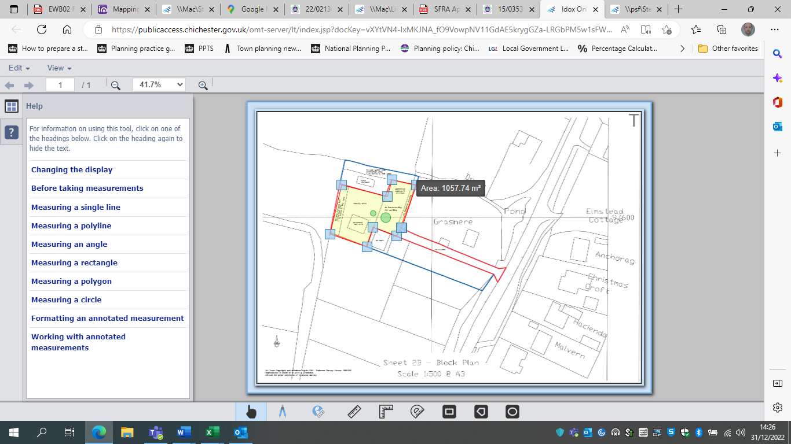
This map shows the site area consented by application 15/03539/FUL – Paddock Barn. It provides an idea of typical plot sizes within the wider site area.
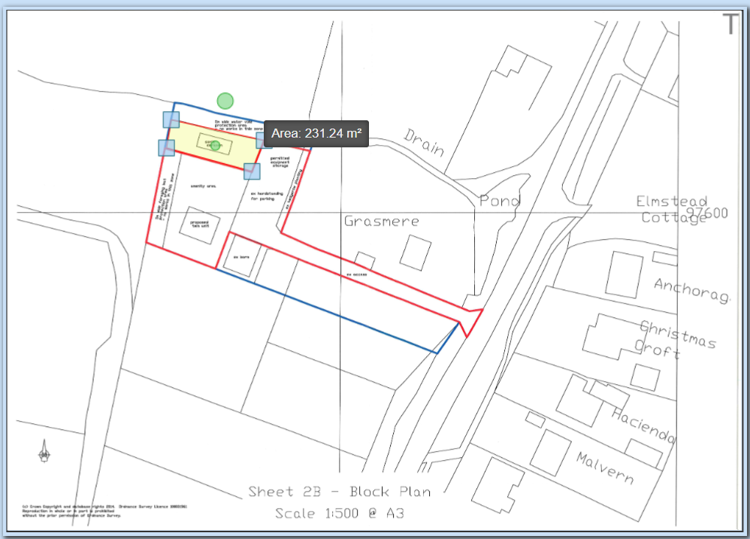
This map shows the remaining site area for the Paddock Barn site and illustrates the manner in which travelling showpeople sites can often encompass plots of a range of size – this plots much smaller than others within the wider site area.

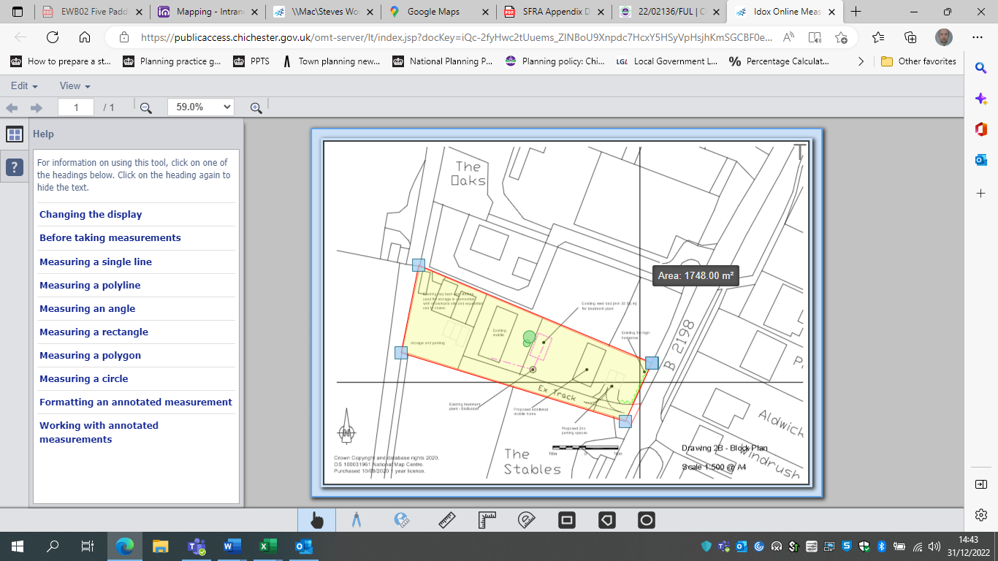
This map shows a recent permission at Mans Rest for the inclusion of a second plot, located adjacent to the B2198 - 22/02136/FUL. This is considered to illustrate how the two sites to the north have similar potential.

Appendix 4 – RAG Assessment of ‘call for sites’ submissions

Site reference | Site name | Proposed no. of pitches for G&T | Proposed no. of plots for TS | When could gypsy and/or traveller development be delivered at this site? | Flood Risk | Contaminated land | Incompatible surrounding land uses | Protected historical land use and character – on site | Protected historical land uses and character – surrounding sites | Habitat Designations | Biodiversity and Protected Species | Site access | Relationship to existing settlements/ residential properties | Topography | Infrastructure and utilities | Accessibility
BI01 | Plot B, Land rear of Premier Business Park | 1 | 0 | Immediately and up to 2023 | The site is located entirely in Flood Zone 1. Climate change flood zones now close to the rear of the site, but does not impact upon it. Present day surface water flood risk next to the site but doesn't seem to impact upon this specific site. No future surface water risk. | The site has no known contaminated land  Site not included in CDC Brownfield Land Register (BLR) and no BLR land near by | To the south of the site lies a business park, the site is immediately surrounded by other G&T pitches and further out, fields. The nearest (non-G&T) residential dwelling appears to be approx. 100m away. | Lies within Chichester Harbour AONB  NOT in a National Park | Lies within Chichester Harbour AONB  NOT adjacent to a National Park | The site does not lie within or adjacent to any designated habitat site (But see SSSI IRZ details below):  Site falls within SSSI Impact Risk Zone (OBJECTID 66176) but falls below thresholds for requirement to consult Natural Eng ("Large non residential developments outside existing settlements/urban areas where net additional gross internal floorspace is > 1,000m² or footprint exceeds 0.2ha")  Access rd lies within SSSI IRZ (OBJECTID 56187) and site itself is directly adjacent to this IRZ. Site meets the criteria for this IRZ -for rural residential development, "Any residential developments outside of existing settlements/urban areas with a total net gain in residential units" | The site does not lie within or adjacent to a Local Wildlife Site (nearest one is 325m N) | There is safe and suitable vehicular access already in place. | Approx. 300m from a settlement boundary (Birdham).  Tree row and field provide privacy for residents. The site is on a site already in G&T use. | Site appears to be gently sloping (on a slight incline). No issues identified at access | Site is adjacent to an existing residential (G&T) use, as well as commercial uses immediately to the south  Site does not fall under current sewerage coverage (lies approx. 200m from existing sewerage coverage)  (Proximity to other utilities unknown) | Safe walking access already in place to and from the site.  The following amenities/ facilities are within 1.2km via existing access routes (i.e. 15 min walk):  - Nearest bus stop - Sidlesham Lane (58m)  - Birdham Post Office (1170m)  - Nisa (1180m)  - St James' Church (846m)
BI02 | Plot C, Land rear of Premier Business Park | 1 |  | Immediately and up to 2023 | The site is located entirely in Flood Zone 1, but appears to be a risk of surface water flooding (present day). | The site has no known contaminated land  Site is not included in CDC brownfield land register and no BLR land near by | To the south of the site lies a business park, the site is immediately surrounded by other G&T pitches and further out, fields. The nearest (non-G&T) residential dwelling appears to be approx. 100m away. | Lies within Chichester Harbour AONB  NOT in a National Park | Lies within Chichester Harbour AONB  NOT adjacent to a National Park | The site does not lie within or adjacent to any designated habitat site (But see SSSI IRZ details below):  SSSI Impact Risk Zones  Most of site and its access road fall within SSSI Impact Risk Zone (OBJECTID 66176) but do not meet any of the critera for consulting Natural Eng. However, the following notes in the IRZ are relevant to the site:  (a) "For new residential development in this area financial contributions are required to mitigate increased recreational disturbance on coastal SPAs and Ramsar Sites. Check with Local Planning Authority."  (b) "SOLENT NUTRIENT IMPACT AREA. For new development with overnight accommodation Reg 63 of the Conservation of Habitats and Species Regulations 2017 must be applied. LPA to refer to Natural England’s Solent Nutrient Neutrality Advice Note June 2019."  Access rd and tiny portion of actual site lie within SSSI IRZ (OBJECTID 56187), Site meets two criteria for this IRZ - (i) for rural residential development, "Any residential developments outside of existing settlements/urban areas with a total net gain in residential units" and (ii) "  The following notes from IRZ 56187 are applicable to the site:  (i) "For new residential development in this area financial contributions are required to mitigate increased recreational disturbance on coastal SPAs and Ramsar Sites. Check with Local Planning Authority."  (ii) "SOLENT NUTRIENT IMPACT AREA. For new development with overnight accommodation Reg 63 of the Conservation of Habitats and Species Regulations 2017 must be applied. LPA to refer to Natural England’s Solent Nutrient Neutrality Advice Note June 2019." | The site does not lie within or adjacent to a Local Wildlife Site (nearest one is approx. 325m N) | There is safe and suitable vehicular access already in place. | Approx. 300m from a settlement boundary (Birdham).  Tree row and field provide privacy for residents. The site is on a site already in G&T use. | Site appears to be gently sloping (on a slight incline). No issues identified at access | Site is adjacent to an existing residential (G&T) use, as well as commercial uses immediately to the south  Site does not fall under current sewerage coverage (lies approx. 200m from existing sewerage coverage)  (Proximity to other utilities unknown) | Safe walking access already in place to and from the site.  The following amenities/ facilities are within 1.2km via existing access routes (i.e. 15 min walk):  - Nearest bus stop - Sidlesham Lane (58m)  - Birdham Post Office (1170m)  - Nisa (1180m)  - St James' Church (846m)
BI03 | Plot A, Land rear of Premier Business Park | 1 |  | Immediately and up to 2023 | The site is located entirely in Flood Zone 1 and has a very low risk of surface water flooding. | The site has no known contaminated land  Site is not included in CDC brownfield land register and no BLR land near by | To the south of the site lies a business park, the site is immediately surrounded by other G&T pitches and further out, fields. The nearest (non-G&T) residential dwelling appears to be approx. 100m away. | Lies within Chichester Harbour AONB  NOT in a National Park | Lies within Chichester Harbour AONB  NOT adjacent to a National Park | The site does not lie within or adjacent to any designated habitat site (But see SSSI IRZ details below):  Site falls within SSSI Impact Risk Zone (OBJECTID 66176) but falls below thresholds for requirement to consult Natural Eng  The following notes from SSSI 66176 are applicable to the site:  (i) "For new residential development in this area financial contributions are required to mitigate increased recreational disturbance on coastal SPAs and Ramsar Sites. Check with Local Planning Authority."  (ii) "SOLENT NUTRIENT IMPACT AREA. For new development with overnight accommodation Reg 63 of the Conservation of Habitats and Species Regulations 2017 must be applied. LPA to refer to Natural England’s Solent Nutrient Neutrality Advice Note June 2019."  Access rd lies within SSSI IRZ (OBJECTID 56187), for which states that for rural residential development, "Any residential developments outside of existing settlements/urban areas with a total net gain in residential units"  The following notes from SSSI 56187 are applicable to the site:  (i) "For new residential development in this area financial contributions are required to mitigate increased recreational disturbance on coastal SPAs and Ramsar Sites. Check with Local Planning Authority."  (ii) "SOLENT NUTRIENT IMPACT AREA. For new development with overnight accommodation Reg 63 of the Conservation of Habitats and Species Regulations 2017 must be applied. LPA to refer to Natural England’s Solent Nutrient Neutrality Advice Note June 2019." | The site does not lie within or adjacent to a Local Wildlife Site (nearest one is approx. 325m N) | There is safe and suitable vehicular access already in place. | Approx. 300m from a settlement boundary (Birdham).  Tree row and field provide privacy for residents. The site is on a site already in G&T use. | Site appears to be gently sloping (on a slight incline). No issues apparent at the access | Site is adjacent to an existing residential (G&T) use, as well as commercial uses immediately to the south  Site does not have sewerage coverage, but lies less than 200m from coverage  (Proximity to other utilities unknown) | Safe walking access already in place to and from the site.  The following amenities/ facilities are within 1.2km via existing access routes (i.e. 15 min walk):  - Nearest bus stop - Sidlesham Lane (58m)  - Birdham Post Office (1170m)  - Nisa (1180m)  - St James' Church (846m)
BI04 | Cowdry Nursery/Cherry West Meadow | 12 |  | Immediately and up to 2023 | The site is in flood zone 1. The site is also not at risk of future flood risk in relation to fluvial or tidal flooding, or current of future surface water flooding. | There could be some potential contamination of the land owing to it's previous use as a commercial nursery. The Environmental Health Officer set out various concerns in relation to the previous planning application on the site, though clearly they were overcome. | The surrounding uses are residential and agricultural, and there is no reason in principle why gypsy and traveller pitches are incompatible with those uses. | The site is located outside of the AONB. | The site was apparently previously used for horticulture, though that use has clearly ceased and hence is no longer protected. | The site does not lie within or adjacent to any designated habitat site (But see SSSI IRZ details below):  SSSI Impact Risk Zones  Most of site and its access road fall within SSSI Impact Risk Zone (OBJECTID 66176) but do not meet any of the critera for consulting Natural Eng. However, the following notes in the IRZ are relevant to the site:  (a) "For new residential development in this area financial contributions are required to mitigate increased recreational disturbance on coastal SPAs and Ramsar Sites. Check with Local Planning Authority."  (b) "SOLENT NUTRIENT IMPACT AREA. For new development with overnight accommodation Reg 63 of the Conservation of Habitats and Species Regulations 2017 must be applied. LPA to refer to Natural England’s Solent Nutrient Neutrality Advice Note June 2019."  Access rd and tiny portion of actual site lie within SSSI IRZ (OBJECTID 56187), Site meets two criteria for this IRZ - (i) for rural residential development, "Any residential developments outside of existing settlements/urban areas with a total net gain in residential units" and (ii) "  The following notes from IRZ 56187 are applicable to the site:  (i) "For new residential development in this area financial contributions are required to mitigate increased recreational disturbance on coastal SPAs and Ramsar Sites. Check with Local Planning Authority."  (ii) "SOLENT NUTRIENT IMPACT AREA. For new development with overnight accommodation Reg 63 of the Conservation of Habitats and Species Regulations 2017 must be applied. LPA to refer to Natural England’s Solent Nutrient Neutrality Advice Note June 2019." | There is an identified watervole habitat on the western edge of the site. | There was no objection to the access arrangements in respect of the consented pitch, and hence presumably that access could be utilised for additional pitches. | There is considerable screening in the form of mature vegetation in relation to the nearest property to the west. The properties to the south back onto the site, with relatively long rear gardens. There is a property on Siddlesham Lane which is fairly close to the site, though there is some seperation and main garden area is to the south and hence away from the site. | The site and surrounding area is flat, forming as it does part of a coastal plain. | Unknown, though the consented pitch appears to have used a septic tank, which was a concern in relation to that application and implies that mains drainage may not be available. | The facilities and services within Birdham are approximately 1.25km away, and do appear to be accessible by foot and there is access to public transport – there is a public footpath running just to the south of the site linking it to the main part of the settlement. Though this footpath link and the walk to the main cluster of facilities and services may not be an easy journey, especially at night. Ultimately, there are a reasonable range of facilities in fairly close proximity to the site and clearly the sustainability of the location did not prevent the granting of consent of the existing pitch.
HBI0028 | Pinks Four | 8 |  |  | 7% of the site is at risk of surface water flooding. This is mainly on the edge of the site and hence is unlikely to impact upon capacity. | The parish council comments in relation to the 2013 application make reference to concerns regarding untreated waste in relation to the site, so there is a risk of some potential contamination. | The surrounding uses are primarily residential, agricultural, horticulture and caravan storage, and there is no reason in principle why gypsy and traveller pitches are incompatible with those uses. | The site is located outside of the AONB. The trees running along the site access linking the site with Bell Lane are subject to TPOs. | The site is currently in equestrian use, which is not a protected land-use. | The site does not lie within or adjacent to any designated habitat site (But see SSSI IRZ details below):  SSSI Impact Risk Zones  Most of site and its access road fall within SSSI Impact Risk Zone (OBJECTID 66176) but do not meet any of the critera for consulting Natural Eng. However, the following notes in the IRZ are relevant to the site:  (a) "For new residential development in this area financial contributions are required to mitigate increased recreational disturbance on coastal SPAs and Ramsar Sites. Check with Local Planning Authority."  (b) "SOLENT NUTRIENT IMPACT AREA. For new development with overnight accommodation Reg 63 of the Conservation of Habitats and Species Regulations 2017 must be applied. LPA to refer to Natural England’s Solent Nutrient Neutrality Advice Note June 2019."  Access rd and tiny portion of actual site lie within SSSI IRZ (OBJECTID 56187), Site meets two criteria for this IRZ - (i) for rural residential development, "Any residential developments outside of existing settlements/urban areas with a total net gain in residential units" and (ii) "  The following notes from IRZ 56187 are applicable to the site:  (i) "For new residential development in this area financial contributions are required to mitigate increased recreational disturbance on coastal SPAs and Ramsar Sites. Check with Local Planning Authority."  (ii) "SOLENT NUTRIENT IMPACT AREA. For new development with overnight accommodation Reg 63 of the Conservation of Habitats and Species Regulations 2017 must be applied. LPA to refer to Natural England’s Solent Nutrient Neutrality Advice Note June 2019." | There is an identified watervole habitat on the western edge of the site. | There is an existing access. The main concern with this is that it is lined with mature trees (which are subject to a TPO), and these have low branches which overhang the single track lane leading up to the site. There are also drainage ditches running along the side. However, presumably equestrian related vehicles are currently using the site and hence it is not necessarily an overriding constraint. Nevertheless, 8 pitches would require a significant intensification of the site the use of this narrow lane, and there is no guarantee that suitable passing places can be provided. | There are only 2 residential properties in close proximity to the site and the existing trees along the boundary along with the properties large gardens suggest that there is unlikely to be conflict. The site itself is set a long way back from the road and hence is unlikely to have a significant impact upon the character of the area. | Unknown in relation to the site itself, but generally this area is very flat. | Unknown, though the consented development in relation to the site appears to have used a septic tank, which was a concern in relation to that application and implies that mains drainage may not be available. | There are a reasonable range of facilities and services to the north of the site, which are fairly easily accessible, including on foot.
C01 | Land north west of Newbridge Farm | 4 |  | Immediately and up to 2023 | The site is located entirely in Flood Zone 1. There is a very small amount of surface water flood risk at the southern edge of the site. | The site has no known contaminated land  Site is not included in CDC brownfield land register (nearest site 800m away) | The site is situated just north of the A27 road. It is separated from the village/small town of Fishbourne by the A27. In terms of immediate surroundings, to the east and north of the site lies agricultural land, woodland to the north west and partially developed open land to the west. | Not within a National Park or AONB | NOT adjacent to a National Park or an AONB | The site does not lie within or immediately adjacent to any designated habitat site (But see SSSI IRZ details below):  The site lies partially within SSSI IRZ OBJECTID 36023, but does not meet the criteria for consulting NE. The following notes from the IRZ are applicable to the site:  (i) "For new residential development in this area financial contributions are required to mitigate increased recreational disturbance on coastal SPAs and Ramsar Sites. Check with Local Planning Authority."  (ii) "SOLENT NUTRIENT IMPACT AREA. For new development with overnight accommodation Reg 63 of the Conservation of Habitats and Species Regulations 2017 must be applied. LPA to refer to Natural England’s Solent Nutrient Neutrality Advice Note June 2019."  The site lies partially within SSSI IRZ OBJECT ID 63007, but does not meeting the criteria for consulting NE. The following notes from the IRZ are applicable to the site:  (i) "For new residential development in this area financial contributions are required to mitigate increased recreational disturbance on coastal SPAs and Ramsar Sites. Check with Local Planning Authority."  (ii) "SOLENT NUTRIENT IMPACT AREA. For new development with overnight accommodation Reg 63 of the Conservation of Habitats and Species Regulations 2017 must be applied. LPA to refer to Natural England’s Solent Nutrient Neutrality Advice Note June 2019.' | The site does not lie within or adjacent to a Local Wildlife Site | There is a road running directly to the field (but no e.g. gate in place for access). Safe and suitable vehicular access could be provided without significant highways safety or traffic flow impacts. | Separated from a settlement boundary (Fishbourne) by A27 road (dual-carriageway). Southern boundary of site screened by mature trees. | Site appears to be relatively flat based on OS and satellite mapping. Land appears uneven at the access. | Apuldram Wastewater Treatment Catchment passes through the site (There is a policy in the adopted local plan which places stipulations on development within the catchment area - Policy 12 - https://www.chichester.gov.uk/CHttpHandler.ashx?id=24759&p=0#page=83  Site not immediately adjacent to existing residential uses (but there are some approx. 80m from the site).  (Proximity to other utilities unknown) | The following amenities/ facilities are within 1.2km via existing access routes (i.e. 15 min walk):  - Nearest bus stop - Clay Lane (521m)  - Fishbourne Train Station (1070m)
CH01 | Land adjacent Plot A, Pond Farm | 2 | 0 | Immediately and up to 2023 | The site is located entirely in Flood Zone 1 and has a very low risk of surface water flooding. | The site has no known contaminated land  Site is not included in CDC brownfield land register (or near to any such land) | The site is surrounded by open land to the west, existing gypsy and traveller pitches to the east, and the A27 dual carriageway to the north. | Not within a National Park or AONB | NOT adjacent to a National Park or an AONB | The site lies wholly within a Local Wildlife Site (Newells Lane Pond & Meadows)  The site lies wholly within SSSI IRZ OBJECTID 63007, but does not meet any of the criteria for consulting Natural Eng. However, the following notes from the IRZ entry are relevant:  (i) "For new residential development in this area financial contributions are required to mitigate increased recreational disturbance on coastal SPAs and Ramsar Sites. Check with Local Planning Authority."  (ii) SOLENT NUTRIENT IMPACT AREA. For new development with overnight accommodation Reg 63 of the Conservation of Habitats and Species Regulations 2017 must be applied. LPA to refer to Natural England’s Solent Nutrient Neutrality Advice Note June 2019." | The site lies wholly within a Local Wildlife Site (Newells Lane Pond & Meadows) | There is safe and suitable vehicular access already in place. | Not immediately adjacent to a settlement boundary. Close to the Hambrook settlement boundary (c. 375m) and there is a relatively direct pedestrian route to the settlement.  Site lies within 'Pond Farm' where there are a handful of existing residential properties in the area and the vicinity. | Site appears to be relatively flat however surrounding land gently sloping upwards. | Site is adjacent to an existing residential (G&T) use  Site does not currently have sewerage coverage (approx. 330m from edge of coverage)  (Proximity to other utilities unknown) | The following amenities/ facilities are within 1.2km via existing access routes (i.e. 15 min walk):  - Hambrook Post Office and Stores (1050m)
CH02 | Land at Plot A, Pond Farm | 1 | / | Immediately and up to 2023 | The site is located entirely in Flood Zone 1 and has a very low risk of surface water flooding. | The site has no known contaminated land  Site is not included in CDC brownfield land register (or near to any such land) | The site is surrounded by open land to the west and north, existing gypsy and traveller pitches to the east. Further to the north lies the A27 dual carriageway. | Not within a National Park or AONB | NOT adjacent to a National Park or an AONB | The site lies wholly within a Local Wildlife Site (Newells Lane Pond & Meadows)  The site lies wholly within SSSI IRZ OBJECTID 63007, but does not meet any of the criteria for consulting Natural Eng. However, the following notes from the IRZ entry are relevant:  (i) "For new residential development in this area financial contributions are required to mitigate increased recreational disturbance on coastal SPAs and Ramsar Sites. Check with Local Planning Authority."  (ii) SOLENT NUTRIENT IMPACT AREA. For new development with overnight accommodation Reg 63 of the Conservation of Habitats and Species Regulations 2017 must be applied. LPA to refer to Natural England’s Solent Nutrient Neutrality Advice Note June 2019." | The site lies wholly within a Local Wildlife Site (Newells Lane Pond & Meadows) | There is safe and suitable vehicular access already in place. | Not immediately adjacent to a settlement boundary. Close to the Hambrook settlement boundary (c. 375m) and there is a relatively direct pedestrian route to the settlement.  Site lies within 'Pond Farm' where there are a handful of existing residential properties in the area and the vicinity. | Site appears to be relatively flat however surrounding land gently sloping upwards. | Site is adjacent to an existing residential (G&T) use  Site does not currently have sewerage coverage (approx. 330m from edge of coverage)  (Proximity to other utilities unknown) | The following amenities/ facilities are within 1.2km via existing access routes (i.e. 15 min walk):  - Hambrook Post Office and Stores (1050m)
CH03 | Land adjacent to Paddock View, Drift Lane | 4 |  | Immediately and up to 2023 | The site is located entirely in Flood Zone 1 and has a very low risk of surface water flooding (though there is some present day risk to the rear, but doesn't affect this specific site). | The site has no known contaminated land  Site is not included in CDC brownfield land register (or near to any such land) | The site is bounded by existing G&T sites to the east, west and north. To the south lies agricultural fields. Nearest non-G&T residential properties are approx. 70m to the east. | Not within a National Park or AONB | NOT adjacent to a National Park or an AONB | The site lies wholly within a Local Wildlife Site (Newells Lane Pond & Meadows) (access is adjacent to the LWS)  The site lies wholly within SSSI IRZ OBJECTID 63007, but does not meet any of the criteria for consulting Natural Eng. However, the following notes from the IRZ entry are relevant:  (i) "For new residential development in this area financial contributions are required to mitigate increased recreational disturbance on coastal SPAs and Ramsar Sites. Check with Local Planning Authority."  (ii) SOLENT NUTRIENT IMPACT AREA. For new development with overnight accommodation Reg 63 of the Conservation of Habitats and Species Regulations 2017 must be applied. LPA to refer to Natural England’s Solent Nutrient Neutrality Advice Note June 2019." | The site lies wholly within a Local Wildlife Site (Newells Lane Pond & Meadows) (access is adjacent to the LWS) | There is a road running directly to the field (but deeper analysis needed to confirm suitability of road for G&T use). | Not immediately adjacent to a settlement boundary. Approx. 550m from the Hambrook settlement boundary.  Very close to a handful of existing residential properties. Not far from the village of Hambrook.  Trees on various boundaries providing screening (but further mitigation may be needed) | Site appears to be sloping | Site is adjacent to an existing residential (G&T) use  No existing sewerage coverage but within 500m of coverage.  (Proximity to other utilities unknown) | The following amenities/ facilities are within 1.2km via existing access routes (i.e. 15 min walk):  - Chidham and Hambrook Village Hall (1080m)  - Nearest Bus stop - Drift Lane (1042m)
CH04 | Land east of Paddock View, Drift Lane | 2 | 0 | Immediately and up to 2023 | The site is located entirely in Flood Zone 1 and has a very low risk of surface water flooding. | The site has no known contaminated land  Site is not included in CDC brownfield land register (or near to any such land) | The site is partially within the boundaries of an existing G&T site. Non-G&T residential properties lies directly to the south. The site lies in a rural setting. Further north of the site lies the A27 dual-carriageway (approx. 140m north). | Not within a National Park or AONB | NOT adjacent to a National Park or an AONB | The site lies wholly within a Local Wildlife Site (Newells Lane Pond & Meadows) (access is adjacent to the LWS)  The site lies wholly within SSSI IRZ OBJECTID 63007, but does not meet any of the criteria for consulting Natural Eng. However, the following notes from the IRZ entry are relevant:  (i) "For new residential development in this area financial contributions are required to mitigate increased recreational disturbance on coastal SPAs and Ramsar Sites. Check with Local Planning Authority."  (ii) SOLENT NUTRIENT IMPACT AREA. For new development with overnight accommodation Reg 63 of the Conservation of Habitats and Species Regulations 2017 must be applied. LPA to refer to Natural England’s Solent Nutrient Neutrality Advice Note June 2019." | The site lies wholly within a Local Wildlife Site (Newells Lane Pond & Meadows) (access is adjacent to the LWS) | There is a road running directly to the field (but deeper analysis needed to confirm suitability of road for G&T use). | A small number of existing residential properties in close vicinity to the site, on Newells Lane. The site is well screened from these properties by tall trees and a private access road.  A number of residential properties (possibly in G&T use) exist to the north of the site. | Site appears to be relatively flat. At the access, the land is sloping upwards. | Site is adjacent to existing residential uses.  No existing sewerage coverage but within 500m of coverage.  (Proximity to other utilities unknown) | The following amenities/ facilities are within 1.2km via existing access routes (i.e. 15 min walk):  - Chidham and Hambrook Village Hall (1080m)  - Nearest Bus stop - Drift Lane (1042m)
CH05 | Pond Farm North, Newells Lane | 3 | 0 | Immediately and up to 2023 | The site is located entirely in Flood Zone 1 and has a very low risk of surface water flooding. | The site has no known contaminated land  Site is not included in CDC brownfield land register (or near to any such land) | The site is adjacent to an existing G&T site. To the east of the site lies a pond. Non-G&T residential properties lie to the south. The A27 dual carriageway is directly to the north. | Not within a National Park or AONB | NOT adjacent to a National Park or an AONB | The site lies wholly within a Local Wildlife Site (Newells Lane Pond & Meadows)  The site lies wholly within SSSI IRZ OBJECTID 63007, but does not meet any of the criteria for consulting Natural Eng. However, the following notes from the IRZ entry are relevant:  (i) "For new residential development in this area financial contributions are required to mitigate increased recreational disturbance on coastal SPAs and Ramsar Sites. Check with Local Planning Authority."  (ii) SOLENT NUTRIENT IMPACT AREA. For new development with overnight accommodation Reg 63 of the Conservation of Habitats and Species Regulations 2017 must be applied. LPA to refer to Natural England’s Solent Nutrient Neutrality Advice Note June 2019." | The site lies wholly within a Local Wildlife Site (Newells Lane Pond & Meadows) | There is safe and suitable vehicular access already in place. | Site is adjacent to an existing G&T site. There are also a number of residential (non-G&T) properties to the west of the site, on Newells Lane - the site is screened from these by a lake and a row of tall trees facing Newells Lane.  Approx. 400m from the settlement boundary of Hambrook. Direct pedestrian access to Hambrook from the site. | Site appears to be relatively flat. At the access, the land is sloping upwards. | Site is adjacent to an existing residential (G&T) use  No existing sewerage coverage but within 500m of coverage.  (Proximity to other utilities unknown) | The following amenities/ facilities are within 1.2km via existing access routes (i.e. 15 min walk):  - Hambrook Post Office and Stores (1050m)
CH06 | Newells Lane | 3 | 0 | Immediately and up to 2023 | The site is located entirely in Flood Zone 1 and has a very low risk of surface water flooding. | At the access to the site, the site lies adjacent to a closed landfill which received inert and industrial waste (1975 - 1992) and possible continuing skip business at present ('Contaminated Land for Consultation', KEYVAL ZZZZZYERCE990).  Site is also partially within a ConLand Buffer (KEYVAL JCF6IIERG7000)  Site is fully within a 'Contaminated Land Informative' ( JCF6URERG7000)  A small portion of the site lies within a Historic Landfill Site ('Newells Lane', hld_ref EAHLD20044)  Site is not included in CDC brownfield land register (or near to any such land) | The site is close (but not adjoining) a site housing multiple G&T pitches (to the west). It is surrounded by open land and to the north there are non-G&T residential properties. | Not within a National Park or AONB | 170m S of South Downs NP  Not adjacent to an AONB | The site does not lie within or immediately adjacent to any designated habitat site (but see SSSI IRZ details below)  The site lies within SSSI IRZ OBJECTID 63007 but does not meet any of the criteria for consulting Natural Eng. However, the following notes from the IRZ are relevant:  (i) "For new residential development in this area financial contributions are required to mitigate increased recreational disturbance on coastal SPAs and Ramsar Sites. Check with Local Planning Authority.  (ii) "SOLENT NUTRIENT IMPACT AREA. For new development with overnight accommodation Reg 63 of the Conservation of Habitats and Species Regulations 2017 must be applied. LPA to refer to Natural England’s Solent Nutrient Neutrality Advice Note June 2019." | The site does not lie within or immediately adjacent to a Local Wildlife Site (LWS) | There is safe and suitable vehicular access already in place. | The site is not within or adjacent to a defined settlement boundary (Nearest one is Hambrook, approx. 650m west). There is an established G&T site approx. 100m to the west of the site (but no direct access to this from the site).  There does not appear to be any residential properties adjoining the site boundary. The site is accessed from Newells Lane, there are a handful of residential properties dotted along Newells Lane. | From the south to north of the site the land slopes upwards. Unable to confirm level of the land at the access | Site close, but not immediately adjacent to, existing residential uses  No existing sewerage coverage but within 100m of coverage.  (Proximity to other utilities unknown) | The following amenities/ facilities are within 1.2km via existing access routes (i.e. 15 min walk):  - Funtington Primary School (1120m)
EWB01 | Land south of Tranjoeen | 0 | 4 (with future capacity for extended families) | Immediately and up to 2023 | The eastern side of the site is flanked by a flood zone 2 area, with flood zone 3 slightly further east, with the flood zone 2 area impinging somewhat on that side of the site, but not to a significant extent. | The site has no contaminated land and is not within a ConLand buffer or Conland Informative.  Site not included in CDC Brownfield land register (nearest such land is 900m to the south) | The site is in a rural location, bounded by Bracklesham Ln to the west. Further west are fields. To the south and east are fields. Further east is a camping site (caravans) . Further north is a farm shop and a cluster of residential properties. | Not within a National Park or AONB | NOT adjacent to a National Park or an AONB | The site does not lie within or immediately adjacent to any designated habitat site (but see SSSI IRZ details below)  The site lies within SSSI IRZ 46175 but does not meet any of the criteria for consulting Natural Eng. However, the following notes from the IRZ are relevant:  (i) "For new residential development in this area financial contributions are required to mitigate increased recreational disturbance on coastal SPAs and Ramsar Sites. Check with Local Planning Authority."  (ii) "SOLENT NUTRIENT IMPACT AREA. For new development with overnight accommodation Reg 63 of the Conservation of Habitats and Species Regulations 2017 must be applied. LPA to refer to Natural England’s Solent Nutrient Neutrality Advice Note June 2019." | The site does not lie within or immediately adjacent to a Local Wildlife Site (LWS) | There is an access in place, however it doesn't have any hardstanding so improvements may be needed in order to make it suitable | The site is not within or adjacent to a defined settlement boundary.  The site is adjacent to Bracklesham Lane. There is one residential property' boundary adjoining the site boundary. The site is well screened from this property by trees along the common boundary.  Further north lies a cluster of residential properties and a small amount of commercial activity, including a farm shop.  Existing screening from Bracklesham Lane comprises a relatively thick but short hedgerow. | Site appears to be generally level, including at the access. | Residential property adjacent to the site at the northern boundary.  No existing sewerage coverage but within 500m of coverage.  (Proximity to other utilities unknown) | The following amenities/ facilities are within 1.2km via existing access routes (i.e. 15 min walk):  - Nearest bus stop - Glen Nurseries (179m)  The site does not currently have safe walking access to it but this could be provided
EWB02 | Five Paddocks Farm and Mans Rest | 0 | 6 | Immediately and up to 2023 | Part of one of the accesses to the site lies within Flood Zone 2. A very small part of the site lies within the low and medium surface water flood risk areas. The northern half of the site is at risk of future flood risk. | A small element of the site lies within a Contaminated Land Informative: the buffer of Stubcroft Farm landfill, closed landfill contents unknown, approx. 300m distant (KEY ID JCF6URERG7000).  Site not included in CDC Brownfield land register (nearest such land is 380m to the south) | The site is bounded by an existing G&T site to the south. A row of non-G&T residential properties lie to the east of the site, adjoining Bracklesham Lane.North and west of the site are open fields, some of which appear to be in agricultural use. | Not within a National Park or AONB | NOT adjacent to a National Park or an AONB | The site does not lie within or immediately adjacent to any designated habitat site (but see the SSSI IRZ details below)  A very small portion of the site lies within SSSI IRZ 46175 but does not meet any of the criteria for consulting Natural Eng. However, the following notes from the IRZ are relevant:  (i) "For new residential development in this area financial contributions are required to mitigate increased recreational disturbance on coastal SPAs and Ramsar Sites. Check with Local Planning Authority."  (ii) "SOLENT NUTRIENT IMPACT AREA. For new development with overnight accommodation Reg 63 of the Conservation of Habitats and Species Regulations 2017 must be applied. LPA to refer to Natural England’s Solent Nutrient Neutrality Advice Note June 2019."  The site lies almost wholly within SSSI IRZ OBJECTID 57564 but does not meet any of the criteria for consulting NE. However, the following notes from the IRZ are relevant:  (i) 'For new residential development in this area financial contributions are required to mitigate increased recreational disturbance on coastal SPAs and Ramsar Sites. Check with Local Planning Authority."  (ii) "SOLENT NUTRIENT IMPACT AREA. For new development with overnight accommodation Reg 63 of the Conservation of Habitats and Species Regulations 2017 must be applied. LPA to refer to Natural England’s Solent Nutrient Neutrality Advice Note June 2019." | The site does not lie within or immediately adjacent to a Local Wildlife Site (LWS) | There is safe and suitable vehicular access already in place. | The site is already in residential / G&T use.  Numerous residential properties also lie immediately to the north, west and south. There is relatively little existing screening from these other properties, however the site is already well-connected to the existing hamlet it is contained within.  Good existing screening provided by tall, thick hedgerows | Site appears to be generally flat, including at the access. | Numerous residential properties lie immediately to the north of the site  No existing sewerage coverage but within 500m of coverage.  (Proximity to other utilities unknown) | The following amenities/ facilities are within 1.2km via existing access routes (i.e. 15 min walk):  - Nearest bus stop - Clayton Lane (88m)  Site has safe walking access to it.
EWB03 | The Stables, Bracklesham Lane | 2 | 0 | Immediately and up to 2023 | The site is located entirely in Flood Zone 1 and has a very low risk of surface water flooding. | A small element of the site lies within a Contaminated Land Informative: the buffer of Stubcroft Farm landfill, closed landfill contents unknown, approx. 300m distant (JCF6URERG7000)  Site not included in CDC Brownfield Land register(nearest such land is 320m to the south) | The site lies within the boundary of an existing G&T site. Residential properties lie immediately to the east of the site, and to the south east lies a caravan park. | Not within a National Park or AONB | NOT adjacent to a National Park or an AONB | The site does not lie within or immediately adjacent to any designated habitat site (but see the SSSI IRZ details below)  The site lies almost wholly within SSSI IRZ OBJECTID 57564 but does not meet any of the criteria for consulting NE. However, the following notes from the IRZ are relevant:  (i) 'For new residential development in this area financial contributions are required to mitigate increased recreational disturbance on coastal SPAs and Ramsar Sites. Check with Local Planning Authority."  (ii) "SOLENT NUTRIENT IMPACT AREA. For new development with overnight accommodation Reg 63 of the Conservation of Habitats and Species Regulations 2017 must be applied. LPA to refer to Natural England’s Solent Nutrient Neutrality Advice Note June 2019." | The site does not lie within or immediately adjacent to a Local Wildlife Site (LWS) | There is safe and suitable vehicular access already in place. | The site is surrounded by residential properties on its northern, eastern and southern boundaries.  It is contained within a small hamlet approx. 500m north of the defined settlement of East Wittering. Safe access to East Wittering from the site is already provided by a pedestrian path running parallel to Bracklesham Lane, separated by a green ribbon and trees.  There is some existing screening from the dwellings opposite, but this could be improved to accommodate the increase in G&T. | Site appears to be generally flat, including at the access. | The site is surrounded by residential properties on its northern, eastern and southern boundaries.  No existing sewerage coverage but within 30m of coverage.  (Proximity to other utilities unknown) | The following amenities/ facilities are within 1.2km via existing access routes (i.e. 15 min walk):  - Nearest bus stop - Clayton Lane (105m)  Site has safe walking access to it.
HU01 | Land south of Little Willows | 3 | 0 | Immediately and up to 2023 | The site is located entirely in Flood Zone 1 and has a very low risk of surface water flooding. | The site does not lie within contaminated land.  Site not included in CDC Brownfield Land Register (BLR) and no BLR land near by | The site is in a rural location. An existing G&T site lies approx. 50m. South of the site. Immediately to the north and west of the site lie non-G&T residential properties and some commercial activities. | Not within a National Park or AONB | NOT adjacent to a National Park or an AONB | A small portion of the site lies within the Chichester Gravel Pits & Leythorne Meadow Local Wildlife Site (LWS).  Part of the site lies within the SSSI IRZ OBJECTID 24820 AND meets the criteria for consulting Natural England:  (i) "Any residential developments with a total net gain in residential units"  The following notes from the IRZ are relevant:  (i) "For new residential development in this area financial contributions are required to mitigate increased recreational disturbance on coastal SPAs and Ramsar Sites. Check with Local Planning Authority."  (ii) "SOLENT NUTRIENT IMPACT AREA. For new development with overnight accommodation Reg 63 of the Conservation of Habitats and Species Regulations 2017 must be applied. LPA to refer to Natural England’s Solent Nutrient Neutrality Advice Note June 2019."  Part of the site lies within the SSSI IRZ OBJECTID 29388 AND meets the following criteria for consulting Natural England:  (i) "Any residential developments with a total net gain in residential units"  The following notes from the IRZ are relevant:  (i) "For new residential development in this area financial contributions are required to mitigate increased recreational disturbance on coastal SPAs and Ramsar Sites. Check with Local Planning Authority."  (ii) "SOLENT NUTRIENT IMPACT AREA. For new development with overnight accommodation Reg 63 of the Conservation of Habitats and Species Regulations 2017 must be applied. LPA to refer to Natural England’s Solent Nutrient Neutrality Advice Note June 2019." | A small portion of the site lies within the Chichester Gravel Pits & Leythorne Meadow Local Wildlife Site (LWS). | There is safe and suitable vehicular access already in place. | Site is adjacent to a cluster of existing residential properties. Some existing screening from the road, provided by hedgerow and trees, but additional mitigation required.  Site lies outside any defined settlement boundary but is within 1km of at least 3 defined settlements via a network of existing pedestrian routes. | Site appears generally flat and level, including at the access | Site is adjacent to a cluster of existing residential properties  No existing sewerage coverage but within 500m of coverage.  (Proximity to other utilities unknown) | The following amenities/ facilities are within 1.2km via existing access routes (i.e. 15 min walk):  - Chichester Free School (467m)  - Nearest bus stop - Berrymead (79m)  - Hunston Village Stores and Post Office (1170m)  Site has safe walking access to it
WE01 | The Stables | 6 | 0 | Immediately and up to 2023 | The site is located entirely in Flood Zone 1. Southern part of the site at risk of surface water flooding, could be a problem in terms of achieving safe access and egress. | Site lies wholly within 'Contaminated Land for Consultation' - land adjacent to former military land, used since for mixed uses including some industrial / commercial uses (KEYVAL ZZZZZYERCE987)  Site directly adjacent to a historic landfill site ('Cemetery Land')  Site not included in CDC Brownfield Land Register (BLR) and no BLR land near by | The site adjoins an existing G&T site. It is approx. 250m from the village of Westbourne. Opposite Westbourne Cemetery. Allotment 220m west. Residential properties lie less than 100m to the north.  (Site not compatible due to contaminated land) | Not within a National Park or AONB | 200m E of SDNP  Not adjacent to an AONB | The site is not within or immediately adjacent to any habitat sites (but see SSSI IRZ details below)  The site lies within SSSI IRZ OBJECTID 25089. It does note meet any of the criteria for consulting Natural England, however the following notes from the IRZ are relevant:  (i) "For new residential development in this area financial contributions are required to mitigate increased recreational disturbance on coastal SPAs and Ramsar Sites. Check with Local Planning Authority."  (ii) "SOLENT NUTRIENT IMPACT AREA. For new development with overnight accommodation Reg 63 of the Conservation of Habitats and Species Regulations 2017 must be applied. LPA to refer to Natural England’s Solent Nutrient Neutrality Advice Note June 2019." | The site is not within or immediately adjacent to a Local Wildlife Site (LWS), the nearest one is c. 200m W ('River Ems and Meadows") | There is safe and suitable vehicular access already in place. | Site does not adjoin any defined settlement boundary but lies only approx. 275m from one (Westbourne). Does not appear to have a safe pedestrian access route at present. Direct road access via Cemetery Lane. Separated from Westbourne settlement by two fields.  Visual screening provided by tree line along western boundary, and a fence along the boundary facing the road (Cemetery Lane).  Site adjoins an existing G&T site. A number of other light commercial / recreational uses immediately surrounding the site, including agriculture, ecclesiastical and one or two non-G&T residential properties. | Site appears to be somewhat uneven and on sloping land | Site adjacent to existing G&T residential use.  No existing sewerage coverage but within 100m of coverage.  (Proximity to other utilities unknown) | Site has safe walking access to it.  The following amenities/ facilities are within 1.2km via existing access routes (i.e. 15 min walk):  - Nearest bus stop - Lingfield Close (462m)  - Murco (Petrol Stn) (745m)  - George and Dragon Surgery (Doctors) (856m)  - The Co-Operative Food (Convenience Store) (827m)  - Rowlands Pharmacy (889m)  - Westbourne Parish Hall (1004m)  - St John the Baptist Church (including Daisy Chain Nursery)(974m)  - Westbourne Primary School (825m)  - Westbourne Meeting Place (1004m)  - Woodmancote Chapel (1114m)
WE02 | Land west of Harwood | 20 | 0 | Immediately and up to 2023 | The site is located entirely in Flood Zone 1. Southern part of the site at risk of surface water flooding, could be a problem in terms of achieving safe access and egress. | Small portion of site lies within the buffer of Stubcroft Farm Landfill, closed landfill contents unknown, approx. 300m distant (Contaminated Land Buffer KEYVAL JCF6IIERG7000)  Rest of the site lies within a Contaminated Land Informative (KEYVAL JCF6URERG7000) - Closed landfill operated approx. pre 1980, received inert and industrial waste, Cutmill Landfill.  Site not included in CDC Brownfield Land Register (BLR) and no BLR land near by | Adjoins an existing G&T site to the west and a site which appears to be in light industrial use to the east. Agricultural fields to the north and south. Overhead cables pass close to the site boundary, pylon in the field south of the site. Residential (non-G&T) properties within 200m of site boundary. | Not within a National Park or AONB | 450m E of SDNP  Not adjacent to an AONB | The site is not within or immediately adjacent to any habitat sites (but see SSSI IRZ details below):  The site lies within SSSI IRZ OBJECTID 25089. It does not meet any of the criteria for consulting Natural England, however the following notes from the IRZ are relevant:  (i) "For new residential development in this area financial contributions are required to mitigate increased recreational disturbance on coastal SPAs and Ramsar Sites. Check with Local Planning Authority."  (ii) "SOLENT NUTRIENT IMPACT AREA. For new development with overnight accommodation Reg 63 of the Conservation of Habitats and Species Regulations 2017 must be applied. LPA to refer to Natural England’s Solent Nutrient Neutrality Advice Note June 2019." | The site does not lie within or immediately adjacent to a Local Wildlife Site (LWS) | There is no existing safe access, however safe and suitable vehicular access can be provided without significant highways safety or traffic flow impacts.  Looks as though there may be an existing steel gate providing access to the site, however this is unlikely to be adequate in its current state given the narrow nature of the lane the site is on | Site not within / adjoining a defined settlement boundary.  Adjoins a relatively large existing G&T site (Ten Acres Compound). Small hamlet of Woodmancote lies to the east of the site, approx. 200m away.  Mature trees on the road-facing boundary and the eastern boundary (adjoining commercial uses) provide good visual screening  On this basis it is considered this site is well connected/ integrated with existing settlements and residential properties. | Site appears to be somewhat uneven and on sloping land | Site adjacent to existing G&T residential use.  No existing sewerage coverage but immediately adjacent to coverage.  (Proximity to other utilities unknown) | Site has safe walking access to it.  The following amenities/facilities are within 1.2 km (15 min walking distance) of the site:  - Westbourne Village Stores (632m)  - Nearest bus stop - Lashleys Corner (632m)  - Westbourne Primary School (1115m)  - Community centre/ Church: 'The Meeting Place' (1042m)  - Woodmancote Chapel (1120m)
WE03 | Hopedene, Common Road | 1 | 0 | Immediately and up to 2023 | The site is located entirely in Flood Zone 1. The site does not appear to be at risk of surface water flooding (there is a surface water flood zone nearby, but just outside of the site to the south-east). | The site contains contaminated land (whole site) - a Closed landfill site which operated approx. 1977 – 1985, received soils and demolition waste, Hambrook North site. (KEYVAL ZZZZZZERCE073)  Site is adjacent to Historic Landfill Site ('Hambrook Landfill and Recycling Plant', hld_ref EAHLD33011)  Site not included in CDC Brownfield Land Register (BLR) and no BLR land near by | Site very close to an existing G&T site and light industrial property. Directly to the north lies Qinetiq Funtington, a military radar base. Light commercial uses approx. 400m to the SE. Agricultural field to the east.  (Site not compatible due to land being contaminated) | Not within a National Park or AONB | 500m E of SDNP  Not adjacent to an AONB | The site is not within or immediately adjacent to any habitat sites (But see SSSI IRZ details below):  The site lies within SSSI IRZ OBJECTID 25089. It does not meet any of the criteria for consulting Natural England, however the following notes from the IRZ are relevant:  (i) "For new residential development in this area financial contributions are required to mitigate increased recreational disturbance on coastal SPAs and Ramsar Sites. Check with Local Planning Authority."  (ii) "SOLENT NUTRIENT IMPACT AREA. For new development with overnight accommodation Reg 63 of the Conservation of Habitats and Species Regulations 2017 must be applied. LPA to refer to Natural England’s Solent Nutrient Neutrality Advice Note June 2019." | The site does not lie within or immediately adjacent to a Local Wildlife Site (LWS) | There is safe and suitable vehicular access already in place. | Site is relatively isolated in that it is quite far from any defined settlement (or non-defined hamlet). It is however within a larger complex containing light commercial use and existing G&T use.  Some existing screening from the road and adjoining uses already in place (trees and hedgerows). | Site appears to be generally flat including at the access | Residential properties (G&T) immediately adjacent to the site  Site does not have existing sewerage coverage, nearest coverage is more than 500m from the site.  (Proximity to other utilities unknown) | Site has safe walking access to it.  The following amenities/facilities are within 1.2 km (15 min walking distance) of the site:  Nearest bus stop - Little Hambrook Farm (1090m)
WE04 | Cemetery Lane South, Westbourne | 4 |  | Immediately and up to 2023 | The site is located entirely in Flood Zone 1. Most of the site is at medium risk of surface water flooding. | Site lies ALMOST wholly within 'Contaminated Land for Consultation (KEYVAL ZZZZZYERCE987) - the land is adjacent to former military land since used for mixed uses including some industrial/commercial uses.  Small portion of the site lies within a Contaminated Land Buffer (KEYVAL JCF6IIERG7000) (Closed landfill operated approx. pre 1980, received inert and industrial waste, Cutmill Landfill).  Close to Cemetery Land Historic Landfill Site  Site not included in CDC Brownfield Land Register (BLR) and no BLR land near by | Site adjoins an existing G&T site. Agricultural fields to the north and south. Overhead cables pass close to the site boundary, pylon in the field south of the site. Nearest non-G&T residential properties approx. 350m away. Equestrian facility 160m SW.  (not compatible owing to Contaminated land) | Not within a National Park or AONB | 360m SW of SDNP  Not adjacent to an AONB | The site is not within or immediately adjacent to any habitat sites (But see SSSI IRZ details below):  The site lies within SSSI IRZ OBJECTID 25089. It does not meet any of the criteria for consulting Natural England, however the following notes from the IRZ are relevant:  (i) "For new residential development in this area financial contributions are required to mitigate increased recreational disturbance on coastal SPAs and Ramsar Sites. Check with Local Planning Authority."  (ii) "SOLENT NUTRIENT IMPACT AREA. For new development with overnight accommodation Reg 63 of the Conservation of Habitats and Species Regulations 2017 must be applied. LPA to refer to Natural England’s Solent Nutrient Neutrality Advice Note June 2019." | The site does not lie within or immediately adjacent to a Local Wildlife Site (LWS) | There is no existing safe access, however safe and suitable vehicular access can be provided without significant highways safety or traffic flow impacts.  There is a hardstanding access, however it appears to be gated as part of a wider site so access rights may need to be negotiated/secured | Site does not adjoin any defined settlement boundary but lies only approx. 300m from one (Westbourne). Does not appear to have a safe pedestrian access route to Westbourne at present. Direct road access via Cemetery Lane.  Site appears to be within an existing G&T site. A number of other light commercial / recreational uses immediately surrounding the site, including agriculture, ecclesiastical and one or two non-G&T residential properties.  The site is very close to the road (Cemetery Lane) however there is just an agricultural field on the other side of the road, so need for acoustic screening lessened (?)  Mature hedgerow in place, providing visual screening for surrounding uses. | Site appears to be somewhat uneven and on sloping land | Residential (G&T) properties lie immediately adjacent to the site  Site does not have existing sewerage coverage, nearest coverage is approx. 200m from the site.  (Proximity to other utilities unknown) | Site has safe walking access to it.  Following amenities/ facilities are within 1.2km via existing access routes (i.e. 15 min walk):  - Nearest bus stop - Drift Lane (568m)  - Murco (Petrol Stn) (873m)  - George and Dragon Surgery (Doctors) (984m)  - The Co-Operative Food (Convenience Store) (955m)  - Rowlands Pharmacy (1017m)  - Westbourne Parish Hall (1135m)  - Westbourne Primary School (953m)  - Westbourne Meeting Place (1132m)
WE05 | Land at Monks Hill | 1 | 0 | Immediately and up to 2023 | The site is located entirely in Flood Zone 1. The site is at very low risk of surface water flooding. | The site has no known contaminated land  Site not included in CDC Brownfield Land Register (BLR) and no BLR land near by | Close to an existing G&T site. A handful of residential properties in the vicinity, nearest approx. 160m S. Site is immediately surrounded by open land. | Not within a National Park or AONB | Approx. 300m S of SDNP  Not adjacent to an AONB | The site is not within or immediately adjacent to any habitat sites (But see SSSI IRZ details below):  The site lies within SSSI IRZ OBJECTID 25836. It does not meet any of the criteria for consulting Natural England, however the following notes from the IRZ are relevant:  (i) For new residential development in this area financial contributions are required to mitigate increased recreational disturbance on coastal SPAs and Ramsar Sites. Check with Local Planning Authority.  (ii) SOLENT NUTRIENT IMPACT AREA. For new development with overnight accommodation Reg 63 of the Conservation of Habitats and Species Regulations 2017 must be applied. LPA to refer to Natural England’s Solent Nutrient Neutrality Advice Note June 2019. | The site does not lie within or immediately adjacent to a Local Wildlife Site (LWS) | There is no existing safe access, however safe and suitable vehicular access can be provided without significant highways safety or traffic flow impacts. | Site is approx. 230m from the nearest defined settlement (Westbourne). No existing footpath in place to Westbourne.  Mainly agricultural fields/uses surrounding the site, one residential property facing the site. One small existing G&T site close to the site (not adjoining).  Mature vegetation along the road-facing boundary, providing visual and acoustic screening. | Site is on sloping land, including at the access. | A handful of residential properties facing the site  Site does not have existing sewerage coverage, nearest coverage is approx. 230m from the site.  (Proximity to other utilities unknown) | Site is approx. 230m from the nearest defined settlement (Westbourne). Safe walking access already in place to the site.  The following amenities/ facilities are within 1.2km via existing access routes (i.e. 15 min walk):  - Westbourne Village Stores (482m)  - Nearest bus stop - Lashleys Corner (482m)  - Westbourne Primary School (965m)  - Community centre/ Church, 'The Meeting Place' (892m)
WE06 | Cemetery Lane North, Westbourne | 4 |  | Immediately and up to 2023 | The site itself is free from flood risk, though there is some surface water risk associated with the access, though this is an existing access and is already being used by the wider site. | Site lies wholly within 'Contaminated Land for Consultation (KEYVAL ZZZZZYERCE987) - the land is adjacent to former military land, since used for mixed uses including some industrial / commercial uses.  Close to Cemetery Land Historic Landfill Site  Site not included in CDC Brownfield Land Register (BLR) and no BLR land near by | Site adjoins an existing G&T site on the western boundary (shares existing G&T access road). Light commercial use to the east of the site with further existing G&T use further to the east. Cemetery to the south west, residential properties within 250m of the site  (not compatible owing to land being contaminated) | Not within a National Park or AONB | Approx. 300m E of SDNP  Not adjacent to an AONB | The site is not within or immediately adjacent to any habitat sites (But see SSSI IRZ details below):  The site lies within SSSI IRZ OBJECTID 25089. It does not meet any of the criteria for consulting Natural England, however the following notes from the IRZ are relevant:  (i) "For new residential development in this area financial contributions are required to mitigate increased recreational disturbance on coastal SPAs and Ramsar Sites. Check with Local Planning Authority."  (ii) "SOLENT NUTRIENT IMPACT AREA. For new development with overnight accommodation Reg 63 of the Conservation of Habitats and Species Regulations 2017 must be applied. LPA to refer to Natural England’s Solent Nutrient Neutrality Advice Note June 2019." | The site does not lie within or immediately adjacent to a Local Wildlife Site (LWS) | There is safe and suitable vehicular access already in place. | Site does not adjoin any defined settlement boundary but lies only approx. 300m from one (Westbourne). Does not appear to have a safe pedestrian access route to Westbourne at present. Direct road access to Westbourne via Cemetery Lane.  Site appears to be within an existing G&T site. A number of other light commercial / recreational uses immediately surrounding the site, including agriculture, ecclesiastical and one or two non-G&T residential properties.  Visual and acoustic screening provided by existing fencing and mature vegetation (as well as distance from non-G&T residential properties by existing G&T pitches/ plots and open countryside) | Site appears to be somewhat uneven and on sloping land | Residential properties (G&T) immediately adjacent to the site  Site does not have existing sewerage coverage, nearest coverage is approx. 200m from the site.  (Proximity to other utilities unknown) | Site has safe walking access to it.  The following amenities/ facilities are within 1.2km via existing access routes (i.e. 15 min walk):  - Nearest bus stop - Lingfield Close (575m)  - Murco (Petrol Stn) (841m)  - George and Dragon Surgery (Doctors) (952m)  - The Co-Operative Food (Convenience Store) (923m)  - Rowlands Pharmacy (985m)  - Westbourne Parish Hall (1100m)  - St John the Baptist Church (including Daisy Chain Nursery) (1070m)  - Westbourne Primary School (921m)  - Westbourne Meeting Place (1100m)

Appendix 5 – Gypsy and traveller and travelling showpeople windfall analysis
Gypsies and travellers
2012 – 2013 = 1
1 qualifying permission for a single pitch:
11/04328/COU: Retrospective change of use of land to caravan site for the stationing of one mobile home for occupation by gypsy family. Permitted 28 June 2012.

2013 – 2014 = 20
13/03787/FUL, Land West Of Hopedene, Common Road, Hambrook - Proposed change of use of land to form 12 no. pitch site comprising the stationing of 12 no. mobile homes for settled gypsy accommodation. This was permitted on 26 March 2014. (12 pitches)
13/03158/FUL | The use of land for the stationing of 3 no. mobile homes and 1 no. touring caravan for settled accommodation, the retention of access and formation of hard standing. The erection of 4 no. stables and tack room, and retention of use of former agricultural barn to provide ancillary utility area in connection with the use of the land as a private gypsy and traveller site. | Land At Lakeside Barn Hunston Road Hunston Chichester West Sussex PO20 1NP, permitted 07 Mar 2014. The application form specifies that this proposal comprises 4 units of accommodation i.e. 4 pitches.
Appeals allowed
11/05313/FUL Cowdry Nursery, 1 pitch, allowed 28/06/2013
12/01036/FUL | Change of use of land to a single permanent Gypsy and Traveller site for the stationing of a single static mobile home; single shed; dog kennels and stable building. | Paddock View Drift Lane Bosham Chichester PO18 8PR, allowed 28/06/2013 (1 pitch)
12/02077/FUL | The use of land for the stationing of caravans for residential purposes for 2 no. gypsy pitches together with the formation of additional hard standing and utility/ dayrooms ancillary to that use. | Land East Of Nutbourne Park Nutbourne West Sussex, allowed 24 April 2013 (2 pitches)

2014 – 2015 = 20
This comprises the 19 set out below plus 1 on appeal.
- 14/01678/FUL | Full application for demolition of existing stable / store and proposed change of use of land to provide two additional mobile homes pitches and one additional utility building for settled gypsy accommodation (total 5 pitch site) revised application further to permission granted under SB/13/03608/FUL for proposed change of use of land to three pitch site comprising the stationing of three mobile homes for settled gypsy accommodation and the construction of three associated utility buildings. | Land South Of Green Orchards Inlands Road Nutbourne West Sussex - permitted Mon 28 Jul 2014 = 5 pitches
- 14/01267/FUL | Provision of four mobile home pitches for occupation by gypsy/travellers (as defined in Planning Policy for Traveller Sites) and erection of three timber-clad utility buildings. | Land East Of Tower View Nursery West Ashling Road Hambrook Funtington West Sussex permitted Mon 28 Jul 2014 = 4 pitches
- 14/00884/FUL | The proposed re-siting of existing mobile home, proposed additional 6 pitch site including the provision of utility buildings for settled gypsy accommodation, re-positioning and widening of existing access following removal of existing stables and hay barn | Littleacre Keynor Lane Sidlesham Chichester PO20 7NL permitted Fri 27 Jun 2014 = 6 pitches
- 13/03867/FUL | The use of land for the stationing of caravans for residential purposes for 1 no. gypsy pitch together with the formation of additional hard standing and utility/ dayrooms ancillary to that use and stable block for the stabling of horses. | Land West Of Harwood Cemetery Lane Woodmancote Westbourne West Sussex permitted Wed 09 Apr 2014 = 1 pitch
- 13/03608/FUL | Proposed change of use of land to three pitch site comprising the stationing of three mobile homes for settled gypsy accommodation and the construction of three associated utility buildings. | Land South Of Green Orchards Inlands Road Nutbourne West Sussex application permitted Thu 03 Apr 2014 = 3 pitches
Appeals allowed:
12/02732/FUL | Removal of condition 3 attached to appeal decision reference APP/L3815/A/33/2153947 (LPA reference CH/10/04468/FUL) to allow permanent permission for the use of the land as a single pitch gypsy site. | Plot B Pond Farm Newells Lane West Ashling Chichester West Sussex PO18 8DF, allowed 15/05/2014

2015 – 2016 = 0
There was a permission for 12 pitches at Hopedene, but this was a variation of an existing permission and hence has not been counted.

2016 – 2017 = 16
15/03023/FUL | Change of use of land to a single pitch site including utility building for settled gypsy accommodation. | Field West Of Beachlands Nursery Newells Lane West Ashling West Sussex, permitted 29 April 2016. (1 pitch)
Appeals allowed:
14/01217/FUL | Provision of 5 Gypsy and Traveller pitches incorporating the re-design of an existing pitch (including the removal of stables granted in permission WE/13/03867/FUL) and the use of land for the stationing of caravans for residential purposes for an additional 4 no. gypsy pitches, together with the formation of additional hard standing and utility/ dayrooms ancillary to that use. | Land West Of Harwood Cemetery Lane Woodmancote Westbourne West Sussex, allowed 12/04/2016
15/02504/FUL | Change of use of land from equestrian use to half equestrian and residential gypsy and traveller site with the erection of barn and 2 no. stable buildings. | Land South Of The Stables Scant Road East Hambrook West Sussex PO18 8UB – application form confirms that the permission is for 10 residential units. Allowed 7 February 2017
16/01529/FUL | Use of land as a single pitch private gypsy plot. Resubmission of WE/15/01114/FUL. | The Meadow Cemetery Lane Woodmancote Westbourne West Sussex, allowed 6 February (1 pitch)

2017 – 2018 = 2
16/03454/COU | Change of use of land to a private gypsy and traveller caravan site consisting of 2 no. pitches each would comprise 1 no. mobile home, 1 no. touring caravan, 1 no. utility building and associated works. | Land Adjacent To Westbourne Gypsy Site Cemetery Lane Woodmancote Westbourne West Sussex, permitted 8 June 2017

2018 – 2019 = 2
17/01191/FUL | Change of use of land for stationing of caravans for residential purposes for 2 no. gypsy pitches with 2 no. caravans on each pitch together with formation of hard standing and ancillary dayroom. | Land At 6 Oaklands West Ashling Road Hambrook Funtington West Sussex, permitted 16 Nov 2018

2019 – 2020 = 6
19/02580/FUL | Change of use of land to a single permanent Gypsy and Traveller site for the stationing of a single static mobile home; single shed; dog kennels and stable building - Variation of condition 2 of planning permission 12/01036/FUL (APP/L3815/A/12/2179869) Change of use of land to a single permanent Gypsy and Traveller site for the stationing of a single static mobile home; single shed; dog kennels and stable building. | Paddock View Drift Lane Bosham Chichester PO18 8PR, permitted 27 Nov 2019 (1 pitch)
18/03132/FUL | Change of use of land to a private gypsy and traveller caravan pitch consisting of 1 no. mobile home, 1 no. touring caravan and 1 no. utility/day room with associated works. | Racton View Marlpit Lane Hambrook Westbourne PO10 8EQ, permitted, 08 Nov 2019 (1 pitch)
Appeals allowed:
18/01173/FUL | Change of use of land from agricultural land for stationing of caravans for residential purposes by 3 gypsy-traveller families with facilitating development (utility buildings, hard standing, widened gateway, septic tank and landscaping). | Land South Of Recreation Grounds At Junction Of Keynor Lane Sidlesham West Sussex, allowed 12/09/2019 (3 pitches)
18/01191/FUL | Continued stationing of a Gypsy/Traveller's mobile home. | Little Oaks The Bridleway Newells Lane West Ashling Chichester West Sussex PO18 8DF (1 pitch) allowed 06/06/2019

2020 – 2021 = 5
20/01331/FUL | Change of use of land to Gypsy and Traveller caravan site consisting of a single pitch, 1 no. mobile home and 1 no. utility dayroom (resubmission of SI/20/00647/FUL) | Melita Nursery Chalk Lane Sidlesham Chichester West Sussex PO20 7LW, permitted, 24 Mar 2021 (1 pitch)
20/00638/FUL | Use of land as a Gypsy and Travellers caravan site consisting of 1 no. pitch containing, 1 no. mobile home and 1 no. touring caravan. | Plot C2 Pond Farm Newells Lane West Ashling Chichester West Sussex PO18 8DF, permitted 27 Nov 2020 (1 pitch)
20/00642/FUL | Use of land as a Gypsy and Travellers caravan site consisting of 2 no. pitch containing 1 no. mobile home and 1 no. touring caravan. | Plot C2a And Cb Pond Farm Newells Lane West Ashling Chichester West Sussex PO18 8DF, permitted 25 Feb 2021 (2 pitches)
19/03030/FUL | Use of land as a gypsy and travellers caravan site consisting of 1 no. pitch containing 1 no. mobile home and 1 no. touring caravan. | Plot F Pond Farm Newells Lane West Ashling Chichester West Sussex PO18 8DF, permitted 03 Apr 2020 (1 pitch)

2021 – 2022 = 5

Application ref: | Address | Description | Number of additional pitches | Decision date
20/01330/FUL | Land Adjacent To Melita Nursery Chalk Lane Sidlesham | Change of use of land to travellers caravan site consisting of 2 no. pitches each containing 1 no. mobile home and ancillary development (re-submission of 19/02876/FUL). | 2 | 11-May-21
21/00322/FUL | Land South Of Telephone Exchange Selsey Road Sidlesham | increase number of gypsy-traveller pitches from 3 to 4 including | 1 | 31-Aug-21
19/03043/FUL | Field South Of Green Lane Piggeries Ham Road Sidlesham | Change of use of land as private gypsy and traveller caravan site (variation of condition 2 of planning permission SI/14/04058/COU (APP/L3815/W/3019459- to make the temporary permission permanent). | 1 | 07-Sep-21
21/03138/FUL | Land and Buildings South of Little Willow, Hunston Road | Change of use of land to private gypsy and traveller caravan site consisting of 1 no. mobile home, 1 no. touring caravan, 1 no. utility dayroom and associated development (alternative scheme following refusal of application 20/03163/FUL). | 1 | 07-Feb-22

2022 – 2023 = 18

21/02905/FUL | Land Adjacent To Plot A Pond Farm North Newells Lane West Ashling | he use of land as a travellers caravan site consisting of 2 no. pitches and associated development. | 2 | 09-Jun-22
21/01714/FUL | Plot A Pond Farm Newells Lane West Ashling | 1 no. additional travellers caravan pitch consisting of 1 no. mobile home and 1 no. touring caravan and associated works, within red line of existing consent CH/19/02880/FUL. | 1 | 10-Jun-22
19/02579/FUL | Land North West Of Newbridge Farm Salthill Road Fishbourne | 19/02579/FUL is for 4 pitches while 20/02009/FUL is for 3. | 4 | 15-Jul-22
19/03112/FUL | Melita Nursery Chalk Lane Sidlesham | Change of use of land to rear of dwelling for siting of residential caravans for 7 no. pitch Gypsy Traveller site with associated development (hard standing fencing and 3 no. utility buildings). | 7 | 28-Jul-22
20/00047/FUL | Hopedene Common Road Hambrook Westbourne | Change use of land to a single private gypsy pitch with associated hardstanding and day room. | 1 | 07-Oct-22
20/00785/FUL | Meadow View Stables Monks Hill Westbourne | Change of use of land for use as extension to Gypsy caravan site for the stationing of 6 additional caravans, including 3 pitches, | 3 | 21-Feb-23

2023 – 2024 = 19

19/00445/FUL (Appeal 19/3271433), | Land South East Of Tower View Nursery West Ashling Road Hambrook Funtington | Relocation of 2 no. existing travelling show people plots plus provision of hard standing for the storage and maintenance of equipment and machinery, 6 no. new pitches for gypsies and travellers including retention of hard standing. | 6 | 14-Jun-23
20/03164/FUL | Land East Of Monk Hill Monks Hill Westbourne | Change of use of land to 1 no. private gypsy and traveller caravan site consisting of 1 no. mobile home, 1 no. touring caravan, 1 no. utility dayroom | 1 | 09-Aug-23
23/01476/FUL | Land South Of Telephone Exchange Selsey Road Sidlesham | Stationing of 4 no. additional caravans for gypsy-traveller families along with associated utility building, hard standing and landscaping. | 4 | 08-Sep-23
23/01477/FUL, | 3 & 4 Melita Nursery Chalk Lane Sidlesham | Change of use of land to a travellers caravan site with stationing of 3 no. additional caravans, erection of 3 no. utility buildings with parking for 1 no. touring caravan, | 3 | 30-Aug-23
23/00086/FUL, | Land Adjacent To Melita Nursery Chalk Lane Sidlesham | Change of use of land to a travellers caravan site consisting of a 4 no. pitches and associated development. | 4 | 23-Oct-23
21/00051/FUL (Appeal 21/3311285). | The Stables, Cemetery Lane, Woodmancote, Westbourne | Increase number of permitted caravans from 1 no. static and 1 no. tourer to 2 no. static and 2 no. tourers and retention of stable block | 1 | 19-Oct-23

Travelling showpeople windfall analysis

2012 – 2013 = 0

2013 – 2014 = 11
11/05305/FUL | Use of land as two pitch travelling shows persons site, including the provision of an area of hard standing for the storage and maintenance of equipment and machinery. | Land South East Of Tower View Nursery West Ashling Road Hambrook Funtington West Sussex (2 plots), permitted 09 Aug 2013
13/00529/FUL | Use of land as a caravan site for the stationing of 6 no. residential static caravans each with an associated non residential touring caravan for show people and staff. Associated equipment maintenance and storage area. | 3 Coneleys Yard 1 Jury Lane Sidlesham Common Chichester West Sussex PO20 7PX. Application for specifies that the proposal is for 6 units of accommodation. Permitted 05 Mar 2014
13/02886/FUL | Change of use from agricultural land to Travelling Showpeoples site. | Land To The Rear Of Fairways Priors Leaze Lane Hambrook Chidham West Sussex. The conditions specify that the permission is for up to 3 plots. Permitted 20 Dec 2013.

2014 – 2015 = 1
14/03861/FUL | Change of use of land to a single pitch travelling showpersons site. | Five Paddock Farm Bracklesham Lane Bracklesham Bay Chichester PO20 8JF, (1 plot). Permitted 06 Jan 2015.

2015 – 2016 = 5
15/03539/FUL | Use of land as single pitch travelling showpersons site, additional plot to that permitted under EWB/14/03861/FUL. | Paddock Barn Bracklesham Lane Bracklesham Bay Chichester PO20 8JF. 1 plot. Permitted 17 Dec 2015
14/04213/FUL | Proposed change of use of land to provide four travelling showmans yard family plots (comprising a total of 12 no. mobile homes). | Land South Of Fair Acre Priors Leaze Lane Hambrook Chidham West Sussex. The conditions and committee report clarify that the permission is for 4 plots. Permitted 02 Jun 2015

2016 – 2017 = 5
15/04086/FUL | Change of use of land to provide 4 no. travelling show person's plots. | The Old Army Camp Cemetery Lane Woodmancote Westbourne West Sussex. Permitted 05 Aug 2016
16/02434/FUL | Use of land as a single pitch travelling showpersons site. | Five Paddock Farm Bracklesham Lane Bracklesham Bay Chichester West Sussex PO20 8JF. Permitted 18 Nov 2016

2017 – 2018 = 1
Appeal allowed:
15/03965/FUL | Retention of 1 no. mobile home to serve the dual purpose of providing a single travelling show persons pitch and a single Gypsy pitch. | The Woodlands Marlpit Lane Hambrook Westbourne PO10 8EQ. 1 plot. Allowed 29 June 2017

2018 – 2019 = 0

2019 – 2020 = 1
19/01582/FUL | Use of land as a single pitch travelling showpersons site. | Five Paddock Farm Bracklesham Lane Bracklesham Bay Chichester West Sussex PO20 8JF. Permitted 15 Aug 2019

2020 – 2021 = 0

2021 – 2022 = 1
20/02299/FUL | Change of use of land as a travelling showpersons site. | Mans Rest Bracklesham Lane Bracklesham PO20 8JF. Permitted 31 Mar 2021

2022 – 2023 = 0

2023 – 2024 = 4

22/00406/FUL | Land Adjacent To Plot 8 Priors Leaze Lane Hambrook Chidham | Change of use of land for 2 no. travelling showpeople plots | 2 | 26-May-23
22/02136/FUL | Mans Rest Bracklesham Lane Bracklesham | Change of use of land as a travelling showpersons site. (Variation of conditions 2 and 9 of permission EWB/20/02299/FUL to allow an additional twin unit mobile home and touring caravan on the site for occupation by son and his family). | 1 | 30-Jun-23
23/00601/FUL | Zsaras Yard, Highleigh Road, Sidlesham, Chichester West Sussex | Change of use of the land to use as a travelling show persons yard. | 1 | 08-Jun-23

Appendix 6 – travelling showpeople site area analysis
Introduction
According to paragraph 9 of the Planning Policy for Traveller Sites (PPTS) 2015, Local Planning Authorities should set plot targets for Travelling Showpeople (TS) which address the likely permanent and transit site accommodation needs of traveller in their area. Policy F for the PPTS compels LPA to have regard to the need that TS have for mixed-used yards to allow residential accommodation and space for storage of equipment.
This analysis seeks to determine the specific accommodation requirements and associated needs of Travelling Showpeople in the plan area. Its focus is to consider plot requirements, in terms of scale and attributes, following analysis of existing yards in the plan area, and the review of available guidance as well as comparable information for other LPA areas. A required outcome is the determination of a representative plot size to enable appropriate provision in the delivery of plots to address needs.
Relevant Guidance
There is an absence of definitive guidance regarding TS plot size and design. The Ministry of Housing, Communities and Local Government’s good practice guidance for designing gypsy and traveller sites (2008, withdrawn in 2015) did not provide specific guidance for TS sites. A Department for Communities and Local Government Circular, published in August 2007 (and replaced by the PPTS) provides some guidance on planning aspects for travelling showpeople. This includes the need to consider the stationing of vehicles on the site and on-site business activities, including the repair of equipment. The provision of adequate landscaping and play areas for children is also considered.
The Showmen’s Guild of Great Britain produced guidance on model standards for Travelling Showpeople’s sites (2007), referenced within the withdrawn MHCLG guidance. The Guild advised that site density should not exceed 20 caravans per hectare, calculated on the basis of usable area allocated for residential purposes. This provides a guideline measure for individual unit plots to exceed 500 square metres to ensure adequate provision of residential space.
The Showmen’s Guild issued updated best practice guidance on the provision of showpeople’s permanent parking sites in 2008. This includes a general rule that showpeople’s yards accommodating an extended family of five showpeople/households (with associated caravans, vehicle and equipment) should be provided in half acre (approx. 2000 sqm) sites. This provides an average of 400sqm per residential unit. It is noted the extended family would typically comprise elderly/retired members, and that a yard housing five fully active showpeople households would require further space for equipment.
The plot size requirements advised by the Guild are reflected within North Yorkshire’s Accommodation Requirements of Showmen study, published in 2009. During interviews, Showpeople indicated that an ‘ideal’ yard size of 0.5 – 1 acre (2000-4000sqm) would provide space for equipment and multiple residential accommodation plots, allowing for household growth. The optimum number of households per yard was considered to be between six and ten.
Studies from other authority areas reference 0.5 acres as a minimum plot size for TS yards (Tonbridge and Malling Borough Council GTAA 2022 and Sevenoaks District Council GTAA 2022). This figure is understood to refer to yard size as per the Guild guidance, rather than for individual plots or units within a yard.
Chichester District Sites
A review of TS plots permitted within Chichester District since September 2012 confirmed that all proposed development provided for storage and maintenance areas, in addition to and separate from residential areas, as well as space provision for vehicle parking, amenity and access. There was variance in plots with regards to the number of caravan or mobile home units permitted within a single plot, ranging from one to six units, with associated additional touring caravans, parking and storage (see table below). It is noted, however that several plots were proposed to be sited adjacent to existing plots/yards housing extended family members and could therefore be considered expansions of existing sites.
Whilst acknowledging the variation in residential units, as well as the relatively small analysis sample from the 19 plots permitted, an average plot size of approximately 1500 square metres was calculated. This is below the 2000 square metres recommended yard size, but exceeds the Guild’s advised minimum residential unit size of 400 sqm. It is therefore assessed that the average size calculated for permitted plots within the Chichester District is a realistic figure which can be used to support the determination of site suitability when addressing current need.

Permitted Site / Yard | Plots | Total Site Area (sqm) | Plot Area (sqm) | Description
Mans Rest, Bracklesham Lane (20/02299/FUL) | 1 | 1300 (as per nitrate statement) | 1300 | Single plot for twin-unit caravan, hardstanding with space for touring caravan and two cars. Existing hay barn and stables for use as storage. Sewage treatment plant and reed bed. Amenity space. Adjacent to 4 plots occupied by relatives.
Five Paddock Farm, Bracklesham Lane (19/01582/FUL) | 1 | 2200 (measured from block plan) | 1200 | Single plot for twin-unit caravan. Parking for two vehicles, driveway and equipment storage area and amenity space. Approx. 1000sqm of site is separate grass/amenity space. Adjacent to 3 plots occupied by relatives.
Five Paddock Farm, Bracklesham Lane (16/02434/FUL) | 1 | 1600 (measured from block plan) | 1600 | Single plot for twin-unit caravan. Parking for touring caravan and flat bed trailers. Equipment storage space and amenity area. Driveway. Adjacent to 2 plots occupied by relatives.
The Old Army Camp, Cemetery Lane (15/04086/FUL) | 4 | 9400 (from application) | 1550 (measured) | Individual plots comprise two mobile homes, two touring caravans, two parking spaces, recreation area and storage and maintenance area. Excludes driveway area. Increased provision within existing yard.
Paddock Barn, Bracklesham Lane (15/03539/FUL) | 1 | 1300 (measured from block plan) | 1300 | Single plot for twin-unit caravan, amenity area, hardstanding for parking and equipment storage and access road/driveway. Includes ecological buffer area. Increased provision within existing yard.
Land South of Fair Acre, Priors Leaze  (14/04213/FUL) | 4 | 9200 (measured from block plan) | 1900 (measured) | Individual plots comprise three mobile homes, two touring caravans and one specialist caravan, three parking spaces, recreation area and storage and maintenance area, and landscaping. Excludes access road. Adjacent to plot occupied by relatives.
Five Paddock Farm, Bracklesham Lane (14/03861/FUL) | 1 | 1,100 (measured from block plan) | 1100 | Single plot for caravan, amenity area, equipment storage and hardstanding for parking and access road. Includes ecological buffer area.
Land to the Rear of Fairways, Prior Leaze Lane (13/02886/FUL) | 3 | 13400 (from application) | 1350 | Individual plots comprise three mobile homes, two touring caravans, two parking spaces, storage and maintenance area and recreational area. Excludes access road and greenfield area. Adjacent to plots occupied by relatives.
3 Coneleys Yard, 1 Jury Lane (13/00529/FUL) | 1 | 1600 (from application) | 1600 | Comprises six residential caravans and 6 touring caravans, equipment maintenance and storage area and access road. Increased provision within existing yard
Land South East of Tower View Nursery (11/05305/FUL) | 2 | 2800 (measured from block plan) | 1400 | Site comprises two plots sharing hardstanding area for parking and storage and maintenance as well as landscaping/boundary planting.
Average Plot Area |  |  | 1500

Lisa Smith v Secretary of State for Levelling Up, Housing & Communities and Others [2022] EWCA Civ 1391
This includes the figure from the base date of the GTAA, which is 2022, so this period is effectively a 7 year period.
This category includes a proportion of the undetermined need (68%), as per the methodology used by the consultants who produced the GTAA.
82 from the first 5 year category in the GTAA, plus the first 2 years of the next 5 year category, 6 pitches (rounded down), plus the 68% figure from the unknowns, 3 (rounded down). Plus 4 from the do not meet the definition category who now need to be included as per PPTS 2023.
Remaining 10 pitches from 2027-31 period in GTAA plus 6 from the next 5 year category in the GTAA (rounded down), plus 1 from the unknowns (68% rounded down).
Remainder of 2032-36 period, 10, plus 7 from final period in GTAA. Plus 1 of the remaining 2 unknowns (on the basis of 68%).
First 5 year category from GTAA, 4, plus first 2 years of 2027-31, 1 (rounded up), 68% i.e. 3 then assigned to PPTS definition section (rounded down).
Remainder of 2027-31, 1 and next two years of 2032-36, 1 (rounded up), then 1 assigned to PPTS definition.
Remainder of 2032-36, 1 (rounded down), and then all of the 2037-39 category, 1. Then 1 assigned to PPTS category on the basis of 68%.
First 5 year category in GTAA, 18, plus 2 years of 2027-31, 2, rounded up. 4 then re-assigned to PPTS 2023 definition on the basis of ORS update in April 2024.
Remainder of 2027-31, 2 (rounded down), first 2 years of 2032-36, 2 (rounded up).
Remainder of 2032-36, 2 (rounded down), all of the 2037-39 category, 2.
PPTS contains a different definition, essentially the old definition from the version of the NPPF in place at the time PPTS was published, however, ultimately the definitions are broadly similar: “To be considered deliverable, sites should be available now, offer a suitable location for development, and be achievable with a realistic prospect that development will be delivered on the site within five years. Sites with planning permission should be considered deliverable until permission expires, unless there is clear evidence that schemes will not be implemented within 5 years, for example they will not be viable, there is no longer a demand for the type of units or sites have long term phasing plans. To be considered developable, sites should be in a suitable location for traveller site development and there should be a reasonable prospect that the site is available and could be viably developed at the point envisaged.”
This includes the figure from the base date of the GTAA, which is 2022, so this period is effectively a 7 year period.
22 plots from the first 5 year period of the GTAA plus 2 years of the 2027-31 period, 2 plots (rounded up)
Remainder of 2027-31 period, 2 plots (rounded down), plus 2 years of the 2032-36 period, plots.
Remainder of 2032-36, 3 plots and all of the 2037-39 period, 2 plots
2 plots from the first 5 year period of the GTAA, plus 2 years of the 2027-31 period, 0 (rounded down)
Remainder of 2027-31 period, 1 plot, plus 2 years of the 2032-36 period, 1 plots (rounded up)
Remainder of 2032-36 period, 1 plot (rounded down), all of 2037-39 period, 2 plots.

