


Chichester Open Space and Recreation Study; and Playing Pitch Strategy



Open Space Study 2024 Update

Main Report (Part 1 of 2)

Final (May 2024)

Chichester Open Space Study Update 2024

Contents

- Introduction 3 - 9
- Methodology 10 - 14

- Strategic context 15 - 26

- Local needs assessment 27 - 36

- Audit of existing open space assets 37 - 50

- The development of standards 51- 63

- Applying local standards 64- 77

8.0 Strategic options, policy and management recommendations 78– 91

9.0 Conclusion 91

Appendix 1 Open space provision maps by Parish
Appendix 2 Access maps by typology and Parish
Appendix 3 Maps showing quality audit results by Parish

Glossary of Terms
Term |  | Meaning
ANGSt |  | Accessible Natural Green Space Standard
BNG |  | Biodiversity Net Gain
BwN |  | Building with Nature
CIL |  | Community Infrastructure Levy
DPD |  | Development Plan Document
FIT |  | Fields In Trust (originally known as the ‘National Playing Fields Association’)
GI |  | Green Infrastructure
GIS |  | Geographic Information Systems
IMD |  | Index of Multiple Deprivation
LAP |  | Local Area for Play
LEAP |  | Local Equipped Area for Play
MUGA |  | Multi Use Games Area
NEAP |  | Neighbourhood Equipped Play Area
NEWP |  | Natural Environment White Paper
NGB |  | National Governing Body
NPPF |  | National Planning Policy Framework
PPG17 |  | Planning Policy Guidance Note 17
PROW |  | Public Rights of Way
SPA |  | Special Protection Area
SPD |  | Supplementary Planning Document
PPS |  | Planning Policy Statement

1.0 INTRODUCTION

1.1 Background

Access to high quality open spaces and opportunities for sport and recreation can make an important contribution to the health and wellbeing of communities, as well as delivering wider benefits for nature and supporting efforts to address climate change. The NPPF requires local planning authorities to set out policies to help enable communities to access high quality open spaces and opportunities for sport and recreation. These policies must be based on a thorough understanding of the local needs for such facilities and opportunities available for new provision.

Ethos Environmental Planning Ltd (Ethos), (in conjunction with Bennett Leisure and Planning (belap) and Strategic Leisure Ltd), were commissioned by Chichester District Council to update the existing Open Space, Sport Facilities, Recreation Study (including Indoor Recreation) and Playing Pitch Strategy, which was completed in 2018. The Study will provide an up-to-date evidence base to inform the preparation of the Council’s Local Plan Review, which is due to be submitted for examination early in 2024.

Since 2018 there have been changes in the local, regional, and national policy/strategy context, including the declaration of the climate and nature emergencies; changes in existing open space, sports and indoor facilities provision; changes to population figures; and changes to planned housing numbers and locations. The Covid 19 pandemic also highlighted the importance of access to high quality green space for people’s wellbeing, but also the inequalities in access, which are linked to poor health outcomes.

This 2024 update takes account of these changes, however, many of the principles of the 2018 strategy have been carried forward as they remain valid.

1.2 The Open Space, Sport Facilities, Recreation Study and Playing Pitch Strategy Update (2024).

This Study update builds on the data and analysis undertaken as part of the 2018 Study and examines existing and projected needs for open space, sport and recreation provision, using a variety of data sources, together with independent investigation, stakeholder and community consultation and surveys. Analysis of the data gathered, and the reporting of findings has followed appropriate national guidance.

In brief, the scope of the Study covers:

- Open space, including amenity and natural space, parks and recreation grounds, play space, allotments;
- Outdoor sports space; and
- Indoor/Built sports facilities.

The study covers the Local Plan Area, rather than the whole district i.e. the South Downs National Park is excluded from the assessment.

1.3 How does the Open Space Study Update 2024 (this report) relate to the overall Open Space, Sport Facilities, Recreation Study and Playing Pitch Strategy Update?

This Open Space Study Update has been undertaken by Ethos Environmental Planning to inform and support the preparation of the Council’s Local Plan Review and the Council’s decision-making process in relation to open space provision up to 2039 (The plan period is 2021 – 2039). The Open Space Study Update (2024) is one of four reports provided as part of the overall Study.

The four reports are the:

- Chichester Open Space Study Update 2024 (this report);
- Chichester Playing Pitch Strategy and Action Plan Update 2024;
- Chichester Indoor and Built Sport and Leisure Facilities Needs Assessment 2024; and
- Chichester Community and Stakeholder Consultation Report 2017

The Study Update has been carried out in-line with the National Planning Policy Framework (NPPF, December 2023) and continues to follow the guidance set out in Planning Policy Guidance Note 17 (PPG 17) ‘Planning for Open Space, Sport and Recreation’ and its companion guide ‘Assessing Needs and Opportunities’. Although this has been omitted from the NPPF, the government has not published guidance to replace it, and it provides a tried and tested methodology and takes a consistent approach with many other local authorities.

1.4 The Local Plan

Chichester Local Plan Key Policies (2014-2029) was adopted in July 2015. The Inspector, however, required the council to complete a review within the short term to make sure sufficient housing would be planned to meet the needs of the area. The Chichester Local Plan Review (2021 – 2039) will shape where new development will go for Chichester District excluding the area in the South Downs National Park.

The first stage of consultation (Issues and Options Consultation) was held during 2017. As part of this consultation the council were seeking views on where and how much housing should be planned for. Stage two (Preferred Approach) was completed in 2018 and considers responses and evidence on the proposed development strategy and policies, to draft a revised version of the plan. Stage three (Regulation 19 and Submission) is currently ongoing, with submission for examination by a planning inspector anticipated in early 2024.

1.5 Purpose of the Report

This Open Space Study Update provides a robust assessment of needs and provision of open spaces in order to establish local provision standards and create an up-to-date evidence base which can be used to inform the Local Plan Review (2021 – 2039). The standards will be used to assess proposals for open spaces during the Local Plan period, recognising the need for improving the quality of existing open spaces in addition to requiring new provision.

This Open Space Study Update 2024:

- Provides an up-to-date evidence base which can be maintained to aid the implementation of open space policies and the provision of open spaces during the plan period and help inform the spending of Community Infrastructure Levy;
- Provides an up-to-date open space GIS layer– based on data provided by the Council.
- Provides an up-to-date assessment of open space provision and supply using the updated GIS mapping and up-to-date population figures;
- Reviews and sets out updated open space quantity standards;
- Provides an updated accessibility analysis, using walk time buffers (rather than straight line buffers) which more accurately illustrate access;
- Updates the consideration of future open space requirements based on changes in planned housing numbers and locations.
- Provides an up-to-date strategic/policy review and policy recommendations;
- Provides updated capital and maintenance costs and cost calculator, that can be used to calculate developer contributions to enhance/provide and manage different types of open space.

Consultation and quality audits have not been undertaken as part of this open space study update, which focuses on a technical review only. Extensive consultation was carried out as part of the 2017/2018 Study, and these are considered to remain valid. The importance of open space has been further highlighted through the Covid 19 pandemic, and the Council’s declaration of a climate emergency, the Environment Act (2021), and a range of local strategy documents relating to health and wellbeing, the environment and climate change. These have been considered in Section 3 and have been factored into the review of the quantity standards.

1.6 Structure of the Report

The Open Space Study Update is presented in two key parts:

Part 1: Main Report (This report) - Provides an overview of open space across the study area at a strategic level. It follows the five key stages as summarised below:

- Step 1 – Identifying Local Needs
- Step 2 – Audit of Existing Open Space Assets
- Step 3 – Setting Local Standards
- Step 4 – Applying Local Standards
- Step 5 – Drafting Policy Recommendations

Part 2: Analysis by sub area (in accordance with the existing and emerging Local Plan). These area profiles (The East- West Corridor, the Manhood Peninsula and The North of the Plan Area) are intended to be a starting point to inform other strategies and plans, including neighbourhood plans, planning policies, development control policies, parks and open spaces service and action plans. For each of the three sub areas, the following information is provided:

- A description of the area;
- Maps showing the provision of open space;
- Quantitative analysis of current provision of open space;
- Analysis of access to open space;
- Summary of quality issues;
- Analysis of future need for open space; and
- Priorities for the area.

It is intended that parts 1 and 2 of the report would be considered together in decision making.

1.7 The Study Area

1.7.1 Overview of Chichester District

Chichester District covers an area of almost 800 km² and is the largest of the seven districts and boroughs within West Sussex. The district stretches from the south coast to the southern border of Surrey and East Hampshire in the north, and from South Hampshire in the west to Arun and Horsham in the east. 67% of the district (in the north) forms part of the South Downs National Park.

From the historic city centre, renowned for its cathedral, its bustling shopping streets and higher education, arts, and cultural scene; to the sweeping downs and breath-taking coastline. It is this high-quality environment that underpins and supports the district’s local economy. It serves to attract prestigious global brands and attracts new entrepreneurs to establish their businesses here. The district hosts approximately 7,700 businesses. These attractive qualities and features taken together, offer a unique and rich experience for people who choose to live, study, work and visit here. In turn, this generates an increasing requirement for homes, jobs, and leisure opportunities. There are approximately 60,600 homes across the district.

The Plan area has a rich and varied natural, historic, and built environment, stretching from the lowland marsh and creeks associated with Chichester Harbour and Pagham Harbour, across the coastal plain to the South Downs, and the Weald further north.

1.7.2 Administrative Boundaries

In order to analyse the current provision and future requirements for open space across the Chichester Local Plan Area, parishes have been used as the geographical areas (as shown in Figure 1). These boundaries are the basis for collating census data across the council area. Of particular relevance to this study are population statistics (2020 mid-year population estimates), which have been used as the basis for the current and future assessment of need for open space.

Figure 1 also shows how the Parishes have been grouped into sub areas (in accordance with the current Local Plan). These sub areas form the basis of the analysis in part 2 of the Open Space Study. There are 34 Parishes located within the Local Plan Area (which excludes the South Downs National Park), including 14 Parishes which are also partly located within the South Downs National Park i.e. these 14 ‘split Parishes’ are only partly within the Local Plan Area, but as they are cross boundary, the Study has covered the whole Parish.

Chichester District Council Planning Authority shares borders with Arun, East Hampshire, Havant, Horsham, Waverley, and the South Downs National Park. Cross-border issues are considered within the Community and Stakeholder Consultation Report (2017). Cross-border issues are most relevant to large natural green spaces and outdoor/indoor sports space. It has been identified that there is significant cross-boundary use of open space across a number of boundaries, most notably the South Downs National Park and Arun District Council.

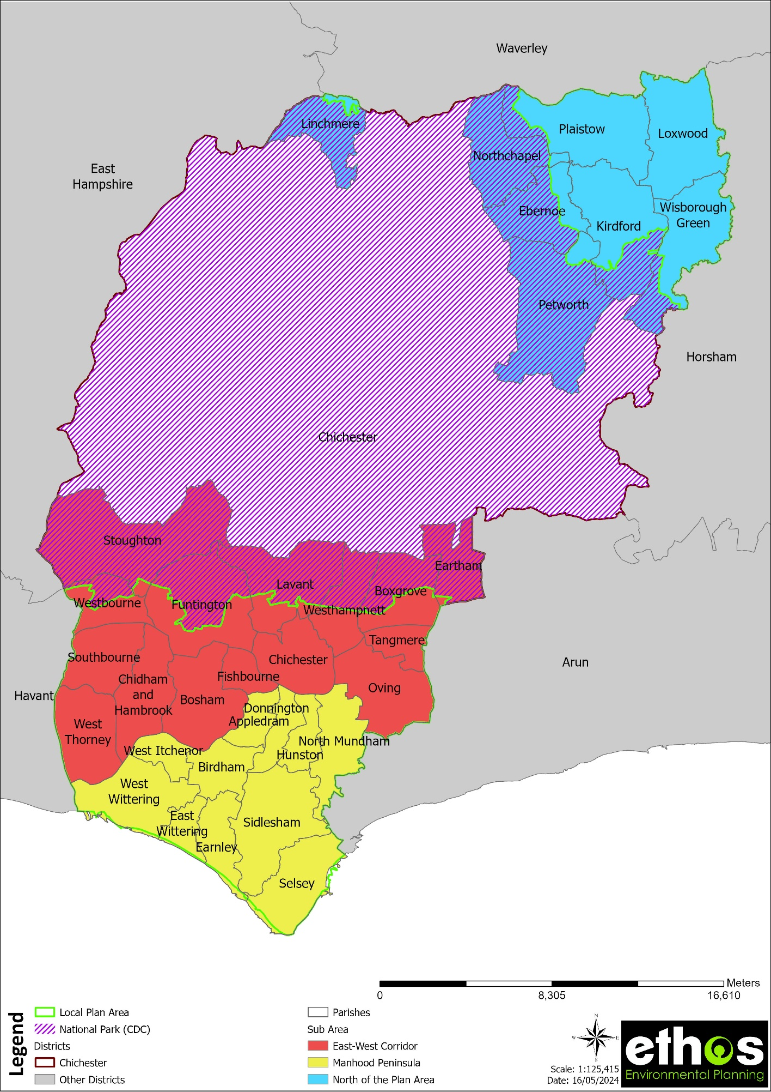
Figure 1 Parishes and Sub Areas included within the Study, and the overlap with the South Downs National Park
1.7.3 Population Statistics

The total population of the Chichester Local Plan Area is 98,146 (ONS mid-year 2020 estimates). Table 1 below shows the breakdown by Parish. As explained under Section 1.7.2 above, 14 of these parishes are only partly within the Local Plan Area (as they cross the boundary with the National Park), however the Study has covered the whole parish. The ‘split’ parishes are highlighted grey in the table below.

Table 1 Parish population statistics (ONS 2020 mid-year population estimates)
Parish | Mid-2020 Population Estimates
Appledram | 211
Birdham | 1625
Bosham | 2881
Boxgrove | 964
Chichester | 29193
Chidham and Hambrook | 1860
Donnington | 2899
Earnley | 622
Eartham | 115
East Wittering | 4889
Ebernoe | 212
Fernhurst | 2970
Fishbourne | 2557
Funtington | 1545
Hunston | 1300
Kirdford | 1063
Lavant | 1800
Linchmere | 2309
Loxwood | 1610
North Mundham | 1613
Northchapel | 843
Oving | 1647
Petworth | 3098
Plaistow | 1995
Selsey | 10668
Sidlesham | 1241
Southbourne | 6820
Stoughton | 551
Sutton | 393
Tangmere | 3158
Tillington | 507
Upwaltham | 115
West Dean | 426
West Itchenor | 308
West Wittering | 2559
Westbourne | 2287
Westhampnett | 1075
Wisborough Green | 1419
Study area wide | 98,146

2.0 METHODOLOGY
2.1 General

The starting point for this study has been the guidance in Section 8 of the NPPF, which adheres to but has superseded PPG17. The new policy gives clear recommendations for the protection of and appropriate provision for open space, however it does not provide any detailed guidance on how to conduct an open space assessment. It is therefore both logical and acceptable to reference the guidance for assessment provided in the former PPG17 and its Companion Guide. PPG17 placed a requirement on local authorities to undertake assessments and audits of open space, sports, and recreational facilities in order to:

- identify the needs of the population;
- identify the potential for increased use;
- establish an effective strategy for open space/sports/recreational facilities at the local level.

The Companion Guide to PPG17 recommended an overall approach to this kind of study as summarised below:

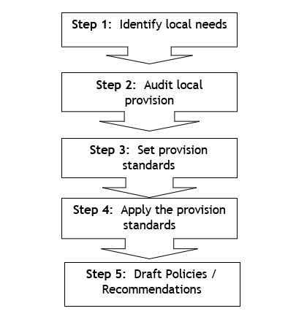
Figure 2 Summary of methodology

Within this overall approach the Companion Guide suggests a range of methods and techniques that might be adopted in helping the assessment process. Where appropriate, these methods and techniques have been employed within this study and are explained at the relevant point in the report. In addition, they are summarised in the paragraphs below.

2.2 Identifying Local Need (Step 1)

The Community and Stakeholder Consultation Report (2017) examines identified local need for various types of open space, sports and recreational opportunities. It has drawn upon a range of survey and analytical techniques as well as a detailed review of existing consultation data and other relevant documentation. This Open Space Study Update Summarises the key findings from this consultation, and also draws on recent policy and strategy at the local, regional and national level in order to identify priorities and needs, which have factored into the development of updated standards.

2.3 Audit of Existing Open Space Assets (Step 2)

The audit of open space undertaken in 2017 was used as the basis for updating the GIS mapping in 2024. The 2017 open space mapping drew on:

- analysis of existing GIS data held by Chichester District Council;
- desktop mapping of open space from aerial photography;
- questionnaires to Town and Parish councils;
- liaison with council officers.

Site visits were undertaken by Ethos at 149 open spaces and 98 outdoor play spaces to assess the quality of sites. The quality audit drew on criteria set out in the ‘Green Flag Award’. The audits were undertaken using a standardised methodology and consistent approach (explained in more detail in Section 7.5).

During 2023/2024 the Council provided Ethos with data on any changes to open space provision since the 2017/18 assessment was undertaken. This included new open spaces that have been delivered as part of development, and also quality upgrades to existing open spaces. This information was used to update the GIS mapping in order to assess the existing provision of open space across the study area (the Chichester Local Plan Area).

The approach to mapping followed the same methodology as the 2017/18 Study, with sites mapped into their primary typologies (further detail in Section 5).

Only open spaces within the district have been mapped i.e. although cross-border use of open space has been noted and considered (including within the Community and Stakeholder Consultation Report 2017), open spaces falling outside of the district have not been included. The quantity of open space within each parish has been calculated using the area of open space that falls within each parish boundary and sites were mapped using the OS basemaps available online.

2.4 Set and Apply Provision Standards (Steps 3 and 4)

Updated local quantity standards have been set, drawing on the updated mapping and quantity analysis, policy/strategy review, findings of previous studies and national standards and benchmarks.

The accessibility standards developed as part of the 2017/18 assessment have been carried forward, and no update to the quality assessment/standards has been undertaken. Further detail is provided in Section 6.

2.5 Drafting Policy Recommendations (Step 5)

This section outlines higher level strategic options which may be applicable at Parish, Sub Area and Study Area level. The strategic options address five key areas:

- Existing provision to be protected;
- Existing provision to be enhanced;
- Opportunities for re-location/re-designation of open space;
- Identification of areas for new provision; and
- Facilities that may be surplus to requirement.

3.0 CONTEXT

3.1 Introduction

This section sets out a brief review of the most relevant national, regional, and local policies, strategies and legislation related to the study (in accordance with the PPG17 Companion Guide), which have been considered in developing the methodology and findings of the study. Policies and strategies are subject to regular change, therefore the summary provided in this section was correct at the time of writing. This section also provides contextual information regarding health and deprivation for the District.

3.2 Strategic Context

3.2.1 National Strategic Context

Tackling the climate and nature emergency
Climate change represents an urgent and potentially irreversible threat to human societies
and the planet. In recognition of this, the overwhelming majority of countries around the world adopted the Paris Agreement in December 2015, the central aim of which includes pursuing efforts to limit global temperature rise to 1.5°C. The Intergovernmental Panel on Climate Change (IPCC) Global Warming Report (2018) provides the scientific evidence that global warming in excess of 1.5C above pre-industrial levels will undermine life support systems for humanity. It found that global net human-caused emissions of carbon dioxide (CO2) would need to fall by about 45% from 2010 levels by 2030, reaching ‘net zero’ around 2050.
The State of Nature Report (2019 and 2023) and The Global Intergovernmental Science-Policy Platform on Biodiversity and Ecosystem Services (IPBES) Report (May 2019) show the degradation and deterioration of natural environments and ecosystems which all life depends, the loss of biodiversity and a knock-on impact on human existence. Climate change, agricultural management, hydrological change, urbanisation, pollution, woodland management, and invasive non-native species as among the most significant of pressures on our wildlife.
The climate and nature emergency are inextricably linked. Biodiversity underpins healthy ecosystems that are able to mitigate and adapt to the impacts of climate change, however climate change is driving declines in biodiversity, and the degradation of our ecosystems, which means we are less able to adapt to change.

The UK government declaration of an environment and climate emergency in May 2019 has put climate and the environment at the centre of government policy. The government has since made a legally binding commitment to achieve net zero emissions by 2050 (through the Climate Change Act 2008, as amended in 2019), and has committed to planting 30,000 hectares of trees annually by 2025 (through the England Tree Strategy), helping to form part of the green recovery from Covid-19 and support the transition to net zero. At the 2022 Biodiversity Conference of the Parties (COP 15) the Government joined the international commitment to protecting 30 per cent of land and sea for nature by 2030 (the '30 by 30' target). The protected sites network and emerging local nature recovery networks are key to achieving this ambitious target.

National Planning Policy Framework (NPPF) (2023)

The NPPF sets out the Government’s planning policies for England and how they should be applied. The NPPF must be adhered to in the preparation of local and neighbourhood plans and is a material consideration in planning decisions.

The NPPF contains the following references that relate to and open spaces and green infrastructure:

- Para 7 - The purpose of the planning system is to contribute to the achievement of sustainable development. At a very high level, the objective of sustainable development can be summarised as meeting the needs of the present without compromising the ability of future generations to meet their own needs.
- Para 98 - Access to a network of high-quality open spaces and opportunities for sport and physical activity is important for the health and well-being of communities and can deliver wider benefits for nature and support efforts to address climate change. Planning policies should be based on robust and up-to-date assessments of the need for open space, sport, and recreation facilities (including quantitative or qualitative deficits or surpluses) and opportunities for new provision. Information gained from the assessments should be used to determine what open space, sport and recreational provision is needed, which plans should then seek to accommodate.
- Para 99 - Existing open space, sports and recreational buildings and land, including playing fields, should not be built on unless:
a) an assessment has been undertaken which has clearly shown the open space, buildings, or land to be surplus to requirements; or
b) the loss resulting from the proposed development would be replaced by equivalent or better provision in terms of quantity and quality in a suitable location; or
c) the development is for alternative sports and recreational provision, the benefits of which clearly outweigh the loss of the current or former use.
- Para 100 - Planning policies and decisions should protect and enhance public rights of way and access, including taking opportunities to provide better facilities for users, for example by adding links to existing rights of way networks including National Trails.
- Para 126 - The creation of high quality, beautiful and sustainable buildings and places is fundamental to what the planning and development process should achieve. Good design is a key aspect of sustainable development, creates better places in which to live and work and helps make development acceptable to communities. Being clear about design expectations, and how these will be tested, is essential for achieving this. So too if effective engagement between applicants, communities, local planning authorities and other interests throughout the process.
- Para 153 - Plans should take a proactive approach to mitigating and adapting to climate change, taking into account the long-term implications for flood risk, coastal change, water supply, biodiversity and landscapes, and the risk of overheating from rising temperatures. Policies should support appropriate measures to ensure the future resilience of communities and infrastructure to climate change impacts, such as providing space for physical protection measures, or making provision for the possible future relocation of vulnerable development and infrastructure.
- Para 174 - Planning policies and decisions should contribute to and enhance the natural and local environment.
- Para 175 – Plans should distinguish between the hierarchy of international, national and locally designated sites; allocate land with the least environmental or amenity value, where consistent with other policies in the NPPF; take a strategic approach to maintaining and enhancing networks of habitats and green infrastructure; and plan for the enhancement of natural capital at a catchment or landscape scale across local authority boundaries.

This is supported by the National Planning Practice Guidance (NPPG) website, which includes guidance on key areas such as Design. The National Design Guide and the National Model Design Code and Guidance Notes for Design Codes illustrate how well-designed places that are beautiful, healthy, greener, enduring, and successful can be achieved in practice.

Green Infrastructure (GI)

The concept of GI is firmly embedded within the NPPF, which requires local planning authorities to set out a strategic approach in their Local Plans, planning positively for the creation, protection, enhancement, and management of networks of biodiversity and green infrastructure. It defines green infrastructure as ‘A network of multi-functional green and blue spaces and other natural features, urban and rural, which is capable of delivering a wide range of environmental, economic, health and wellbeing benefits for nature, climate, local and wider communities and prosperity’.

The study area has a wide range of existing green infrastructure assets such as open spaces, allotments, woodlands, street trees, fields, hedgerows, treelines, lakes, ponds, rivers, meadows, grassland, playing fields, footpaths, and cycleways.

GI takes many different forms and can be delivered at multiple scales. It provides multiple functions, which in turn provide significant environmental, social, and economic benefits (also known as ecosystem services). The key benefits provided by GI are set out in the table below.

Table 2 Benefits provided by GI
Environmental
- Supports and provides biodiversity (which underpins healthy and resilient ecosystems) and species movement/dispersal including through providing habitat, wildlife corridors and stepping-stones.
- Provides climate change mitigation and adaptation e.g., through providing flood and soil erosion protection, carbon sequestration and storage, and urban cooling.
- Improves air and water quality (pollution absorption and removal).
- Enables food production and supports pollination.
- Supports and creates attractive and sustainable places and landscapes i.e., quality placemaking and place keeping.
Social/health and wellbeing
- Provides opportunities for outdoor recreation, exercise, play and access to nature.
- Provides attractive and safe spaces for people to enjoy and improve social contacts – a key component of ‘liveable’ towns and cities where people want to live.
- Supports the development of skills and capabilities.
- Improves air and water quality, provides urban cooling and shade, reduces noise pollution.
- Provides green active travel routes.
Economic
- Provides attractive places to live and work, attracting inward investment and tourism.
- Increased land and property values.
- Supports sustainable homes and communities e.g., through providing local food and building materials, encouraging low carbon lifestyles e.g., through well connected and attractive walking and cycling routes.
- Provides health and wellbeing benefits that result in avoided healthcare costs.
- Provides local food, energy, and timber production.
- Climate change mitigation and adaption.

Nature-based Solutions

The terms green infrastructure and nature-based solutions are overlapping and are often used interchangeably, with GI falling under the umbrella of nature-based solutions.

Nature-based solutions are defined as ‘actions to protect, sustainably manage, and restore natural or modified ecosystems that address societal challenges effectively and adaptively, simultaneously providing human well-being and biodiversity benefits’ . They have huge potential to help cities and urban areas become more resilient to climate change, and benefit people’s health and the economy.

Nature-based solutions tend to be focused on six key areas:

- Urban trees – found in parks, gardens, and along streets, trees can help to regulate urban temperatures, reduce flood risk, and clean the air
- Parks and green spaces – natural or planted green spaces are used for recreation and exercise, as well as being rich habitats for wildlife
- Green buildings – walls and roofs covered with vegetation act like sound and heat insulation for buildings, and absorb rainwater, so reducing flood risk
- Riverbank vegetation – plants along riverbanks trap soil and sediment, improving water quality and reducing flood damage by slowing the flow of water
- Wetland and bioswales – natural wetlands and man-made bioswales (or ‘rain gardens’) help to purify water and reduce flooding
- Lakes and ponds – natural or artificial waterbodies in cities can hold water for irrigation or drinking and support a wide range of wildlife.

Green Infrastructure Standards

Natural England’s National Green Infrastructure Framework was launched in January 2023 and establishes national standards (voluntary) for GI in England and comprises the following:

- GI Principles – underpin the framework and cover why, what and how to do good GI.
- GI Mapping Database and Analysis– a freely available tool providing GI Mapping layers and analyses.
- GI Standards (5 headline standards – GI Strategy Standards, Accessible Greenspace Standards, Urban Nature Recovery Standard, Urban Greening Factor Standard and Urban Tree Canopy Cover Standard).
- GI Planning and design guide (which complements existing guidance such as the National Design Guide and National Model Design Code).
- Process Journeys (to assist different audiences) are still to be published.

The Framework does not seek to duplicate existing standards such as Building with Nature, but rather to learn from best practice and reinforce key messages, such as that green infrastructure and natural capital needs to be considered and incorporated at the earliest stages of development and treated like other types of essential infrastructure.

Building with Nature is the UK’s first benchmark for GI. It provides a framework of robust and evidence-based quality standards which define what good looks like at each stage of the development process, so that developments deliver for the natural world and healthy communities. It can be used to guide physical development and also strategic planning policy documents, and there are accreditation options available for both physical developments and policy documents.

The 25 Year Environment Plan (25 YEP) and The Environmental Improvement Plan (EIP)
In 2018 the 25YEP set out the governments goals for improving the environment, within a generation. The Nature Recovery Network (NRN) is a key policy commitment in the 25 YEP. The NRN will benefit people and wildlife by increasing, improving and joining-up wildlife-rich places across England. It will create or restore 500,000 hectares of wildlife habitat outside protected sites, more effectively linking existing protected sites and landscapes, as well as urban green infrastructure (such as trees, hedgerows, parks, fields, forests) and urban blue infrastructure (such as rainwater tanks, bioswales, rivers, canals, ponds, wetlands, and floodplains).
The EIP (2023) is the first revision of the 25 YEP. It uses the ten goals set out in the 25 YEP as the basis for the document: setting out the progress made against all ten, the specific targets and commitments made in relation to each goal, and the government’s plan to continue to deliver these targets and the overarching goals. The apex goal of the strategy is to halt the decline in biodiversity to achieve thriving plants and wildlife.

The Environment Act (2021) places the 25 YEP on statutory footing and provides a comprehensive legal framework for environmental improvement within the UK. The Act received royal ascent in November 2021 with pending secondary legislation planned for 2024. This makes provision for a mandatory requirement for biodiversity net gain in the planning system, requiring development to deliver a 10% improvement in biodiversity value from 2024.
The Act introduces a statutory requirement for Local Nature Recovery Strategies (LNRS) to be produced by a responsible authority appointed by the Government. LNRS will support the Nature Recovery Network as a spatial plan to protect and restore wildlife. It also makes provision for strengthening the Biodiversity Duty for Local Authorities - public authorities who operate in England must consider what they can do to conserve and enhance biodiversity in England.

Covid 19 and the impact on open spaces and green infrastructure
The value of green infrastructure has also been keenly recognised during the Covid 19 pandemic where access to green space played a key role in people’s well-being; alongside a wider appreciation of nature.
From 2009 to 2019, Natural England ran the Monitor of Engagement of the Natural Environment (MENE) survey. It collected data about outdoor recreation, pro-environmental behaviours, attitudes towards and engagement with the natural environment. It was estimated there were 4 billion visits to the natural environment in 2019, up from 2.9 billion over 10 years. The survey highlights the importance of access to nature for our health and wellbeing, but also clear inequalities between different age, ethnic and socio-economic groups, and those with different states of health, in how they use and experience the natural environment.
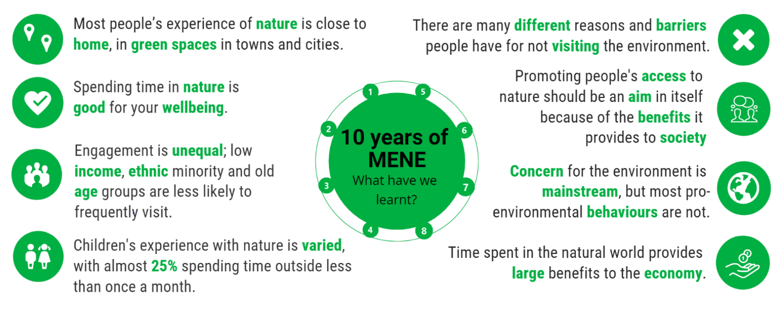
MENE concluded in 2019 and has been superseded by The People and Nature Survey for England. This has also helped understand how adults and children in England have engaged with nature since the coronavirus pandemic.
The findings continue to demonstrate the importance of spending time in nature for people’s wellbeing. During April 2020 (during lockdown restrictions) the survey polled 2000 people and key findings included:
- The survey also revealed that a smaller proportion of adults spent time outside in April 2020 than their reported average over 12 months, which suggests that lockdown restrictions impacted people using green spaces.
- The most regular visits to green spaces were to urban green spaces such as parks and playing fields (41%), followed by fields, farmland, and countryside (25%), woodland and forests (24%) and rivers, lakes, and canals (21%).
- 86% of adults with access to a private garden of allotment felt that these spaces are important to them.
- 89% of adults agreed or strongly agreed that green and natural spaces should be good places for mental health and wellbeing.
- 87% of adults agreed that ‘being in nature makes me happy’.

The Natural Environment White Paper (NEWP) The Natural Choice: securing the value of nature (2011)

The White Paper recognises that a healthy natural environment is the foundation of sustained economic growth, prospering communities and personal wellbeing. It sets out how the value of nature can be mainstreamed across our society by facilitating local action; strengthening the connections between people and nature; creating a green economy and showing leadership in the European Union (EU) and internationally. It responds to the 2010 independent review of England’s wildlife sites and ecological network, chaired by Professor Sir John Lawton, which identifies the need for more, better and bigger joined spaces for nature.
Biodiversity 2020: A strategy for England’s wildlife and ecosystem services (August 2011)

International obligations set out in the United Nations (UN) Convention on Biological Diversity (CBD) Strategic Plan for Biodiversity (2011–2020) included 20 targets known as the Aichi biodiversity targets.

In 2011, the Department for Environment, Food and Rural Affairs (DEFRA) published a strategy for England called ‘Biodiversity 2020’. This sought to reverse the decline of habitats and species in England. The strategy aligned with international obligations set out in the CBD strategic plan for biodiversity 2011–2020.

The majority of the 2020 outcomes and indicators were not met. The most recent United Nations (UN) Biodiversity Conference of the Parties (COP) took place in December 2022 in Montreal, Canada (known as COP15). It is an international biodiversity conference held under the UN CBD. COP15 saw the adoption of a new set of international goals for biodiversity called the Kunming-Montreal Global Biodiversity Framework (GBF), which replace the CBD's Strategic Plan for Biodiversity 2011-2020 and its Aichi Targets. The GBF contains four overarching goals which set out a vision for biodiversity by 2050, and 23 targets.

Fields in Trust

Fields in Trust (FIT) is an independent charity with over 90 years’ experience protecting parks and green spaces. They work with landowners, community groups and policy makers to champion the value of our parks and green spaces to achieve better protection for their future at both local and national level.

Fields in Trust works in partnership with landowners to protect land through a Deed of Dedication, a binding legal commitment with the landowner which secures spaces (usually a public park, playing field or recreation ground) in perpetuity for current and future generations to enjoy. Even if a space already has a form of protection (such as a covenant, or town and village green registration), a Deed of Dedication will strengthen the protection.

The FIT report ‘Guidance for Outdoor Sport and Play, Beyond the Six Acre Standard provides benchmark guidelines for practitioners on open space provision and design, which have been considered as part of the development of quantity, access and quality standards in Section 6 of this report.

FIT also conduct research into the benefits that local parks provide, such as the Revaluing Parks and Green Spaces Study (see below).

Revaluing Parks and Green Spaces - Measuring their economic and wellbeing value to individuals (Fields in Trust (FIT), 2018)
This report provides a robust economic valuation of parks and green spaces in the UK as well as valuing improvements in health and wellbeing associated with their frequent use. This is the first research study on parks and green spaces to use welfare weighting methodology, allowing for more informed evidence-based policy decisions. The headline figures are:
- The Total Economic Value to an individual is £30.24 per year (£2.52 per month), and includes benefits gained from using their local park or green space and non-use benefits such as the preservation of parks for future generations. The value of parks and green spaces is higher for individuals from lower socio-economic groups and from black and minority ethnic backgrounds. The findings show that any loss of parks and green spaces will disproportionately impact disadvantaged and underrepresented communities, precisely those who value them the most.
- The Wellbeing Value associated with the frequent use of local parks and green spaces is worth £34.2 billion per year to the entire UK adult population.
- Parks and green spaces are estimated to save the NHS around £111 million per year based solely on a reduction in GP visits and excluding any additional savings from prescribing or referrals.

Making Parks Count (The Parks Alliance (TPA), 2020)
This report makes the business case for parks, why they matter, and why they are a ‘smart investment’. It illustrates how parks in England deliver over £6.6bn of health, climate change and environmental benefits each year including £2.2bn in avoided health costs alone and worth £140 per year for each urban resident. For every £1 spent on parks in England an estimated £7 in additional value for health and wellbeing and the environment is generated. Some of the other key figures referenced in the report are:
- Urban green spaces raise house prices by an average of £2,500;
- London’s parks alone help avoid an estimated £370m of mental health related costs each year;
- Parks are among the most species rich types of urban green spaces, and over 1,500 species of UK’s pollinators deliver an estimated £680m in value to the economy;
- The benefits of air pollutant removal by trees in public parks in England is estimated at £60m per year;
- The value of carbon sequestration by trees in public parks in England is estimated at £9m per year;
- Parks in England provide an urban cooling benefit of £4.8m per year.

The State of the Market Survey for Local Authority Parks and Green Spaces Services (2021)

The report presents the findings from a survey of local authorities throughout the UK, in relation to the management, use and value of parks. 78 responses from local authorities were received. Some of the main headline statements are summarised below:

- 35% of authorities thought that the squeeze on public sector resources is affecting parks and green spaces disproportionately to other service areas.
- 69% of respondents strongly agreed that the lack of investment in parks and green spaces will have health and social impacts.
- The three top environmental issues highlighted by local authorities were litter control (88%), biodiversity (82%) and dog fouling (70%).
- Generating income through parks came through the following areas by local authorities, sports pitch lettings (83%), cafes in parks (75%), events (70%), fairgrounds (64%) and mobile catering (60%). The report highlighted that since the 2020 survey pitch lettings, provision of tennis and sponsorship have seen significant increases.
- 77% of respondents have accessed section 106 funding for parks which was an increase on 60% in 2020. Authorities accessing national lottery heritage funding also fell on 2020, potentially due to changes in HLF funding allocation criteria.
- The importance of parks in meeting public health and wellbeing needs, particularly during the Covid-19 pandemic has been highlighted, with 94% of respondents stating they had experienced increases in visitor numbers.

The report concludes that local councils are working hard to meet budget and resource challenges through making efficiencies and looking for income generation opportunities to plug funding gaps. However, the drive to generate income needs to be tempered with the ability to ensure there is still free public access to the UK’s parks and greenspaces. Sporadic pockets of funding will help some of those parks in need of renovation and is welcome, but it still falls well short of the hundreds of millions of pounds which has been lost from parks budgets over the past decade.

It will be critical that resources are targeted more effectively in those areas where public use and greenspace maintenance need is at its highest. Therefore, there needs to be a greater appreciation by Government and senior local authority leaders and members of the increasing number of benefits parks and greenspace bring, many beyond health and wellbeing such as, climate change mitigation, flood alleviation, biodiversity opportunities contributors towards cleaner air etc. It should also be noted that many of these benefits sit within targets identified as corporate goals outlined in such as Climate Emergency and Local Plans. Indeed, both climate change and biodiversity issues have clearly come to the fore in this year’s survey results, with councils striving to meet climate change targets and protect and enhance biodiversity.

State of the Market Survey 2020 – Local Authority Allotment Services

The report presents the findings from a survey of local authorities throughout the UK, in relation to the use and value of allotments to communities, particularly for health and wellbeing. 80 responses from local authorities were received.

As well as providing environmental benefits, allotments are also seen as having considerable social cohesion benefits, where all sectors of the local community can engage in a common interest where skills and knowledge can be exchanged, and friendships forged. The intergenerational value of allotments has also been recognised as one way which anti-social behaviour can be reduced as different age groups work together and share common experiences.

Many local authorities are now building the importance of allotments into their Health and Well-Being Strategies and also their Local Development Plans, requiring new developments to provide additional allotment sites.

The increasing demand for building land and the lack of plots for new allotments is causing concern amongst allotment holders as is the reductions in council budgets which is having an impact on the ability to maintain them. Many allotment sites are now moving to self-management models, often with the continuing support of the local authority. In this way allotment holders can not only ensure what finance is available is used to meet the known needs of their site, but they are also able to apply for funding which is not available to local authorities.

It is unlikely that local authorities will ever make high levels of income from allotments, indeed many are openly subsidising allotments, but when one considers the multiple benefits they bring, which have only been increased during the Covid-19 pandemic, they are acknowledged as being a key community asset and one which residents, allotment holders and agencies across the country are increasingly helping to sustain.

Sport England Strategy – ‘Uniting the movement: A 10-year vision to transform lives and communities through sport and physical activity’.

The Uniting the Movement Strategy by Sport England is a 10-year vision to transform lives and communities through sport and physical activity. It sets out how the sector needs to change to give people opportunities now and, in the future, to allow people to live happier, healthier, and more fulfilled lives. This includes tackling inequalities seen in sport and physical activity and helping to remove barriers. The three objectives for the strategy are:

- Advocating for movement, sport, and physical activity.
- Joining forces on five big issues: recover and reinvent; connecting communities; positive experience for children and young people; connecting with health and wellbeing and active environments.
- Creating the catalysts for change.

Yearly implementation plans will ensure that Sport England are investing most in those that need it the most with the right blend of national and local action and keeping the plan simple providing information and guidance to support colleagues and partners.

Environment Agency National Flood and Coastal Erosion Risk Management Strategy (2020)

The Environment Agency’s Flood and Coastal Erosion Risk Management Strategy provides a framework for guiding the operational activities and decision making of practitioners supporting the direction set by government policy to protect people and places. It seeks to better manage the risk and consequences of flooding from rivers, the sea, groundwater, reservoirs, ordinary watercourses, surface water, sewers, and coastal erosion.

The strategy sets out the long-term delivery objectives the nation should take for the next 10 to 30 years as well as practical measures risk management authorities should take working with partners and communities. It has a vision for ‘a nation ready for, and resilient to, flooding and coastal changes – today, tomorrow and to the year 2100’. To achieve this vision the strategy has three long-term ambitions:

- Climate resilient places – working with partners to improve resilience to flooding and coastal change both now and in the face of climate change. This includes using nature-based solutions and working with landowners to adapt practices to become more resilient.
- Today’s growth and infrastructure resilient in tomorrow’s climate – making the right investment and planning decisions to secure sustainable growth and environmental improvements as well as providing resilience to change. This includes contributing to environmental net gain for new development proposals and putting a focus on providing planning advice that helps avoid inappropriate development in areas of risk.
- A nation ready to respond and adapt to flooding and coastal change – ensuring local people understand their risk to flooding and coastal change and know their responsibilities and how to take action. This includes supporting communities to prepare and respond to flooding and coastal change by ensuring they have the skills and capabilities to adapt.

3.2.2 Regional Context

West Sussex Climate Change Strategy (2020 – 2030)

West Sussex County pledged a motion in April 2019 to reach net zero carbon emissions by 2030. This led to the climate change strategy being published in July 2020 which set out five priority commitments:

- Mitigate the effects of climate change by reducing carbon emissions (aligning with the ambitions of being net zero by 2030).
- Adapt and be resilient to a changing climate.
- Source and use resources sustainably.
- Support and grow the local green economy.
- Transform how we work.

In terms of open space, under the priority 2, it is highlighted that to achieve this there is a need to increase access to nature and take action to sequester carbon in the natural environment.

West Sussex Pollinator Action Plan (2019 – 2022)

The Pollinator Action Plan seeks to protect and enhance the amount and quality of pollinator habitat and manage green spaces to provide greater benefits for pollinators. This includes increasing the value of parks and greenspaces for pollinators through reducing cutting on road verges and creating a balanced approach to park management for both the public and wildlife.

3.2.3 Local Context

Chichester District Council Corporate Plan 2022 - 2025

The Corporate plan was developed in in 2022 to enable the council to deliver its vision of “a stunning rural district, with vibrant local communities, where businesses can grow, residents and visitors feel supported and fulfilled, and where carbon emissions are minimised”.

The strategy sets out five priorities:

- Homes for all
- Thriving economy
- Supported communities
- Financial prudence
- A cared-for environment

Under the ‘supported community’s’ priority, the plan sets out to achieve promoting active and healthy lifestyles and biodiverse, attractive, and well used green spaces. This will involve focusing on those who are in the most disadvantaged areas, communities, and groups, and using parks and green spaces to encourage more active lifestyles. Parks and green spaces are also included within the ‘a cared-for environment’ priority to help restore natural habitats, increase tree cover, and increase biodiversity.

Chichester Climate Emergency Action Plan

Chichester District Council declared a climate emergency in July 2019 and developed its climate emergency action plan to set a target of a 10% reduction in greenhouse gas emissions year-on-year until 2025. This target was set for both the council and the district as a whole. Actions that are currently being undertaken as part of this action plan include:

- Moving to electric vehicles.
- Increasing energy efficiency in buildings and helping residents in their homes.
- Increasing tree cover in both urban and rural areas.
- Protecting strategic wildlife corridors.
- Improvements to waste and recycling.
- Encouraging more walking and cycling through the production of a 10-year local cycling and walking infrastructure plan.

Chichester Local Plan 2021 - 2039

Chichester Local Plan Key Policies (2014-2039) was adopted in July 2015. The Inspector, however, required the council to complete a review within five years to make sure sufficient housing would be planned to meet the needs of the area. This work will form the Chichester Local Plan Review 2036. The Local Plan Review will shape where new development will go for Chichester District excluding the area in the South Downs National Park.

The first stage of consultation (Issues and Options Consultation) was held during 2017. As part of this consultation the council were seeking views on where and how much housing should be planned for. Stage two (Preferred Approach) was completed in 2018 and considers responses and evidence on the proposed development strategy and policies, to draft a revised version of the plan. Stage three (Regulation 19 and Submission) is currently ongoing, with submission for examination by a planning inspector anticipated in early 2024.

Mitigating and adapting to climate change, protecting biodiversity and the natural environment, and sustainable development and neighbourboods, healthy lifestyles and access to open space and nature are key elements of the Vision and Strategic Objectives.

The spatial development strategy identifies the broad approach to providing sustainable development in the plan area. It seeks to disperse development across the plan area by:
- Focusing the majority of planned sustainable growth at Chichester city and within the east-west corridor,
- Reinforcing the role of Manhood Peninsula as a home to existing communities, tourism and agricultural enterprise, and
- Where opportunities arise, supporting the villages and rural communities in the North of the Plan Area.
To help achieve sustainable growth the council will:
- Ensure that new residential and employment development is distributed in line with the settlement hierarchy, with a greater proportion of development in the larger and more sustainable settlements.
Chichester Local Plan: Key Policies 2014-2029

Adopted in July 2015, the Chichester Local Plan: Key Policies 2014 – 2019 provides the broad policy framework and a long-term strategy to manage development, protect the environment, deliver infrastructure and promote sustainable communities within Chichester District, excluding the area within the South Downs National Park.

The Plan area (Chichester District excluding the area within the South Downs National Park) has been split into three sub-areas to recognise the distinct characteristics of each sub-area and respond to each area in an appropriate manner (these areas are carried forward in the emerging Local Plan). The sub areas are as follows:

- The East-West Corridor (Chichester city, east of the city, west of the city);
- The Manhood Peninsula; and
- The North of the Plan Area (the north east of the District and Hammer/Camelsdale).

Key areas of the Vision of particular relevance to this study include environmental sustainability, healthy lifestyles supported by good access to open space and nature, environmental protection, sustainable neighbourhoods and travel. A number of objectives were also set in order to achieve the vision which are of particular relevance to the study, particularly the Environment and Health and Wellbeing objectives.

Strategy for development

A key theme running through the whole Plan is the need to conserve and enhance the quality of the environment and heritage of the area, in particular designated sites and assets of national and international importance. The Local Plan strategy aims to steer major development away from the most environmentally sensitive areas and towards locations that have the widest access to employment opportunities and community facilities, or where development can contribute to addressing an under provision of such facilities.

New development is focused mainly in the east-west corridor between Southbourne and Tangmere; especially around Chichester city itself. This includes planning for new neighbourhoods to the west of Chichester city and at Shopwyke, and providing for the expansion of Tangmere, Westhampnett (including land north east of the city) and Southbourne. A number of policies are particularly relevant to the open space study as highlighted below.

Policy 7: Masterplanning Strategic Development

Development of the strategic locations identified in the Local Plan will be planned through a comprehensive masterplanning process. Preparation of masterplans will involve the active participation and input of all relevant stakeholders, including the Council, landowners, developers, the local community, service providers and other interested parties. Masterplans will be developed in consultation with the Council prior to the submission of a planning application. The policy includes a number of points that should be achieved such as:

- Reduce the need for car use and encourage sustainable modes of travel, including provision for public transport, cycle routes, footpaths and bridleways;
- Create a network of permeable and interconnected streets and public spaces;
- Provide for accessible open space to meet identified local needs and/or increase accessibility to existing open spaces;
- Incorporate a green infrastructure strategy, providing an integrated network of green spaces, taking advantage of opportunities for off-site links to the Coast, South Downs National Park and wider green network, and where necessary providing alternative recreational space to mitigate potential environmental impacts of development on EU designated sites;
- Demonstrate a good understanding and respect for the natural environment, its heritage assets and their setting both within the site and in the wider locality, whether designated or not, and include details of how the natural environment and heritage assets will be preserved, conserved and enhanced.

Policy 9: Development and Infrastructure Provision

The Council will work with partners, neighbouring councils, infrastructure providers and stakeholders to ensure that new physical, economic, social, environmental, and green infrastructure is provided to support the development identified in the Local Plan….

Policy 52: Green Infrastructure

Development will be expected to contribute towards the provision of additional green infrastructure and protect and enhance existing green infrastructure….

Policy 54: Open Space, Sport, and Recreation

The Council will seek to retain, enhance, and increase the quantity and quality of open space, sport, and recreation facilities, and improve access to them.

Development involving the loss of open space, sport and recreation facilities will be granted permission where all the following criteria have been met:

1. Alternative accessible replacement facilities of overall at least equivalent quantity and quality are provided: or
2. Where the Chichester Open Space Study identifies a surplus of provision, future needs and the potential of the open space to meet any shortfall in other types of provision in the local area have been taken into account; and
3. There are no adverse impacts on biodiversity, heritage assets or the integrity of the Green Infrastructure network.

Exceptions will only be made where the benefit of the development outweighs any harm, and it can be demonstrated there are no reasonable alternative sites available.

New residential development (excluding replacement dwellings) will be required to contribute towards:

1. The creation of new open space, sports and recreation facilities; and/or
2. Improving the quality and/or accessibility of existing open space or indoor facilities

New or improved facilities should be provided to the standard of 3.65ha per 1,000 population (3.55ha in rural areas), in accordance with the detailed standards and methodology set out in the Planning Obligations Supplementary Planning Document.

Subject to competing priorities, the Community Infrastructure Levy may contribute to provision, but larger sites will be expected to make on site provision secured via S106 agreements.

Where opportunities arise, the provision of new or enhanced open space, sport and recreation facilities will be encouraged to meet any identified shortfalls in the local area.

Where possible, sports and built facilities that attract large numbers of people will be located in larger settlements and will be easily accessible by public transport, cycling and walking.

Chichester District Council Open Space Assessment (2013)

The 2013 Open Space, Sport and Recreation Facilities Study provided a detailed assessment of existing open space provision, and a review of the qualitative and quantitative need for additional provision in 2013 and in the future. The study presented the findings of the assessment and provided advice and recommendations for the development of the Local Plan. This evidence fed into the development of Policy 54 outlined above.

The study followed guidance within the National Planning Policy Framework, and the key aim of the study was ‘to evaluate the quantity, quality and accessibility of open space and recreational land provision in Chichester District Council (excluding the South Downs National Park) and to recommend standards and effective mechanisms in order for appropriate provision to be secured to meet future needs.’

The evidence gathered through the local needs assessment, and the local provision analysis was used along with national benchmarks to develop a set of standards for the provision of open space, sport and recreation facilities. The standards proposed were subject to scrutiny and agreement through a working party of council members and officers. A summary of the standards recommended is provided below:

Table 3 Standards from 2013 Chichester District Council Open Space Assessment (adopted)
Typology | Quantity standards |  | Access standard
 | Main settlements & Housing Growth Areas | Parishes
Allotments | 0.40 | 0.30 | 480 metres or 10 minutes’ walk time
Amenity Open Space | 0.50 | 0.50 | 480 metres or 10 minutes’ walk time
Natural/Semi-Natural Green Space | 1.00 | 1.00 | - 960 metres or 20 minutes’ walk time  - Analysis will also include ANGSt
Parks, Sport and Recreation Grounds | 1.60 | 1.60 | 600 metres or 12-13 minutes’ walk time
- Outdoor Sport
- Outdoor Sport (LA)
- Park and Recreation Ground
Play Space | 0.15 | 0.15 | - Childs space: 480 metres or 10 minutes’ walk time  - Teenage space: 600 metres or 12-13 minutes’ walk time
Total | 3.65 | 3.55

Overall, the District was found to have a shortfall in the provision of all types of open space, with the exception of natural and semi-natural greenspace which is abundant throughout much of the District. The study also recommended Quality Standards in relation to the different typologies.

Chichester District Council Open Space Assessment (2018)

Ethos was commissioned in 2018 to undertake an open space assessment to inform the local plan review. It updated the 2013 evidence base providing up to date information on open space location, coverage, and provision. The evidence base was considered, and a new set of open standards were proposed which are summarised in the table below.

Table 4 Proposed open space standards from 2018 assessment
Typology | Quantity standards |  | Access standard
 | Analysing existing provision | Requirements from new development
Allotments | 0.30 | 0.30 | 600 metres or 12 – 13 minute straight line walk time
Amenity Open Space | 0.60 | See natural green space standard | 600 metres or 12 - 13 minute straight line walk time
Parks and Recreation Grounds | 1.2 | 1.2 | 600 metres or 12 - 13 minute straight line walk time  10 minute drive time for larger multi-functional facilities
Play Space (Children) | 0.05 | 0.05 | 480 metres or 10 minutes straight line walk time
Play Space (Youth) | 0.05 | 0.05 | 720 metres or 15 minutes straight line walk time
Natural Green Space | ANGSt | 1.0 to include natural and amenity green space | ANGSt
Total for new provision |  | 2.6 ha/1000

Green Infrastructure Delivery Document

This delivery document is an information document and is not a formal policy. It sets out guidance for the content of planning applications to ensure the delivery of green infrastructure as part of new development.

New developed is expected to contribute towards the provision of additional green infrastructure and to protect and enhance existing green infrastructure. Existing provision is protected through the strategic development locations allocated in the Chichester Local Plan and neighbourhood plans. New green infrastructure is to be delivered through the local plan Policies 52 and 54, concept statements and subsequent masterplans, developer contributions and the mitigation for development and disturbance of birds in special protection areas. There are also several green infrastructure projects within the local plan area that contribute to protecting, enhancing, and creating new green infrastructure including Green Links across the Manhood, West Weald Landscape Project, and the South Down National Park Authority Green Infrastructure Framework.

3.3 Health and Deprivation Context

3.3.1 Introduction

Public Health England publish a number of indicators which can provide a summary of the health context of Chichester. In summary, the health of people in Chichester is generally better than the England average based on the following indicators:

- Both male and female life expectancy is better than the England average (2022 data).
- Adult health overall is better than the England averages based on the percentage of physically active adults and the percentage of adults classified as overweight or obese (2021/22 data).
- Child health is also better in Chichester when compared to the England averages, with 15% of children living in low-income families (2021/22 data) and 16% of year 6 children classified as obese.

As part of the Census 2021 residents were asked to assess their own state of health. 83.3% of residents stated that they are in good or very good health which has increased from the Census 2011 data (82.5%). Only 4.3% of residents said they are in bad or very bad health, which has only slightly decreased from 2011 (4.4%).

Table 5 Health categories for Census 2021 for all districts and boroughs in West Sussex, compared to county, regional and national averages
 | Very good health | Good health | Fair health | Bad health | Very bad health
Adur | 45.4 | 35.0 | 14.1 | 4.3 | 1.2
Arun | 43.2 | 36.6 | 14.8 | 4.3 | 1.1
Chichester | 49.0 | 34.3 | 12.4 | 3.4 | 0.9
Crawley | 49.1 | 35.0 | 11.6 | 3.4 | 1.0
Horsham | 51.5 | 33.9 | 11.0 | 2.8 | 0.8
Mid Sussex | 52.9 | 33.1 | 10.5 | 2.7 | 0.8
Worthing | 45.3 | 35.6 | 13.8 | 4.1 | 1.2
West Sussex | 48.3 | 34.8 | 12.5 | 3.5 | 1.0
South East | 50.0 | 34.0 | 11.8 | 3.3 | 0.9
England | 48.5 | 33.7 | 12.7 | 4.0 | 1.2

A Public Health England Report: Improving Access to Greenspace: a new review 2020 highlights that improving access to quality green space has the potential to improve health outcomes for the whole population, in a number of ways:

- Promoting health behaviour including encouraging physical activity and active travel;
- Improving social contacts and giving people a sense of familiarity and belonging;
- Supporting the development of skills and capabilities; and
- Mediating potential harms posed by the local environment for example air pollution, heat, noise and flood risk.

This is particularly true for disadvantaged communities, where the evidence suggests that people’s health and wellbeing is enhanced by living in a greener environment. This means that green space also can be an important tool in the ambition to increase healthy life expectancy and narrow the gap between the life chances of the richest and poorest in society.

3.3.2 Index of Multiple Deprivation (IMD) Analysis

The Indices of Deprivation 2019 provide a set of relative measures of deprivation for small areas (Lower-layer Super Output Areas) across England, based on seven different domains of deprivation:

- Income Deprivation
- Employment Deprivation
- Education, Skills, and Training Deprivation
- Health Deprivation and Disability
- Crime
- Barriers to Housing and Services
- Living Environment Deprivation

Each of these domains is based on a basket of indicators. As far as is possible, each indicator is based on data from the most recent time point available. The Index of Multiple Deprivation (IMD) combines information from the seven domains to produce an overall relative measure of deprivation.

The figure below shows the IMD rank for each LSOA within the district, where 1 is most deprived and 10 is least deprived. As can be seen, levels of deprivation vary across the Study Area, with some of the highest levels of deprivation occurring in the Parish of Chichester.

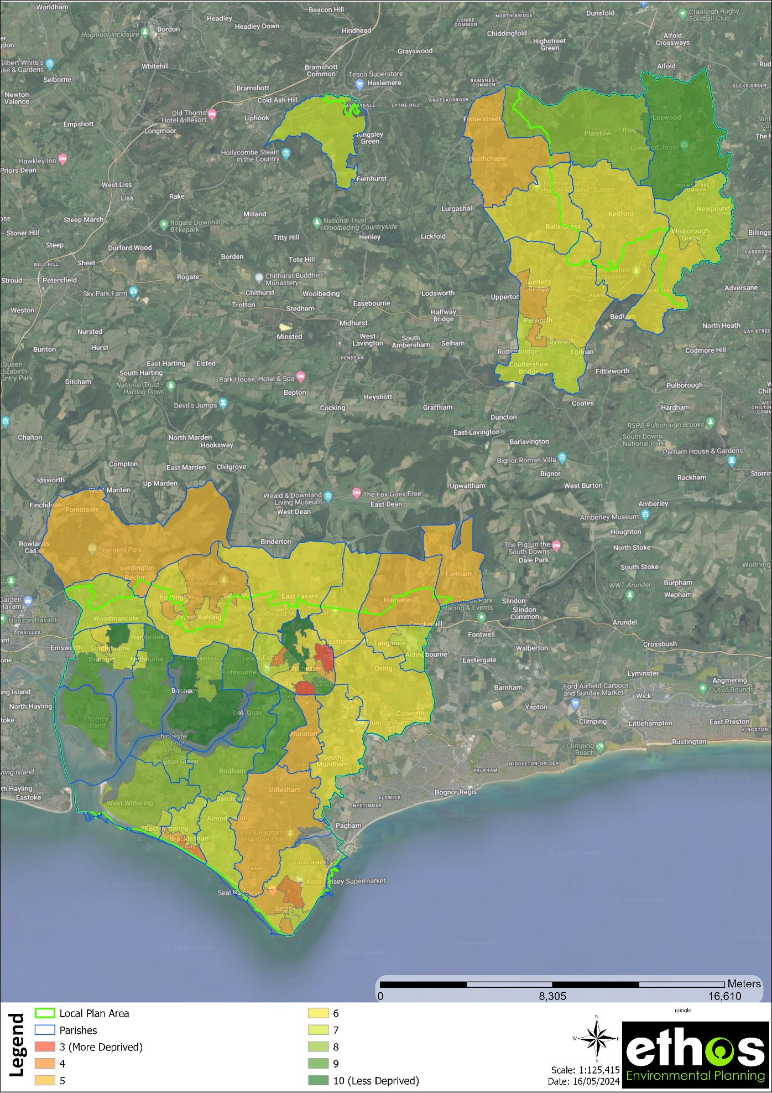
Figure 3 IMD deciles in Chichester Study Area (by LSOA)

4.0 LOCAL NEEDS ASSESSMENT (STEP 1)

4.1 Introduction

As part of the 2017/2018 Chichester Open Space Study, Community and Stakeholder Consultation was undertaken to examine the local need for a wide range of different types of recreational open space. It draws upon a range of survey and analytical techniques including a review of consultation findings from relevant studies, questionnaire surveys and one to one stakeholder interviews. The work was undertaken from June to September 2017.

Questionnaire surveys were undertaken looking at the adequacy of current provision in terms of the quantity, quality, and access, in relation to the various typologies of open space. The surveys were:

- A general household survey (online, with 424 surveys completed)
- A survey of Town and Parish councils
- Local groups and organisations’ survey

In addition to the above a series of one-to-one stakeholder interviews/surveys were undertaken.

The results of this consultation and other analyses have helped amongst other things to inform the local standards (Section 6 of this report). Crucially it has also helped the study to understand local people’s appreciation of open space, sport and recreation facilities, and the wider green infrastructure and the values attached by the community to the various forms of open spaces and facilities. This appreciation will have clear implications for the way in which open space, sport and recreation facilities are considered as part of plan- making, as well as in dealing with planning applications.

The key findings from the Community and Stakeholder Consultation Report (2017) are summarised below under 4 sections:

- General community consultation;
- Neighbouring local authorities; and Town and Parish councils;
- Parks, green spaces, countryside, and rights of way; and
- Play and youth facilities.

4.2 General Community Consultation – Key Findings

This section provides some key consultation findings in relation to open space from the Chichester District household survey and public health stakeholders.

4.2.1 Quantity

- There are several open space typologies that respondents suggest there is a general need for more. 60% or more suggest a shortfall of facilities for teenagers (66%); footpaths, bridleways, and cycle paths etc (63%); and woodlands, wildlife areas and nature reserves (60%).
- Following this, other aspects where there was considered to be an overall shortfall by a majority were: informal open spaces (58%); children’s play areas (53%); local parks and recreation grounds (53%); water recreation facilities (51%); and artificial turf pitches (51%).
- A large majority thought that overall, there are enough outdoor bowling greens (77%), of which 9% said that there are more than enough. Clear majorities also think that, in general there are enough grass playing fields (62%); MUGAs (58%); and tennis courts (58%).

4.2.2 Quality

- For all kinds of outdoor facilities/open spaces a majority of households suggested that in general they were of average or better quality (though the most common rating tended to be only "average").
- However, for some typologies there were notable levels of dissatisfaction with general levels of quality as noted below.
  - 38% of households highlighted the overall quality of outdoor facilities for teenagers as being either poor or very poor.
  - The quality of MUGAs and artificial turf pitches - was rated as poor or worse by at least 22% of respondents.
- Some kinds of facilities/open spaces were rated relatively highly in terms of quality. These include: parks and recreation grounds (56% rate quality in general as being good or very good); woodlands, wildlife areas and nature reserves (51% similarly); play areas (47%); and rights of way (45%).

4.2.2 Access

In general, the majority of household respondents report that they would not normally travel more than 15 minutes to visit the different kinds of open spaces and outdoor facilities. There is considerable variation however between the typologies.

For example, 50% of user households are prepared to travel 16 minutes or more to visit woodlands, wildlife areas and nature reserves; 46% of households are prepared to travel that long to make use of artificial turf pitches; and 41% to access water recreation facilities.

In contrast, for significant numbers of residents, facilities need to be much more locally accessible before they will be used (for example, play areas, parks and recreation grounds, and informal open space areas - for ball games, picnics, hobbies, dog walking etc).

- 65% of users would expect play areas to be within a 10-minute travel time, of which 32% would not wish to travel more than 5 minutes.
- 58% of users would expect allotments to be within a 10 minute travel time, of which 22% would not wish to travel more than 5 minutes.
- 56% of users would expect local parks/recreation grounds to be within a 10 minute travel time, of which 24% would not wish to travel more than 5 minutes.

For most typologies walking/cycling is the norm, most notably for facilities such as play areas (73%); footpaths/bridleways and cycle paths (75%); parks and recreation grounds (74%); and informal open spaces (71%). However, a majority of respondent households would normally drive to artificial turf pitches (55%).

Importance of footpath/cycle access

- 84% of households confirmed that they would be prepared to walk/cycle further if the quality of the route was improved. 85% also said that if the quality of the route was improved, they would make the journey more often.

4.2.3 Priorities

- The category highlighted by the largest number of households as a high priority for potential improvement/new provision was better footpaths, bridleway, and cycle path provision (44%) and woodlands, wildlife areas and nature reserves (42%) followed by improved provision for teenagers (38%).
- Other notable high priorities for improvement noted by significant numbers were play areas; parks and local recreation grounds (35%); and informal open space.

4.2.4 Public Health and other issues

- Chichester District Council recognises the value and importance of access to open space, outdoor recreation facilities and indoor leisure facilities, in relation to improving health and wellbeing and in relation to residents' quality of life.
- Whilst the Council does not have a specific public health strategy, they have a work stream within the corporate plan that supports the health and wellbeing of Council staff and local communities.
- The District Council Wellbeing Service aims to support adults to lead healthy lifestyles including being more active. A big part of being active is to help people understand how they can introduce activity into their daily lives and having access to parks and green spaces and leisure facilities is a key element of this.
- In addition, Chichester Wellbeing commissions, a service from Westgate leisure called First Steps to Fitness which provides support to inactive members of our population to increase their activity levels.
- The West Sussex County Council Public Health lead officer highlighted the general importance of open space, sport and recreation in relation to supporting a number of objectives of the Health and Wellbeing Board. A particular focus highlighted was the potential of open space and leisure services to help reduce child obesity levels.
- Some sectors of the community face particular barriers to access such as disabled people; children and young people; households in the more isolated rural areas and those in the more deprived wards of the study area

4.3 Neighbouring Local Authorities and Town/Parish Councils - Observations and key issues

4.3.1 Neighbouring Local Authorities – Cross-boundary Issues

Section 3.2 of the Community and Stakeholder Consultation Report (2017) briefly reviewed feedback from neighbouring Local Authorities in relation to the status of their open space strategies/associated studies and any cross-border issues of significance. The variety of documents and strategies in place (and their relevance to current planning policy) is considerable, embracing green infrastructure studies, open space strategies, and sport, recreation and play strategies. The approach adopted by each authority is very much locally derived.

Arun District Council highlighted joint working with Chichester District Council on the Coastal Plain element of the SDNPA GI Framework; and a number of cross-border sports pitch issues. The South Downs National Park also highlights joint working on this aspect. Otherwise few cross-border and wider strategic issues have been identified. There may be scope for other neighbouring local authorities to work together to make the most of accessible natural green space resources and to develop additional common themes and agendas.

It is notable that many authorities are currently involved with commissioning new open space related studies or updating previous strategies that are out of date.

The South Downs National Park noted that it is not preparing its own Open Space, Sports and Recreation Study. They note that they are working with some Districts (who have a sports/leisure provider function that they do not) with whom they overlap. They note that their emerging Local Plan policy will reference the standards recommended by such studies that cover whole districts including those areas which fall with the National Park planning area.

4.3.2 Town/Parish Councils

Section 3.3 of the Community and Stakeholder Consultation Report (2017) provided findings from the town and Parish councils’ survey undertaken for the study. 20 of the 24 local Town and Parish councils responded.

General Overview

- 20 of the 24 Town/Parish councils who responded were directly responsible for the management of various local spaces and outdoor recreational facilities. Only five managed indoor halls.
- 14 of the local councils who responded noted that that there was a need for additional or improved open space, play, sport and recreation facilities within their town or Parish.
- The sectors of the community most commonly identified as being poorly served in relation to their needs were children, young people/teenagers and various sports teams/clubs.

Common areas of concern

The needs and aspirations that individual Parishes identified were very varied. The more frequently highlighted typologies are:

- Indoor facilities – varied needs including village hall improvements, additional storage space, sports halls and swimming pools.
- Parks and recreation grounds – mainly highlighting a need for additional space for such provision in relation to population/housing growth.
- Play areas, youth facilities and MUGAs – a mix of new provision and refurbishments and improvement to existing facilities.

Quality factors - open space provision

The quality factors most commonly deemed to be of a high priority as regards recreational public open spaces are that:

- They should be easy to get to for all members of the community; and internally they should be easy to get around.
- They should be safe and secure for those using them.
- Equipment and grounds should be of high quality and well maintained - they should be clean and free from litter and graffiti.
- Spaces need to be designed and managed so that noise and antisocial behaviour is minimised.

Other factors specifically highlighted included:

- Design and management of open spaces should encourage biodiversity.
- Provision of useful information and Interpretation is important, particularly for sites with environmental and heritage interest.
- Accessibility for disabled people and mobility scooters.
- Provision of adequate car parking.
- The recent drive towards leaving entire open space areas as ‘Wild Flower Meadows’ with just mown paths can present difficulties as in practice these areas can be unmanageable, unusable and unsightly. It can take many years of careful management to create a successful wild flower meadow when starting from an area which in is a poor state to begin with. When outdoor space is limited in a Parish, this may not represent the best use of that entire open space area and be of the best benefit to the residents.

Detailed responses on open space typologies

The Parish councils provided detailed responses relating to aspects of quantity, quality and access for the various elements of open spaces surveyed.

4.4 Parks, Natural Green Space and Rights of Way - Key Findings

4.4.1 Overview

- Public Health leads at both the District and County Council highlight the important role that open space provision can have in relation to improving health and wellbeing.
- Providing and maintaining sufficient good quality open spaces and outdoor recreation facilities supports a number of objectives in the District Council Corporate Plan.
- The importance of partnership working, both with strategic organisations, local groups and through Town and Parish councils etc. is highlighted.
- Priory Park has the potential to be developed and improved further to become a flagship park for the city. Florence Park is a good example of a planned community approach. It has toilets, an on-site café, a good play area and a community room. The ‘Friends of’ Group is very active.
- Natural England suggests that the ANGst standard should be a starting point for developing a standard for natural and semi natural green space. Variations from this standard should be justified.
- The Woodland Trust Woodland Access Standard (WASt - endorsed by Natural England) provides guidance on access to Woodland, which should also be taken into consideration.
- Many stakeholders highlight the importance of biodiversity and having multi-functional open spaces that take biodiversity into account in relation to design and maintenance. A number of stakeholders also note the need to balance access and outdoor recreation with conservation in environmentally sensitive areas.
- The importance of biodiversity, ecological networks and the health and wellbeing benefits associated with access to good quality open space were key issues highlighted throughout the consultation.

4.4.2 Quantity

- The District Council Green Space Officer suggested that overall in terms of parks and green space in Chichester City there is no obvious shortfall in the quantity of provision; but quality is variable – need for improvement in some areas.
- He also noted that while the District Council manages many sites in Chichester City elsewhere across the District the key managers of open spaces tend to be strategic organisations such as the RSPB, National Trust, Wildlife Trust and Town and Parish councils.

Household Survey:

- 60% or more of respondents suggest a need for more footpaths, bridleways and cyclepaths; and woodlands, wildlife areas and nature reserves.
- Other aspects where there was considered to be an overall shortfall by a majority were: informal open spaces, local parks and recreation grounds and water/coastal recreation sites.

4.4.3 Quality

- The District Council Green Space Manager notes that generally quality is quite good though budgets for maintenance have been reduced over recent years meaning that there is little scope for new or significant refurbishment of existing provision without significant funding being secured.
- He also noted that it would be useful to develop a strategic plan to prioritise needs for development, refurbishment and maintenance. Currently however due to reducing budgets the primary aim is simply to maintain the quality of existing facilities.

Household survey:

- For all kinds of outdoor facilities/open spaces a majority of households suggested that in general they were of average or better quality (though the most common rating tended to be only "average").
- Some kinds of facilities/open spaces were rated highly in terms of quality. These include: parks and recreation grounds; woodlands, wildlife areas and nature reserves; and rights of way.

Community group survey:

- Nearly all of the groups suggested that the quality of parks and recreation grounds is either good or very good.
- Similarly, the quality of water recreation facilities including beaches, the coast, canals, lakes etc; and wildlife areas, nature reserves and woodlands were rated highly by a clear majority.
- The quality of footpaths bridleways and cyclepaths is rated as at least adequate with more rating them as good than adequate. Similarly, for amenity green spaces such as grassed areas for dog walking, informal games, picnics etc.
- Groups are generally less happy with the quality of allotments with more rating them as adequate or poor than rating them as good.

4.4.4 Access

Household survey:

- In general, the majority of household respondents report that they would not normally travel more than 15 minutes to visit the different kinds of open spaces and outdoor facilities. There is considerable variation however between the typologies.
- The detailed findings relating to acceptable access times to the various typologies will be considered in detail to help determine the access elements of relevant standards for different kinds of open space.
- 84% of households confirmed that they would be prepared to walk/cycle further if the quality of the route was improved. 85% said that if the quality of the route was improved they would make the journey more often.

4.4.5 Other points raised

- Some sectors of the community face particular barriers to access such as disabled people, children and young people, households in the more isolated rural areas and those in the more deprived areas of the District.

The District Council Green Space Manager noted that for District Council sites access for disabled people is generally good and care is taken to maximise access in line with the good practice guidance relating to the different kinds of open space/facility.

4.5 Play and Youth Facilities - Key Findings

4.5.1 Quantity

The District Council Sport & Leisure Development Manager noted that:

- There is a need for more and better play facilities across the district, particularly for older children.
- Overall, there is still a shortage of teenage play provision, adventurous and challenging play etc. There is limited provision of wheeled sports facilities. There is no dedicated official facility for BMX. There is demand but insufficient provision.

Residents survey:

- A clear majority (66%) of households suggest that overall, there are not enough facilities for teenagers across the District.
- A small majority (53%) also thought that overall, there is a shortfall in children’s play areas.

4.5.2 Quality

The District Council Green Space Officer noted that:

- The play area at Priory Park is a good example of the standard the Council should be aiming at in terms of quality/design etc. Whyke Oval has recently been provided with improved facilities for young children (teenage facilities are also good).
- Many play areas across the District are of quite poor quality when looked at in relation to the design recommendations from Play England.
- The Amphitheatre play area in Velyn Avenue, Chichester would benefit from a refurbishment, but this is difficult to achieve due to its Heritage status.

Residents survey:

- 38% of households highlighted the overall quality of outdoor facilities for teenagers as being either poor or very poor; 28% rate them as good or very good.
- This contrasts with children’s play areas where 47% rate them as being good or very good compared to 14% rating them as poor or very poor.

4.5.3 Access

District Council Green Space and Leisure Officers noted that:

- Pedestrian and cycle access to parks in Chichester is generally good and over recent years, a number of paths have been repaired and resurfaced.
- In Florence Park (Chichester) there has been demand for a wheelchair swing. This provision is currently being considered.

Residents survey:

- 65% of users would expect play areas to be within a 10-minute travel time, of which 32% would not wish to travel more than 5 minutes.
- 78% of users would expect youth facilities to be within a 15-minute travel time; of which 33% would not wish to travel more than 10 minutes, and 16% no more than 5 minutes.

Community Organisations Survey:

- A number of organisations commented on the need for improved access for disabled children and young people.

4.5.4 Other Issues / General Observations

- The District Council Green Space Officer noted the difficulty in maintaining the quality and adequate maintenance of play and youth facilities when budgets are reducing; and that a number of sites are still in need of refurbishment.
- Many Town and Parish councils manage play areas and youth facilities and aspire for improved provision.
- The value of play in relation to improvements to children and young people’s health and wellbeing was highlighted by a number of stakeholders.
- Stakeholders noted the need for well-designed play and youth facilities, the value of consultation with young people and the wider community in that process, and the potential for natural landscaped play areas in which play equipment may not be necessary or simply be a small element of the overall design.
- Play England provide useful guidance on play and spatial planning; play space design; and managing risk in play. Some of these could be adopted as guidance and Supplementary Planning Documents.

4.6 Concluding remarks

The 2017 survey work, stakeholder consultation, desk-based research and group sessions have highlighted a wide range of issues of value to the assessment. There is a strong degree of consistency across the various sources on key areas of local need and aspiration from which we can be confident that the findings are robust and reliable, providing a strong evidence base to be combined with the detailed facilities audit. The findings and evidence highlighted in the Community and Stakeholder Consultation Report (2017) have fed into the review of open space standards and policy recommendations.

5.0 AUDIT OF EXISTING OPEN SPACE ASSETS
5.1 General approach

This section sets out the typologies which have standards developed or have been included within the quantitative or access analysis. The typologies of open space have drawn on guidance provided within PPG17, and through discussions with the project Steering Group. The agreed list of typologies are seen to be locally derived and appropriate for the type and range of open spaces that exist within the district. These have not changed from the previous 2017/2018 Study.

Although sites have been categorised into different typologies, the multifunctionality of different types of open space is important to recognise e.g. amenity green space, natural green space, parks and recreation grounds and allotments may all provide numerous functions such as providing space for recreation, habitat for wildlife conservation, flood alleviation, improving air quality, and providing food growing opportunities. Linked to this are the intrinsic benefits of open space, such as providing an attractive landscape or improving health and wellbeing.

The following typologies have been used in this Study:

Table 6 Chichester Local Plan Area typologies
Typologies mapped with standards | Typologies mapped but no standards
- Allotments  - Amenity Green Space (>0.15 ha)  - Park and Recreation Grounds:  - Parks and Recreation Grounds  - Outdoor Sports Space (Fixed)  - Play Space (Children)  - Play Space (Youth)  - Accessible Natural Green Space | - Education sites  - Churchyards and Cemeteries  - Outdoor Sports Space (Private)  - Beach and Headland

Open Space Typologies with standards

5.1.1 Allotments

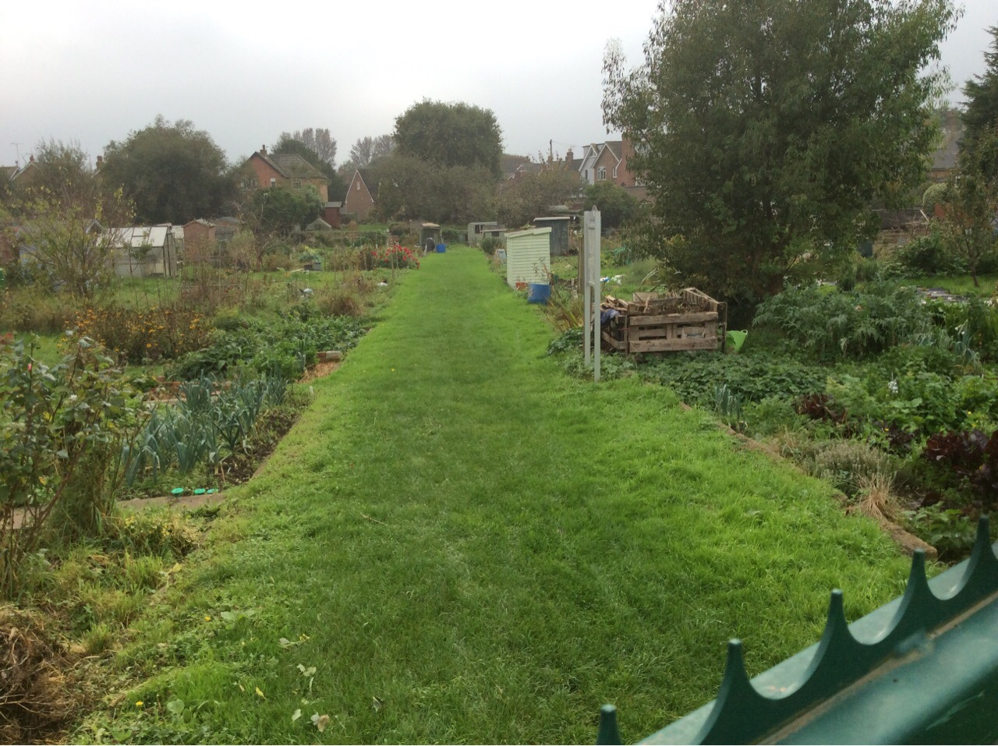

Allotments provide areas for people to grow their own produce and plants. It is important to be clear about what is meant by the term ‘Allotment’. The Small Holdings and Allotments Act 1908 obliged local authorities to provide sufficient allotments and to let them to persons living in their areas where they considered there was a demand. The Allotment Act of 1922 defines the term ‘allotment garden’ as:

“an allotment not exceeding 40 poles in extent which is wholly or mainly cultivated by the occupier for the production of vegetable or fruit crops for consumption by himself or his family”

The Allotments Act of 1925 gives protection to land acquired specifically for use as allotments, so called Statutory Allotment Sites, by the requirement for the need for the approval of Secretary of State in event of sale or disposal. Some allotment sites may not specifically have been acquired for this purpose. Such allotment sites are known as “temporary” (even if they have been in use for decades) and are not protected by the 1925 legislation.

5.1.2 Amenity Green Space

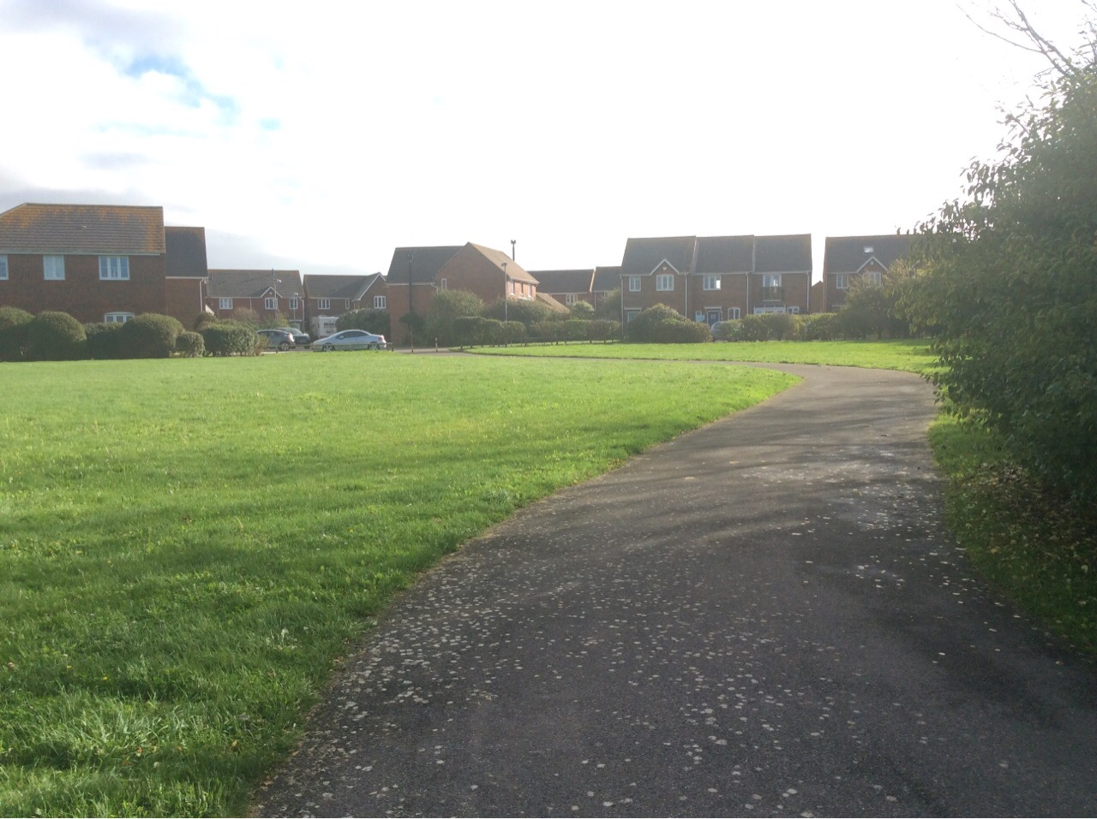

The category is considered to include those spaces (minimum 0.15 ha in size) open to free and spontaneous use by the public, but neither laid out nor managed for a specific function such as a park, public playing field or recreation ground; nor managed as a natural or semi-natural habitat. These areas of open space will be of varied size, but are likely to share the following characteristics:

- Unlikely to be physically demarcated by walls or fences.
- Predominantly lain down to (mown) grass.
- Unlikely to have identifiable entrance points (unlike parks).
- They may have shrub and tree planting, and occasionally formal planted flower beds.
- They may occasionally have other recreational facilities and fixtures (such as play equipment or ball courts).

Examples might include both small and larger informal grassed areas in housing estates and general recreation spaces. They can serve a variety of functions dependent on their size, shape, location and topography. Some may be used for informal recreation activities, whilst others by themselves, or else collectively, contribute to the overall visual amenity of an area.

It should be noted that amenity green spaces smaller than 0.15 ha are not included within the analysis for this typology, as it is considered that these sites will have limited recreation function and therefore should not count towards open space provision.

5.1.3 Park and Recreation Grounds

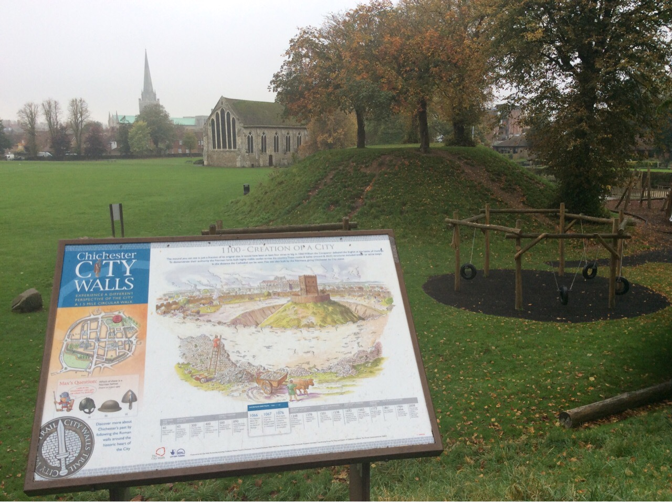

This typology brings together the function of Parks and Recreation Grounds and Outdoor Sports Space as identified in the former PPG17 typology. The distinction between the two typologies in the study area is blurred, with very few formal gardens and many parks and/or outdoor sports space having multi-functions used for both informal and formal recreation. The consultation undertaken indicated that people refer to their local park or rec, and communities do not make a distinction between outdoor sports space and parks and recreation grounds. Therefore, for the study an overarching typology for Park and Recreation Grounds has been used.
For the purpose of this study, a Park and Recreation Ground is defined as an open space that:

- Has at least two facilities e.g. a children’s play area and tennis courts, or;
- Has provision for formal sport e.g. football or cricket pitch (informal football would be excluded);
- Includes private sports grounds where there is open public access i.e. although it is private (e.g. managed by a football club), access is allowed for informal recreation.

Those outdoor sports grounds which have no public access at all have been mapped as Outdoor Sport (Private), as set out in Section 5.1.7.

This typology comprises the general open space surrounding play areas, sports facilities etc. used for general recreation and includes those areas laid out as pitches which are accessible i.e. they can be walked over/used informally i.e. pitches have not been mapped separately, as the assessment of these facilities is included within the separate Playing Pitch Study. Pitches which have no access e.g. they are fenced off/privately managed have been mapped as Outdoor Sport (Private) and are not included within the quantity analysis for parks and recreation grounds.

The quantity analysis for Parks and Recreation Grounds also includes fixed outdoor sports space (comprising all other non-pitch based provision including tennis courts, outdoor gyms and bowling greens) which are publicly accessible/available to book (these types of facilities have been mapped separately as Outdoor Sport Space (Fixed). Those facilities that are managed by a club and are not freely accessible are mapped as Outdoor Sport (Private) and are not included within the quantity analysis (see Section 5.1.7).

The quantity figure for Parks and Recreation Grounds excludes the provision of children and youth play spaces which have a separate typology and have been mapped separately (see Section 5.1.4).

Parks and Recreation Grounds take on many forms, and may embrace a wide range of functions including:

- Play space of many kinds;
- Provision for a range of formal pitch and fixed sports;
- Informal recreation and sport;
- Providing attractive walks and cycle routes to work;
- Offering landscape and amenity features;
- Areas of formal planting;
- Providing areas for ‘events’;
- Providing habitats for wildlife;
- Providing areas for community food growing;
- Dog walking.

5.1.4 Play Space (Children and Youth)

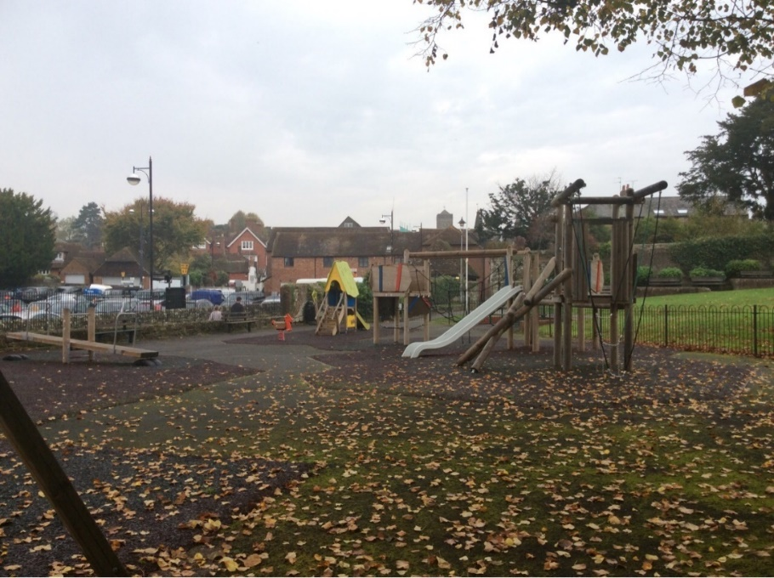 | 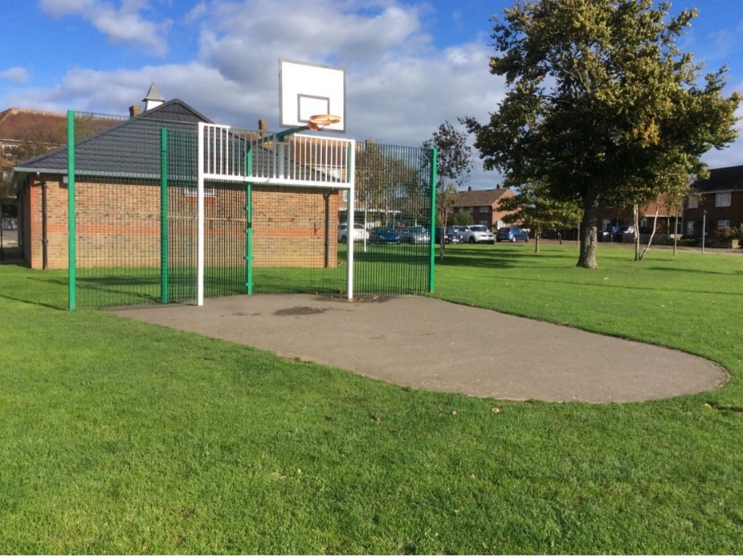

It is important to establish the scope of the Study in terms of this type of open space. Children and young people will play/’hang out’ in almost all publicly accessible “space” ranging from the street, town centres and squares, parks, playing fields, “amenity” grassed areas etc. as well as the more recognisable play and youth facility areas such as equipped playgrounds, youth shelters, BMX and skateboard parks and Multi Use Games Areas (MUGAs) etc. Clearly many of the other types of open space covered by this Study will therefore provide informal play opportunities.

To a child, the whole world is a potential playground: where an adult sees a low wall, a railing, kerb or street bench, a child might see a mini adventure playground or a challenging skateboard obstacle. Play should not be restricted to designated ‘reservations’ and planning and urban design principles should reflect these considerations. However, there are a number of recognised types of play area including Local Areas for Play (LAPs), Local Equipped Areas for Play (LEAPs), Neighbourhood Equipped Areas for Play (NEAPs), school playgrounds, informal ball courts, and ‘hang out’ areas.

The Study has recorded the following:

- Children’s Play Space: Equipped areas of play that cater for the needs of children up to and around 12 years of age.
- Youth Play Space: informal recreation opportunities for, broadly, the 13 to 16/17 age group, and includes skateboard parks, BMX tracks, basketball courts and ‘free access’ MUGAs.

In practice, there will always be some blurring around the edges in terms of younger children using equipment aimed for youths and vice versa.

5.1.5 Accessible Natural Green Space
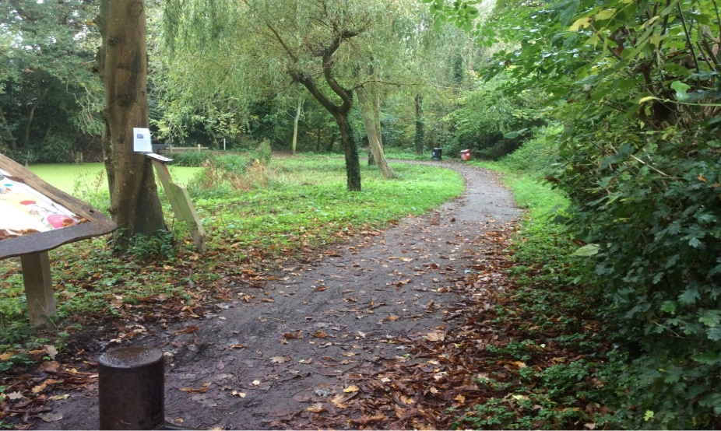
For the purpose of this study, natural and semi-natural green space covers a variety of spaces including meadows, woodland, copses, river valleys and lakes all of which share a trait of having natural characteristics and biodiversity value and are also partly or wholly accessible for informal recreation.

The nature of the geography of Chichester means there are large tracts of open countryside, much of this is private land used for farming, however, there is significant access to the countryside provided through the rights of way network. It was not the intention of this audit to survey and map all these areas, but to focus on sites where there are definitive boundaries or areas of natural green space which have some form of public access.

Access to these spaces may be provided via statutory rights of access or permissive codes allowing the public to wander freely, or via defined Rights of Way or permissive routes running through them. In some cases, access may not be fully clear, however, there is evidence of some level of informal use and access.

Some sites may provide access in different ways; for example, rivers or lakes are often used for water recreation (e.g. canoeing, fishing, sailing). Whilst access may not be available fully across all areas of these sites (e.g. the middle of a lake or dense scrub in a woodland), the whole site has been included within the assessment.

Some natural spaces were found to have no access at all, and whilst they cannot be formally used by the general community, they can be appreciated from a distance, and contribute to visual amenity, green infrastructure and biodiversity. Whilst every effort was made to exclude these spaces from the assessment, as already identified, in certain sites access was not always clear.

The local consultation and research elsewhere (Natural England)) have identified the value attached to natural spaces for recreation and emotional well-being. A sense of ‘closeness to nature’ with its attendant benefits for people is something that is all too easily lost in urban areas. Natural green spaces can make important contributions towards local Biodiversity Action Plan targets and can also raise awareness of biodiversity values and issues.

Open space typologies with no standards

5.1.6 Education

Many schools and colleges have open space and sports facilities within their grounds. This may range from a small playground to large playing fields with several sports pitches. More often than not, public access to these spaces is restricted and, in many cases, forbidden. Nevertheless, many of the sports facilities are used by local people on both an informal and formal basis.

Sports clubs may have local informal arrangements with a school to use their pitches, and in some cases more formal ‘dual use’ agreements may be in place. School grounds can also contribute towards the green infrastructure and biodiversity of an area.

Quantity and access standards have not been proposed for education sites. This is because they are not openly accessible to the public and whilst important to the local community, there is less opportunity for the Council to influence their provision and management. Furthermore, community access to education sites is assessed within the separate playing pitch strategy for Chichester.

5.1.7 Outdoor Sport (Private)

Outdoor sports spaces with no public access (e.g. private sports grounds), have also been recorded and mapped where known. Private sport space makes up an important part of outdoor sports provision across the District and forms an important part of the community facilities. The private sports spaces have been mapped separately to publicly accessible sites, to determine the provision of the different types of provision.

This typology includes golf courses, where more often than not, public access is restricted. Nevertheless, these facilities are used by local people, and they form part of the Green Infrastructure network. This typology also includes fixed outdoor sports spaces (including tennis courts and bowling greens) which are privately managed, and not accessible.

No quantity or access standards for provision have been set, as it is outside the scope of this study to make recommendations related to requirements for new provision. The separate playing pitch strategy and built leisure facilities strategy covers this typology in more detail.

5.1.8 Churchyards and Cemeteries

The District has numerous churches and cemeteries, and these provide significant aesthetic value and space for informal recreation such as walking and relaxing. Many are also important in terms of biodiversity. Their importance for informal recreation, aesthetic value and contribution towards biodiversity must be acknowledged, and as such, investment in their upkeep, maintenance and quality is an important factor. Churchyards and Cemeteries have been identified and mapped where known, however, no quantity or access standard for provision have been set, as it is outside the scope of this study to make recommendations related to requirements for new provision.

5.1.9 Beach and Headland

The southern part of the district borders some fine coastland, including beaches and harbours which are important for biodiversity, recreation and tourism. The coastline differs in its character, from shingle ridges, sandy beaches, salt marsh and harbours. The coastline includes some internationally important sites for biodiversity and are afforded high levels of protection and designation. Whilst no specific quantity or access standards are proposed for this typology, the study does include an assessment of the resource.

5.2 Existing provision of open space
5.2.1 Provision across the Chichester Local Plan Area

The following table shows the average existing provision of open space in hectares and hectares per thousand population across the Local Plan area.

Table 7 Summary of existing provision of open space across the Chichester Local Plan Area
Typology | Number of Sites | Ha | Ha/1000
Allotments | 26 | 15.22 | 0.16
Amenity Green Space (>0.15Ha) | 68 | 85.92 | 0.88
Parks and Recreation Grounds | 44 | 103.35 | 1.05
Outdoor Sport (Fixed) | 28 | 2.49 | 0.03
Play Space (Child) | 88 | 4.80 | 0.05
Play Space (Youth) | 32 | 1.13 | 0.01
Accessible Natural Green Space | 36 | 1302.55 | 13.27
Churchyards and Cemeteries | 50 | 28.95 | 0.29
Education | 50 | 186.73 | 1.90
Outdoor Sport (Private) | 25 | 188.88 | 1.92
Beaches and Headlands | 3 | 122.51 | 1.25

The following tables show the existing provision of open space in hectares (Table 8) and ha/1000 population (Table 9) for each of the Parishes in the Local Plan area.

The figures for ‘Park and Recreation Grounds (combined)’ include a combination of the following typologies:

- Park and Recreation Grounds; and
- Outdoor Sport (Fixed).

5.2.2 Mapping of open space

For each of the sub areas (see Figure 1 and part 2 of this report), a map showing the provision of open space has been provided. A GIS database of all sites has also been provided to the council.
Table 8 Existing provision of open space by Parish (hectares)
Parish | Allotments | Amenity Green Space > 0.15Ha | Parks and Recreation Grounds (Combined) | Parks and Recreation Grounds | Outdoor Sport (Fixed) | Play Space (Child) | Play Space (Youth) | Accessible Natural Green Space | Churchyards and Cemeteries | Education | Outdoor Sport (Private) | Beaches and Headlands
Appledram | 0 | 0 | 0.00 | 0 | 0 | 0 | 0 | 0 | 0.22 | 0 | 0 | 0
Birdham | 0 | 0 | 2.46 | 2.46 | 0 | 0.12 | 0 | 0 | 0.35 | 1.34 | 1.81 | 0
Bosham | 0 | 0.86 | 1.03 | 1.03 | 0 | 0.1 | 0.01 | 0.49 | 1.28 | 0.36 | 1.8 | 0
Boxgrove | 0 | 0.01 | 1.95 | 1.95 | 0 | 0.04 | 0.01 | 0 | 0.73 | 1.18 | 0 | 0
Chichester | 6.88 | 32.56 | 45.44 | 44.29 | 1.15 | 1.52 | 0.19 | 10.03 | 10.36 | 65.74 | 2.97 | 0
Chidham and Hambrook | 0.06 | 5.33 | 0.00 | 0 | 0 | 0.12 | 0 | 3.36 | 0.19 | 0.57 | 0 | 0
Donnington | 0 | 3.03 | 0.36 | 0.36 | 0 | 0.13 | 0.02 | 0 | 0 | 0 | 0 | 0
Earnley | 0 | 0 | 0.00 | 0 | 0 | 0 | 0 | 0 | 0 | 0 | 0 | 4.68
Eartham | 0 | 0 | 0.00 | 0 | 0 | 0 | 0 | 92.16 | 0.22 | 6.26 | 0 | 0
East Wittering | 0 | 1.28 | 5.64 | 5.5 | 0.14 | 0.13 | 0.09 | 0 | 0.21 | 3.82 | 0 | 12.5
Ebernoe | 0 | 0 | 0.82 | 0.82 | 0 | 0 | 0 | 135 | 0.11 | 0 | 0 | 0
Fishbourne | 0 | 0.59 | 5.96 | 5.38 | 0.58 | 0.1 | 0.05 | 0 | 0.4 | 1.36 | 0 | 0
Funtington | 0 | 1.49 | 0.00 | 0 | 0 | 0.02 | 0 | 42.01 | 1.13 | 8.18 | 1.18 | 0
Hunston | 0.67 | 0 | 1.80 | 1.8 | 0 | 0.12 | 0.1 | 0 | 0.28 | 0 | 0 | 0
Kirdford | 0 | 1.18 | 2.49 | 2.43 | 0.06 | 0.03 | 0.01 | 129.58 | 0.87 | 0 | 0 | 0
Lavant | 0.98 | 4.38 | 0.00 | 0 | 0 | 0.18 | 0.03 | 29.69 | 0.56 | 2.7 | 57.64 | 0
Linchmere | 0.21 | 2.22 | 2.26 | 2.26 | 0 | 0.17 | 0.03 | 373.82 | 0.55 | 26.27 | 3.35 | 0
Loxwood | 0 | 1.16 | 3.92 | 3.92 | 0 | 0.13 | 0 | 41.4 | 0.89 | 0.83 | 0.77 | 0
North Mundham | 0 | 0 | 2.29 | 2.18 | 0.11 | 0.08 | 0.04 | 0 | 0.54 | 0.82 | 0 | 0
Northchapel | 0.48 | 1.71 | 0.00 | 0 | 0 | 0.07 | 0 | 2.24 | 0.48 | 0.46 | 0 | 0
Oving | 0 | 11.53 | 1.08 | 1.08 | 0 | 0.22 | 0.07 | 0 | 0.32 | 39.35 | 0 | 0
Petworth | 1.71 | 1.8 | 4.27 | 4.27 | 0 | 0.14 | 0.02 | 146.81 | 2.73 | 4.35 | 0.52 | 0
Plaistow | 0 | 0.27 | 2.68 | 2.68 | 0 | 0.08 | 0 | 2.6 | 0 | 1.05 | 20.52 | 0
Selsey | 0.3 | 3.54 | 5.42 | 5.42 | 0 | 0.28 | 0.29 | 1.21 | 1.36 | 8.37 | 27.04 | 22.73
Sidlesham | 0 | 0 | 2.56 | 2.55 | 0.01 | 0.09 | 0 | 0 | 0.67 | 0.99 | 0 | 0
Southbourne | 0.08 | 0 | 1.96 | 1.96 | 0 | 0.22 | 0 | 0 | 0 | 8.56 | 0.13 | 0
Stoughton | 0 | 0.16 | 0.00 | 0 | 0 | 0 | 0 | 270.63 | 0.07 | 0 | 3.19 | 0
Tangmere | 0.8 | 1.89 | 3.52 | 3.41 | 0.11 | 0.2 | 0.11 | 0.4 | 0.31 | 1.22 | 0 | 0
West Itchenor | 0 | 0 | 0.00 | 0 | 0 | 0 | 0 | 0.98 | 0.14 | 0 | 1.38 | 0
West Thorney | 0 | 0 | 0.00 | 0 | 0 | 0 | 0 | 0 | 0 | 0 | 0 | 0.17
West Wittering | 1.14 | 1.47 | 3.88 | 3.56 | 0.32 | 0.09 | 0 | 0 | 0.92 | 0.61 | 0.39 | 82.43
Westbourne | 1.52 | 0 | 2.11 | 2.1 | 0.01 | 0.13 | 0.06 | 0 | 2.15 | 0.64 | 1.02 | 0
Westhampnett | 0 | 8.38 | 0.00 | 0 | 0 | 0.29 | 0 | 0 | 0 | 0.77 | 63.68 | 0
Wisborough Green | 0.39 | 1.08 | 1.94 | 1.94 | 0 | 0 | 0 | 20.14 | 0.91 | 0.93 | 1.49 | 0
Study area wide | 15.22 | 85.92 | 105.84 | 103.35 | 2.49 | 4.80 | 1.13 | 1302.55 | 28.95 | 186.73 | 188.88 | 122.51

Table 9 Existing provision of open space in Parishes (ha per 1000 population)

Parish | Allotments | Amenity Green Space > 0.15Ha | Parks and Recreation Grounds (Combined) | Parks and Recreation Grounds | Outdoor Sport (Fixed) | Play Space (Child) | Play Space (Youth) | Accessible Natural Green Space | Churchyards and Cemeteries | Education | Outdoor Sport (Private) | Beaches and Headlands
Appledram | 0.00 | 0.00 | 0.00 | 0.00 | 0.00 | 0.00 | 0.00 | 0.00 | 1.04 | 0.00 | 0.00 | 0.00
Birdham | 0.00 | 0.00 | 1.51 | 1.51 | 0.00 | 0.07 | 0.00 | 0.00 | 0.22 | 0.82 | 1.11 | 0.00
Bosham | 0.00 | 0.30 | 0.36 | 0.36 | 0.00 | 0.03 | 0.00 | 0.17 | 0.44 | 0.12 | 0.62 | 0.00
Boxgrove | 0.00 | 0.01 | 2.02 | 2.02 | 0.00 | 0.04 | 0.01 | 0.00 | 0.76 | 1.22 | 0.00 | 0.00
Chichester | 0.24 | 1.12 | 1.56 | 1.52 | 0.04 | 0.05 | 0.01 | 0.34 | 0.35 | 2.25 | 0.10 | 0.00
Chidham and Hambrook | 0.03 | 2.87 | 0.00 | 0.00 | 0.00 | 0.06 | 0.00 | 1.81 | 0.10 | 0.31 | 0.00 | 0.00
Donnington | 0.00 | 1.05 | 0.12 | 0.12 | 0.00 | 0.04 | 0.01 | 0.00 | 0.00 | 0.00 | 0.00 | 0.00
Earnley | 0.00 | 0.00 | 0.00 | 0.00 | 0.00 | 0.00 | 0.00 | 0.00 | 0.00 | 0.00 | 0.00 | 7.52
Eartham | 0.00 | 0.00 | 0.00 | 0.00 | 0.00 | 0.00 | 0.00 | 801.39 | 1.91 | 54.43 | 0.00 | 0.00
East Wittering | 0.00 | 0.26 | 1.15 | 1.12 | 0.03 | 0.03 | 0.02 | 0.00 | 0.04 | 0.78 | 0.00 | 2.56
Ebernoe | 0.00 | 0.00 | 3.87 | 3.87 | 0.00 | 0.00 | 0.00 | 636.79 | 0.52 | 0.00 | 0.00 | 0.00
Fishbourne | 0.00 | 0.23 | 2.33 | 2.10 | 0.23 | 0.04 | 0.02 | 0.00 | 0.16 | 0.53 | 0.00 | 0.00
Funtington | 0.00 | 0.96 | 0.00 | 0.00 | 0.00 | 0.01 | 0.00 | 27.19 | 0.73 | 5.29 | 0.76 | 0.00
Hunston | 0.52 | 0.00 | 1.38 | 1.38 | 0.00 | 0.09 | 0.08 | 0.00 | 0.22 | 0.00 | 0.00 | 0.00
Kirdford | 0.00 | 1.11 | 2.34 | 2.29 | 0.06 | 0.03 | 0.01 | 121.90 | 0.82 | 0.00 | 0.00 | 0.00
Lavant | 0.54 | 2.43 | 0.00 | 0.00 | 0.00 | 0.10 | 0.02 | 16.49 | 0.31 | 1.50 | 32.02 | 0.00
Linchmere | 0.09 | 0.96 | 0.98 | 0.98 | 0.00 | 0.07 | 0.01 | 161.90 | 0.24 | 11.38 | 1.45 | 0.00
Loxwood | 0.00 | 0.72 | 2.43 | 2.43 | 0.00 | 0.08 | 0.00 | 25.71 | 0.55 | 0.52 | 0.48 | 0.00
North Mundham | 0.00 | 0.00 | 1.42 | 1.35 | 0.07 | 0.05 | 0.02 | 0.00 | 0.33 | 0.51 | 0.00 | 0.00
Northchapel | 0.57 | 2.03 | 0.00 | 0.00 | 0.00 | 0.08 | 0.00 | 2.66 | 0.57 | 0.55 | 0.00 | 0.00
Oving | 0.00 | 7.00 | 0.66 | 0.66 | 0.00 | 0.13 | 0.04 | 0.00 | 0.19 | 23.89 | 0.00 | 0.00
Petworth | 0.55 | 0.58 | 1.38 | 1.38 | 0.00 | 0.05 | 0.01 | 47.39 | 0.88 | 1.40 | 0.17 | 0.00
Plaistow | 0.00 | 0.14 | 1.34 | 1.34 | 0.00 | 0.04 | 0.00 | 1.30 | 0.00 | 0.53 | 10.29 | 0.00
Selsey | 0.03 | 0.33 | 0.51 | 0.51 | 0.00 | 0.03 | 0.03 | 0.11 | 0.13 | 0.78 | 2.53 | 2.13
Sidlesham | 0.00 | 0.00 | 2.06 | 2.05 | 0.01 | 0.07 | 0.00 | 0.00 | 0.54 | 0.80 | 0.00 | 0.00
Southbourne | 0.01 | 0.00 | 0.29 | 0.29 | 0.00 | 0.03 | 0.00 | 0.00 | 0.00 | 1.26 | 0.02 | 0.00
Stoughton | 0.00 | 0.29 | 0.00 | 0.00 | 0.00 | 0.00 | 0.00 | 491.16 | 0.13 | 0.00 | 5.79 | 0.00
Tangmere | 0.25 | 0.60 | 1.11 | 1.08 | 0.03 | 0.06 | 0.03 | 0.13 | 0.10 | 0.39 | 0.00 | 0.00
West Itchenor | 0.00 | 0.00 | 0.00 | 0.00 | 0.00 | 0.00 | 0.00 | 3.18 | 0.45 | 0.00 | 4.48 | 0.00
West Thorney | 0.00 | 0.00 | 0.00 | 0.00 | 0.00 | 0.00 | 0.00 | 0.00 | 0.00 | 0.00 | 0.00 | 0.14
West Wittering | 0.45 | 0.57 | 1.52 | 1.39 | 0.13 | 0.04 | 0.00 | 0.00 | 0.36 | 0.24 | 0.15 | 32.21
Westbourne | 0.66 | 0.00 | 0.92 | 0.92 | 0.00 | 0.06 | 0.03 | 0.00 | 0.94 | 0.28 | 0.45 | 0.00
Westhampnett | 0.00 | 7.80 | 0.00 | 0.00 | 0.00 | 0.27 | 0.00 | 0.00 | 0.00 | 0.72 | 59.24 | 0.00
Wisborough Green | 0.27 | 0.76 | 1.37 | 1.37 | 0.00 | 0.00 | 0.00 | 14.19 | 0.64 | 0.66 | 1.05 | 0.00
Study area wide | 0.16 | 0.88 | 1.08 | 1.05 | 0.03 | 0.05 | 0.01 | 13.27 | 0.29 | 1.90 | 1.92 | 1.25

6.0 THE DEVELOPMENT OF STANDARDS

6.1 Introduction

Updated local quantity standards have been recommended (updating those recommended as part of the 2017/18 Study), drawing on the updated GIS mapping and quantity analysis, policy/strategy review, findings of previous studies and consultation and national standards and benchmarks. This section explains how the quantity standards for the Chichester Local Plan Area have been developed and provides specific information and justification for each of the typologies where standards have been proposed.

Key changes in the evidence base since 2018

Updated mapping
The open space mapping has been updated in accordance with information provided by the council in Jan 2024, to take account of new open space delivered through development.

Updated population figures
Mid 2020 population figures have been used as the most up-to-date population figures at the time of the Study update. Together with the updated mapping, this has resulted in updated levels of provision for each open space typology.

Policy and strategy changes
These are covered in more detail in Section 3 of this report, but some of the key headlines include:
- Covid 19 pandemic and health and wellbeing – There is increasing evidence highlighting the importance of access to high quality public open space for both physical and mental health, as well as in tackling health inequalities e.g. Public Health England Report: Improving access to greenspace – A new review for 2020.
- Climate and nature emergency and the Environment Act 2021 – emphasizing the importance of open space in helping to tackle the climate and nature emergencies and setting out legal requirements for biodiversity net gain through new development, local nature recovery strategies and an enhanced duty for local authorities to conserve and enhance biodiversity.
- Natural England Green Infrastructure Standards – setting out new standards for green infrastructure – includes that local authorities should have at least 3 hectares of publicly accessible greenspace per 1,000 population.

The accessibility standards developed as part of the 2017/18 Study have been carried forward in this Open Space Study Update. The justification for these is also set out below. No updates to the quality assessment/standards from the 2017/18 Study have been undertaken.

The standards for open space have been developed in-line with the NPPF. Standards comprise the following components:

- Quantity standards (revised in 2024): These are determined by the analysis of existing quantity, consideration of existing local and national standards and benchmarks and evidence gathered from the local needs assessment. It is important that quantity standards are locally derived and are realistic and achievable. The recommended standards need to be robust, evidence-based and deliverable through new development and future mechanisms of contributions through on-site provision and the Community Infrastructure Levy (CIL).

- Accessibility standards (carried forward from 2017/18 Study): These reflect the needs of potential users. Spaces likely to be used on a frequent and regular basis need to be within easy walking distance and to have safe access. Other facilities where visits are longer but perhaps less frequent, for example country parks, can be further away. Consideration is also given to existing local or national standards and benchmarks.

- Quality standards (carried forward from 2017/18 Study): The standards for each form of provision are derived from the quality audit, existing good practice and from the views of the community and those that use the spaces. Again, quality standards should be achievable and reflect the priorities that emerge through consultation.

The principles behind applying the standards

The standards are explained and justified in more detail below. The efficacy of standards will depend heavily on the way that they are applied. Here are some important and interrelated principles:

- The standards that have been proposed are for minimum guidance levels of provision. So, just because geographical areas may enjoy levels of provision exceeding minimum standards does not mean there is a surplus, as all such provision may be well used.
- An inability to provide sufficient quantity might be at least partly compensated for through better quality and access. Investment in the quality and robustness of open space can also often improve the ‘carrying capacity’ of open spaces and therefore offset some shortcomings in quantitative provision.
- New and improved open space should be designed to optimise multi-functionality to benefit both people and nature/the wider environment e.g., offering wildlife habitats, flood management opportunities, providing recreation opportunities etc. Wherever possible it should heighten residents’ overall appreciation, understanding of, and respect for that environment so it becomes an important and valued local resource. Good practice guidance for the design of high-quality green space should draw on best practice guidance such as the Green Flag Award guidance, the Building with Nature Benchmark, and Natural England’s Green Infrastructure Standards Framework.
- Standards will need to be applied to a variety of circumstances, and flexibility of interpretation is the key to success. A pragmatic approach will be essential given the range of circumstances in which they will be used.

6.2 Allotments

Summary of quantity and access standard

Table 10 Quantity and access standards for allotments
Quantity Standard | Access Standard
0.30 ha/1000 population | 600m straight line (12-13 minutes’ walk time)

Existing national or local standards

National standards for allotments and other such open spaces are difficult to find. The closest thing to such standards appears to be those set out by the National Society of Allotment and Leisure Gardeners (NSALG). These are as follows:

- Standard Plot Size = 330 sq yards (250sqm)
- Paths = 1.4m wide for disabled access
- Haulage ways = 3m wide
- Plotholders shed = 12sqm
- Greenhouse = 15sqm
- Polytunnel = 30sqm

The open space assessment (2013) recommended the following local standards for allotments:

- Quantity: 0.40 ha per 1000 population for main settlements and proposed housing growth areas, and 0.30 ha per 1000 population for all other areas.
- Access: 480m (10 minutes straight line walk time).

The 2017/18 open space assessment recommended a single quantity standard of 0.3ha per 1000 population and an access standard of 600m (12 – 13 minutes’ walk time).

Quantity standard for allotments

- The average level of provision across the study area is 0.16ha/1000 population (the average level of provision in 2017 was also 0.16ha/1000 population).
- Numerous Parishes have no provision, of those that do have allotments, the level of provision varies significantly.
- The 2017 household survey identified that 48% of people felt there should be more allotments, however, 45% felt there are enough.
- The continuing trend for smaller gardens in new development is likely to increase demand.
- Since 2018, there is increasing evidence around the considerable social cohesion and health and wellbeing benefits that allotments and community food growing areas can provide, as well as climate change mitigation and adaptation, providing space for nature and local and sustainable food production.
- It is therefore considered that a standard in accordance with the 2013 and 2018 study is justified, which is significantly higher than the average level of provision. It is recommended that a single standard of 0.3ha/1000 population is applied across the study area, which is considered to be achievable and deliverable.
- It is considered that the allotment standard would be used flexibly to meet local needs – for example, in some areas the standard might be used to deliver other types of community food growing, such as community orchards; unfenced growing plots e.g., within open spaces; and urban farms.

Access standard for allotments

- Responses received from the 2017 household survey in relation to acceptable travel times to allotments from the household survey identified a mix in responses, with 22% wanting allotments within 5 minutes, 36% within 10 minutes, 22% within 15 minutes and 11% up to 20 minutes; of this, 40% walk to allotments and 38% drive.
- It is considered that the availability of allotments is more important than having them very close to home, nevertheless there is some demand for facilities relatively nearby.
- Natural England’s GI Standards Framework recommends that everyone should have access to green and blue spaces within 15 minutes’ walk from home.
- Therefore, a standard of no more than 12-13 minutes’ walk time (600 metres straight line) remains justified.

Quality standards for allotments

The 2017 household survey identified that 8% and 31% of people felt allotments were very good or good, whilst the majority (42%) felt they were average. Compared to other typologies of open space, fewer comments were received in relation to the quality of allotments, furthermore the information gathered in relation to allotments is more difficult to assess in comparison to other types of open space. The reason for this is twofold:
- firstly, the number of people who actually use allotments is low compared to the numbers who use other types of open space and, therefore specific comments related to the quality of allotments are less frequent;
- and secondly, the majority of allotments sites are locked, and the 2017 quality audit only allows for assessment against key criteria such as the level of cultivation and general maintenance, which is less comprehensive than the assessments of other open space.

For allotments, a number of general recommendations are made in relation to quality, which should include the following:

- Well-drained soil which is capable of cultivation to a reasonable standard;
- A sunny, open aspect preferably on a southern facing slope;
- Limited overhang from trees and buildings either bounding or within the site;
- Adequate lockable storage facilities, and a good water supply within easy walking distance of individual plots;
- Provision for composting facilities;
- Secure boundary fencing;
- Good access within the site both for pedestrians and vehicles;
- Good vehicular access into the site and adequate parking and manoeuvring space;
- Disabled access;
- Toilets; and
- Notice boards.

The National Society of Allotments and Leisure Gardeners (NSALG) has set out a guide for designing new allotments – 21st Century Allotments in New Developments. The aims of the guide are to ensure that allotments are productive, inclusive, accessible, and functional to maximise plot numbers and improve biodiversity. They bring together the design outcomes from national design guides, inclusive designs, accessible designs, Building with Nature Benchmark, and active design. It is recommended that all new and improved provision seeks to meet these guidelines.

6.3 Amenity Green Space

Summary of quantity and access standard

Table 11 Quantity and access standards for amenity green space
Quantity Standard | Access Standard
0.65 ha/1000 population | 600 metres straight line (12-13 minutes’ walk time)

Existing national or local standards

The Fields in Trust (Previously known as the National Play Fields Association) Guidance for Outdoor Sport and Play report ‘Beyond the Six Acre Standard’ proposes a benchmark guideline of 0.6ha/1000 population of amenity green space, and a walking distance guideline of 480m. FIT recommend that the quantity guidelines are adjusted to take account of local circumstances.

The 2013 open space assessment (2013) recommended the following local standards for amenity green space (which are adopted within the Local Plan 2014 - 29):

- Quantity: 0.50 ha per 1000 population
- Access: 480m (10 minutes’ walk time).

The 2017/18 open space assessment recommended a quantity standard of 0.6ha per 1000 population and an access standard of 600m (12-13 minutes’ walk time).

Quantity standard for amenity green space
- The average level of provision is 0.88ha/1000 population (for sites above 0.15ha in size). The average level of provision in 2018 was 0.5ha/1000 (for sites above 0.15ha in size).
- Although overall there is an increase in the level of provision of amenity green space compared to that in 2018, provision does vary significantly across Parishes. The majority have low quantities or no provision, with a couple (Westhampnett (7.8ha/1000) and Oving (7ha/1000)) far exceeding the average level of provision which is skewing the figures (when these areas of very high levels of provision are removed, the average level of provision across the study area is 0.65ha/1000).
- Fields in Trust (FIT) Guidance ‘Beyond the Six Acre Standard’ recommends a quantity benchmark of 0.6ha/1000 population for amenity green space.
- The previous open space assessment (2013) set out a quantity standard of 0.5ha/1000 population of amenity green space (which represented a slight increase against the average level of provision at that time).
- The 2017 household survey identified that 58% of people felt there was a need for more informal open space areas, whilst 38% felt there were enough, and therefore recommended a slight increase against existing levels of provision, with a quantity standard of 0.6ha/1000, which also considered the FIT guidance).
- There is increasing evidence of the importance of local access to high quality green space for health and wellbeing.
- With the above in mind, it is recommended that a standard of 0.65ha/1000 population is deliverable and achievable. This is in line with the FIT guidance and a slight increase compared to the 2018 recommendation.
- When delivering new provision, consideration should be given to combining this with the accessible natural green space standard (i.e., a combined standard of 1.85 ha/1000) in order to provide bigger, more biodiverse spaces, in accordance with the NPPF.
- The minimum size of a space that will be considered acceptable and count towards open space provision is recommended to be 0.15 ha in size (about the size of a mini football pitch). This will avoid a proliferation of small amenity spaces which have no real recreation function.

Access standard for amenity green space

- The 2017 household survey identified people want spaces relatively close to home (21% less than 5 mins, 26% less than 10 mins, 26% less than 15 minutes), and that the majority of people access these spaces by foot (55%).
- It is considered that amenity green spaces/informal open spaces provide important local access to open space close to home.
- Natural England’s GI Standards Framework recommends that everyone should have access to green and blue spaces within 15 minutes’ walk from home.
- It is therefore considered that a standard of 600 metres (12-13 minutes’ walk time) remains justified.

Quality standards for amenity green space

The 2017 household survey identified that 11% of people felt this type of provision was very good, 32% good and 44% average. 13% stated poor or very poor.

The value of informal/amenity green space must be recognised especially within housing areas, where it can provide important local opportunities for play, exercise, visual amenity, and biodiversity that are almost immediately accessible. It is important to strike the correct balance between having accessible and attractive space to meet the needs of the community and having too much which may be difficult to manage properly and therefore a potential liability and source of nuisance. It is important that amenity green space should be capable of use for at least some forms of public recreation activity.

It is therefore recommended that in addition to the minimum size threshold identified above (0.15ha), that all amenity green space should be subject to landscape design, ensuring the following quality principles:

- Capable of supporting informal recreation such as a kickabout, space for dog walking or space to sit and relax;
- Include high quality planting of trees and/or shrubs to create landscape structure and biodiversity value;
- Include paths along main desire lines (lit where appropriate);
- Be designed to ensure safety and personal security; and
- Be designed to ensure easy maintenance.

6.4 Parks and Recreation Grounds

Table 12 Quantity and access standards for parks and recreation grounds
Quantity Standard | Access Standard
1.2 ha/1000 population | 600m straight line (12-13 minutes’ walk time).

Existing national and local policies

The Fields in Trust (FIT) Guidance for Outdoor Sport and Play report ‘Beyond the Six Acre Standard’ proposes a benchmark guideline of 0.80ha/1000 population for parks and gardens, with a walking distance guideline of 710m. In addition to this they also recommend the following standards:

- Playing pitches: 1.20ha/1000 population with a walking distance of 1,200m
- All outdoor sports: 1.6ha/1000 population with a walking distance of 1,200m

FIT also accepts the importance of developing locally researched standards.

The 2013 open space assessment recommended the following local standards for Parks, Sport and Recreation Grounds (public and private provision combined) (which are adopted within the Local Plan 2014 - 29):

- Quantity: 1.6 ha per 1000 population
- Access: 600m (12-13 minutes’ walk time).

The 2017/18 assessment recommended quantity standard for parks and recreation grounds was 1.2ha/1000 population (for public parks only, not combined with private provision). The recommended access standard was 600m (12 – 13 minutes’ walk time).

Quantity of parks and recreation grounds

- The average level of provision is 1.08ha/1000 population plus an additional 1.92ha/1000 population of outdoor sport private (excluding golf). (The average level of provision in 2018 was 1.01ha/1000 plus an additional 0.26 outdoor sport private (excluding golf).
- Provision by parish varies significantly.
- The 2017 household survey identified found that 53% of respondents felt there was a need for more local recreation grounds/parks whilst 43% felt there were enough.
- Research is increasingly evidencing how parks and green spaces deliver multiple benefits including for health and wellbeing, climate change mitigation and adaptation and nature recovery.
- Considering the above, a standard of 1.2ha/1000 population is recommended for public parks and recreation grounds (in line with the 2018 recommendation), representing an increase against the existing average levels of provision of publicly accessible parks and recreation grounds. This would provide a reasonable baseline to assess current levels of provision and to inform the requirements from new development.
- The recommended standards for this typology are intended to provide sufficient space. The Playing Pitch Strategy deals with some of the details, i.e. supply of pitches and how they will be laid out.
- Whilst no standards are proposed for privately managed facilities, the value of this provision for community use is recognised, and it is therefore recommended that appropriate policy is adopted to afford protection to these spaces within the local plan.

Access standard for parks and recreation grounds

- Natural England’s GI Standards Framework recommends that everyone should have access to green and blue spaces within 15 minutes’ walk from home.
- The 2017 household survey identified that 57% of people walk and 23% drive to local parks and recreation grounds, and that 24% travel up to 5 minutes, 32% up to 10 minutes and 22% up to 15 minutes. For outdoor playing fields, 31% of people walk and 47% use the car, of this, 15% travel up to 5 minutes, 29% up to 10 minutes and 25% up to 15 minutes.
- The findings indicate that people do want local parks close to home but are willing to travel further (and even drive) to facilities that have playing pitches and outdoor sport.
- It is therefore considered that an access standard of 600m straight line (12-13 minutes’ walk time) remains justified.

Quality standards for parks and recreation grounds

For local parks and recreation grounds, the 2017 household survey identified that 14% of people felt this type of provision was very good, 42% good and 35% average, the rest (9%) stated facilities were poor or very poor. For outdoor playing fields 8% of people felt this type of provision was very good, 35% good and 40% average, the rest (17%) stated facilities were poor or very poor.

National guidance relevant to this typology is provided in the ‘Green Flag’ quality standard for parks which sets out benchmark criteria for quality open spaces. Recent guidance is also available from Building with Nature and the Natural England Green Infrastructure Standards Framework.
For outdoor sports provision, Sport England and the various national governing bodies of sport have produced a wealth of useful documents outlining the quality standards for facilities such as playing pitches, changing rooms, MUGAs and tennis courts plus associated ancillary facilities. It is recommended that the guidance provided in these documents is adopted by the Council, and that all new and improved provision seeks to meet these guidelines.

6.5 Play Space (children and youth)
Table 13 Quantity and access standards for children's play space and youth play space
Typology | Quantity Standard | Access Standard
Children’s Play Space | 0.075 ha/1000 population | 480m straight line (10 minutes’ walk time)
Youth Play Space | 0.075 ha/1000 population | 720m straight line (15 minutes’ walk time)

Existing National and Local Policies

The Fields in Trust (FIT) Guidance for Outdoor Sport and Play report ‘Beyond the Six Acre Standard’ recommend the following standards:

- Equipped/designated play areas: 0.25ha/1000 population, with a walking distance of 100m for Local Areas for Play (LAPs), 400m for Local Equipped Areas for Play (LEAPs) and 1000m for Neighbourhood Equipped Areas for Play (NEAPs).
- Other outdoor provision (MUGAs and skateboard parks): 0.30ha/1000 population and a walking distance of 700m.

The following minimum size guidelines and buffers are recommended by FIT:
Playable space (LAP type - need not be equipped)
- Minimum active playable space of 100 sq. m (need not be equipped).
- Buffer zone of 5m minimum depth between the active playable space and the nearest dwelling.
Equipped play area (LEAP type)
- Minimum activity zone area of 400 sq. m.
- Buffer zone of not less than 10m in depth between the edge of the equipped activity zone and the boundary of the nearest dwelling and a minimum of 20m between the equipped activity zone and the habitable room facade of the dwelling.
Teen Play including a MUGA (NEAP type)
- Minimum activity zone area of 1000 sq. m divided into two parts; one part containing a range of playground equipment; and the other a hard surface MUGA of at least 465 sq. m.
- Buffer zone of not less than 30m in depth between the activity zone and the boundary of the nearest dwelling. A greater distance may be needed where purpose built skateboarding facilities are provided.
The 2013 open space assessment recommended the following local standards for equipped play space (which are adopted within the Local Plan 2014 - 29):

- Quantity: 0.15 ha per 1000 population
- Access: 480m (10 minutes’ walk time) for children’s play space and 600m (12-13 minutes’ walk time) for youth play space.

The 2017/18 open space assessment recommended a quantity standard of 0.05 ha/1000 for both children’s and youth play space, with an access standard of 480m (10 minutes’ walk time) for children’s play space, and 720m (15 minutes’ walk time) for youth play space.

Quantity standards for play space (children and youth)

- The average level of provision is 0.05ha/1000 population for children’s play space and 0.01ha/1000 population for youth play space. (The average level of provision in 2018 was 0.03ha/1000 of children’s play space and 0.01 ha/1000 population, for youth space).
- The 2017 household survey identified that 53% of people felt there was a need for more children’s play space, and 41% felt there was enough. 66% of people felt there was a need for more youth facilities, with 29% of people identifying there was sufficient provision.
- The FIT guidance ‘Beyond the Six Acre Standard’ recommends provision of 0.25ha/1000 population of equipped/designated play areas and 0.30ha for MUGAs and skateboard parks. These standards are considered high, and difficult to deliver (this is in Ethos’s experience).
- The importance of play is recognised in terms of helping children stay physically active and tackling childhood obesity, and the social and mental health benefits provided. Providing high quality and challenging play opportunities that are accessible to children and young people plays an important role in this.
- Having reviewed the deliverability of the 2018 recommended standard, and considering the adopted 2013 standard, it is recommended that the standards for children and youth play space are increased compared to the 2018 recommendation, with a standard of 0.075ha/1000 population for children’s play space and 0.075ha/1000 population for youth play space. This is in line with the 2013/adopted standard (which is 0.15ha/1000 combined) and aims to provide sufficient space to provide sufficient space for play areas of high play value. This represents an increase against the existing average levels of provision, with a more significant increase in youth play space.
- It is considered that the minimum size of equipped play provision would be 100 sqm (0.01ha). In addition to this, buffer zones (which will take a landscape design approach) will be provided between 5m and 30m, depending on the size of the play area. Proximity to housing requires careful consideration in order to avoid conflict.
- It is also recognised that open space (not only equipped children’s play areas and youth facilities) provides ‘playable space’.

Access standards for play space (children and youth)

- Generally, there is a requirement for children’s play spaces closer to home, due to the reliance on walking, whereas for youth play spaces older children can walk further and will often use other modes of transport such as cycling.
- This is reflected in the FIT ‘Beyond the Six Acre Standard’, which proposes a walking distance guideline of 100m for Local Areas for Play (LAPs), 400m for Local Equipped Areas for Play (LEAPs) and 1000m for Neighbourhood Equipped Areas for Play (NEAPs). For MUGA’s and skateboard parks FIT propose a walking distance guideline of 700m.
- The 2017 household survey identified that for children’s play space 61% of people walk to facilities, and 32% want facilities within 5 minutes, 33% within 10 minutes and 17% within 15 minutes. For teenage facilities, 34% walk, 28% cycle and 23% drive, and 16% want facilities within 5 minutes, 33% within 10 minutes, and 29% within 15 minutes, indicating users are willing to travel slightly further to teenage facilities than children’s facilities.
- It is therefore considered that an access standard of 480m (10 minutes’ walk time) for children’s play space and 720m (15 minutes’ walk time) remain justified.

Quality standards for play

The 2017 household survey identified that 10% of people identified children’s play space as very good, 37% as good, 38% as average, and 9% as poor. For youth facilities, 7% was very good, 21% good, 33% average and 28% poor. This indicates there is less satisfaction with the quality of youth facilities compared to children’s facilities.

It is expected that the design of new play provision would take a landscape design approach (designed to fit its surroundings and enhance the local environment), incorporating play into the overall landscape masterplan for new development, and could include natural play e.g. grassy mounds, planting, logs, and boulders to make a more attractive and playable setting for equipment, and planting which can also help attract birds and other wildlife to literally bring the play space alive. In densely populated urban areas with little or no natural or green space, this more natural approach can help soften the hard, urban landscape.

The challenge for play providers is to provide the best possible play opportunities, and to create play spaces which will attract children, capture their imagination and give them scope to play in new, more exciting, and more creative ways e.g. moving away from fencing play areas (where it is safe to do so), so that the equipment is integrated with its setting, making it feel more inviting to explore and so people are free to use the space without feeling restricted.

In terms of adopting quality standards for children’s and teenage facilities, Play England are keen to see a range of play spaces in all urban environments:

A Door-step spaces close to home
B Local play spaces – larger areas within easy walking distance
C Neighbourhood spaces for play – larger spaces within walking distance
D Destination/family sites – accessible by bicycle, public transport and with car parking.

Moving forward, Play England would like their new Design Guide; ‘Design for Play’ to be referenced and added as a Supplementary Planning Document (SPD) in standard configuration. Play England have also developed a ‘Quality Assessment Tool’ which can be used to judge the quality of individual play spaces. It is recommended that the council considers adopting this as a means of assessing the quality of play spaces. Play England also highlight a potential need for standards for smaller settlements and rural areas where the doorstep, local, neighbourhood, and destination hierarchy is unlikely to be appropriate.

Disability access is also an important issue for Play England, and they would like local authorities to adopt the KIDS publication; ‘Inclusion by Design’ as an SPD. Their most recent guidance document, ‘Better Places to Play through Planning’ gives detailed guidance on setting local standards for access, quantity and quality of playable space and is considered as a background context for the standards suggested in this study.

Make space for girls is a campaign for parks and public spaces to be designed for girls and young women, not just boys and young men. In their ‘Research Background Report (2023)’ they identify that currently provision for young people consists almost entirely of facilities such as skate parks, MUGA (aka fenced pitches) and BMX tracks. These are seen as meeting the needs of all young people when in fact they are places dominated by boys. Girls feel that parks are unsafe, and offer nothing for them, yet these issues are seldom acknowledged or addressed. Race and national heritage, religion, culture, relative deprivation and disability all affect girls’ access to public spaces. Many boys are also not interested in the facilities which are on offer or don’t feel they can access them. Furthermore, improving parks, in particular lighting and toilets, could have benefits for many other groups too, such as older people, women and other marginalised genders, and the disabled. One of the most important actions is to ask girls what they want and provide facilities which they are interested in and will use. Only by doing this can councils, designers and planners find out what girls want from parks, and what the problems are with the current provision.

6.6 Accessible Natural Green Space

Quantity Standard | Access Standard
1.2 ha/1000 population (for new provision) | 15 minutes’ walk time (720m straight line) and Natural England’s Accessible Natural Green Space standards and Woodland Trust’s Woodland Access Standard.

Existing National and Local Policies

Natural England’s National Green Infrastructure Framework (2023) establishes national standards for GI in England. They recommend the following:

Capacity criteria: Local authorities have at least 3 hectares of publicly accessible greenspace per 1,000 population (n.b. not only accessible natural greenspace).
Size and Proximity criteria: The Green Infrastructure Headline Standards states everyone should have access to good quality green and blue spaces close to home for health and wellbeing and contact with nature, to meet the Accessible Greenspace Standards, with an initial focus on access to green and blue spaces within 15 minutes’ walk from home. Those in bold below relate specifically to accessible natural green space.
Within 15 minutes’ walk:
EITHER a Doorstep OR Local Accessible Greenspace
- A doorstep greenspace of at least 0.5ha within 200 metres, or
- A local natural greenspace of at least 2ha within 300 metres walk from home.
AND
- A medium sized neighbourhood natural greenspace (10ha) within 1km.
AND, beyond 15 minutes’ walk:
- A medium/large wider neighbourhood natural greenspace (20ha) within 2km, and
- A large district natural greenspace (100ha) within 5-km, and
- A very large subregional greenspace within (500 ha) within 10 km.

Quality criteria: Accessible greenspace meets the Green Flag Award Criteria, (Ellicott, 2016) and best practice in accessibility for all: By All Reasonable Means: Least restrictive access to the outdoors (The Sensory Trust, 2020).
The Woodland Trust has researched and developed the Woodland Access Standard (WASt) for local authorities to aim for which is written in the Space for People publication. They believe that the WASt can be an important policy tool complimenting other access standards using in delivering green infrastructure for health benefits. The WASt is complimentary to Natural England’s ANGST and is endorsed by Natural England. The Woodland Access Standard recommends:

- that no person should live more than 500m from at least one area of accessible natural woodland of no less than 2ha in size.
- that there should be at least one area of accessible natural woodland of no less than 20ha within 4km (8km round-trip) of people’s homes.

The FIT guidance ‘Beyond the Six Acre Standard’ also recommends a quantity standard of 1.8ha per 1000 population for natural and semi-natural green space, with a walking distance of 720m.
The 2013 open space assessment recommended the following local standards for natural/semi natural green space (which are adopted within the Local Plan 2014 - 29):

- Quantity: 1.0 ha per 1000 population
- Access: 960m straight line (20 minutes’ walk time) and analysis using ANGSt standards.

The 2018 open space assessment recommended a combined standard with amenity green space for new provision, which was 1ha/1000 population, and use of the Natural England ANGSt standards for analysing existing provision.
Quantity Standards for accessible natural green space
- The average level of provision is 13.27ha/1000 population (the average level of provision in 2018 was 14.33ha/1000).
- The 2017 household survey found that 60% of respondents thought there is a need for more woodlands, wildlife areas and nature reserves.
- Since the national declaration of a climate and nature emergency (2019), the local declaration of a climate emergency (2019) and the introduction of the Environment Act (2021), the importance of natural green spaces in particular (along with other types of open space) is increasingly recognised in terms of the ecosystem services/benefits provided by these spaces, which includes the protection and restoration of biodiversity, climate change mitigation/adaptation and connection with nature/health and wellbeing.
- Considering the above, it is recommended that a standard of 1.2ha/1000 population is set for assessing the requirements for new provision and assessing existing provision levels of accessible natural green space, which is an increase compared to the 2018 recommendation.
- The minimum standard for assessing existing provision serves to highlight those areas with low levels of provision, and therefore where new provision should be focused. Just because a parish may have levels of provision above the minimum standard, it does not mean these spaces are surplus to requirement (as access and quality also need to be considered, and they may be important in terms of heritage, biodiversity, green infrastructure etc).
- As already mentioned under the quantity standard for amenity green space, when delivering new provision, consideration should be given to combining this with the amenity green space standard (i.e., a combined standard of 1.85 ha/1000) in order to provide bigger, more biodiverse spaces, in accordance with the NPPF.

Access standards for natural and semi-natural green space

- The FIT guidance ‘Beyond the Six Acre Standard’ recommends a walking distance of 720m for natural and semi-natural green space.
- Natural England’s green space standard for accessible green space recommends that accessible green space should be within a 15-minute walk time. The standards based on different size thresholds will be applied to identify key gaps in access.
- It is therefore recommended that an access standard of 15 minutes’ walk time (720m straight line) is used to identify key gaps in access to all accessible natural green spaces, in addition to the Natural England Accessible Green Space Standards.
- It is also recommended that the Woodland Trust Woodland Access Standards are applied to areas of woodland mapped within open space. This could help indicate where key tree/woodland planting and restoration initiatives might be targeted, alongside other analysis such as tree canopy cover (not covered in this assessment).

Quality standards for natural and semi-natural green space

The 2017 household survey identified that 16% of people felt the quality of this provision was very good, 35% good, 37% average and the remaining 13% poor/very poor. Consultation results highlight the value attached to certain attributes of open space, in particular:

- Good maintenance and cleanliness;
- Ease of access;
- Safety and security and lack of antisocial behaviour, noise etc; and
- Design and management that encourages biodiversity.

This suggests that the provision of new or improved open space cannot be considered in isolation from the means of maintaining such space, perceptions of antisocial behaviour, and ease of access from within the surrounding environment.

The shape and size of space provided should allow for meaningful and safe recreation. Provision might be expected to include (as appropriate) elements of woodland, wetland, heathland and meadow, and could also be made for informal public access through recreation corridors. For larger areas, where car borne visits might be anticipated, some parking provision will be required. The larger the area the more valuable sites will tend to be in terms of their potential for enhancing local conservation interest and biodiversity. Wherever possible these sites should be linked to help improve wildlife value as part of a network.

In areas where it may be impossible or inappropriate to provide additional natural green space consistent with the standard, other approaches should be pursued which could include (for example):

- Changing the management of marginal space on playing fields and parks to enhance biodiversity;
- Encouraging living green roofs as part of new development/ redevelopment;
- Encouraging the creation of mixed species hedgerows;
- Additional use of long grass management regimes;
- Improvements to watercourses and water bodies;
- Innovative use of new drainage schemes / Sustainable Drainage Systems (SuDS); and
- Use of native trees and plants with biodiversity value in high quality soft landscaping of new developments.

The above are principles to be pursued and encouraged at all times. Further guidance in this regard should be included in appropriate SPDs.

Protecting, creating, enhancing and retro-fitting high quality accessible natural and semi-natural features is a cost-effective and win-win approach to delivering positive outcomes for people and wildlife. The Building with Nature benchmark quality standards for the design and delivery of GI could be advocated by the council and included within their GI policy.

6.7 Summary of open space standards

Taking into account the updated evidence base (particularly the updated policy and strategy review and updated mapping/open space provision figures), it is considered that an overall increase the quantity standards are justified, compared to those recommended in 2018. The total standard for new provision exceeds the minimum standard recommended by the Natural England Accessible Green Space Standard (which is 3ha/1000 population).
Table 14 Summary of open space quantity and access standards recommended (2024)
Typology | Quantity standards  (ha/1000 population): Analysing existing provision | Quantity standards  (ha/1000 population): Requirements from new development | Access standard
Allotments | 0.30 | 0.30 | 600m or 12-13 minutes’ walk time
Amenity Green Space | 0.65 | 0.65 | 600m or 12-13 minutes’ walk time
Parks and Recreation Grounds | 1.2 | 1.2 | 600m or 12-13 minutes’ walk time
Play Space (Children) | 0.075 | 0.075 | 480m or 10 minutes’ walk time
Play Space (Youth) | 0.075 | 0.075 | 720m or 15 minutes’ walk time
Accessible Natural Green Space | 1.2 | 1.2 | 720m or 15 minutes’ walk time  Natural England’s Accessible Natural Green Space standards  Woodland Trust’s Woodland Access Standard.
Total for new provision |  | 3.5 ha/1000

7.0 APPLYING LOCAL STANDARDS

7.1 Introduction

This part of the report uses the set standards to analyse open space provision. This section provides an overview of provision across the Chichester Local Plan Area and also by individual Parishes, with further detail being provided in the Sub Area analysis in part 2 of this report. This section includes:

Quantity analysis

The quantity of provision is assessed using the recommended quantity standards for each of the typologies where a quantity standard has been developed. Recommended standards are expressed as hectares of open space per 1000 people.

The quantity assessment looks at the existing levels of provision, then uses the recommended standard to assess the required level of provision. From this a calculation is made of the supply, which will either be sufficient or insufficient. Within this section, levels of provision are provided by Parish. Provision by sub area is analysed in part 2 of this report.

Access analysis

This section of the report provides analysis of the recommended access standards for each typology across the study area. The maps and analysis in this section are intended to be indicative, providing an overall picture of provision and highlighting any key issues across the district.

However, the key to access analysis, is understanding the picture at a more localised level, therefore, maps showing local access provision by sub area are provided in part 2 of this report.

Quality analysis

This section of the report carries forward the quantity analysis for each open space typology from the 2017/18 assessment. It highlights any common themes or issues that have arisen from the quality audit. More detail is provided by sub area within part 2 of this report. Several typologies were not included within the quality audit. These are: churchyards and cemeteries; education sites; private outdoor sports facilities; allotments and amenity green spaces smaller than 0.15 ha.
7.2 Application of quantity standards

7.2.1 Current supply against the Chichester Local Plan Area standards

Table 14 shows the existing supply (in hectares) of open space for each typology for each of the Parishes. The supply is calculated using the population figures for each Parish, and the quantity of open space compared to what the requirements for open space are against the standards set.

The figures of ‘Park and Recreation Grounds (Combined)’ includes a combination of the following typologies:

- Park and Recreation Ground; and
- Outdoor Sport (Fixed).

The supply of open space by sub area is covered in part 2 of this report.

Positive figures show where the study area/parish meet the quantity standard for the open space typology, and negative figures show where there is a shortfall in supply against the quantity standard.

Although these figures highlight where there are shortfalls in supply against the quantity standards and therefore where new provision should be sought, in many cases new provision will not be achievable (unless, for example, through new development). These figures can help inform decisions about the form of new open spaces and improvements to existing open spaces, rather than it being imperative that every parish must achieve a ‘+’ number.
It is important that these figures are considered alongside the access analysis (see section below), as even if a parish is showing a shortfall in the supply of a particular typology, there may be access to open space in a neighbouring parish.
Table 15 Supply by Parish (hectares) against the Chichester Local Plan Area quantity standards
Parish | Allotments | Amenity Green Space | Parks and Recreation Grounds (Combined) | Play Space (Child) | Play Space (Youth) | Accessible Natural Green Space
Appledram | -0.06 | -0.14 | -0.25 | -0.02 | -0.02 | -0.25
Birdham | -0.49 | -1.06 | 0.51 | 0.00 | -0.12 | -1.95
Bosham | -0.86 | -1.01 | -2.43 | -0.12 | -0.21 | -2.97
Boxgrove | -0.29 | -0.62 | 0.79 | -0.03 | -0.06 | -1.16
Chichester | -1.88 | 13.58 | 10.41 | -0.67 | -2.00 | -25.00
Chidham and Hambrook | -0.50 | 4.12 | -2.23 | -0.02 | -0.14 | 1.13
Donnington | -0.87 | 1.15 | -3.12 | -0.09 | -0.20 | -3.48
Eartham | -0.03 | -0.07 | -0.14 | -0.01 | -0.01 | 92.02
East Wittering | -1.47 | -1.90 | -0.23 | -0.24 | -0.28 | -5.87
Ebernoe | -0.06 | -0.14 | 0.57 | -0.02 | -0.02 | 134.75
Fishbourne | -0.77 | -1.07 | 2.89 | -0.09 | -0.14 | -3.07
Funtington | -0.46 | 0.49 | -1.85 | -0.10 | -0.12 | 40.16
Hunston | 0.28 | -0.85 | 0.24 | 0.02 | 0.00 | -1.56
Kirdford | -0.32 | 0.49 | 1.21 | -0.05 | -0.07 | 128.30
Lavant | 0.44 | 3.21 | -2.16 | 0.04 | -0.11 | 27.53
Linchmere | -0.48 | 0.72 | -0.51 | 0.00 | -0.14 | 371.05
Loxwood | -0.48 | 0.11 | 1.99 | 0.01 | -0.12 | 39.47
North Mundham | -0.48 | -1.05 | 0.35 | -0.04 | -0.08 | -1.94
Northchapel | 0.23 | 1.16 | -1.01 | 0.01 | -0.06 | 1.23
Oving | -0.49 | 10.46 | -0.90 | 0.10 | -0.05 | -1.98
Petworth | 0.78 | -0.21 | 0.55 | -0.09 | -0.21 | 143.09
Plaistow | -0.60 | -1.03 | 0.29 | -0.07 | -0.15 | 0.21
Selsey | -2.90 | -3.39 | -7.38 | -0.52 | -0.51 | -11.59
Sidlesham | -0.37 | -0.81 | 1.07 | 0.00 | -0.09 | -1.49
Southbourne | -1.97 | -4.43 | -6.22 | -0.29 | -0.51 | -8.18
Stoughton | -0.17 | -0.20 | -0.66 | -0.04 | -0.04 | 269.97
Tangmere | -0.15 | -0.16 | -0.27 | -0.04 | -0.13 | -3.39
West Itchenor | -0.09 | -0.20 | -0.37 | -0.02 | -0.02 | 0.61
West Thorney | -0.36 | -0.79 | -1.45 | -0.09 | -0.09 | -1.45
West Wittering | 0.37 | -0.19 | 0.81 | -0.10 | -0.19 | -3.07
Westbourne | 0.83 | -1.49 | -0.63 | -0.04 | -0.11 | -2.74
Westhampnett | -0.32 | 7.68 | -1.29 | 0.21 | -0.08 | -1.29
Wisborough Green | -0.04 | 0.16 | 0.24 | -0.11 | -0.11 | 18.44
Study area wide | -14.22 | 22.13 | -11.94 | -2.56 | -6.23 | 1184.77

Table 15 shows that provision varies across Parishes and typologies, with some meeting the standards and some falling below. This will be an important consideration when determining the need for new provision of open space on site as part of new development, along with the access analysis (covered in the section below and in more detail within part 2).

Even in cases where there is no shortfall in supply of a particular typology, there may be a need for new provision due to accessibility issues. Just because a typology is in sufficient supply, this does not mean it is ‘surplus’ to requirements, as the access and quantity standards also need to be considered alongside the quantity requirements. There may also be other factors such as a sites nature conservation, historic or cultural value, or its contribution to the Green Infrastructure network which mean it should be protected, or if it can be re-designed/re -designated used to reduce the shortfalls in other types of open space (see Section 8.2 of this report).

7.2.2 Future supply and need for open space

The total potential additional housing land requirement in the Chichester Local Plan area for the period 2021 – 2039 is for 10,429 houses. At an estimated occupancy rate of 2.3 people per dwelling, the demand will emanate from 23,987 people.

This section of the report considers the overall implications for open space provision from this predicted population growth. Further detail by sub area is provided in the Part 2 report.

Requirements from predicted population growth across the Chichester Local Plan Area

Table 16 Chichester Local Plan Area open space requirements from new development (up to 2039)
Typology | Required standard for new provision (Ha/1000) | Requirement for 23,987 people (Ha)
Allotments | 0.30 | 7.2
Amenity Green Space | 0.65 | 15.6
Park and Recreation Ground (Combined) | 1.2 | 28.8
Play Space (Children) | 0.075 | 1.8
Play Space (Youth) | 0.075 | 1.8
Accessible Natural Green Space | 1.2 | 28.8
Total | 3.5 | 84.0

Impact of population growth on existing open space provision

Table 17 shows the impact on the current supply of open space at the Local Plan area level, if no new open space were provided on site as part of new housing developments. This has been calculated using the requirements for open space in Table 16.

Table 17 Supply of open space following new housing development if no open space provided on-site
Typology | Existing Supply (Ha) | Resulting Supply (Ha) following a population increase of 23,987 people
Allotments | -14.22 | -21.42
Amenity Green Space | 22.13 | 6.53
Park and Recreation Ground (Combined) | -11.94 | -40.74
Play Space (Children) | -2.56 | -4.36
Play Space (Youth) | -6.23 | -8.03
Accessible Natural Green Space | 1184.77 | 1155.97

As can be seen from Table 17, the existing shortfalls in allotments, parks and play space would be exacerbated, and therefore on-site provision of these types of open space as part of new development is a priority. Although amenity green space and accessible natural green space would still be in sufficient supply at the study area level, however, as with all types of open space this needs to be considered at the sub area and Parish level. Further detail by sub area is provided in the Part 2 report.
7.3 Application of access standards
This section provides an overview of access to different types of open space typologies across the Chichester Local Plan Area, using the access standards summarised in Table 14. The maps are intended to provide an overview and are for illustrative purposes only. More detailed maps by sub area are provided in part 2 of this report.

The maps show the walk-time buffers for each open space typology and are created using QGIS and the OSM Tools plugin which relies on the OpenStreetMap paths and street network to accurately map realistic potential walking routes. The buffers are based on a walk-time of 5 kilometres/3.1 miles an hour. This analysis is more accurate than the basic buffer analysis which is based on distance only, as it takes account of the road network/barriers to access.

The table below shows how walk-time relates to straight-line distances and pedestrian route distances. The straight-line walking distances do not take into account roads or barriers to access and so the actual route walked (the pedestrian route) is generally further i.e., straight-line distances are around 60% of actual distances. The more basic straight-line buffer access analysis approach has been used for the Natural England and Woodland Trust access standards, which define straight line buffers and not walk times.

It should also be noted that the public rights of way network also provides an important access between open space and the wider countryside, but this is not considered as part of this report.

Table 18 Standard walk times and distances
walk time (minutes) | Pedestrian Route (metres) | Straight line (metres)
1 | 100 | 60
2 | 160 | 96
3 | 240 | 144
4 | 320 | 192
5 | 400 | 240
6 | 480 | 288
7 | 560 | 336
8 | 640 | 384
9 | 720 | 432
10 | 800 | 480
11 | 880 | 528
12 | 960 | 576
13 | 1040 | 624
14 | 1120 | 672
15 | 1200 | 720
16 | 1280 | 768
17 | 1360 | 816
18 | 1440 | 864
19 | 1520 | 912
20 | 1600 | 960

7.3.1 Access to allotments, parks and recreation grounds, amenity green space and play space across the Local Plan Area

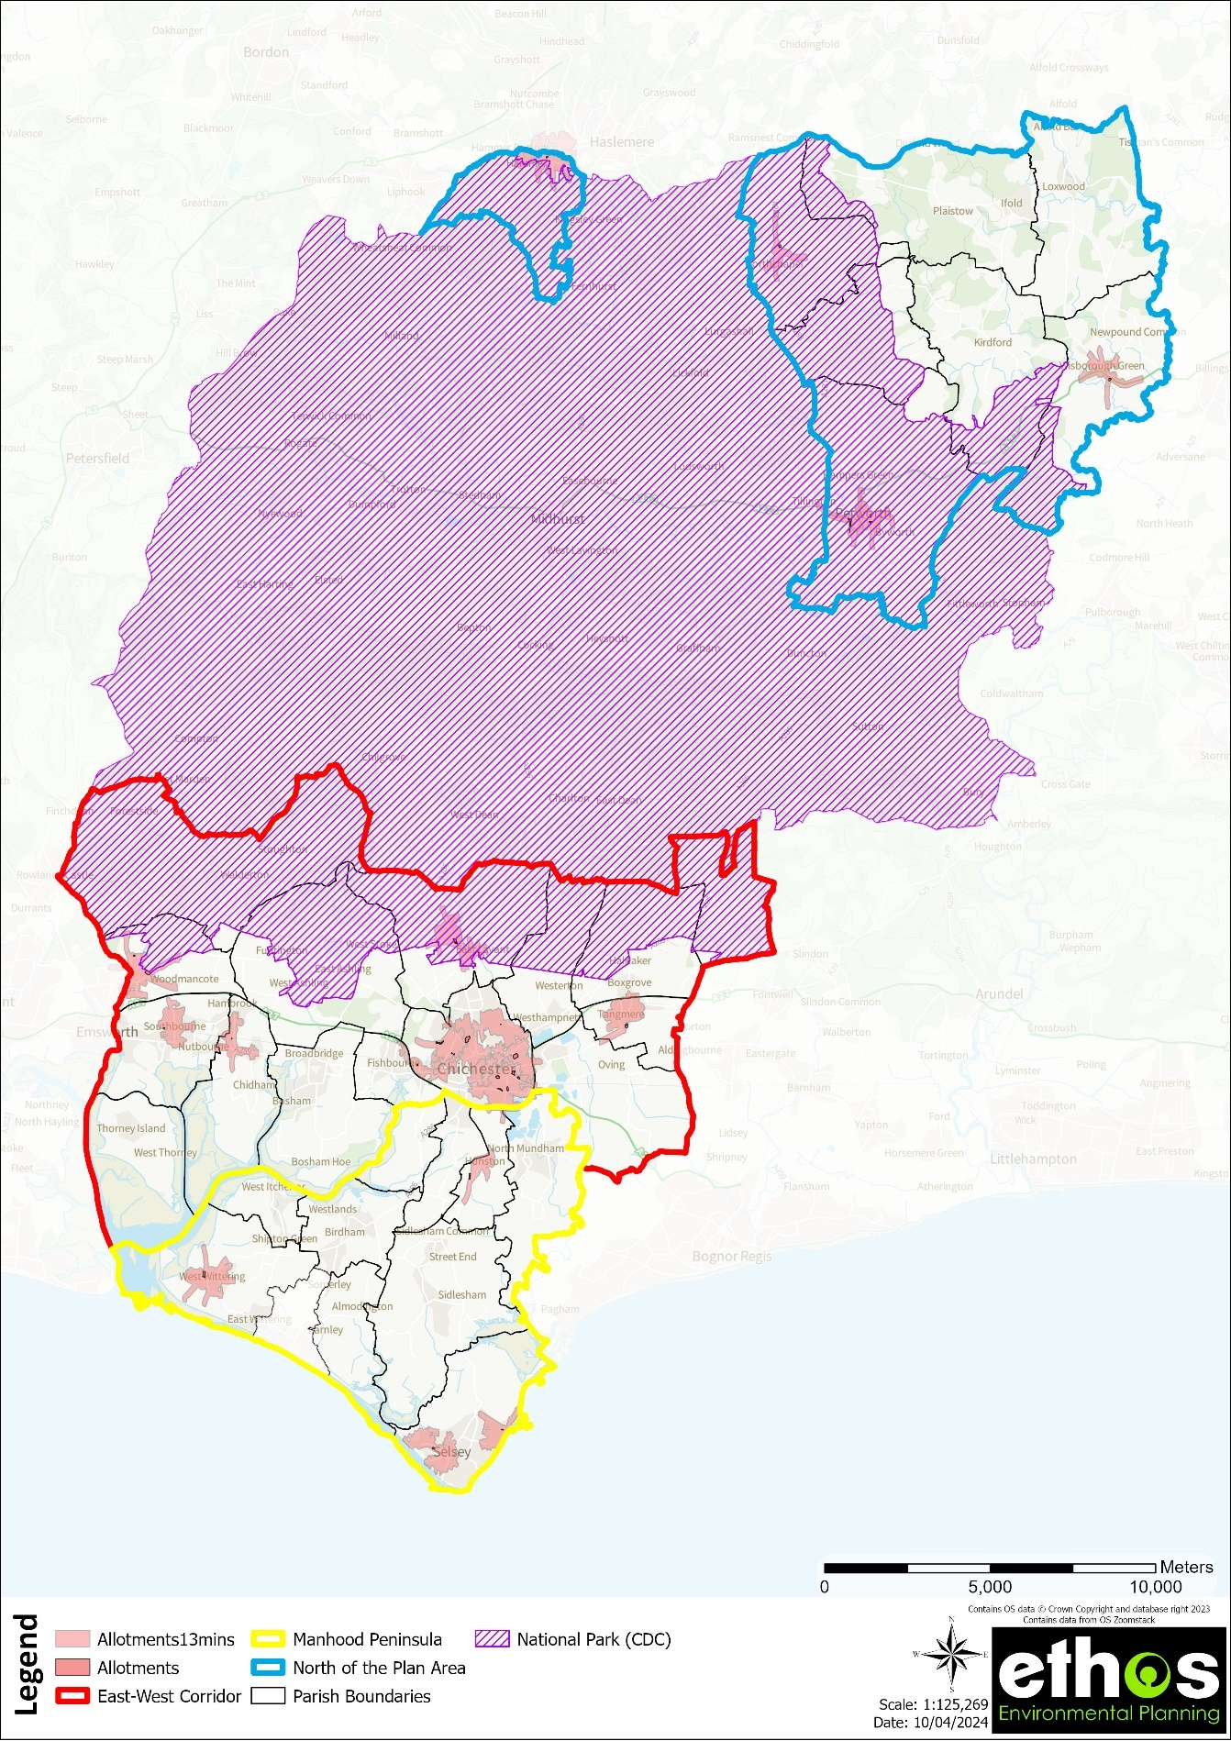
Figure 4 Access to allotments (13 minutes' walk time)

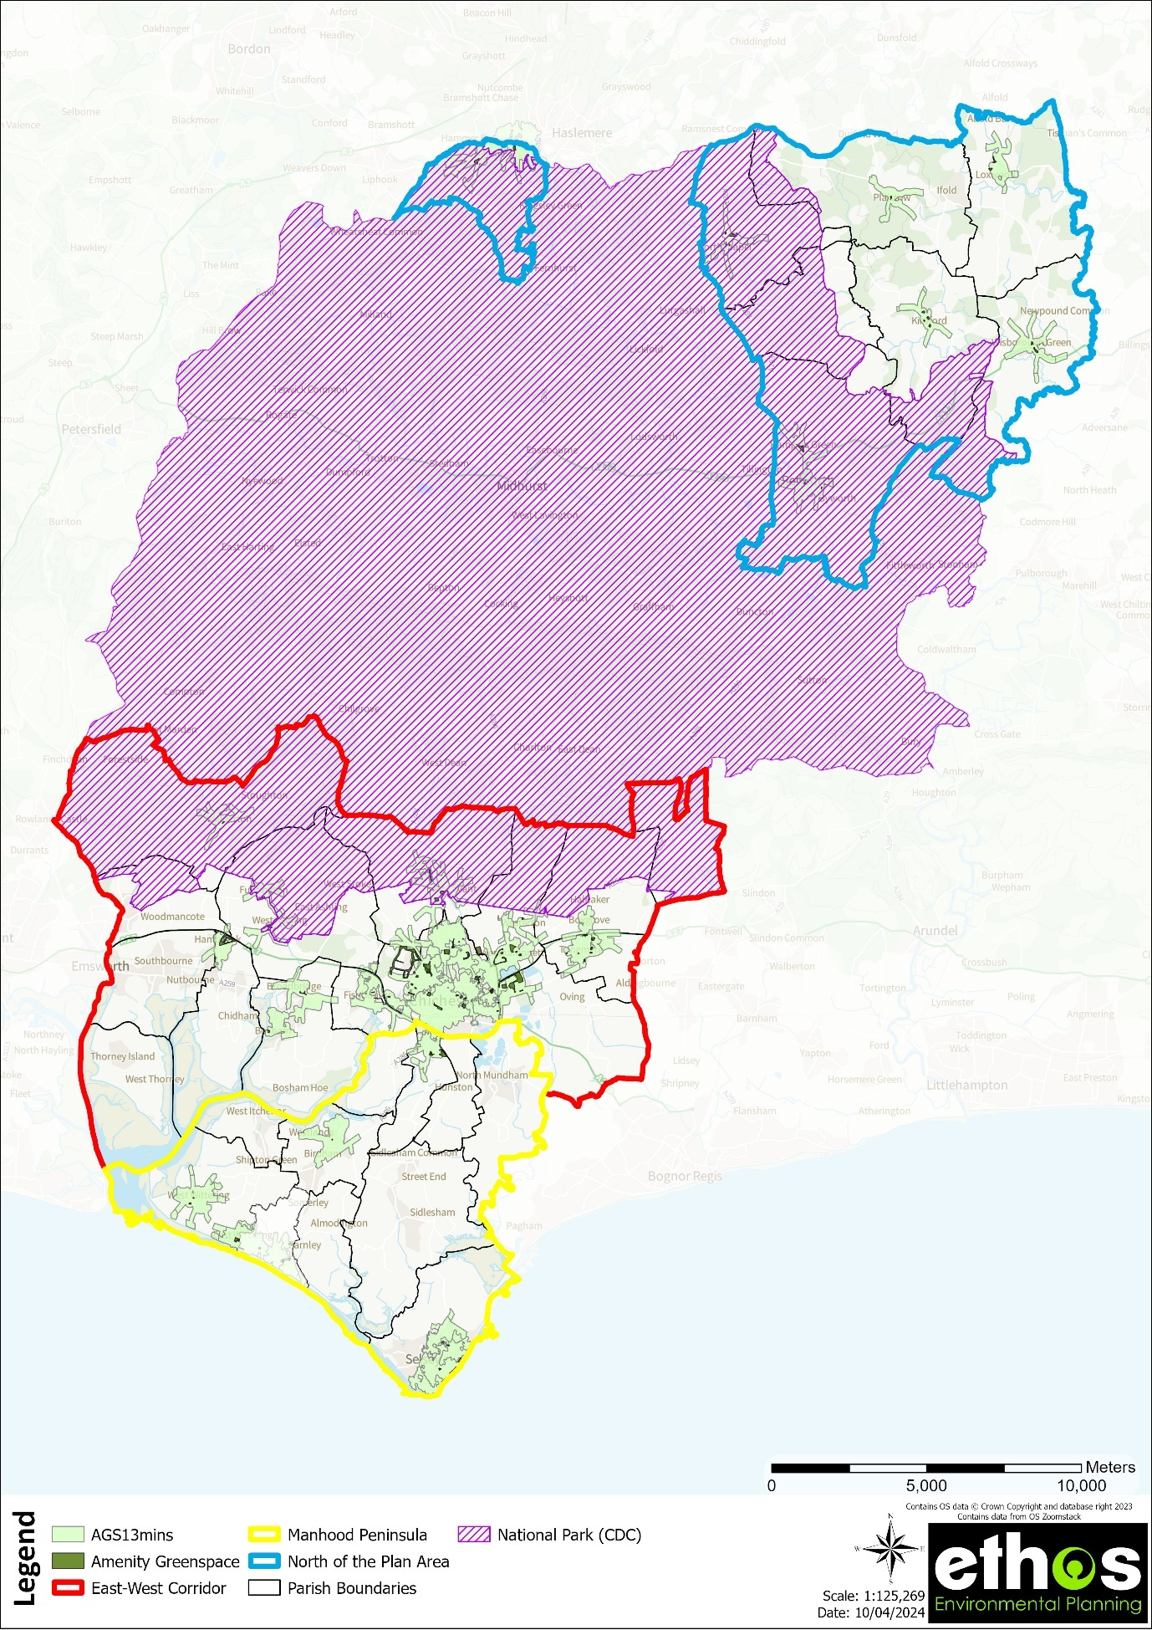
Figure 5 Access to amenity green space (13 minutes' walk time)
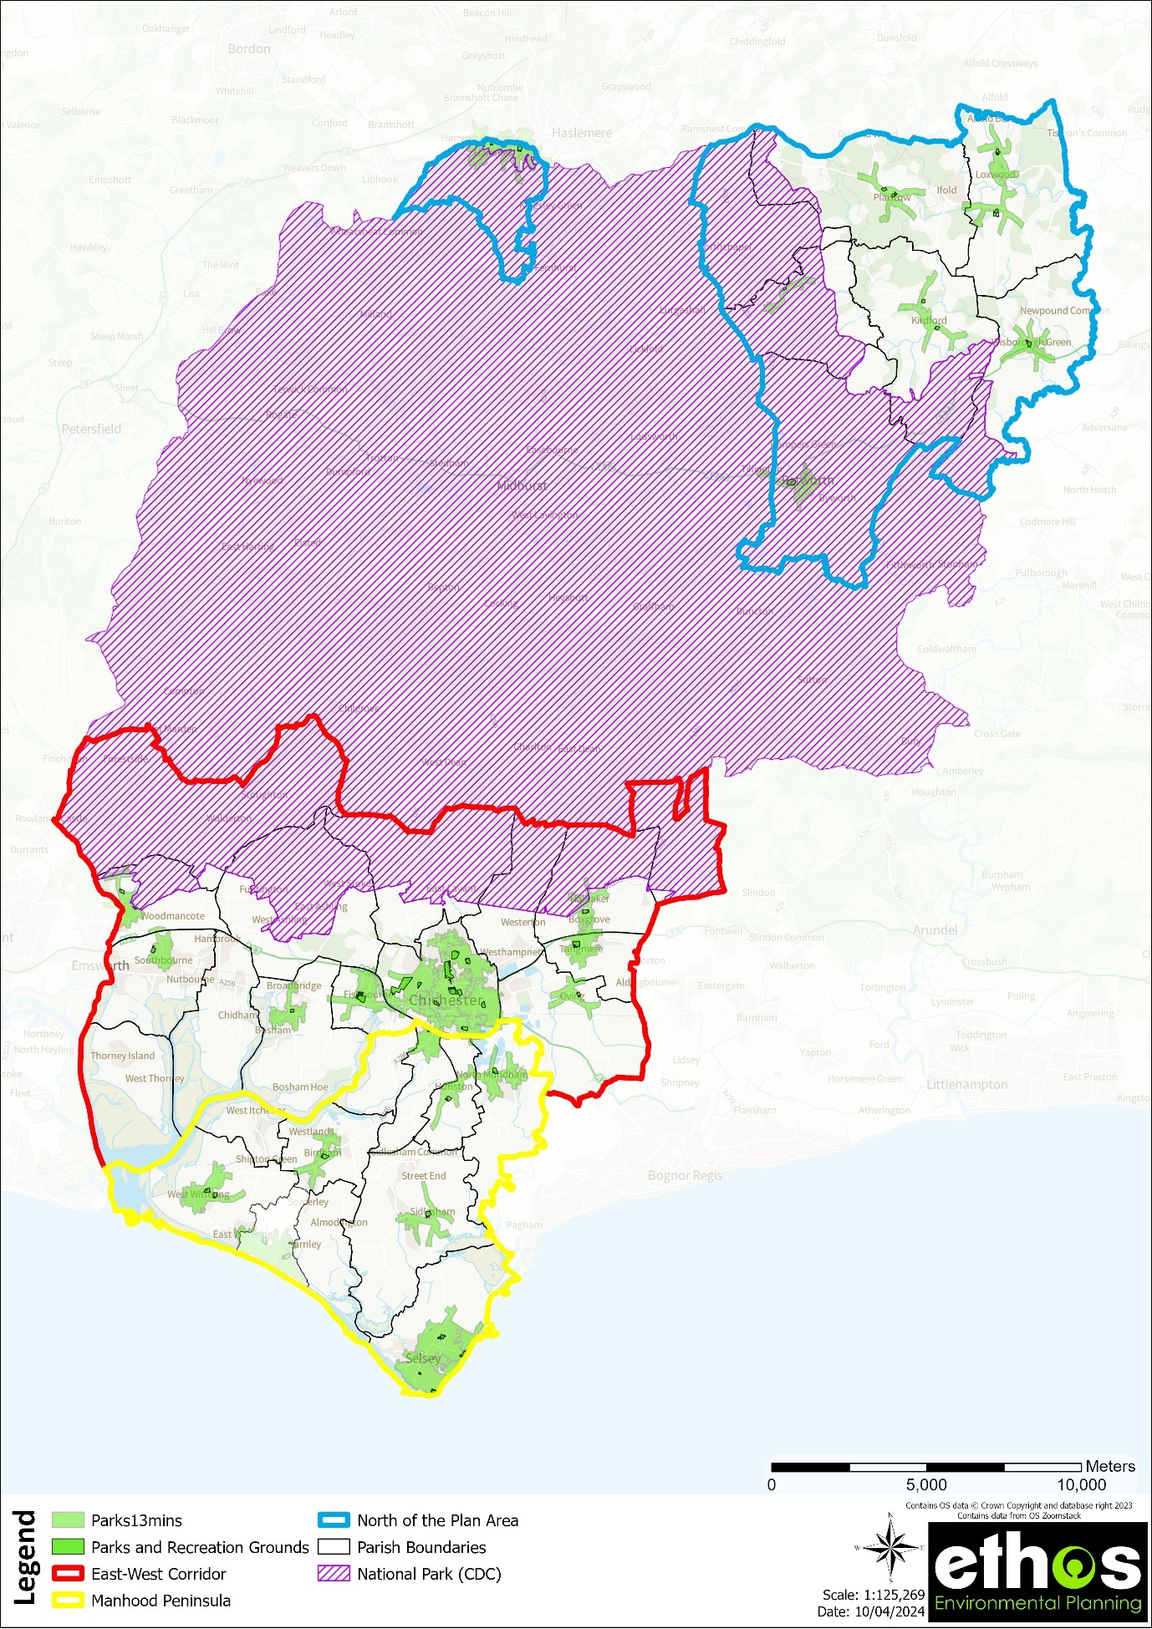
Figure 6 Access to Parks and Recreation Grounds (13 minutes' walk time)

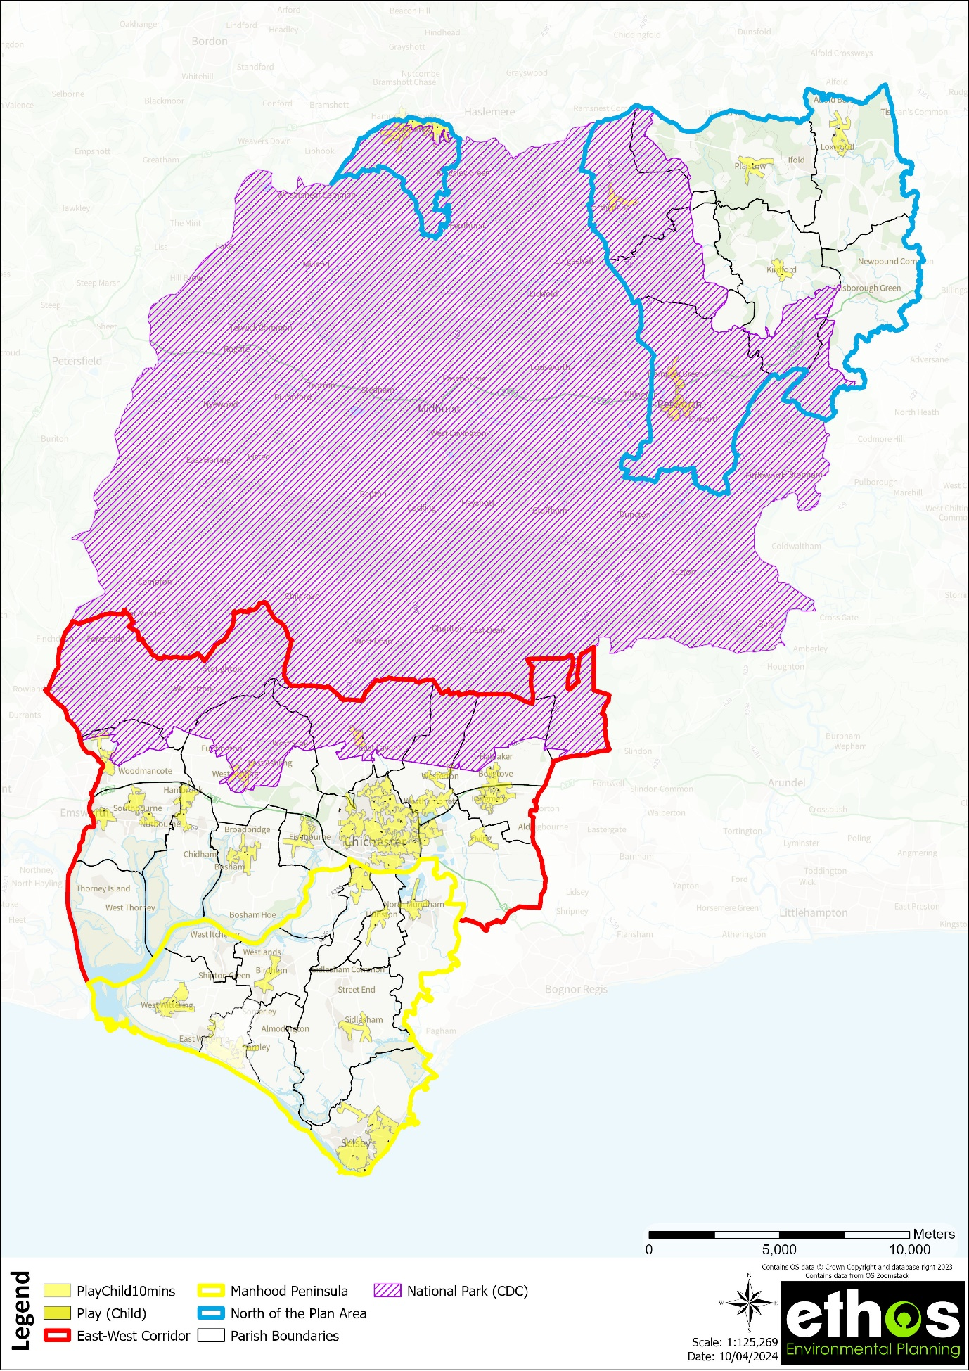
Figure 7 Access to children's play space (10 minutes' walk time)

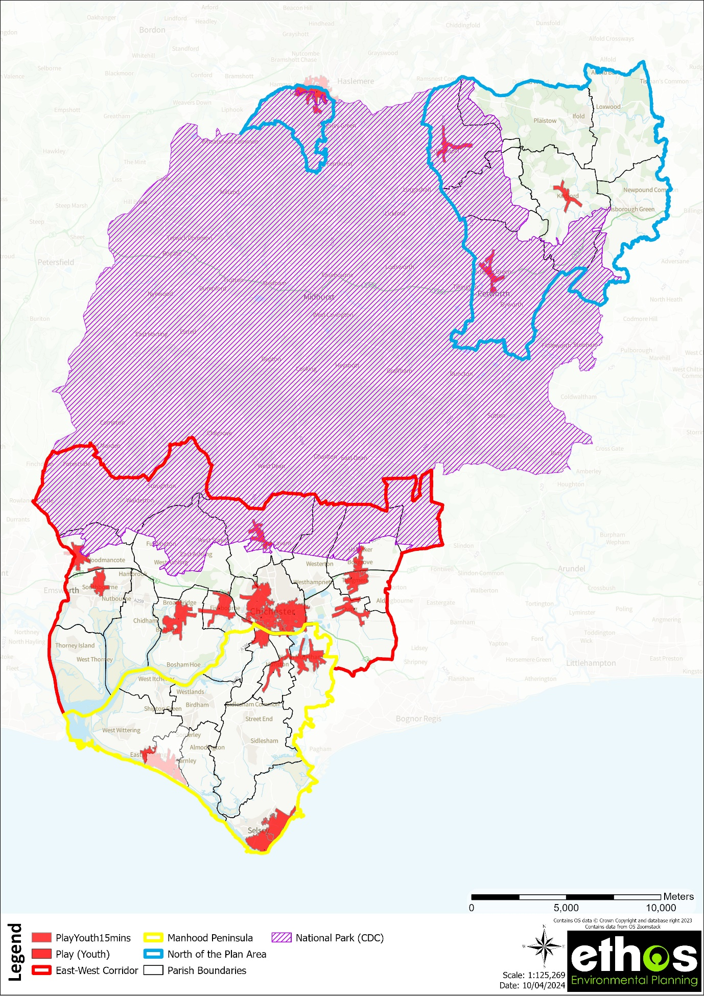
Figure 8 Access to youth play space

7.3.2 Access to accessible natural green space across the Local Plan Area

This section looks at access to accessible natural/semi-natural green space within the study area, through the application of the locally derived access standard (see Figure 9), and the Natural England Accessible Greenspace Standards and Woodland Trust Accessible Woodland Standard, in order to identify the main gaps in access.

As already mentioned under Section 5.1.5, this typology only includes those natural green spaces which have a definitive boundary and public access e.g., Local Nature Reserves, and not the open countryside where the only access is via the Public Right of Way network. Only natural/semi-natural green spaces within the study area have been mapped and considered within the access maps below. It is also important to note the presence of beaches and headland, and SPA’s (Chichester, Langstone and Pagham Harbours) within the Manhood Peninsula sub area, which have not been mapped as accessible natural green space and therefore are not covered within the analysis below. These sites/areas are considered further within the sub area analysis report (part 2 of this report).

Natural England Accessible Greenspace Standards (2023)

The Green Infrastructure Headline Standards states everyone should have access to good quality green and blue spaces close to home for health and wellbeing and contact with nature, to meet the Accessible Greenspace Standards, with an initial focus on access to green and blue spaces within 15 minutes’ walk from home. Those in bold below relate specifically to accessible natural green space.
Within 15 minutes’ walk:
EITHER a Doorstep OR Local Accessible Greenspace
- A doorstep greenspace of at least 0.5ha within 200 metres, or
- A local natural greenspace of at least 2ha within 300 metres walk from home.
AND
- A medium sized neighbourhood natural greenspace (10ha) within 1km.
AND, beyond 15 minutes’ walk:
- A medium/large wider neighbourhood natural greenspace (20ha) within 2km, and
- A large district natural greenspace (100ha) within 5-km, and
- A very large subregional greenspace within (500 ha) within 10 km

The Woodland Trust Woodland Access Standard

The Woodland Trust has researched and developed the Woodland Access Standard (WASt) for local authorities to aim for which is written in the Space for People publication. They believe that the WASt can be an important policy tool complimenting other access standards using in delivering green infrastructure for health benefits. The WASt is complimentary to Natural England’s ANGST and is endorsed by Natural England. The Woodland Access Standard recommends:

- that no person should live more than 500m from at least one area of accessible natural woodland of no less than 2ha in size.
- that there should be at least one area of accessible natural woodland of no less than 20ha within 4km (8km round-trip) of people’s homes.

The woodland access maps use the Woodland Trust Accessible Woodland data.

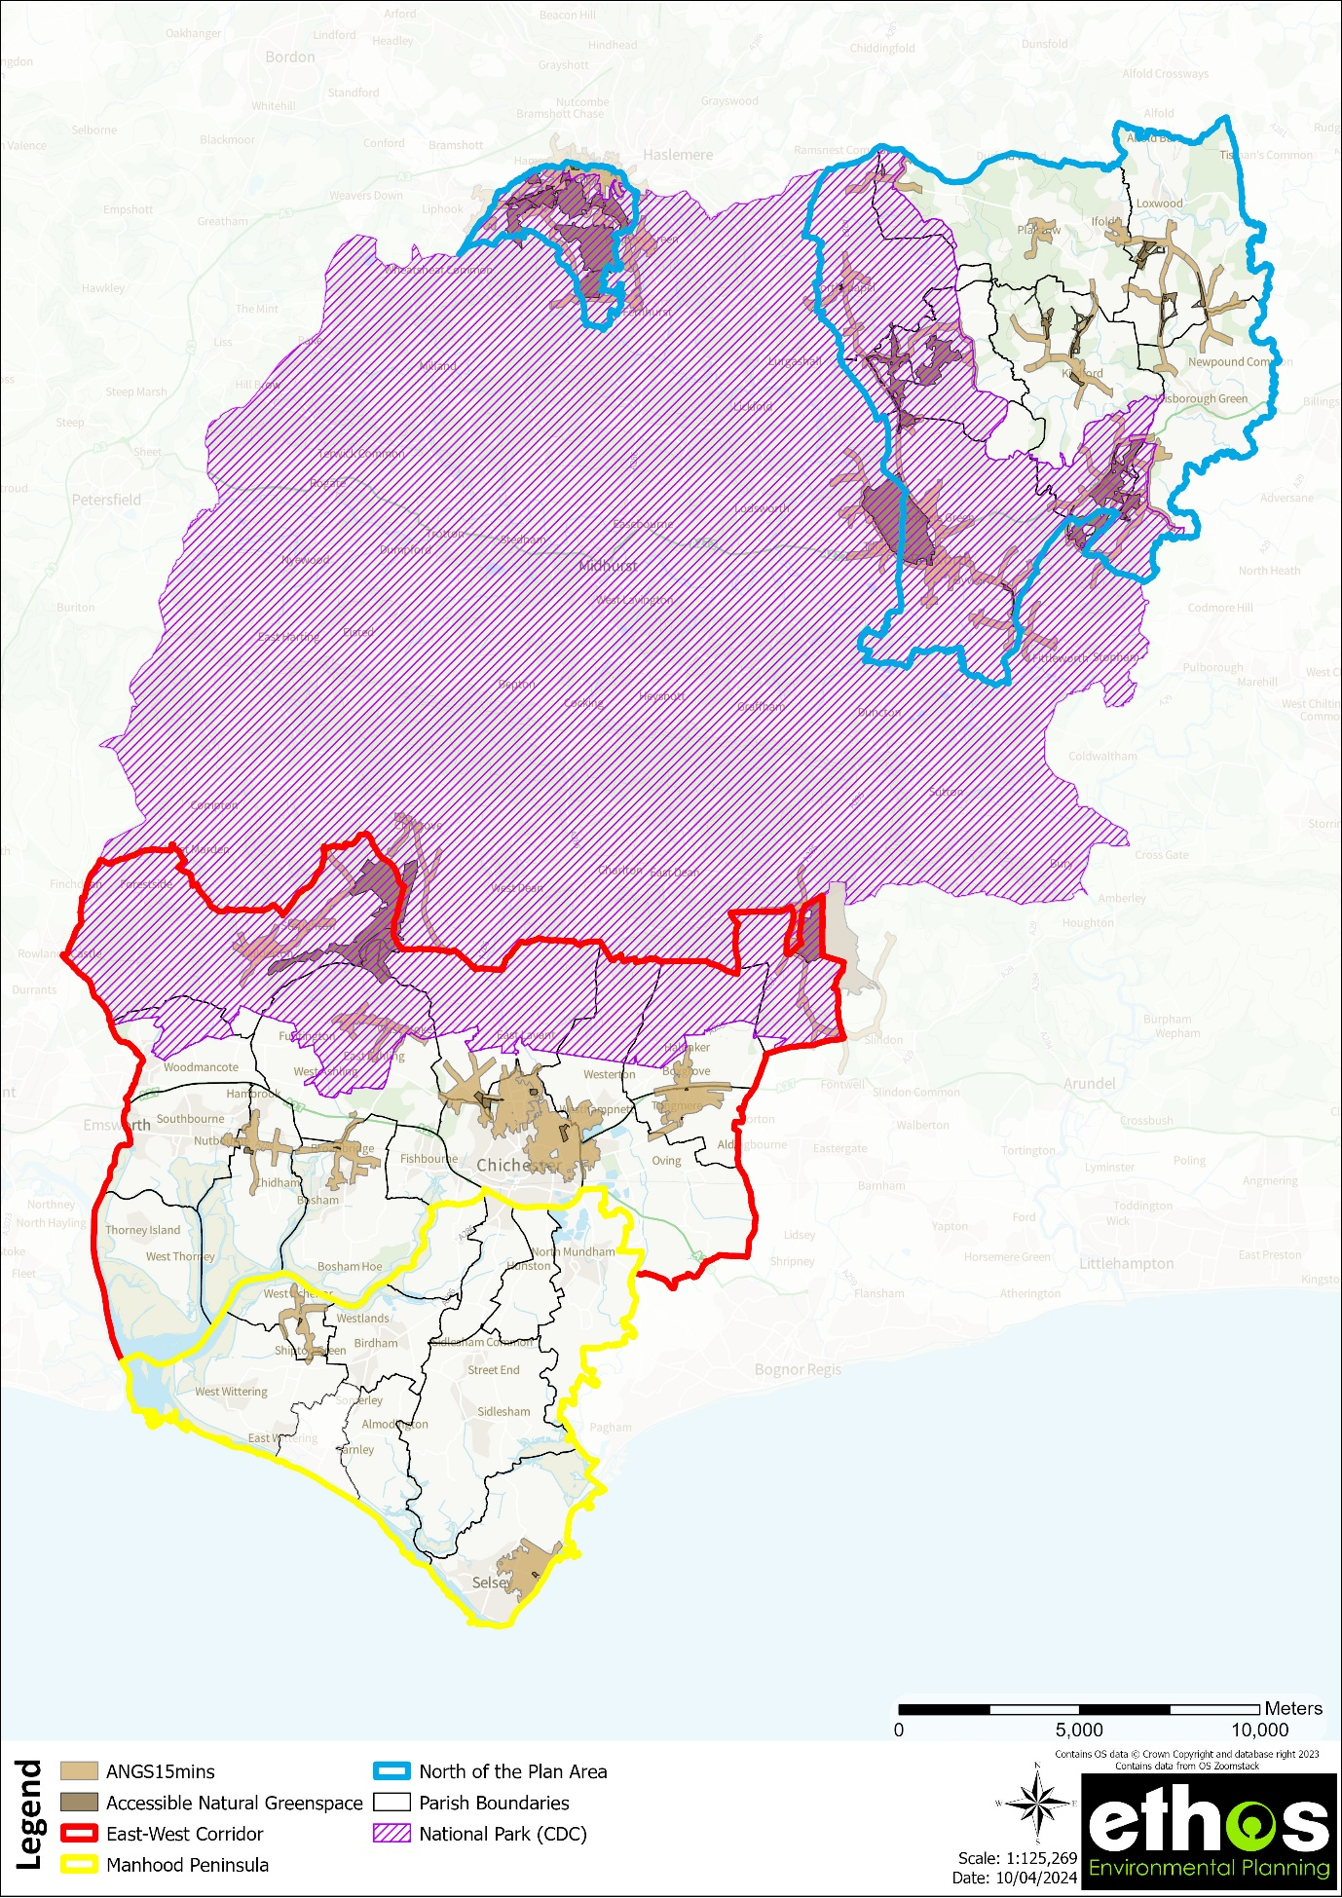
Figure 9 Access to accessible natural green space (15 minutes' walk time)

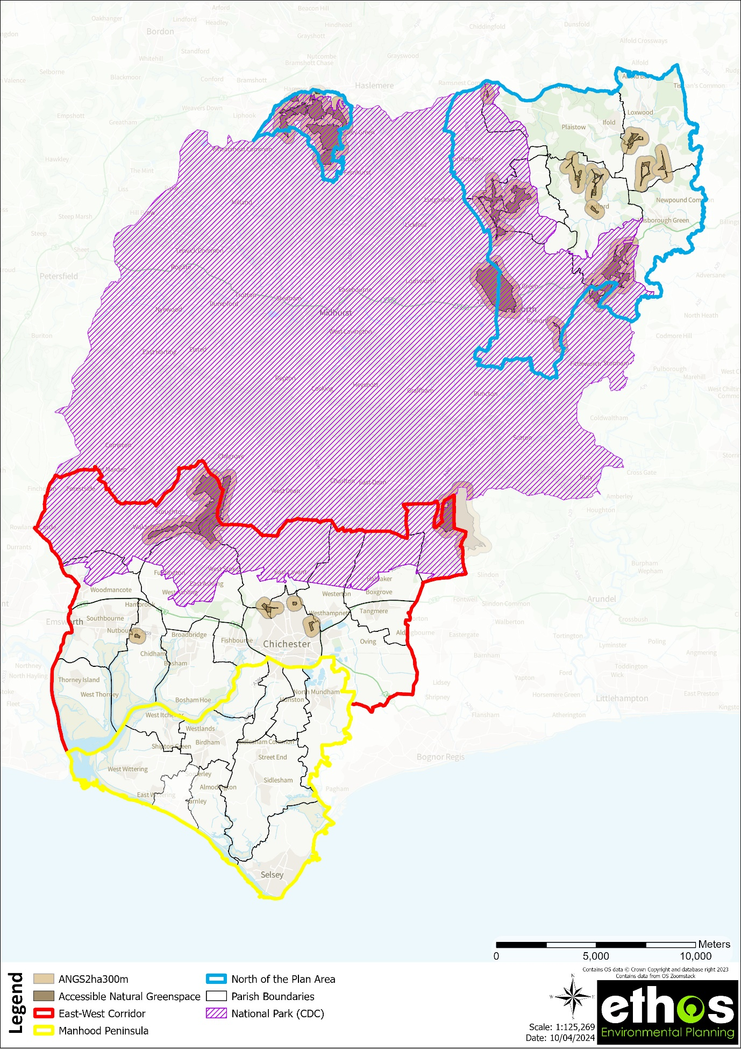
Figure 10 Access to 2ha site within 300m

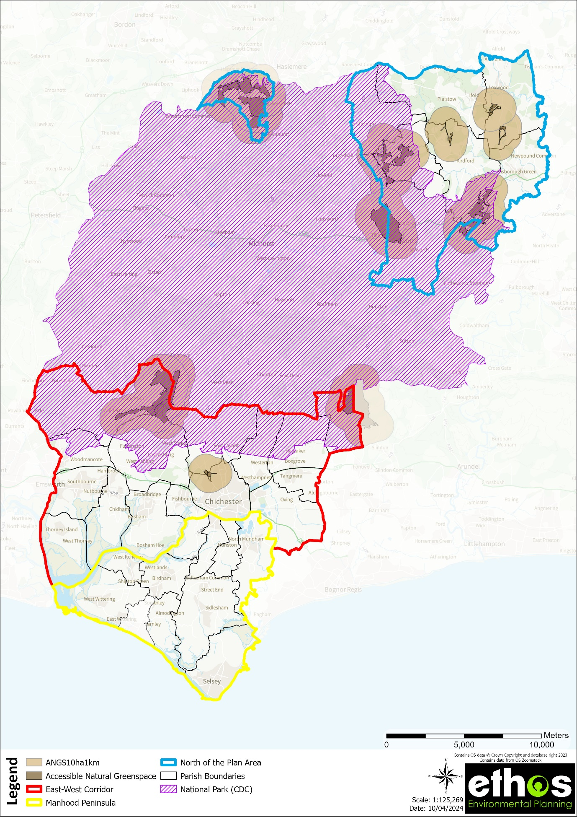
Figure 11 Access to 10ha site within 1km

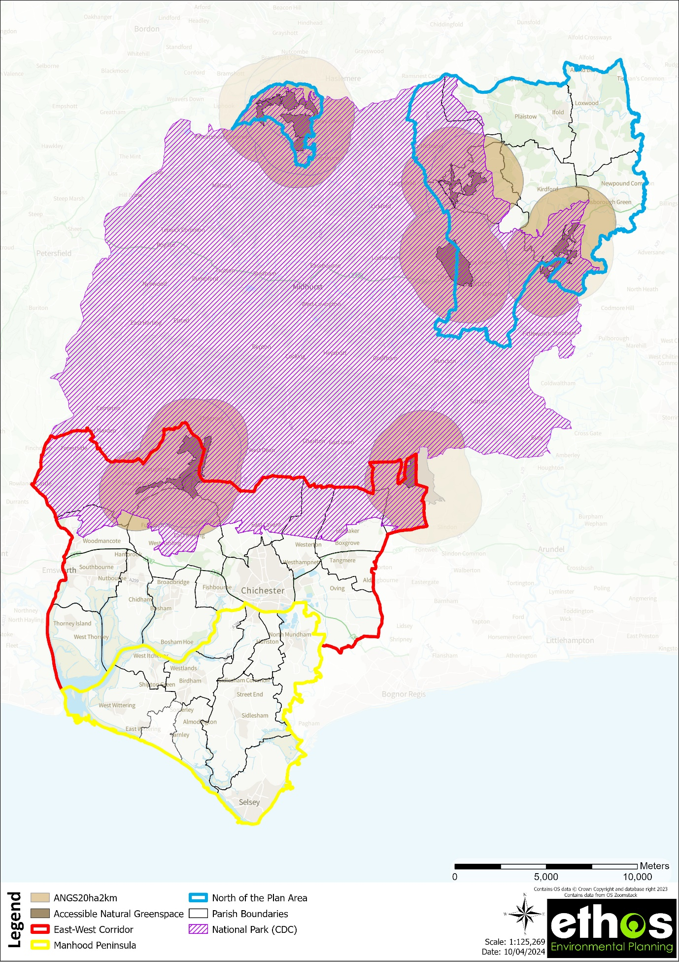
Figure 12 Access to 20ha site within 2km

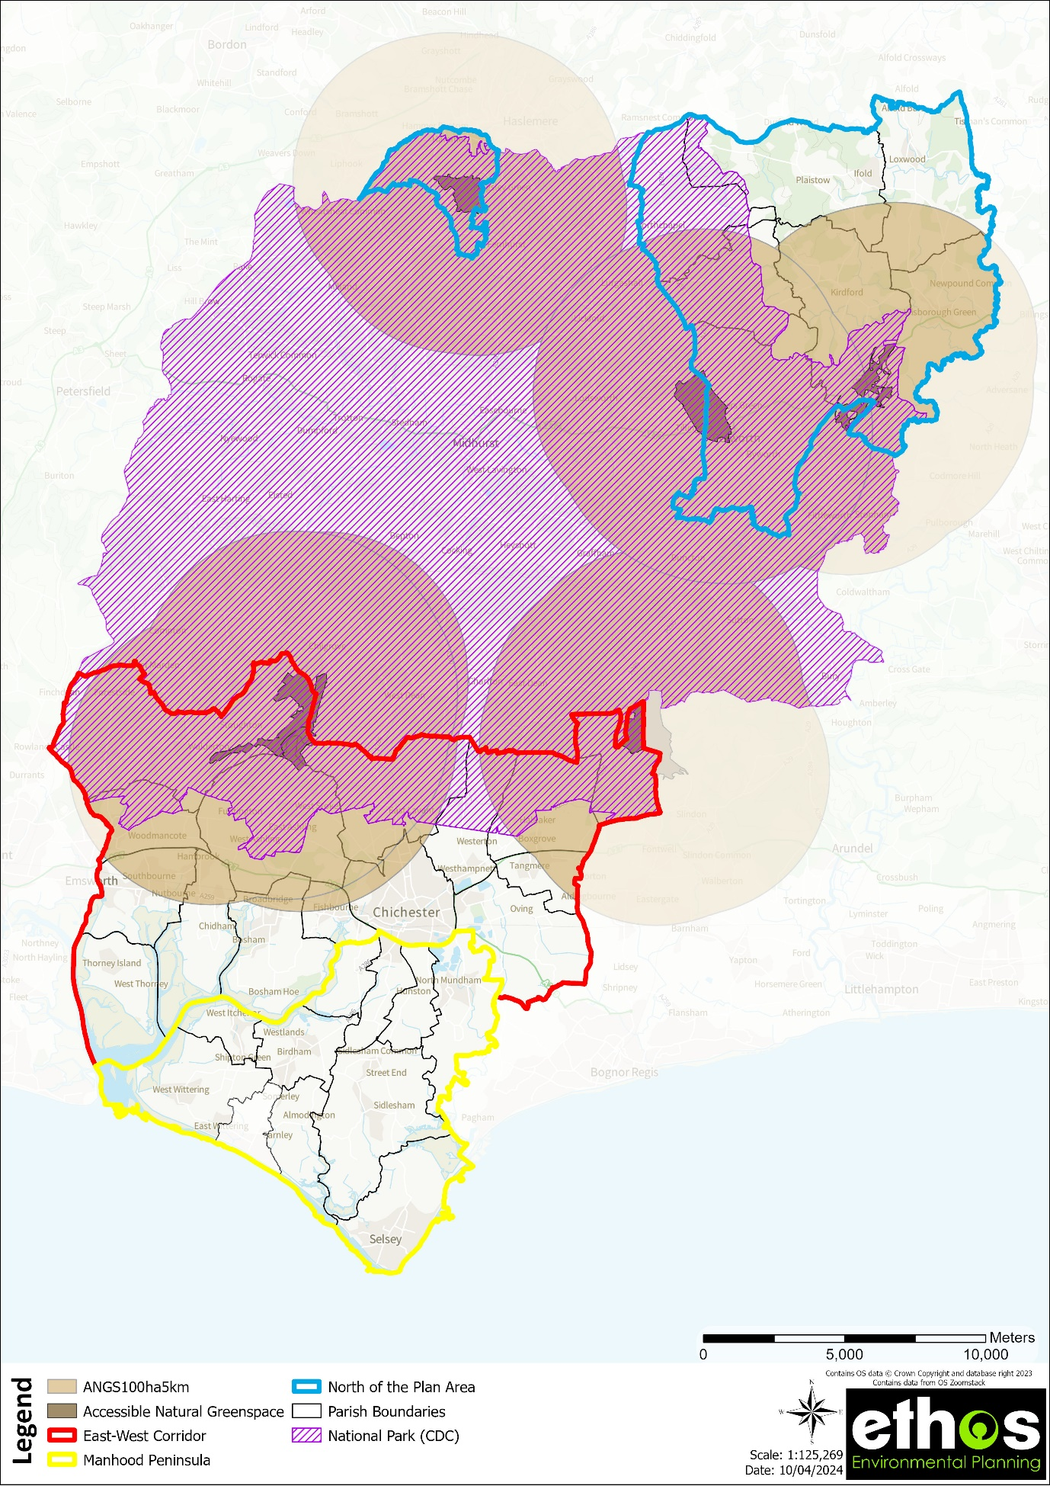
Figure 13 Access to 100ha site within 5km

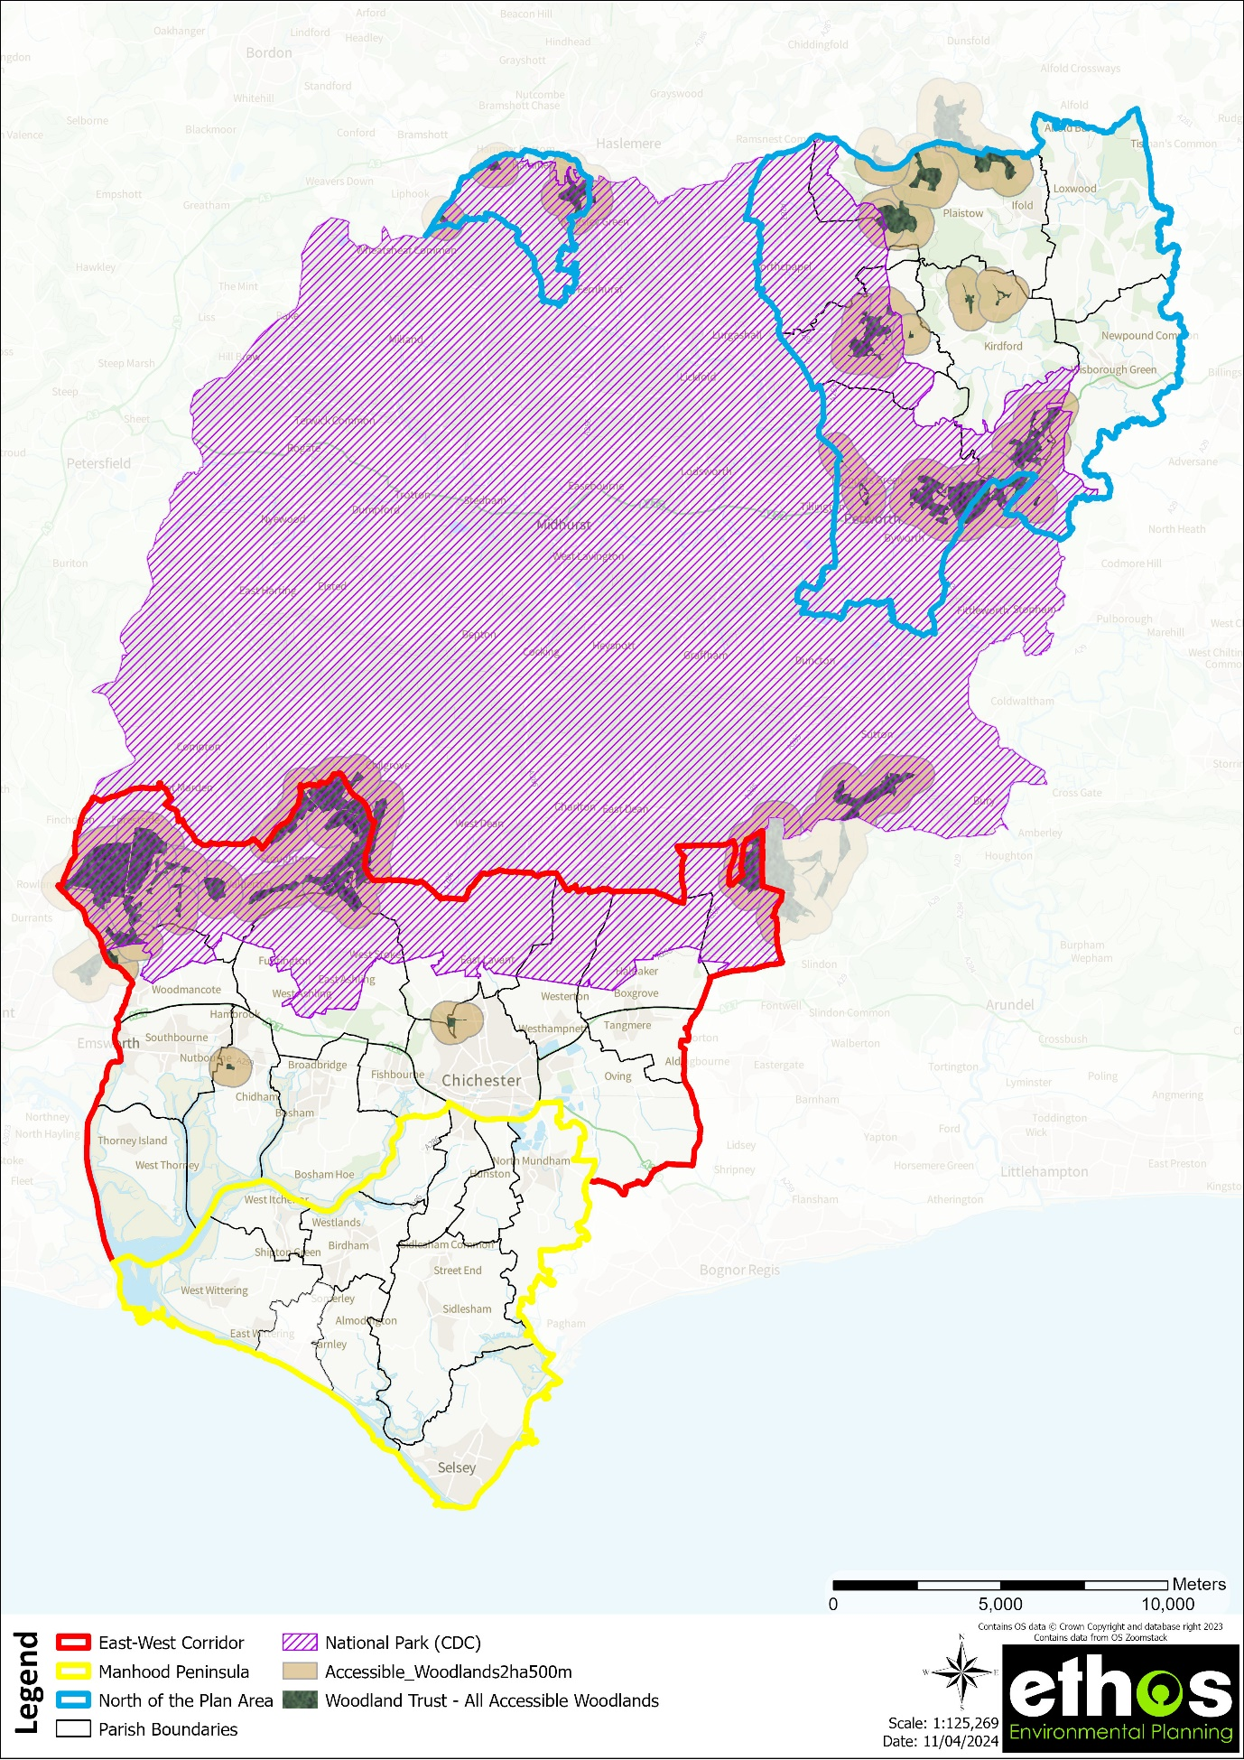
Figure 14 Access to 2ha woodland within 500m
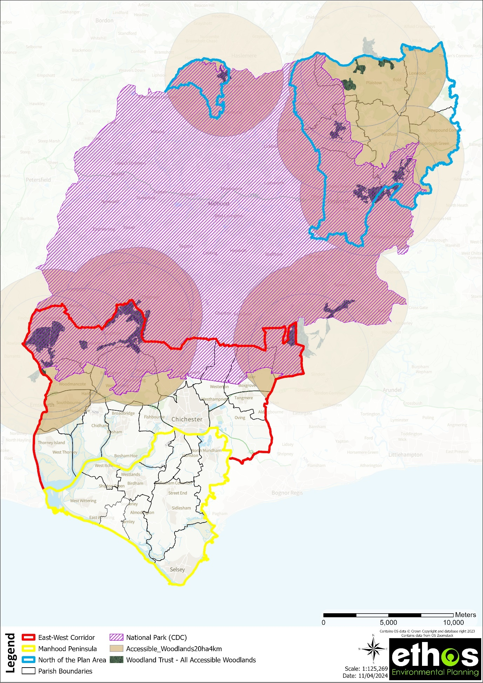
Figure 15 Access to 20ha woodland within 4km

7.5 Application of quality standards
7.5.1 Quality of open space – consultation key findings (2017)

Respondents were asked how they rated various types of facilities in the district in terms of quality. The responses of those expressing an opinion on specific categories of facility are illustrated in Figure 16 below.

Figure 16 Quality of open space (responses from 2017 household survey)
For all kinds of outdoor facilities/open spaces a majority of households suggested that in general they were of average or better quality (though the most common rating tended to be only "average"). However, for some typologies there were notable levels of dissatisfaction with general levels of quality, as noted below.

38% of households highlighted the overall quality of outdoor facilities for teenagers as being either poor or very poor. The quality of MUGAs and artificial turf pitches was rated as poor or worse by at least 22% of respondents.

In contrast some kinds of facilities/open spaces were rated relatively highly in terms of quality. These include: parks and recreation grounds (56% rate quality in general as being good or very good); woodlands, wildlife areas and nature reserves (51% similarly); play areas (47%); and rights of way (45%).

7.5.2 Quality of open space – audit methodology (2017)

Site audits were undertaken in 2017 using a standardised methodology and consistent approach. However, audits of this nature can only ever be a snapshot in time and their main purpose is to provide a consistent and objective assessment of a site’s existing and potential quality rather than a full asset audit.

It was not possible to survey all sites due to access restrictions, namely private sports grounds/open space and education sites. Other sites were also excluded due to limitations of resources, these included small amenity green spaces (<0.15 ha in size, which have little or no recreational value), churchyards and cemeteries and a small number of allotments and natural green spaces.

Sites were visited, and a photographic record made of key features, along with a description of the site and recommendations for improvements. An assessment of the quality of the open space was undertaken using the following criteria:
- Welcoming
- Good and Safe Access
- Community Involvement
- Safe Equipment & Facilities
- Appropriate Provision of Facilities
- Quality/Management of Facilities and Infrastructure
- Personal Security on Site
- Dog Fouling
- Litter and Waste Management
- Grounds/Habitat Management

Children’s play space and youth play space was also audited separately using the above criteria.
For each of the criteria a score of 1 -10 is given, where 1 is very poor and 10 is very good. The scores for each site are added together and the mean calculated based on how many criteria were scored (e.g. If ‘Community involvement’ is given N/A for a site, the total will be divided by 9). This mean is then multiplied by 7 to produce the final score from which sites are grouped into 3 categories – good (those sites with a score of between 7 and 27), average (those sites with a score of between 28 and 49) or poor (those sites with a score of between 50 and 70).

7.5.3 Quality of open space – audit findings (2017)

The quality audit was undertaken at 149 open spaces and 98 children and youth play spaces across the study area. For each of the sub areas within the study area, a map showing the quality audit results has been produced (see part 2 of this report). Each map is based on the quality audit GIS database provided to the council and show the sites categorized into three groups – good quality (with a score of A), average quality (with a score of B) and poor quality (with a score of C).

Figure 17 provides an overview of the quality audit results across the Local Plan area.

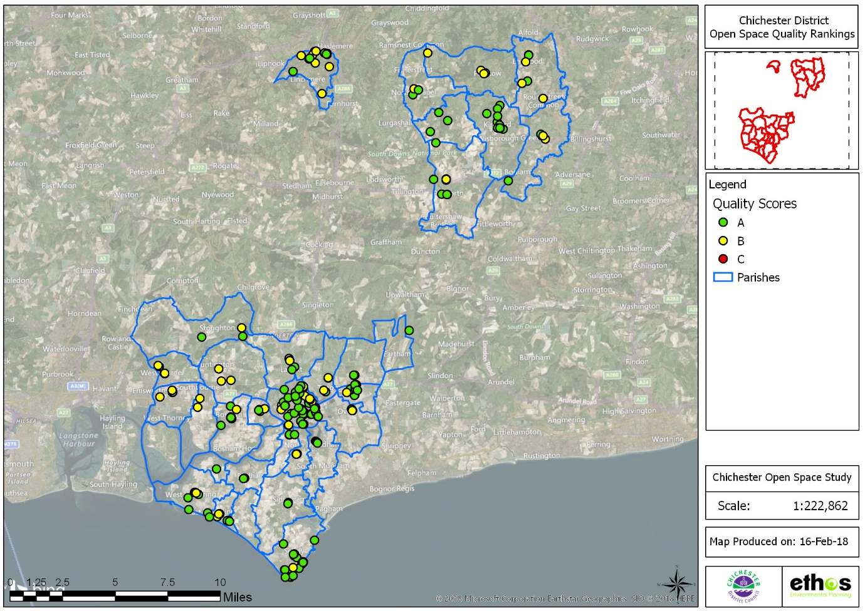
Figure 17 Overview of open space quality audit results
8.0 STRATEGIC OPTIONS, POLICY & MANAGEMENT RECOMMENDATIONS

This section sets out strategic options and policy recommendations for open space within the Chichester Local Plan area. It draws on all the previous steps of the study to bring together informed recommendations and addresses a number of specific requirements of the study brief.

8.1 Strategic Options

8.1.1 Introduction

The strategic options address the following key areas:

- Existing provision to be protected;
- Existing provision to be enhanced;
- Opportunities for re-location/re-designation of open space;
- Identification of areas for new provision;
- Facilities that may be surplus to requirement; and
- Developer contributions and recommended thresholds for on-site provision of open space

8.1.2 Delivering Strategic Options

The National Planning Policy Framework (NPPF) sets out the government’s planning policies for England and how these are expected to be applied. The purpose of the planning system is to contribute to the achievement of sustainable development. The planning system has three overarching objectives (economic, social, and environmental), which are interdependent and need to be pursued in mutually supportive ways. Open spaces (provision, protection, enhancement) and their associated intrinsic benefits are key components of all three of the objectives.

Whilst the Local Authority will have an important role in delivering open space, sport, and recreation facilities (as do the private sector), in some cases their role may move from that of ‘deliverer’ to ‘facilitator’. The aim will be to work with community organisations to make local decisions about how facilities and services will be provided. Organisations such as residents’ groups, voluntary organisations, sports clubs and societies will all have a key role in this.

Although it is up to local communities to define their own priorities (such as through neighbourhood plans) the information provided within this study will form a good basis to inform any decisions related to the provision of open space.

The following sections consider the key issues for open space in the study area, and the recommendations that emerge need to be taken in context with national policy and legislation and consider how they can fit into local decision making. The following sections serve to highlight issues, but do not necessarily resolve how they may be delivered. The information provided within this study will also form the basis for potential future strategies. The recommended policies within this study can also be used to help form the basis of any open space policies adopted by the Council.

8.2 Existing provision to be protected

The starting point of any policy adopted by the local authorities should be that all open space should be afforded protection unless, it can be demonstrated it is not required/is surplus to requirements (in accordance with the NPPF). Even where open spaces are in sufficient supply within a given area, this does not necessarily mean there is a ‘surplus’ in provision of open space, as additional factors such as access to open space, the supply of other typologies of open space, the quality of open space and where new development is planned needs to be taken into account (as explained further in the sections below and covered in section 7 of this report).

Existing open space or sport and recreation facilities which should be given the highest level of protection by the planning system are those which are either:

- Critically important in avoiding deficiencies in accessibility, quality or quantity and scored highly in the quality assessment; or
- Are of particular nature conservation, historical or cultural value.

The sub area analysis (part 2 of this report) and analysis of supply by Parish (Table 15, Section 7.2) provide more detailed results as to the above considerations. The following draws on this and makes some more general observations and recommendations.

Open Space Policy Direction (protecting open space):

OS1 | The distribution of open space varies across the Chichester Local Plan area, however, there are identified shortages of at least 1 typology of open space in all Parishes and sub areas, and in addition, gaps in access to open spaces. It is therefore recommended that priority is placed on protecting those open spaces where there is an existing shortfall of supply or access, and also those open spaces which have scored highly in the quality assessment.
OS2 | Sites which are critical to avoiding deficiencies, or making existing deficiencies worse, in quality, quantity or access should be protected unless suitable alternative provision can be provided which would compensate for any deficiencies caused.
OS3 | Sites which have significant nature conservation, historical or cultural value (or other functions contributing to the overall connectivity and functioning of the green and blue infrastructure network, such as water management) should be afforded protection, even if there is an identified surplus in quality, quantity, or accessibility in that local area.

The importance of privately managed spaces (e.g. sports grounds) as a community facility has been highlighted in this study, although these spaces are not afforded protection through policy recommended as part of this study, as they are not covered by standards. The Playing Pitch Strategy however, covers these spaces.

8.3 Existing provision to be enhanced

In areas where there is a quantitative deficiency of provision but no accessibility issues, then quantitative deficiencies could be met by increasing the capacity of existing facilities through quality improvements e.g., increasing the size and quality of a play area.

In areas where facilities or spaces do not meet the relevant quality standards, then enhancements will be sought. These can be delivered either through development where opportunities arise as above, or through other funding sources identified by the council.

This includes those spaces or facilities which:

- Are critically important in avoiding deficiencies in diversity, accessibility, or quantity, but
- Scored poorly in the quality assessment.

Those sites which require enhancement are identified within the 2017 quality audit that was undertaken (although there may also be local priorities that have not been picked up as part of the quality audits, and updated quality assessments would be beneficial). Some of the key observations related to site quality, functionality and enhancement include:

In areas where there is a quantitative deficiency of provision but no accessibility issues then increasing the capacity of existing provision may be considered. Alternatively, in areas where facilities or spaces do not meet the relevant quality standards, qualitative enhancements will be required.

- The importance of providing high quality provision and maintenance of formal facilities such as Parks and Recreation Grounds and Play Space.
- The need for additional and improved facilities for young people.
- The role of private sports spaces to some local communities and the need to provide opportunity for investment.
- The need to ensure high quality open spaces are designed and provided through new development where feasible.
- The importance of rights of way and natural green space within the Study area, and the need to maintain and enhance provision for biodiversity.
- The role of open space in contributing to wider initiatives and strategies, such as health and wellbeing, climate adaptation and mitigation, and biodiversity.
- The role of open space in extending and enhancing the network of green infrastructure including the connectivity between sites and improved accessibility to existing sites.

The sub area analysis (part 2 of this report) provides maps showing sites grouped into three categories – good, average and poor (as identified within the 2017 quality audit GIS database provided to the council). An overview of the open space quality audit rank scores is provided in Section 7.5.3 of this report. The following recommendations are made in relation the quality of open space:

Open Space Policy Direction (enhancing open space):

OS4 | Where new housing development is proposed, consideration should be given to improving existing open spaces first within the Parish and then within the sub area where the development is located. Priority should be given to those sites identified as being of poor or average quality, as detailed in the quality audit.
OS5 | The study makes recommendations for improving the quality of open space across the district. However, a long term strategy for achieving improvements would assist which could be delivered through a green space/GI strategy, play strategy, neighbourhood plans or additional design guidance.
OS6 | The priorities for improvement (identified within the 2017 household survey) are footpaths, bridleway and cycle path provision and woodlands, wildlife areas and nature reserves, followed by improved provision for teenagers.
OS7 | Management plans (if not already established) should be developed for the main parks and open spaces. These priorities could be considered in neighbourhood plans and by the local community.
OS8 | New development should seek to follow best practice guidance e.g., the Building with Nature Standards for high quality Green Infrastructure, in order to ensure that open space delivered through new development is multi-functional, climate resilient, future proof, responds to policy (local and national) and is appropriate to the landscape context/ contributes to sense of place.

8.4 Opportunities for re-location/re-designation of open space

In some areas it may be possible to make better use of land by relocating an open space or upgrading an existing open space e.g., upgrading an amenity green space to a park and recreation ground, especially if this will enhance its quality or accessibility for existing users or use land which is not suitable for another purpose. This needs to be determined at a local level, considering the quality, quantity, and access to facilities at neighbourhood level and in some cases across the study area.

Although it is up to local communities to define their own priorities within neighbourhood plans, the information provided within this study will form a good basis to inform any decisions related to the provision or replacement of open space, sport and recreation facilities. Some settlements may seek a consolidation of facilities on a single site, such as a new sports hub.

These decisions could include the spatial and investment plans for green space and set the foundations for green space provision (e.g., for the lifetime of a plan period). They should outline where different types of facilities and space - such as children's playgrounds, sports pitches, young people's facilities etc. are to be located. It will also identify if any open space is no longer needed and how its disposal or re use can be used to fund improvements to other spaces.

The new Local Plan, and any neighbourhood plans should apply the standards and policies set out in this study and ensure that the significant investment anticipated for open spaces is prioritised with the help of stakeholders and communities. The standards agreed in this study can determine a minimum level of quality and quantity of open space provision and the maximum distance people should have to travel to access different types of open space.

This study provides information on the existing supply of different types of open space, an analysis of access and identifies local issues related to quality. The sub area analysis (part 2 of this report) sets out broad opportunities for re-location/re-designation of open space where there is sufficient supply, in order to reduce shortfalls in supply and access to other open space typologies. This will act as a good starting point for feeding into the Local Plan review and any neighbourhood plans/strategies for future decision making in consultation with the local community.

8.5 Identification of areas for new provision

New provision will be required where there is a new development and a planned increase in population, and/or an existing deficiency in supply or access to facilities exists. Section 7 outlines the existing situation with regards to supply and access to open space. As discussed, neighbourhood plans would form a good mechanism to determine exactly where new provision is required, however, this study can be used as the basis for decision making, as follows:

Quantity

Within the study report, for each typology, there is an identified ‘sufficient supply’ or ‘under supply’ for each of the Parishes and sub areas. If an area has an existing under supply of any typology, there may be need for additional provision. This could be delivered through developing a new site (for example as part of a housing development), acquiring land to extend the site or changing the typology of an existing space (which may be in over supply).

The supply statistics should be used as part of the decision making process in development management to determine if a new development should provide facilities on-site or enhance existing provision through developer contributions.

The use of the quantity statistics should not be in isolation and should be considered alongside the access standards.

Access

This study considers how access to different types of open space varies across Parishes/sub areas against the proposed standards. The maps in Section 7 (and in part 2 of this report - the sub area analysis) show where there are deficiencies and potential over-supply of facilities. This information can be used alongside the quantity statistics to determine if new provision or improved accessibility is required in an area. For example, if a new development is proposed, the maps should be consulted to determine if there is an existing gap in provision of a particular typology which could be met by the development.

Therefore, even though the quantity statistics may identify a sufficient supply of a particular typology, there may be gaps in access, and thus a new facility may still be required.

Delivering new provision

There are a number of opportunities for delivering new facilities through new development – developer contributions (CIL and S106), biodiversity net gain, and to a lesser extent through capital and grant funding.

Developer contributions

The council implemented its Community Infrastructure Levy (CIL) on 1 February 2016 to contribute to the costs of key strategic infrastructure. The Council has a list of Infrastructure Projects (Regulation 123 List) which may be funded from the CIL. Planning obligations (S106) continue to play a key role in relation to affordable housing and certain site specific requirements (despite being scaled back).

Amendments to the Community Infrastructure Levy (CIL) Regulations (2010) came into force on 1 September 2019. One of the key changes is the lifting of the ‘pooling restriction,’ due to the deletion of Regulation 123. This allows CIL and planning obligations (S106) to fund the same piece of infrastructure and accordingly remove what can be a barrier to development. The new Infrastructure Funding Statements (which replace the regulation 123 lists) required annually from 31 December 2020, provides an appropriate audit trail of all contributions to receiving authorities and how they are spent, whether S106 or CIL. The IFS includes an ‘Infrastructure List’ that sets out the priorities for spending CIL.

New development will be required to provide on-site open space in line with Chichester District Council planning requirements, as informed by the standards outlined in this study. Whilst not all developments will be of a size that will generate the requirement for on-site open space (see Table 21), when considering future housing numbers for Chichester, there will be many that will. This study should be used to make local decisions about where and when new on-site provision will be required.

Figure 18 shows an example flow chart/decision making process to help developers/council officers determine the need for on-site provision of open space, or where developer contributions would be required to improve existing open space provision. This is only a guide, and requirements will be determined on a case by case basis using the standards and assessment within this study. This should be determined through pre-application discussions with the council.

Biodiversity net gain (BNG)

Biodiversity Net Gain is an approach to development that leaves biodiversity in a better state than before. Where a development has an impact on biodiversity it encourages developers to provide an increase in appropriate natural habitat and ecological features over and above that being affected in such a way it is hoped that the current loss of biodiversity through development will be halted and ecological networks can be restored.

Mandatory Biodiversity Net Gain to compensate for loss of biodiversity through development is set to become a part of planning in early 2024 through requirements within the Environment Act 2021 which was ratified in November 2021. Once enacted, this will require any development under the Town and Country Planning Act 1990 (except Permitted Development and Householder Applications) to evidence a minimum 10% increase in biodiversity value, delivered through habitat creation or enhancement either on-site, off-site or through biodiversity credits, and 30 years management of those habitats. Further to this, BNG is supported within the National Planning Policy Framework (NPPF), which states that planning policies and decisions ‘should contribute to and enhance the natural and local environment by minimising impacts on and providing net gains for biodiversity, including by establishing coherent ecological networks that are more resilient to current and future pressures.’

Capital and grant funding

Although the availability of capital and grant funding has diminished in recent years, nevertheless funding does become available for providing facilities for open space, sport and recreation. National and governing bodies for individual sports should be consulted where new infrastructure is required, such as changing rooms and sports pitches. Environmental grants and stewardship schemes are available for managing natural green space. As neighbourhood plans are developed and open space priorities are established within these, funding requirements will be identified and delivery through grant funding can be considered.

The Green Infrastructure Partnership provide a summary of current opportunities to access funding for green infrastructure projects across the UK, in cities, towns and villages.

Requirements for open space from new housing

Section 7.2 outlines the variation in supply of different typologies of open space across Parishes. Part 2 of this report also shows the supply of open space by sub area. As identified, every Parish and sub area has a shortfall in at least one typology of open space, therefore, the starting point for new housing is to assume that some form of on-site open space provision would be required.

Is development eligible for on-site provision? (See Table 20)
On site provision required in line with standards*

No
No
Yes
Offsite provision most likely required to improve existing open space in the local area (see quality audit database)

Yes
No
For each typology required on site, is there currently sufficient provision in the local area? (See Table 15)

Does size of development require on site provision? (See Table 21)
No
Yes

See Table 19 and cost calculator for costs/developer contributions

Is there sufficient access to each type of open space in the vicinity of the development? (See Section 7.3 and Part 2 report)

Yes

*if it is not feasible to deliver open space on site due to exceptional circumstances e.g., viability or land availability, then potential to provide off site provision will be considered on a case by case basis.
Figure 18 Decision making process for on-site provision of open space, or off-site contributions to enhance existing open space
Open Space Policy Direction (new provision of open space):

OS9 | New provision of open space will be required as part of new development in Parishes where there are existing deficiencies in quantity or access to open space and/or where the new development will result in deficiencies. Where on-site provision is required, it should be provided in line with the proposed open space standards.  The priorities for additional facilities (identified within the 2017household survey) are for facilities for teenagers and children’s play areas.  Where on-site provision is deemed impractical, or not required e.g. for small sites, consideration will be given to opportunities for off-site provision and/or improvements.  Improvements to existing open space will be considered first in the Parish within which the development is located, then in open spaces in neighbouring Parishes. Priority sites requiring improvements will be identified from the quality audit (those sites assessed as being of poor or average quality being the highest priority for improvement) and also from site management plans and the Council’s own knowledge of their sites.

8.6 Facilities that are surplus to requirement

In addition to the strategic options outlined above, consideration should also be given to facilities that are surplus to requirement. There are important issues to resolve in terms of getting the correct balance of open space across the study area before any disposal can be contemplated. Whilst there is under provision relative to the minimum standards in several areas, there are other areas where provision compares favourably with the standards. However, it is once again emphasised that the proposed standards are for minimum levels of provision. Factors to be taken into account before any decision to release open space for alternative uses can be taken include:

- The local value and use of a given open space - as it may be a locally popular resource.
- Whether future local development/population growth might generate additional demands for open space.
- Whether there is a demonstrable need for some other type of open space within the locality that a given space (subject to a change of management regime) would be well placed to meet.
- Other non-recreational reasons that suggest a space should be retained (which might include ecological and visual reasons).

Figure 19 and the associated paragraphs below provide an example and suggests an outline of the decision process that should be followed before the development/alternative use of an open space can be seriously contemplated.
No
No
Yes
No
Is there sufficient quantity elsewhere?
Figure 19 Outline decision making process in relation to sanctioning (re)development of open space

Fail, unless compensatory provision made

A hypothetical example of how this might be applied is as follows as related to an area of informal/amenity space.

Q. Is there sufficient quantity?
Need to take into account application of minimum quantity standards and other relevant local information

A. If the minimum quantitative standard for Informal/amenity space is achieved in a defined geographical area, the relative provision of other forms of open space must then be considered. (Informal open space can in principle be converted into other forms of open space where the need arises). If a) provision meets the minimum quantitative standard; b) there is no significant local information suggesting a need to retain the site; and, c) there is not a perceived lack of other forms of open space. The next question can be addressed.
Is there adequate access to alternative provision opportunities?
Fail, unless access improvements made

Q. Is there sufficient access to other opportunities?

A. Within the defined geographical area there may be good overall provision of informal space relative to the quantity standard, but is it in the right place and can it be easily reached? Applying the accessibility component of the minimum standards will help to answer this question. If other similar open space cannot be easily reached, the site’s disposal for other uses may be unacceptable.
Need to take into account application of minimum access standards and other relevant local information
Yes
Is there sufficient quality of alternative provision?
Q. Are other accessible and similar opportunities elsewhere of sufficient quality?
Fail, unless quality improvements made

A. If it can be demonstrated that alternative opportunities are sufficient both in quantity and accessibility, there may still exist issues with the quality of these alternative provisions. The quality component of the proposed standards may indicate that certain improvements to alternative opportunities must be made which should be funded and secured before development is sanction.
Need to take into account application of minimum quality standards and other relevant local information
Even if these three tests are passed there may be other reasons for the site to remain as open space. For example, it may have value as a natural habitat or for views offerh considerations are important, but beyond the scop
Yes
Consider other environmental and visual issues

A hypothetical example of how this might be applied follows, and relates to an area of amenity open space.

A hypothetical example of how this might be applied follows and relates to an area of amenity green space.

Q. Is there sufficient quantity?

A. If the minimum quantitative standard for amenity green space is exceeded in a defined geographical area, the relative provision of other forms of open space must then be considered (amenity green space can in principle be converted into other forms of open space where the need arises). If a) provision meets the minimum quantitative standard; b) there is no significant local information suggesting a need to retain the site; and, c) there is not a perceived lack of other forms of open space, the next question can be addressed.

Q. Is there adequate access to alternative provision?

A. Within the defined geographical area there may be good overall provision of amenity green space relative to the quantity standard, but is it in the right place and can it be easily reached? Applying the accessibility component of the minimum standards will help to answer this question. If other similar open space cannot be easily reached, the site’s disposal for other uses may be unacceptable.

Q. Are other accessible and similar opportunities elsewhere of sufficient quality?

A. If it can be demonstrated that alternative opportunities are sufficient both in quantity and accessibility, there may still exist issues with the quality of these alternative provisions. The quality component of the proposed standards may indicate that certain improvements to alternative opportunities must be made which should be funded and secured before development is sanctioned.

The quality audit provided as part of this study provides a useful framework for identifying and prioritising open spaces that require improvements. Those open spaces which have been assessed as being of poor or average quality have the highest potential for improvement. If existing open spaces in the vicinity of new development are of poor/average quality, then funding for their improvement (e.g. access improvements, signage, improvements to facilities and/or habitats – as recommended in the quality audit GIS database provided to the council) would need to be secured before any ‘surplus’ in a particular open space typology could be considered.

Even if these three tests are passed there may be other reasons for the site to remain as open space. For example, it may have value as a natural habitat or be visually important. Such considerations are important, but beyond the scope of this report.

8.7 Developer Contributions

This section draws on the policy recommendations in the previous section and outlines a process for calculating developer contributions (S106) for on and off-site provision and recommendations for management and maintenance procedures and costs.

8.7.1 Developer contributions and Community Infrastructure Levy

This section sets out higher level strategic recommendations and recommends an approach to developer contributions which can be used to inform policy for on-site contributions and to inform the feasibility for any off-site investment proposed.

1) Capital cost of providing open space (on and off site).

In order to calculate developer contributions for facilities, a methodology has been recommended which calculates how much it would cost the Local Authority to provide them. These costs have been calculated by Ethos Environmental Planning using Spon’s. A summary of the costs is outlined in Table 19 below. These costs are indicative and may be reviewed and updated by the Local Authority with localised information/costings from other sources.

Contributions towards the provision or improvement of open space are calculated using the capital cost of provision. The same charges apply to both provision of new facilities and the upgrading/improvement of existing facilities (where related to new development), which will normally include at least some new provision. Contribution per person is taken to be a reasonable approach to calculating the amount of money required and is an accepted approach used by many local authorities, irrespective of whether new provision or improvement of existing facilities is required. It ensures contributions are “in scale” as required by the CIL Regulations. The calculated costs have drawn on the standards of provision summarised in Section 6.7, Table 14.

Table 19 Costs for providing open space (excludes land costs)
Typology | Standard (m²) per person (see Table 15) | Cost of provision
 |  | Cost / m² | Contribution per person
Allotments | 3.0 | £34.20 | £102.60
Parks and Recreation grounds (Combined) | 12.0 | £116.53 | £1,398.36
Play Space (Children) | 0.75 | £149.91 | £112.43
Play Space (Youth) | 0.75 | £163.30 | £122.48
Amenity green space | 6.5 | £16.40 | £106.60
Accessible Natural green space | 12.0 | £6.20 | £74.40
Total | 35.0 |  | £1,916.87

This shows that it costs £1,916.87 per person to provide new open space to meet the Chichester standards for open space. These calculations are to be used to calculate developer contributions for on-site provision and where feasible any off site projects. Costs should be updated at least annually to account for inflation based on the Bank of England inflation rate (“Index Linking”).

Viability issues will be taken into account when considering the open space and contributions that would be required, on a case by case basis.

A cost calculator has been provided to the council so that the on and off-site requirements for open space can be calculated for different sized developments. This cost calculator is a recommendation by Ethos that might be further developed by the council, taking into account overall development viability. It provides an example of how costs might be calculated, but site circumstances will also need to be taken into account such as topography, or proximity to existing open space.

2) Maintenance Contributions for on-site provision

If a development is required to provide open space on-site, the developer would be expected to maintain the open space for a minimum period of 1 year. Developers will then be asked to maintain the new provision through a management company. It is expected that a management plan for the open space would be submitted and approved by the council as a planning condition. In the event that the open space would be adopted by the council, they may be willing to accept a commuted sum and make arrangements for management of the open space through the council or a third party. The amount payable for the commuted sum will be determined through negotiation and taking account of the type of facility provided.

3) Eligible types of development for on-site provision

Table 20 outlines the type of housing that will be considered eligible for making contributions towards open space to meet the needs of future occupants.

Table 20 Eligible types of residential development
Category | Open Market Dwellings | Housing for the active elderly
Play Space | ✓ | ×
Outdoor Sports Space | ✓ | ✓
Parks and Recreation Grounds | ✓ | ✓
Amenity Green Space | ✓ | ✓
Natural Green Space | ✓ | ✓
Allotments | ✓ | ✓

4) Thresholds for provision

The required open space should in the first instance be provided on-site, with off-site provision/contributions only to be considered where on-site provision is either not needed (considering the analysis of supply, accessibility) or not possible/practicable.

Where facilities are to be provided on-site, the Council will expect the developer to provide the land for the facility and either:

- Design and build the provision to the satisfaction of the Council; or
- Make a financial contribution to the Council so that it may arrange for the construction and development of the required facility.

The decision on whether facility provision is to be on-site, off-site or both depends on the following considerations:

- The scale of the proposed development and site area;
- The suitability of a site reflecting, for example, its topography or flood risk;
- The existing provision of facilities within the neighbourhood and/or the sub area;
- Other sites in the parish/neighbourhood where additional provision is proposed;
- Existing access to facilities within the parish/neighbourhood and/or sub area.

Table 21 below provides a guide to assess which scales of housing generate a need for facilities in the categories listed to be provided on-site. The minimum size of amenity/natural green space considered acceptable as part of new development is 0.15ha, i.e. for developments that require on-site provision, but which would result in less than 0.15ha of amenity/natural green space against the standard, the minimum size of amenity/natural green space is 0.15ha.
Table 21 Requirement for open space based on scheme size (guidance only)
Type of Provision | 1-19 dwellings | 20-49 dwellings | 50-99 dwellings | 100+ dwellings
Allotments | X | X | X | ✓
Amenity Green Space | X | ✓ | ✓ | ✓
Parks and Recreation Grounds | X | X | X | ✓
Play Space (children) | X | X | ✓ | ✓
Play Space (Youth) | X | X | X | ✓
Accessible Natural Green Space |  | ✓ | ✓ | ✓
KEY: ✓ on-site provision normally sought
X improvements to existing (off-site) provision normally required via CIL

9.0 CONCLUSION

This Open Space Study Update (2024) study provides a robust analysis of the status of open space within the Chichester Local Plan area. It includes an updated policy review, open space mapping and takes account of updated population figures and housing requirements. The updated assessment has been used to produce new recommended standards for the quantity open space. The study also includes a suite of policy recommendations and methodologies for interpreting and informing the needs for the assessed open space typologies over a period up to 2039, as well as a process for calculating developer contributions. It should be read in conjunction with the Chichester Community and Stakeholder Consultation Report (2017).

The role and value of open space in contributing to the delivery of national and local priorities and targets, including climate change mitigation and adaptation, biodiversity and health and wellbeing, is clear from this assessment. It is important that the policies and recommendations included within this assessment are considered for inclusion as statutory planning policy, associated guidance and other council strategies and policy documents.

Council officers and elected members play a pivotal role in adopting and promoting the recommendations within this assessment and ensuring that key stakeholders such as Parish councils, developers and community groups are suitably informed and engaged in the open space process.

No updated consultation has been carried out as part of the update, as the findings from 2017 are considered to remain valid, and these have been supplemented by an updated policy and strategy review).
Census 2021 data by parish was not available at the time of writing. Therefore, the most recent ONS figures (mid 2020) have been used.
These provide a more accurate picture of access compared to the straight line buffers used in the previous assessment, as they are based on the road and path network and take account of barriers to access such as rivers, railway lines and busy roads.
West Thorney has been excluded from the assessment as the open space within this Parish is within the army barracks and is not publicly accessible.
A total of 322 sites were visited, which included checking the typology and access of sites where the desktop audit revealed uncertainty.
http://www.greenflagaward.org.uk/judges/judging-criteria
Chichester District Council reserve the right to change and update this section as policies change.
https://www.iucn.org/our-work/nature-based-solutions
https://earthwatch.org.uk/working-with-business/climate-proof-cities
The CBD is an international treaty for the conservation of biological diversity. The CBD was agreed in 1992 and has seen nearly every country in the world become a party to it. The UK brought the CBD into force in 1993. This put the UK government under a legal obligation to protect biodiversity in its territories.
https://www.fieldsintrust.org/what-is-protection
https://www.fieldsintrust.org/Upload/file/guidance/Guidance-for-Outdoor-Sport-and-Play-England.pdf
https://fingertips.phe.org.uk/profile/health-profiles/data#page/1/ati/301/are/E07000225
An explanation for not developing standards for these typologies is outlined in the following sections
40 Poles equals 1,210 square yards or 1,012 square metres. A Pole can also be known as a Rod or Perch
Make Space for Girls is a campaign for parks and public spaces to be designed for girls and young women, not just boys and young men. In their Research Background Report (2023) they identify that currently provision for young people consists almost entirely of facilities such as skate parks, MUGA and BMX tracks. These are generally seen as meeting the needs of all young people, where as their findings suggest that these places dominated by boys.
The 2013 open space study recommended a combined quantity standard for children’s and youth play space, with a separate access standard for each, acknowledging the needs of different users. The 2017/18 Study and This 2024 Study Update goes further and recommends separate quantity standards for children’s and youth play space.
Natural England have published a variety of health and the natural environment publications at http://publications.naturalengland.org.uk/category/127020
e.g., 21st Century Allotments in New Developments, The National Allotment Society and State of the Market Survey 2020 – Local Authority Allotment Services.
https://www.nsalg.org.uk/21st-century-allotments-in-new-developments/
Examples include Making Parks Count (The Parks Alliance, 2020) and Revaluing Parks and Green Spaces - Measuring their economic and wellbeing value to individuals (Fields in Trust (FIT), 2018), and The State of the Market Survey for Local Authority Parks and Green Spaces Services (2021), Improving access to greenspace A new review for 2020 (Public Health England), Natural England GI Standards Framework (2023).
The 2018 Study recommended a drive-time standard of 10 minutes for facilities that are multi-functional and include 2 or more sports pitches. Drive-time standards have not been proposed in this update as these are normally only appropriate for strategic sites such as country parks and sports hub sites. Drive-time standards generally do not work well for analysing access to local facilities/open space, as they do not generally show where the gaps in access are.
KIDS, is a charity which in its 40 years, has pioneered a number of approaches and programmes for disabled children and young people. KIDS was established in 1970 and in 2003, KIDS merged with KIDSACTIVE, previously known as the Handicapped Adventure Play Association.
Space for People: targeting action for woodland access – May 2017
https://www.buildingwithnature.org.uk/about
This is in line with the British Heart Foundation state as an average walking pace on country and forestry footpaths: https://www.bhf.org.uk/how-you-can-help/events/training-zone/walking-training-zone/walking-faqs
Space for People: targeting action for woodland access – May 2017
It was agreed with the Council that updated quality audits were not required as part of the 2024 update, and that it would focus on a technical review.
Quality assessments of open spaces were last undertaken in 2017 and would therefore benefit from updating.
Quality assessments of open spaces were last undertaken in 2017 and would therefore benefit from updating.
https://www.buildingwithnature.org.uk/how-it-works
https://gipartnership.org.uk/funding/
Spon's Architects' and Builders' Price Book 2021
The cost of provision for parks and recreation grounds does not include the cost of providing playing pitches or fixed facilities such as tennis and bowls, which are additional costs which would need to be agreed in addition to the open space costs, where new pitches or contributions to existing pitches are required. Sport England also set out facilities costs: https://www.sportengland.org/media/13346/facility-costs-q2-18.pdf.
Also see flow chart Figure 18.

