3

# TOWN AND COUNTRY PLANNING ACT 1990

**AND**

# ACQUISITION OF LAND ACT 1981

STATEMENT OF REASONS

# of

**CHICHESTER DISTRICT COUNCIL**

# accompanying the

**CHICHESTER DISTRICT COUNCIL (ACCESS TRACK OFF CROOKED LANE, BIRDHAM) COMPULSORY PURCHASE ORDER 2023**

# Contents

1. Introduction 1
2. Description of the Order Land, its location, present use and ownership 2
3. Description of the Crooked Lane Site, its location, present use and ownership 4
4. The Scheme 5
5. Purpose of Compulsory Acquisition 6
6. Enabling power and statutory provisions
7. Planning Policy Framework 8
8. Need for and Delivery of Social Rented Housing 11
9. Justification for compulsory acquisition 13
10. Potential alternative access to the Crooked lane site… 16
11. Scheme Deliverability 18
12. Negotiations to acquire the Order Land 21
13. Human Rights 24
14. Public Sector Equality Duty 26
15. Conclusion 28
16. Additional information 29

**Appendices**

Appendix 1 Location Plan Appendix 2 Order Map

Appendix 3 The Crooked Lane Site Appendix 4 List of Documents

# INTRODUCTION

* + 1. This is the Statement of Reasons (the “Statement”) prepared by Chichester District Council (the “Council”) relating to the acquisition of land (and interests in land) in an access track adjoining Crooked Lane, Birdham, to provide a means of road access along the access track to Crooked Lane; and so facilitate the residential development of land lying to the west of (and adjoining) the access track.
    2. The Council is the local planning authority for the area.
    3. On 2 May 2023 the Council made the Chichester District Council (Access Track adjoining Crooked Lane, Birdham) Compulsory Purchase Order 2023 (the “Order”) which has been submitted to the Secretary of State for Levelling Up, Housing and Communities for confirmation, together with this Statement. This document is the non-statutory Statement of Reasons prepared by the Council which sets out the background to, and the reasons for, making the Order.
    4. The Order has been made pursuant to Section 226(1)(a) of the Town and Country Planning Act 1990, (‘the 1990 Act’) for the acquisition of all estates and interests (except any specifically excluded) in the land shown coloured pink on the map accompanying the Order (the “Order Map”) and described in the schedule to the Order; (the “Schedule.” The Order Map and the Schedule together describe the land to be acquired (the “Order Land”).
    5. Details of all known (and claimed) ownerships of relevant interests in the Order Land are summarised in section 2 below. The Order Land includes land in unknown ownership, or land reputed to be in unknown ownership, which needs to be compulsorily acquired in order to facilitate the delivery of the Scheme. The Scheme is the development on a field north west of The Saltings, being land west of Crooked Lane, Birdham, for the purpose of identification shown edged with green on the Plan at Appendix 3 to this Statement (“the Crooked Lane Site”) to provide 15 affordable dwellings together with associated external works, including a means of access thereto over the Order Land (the development on the Crooked Land Site and the construction of a road on the Order Land being together called the “Scheme”).
    6. The Scheme is to be carried out pursuant to the grant of an express planning permission.
    7. The Scheme will provide much needed affordable housing, to meet the requirements of the Council’s Local Plan.
    8. The following sections of this Statement set out in further detail the reasons and public interest case to justify the compulsory acquisition of the Order Land, which is required for the Scheme. It also sets out how the Scheme meets the requirements of relevant legislation, policy and Guidance.

# DESCRIPTION OF THE ORDER LAND, ITS LOCATION, PRESENT USE AND OWNERSHIP

Description, location and present use

* + 1. The Order Land comprises an access track which runs between the site boundaries of two properties fronting Crooked Lane, Birdham. The two properties are Copperfields to the north, and Hedgecox to the south. The access track sits at a lower level than the adjacent properties and is currently overgrown and appears impassable to vehicular traffic. It is gated at the Crooked Lane junction, with a padlock securing the gate.
    2. The Order Land extends from a point on the north-eastern boundary of the Crooked Lane Site, eastwards for a distance of approximately 100 metres to its junction with Crooked Lane. Crooked Lane is a highway maintainable at the public expense. West Sussex is the local highway authority for Crooked Lane. The land is shown coloured pink on the Order Map, a copy of which is at Appendix 2 to this Statement.
    3. The Order Land is situated within the administrative area of the Council.
    4. The Order Land has, in the past, been used as a vehicular access track from Crooked Lane to adjacent farmland. In addition, part of the Order Land (nearest Crooked Lane) is used as a means of access by the owners of Copperfields, to gain access to and from their property, from and to Crooked Lane.
    5. The Order Land lies within the Chichester Harbour Area of Outstanding Natural Beauty (‘AONB’). Otherwise, no part of the Order Land lies within any areas designated for nature conservation, including a Site of Special Scientific Interest, a Special Area of Conservation or a Special Protection Area. In addition, no part of the Order Land is within any Local Landscape Area, and the no part of the Order Land is included within any World Heritage Site, Registered Battlefield, Listed Building, Registered Park or Garden, Common, Village Green or Public Open Space.

Ownership of the Order Land

* + 1. The Schedule to the Order identifies those parties with a known or claimed interest or known or claimed rights in or over the Order Land including areas of unknown ownership (as recommended in paragraph 217 of the CPO Guidance). The Schedule has been prepared based on information gathered through inspection of Land Registry title documents, further land searches and enquiries, site inspections and the responses to notices issued under section 5A of the Acquisition of Land Act 1981. The Order Land is described in summary below, by reference to the numbered Plots shown on the Order Map.
    2. In summary, the Order Land comprises the following:

## Plot 1

* + 1. Plot 1 is a section of the verge adjoining the highway. It comprises approximately 116 square metres in area.

## Plot 2

* + 1. Plot 2 is a section of private verge adjoining the highway known as Crooked Lane. It comprises approximately 1 square metre in area.
    2. It is within the ownership of Anthony John Corkett and Linda Mary Corkett.

## Plot 3

* + 1. Plot 3 is a section of the access track adjacent to the entrance to the property known as Copperfields, Crooked Lane. It comprises approximately 9 square metres in area. Title to the land is unregistered and its ownership is unknown.
    2. Anthony Corkett and Linda Corkett claim ownership of this plot; on the basis that it lies within the northernmost half width of the access track. In addition, Anthony Corkett and Linda Corkett claim a right of way over this plot.
    3. Alice Landy, Heather Priest, Patricia Humphries and Robert Stokes claim a right of way over this plot, as does separately Mabel Evans, as does separately Donald Pick, as does separately Martlet Homes Limited. Nicholas Way claims a right of way and a right to carry out improvement and upgrading works.

## Plot 4

* + 1. Plot 4 is a section of the access track adjacent to the property known as Copperfields, Crooked Lane. It comprises approximately 31 square metres in area. Title to the land is unregistered and its ownership is unknown.
    2. Anthony Corkett and Linda Corkett claim ownership to a part of this plot (in respect of the northernmost half width of the access track). In addition, Anthony Corkett and Linda Corkett claim a right of way over this plot.
    3. Mabel Evans claims ownership to the remainder of this plot (in respect of the southernmost half width of the access track). In addition, Mabel Evans claims a right of way over this plot.
    4. Alice Landy, Heather Priest, Patricia Humphries and Robert Stokes claim a right of way over this plot, as does separately Anthony Corkett and Linda Corkett, as does separately Donald Pick, as does separately Martlet Homes Limited who also claim a right to install conduits.
    5. Nicholas Way claims a right of way and a right to carry out improvement and upgrading works.

## Plot 5

* + 1. Plot 5 is the major part of the access track. It comprises approximately 579 square metres in area. Title to the land is unregistered and its ownership is unknown.
    2. John Corkett and Linda Corkett claim ownership to a part of this plot (in respect of that part of the plot which abuts Copperfield, Crooked Lane, and lies to the north of the centre line of the access track). In addition, John Corkett and Linda Corkett claim a right of way over this plot.
    3. Alice Landy, Heather Priest, Patricia Francis Humphries and Robert William Stokes jointly claim ownership to a further part of this plot (in respect of that part of the plot

which abuts the field lying to the rear of the properties Copperfield, Highfield and Skelwith, Crooked Lane, and lies to the north of the centre line of the access track). In addition, each of them claims a right of way over this plot.

* + 1. Mabel Evans, and separately Nicholas Way, and separately Donald Pick (trading as Itchener Gate Farms Limited), each individually claim ownership to the remaining part of this plot (in respect of that part of the plot which lies to the south of the centre line of the access track).
    2. Mabel Evans also claims a right of way over this plot, as does separately Donald Pick.
    3. Nicholas Way claims a right of way and a right to carry out improvement and upgrading works. Martlet Homes claims a right of way and rights to install conduits.

.

# DESCRIPTION OF THE CROOKED LANE SITE, ITS LOCATION, PRESENT USE AND OWNERSHIP

* + 1. The general location of the Crooked Lane Site is shown on the Location Plan at Appendix 1 to this Statement.
    2. The Crooked Lane Site comprises a roughly rectangular area of approximately 0.7 hectares on the west side of Crooked Lane. The eastern boundary of the site contains a mature belt of trees and low vegetation and abuts the rear gardens of a number of dwellings fronting Crooked Lane including Hedgecox, Oakhurst and Swallow Cottage.
    3. The site’s southern boundary is not physically defined because it forms part of a larger field.
    4. The western boundary of the site is defined by the line of a field ditch which abuts neighbouring agricultural land, with occasional deciduous trees along its length.
    5. The northern boundary of the site is marked by a shallow open ditch which also abuts neighbouring agricultural land.
    6. The Crooked Lane Site comprises an old arable field which is now left to grass.
    7. The north-eastern corner of the Crooked Lane Site abuts the Order Land.
    8. Martlet Homes Limited (Industrial and Provident Society No. IP030648R) is the registered proprietor of the freehold interest in the Crooked Lane Site, which is registered at the Land Registry under title number WSX362152. Martlet Homes Limited is a Registered Provider of Affordable Homes, and is a wholly owned subsidiary, within the Hyde Group of companies.

# THE SCHEME

* + 1. The Scheme is the delivery of new affordable social rented homes on the Crooked Lane Site. This will be delivered by Martlet Homes Limited. On 14 October 2016 the Council granted planning permission (under reference BI/16/01809/FUL) (‘the Planning Permission’) to Martlet Homes Limited for the development, which delivers the Scheme on the Crooked Lane Site and the Order Land, in the following manner:

In respect of the Crooked Lane Site

* + 1. The Planning Permission grants full planning permission for the construction of 15 affordable dwellings on the Crooked Lane Site and associated external works.
    2. The size and mix of the dwellings is as follows:
       - 1 x 4 bedroom house
       - 3 x 3 bedroom houses
       - 8 x 2 bedroom houses
       - 1 x 2 bedroom bungalow
       - 2 x 1 bedroom bungalows
    3. The affordable housing dwellings will be for social rent, for occupation by persons who are both on the Council’s housing register and have a local connection. Further details are set out in para 9.2.3 below.
    4. Included in the development on the Crooked Lane Site is an area of amenity space. The boundaries of the Crooked Lane Site will contain a peripheral landscaping belt.

In respect of the Order Land

* + 1. The Planning Permission for the Scheme includes permission for the construction of an access road on the Order Land from Crooked Lane to the north-eastern boundary of the Crooked Lane Site, to provide a means of access from the Crooked Lane Site to Crooked Lane.
    2. The access road will comprise a 4.8 metres wide shared surface and include appropriate traffic calming measures and lighting. The track’s existing bell mouth, where it joins Crooked Lane, will be widened.
    3. The works will also include the provision of a new section of footway linking the northern side of the access to a new dropped kerb on both sides of Crooked Lane which will facilitate pedestrian crossing of Crooked Lane at this point.

# PURPOSE OF COMPULSORY ACQUISITION

* + 1. The Council’s purpose in acquiring the Order Land is to facilitate delivery of the Scheme. The Order will enable the provision of access to the adjacent Crooked Lane Site, to facilitate the construction and delivery of 15 social rented dwellings on the Crooked Lane Site. Martlet Homes Limited will construct the necessary access road on the Order Land, in order to bring forward the Scheme.
    2. For the purposes of any analysis regarding the extent of development to be disregarded in the ‘no scheme world’, such development is the Scheme as defined in this Statement, for which the Order is being promoted.
    3. As set out in Section 2 above, the Order contains some areas of land which are in unknown ownership and land over which there are a number of conflicting claims for ownership and rights. There is very limited documentary evidence to support the majority of these claims and, despite the efforts set out in Section 12 of this Statement the Council has been unable to satisfy itself in respect of these areas of unknown ownership and rights, in view of the various conflicting claims.
    4. Even if agreement were reached with some of the owners, claimed owners, rights holders and claimed rights holders set out in Section 2 above, given the areas of unknown ownership and conflicting claims, the Council would still need to progress with making, confirming and implementing the Order to provide the necessary documentary certainty, cleanse the title and facilitate delivery of the Scheme.

# ENABLING POWERS AND STATUTORY PROVISIONS

* + 1. In July 2019, the then Ministry of Housing, Communities and Local Government published Guidance on Compulsory purchase process and The Crichel Down Rules (the “CPO Guidance"). Paragraph 11 of the CPO Guidance states:

*“Acquiring authorities should look to use the most specific power available for the purpose in mind, and only use a general power when a specific power is not available.”*

* + 1. The works which are proposed on the Order Land comprise the construction of a road which will provide the means of access to a housing development.
    2. Having regard to the nature of the Scheme and having considered all powers available to it for this purpose, and the advice set out in the CPO Guidance the Council is satisfied that the most appropriate power available to secure the necessary land for the Scheme is to make an Order pursuant to section 226(1)(a) of the 1990 Act. to facilitate the implementation of that part of the Scheme located on the Order Land.
    3. Under Section 226(1)(a) of the 1990 Act a local authority may be authorised to acquire compulsorily any land within its area:
    4. if it thinks that the acquisition will facilitate the carrying out of development, re-development or improvement on or in relation to the land; and
    5. the development, redevelopment or improvement is likely to contribute to the promotion or improvement of the economic, social or environmental well-being or their area.
    6. Paragraph 95 of the CPO Guidance states that the power under section 226(1)(a) is intended to provide a positive tool to help acquiring authorities with planning powers to assemble land where this is necessary to implement proposals within its Local Plan or where strong planning justifications for the use of the power exist.
    7. A local authority must not exercise the power under section 226(1)(a) of the 1990 Act unless it considers that the development, re-development or improvement is likely to contribute to the achievement of any one or more of the following objectives:
       - 6.6.1 the promotion or improvement of the economic well-being of its area;
       - 6.6.2 the promotion or improvement of the social well-being of its area; and
       - 6.6.3 the promotion or improvement of the environmental well-being of its area.
    8. The Council is exercising its powers under section 226(1)(a) because it has not been possible to acquire by agreement all the interests that are required for the Scheme and it is not certain it will be able to acquire all the remaining land by agreement.
    9. The CPO Guidance provides guidance to acquiring authorities on the use of compulsory purchase powers and sets out the overarching consideration in

paragraph 12 that there must be a compelling case in the public interest for making a compulsory purchase order. The Council has taken full account of this overarching consideration in making this Order. The CPO Guidance states that compulsory purchase is intended as a last resort to secure the assembly of land needed to implement projects. It makes clear that acquiring authorities will be expected to demonstrate that they have taken reasonable steps to acquire the land included in an Order by agreement. However, the CPO Guidance also notes that if an acquiring authority waits for negotiations to break down before starting the compulsory purchase process valuable time will be lost. Dependent on when the land is required, the CPO Guidance acknowledges that it may often be sensible for local authorities to plan a compulsory purchase timetable and initiate formal procedures, in parallel with conducting negotiations (paragraph 2 of the CPO Guidance).

* + 1. Further consideration of the compelling case for making the Order is set out elsewhere in this Statement; in particular, in Section 8 which addresses the need for the delivery of affordable Social Rented Housing, and Section 9 which addresses the three objectives referred to above and concludes that the Scheme will contribute to the wellbeing of the area in each of the three categories mentioned.
    2. In summary, in exercising its powers of compulsory purchase, the Council is satisfied that it may lawfully do so under the powers set out above and there is a compelling case in the public interest for such exercise and that the public interest is sufficiently important to justify the interference with private rights.
    3. The Acquisition of Land Act 1981 sets out the process for compulsory acquisition and applies to the Order.

# PLANNING POLICY FRAMEWORK

* + 1. The CPO Guidance at para 104 requires that a programme of land assembly needs to be set within a clear strategic framework and this will be particularly important when demonstrating the justification for acquiring land under the 1990 Act. Such a framework will need to be founded on an appropriate evidence base, and to have been subjected to consultation processes, including those whose property is directly affected. The same paragraph provides that the planning framework providing the justification for an order should be as detailed as possible in order to demonstrate that there are no planning or other impediments to the implementation of the scheme.

National Policy

* + 1. The National Planning Policy Framework (July 2021) (‘NPPF’) sets out a presumption in favour of sustainable development and promotes the creation of sustainable inclusive and mixed communities.
    2. It declares that the Government’s objective is to significantly boost the supply of homes, including the needs of groups with specific housing requirements. Further, it provides that where a need for affordable housing is identified, planning policies should specify the type of housing required. Set out below

is a summary of the principal paragraphs of the NPPF relating to the provision of affordable housing.

* + 1. Paragraph 60 of the NPPF states that to support the Government’s objective of significantly boosting the supply of homes it is important that a sufficient amount and variety of land can come forward where it is needed, that the needs of groups with specific housing requirements are addressed, and that land with permission is developed without unnecessary delay.
    2. Paragraph 63 provides that where a need for affordable housing is identified, planning policies should specify the type of affordable housing required.
    3. Paragraph 66 provides that strategic policy making authorities should establish a housing requirement figure for their whole area, which shows the extent to which their identified housing need can be met over the plan period.
    4. Paragraph 68 states that strategic policy-making authorities should have a clear understanding of the land available in their area through the preparation of a strategic housing land availability assessment. From this, planning policies should identify a sufficient supply and mix of sites taking into account their availability, suitability and likely economic viability.
    5. Paragraph 69 provides that small and medium sized sites can make an important contribution to meeting the housing requirement of an area

Local Plan

* + 1. The local plan covering the Scheme is the Chichester Local Plan: Key Policies 2014-2029” (the “Local Plan”) adopted by the Council on 14 July 2015.
    2. Section 8 of this Statement sets out the overall housing (and affordable housing) allocations within the Local Plan.
    3. In addition, to these overall requirements Policy 5 of the Local Plan requires small scale housing sites to be identified within Parishes. In the case of Birdham, a requirement for 50 homes has been identified. The Scheme satisfies part of this allocation.
    4. Policy 35 of the Local Plan provides that where there are no available and deliverable sites within a settlement, affordable housing may be permitted on exception sites outside of settlement boundaries, providing certain criteria are met including that the site: is located adjacent to the boundary of the settlement; provides 100% affordable housing; meets an identified local need by households and with a local connection to the parish; and is properly managed by a Registered Provider. The Crooked Lane Site meets all the relevant criteria and has been accepted as a Rural Exception Site.
    5. Accordingly, the Scheme is consistent with relevant policy as contained in the Local Plan.

Emerging Local Plan 2021 - 2039

* + 1. The Local Plan is currently under review. The Council consulted on the Chichester Local Plan Review 2016 – 2035 Preferred Approach between December 2018 and February 2019. A Regulation 19 consultation on the Proposed Submission Local Plan 2021 – 2039 took place 3 February – 17 March 2023.
    2. As explained further in Section 8 this review increases the overall level of housing (and affordable housing) allocations across the Plan area. It also continues the existing Rural Exception Sites policy.
    3. The Scheme is consistent with relevant policy as contained in the Emerging Local Plan

Birdham Neighbourhood Development Plan

* + 1. On 7 June 2016 the Council resolved to make the Birdham Neighbourhood Development Plan. This Neighbourhood Plan identifies the Crooked Lane Site as an allocated site which is included in meeting its 50 housing unit allocation under policy 5 of the Local Plan.
    2. At section 3.5 of the Neighbourhood Plan, the Scheme (known as Land off Crooked Lane) is referenced as delivering 15 affordable homes, and this site is one of the Schemes which will deliver the allocation of circa 50 houses set out in the Local Plan.
    3. This is confirmed in policy 12, Housing Development, of the Neighbourhood Plan, which confirms this Scheme’s role in delivering the Local Plan Housing allocation.
    4. Policy 17 of the Neighbourhood Plan sets out the requirement for development to contain a mix of housing sizes and types to suit the demographic characteristics and needs of the Parish, with affordable housing to be prioritised for local people. Paragraph 4.3 above sets out the type and mix of housing within the Scheme and paragraph 4.4 above confirms that the affordable housing to be delivered will be prioritised for those with a local connection.
    5. For these reasons the Scheme is fully consistent, and compliant with, the Neighbourhood Plan.

# NEED FOR AND DELIVERY OF SOCIAL RENTED HOUSING

Overall delivery of housing in the District

* + 1. Policy 4 of the Local Plan makes provision for the Council to deliver 7,388 homes over the period 2012–2029. This equates to an average housing delivery of approximately 435 homes per year.
    2. As part of its Local Plan review the Council undertook a Housing and Economic Development Needs Assessment (“HEDNA”).
    3. The HEDNA (2022) provides analysis to estimate the need for affordable housing in the 2021-39 period. The analysis is split between a need for social/affordable rented accommodation (based on households unable to buy or rent in the market) and the need for affordable home ownership. The HEDNA suggests a need for 278 social rented homes per annum across the whole study area, with a need shown for all individual sub-areas. In addition the HEDNA shows a need for around 301 dwellings per annum affordable home ownership.

Sub-market area and local housing need

* + 1. The Manhood Peninsula is one of five sub-market areas identified in the HEDNA. The Manhood Peninsula covers the southernmost part of the Chichester Local Plan area, extending from just south of Chichester City to the coast and includes Birdham. In June 2022, the Council reviewed the need for affordable housing within the Manhood Peninsula including the need for affordable rented housing.
    2. The HEDNA has identified:
       - A total net need of 76 social/affordable rent homes and 60 affordable home ownership dwellings per annum in the Manhood Peninsula.
       - An average lower quartile dwelling price of £296,000.
       - The Manhood Peninsula is also recognised as having the lowest median household income of the 5 sub-areas at £32,400, contributing to the need for more affordable housing options such as affordable or social rented homes to come forward.
    3. Analysis of allocated sites and progress to date shows that for the remainder of the plan period, up to 2029, a maximum of 41 affordable rental units will be delivered. When compared to the demand for 76 affordable homes per annum for the next five years (370 in total) it illustrates a significant short fall in affordable housing delivery.
    4. In addition, the Council’s work on reviewing the Local Plan is well underway to consider the development of the plan area through to 2039. Consultation on a Preferred Approach Local Plan (Regulation 18) took place between December 2018 and February 2019. The Regulation 19 (Proposed Submission) consultation took place 3 February – 17 March 2023.
    5. The Proposed Submission version of the emerging Local Plan 2021 – 2039 does not propose any further development for Birdham.

# JUSTIFICATION FOR COMPULSORY ACQUISITION

* + 1. This section of the Statement considers the extent to which the Scheme is likely to contribute to the achievement of the promotion or improvement of the economic, social and environmental wellbeing of the Council’s area.

Promotion or improvement of the economic well-being of the area

* + 1. The Scheme will contribute to the economic well-being of the area in the following way.
    2. As regards economic matters, the provision of the new affordable housing will not only create and support jobs in the construction sector but will also result in an increase in population, bringing with it enterprise, labour, wealth and income, all of which are necessary for economic prosperity.
    3. Once completed and occupied, the Scheme will deliver an additional 15 households with associated spending power to support village retailers and businesses in Birdham including the Post Office Spar Store, an ATM, the Post Office, the Shell Garage, a vet, plant nursery and garden centre, several pubs and a tearoom.
    4. The Nominations Agreement between the Council and Martlet Homes Limited in respect of the Scheme requires demonstration of a local connection to Birdham and, in order to satisfy this, potential residents must show that they are permanently employed within the parish for more than 20 hours per week. Even where nominations don't apply, the existing section 106 agreement requires priority to be given to people who live, used to live, work or have close family living in Birdham. The new housing will ensure that local workers are able to live close to their work and assist in retaining the spend for those residents within the area.
    5. Social rents are on average 30-40% of market rents in this area, making them substantially more affordable to low income families.
    6. The development increases the ability of local people to secure family homes at affordable prices and which will provide a stable base enabling the chances of improved economic prosperity.
    7. The Construction phase of the development will deliver approximately 45-50 full time equivalent jobs during the construction phase.

Promotion or improvement of the social well-being of the area

* + 1. The Scheme will contribute to the social well-being of the area in the following way:
    2. In terms of social issues, it is evident that there is a significant need for affordable rented housing to come forward at all levels: at a District level; more locally in the Manhood Peninsula; and at a local Parish level in Birdham, in order to meet an existing affordable housing need, which is set out in Section 8 above.
    3. Providing such additional affordable housing will contribute towards meeting affordable housing targets, and help create mixed, balanced and sustainable communities for local people. The Scheme already benefits from planning permission. The Crooked Lane Site is in the ownership of Martlet Homes Limited; one of the Council’s principal Registered Providers. The acquisition of the Order Land will enable the Crooked Lane Site to be developed to provide 100% affordable housing (social rented housing) for local people, in conformity with national, local and neighbourhood planning policy.
    4. The scheme is described at paragraph 4.3 and includes two bungalows as well as a variety of house sizes. The provision of bungalows will widen the opportunities for elderly or disabled residents to remain within the area.
    5. The delivery of the Scheme will support increasing diversity within Birdham by ensuring much needed affordable housing provision for those who struggle to access this on the open market.
    6. Increased support for local business improves the chances of those businesses remaining viable in the locality. Their continued presence increases the probability of social interactions, retains the quality and diversity for local services, ensures those less mobile have access to local resources which they can use. Cumulatively these factors improve the social capital of the residents of Birdham and its surrounds.

Promotion or improvement of the environmental well-being of the area

* + 1. The Scheme will contribute to the environmental well-being of the area in the following way.
    2. The scheme’s delivery of modern, energy efficient homes in a well planned development which incorporates open space and sustainable drainage solutions will represent an environmental benefit. The Registered Provider intends to employ the use of air source heat pumps and photovoltaic panels, together with improvements to the building fabric to enable the homes to achieve an Energy Performance Certificate A rating, making the running costs of the home more affordable and contributing to reducing the carbon impact of new housing on the Manhood Peninsula and the wider district.
    3. The development is also expected to utilise Sustainable Urban Drainage Systems which should reduce runoff rates and risks of flooding, encourage natural groundwater recharge, reduce pollutants entering watercourses, provide natural habitats and promote biodiversity.
    4. The Scheme will provide housing for new residents close to their employment, reducing distances travelled to work, reducing associated energy and fuel usage and allowing alternatives to private car use. Electric Vehicle charging points will be provided for all of the new homes.
    5. The environmental well-being of the area is further aided by the fact that the development site's location is a short distance from a number of local

facilities. For example, the development provides the ability to walk or ride to school, access play areas, playing fields and a cricket club without reliance on vehicular transport.

* + 1. The approved masterplan reflects a sensitively designed small development interacting sympathetically with its surroundings. Natural site boundaries are respected and enhanced with a strong landscape buffer. The proposed properties are well spaced and provide generous private garden space for the residents, supplemented by new public green open space with associated environmental benefits.

Conclusions on wellbeing

* + 1. The Council is therefore satisfied that the Scheme will deliver significant contributions to the achievement of the promotion and/or improvement of the economic, and/or social, and/or environmental well-being of the Council's area.
  1. **POTENTIAL ALTERNATIVE ACCESS TO THE CROOKED LANE SITE**
     1. Paragraph 106 of the CPO Guidance states that, amongst the factors which the Secretary of State can be expected to consider when determining whether to confirm an order made under section 226(1)(a), is “whether the purpose for which the acquiring authority is proposing to acquire the land could be achieved by any other means”.
     2. Following a pre-application submission by Martlet Homes Limited, the Council considered whether there were alternative access arrangements to the Crooked Lane Site.
     3. The Crooked Lane Site sits entirely to the west of the village of Birdham. This means that the nearest existing roads to the Crooked Lane Site are located either to the north-east (St James's Close or Westlands Lane) or the south (The Saltings or Chaffer Lane/Florence Close).
     4. In relation to a potential access to the Crooked Lane Site from the Saltings, Martlet Homes Limited approached the freehold owner of 6 The Saltings, to discuss the feasibility of an access road across this property. This would involve the loss of one residential unit. The Saltings is a small estate of ten houses built in the early 1990s). 6 The Saltings benefits from a right to pass and repass for all purposes over the estate road of the development. However, the houses at The Saltings are subject to estate covenants that would prevent access into the Crooked Lane Site, notably:
     5. the right of way only served the properties at the Saltings and would not allow the access road to be used as part of an extended access road to the Crooked Lane Site; and
     6. there was a covenant not to use The Saltings properties, otherwise than for private residential use.
     7. In addition, comments received from the Chichester Harbour Conservancy Council included the following:

"*The proposed alternative access would be harmful to the rural landscape and natural beauty of the AONB through an unjustified and excessive length of hard surfacing along what are currently agricultural field margins. There are long distance views back towards the village from the public footpath to the west, whereby the proposed access road would be visible and would harm the existing rural setting and soft, planted edge to the village that exists currently, and would create a visible urban intrusion in the landscape. The proposed access road would also disrupt species networks, following existing field drainage ditches, as identified in the map on page 20 of the Birdham Neighbourhood Plan*".

* + 1. The Council was concerned that any proposed new access road between The Saltings and the Crooked Lane Site, would be outside of the defined settlement boundary and would run along field boundaries and encroach into the rural landscape which was located within the Chichester Harbour Area of Outstanding Natural Beauty.
    2. In relation to a potential access to the Crooked Lane Site from Chaffer Lane/Florence Close, some of the same concerns arose namely, those expressed by the Chichester Harbour Conservancy Council, and those of the Council, in each case as set out above.
    3. As a consequence, the Council concluded that:

"*there are fundamental concerns with the principle of an access road as proposed and such a scheme would be unlikely to receive officer support. Therefore an application would not be encouraged*"

* + 1. In relation to a possible access from St. James’s Close or Westlands Lane, to the north, this would involve a much longer access road.
    2. Given the Council's conclusion in relation to a possible means of access from existing roads to the south, which were significantly nearer to the Crooked Lane Site; the Council considered that options from St.James’s Road or Westlands Lane were even less likely to be acceptable and did not warrant a formal pre-application request because such access roads would:
    3. cross more agricultural fields and a greater area of open countryside in the Chichester Harbour AONB;
    4. involve the loss of priority habitat areas and protected open countryside designations; and
    5. be even further outside the settlement boundary of Birdham.
    6. In deciding to make the Order to secure access to the Crooked Lane Site the Council considered the proportionality of its actions in relation to the potential alternatives.
    7. As set out above, any potential alternatives had significant negative impacts on individuals, the parish of Birdham and the wider District including:
    8. Demolition of an existing dwelling;
    9. Significant impact on the Chichester Harbour AONB; and
    10. Increased length of access road and subsequent increase in financial costs and impact on surrounding area.
    11. The Council considers that taking all these matters into account, the making of the Order was a proportionate and reasonable decision, in order to secure access to facilitate delivery of the Scheme. No alternative proposals to the Scheme have been promoted.

# SCHEME DELIVERABILITY

* + 1. The Council has carefully considered the deliverability of the Scheme in advance of making the Order.

Intended Developer

* + 1. Martlet Homes Limited, a fully owned subsidiary of The Hyde Group, is the freehold owner of the Crooked Lane Site. The Council are intending to transfer the Order Land to Martlet Homes Limited and Martlet Homes Limited will be undertaking the development authorised by the Planning Permission, including the construction (at its own cost and expense) of the Access Road.
    2. Hyde Housing Association Limited, the parent company of Martlet Homes, Limited is a Registered Provider, with over 50 years of experience developing and managing affordable housing. It is a social housing business with around 48,000 homes under management. The Hyde Group has a long track record in delivering affordable housing schemes in London, Kent and across the wider south of England. Notable developments in the area include:
    3. Woodfield Park, Emsworth where Hyde Group has delivered 17 affordable homes comprising nine for affordable rent and eight for shared ownership;
    4. Bilsham Road, Yapton in Arun where Hyde are delivering a total of 250 new affordable homes for a mix of social rent and shared ownership;
    5. a total of 26 new affordable rented homes on existing Hyde estates within Chichester district and
    6. Ropetackle North, Shoreham where Hyde has delivered 120 new high quality mixed tenure homes including affordable rented homes.
    7. The Hyde Group's last financial statement and annual accounts as at 31 March 2022 show a turnover of £373.9 million, and an operating surplus of

£81.7 million. Total development turnover was £99.68 million. Indemnity Agreement

* + 1. On 5 November 2018 Martlet Homes and the Council entered into an Indemnity Agreement in respect of the Order Land. Under this Agreement Martlet Homes indemnify the Council in respect of the Council’s costs of making and prosecuting the Order.

Timescale for delivery

* + 1. Martlet Homes Limited have indicated to the Council that upon the confirmation of the Order and following the acquisition of the Order land by the Council (and the transfer of this to Martlet Homes Limited) it intends immediately to commence the development permitted by the Planning Permission in accordance with a delivery programme determined by the requirements of Homes England – the scheme benefits from Homes England’s Strategic Partnership Funding. Martlet Homes Limited anticipate

that upon confirmation of the Order, and upon the Order Land being made available to them, they will require:

* + 1. a period of 3 months for the appointment of a contractor, site mobilisation and site set-up; and
    2. a construction period of 12 months;

so that the first social rented homes would be ready for occupation approximately 15 months after the Order Land is made available to them.

Funding of the Scheme

* + 1. Martlet Homes Limited has already funded the purchase of the Crooked Lane Site.
    2. The land acquisition cost and the construction costs of the Scheme are estimated to amount to £3.31m.
    3. As to the funding of the construction cost, there are a number of funding streams upon which Martlet Homes Limited can rely. These are referred to below:
    4. Martlet Homes Limited originally secured approximately £300,000 of funding through the Rural Housing Partnership Fund, and this remains ring fenced specifically for the Scheme;
    5. The Scheme is also eligible for monies from the Homes England Strategic Partnership Fund and Recycled Capital Grant funding. This provides an additional sum of circa £1,490,000;
    6. The Council retain an affordable housing fund comprising receipts from section 106 affordable housing contributions. Additional grant of up to

£30,000 per unit may be available, subject to the usual approval process;

* + 1. The above funding streams represent 57% of the total cost of the Scheme;
    2. The balance of the total cost of the Scheme is being borne by the Hyde Group from internal resources. The Hyde Group has sufficient resources to fund the balance of the scheme costs.

Planning Permission

* + 1. On 29 November 2013 the Council granted full planning permission for the development of 15 new affordable dwellings and associated works on the Crooked Lane Site, with access across the Order Land. On the same date the Council and Martlet Homes Limited entered into a Section 106 Agreement in respect of the Crooked Lane Site and the Order Land. This contained planning obligations including: for the provision of affordable housing for rent (at an affordable rent); the payment of a contribution to mitigate any impact of the development on the Chichester Harbour Special Protection Area; the laying out of open space within the Crooked Lane Site;

and the provision of a landscaping planting buffer on the northern, southern and western boundaries of the Crooked Lane Site.

* + 1. On 14 October 2016 the Council granted the Planning Permission, being a further full planning permission granted pursuant to section 73 of the 1990 Act, for the same development, on the Crooked Lane Site, with access across the Order Land, but with the variation of certain of the conditions on the earlier planning permission. On the same date a Deed of Variation was entered into. This varied the Section 106 Agreement to introduce a further planning obligation namely, a requirement for the approval and implementation of a surface water disposal scheme. In addition, it provided that the terms of the Section 106 Agreement (as varied by the Deed of Variation) would apply, and have effect, in circumstances where the Planning Permission (the section 73 planning permission) was implemented.
    2. On or before 29 November 2016 ‘material operations’ (as defined in the 1990 Act) were carried out on the Crooked Lane Site in order to lawfully commence the development permitted by the (Planning Permission (the section 73 planning permission dated 14 October 2016).
    3. On 25 July 2017 the Council granted a certificate of lawful development in respect of such material operations, confirming that the development permitted by the Planning Permission can be lawfully carried out. Accordingly, the Planning Permission dated 14 October 2016 and granted under section 73 of the 1990 Act has been lawfully implemented and remains extant.

Other Consents

*Temporary Road Traffic Orders*

* + 1. Applications will be made, at the appropriate time, to West Sussex County Council as local highway authority, for any necessary Temporary Road Traffic Orders required in order to construct the Scheme.
    2. Paragraph 15 of the CPO Guidance confirms that an acquiring authority will need to show that the scheme is unlikely to be prevented by any physical or legal impediments to implementation. As described above, the Council has considered the means of delivery and funding of the Scheme and is satisfied that there are no resulting impediments to delivery. In addition, the Council is also satisfied that there are no physical or legal impediments to the Scheme proceeding. Accordingly. subject to the confirmation of the Order, the Council considers there are no procedural, financial or practical impediments to delivery of the Scheme.

# NEGOTIATIONS TO ACQUIRETHE ORDER LAND

Guidance

* + 1. The CPO Guidance states at Paragraph 17 that:

*"Acquiring authorities are expected to provide evidence that meaningful attempts at negotiation have been pursued or at least genuinely attempted, save for lands where land ownership is unknown or in question".*

* + 1. In accordance with a strategy agreed with the Council, the Hyde Group has sought to acquire the various interests in, and rights over, the Order Land by agreement and will continue to do so in parallel with the making of this Order.

Background

* + 1. Martlet Homes Limited purchased the freehold interest in the Crooked Lane Site on 13 January 2014, which is registered at the Land Registry with title absolute under title number WSX362152.
    2. A previous owner (a Mr. Craig Douglas Kings) claimed a right of way with or without vehicles over the Order Land. Mr. Kings provided a statutory declaration in support of this claim to a right of way. This was subsequently delivered to the Land Registry with the application for registration of the title. However, the Land Registry determined that that was insufficient evidence of such a right, and so declined to register a right of way over the Order Land.

Attempted acquisition of the Order Land

*Historic attempts at acquisition*

* + 1. Apart from a very small part of the land within Plot 2, the Order Land is unregistered land.
    2. On 28 October 2014 Martlet Homes Limited’s solicitor wrote to the known freehold owner and all of those persons who claimed freehold ownership in the track, offering to acquire their interests or claimed interests in, and rights or claimed rights over, the Order Land. This included an offer to acquire the adjacent owners’ interests in, and rights over, the whole of the Order Land (including a total financial offer for the whole of the Order Land) and suggesting that the different owners might wish to apportion the sum offered between themselves, according to their respective claims.
    3. Since then, repeated efforts have been made to continue discussions with such owners or claimed owners, but Martlet Homes Limited has been unsuccessful in being able to acquire any part of the Order Land. In part, this has been because a number of the adjacent owners are claiming ownership of, and/or rights of way, over the same plots of land and there is limited documentary evidence to support these claims.

*Recent attempts at acquisition*

* + 1. Avison Young were instructed by Chichester Council in 2021 to provide advice on the ownership and rights or claimed ownership and rights within the Order Land and enter into negotiations in respect of these rights.
    2. A brief summary of the negotiations, and attempted negotiations in relation to each reputed owner is set out below.
    3. In February 2022 Avison Young wrote to all third party owners and reputed owners of land and rights within the Order Land making an offer on behalf of the Council to purchase the land or rights that they held or claimed to hold.
    4. The offers made were based on the compensation to which owners would be entitled were the Council to progress a purchase via compulsory purchase, and included market value, severance and injurious affection (where appropriate) and a contribution towards professional adviser fees. In the case of reputed owners, the offers made were based on market values if good title could be demonstrated. This was all in an effort to reach agreement in advance of the use of compulsory purchase powers and is consistent with the CPO Guidance.
    5. In addition, the offers reflected paragraph 3 of the CPO Guidance, taking into account the overall benefits to the project of reaching agreement on acquisitions in advance of the CPO process.

# Mr Pick and Mrs Humphries (et al)

* + 1. Avison Young received responses from an agent acting on behalf of Mr Pick, and Mrs P Humphries on behalf of herself and 3 other owners of land at the rear of Copperfields. No other responses were received at that time.
    2. Both Mr Pick’s agent and Mrs Humphries expressed willingness to sell their claimed interests if agreement could be reached on price.
    3. On 8 March 2022, Avison Young met the agent acting on behalf of Mr Pick and discussed the purchase by agreement of his interest (if any) in the Order Land.
    4. Subsequently Mrs Humphries and her co-owners have instructed the same agent as Mr Pick to act on their behalf.
    5. The agent acting on behalf of these parties has made a counter-offer in excess of the level to which Avison Young consider they would be entitled under statutory compulsory purchase compensation, assuming good title could be demonstrated. Negotiations continue with both parties via the agent, but agreement has not yet been reached on price.

# Mr & Mrs Corkett

* + 1. In April 2022, Avison Young was contacted by a surveyor who had been instructed by Mr & Mrs Corkett to advise in respect of the February 2022 offer made by Avison Young. He requested an undertaking for professional fees. Avison Young responded to state that the principle of reimbursement of professional fees was accepted by the Council and suggesting a telephone call to discuss.
    2. Shortly afterwards, the surveyor responded to Avison Young that he was no longer instructed and therefore a call would not be required.
    3. Avison Young followed up via email with Mr & Mrs Corkett directly, suggesting a meeting to discuss acquisition of the ownership and rights and claimed ownership and rights held by Mr & Mrs Corkett. Mr and Mrs Corkett confirmed via email in April 2022 that they were not interested in a meeting or discussion of the February 2022 offer made by Avison Young.

# Mrs Evans

* + 1. Avison Young sent a follow up letter to Mrs Evans in April 2022 suggesting meeting to discuss a purchase by agreement of any ownership and rights or claimed ownership and rights within the Order land. Mrs Evans responded via email in April 2022 to state that she did not wish to meet as she had nothing to discuss with Avison Young. This followed correspondence from Mrs Evans to senior politicians in the Council when she again advised she did not wish to even discuss any offer of purchase by agreement.

*Summary*

* + 1. In accordance with the CPO Guidance the Council and Avison Young will continue to engage with all of the parties referred to above in parallel with all stages of the compulsory purchase process. The Council remains committed to acquire all interests by agreement. Discussions with affected parties will continue with a view to securing the acquisition of interests by agreement where appropriate and reducing the number of interests that need to be acquired compulsorily.

# HUMAN RIGHTS

**Protocol and Convention rights**

* + 1. Section 6 of the Human Rights Act 1998 prohibits public authorities from acting in a way which is incompatible with the European Convention on Human Rights. The parts of the Convention rights which should be considered in the course of the making of an order, and leading up to its confirmation, are contained in Article 1 of the First Protocol and Articles 6 and 8 of the Convention.
    2. Relevant parts of Article 1 of the First Protocol of the Convention provide that:

*"Every natural or legal person is entitled to the peaceful enjoyment of his possessions. No one shall be deprived of his possessions except in the public interest and subject to the conditions provided for by law and by the general principles of international law.”*

*"The preceding provisions shall not, however, in any way impair the right of a State to enforce such laws as it deems necessary to control the use of property in accordance with the general interest "*

* + 1. If confirmed by the Secretary of State, the Order will affect the Article 1 rights of the present freeholders and those with interests in the Order Land (including those having a claim to such freeholds and rights). However, there will be no violation of those rights where the steps taken are in the public interest and are lawful, as is required by Article 1 of the First Protocol (above) and Article 8 of the Convention (below).
    2. Relevant parts of Article 6 of the Convention provide that:-

*"In the determination of his civil rights and obligations everyone is entitled*

*to a fair and public hearing within a reasonable time by an independent and impartial tribunal established by law".*

* + 1. The Order proposals have been extensively publicised and negotiations have been undertaken with the persons that will be affected by the Order.
    2. All those affected by the Order have been notified of its making and will have the opportunity to make objections to the Order and to be heard at a public inquiry before a decision is made on whether the Order should be confirmed by the Secretary of State. Those persons directly affected by the Order will also be entitled to compensation proportionate to any losses that they may incur, as a result of any compulsory acquisition made pursuant to the Order.
    3. Relevant parts of Article 8 of the Convention provide that:

*"(1) Everyone has the right to respect for his private and family life, his home and his correspondence.”*

*"(2) There shall be no interference by a public authority with the exercise of this right except such as is in accordance with the law and is necessary in a democratic society in the interests of national security, public safety or the economic well-being of the country, for the prevention of disorder or crime,*

*for the protection of heath or morals, or for the protection of the rights and freedom of others".*

* + 1. Article 8(1) is a qualified right and interference with it may be justified in appropriate cases by reference to Article 8(2).
    2. The Order has been made pursuant to section 226(1)(a) of the 1990 Act, referred to in Section 6 of this Statement. These provisions authorise the Council to acquire land compulsorily, subject to following the procedures laid down in the Acquisition of Land Act 1981.
    3. The Council considers that there is a compelling case in the public interest such that, if the Order Land is acquired, and the works described in the Side Roads Order implemented, the public benefit will outweigh the private loss arising from that acquisition, or the carrying out of those works. In the circumstances, the compulsory acquisition of the Order Land will not conflict with the rights provided by Article 8(1) of the Convention, as the qualifications in Article 8(2) apply.

# Application of the principle that interference with Convention rights must be proportionate and justified in the public interest

* + 1. In promoting the Order, the Council has carefully considered the balance to be struck between individual rights and the wider public interest.
    2. To the extent that the Order would affect those individual rights, the Council considers that the proposed interference with them would be in accordance with the law, necessary in the public interest, and proportionate.
    3. All of those persons whose rights under Article 8 of the Convention and under Article 1 of the First Protocol of the Convention would be affected by the Order will have an opportunity to object to the Order and to have their objection considered at a fair and public hearing, in accordance with their rights under Article 6 of the Convention.
    4. Appropriate compensation will be made available to those entitled to claim it under the relevant provisions of the statutory compensation code.
    5. In addition, having regard to the provisions of the 1990 Act and the CPO Guidance, the Council considers that the Order Land is both suitable for, and will facilitate, the carrying out of the Scheme, which will meet the need, and provide the benefits, set out in Sections 9 and 9 of this Statement. The Council therefore has a clear idea of how it intends to use the land which it is proposing to acquire compulsorily. Further, the necessary resources are in place to achieve delivery of the Scheme within a reasonable timescale. Subject to confirmation of the Order there are no impediments to the delivery of the Scheme.
    6. Accordingly, it is considered that the Scheme and the Order will not unduly infringe the rights of individuals which are provided by the European Convention on Human Rights.

# PUBLIC SECTOR EQUALITY DUTY

* + 1. In discharging all its functions, the Council (and the Secretary of State) has a statutory duty under section 149 of the Equality Act 2010 (the "2010 Act"), "the public sector equality duty", to have due regard to the need to:
    2. eliminate discrimination, harassment, victimisation and any other conduct that is prohibited by or under the 2010 Act;
    3. advance equality of opportunity between persons who share a relevant protected characteristic and persons who do not share it; and
    4. foster good relations between persons who share a relevant protected characteristic and persons who do not share it.
    5. Section 149 of the 2010 Act gives greater detail of what each of the above matters involves, which the Council has taken into account. The "relevant protected characteristics" are age; disability; gender reassignment; pregnancy and maternity; race; religion or belief; sex; and sexual orientation
    6. An Equality Impact Assessment ("EqIA") was carried out as part of the decision and approval process to move ahead with the Scheme, and secure authority for the making of the Order granted by the Council's Cabinet. The EqIA was included within the Cabinet Report dated 7 March 2023.
    7. The land being acquired is an access track serving agricultural land and does not require relocation of or affect any protected groups.
    8. The EqIA has shown that the proposals have the potential to deliver multiple beneficial impacts for the local community, including those with protected characteristics in the local area, as follows:
    9. The delivery of a range of affordable housing dwellings within the Scheme to address local need. The quality of the new homes provided and specifically the provision of bungalows, will have a range of positive impacts on equality, including accessibility and adaptability which will be of significant benefit particularly to those with disabilities, and the elderly;
    10. Birdham’s existing stock is weighted in favour of larger detached properties with high sales values. The development of the Crooked Lane Site will provide 15 affordable rented homes of various bedroom sizes to meet the needs of local people identified on the Council’s housing register;
    11. The new homes will be allocated with priority being given to those on the Council’s housing register with a local connection to Birdham Parish. Where no household from Birdham bids for a property, then the cascade provisions of the Section 106 Agreement will make these homes available to households on the Council’s housing register in adjacent parishes;
    12. The development will seek to integrate with the existing village of Birdham and balance the existing stock to create a mixed balanced and

sustainable community. This will benefit new and future residents of affordable housing in Birdham;

* + 1. The new homes will utilise sustainable design and construction techniques and be more energy efficient, which will benefit residents by reducing their energy usage; and
    2. Providing enhanced open space within the Scheme will allow residents easy access to open space for health and wellbeing benefits.
    3. With regards to removing or minimising disadvantages suffered by those with protected characteristics and steps that can be taken as part of the compulsory purchase process, the Council can provide copies of this Statement in different formats. The Council has published all the Order documents on its website to make them as accessible and available as early as possible. It will also provide hard copies of the Order documents for those without access to the internet.
    4. The EqIA will be monitored and reviewed throughout the progress of the proposals, in order to ensure that any future impact can be measured and mitigated against as necessary.
    5. To conclude, steps are being taken to ensure that the acquisition and relocation processes are applied in a fair and non-discriminatory manner. Steps will also be taken to minimise the adverse effects on protected groups during construction. The Scheme proposals will bring a range of benefits to protected groups. These features of the proposals will assist in ensuring that protected groups have equal access to the new jobs, facilities and homes in a major growth area.

# CONCLUSION

* + 1. There is an unmet need for affordable housing (and specifically social rented housing) within the Birdham area. The development of the Crooked Lane Site will contribute to meeting this unmet need.
    2. There is no satisfactory alternative means of access to the Crooked Lane Site, other than through and along the Order Land.
    3. The development of the Crooked Lane Site is in conformity with the Development Plan; it is specifically allocated for development in both the Local Plan and the Birdham Neighbourhood Plan; and Planning Permission has been granted for the Scheme.
    4. The Council intends that Martlet Homes Limited will carry out the development of the Scheme. This company is a Registered Provider and experienced in developing affordable housing. It also possesses the necessary resources, including the required funding, to enable it to implement the Scheme.
    5. Attempts have been made to acquire the Order Land by agreement, but it has not been possible to reach agreement with owners and reputed owners: partly because it has not been possible to reach agreement on a level of compensation which the Council considers to fall within the parameters contained in the statutory compensation code. In addition, due to the areas of unknown ownership, even if agreement could be reached with all reputed owners and those claiming rights, the Council would not have certainty on the ownership of all of the land required for the access road.
    6. By reason of this, the Council has concluded that it will not be possible to acquire all land interests necessary to deliver the Scheme by agreement, and therefore the Scheme will not be capable of being delivered without the use of compulsory acquisition powers.
    7. Accordingly, the Council has concluded that a compulsory purchase order under section 226(1)(a) of the 1990 Act is required to facilitate the carrying out of the Scheme and such Scheme will achieve the promotion and improvement of the economic, social and environmental wellbeing of the Council’s area.
    8. The Council is satisfied that the Scheme, and the Order will not infringe the rights of persons which are provided under the Human Rights Act and the Convention on Human Rights.
    9. The Council has complied with its public sector equality duty and is satisfied that the Scheme will have an overall positive effect on persons, with protected characteristics.
    10. Having regard to the matters set out in this Statement, the Council believes there is a compelling case in the public interest that justifies the proposed compulsory acquisition of the Order Land, and the Council respectfully requests the Secretary of State to confirm the Order.

# ADDITIONAL INFORMATION

Contact details

* + 1. Persons requiring further information regarding the Order should contact Elizabeth Reed Housing Standards & Delivery Manager T: 01243 534816 E: [lreed@chichester.gov.uk](mailto:lreed@chichester.gov.uk) at East Pallant House, Chichester, West Sussex, PO19 1TY.
    2. Owners and tenants of the land, and any other parties with interests affected by the Order, who wish to negotiate a sale or discuss matters of compensation should contact Charles Trustram-Eve of Avison Young on [Charles.TrustramEve@avisonyoung.com](mailto:Charles.TrustramEve@avisonyoung.com) or 0207 911 2412

Copies of the Order, accompanying Map and this Statement of Reasons

* + 1. Copies of the Order, Order Map and this Statement of Reasons can be inspected between the hours of 9.30am and 4.40 pm Monday to Friday at the Council's offices at East Pallant House, Chichester, West Sussex, PO19 1TY.
    2. In addition, a copy of the Order, the accompanying Map and this Statement of reasons is available online at:

[www.chichester.gov.uk/birdhamCPO](http://www.chichester.gov.uk/birdhamCPO)

List of Documents

* + 1. At Appendix 4 to this Statement is a list of documents the Council may wish to refer to in the event of a public local inquiry. This list is not exhaustive. Should there be a public local inquiry, the Council may refer to further documents.

Inquiries Procedure Rules

* + 1. This Statement of Reasons for making the Order is not intended to discharge the Council's obligations under the Compulsory Purchase (Inquiries Procedure) Rule 2007 (SI 2007 No.3617), should a public inquiry be held.
    2. In the event of a public inquiry, a Statement of Case, further supporting material, plans and documents will be put in evidence by the Council. A list of these, together with the addresses at which they can be inspected, will be notified to the public in accordance with the relevant Rules.

# Appendix 1

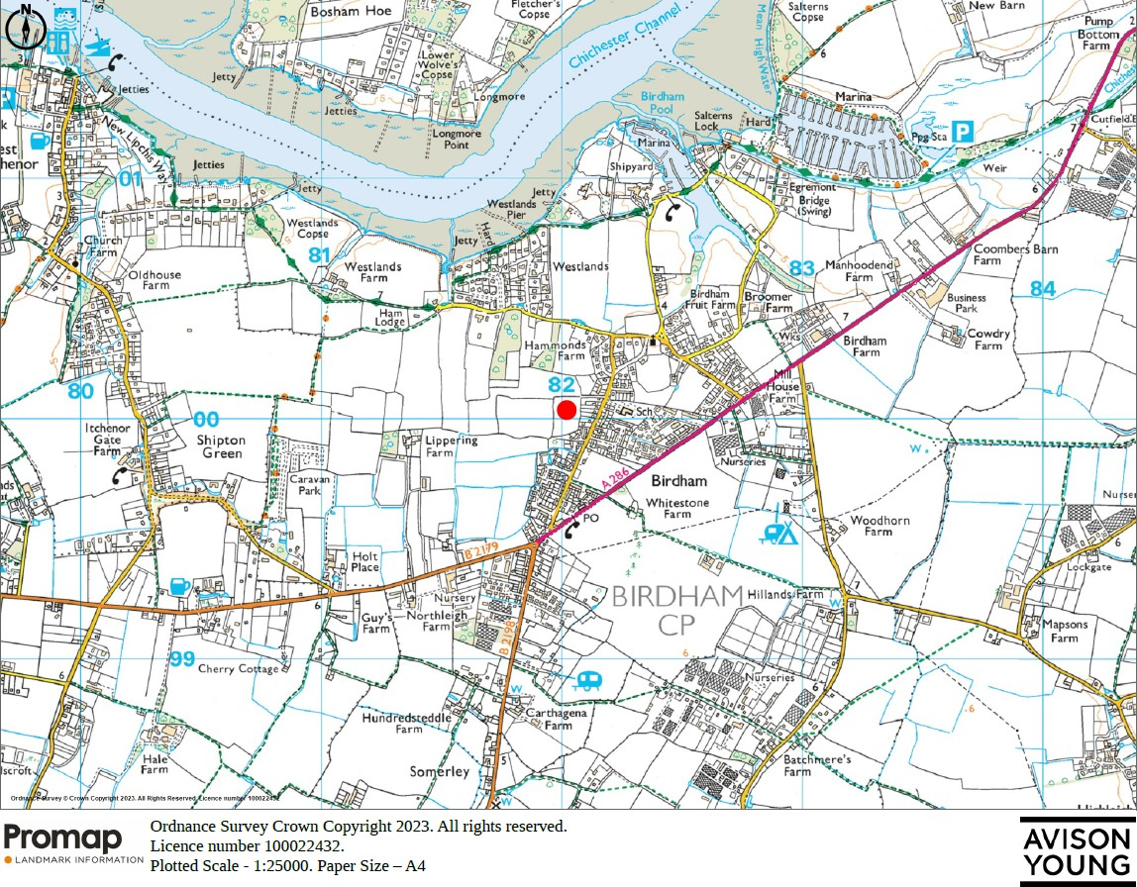

**Appendix 2**

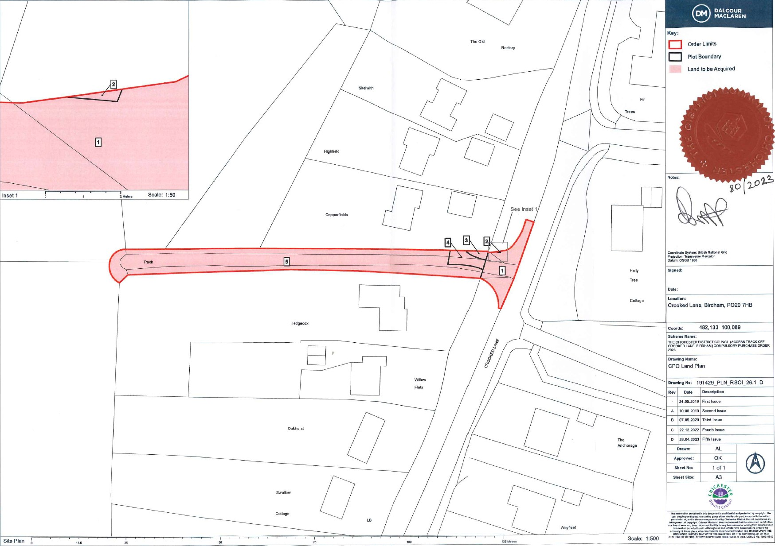

# Appendix 3

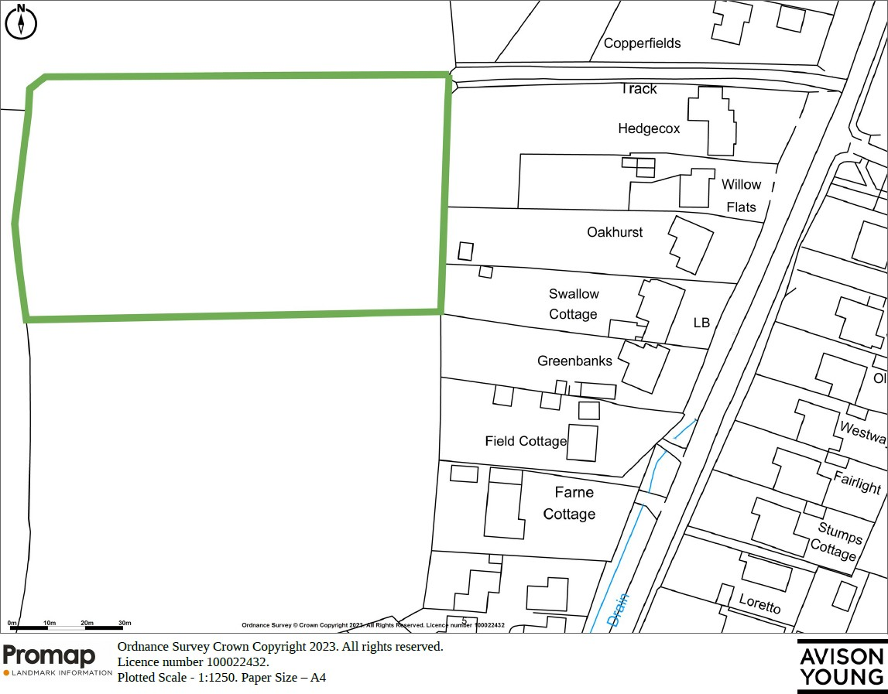

**Appendix 4**

|  |  |
| --- | --- |
| **Document Number** | **Document** |
| 1. | Chichester District Council (Access Track adjoining Crooked Lane Birdham) Compulsory Purchase Order 2022 |
| 2. | Order Map |
| 3. | Statement of Reasons |
| 4. | Press Notices |
| 5. | Specimen Notice of Making of the Order served on Owners |
| 6. | Specimen Site Notice advertising Making of the Order |
| 7. | Cabinet Report to Full Council and Resolutions |
| 8. | Guidance on Compulsory purchase process and the Crichel Down Rules: DLUHC July 2019 |
| 9. | The National Planning Policy Framework, DLUHC July 2021 |
| 10. | Chichester Local Plan: Key Policies 2014-2019 |
| 11. | Chichester Local Plan 202021 – 2039 Proposed Submission |
| 12. | Birdham Neighbourhood Development Plan |
| 13. | Housing and Economic Development Needs Assessment (HEDNA) April 2022 |
| 14. | planning permission (reference BI/13/01391/FUL) dated 29 November 2013 in respect of the Scheme |
| 15. | Section 106 Agreement dated 29 November 2013 made between the Council (1). Martlet Homes Limited (2) and others, in respect of the Scheme |
| 16. | Planning Permission (reference BI/16/01809/FUL) dated 14 October 2016 in respect of the Scheme |
| 17. | Deed of Variation dated 14 October 2016 made between the Council (1) Martlet Homes Limited (2) and others, in respect of the Scheme |
| 18. | Certificate of lawful development dated 25 July 2017 in respect of the carrying out of a ‘material operation’ on the Crooked Lane Site pursuant to the Planning Permission |

|  |  |
| --- | --- |
| 19. | Equality and Consultation Analysis |

The Council reserves the right to refer to any other documentation at a later stage.