[Proper Officer]  [Party Name]  [Party Address] |  |  |  |  | Chichester District Council  East Pallant House  Chichester  PO19 1TY
 |  |  |  | Date: | [DATE] 2023

Dear [Salutation],

CHICHESTER DISTRICT COUNCIL (ACCESS TRACK OFF CROOKED LANE, BIRDHAM)
COMPULSORY PURCHASE ORDER 2023

We write to confirm that on 2 May 2023, Chichester District Council (“the Council”) made the above-mentioned Compulsory Purchase Order (“the Order”).

Please find enclosed with this letter a copy of the Order, the Schedule to the Order and the Order Map together with a notice confirming that the Order has been made and a Statement of Reasons setting out the Council’s detailed justification for its decision to make the Order.

Should you wish to lodge an objection in respect of the Order, you should write to Secretary of State for Levelling Up, Housing and Communities, Planning Casework Unit, 23 Stephenson Street, Birmingham, B2 4BH before close of business on 8 June 2023 stating the title of the Order, your grounds of objection, your address and your interest in the land which is the subject of the Order. Your objection should be submitted by post or via email to pcu@communities.gsi.gov.uk.

An online copy of the order and the accompanying map has been made available on the Council website at www.chichester.gov.uk/birdhamCPO

Should you have any queries in connection with the Order or the documentation enclosed, or should you wish to discuss the acquisition of your land and / or interests, the subject of the Order, together with any compensation to which you may be entitled, please refer to Section 14 of the Statement of Reasons, which contains contact names and numbers for relevant queries.

Yours faithfully

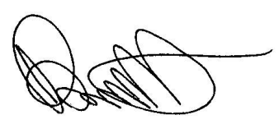

Nicholas Bennett
Divisional Manager, Democratic Services
Chichester District Council

