To:

TOWN AND COUNTRY PLANNING ACT 1990: SECTION 191 AND 192

(as amended by section 10 of the Planning and Compensation Act 1991) TOWN AND COUNTRY PLANNING

(DEVELOPMENT MANAGEMENT PROCEDURE ORDER) 2015 (as amended) ARTICLE 39 CERTIFICATE OF LAWFUL USE OR DEVELOPMENT

Agent : Applicant Details :

Mr Keith Lancaster Blake Morgan LLP

6 New Street Square London EC4A 3DJ

Mrs Sarah Poulter Martlett Homes Limited Telecom House

125-135 Preston Road Brighton BN1 6AF



Chichester District Council hereby certifies that on 18th April 2017 the use and building operations described in the First Schedule in respect of the land specified in the Second Schedule to this certificate and edged in red on the plan attached to this certificate, would have been lawful within the meaning of section 192 of the Town and Country Planning Act 1990 (as amended), for the following reasons:

1) FIRST SCHEDULE

The true pre-commencement conditions were discharged by the Council before 29th November 2016 for the purposes of implimentation of the planning permission. All other conditions, for the reasons outlined above, are not considered to true pre-commencement conditions, although a number have, however, still be discharged by the Council. Planning permission (ref: BI/16/01809/FUL) was lawfully implemented on or before 29 November 2016 by the carrying out of material operations and, therefore, the development permitted by the planning permission can be lawfully carried out, pursuant to that permission.

SECOND SCHEDULE

Field North West of The Saltings, Crooked Lane, Birdham, West Sussex.

INFORMATIVE

The applicant is reminded that the Council operate a formal procedure for the discharge of conditions. Details of this procedure can be found on the Council’s website (<http://www.chichester.gov.uk/planningadvice#planningapplications>) or by telephone (01243 534734).

The plans the subject of this decision can be viewed on the Council’s website [www.chichester.gov.uk](http://www.chichester.gov.uk/) quoting the reference number of the application. For all applications after May 2003, the

relevant plans are listed as “Plans-Decided”.

Date : 25 July 2017 Signed:

Andrew Frost Head of Planning Services signature 

Andrew Frost

Head of Planning Services Chichester Distict Idox

Notes

1. This certificate is issued solely for the purpose of section 192 of the Town and Country Planning Act 1990 (as amended).
2. It certifies that the use and operations specified in the First Schedule taking place on the land described in the Second Schedule would have been lawful on the specified date and, thus, would not have been liable to enforcement action under section 172 of the 1990 Act on that date.
3. This certificate applies only to the extent of the use and operations described in the First Schedule and to the land specified in the Second Schedule and identified on the attached plan. Any use or operations which are materially different from those described or which relates to other land may render the owner or occupier liable to enforcement action.
4. The effect of the certificate is also qualified by the proviso in section 192(4) of the 1990 Act, as amended, which states that the lawfulness of a described use or operation is only conclusively presumed where there has been no material change, before the use is instituted or the operations begun, in any of the matters relevant to determining such lawfulness

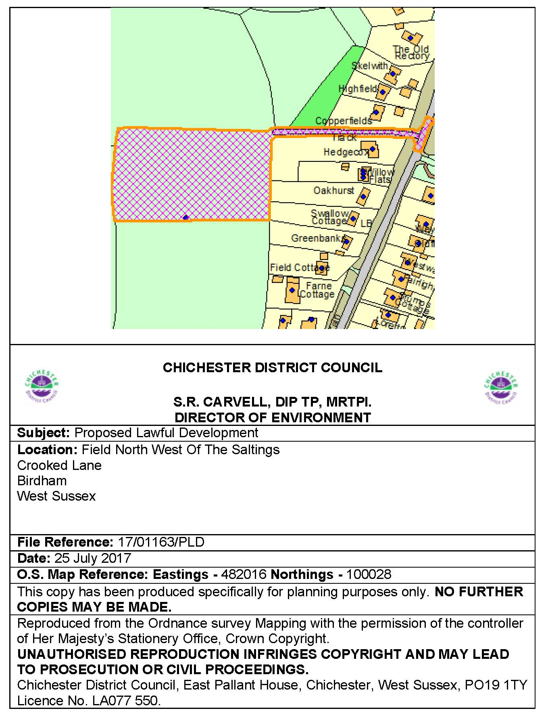

# NOTES

**Town and Country Planning Act 1990**

# Town and Country Planning (Control of Advertisements) Regulations 1992 Town and Country Planning (Trees) Regulations 1999

**Your attention is directed to the following notes. They are for information only and do not pretend to set out the whole of the law on the subject. It would be well for you to consult your solicitor if you are in any doubt.**

1. If the applicant is aggrieved by the decision of the District Planning Authority to refuse permission for the development, or is aggrieved by a condition imposed on a planning permission, he may appeal to the Secretary of State in accordance with Section 78 of the Town and Country Planning Act 1990 within six months* from the date of notice or determination giving rise to the appeal. (All appeals must be made on a form which is obtainable from The Planning Inspectorate, Room 3/04A Kite Wing, Temple Quay House,

2 The Square, Temple Quay, Bristol BS1 6PN. <https://www.gov.uk/planning-inspectorate>. Advertisements and ELD/PLD appeal forms are available from County House, Portland Square, Bristol; Tree Preservation Order appeals forms are available from Government Office from The Planning Inspectorate, The Environment Appeals Team, Trees and Hedges, Room 3/25 Hawk Wing, Temple Quay House, 2 The Square, Temple Quay, Bristol, BS1 6PN. Email – [environment.appeals@pins.gsi.gov.uk](mailto:environment.appeals@pins.gsi.gov.uk) Telephone – 0303 444 5584. One copy of the appeal form must be submitted to the Head of Planning and Building Control Services, Chichester District Council, East Pallant House, Chichester, West Sussex PO19 1TY).

The Secretary of State has power to allow a longer period for the giving of a notice of appeal but he will not normally be prepared to exercise this power unless there are special circumstances which excuse the delay in giving notice of appeal. The Secretary of State is not required to entertain an appeal if it appears to him that permission for the proposed development could not have been granted by the District Planning Authority, or could not have been so granted otherwise than subject to the conditions imposed by them, having regard to the statutory requirements to the provisions of the development order, and to any directions given under the order.

* **APPLICANTS SHOULD NOTE THAT THE PERIOD FOR MAKING AN APPEAL IN RESPECT OF HOUSEHOLDER APPLICATIONS (SUFFIX /DOM) IS 12 WEEKS FROM THE DATE OF THIS NOTICE; FOR ADVERTISEMENT APPLICATIONS (SUFFIX /ADV) IT IS 8 WEEKS; AND FOR TREE APPLICATIONS (SUFFIX /TPA) IT IS 28 DAYS.**

1. If permission to develop land is refused or granted subject to conditions, whether by the District Planning Authority or by the Secretary of State, and the owner of the land claims that the land has become incapable of reasonably beneficial use by the carrying out of any development which has been or would be permitted, he may serve on the Council of the County District in which the land is situated a purchase notice requiring that Council to purchase his interest in the land in accordance with the provisions of Part V of the Town and Country Planning Act 1990.
2. In certain circumstances a claim may be made against the District Planning Authority for compensation where permission is refused or granted subject to conditions by the Secretary of State on appeal or on a reference of the application to him. The circumstances in which such compensation is payable are set out in the Town and Country Planning Act 1990.
3. By Section 195 of the Town and Country Planning Act 1990 where an application is made to a District Planning Authority for a Certificate of Lawful Use or Development and is refused in part, the applicant

may by notice under this sub-section appeal to the Secretary of State and on any such appeal the Secretary of State shall:

* 1. if and so far as he is satisfied that the Authority’s refusal is not well-founded, grant to the appellant a Certificate of Lawful Use or Development accordingly or, as the case may be, modify the certificate granted by the Authority on the application, and:
  2. if and so far as he is satisfied that the Authority’s refusal is well-founded, dismiss the appeal.

1. Applicants are advised to consult Regulation (15) of the Advertisements Regulations 1992 regarding appeals in respect of advertisements.
2. Where this notice conveys approval or permission, conditional or unconditional please note that the decision given does not purport to convey any consent or approval which may be required under the Public Health Acts and Building Regulations. Additionally applicants are advised to check the need for notice to be given under the Party Wall etc. Act 1996.
3. Where this notice conveys approval or permission subject to conditions, applicants are reminded that the onus is on them to ensure the conditions have been complied with. Under some circumstances a failure to comply with a condition may result in the whole development being unauthorised.