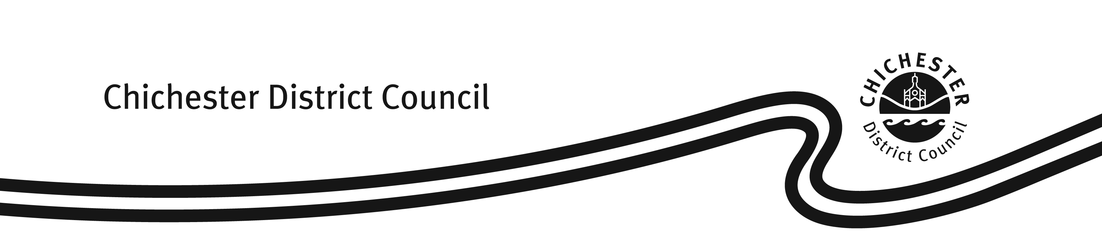

Complaint or Compliment

Mr/Mrs/Miss/Ms: ______________________________Tel. No (optional): ______________________________

Your Surname: _______________________________Your First Name: _______________________________

Your Address: _______________________________________________________________________________

___________________________________________________________________________________________
Your complaint:

Please tell us what you think the Council should do to put matters right:

Equalities and Monitoring form

Chichester District Council is committed to fair treatment and equal access to our services.
In order to ensure the effectiveness of service delivery, all service users are asked to provide the following information. Any information given will be used solely for the purpose of monitoring service delivery.

Age: | 0-15 | 16-20 | 21-30 | 31-40 | 41-50
 | 51-60 | 61-70 | 71-80 | 81 plus

Gender: Male Female

Ethnic Origin*: I would describe my ethnic origin as:

(a) WHITE: British Irish

Any other white background (please specify): __________________________________________________

(b) MIXED: White & Black Caribbean White & Black African White & Asian

Any other white background (please specify): __________________________________________________

(c) ASIAN OR ASIAN BRITISH:

Indian Pakistani Bangladeshi

Any other white background (please specify): __________________________________________________

(d) BLACK OR BLACK BRITISH: Caribbean African

Any other white background (please specify): __________________________________________________

(e) CHINESE OR OTHER:

Chinese Any other (please specify): __________________________________________________

Are you disabled? Yes No

*Ethnic origin questions are not about nationality, place of birth or citizenship.
They are about colour and broad ethnic group. U.K. citizens can belong to any of the groups indicated.
✉When this form is completed, please sent it to mailto:contact@chichester.gov.uk
Unfortunately we cannot usually investigate anonymous complaints.

This publication is available in large print or on tape. Please phone (01243) 534679 for further details.

