

DIRECTION OF THE CHIEF EXECUTIVE UNDER THE HOUSING BENEFIT AND COUNCIL TAX BENEFIT (ELECTRONIC COMMUNICATIONS) (MISCELLANEOUS BENEFITS) ORDER 2006 ANDTHE COUNCIL TAX REDUCTION SCHEMES (PRESCRIBED REQUIREMENTS) (ENGLAND) REGULATIONS 2012

Chichester District Council hereby makes the following directions:

1. An individual who makes a claim for housing benefit under the Social Security Contributions and Benefits Act 1992 or a claim for council tax reduction under the Local Government Finance Act 1992 is authorised to do so by an electronic communication, provided that the individual uses the method approved by the Authority in relation to the claim.
2. The method approved by the Authority means the electronic claim form available on the Council's web site or any other web based forms from time to time available. It also means any e-mails sent to the Council's e-mail in box in relation to any such claim.

Signed by

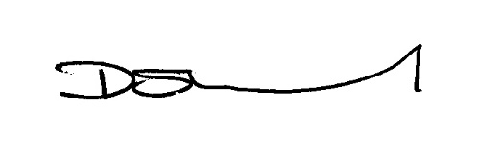

Diane Shepherd Chief Executive

Chichester District Council

16 April 2013