# Chichester District Greenhouse Gas Emissions in 2022

In 2019 Chichester District Council declared a climate emergency and set a challenging target of a 10% reduction in greenhouse gas emissions every year until 2025 for the whole of the Chichester district. The target was chosen to reflect the emission reductions that need to be made to reduce the disastrous effects of climate change, rather than what was easily achievable.

Emission figures are published annually for all council areas by the Government. Each year the Government improves its methods for estimating emissions and then uses the new methods to re-calculate previously published figure. There is always a two-year time lag in the information received from the Government due to the amount of data to be processed. The table below is based on the latest data from Government.

Table 1: Greenhouse gas emission figures for Chichester district with 2019 as a baseline

|  |  |  |
| --- | --- | --- |
| **Year** | **Emissions ktCO2e** | **% Change** |
| 2019 | 727.6 | Baseline year |
| 2020 | 646.8 | 11.1% reduction |
| 2021 | 661.3 | 2.3% increase |
| 2022 | 617.9 | 6.6% reduction |

The Covid pandemic was responsible for much of the emission reductions in 2020, but even such drastic changes in our behaviour could only reduce emissions by 11%. This shows the challenge that we face. In 2021 we started to return our pre-pandemic lifestyles and emissions rose, but in 2022 they decreased again by 6.6%. Across the country, the overall decrease for council areas was about 5%. The Government says this reduction was largely because of warmer temperatures in 2022 resulting in less energy being used to heat buildings, and it may have also been affected by higher energy prices, particularly towards the end of that year. This was despite an increase in emissions from transport as the UK continued to recover from the pandemic.

Making the 10% year-on-year reduction requires action from us all. Although few emissions in the district are under the council’s direct control, we are working to help others reduce their emissions. See some examples below. We also apply the same target to our own greenhouse gas emissions, which are less than a 0.5% of the emissions of the district. You can find out about all our actions within our regular updates on our Climate Emergency Action Plan and we have created a video (on the page that you downloaded this report from) explaining the many actions we have taken.

The climate emergency is a very complex problem, with impacts that are cultural, social, political and environmental and there is no single solution. However, the technology is available and many of the solutions solve multiple problems such as reducing inequality and resolving social issues, reducing household bills, creating jobs and reskilling for a low carbon future. The co-benefits go way beyond carbon saving. By having a district wide target, the climate emergency issues can be addressed together.

Looking more closely at the district’s emissions, road transport is the biggest source of emissions. You can see that in a graph of the area’s emissions below. The public road network is the responsibility of West Sussex County Council (WSCC) except for the A27 which is the responsibility of National Highways. However, Chichester District Council works with WSCC on walking and cycling schemes. See this webpage [Cycle lanes and routes - Chichester District Council](https://www.chichester.gov.uk/article/23971/Cycle-lanes-and-routes)

Households are another big source of greenhouse gas emissions. Chichester District Council has successfully applied for Government funding to improve the energy efficiency of homes and install renewable energy generation. We need householders and landlords to sign up for these schemes. See this webpage [Home energy efficiency - Chichester District Council](https://www.chichester.gov.uk/homeenergyefficiency)

Forests and other ecosystems such as grassland can be greenhouse gas “sinks”. This means that on balance they take in and store more greenhouse gases than they give out. That is why there are two negative bars in the graph below. Mindful of this, and the need to protect wildlife and biodiversity in the district, the council is taking part in a major tree planting project, funded by HM Treasury in partnership with the Department for Environment, Food and Rural affairs. About 50,000 trees have been planted in partnership with landowners, farmers, community groups, parish councils, schools, charities and businesses and on the council’s own land. See this webpage [Chichester District tree scheme - Chichester District Council](https://www.chichester.gov.uk/treescheme)

### Graph: Chichester District Greenhouse Gas Emissions for 2019-2022

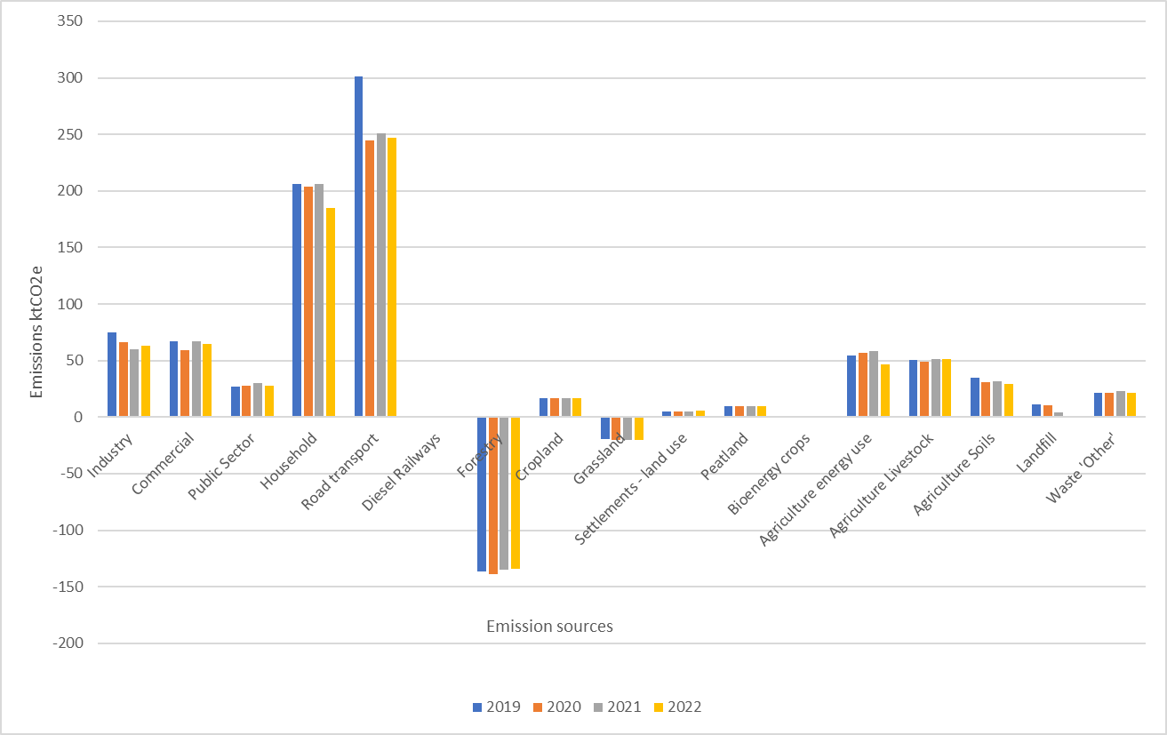

### Table of data used for the graph: Chichester district emissions in ktCO2e for 2019-2022

|  |  |  |  |  |
| --- | --- | --- | --- | --- |
| Year | 2019 | 2020 | 2021 | 2022 |
| Industry | 75 | 66 | 60 | 63 |
| Commercial | 67 | 59 | 67 | 65 |
| Public Sector | 27 | 28 | 30 | 28 |
| Household | 206 | 204 | 206 | 185 |
| Road transport | 301 | 245 | 251 | 247 |
| Diesel Railways | 0 | 0 | 0 | 0 |
| Transport Total | 305 | 248 | 254 | 250 |
| Forestry | -137 | -139 | -135 | -134 |
| Cropland | 17 | 17 | 17 | 17 |
| Grassland | -20 | -20 | -20 | -20 |
| Settlements - land use | 5 | 5 | 5 | 5 |
| Peatland | 10 | 10 | 10 | 10 |
| Bioenergy crops | 0 | 0 | 0 | 0 |
| Agriculture energy use | 55 | 57 | 58 | 47 |
| Agriculture Livestock | 51 | 49 | 51 | 51 |
| Agriculture Soils | 35 | 31 | 31 | 30 |
| Landfill | 11 | 10 | 4 | 1 |
| Waste 'Other' | 21 | 21 | 23 | 21 |

### Notes:

Agriculture soils - urea application, liming of soils and fertiliser application to soils.

Waste ‘Other’ - emissions from waste water treatment, sewage sludge decomposition, composting and anaerobic digestion.