# Greenhouse Gas (GHG) emissions inventory[1] for Chichester District Council

## 1. Overview

This report follows the template set out in UK Government’s Environmental Reporting Guidelines dated March 2019. The template is technical but the aim is to enable emissions reported by different organisations to be compared, so readers know that broadly speaking they are comparing like-for-like. This section aims to put across the key points in a non-technical way.

This report covers the council’s fleet including its refuse collection vehicles, which are the council’s biggest source of emissions. It covers the council’s headquarters, East Pallant House, the Novium museum, Westhampnett vehicle depot, short stay accommodation for people experiencing homelessness (Westward House and Freeland Close), car parks and small buildings such as public conveniences.

The report also includes some leased out buildings that the council owns: three leisure centres (Westgate, Bourne and Grange) and St James Industrial Estate. The council does have other leased assets that are not included e.g. Ravenna Point and Chichester Enterprise Centre, both business accommodation.

Our target is to reduce our emissions by 10% year-on-year from a start year of October 2018-September 2019. The year was chosen because it covers when the Council declared a Climate Emergency and the start month of October reflects the start of the Council’s energy contract.

### Table 1: Council’s emissions

|  |  |
| --- | --- |
| Year 1 (Oct 2019-Sep 2020) | Emissions reduced by 12% |
| Year 2 (Oct 2020-Sep 2021) | Emissions reduced by 4% |
| Year 3 (Oct 2021-Sep 2022) | Emissions increased by 2% |
| Year 4 (Oct 2022-Sep 2023) | Emissions increased by 2% |

The emissions have risen by 2% for the second year running, even though there have been some significant reductions, particularly at Westward House, the council’s short-term accommodation for people experiencing homelessness, which is down by 26% following energy efficiency work. However, the increases in emissions have been greater, although in some cases this is because CDC is offering new or growing services.

## 2. Organisation information

Chichester District Council is a lower-tier local authority with its main offices at 1 East Pallant, Chichester, West Sussex, PO19 1TY.

## 3. Reporting period

01/10/2022 to 30/9/2023

## 4. Organisational boundary[2]

We have used the operational control approach. Therefore, all services delivered directly by the Council and Chichester Contract Services are included in Scope 1 and Scope 2 emissions.

This encompasses fuel and electricity use at:

* The council’s headquarters at East Pallant House which has solar electric (PV) and solar thermal arrays
* Westward House and Freeland Close short stay accommodation. Freeland Close also has PV panels.
* Novium museum which has a wood pellet-fueled boiler
* Car parks
* Westhampnett depot
* Other smaller buildings
* Refuse fleet
* Other council-operated vehicles

We have been trying to include emissions from assets that we own but lease out to reflect our shared responsibility for these assets. These emissions fall into the Scope 3 emissions category for the council. For some leased out buildings, we pay for the energy and then recharge the tenant. For other buildings, we request the data from the tenant. We have included Westgate, Bourne and Grange leisure centres and St James industrial estate and some smaller leased out buildings within the inventory.

## 5. Reasons for change in emissions

The emissions have risen by 2% again this year, even though there have been some significant reductions. However, the increases in emissions have been greater, although in some cases this is because CDC is offering new or growing services, which accounts for almost half of the increase.

### Reductions

1. Westward House, the council’s short stay accommodation for people facing homelessness, had a 26% reduction in emissions, reflecting the energy efficiency improvements which were completed in October 2022.

2. Emissions from gas use at East Pallant House fell by 48% because the gas boilers had to be switched off in April-November 2023 due to a fault. The boilers were replaced by new gas boilers as the lead in time for installation of heating methods that produce fewer greenhouse gases would have risked leaving the building without a heating system over winter. However, the new boilers will still generate a reduction in emissions compared to the older, more inefficient boilers.

### Increases

1. The benefits of Westgate Leisure Centre’s decarbonisation project have still not been fully realised. The control system for the swimming pool heating is being monitored and further adjustments made so the benefits of the solar thermal and air source heat pump are optimised.

We believe the 8% increase in emissions may be partly due to the high gas use between April-June 2023. This is still being investigated but it is thought may be due to a pump failure which has now been fixed. Further improvements to the energy monitoring system are being implemented which will assist in the close monitoring of these changes.

2. More natural gas and less renewable generation was used to produce electricity in this time period leading to a 7% increase in emissions for every kWH produced.[3]

3. Looking across all council installed public use charge-points, there has been a 103% increase in electricity use, leading to a 118% increase in emissions.

4. We had the first full year of operation of Freeland Close, the council’s new short stay accommodation for people facing homelessness. The energy efficiency measures and PV panels on the roof mean that the emissions are more than compensated by the reduction emissions at its sister facility of Westward House.

Another point to note is that St James’ industrial estate which has been re-developed by the council is starting to be occupied by tenants. Only emissions from tenants’ heating and lighting is shown in the council figures to show the effect on greenhouse gas emissions of the re-development, which has been to a BREEAM ‘Very Good’ Rating. If emissions from electricity used to power tenants’ tools and equipment were included, this would make like-for-like comparison impossible.

These changes are illustrated by Graph 1 below.

### Graph 1: year on year changes in main emission sources

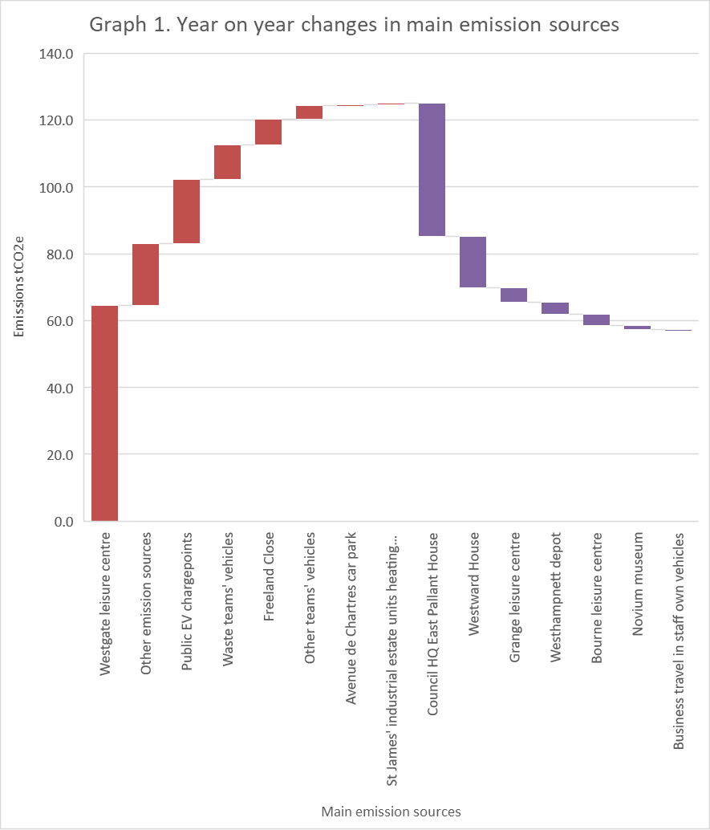

## 6. Quantification and Reporting Methodology

The UK government’s Environmental Reporting Guidelines dated March 2019 and the 2023 UK Government Conversion Factors for Company Reporting have been used, along with the GHG Protocol Value Chain (Scope 3) Standard.

Regarding our gas and electricity consumption, our energy suppliers do estimate some of our usage. This relates to periods when the supplier does not have a reading for a particular building and also for unmetered supply. This is electricity use by a piece of equipment that is connected to the electricity distribution network without a meter. This is usually equipment that uses a predictable amount of electricity e.g. street lighting and signs. Unmetered supply accounts for about 6% of our Scope 2 electricity emissions. We have not estimate emissions ourselves with the exception of St James’ industrial estate.

Data for St James’ industrial estate is completely modelled. Prior to demolition, tenants were responsible for their own electricity purchase, so CDC does not know how much electricity was used and tenants’ electricity use would have varied according to the nature of their business. CDC bought electricity only for the communal areas. After re-development, CDC is buying electricity for the whole site and re-charging tenants for their use. Tenants are not the same ones as prior to demolition. To enable comparison of the greenhouse gas emissions before and after re-building, only electricity use for heating, lighting and aircon will be factored into our emission figures. This has been estimated using the Energy Performance Certificates of the units before demolition. The new units’ electricity use for heating, lighting and aircon has been modelled using construction plan data. Emissions will be incorporated into the CDC inventory as these units are let.

## 7. Operational Scopes

We have estimated our Scope 1, 2 and certain Scope 3 emissions. Emissions are measured in tCO2e or tonnes of carbon dioxide equivalent. Scope 1 (S1) is direct emissions from burning fuels or emissions from air conditioning units. Scope 2 (S2) are indirect emissions from electricity use. They take place at power stations. Scope 3 (S3) emissions are all other emissions. They encompass emissions from goods we purchase to emissions as a consequence of the services we provide. We do not report on all S3 emissions. We do report on:

* larger buildings that CDC leases out
* the energy it takes to make and deliver the gas, fuel and electricity CDC uses
* business mileage employees do in their own vehicles
* the electricity that CDC provides to the public via its network of EV chargepoints.

### Table 2: CDC’s Scope 1, Scope 2 and Scope 3 emissions

| **Emissions in tCO2e[4]** | **2022-2023** | **Excluded emission sources** | **% of activity data[5] that is estimated** | **2021-2022** |
| --- | --- | --- | --- | --- |
| Gas consumption | 88 | None | See methodology section. | 133 |
| LPG | 21 | None | 0 | 31 |
| Fuel emissions for vehicles | 1,177 | None | 0 | 1,170 |
| Fugitive[6] emissions of refrigerants used in air con. |  | Air con unit reporting is to be developed. |  |  |
| Wood pellets (nonbiogenic emissions) | Less than 1 |  |  | 0 |
| TOTAL SCOPE 1 | 1,288 |  |  | 1,333 |
| Purchased electricity – location-based approach | 299 | Public conveniences at Itchenor[7]. | See methodology section. | 277 |
| TOTAL SCOPE 2 | 299 |  |  | 277 |
| **Scope 38 emissions in tCO2e** |  |  |  |  |
| Purchased goods & services |  | We have not tried to quantify these emissions yet. |  |  |
| Capital goods |  | We have not tried to quantify these emissions yet. |  |  |
| Electricity – transmission & distribution (T&D) losses | 26 |  | 0 | 25 |
| Fuel- and energy-related activities not included in Scopes 1 & 2 | 374 |  | 0 | 378 |
| Upstream transportation & distribution |  | We have not tried to quantify these emissions yet. |  |  |
| Waste generated in operations |  | We have not tried to quantify these emissions yet. |  |  |
| Business travel | 25 | Employees who use their own vehicles for business travel but do not claim the mileage allowance. Travel using rail. This is infrequent. | 6% is estimated. This is due to CDC not having the gCO2/km from the employee’s V5 vehicle document. | 25 |
| Employee commuting |  | We have not tried to quantify these emissions yet. |  |  |
| Upstream leased assets |  | Other organizations’ premises used by community wardens as bases. |  |  |
| Downstream leased assets | 1,013 | Buildings where tenant receives energy bill tend to be excluded apart from three leisure centres. | Less than 1% is estimated. | 948 |
| Downstream transportation & distribution |  | Not relevant. |  |  |
| Processing of sold products |  | Not relevant. |  |  |
| Use of sold products | 35 | Electricity used via CDC’s public EV charge-points and electricity used by event organisers at Priory Park. | 0 | 16 |
| End-of-life treatment of sold products |  | We have not tried to quantify these emissions yet. They would include emissions from trade waste collected by CCS. |  |  |
| Franchises |  | Not relevant. |  |  |
| Investments |  | We have not tried to quantify these emissions yet. |  |  |
| Biogenic emissions (wood pellets and biofuel component of diesel and petrol) | 70 |  | 0 | 0 |
| **Intensity metrics** |  |  |  |  |
| Scope 1, Scope 2 & selected Scope 3 emissions per district resident  (tCO2e per capita) | 0.02 |  |  | 0.02 |
| Scope 1, Scope 2 & selected Scope 3 emissions per unit area (tCO2e per km2) | 3.77 |  |  | 3.70 |

### Table 3: Emissions totals

|  | **2022-2023** | **2021-2022** | **% change** |
| --- | --- | --- | --- |
| **Emissions (S1, S2 & selected S3) tCO2e** | 3,059 | 3,002 | 2% increase |

The year-on-year change in emissions from the Council’s key emission sources is shown in Graph 1 below. The data used for Graph 1 is presented below in Table 4.

Scope 1 (S1) emissions are from burning gas or fuel. Scope 2 (S2) emissions are from electricity use. Scope 3 (S3) emissions are from buildings CDC leases out, from the energy it takes to make and deliver the gas, fuel and electricity CDC uses, and from business mileage employees do in their own vehicles. Emissions are measured in tCO2e or tonnes of carbon dioxide equivalent.

### Table 4: Chichester District Council annual emissions of main sources (Scopes 1,2, and 3 in tCO2e)

|  |  |  |  |  |  |  |
| --- | --- | --- | --- | --- | --- | --- |
| **Emission sources** | **Oct 2018 - Sep 2019** | **Oct 2019 - Sep 2020** | **Oct 2020 - Sep 2021** | **Oct 2021 - Sep 2022** | **Oct 2022- Sep 2023** | **tCO2e difference** |
| Waste teams' vehicles | 1,201 | 1,230 | 1,167 | 1,235 | 1,245 | 10 |
| Westgate leisure centre | 821 | 628 | 752 | 783 | 848 | 64 |
| Other teams' vehicles | 252 | 198 | 214 | 214 | 218 | 4 |
| St James' industrial estate units heating & lighting only | 226 | 213 | 71 | 1 | 1 | 0 |
| Council HQ East Pallant House | 220 | 180 | 176 | 200 | 161 | -40 |
| Grange leisure centre | 149 | 105 | 101 | 110 | 106 | -4 |
| Novium museum | 105 | 84 | 86 | 104 | 103 | -1 |
| Westhampnett depot | 77 | 71 | 81 | 69 | 65 | -3 |
| Westward House | 71 | 88 | 63 | 60 | 44 | -15 |
| Bourne leisure centre | 56 | 40 | 38 | 46 | 42 | -3 |
| Business travel in staff own vehicles | 49 | 33 | 25 | 25 | 25 | -1 |
| Avenue de Chartres car park | 37 | 34 | 33 | 31 | 31 | 0 |
| Freeland Close |  |  |  | 6 | 13 | 8 |
| Public EV chargepoint use1 |  |  |  | 16 | 35 | 19 |
| Other emission sources | 215 | 143 | 123 | 102 | 121 | 19 |
| TOTAL | 3,479 | 3,046 | 2,930 | 3,002 | 3,059 | 57 |

1. For first three years, electricity for public EV charge-points is included in the electricity use of the building/car-park to which the charge-point is connected.

## Graph 2: Chichester District council’s main emission sources from 2018-2019 to 2022-2023

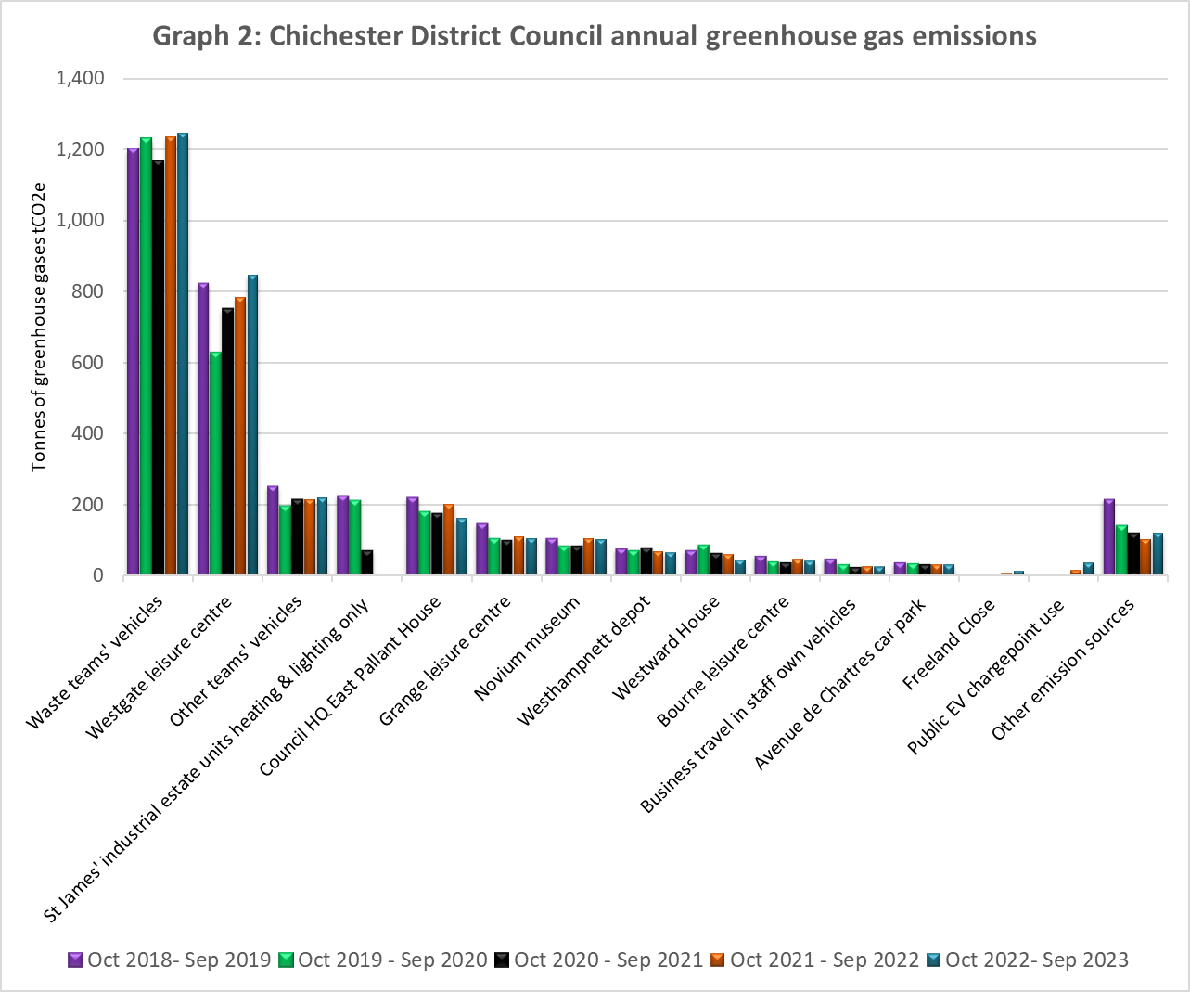

## 8. Base year

The base year is 01/10/2018 to 30/9/2019.

We have chosen this period as it is:

• the year of the council’s climate emergency resolution

• fits with the electricity and gas contract periods

• the subsequent periods will show the effect of Covid 19 lockdown and any GHG reduction initiatives we put in place following the declaration of a climate emergency.

## 9. Target

Our target is a 10% year-on-year reduction from the 2018-2019 base year, covering Scopes 1 and 2 and selected Scope 3 categories until year-end 2025.

## 10. Intensity Metrics

Our chosen intensity metrics are Scope 1, Scope 2 and selected Scope 3 emissions per resident in the district (tCO2e per district resident) and emissions per unit area (tCO2e per km2). The number of residents within the district is a key factor in determining the scale of our activities and hence our emissions. The acreage of the district is a factor in determining the how we deliver those services i.e. the extent to which services can be centralised.

## 11. Electricity & heat data

### Table 5: Electricity and heat data

| **Energy purchased for consumption (MWh)** | 1,443 MWh electricity. 483 MWh gas. |
| --- | --- |
| **Green tariffs or other renewable/low-carbon contractual instruments used** | No. We have been looking at options that allow us to purchase energy in a way that is likely to lead to greenhouse gas emission reductions. |
| **Renewable electricity (in MWh) generated in council-operated plants that was exported to the grid** | Electricity is generated via the PV panels on East Pallant House and Freeland Close, but how much - if any - that is exported to the grid has not been measured. |
| **Was this backed by Renewable Energy Guarantees of Origin (REGOs)?** | No. |
| **Heat generated from council operated sources (in MWh).** | CDC has a solar thermal array generating hot water on East Pallant House roof. We do not have data on the quantity generated. |

1. Inventory is the technical term for a footprint.
2. There are different ways to draw a line around organisations – its boundary. We have used operational control so that we are accounting for emissions from activities over which we have day-to-day control.
3. Scope 2 only.
4. tCO2e stands for metric tonnes of carbon dioxide equivalent. The global warming caused by gases is standardised to the warming caused by one unit of carbon dioxide hence carbon dioxide equivalent.
5. Activity data is the data used to estimate emissions e.g. how much fuel we have used, how many miles we have driven for business. Some activity data has not been measured or taken from records and is estimated instead.
6. Fugitive is the technical terms for emissions from leaks or accidental venting of equipment.
7. These conveniences at Ferryside, The Street, are leased from Chichester Harbour Conservancy.