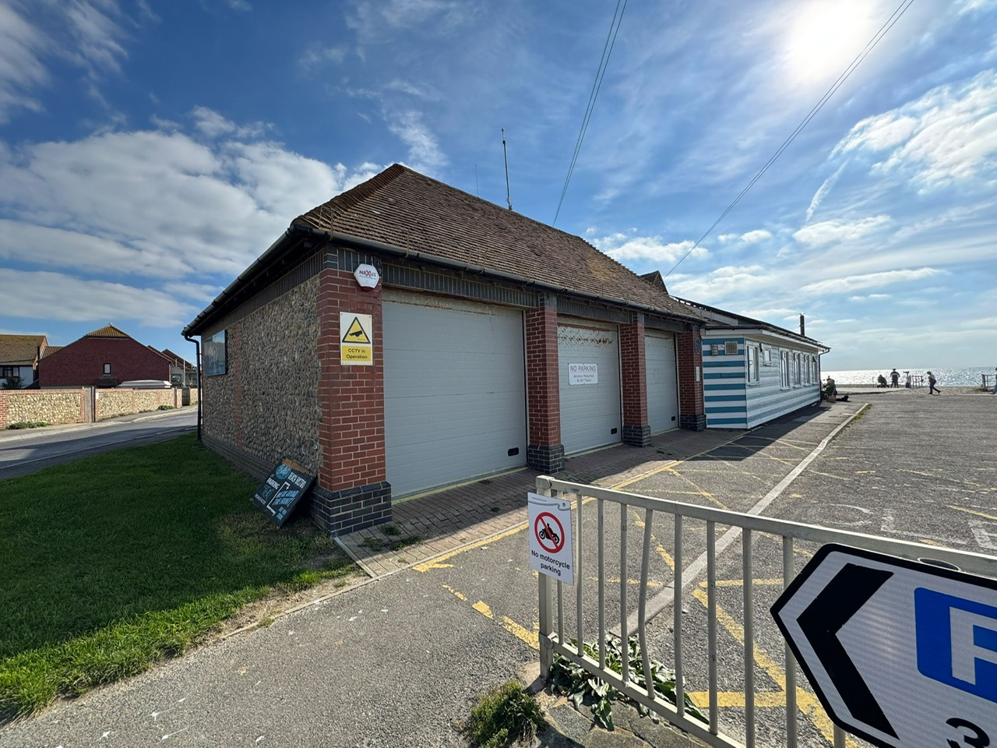

ACCOMMODATION AT BRACKLESHAM BAY, WEST SUSSEX

Location

Bracklesham Bay is situated South of the Cathedral City of Chichester in West Sussex, on the South coast of England. The area is popular with local residents, walkers, beach combers and cyclists (amongst others).

The Property

The property is set back from the beach off of Bracklesham Drive, adjacent to a popular restaurant, the ‘Kosy Kot’ public open space, public conveniences and public car park.

The proposed accommodation is part of the former boat store at the Council’s Foreshore’s Office. Please see the schedule of photographs below showing the accommodation available.

The Opportunity

At this time, the Council is seeking expressions of interest only in respect to this accommodation. Proposals should include a proposed use and likely lease terms. The proposal may include the interested parties past or current business experience.

We will then invite best and final offers when the accommodation is available for to let. Offers will be subject to contract and any relevant planning consents.

Expressions of interest are to be emailed to the Estates team for ease of communication. Alternatively, we can accept written interest via Estates Team, Chichester District Council, East Pallant House, 1 East Pallant, Chichester, PO19 1TY.

At this time the Council is not committed to pursue any potential interest submitted, nor commits to a start date for any agreement to commence in respect to the accommodation.

Viewings

Should you wish to view the interior of the premises, please contact the Estates Service on 01243 534632 or email [property@chichester.gov.uk](mailto:property@chichester.gov.uk) to arrange a viewing.

