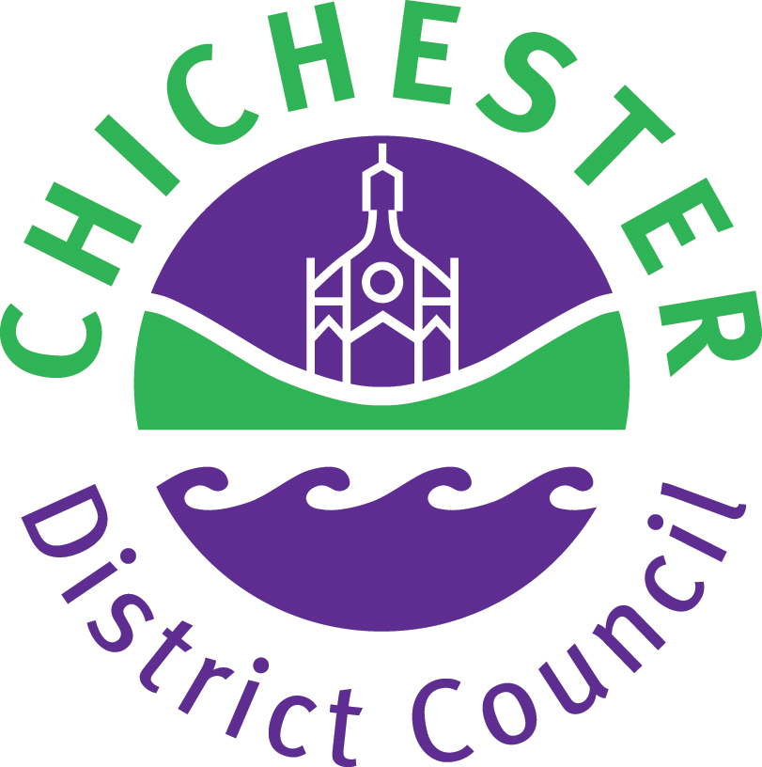

Chichester District Council
Event Guidance Notes

Introduction

This guidance pack has been designed to provide information to organisations wishing to arrange an event at a Chichester District Council, Cultural Services Section owned venue. The forms contained within the pack can be used for all events regardless of size, however some parts may not be relevant for smaller events.

The guide gives general advice that should be used when arranging any type of event. However, it must be remembered that events can be extremely diverse, ranging from a simple car boot sale, to a large outdoor carnival and therefore this guidance cannot be considered exhaustive. It is likely that additional guidance will be required for specialist events and larger scale activities.

Should you consider that more information is required there are many national associations and clubs who may be able to offer advice on specific types of event.

Risk assessment

Please remember that organisers of events have a legal responsibility to ensure the Health, Safety and Welfare of any employees, volunteer helpers or contractors involved in arranging the event and to the public and participants attending. This should be ensured by carrying out a detailed risk assessment. All hazards associated with the event should be identified, the level of risk assessed and appropriate action taken to reduce these risks to an acceptable level. All events must comply with recognised safety standards and you must take all reasonable precautions to ensure the event takes place safely.

A formal record should be kept of the risk assessments. A simple guidance note and an example form is provided with this pack. Completed forms should be retained for future reference.

Where the event consists of more than one attraction e.g. a summer fete a written risk assessment may be required for each activity. In these circumstances, the enclosed risk assessment form can be photocopied.

Any contractors involved in the event should also carry out risk assessments. Where relevant, you should obtain copies of these.

More information regarding risk assessments can be obtained from the Health and Safety Executive (HSE) publications at HSE information Centre, Broad Lane, Sheffield, S3 7HQ. Tel: 01787 881165.
Stage 1 - Pre-planning

Detailed preplanning is essential to ensure the event is successful. The following need to be considered at this stage:

- Where. Make sure the venue you have chosen, is adequate for the proposed event. Do not forget to consider the impact on the local community, how easy it will be for people to get to the venue and any car parking requirements. Consider the suitability of the venue and any existing hazards, which may be on the site such as water hazards, overhead power lines etc. Consider whether or not emergency routes will be adequate.

- When. Consider the time of year, including the consequences of extreme weather conditions at an outside event. The day of the week and time will also need consideration regarding the nature of the event, noise and ease of travel etc. You will probably need to arrange lighting for an evening function. The event should not clash with any other major events in the area, the Tourist Information Centre will be able to advise you of other events taking place 01243 775888.

- Who. Identify the aims of the event. Are particular groups or types of people to be targeted, such as young children, teenagers, the elderly or disabled? If so, specific facilities may be required to accommodate them or additional stewards to ensure adequate safety standards are maintained.

- What. Decide on the type of activities to be held. Will there be any specific hazards such as animals or water sports? If possible also try to establish the size of the proposed event and whether or not an entrance fee will be charged.

- Specialist equipment. Will the activities require the use of any specialist equipment such as bungee jumps etc.? If so, does this equipment pose any specific hazards? Will a particular activity need barriers etc? Some equipment may require certificates of erection by a competent person.

- Code of practice. For larger events there will be a need to comply with guidance particularly the Code of Practice for Outdoor Events published by the National Outdoor Events Association Tel: 0208 6998121, which gives advice on structures, marquees, tents and electrical matters. The HSE Guide to Safety at Events is also a very useful reference document.

- Welfare arrangements. The organiser must estimate the number of attendees to the event and consider its duration. Toilet and first aid requirements should be based on these estimations. Advice is given in the Code of Practice for Outdoor Events referred to above. Permanent toilets should be checked for adequacy and maintained during the event. The provision of drinking water will be necessary. Depending upon the scale of the event, refreshments and other facilities may be required. Provision also needs to be made for lost children, missing persons, baby changing and lost property.

- Special permission. If you are proposing to sell/supply alcohol, provide regulated entertainment (e.g. a performance of live music, provision of facilities for dancing, playing of recorded music, performance of a play) or provide late night refreshment (supplying hot food and/or drink between 23:00 and 05.00) you may require a permission under the Licensing Act 2003. Please contact the Licensing Team on 01243 534740.

- Insurance. All events will require public liability insurance. All contractors and performers will also need their own public liability cover with a £5 million Limit of Indemnity. Depending upon the nature of your organisation and the proposed event other insurances may also be required. Quotations should be obtained from your insurance provider.

- Timescale. Set out the proposed timescale and give yourself as much time as possible to organise the event. You may need as much as 9 to 12 months planning. Some specialist advice may be required, and special permission could take time. Do not forget the summer can be a busy time with hundreds of events taking place within your area.

- Event plan. This should include all your health and safety arrangements. Once you have resolved all the issues referred to above, keep records of the proposals as a formal plan for the event. This will help you when carrying out your risk assessments.

Stage 2 - Organising the event

Once you have decided on the fundamental objectives behind the activities, you can then start to organise the event in detail. Remember to write things down as you go and to keep the event plan up to date.

- Establish a committee. Identify specific responsibilities for all committee members. One person should be identified as the event manager and be responsible for liaison with other organisations such as the council, the local police force and other emergency services. One person, with suitable experience, should be given overall responsibility for health and safety and another person co-ordination and supervision of stewards.

- Liaison. Contact the local police, fire brigade, ambulance and first aid providers. Tell them about the event and ask them for advice. Decide what additional information is required regarding specific activities and make contact with the council and/or the relevant organisations. Other emergency services may need to be contacted such as HM Coastguard for waterborne events at sea.

- Site plan. Draw out a site plan identifying the position of all the intended attractions and facilities. Plan out and designate the entrance and exit points, circulation routes, vehicle access and emergency evacuation paths.

- Emergency plan. A formal plan should be established to deal with any emergency situations, which may arise during the event. The complexity of this will depend upon the size and nature of the event itself. A simple easy to follow plan will be acceptable for a small event. You may have to liase with the emergency services, local hospitals and the council’s emergency planning officer and create a planning team to consider all potential major incidents and how you would deal with them. Organisers of larger events may wish to contact the council for further information.

- Temporary structures. Many events will require temporary structures such as staging, tents, marquees, stalls etc. Decide where this equipment is to be obtained, who will erect it and what safety checks will be required. The location of any such structures should be identified on the site plan. Consider whether barriers will be required to protect the public against specific hazards such as moving machinery, barbecues, vehicles and any other dangerous displays etc. In some cases, barriers will need to have specified safety loadings dependant upon the number of people likely to attend. Temporary structures should only be obtained from experienced suppliers.

- Catering. Ensure any caterers have been licensed by their local authority and that they will be sensibly positioned such as away from children’s activity areas and near to water supplies etc. Adequate space should be left between catering facilities to prevent any risk of fire spread. Ask to see caterers’ food hygiene certification. You may wish to use only caterers who are members of the Mobile Outside Caterers Association. You should obtain a list of their menu and charges to ensure their prices are reasonable.

- Stewards. Stewards at larger events must be fully briefed on all aspects of the event including crowd control and emergency arrangements. Written instructions, site plans and checklists should be provided to them. It is important that stewards can be easily identified by the public and that they can effectively communicate with each other, their supervisor, the person responsible for health and safety, and the event manager.

All stewards should be properly trained and competent as they will need to be constantly on the lookout for hazards, which could develop during the event. They may also be required to guide vehicles, clear emergency exits, and sort out any behavioural problems. Specific training should be provided for basic first aid assistance and fire fighting. Stewards may require personal protective clothing such as hats, boots, gloves or coats. For evening events, they may need to be issued with torches. At all day events, duty rotas will be required.

- Crowd control. The type of event and the numbers attending will determine the measures needed. Consideration will need to be given to the number and positioning of barriers, and the provision of a public address system.

- Numbers attending. The maximum number of people the event can safely hold must be established. This may be reduced dependant upon the activities being planned. The numbers of people attending the event may have to be counted to prevent overcrowding. Remember that one particular attraction may draw large numbers of visitors.

- Provision for the disabled. Specific arrangements should be made to ensure disabled visitors have adequate facilities, parking and specific viewing areas and can safely enjoy the event.

- Security. Depending upon the nature of the event, specific security arrangements may be necessary, including arrangements for securing property overnight. Cash collection should be planned to ensure this is kept to a minimum at collection points and that regular collections are made to a secure area. Following your risk assessment, stewards or helpers collecting cash may require money belts or other carrying facilities. Counting and banking arrangements should be given careful consideration.

- On-site traffic. Contractors and/or performers vehicles and other traffic should be carefully managed to ensure segregation from pedestrians. It may be necessary to only permit vehicular access at specific times and not during the event itself. Separate entrances should be provided for vehicles and pedestrians with specific arrangements for emergency vehicle access. Car parking facilities will be required at most events and these will have to be stewarded. Consider where such facilities should be situated.

- Off-site traffic. Unplanned and uncontrolled access and egress to a site can result in a serious accident. Traffic control both inside and outside the site should be discussed with the police. Adequate signs and directions should be provided in prominent positions on the approaches to the entrances. If road closures, signs on the highway, traffic diversions and/or the placement of cones are required then an application must be made for a traffic regulation order and/or approval from the highway authority.

- Transportation. The local rail and bus companies should be advised of larger events to establish if existing services will be adequate. You will also need to liase with them if road closures or diversions are intended.

- Contractors. All contractors should be vetted to ensure they are competent to undertake the tasks required of them. Wherever possible personal references should be obtained and followed up. Ask contractors for a copy of their safety policy and risk assessments, and satisfy yourself that they will perform the task safely. Always ask to see their public liability insurance certificate, which should provide a limit of indemnity of at least £5 million. Provide contractors with a copy of the event plan and arrange liaison meetings to ensure they will work within your specified parameters.

- Performers. All performers should have their own insurances and risk assessments and the same considerations will apply as for contractors. Where amateur performers are being used, discuss your detailed requirements with them and ensure they will comply with your health and safety rules and event plan.

- Facilities and utilities. Where electricity, gas or water is to be used, detailed arrangements must be made to ensure the facilities are safe. All portable electrical appliances including extension leads etc. should be tested for electrical safety and a record kept. Any hired equipment should come with a certificate of electrical safety.

Where events are taking place outside, residual current circuit breakers should be used and if possible the power supply stepped down to 110volts. All cables will have to be safely channelled to eliminate any electrical and tripping hazards. Potential hazards due to extreme weather should not be overlooked at outside events. Portable gas supplies for cooking should be kept to a minimum in designated areas away from the general public. The same should apply to any fuel supplies items such as portable generators etc. Generators should be suitably fenced or barriered to prevent public access from public areas. All these arrangements should be clearly shown on the site plan.

- Contingency plans. Consider the implications on the event of extreme weather conditions. Will the event be cancelled? Could specialist matting be hired in at short notice? Or could the event be moved to an alternative inside venue. This will involve a lot of planning and may be too complex for anything other than the smallest of events. There could also be other scenarios, which should be planned for, such as dealing with a disappointed crowd if the main attraction has not turned up.

- Clearing up. Arrangements may be required for waste disposal and rubbish clearance both during and after the event. Individuals should be designated specific responsibilities for emptying rubbish bins and clearing the site. At some events there could be discarded hypodermic needles which need to be disposed of safely. This will require specialist training and equipment.

- Risk assessments. Taking all the above into consideration, you should establish which specific hazards require individual risk assessment. Initial assessments should be undertaken and any remedial action specified in the updated event plan. A timescale should be specified where necessary.

Stage 3 – Final preparations

Just prior to the event a detailed safety check will have to be carried out. This should include the following:

- Routes. Ensure clear access and exit routes and adequate circulation within the site. Pay particular attention to emergency routes

- Inspections. A checklist is provided as an example. A walk through inspection of the site should be carried out immediately prior to, during and after the event to identify any potential hazards and to check out communications are working. You may want to carryout more than one inspection during the event. All defects should be noted and also the remedial action taken. These checklists should be retained for future reference.

- Siting. Make sure that all facilities and attractions are correctly sited as per your site plan. Be certain that the first aid facilities, fire extinguishers and any cash collection boxes are in place. Check waste bins are in their correct locations.

- Signage. Ensure adequate signage is displayed where necessary. This should include emergency exits, first aid points, information and lost children points and other welfare facilities such as toilets and drinking water.

- Vehicles. Check that all contractors, performers and exhibitors vehicles have been removed from the site or parked in the designated area before the public are permitted to enter.

- Structures. Ensure all staging, seating, marquees and lighting structures have been erected safely and that certification has been obtained from the relevant contractors as a record of this.

- Barriers. Check that all barriers and other protection against hazards are securely in place and there is no risk of falling from staging or other facilities.

- Stewards. Make sure that all staff have arrived and are in their correct location. Ensure all stewards are wearing the correct clothing for easy identification.

- Lighting. Check all lighting is working, including any emergency lighting.

- Public information. Make sure the public address system is working and can be heard in all areas.

- Briefing. Check that all stewards and staff have been fully briefed and understand their responsibilities.

Stage 4 – After the event

- Site condition. After the event, another inspection should be carried out to make sure nothing has been left on the site which could be hazardous to future users. This inspection should also identify any damage which may have been caused during the event. If any structures are left overnight, it must be ensured they are left in a safe condition and are safe from vandalism etc. If numerous structures are left, specific security arrangements may be required.

- Accidents. If an accident occurs, the names and addresses of witnesses should be obtained, photographs taken and a report made by the organisers. An accident form should be completed and a copy sent to the landowner. A sample accident reporting form is included in the pack. You will also need to advise you own insurance company. If any accident or dangerous occurrence is reported, action must be taken to prevent any further incidents taking place.

- Claims. Should any person declare an intention to make a claim following an alleged incident associated with the event, you should contact your insurers immediately. They may also require a completed accident form.

