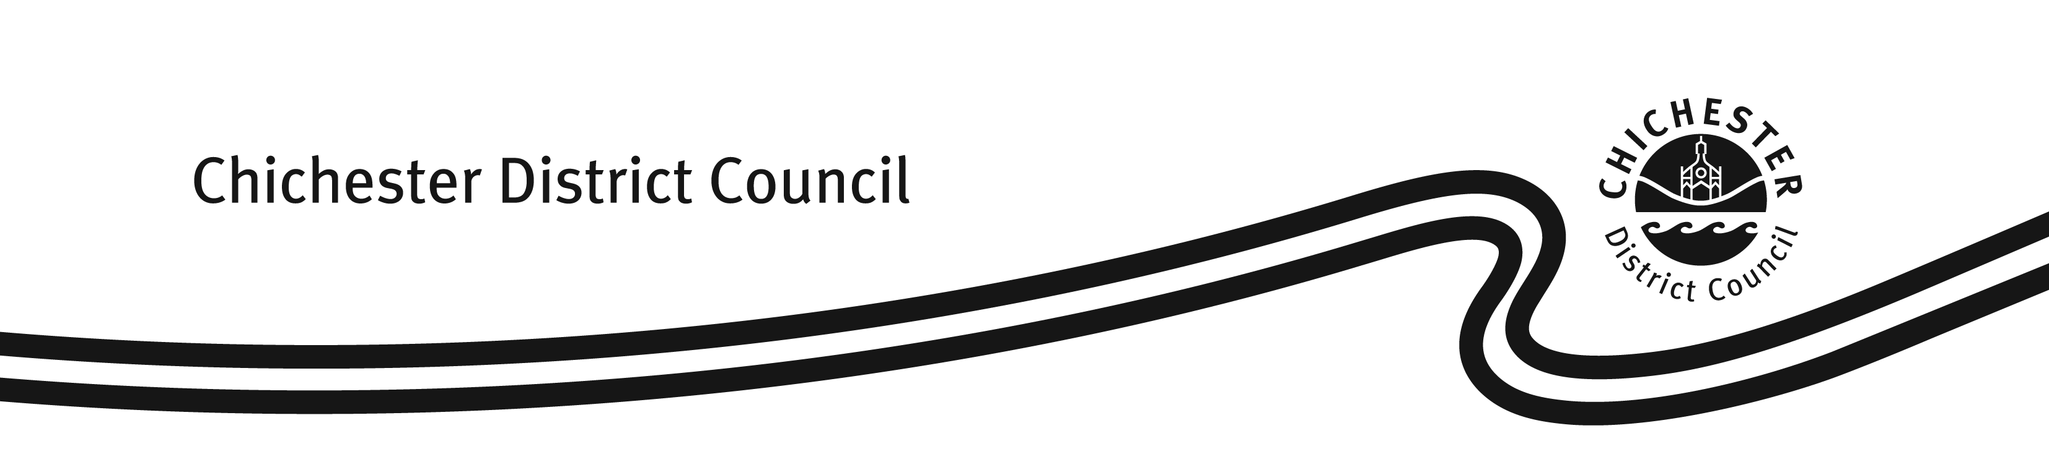
FORM: L44

Case Reference Number:

Personal Licence – Request for a replacement copy
Licensing Act 2003

Where a Personal Licence (the ‘licence’) is lost, stolen, damaged or destroyed, the holder of the licence may apply under Section 126 of the Licensing Act 2003 to the issuing Licensing Authority for a replacement copy.

However, in order for the Licensing Authority to issue a replacement, it must be satisfied that the licence has either been lost, stolen, damaged or destroyed.

This Licensing Authority has developed this form to assist licence holders in applying for a copy of the licence. Please ensure that the form is completed correctly and the fee paid. It is possible to submit this request by either of the following methods:

Email to: licensing@chichester.gov.uk

Post to: Licensing Team, Housing & Environment Services, Chichester District Council, East Pallant House, 1 East Pallant, Chichester, West Sussex, PO19 1TY

The current fee payable when applying for a copy of a licence is £10.50. Payment can be made by debit card by calling our Customer Services Team on 01243 534740.

PERSONAL LICENCE NUMBER (if known):
SECTION A
Name:
SECTION B
Address:

Home: Work:

Mobile: Email:

SECTION C
I am:

(a) Requesting a replacement copy of the A4 paper part
of my Personal Licence Yes / No

If ‘Yes’, please explain why:

(b) Requesting a replacement copy of the durable card part Yes / No
of my Personal Licence

If ‘Yes’, please explain why if reason different from (a) above:

(c) Enclosing payment of the fee or have made the payment Yes / No

SECTION D - Declaration

I certify that the information contained within this form is correct to the best of my knowledge.

Signature:

Name:

Date:

Useful contact details:

Tel: 01243 534740 Fax: 01243 776766
Email: licensing@chichester.gov.uk Web: http://www.chichester.gov.uk/licensing

(v6 – 24.07.23

