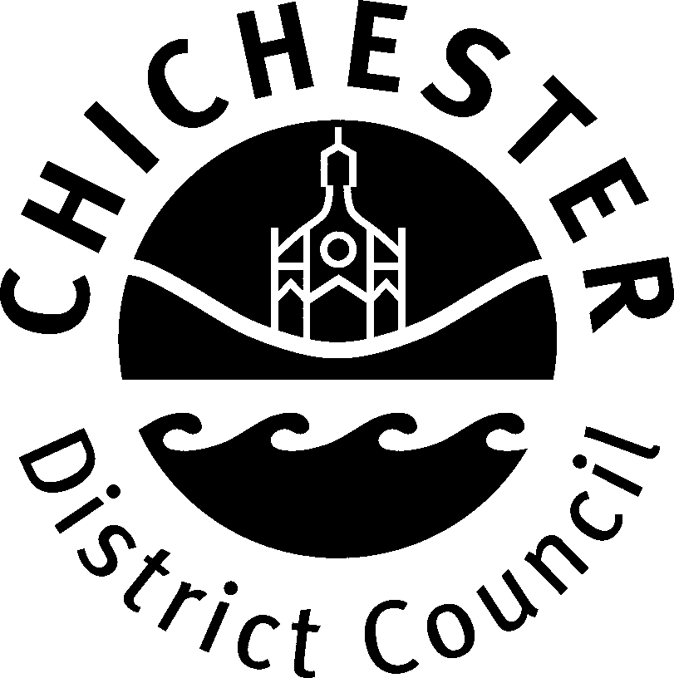 | Licensing Team, Growth & Place,  Chichester District Council, East Pallant House,  East Pallant, Chichester, West Sussex, PO19 1TY
CHICHESTER DISTRICT COUNCIL

STREET COLLECTION POLICY GUIDELINES

The Licensing and Enforcement Committee agreed on 13th December 2004 that applications for the City Centre of Chichester should continue to be dealt with annually with the closing date for submission of applications remaining at 30th November in the year preceding the proposed collection.

Officers should circulate to Members a list of the applications received some three weeks or so before any decisions are taken. This would enable Members to feed comments back to officers. In the event of a contentious matter arising, officers would, in consultation with the Chairman, consider the need to call a special meeting of the Committee.

The following policy guidelines must be adhered to when determining an application for a Street Collection Permit:

- The number of permits to be issued for the City Centre of Chichester must be limited to a maximum of 30 a year. In exceptional circumstances additional permits may be granted by the officers in consultation with the Chairman of the Committee.

- Permits will only be granted to charities that are registered with the Charities Commission except where the application is to collect money or sell articles the proceeds of which will be applied for charitable, benevolent, philanthropic or purposes of a like nature within the administrative area of the Chichester District Council.

- Preference is to be given to:

  - Local charities and
  - Charities with a local connection.

- In addition to the numbers identified in item 1 a day in June each year will be allocated for the Mayor of Chichester's chosen charity.

- The following charities of national significance will be supported when an application is received from them:

    - Royal British Legion
    - British Red Cross
    - Army Benevolent Fund
    - Salvation Army
    - RNLI
    - Rotary Club
    - Lions Club
    - Children in Need
    - Royal Air Forces Association

- Permits must not be granted to organisations that:

  - have any direct political allegiance or affiliation
  - are involved in, or advocate any form of direct action which intimidates or threatens any person, or involves any form of potentially criminal activity in order to further their cause.

- Not more than one permit is to be granted to any organisations in any year for a collection in the City Centre of Chichester except in exceptional circumstances and following consultation between' the officers and the Chairman of the Committee.

- These policy guidelines shall apply to the granting of permits throughout the whole of the District of Chichester except that the restriction on numbers contained in items 1 and 7 shall only apply to the City Centre of Chichester.

- Applications that do not meet the requirements of the above policy guidelines will be refused.

- Where the officers consider that an application merits consideration by the Committee the officers will initially consult the Chairman of the Committee, and may, subject to that consultation, refer the application to the committee for determination.

