It is important that Part 2 of the registration document is completed by the person receiving the shellfish and that both they and the gatherer keep a copy for 12 months.
However, if a batch is split, then a copy of the original Registration Document is permitted and must accompany each sub batch together with the full name and address of the person splitting the batch.

Failure to comply with these requirements

If Shellfish are harvested from unclassified or prohibited beds or a batch of live shellfish is not accompanied by a completed registration document, food authorities are empowered to seize them and seek an order for their destruction through the Court. Further charges can also be brought against the gatherer.
A person found guilty of an offence under these regulations can be subject to a fine, and/or imprisonment of up to two years.

Further information and advice
Food Standards Agency website www.food.gov.uk
Your local authority:

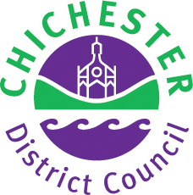
Health Protection Team
Health Protection and Environmental Management
Chichester District Council
East Pallant House
1 East Pallant
Chichester PO19 1TY

Tel: 01243 534602
Email: environmentalhealth@chichester.gov.uk

Environmental Health Team (Commercial)
Havant Borough Council
Public Service Plaza
Havant PO9 2AX

Tel: 02392 446654
Email: ehcommercial@havant.gov.uk

Produced by
The Southern Shellfish Liaison Group October 2008
(Amended October 2013)
Shellfish
Information for
commercial gatherers
and merchants

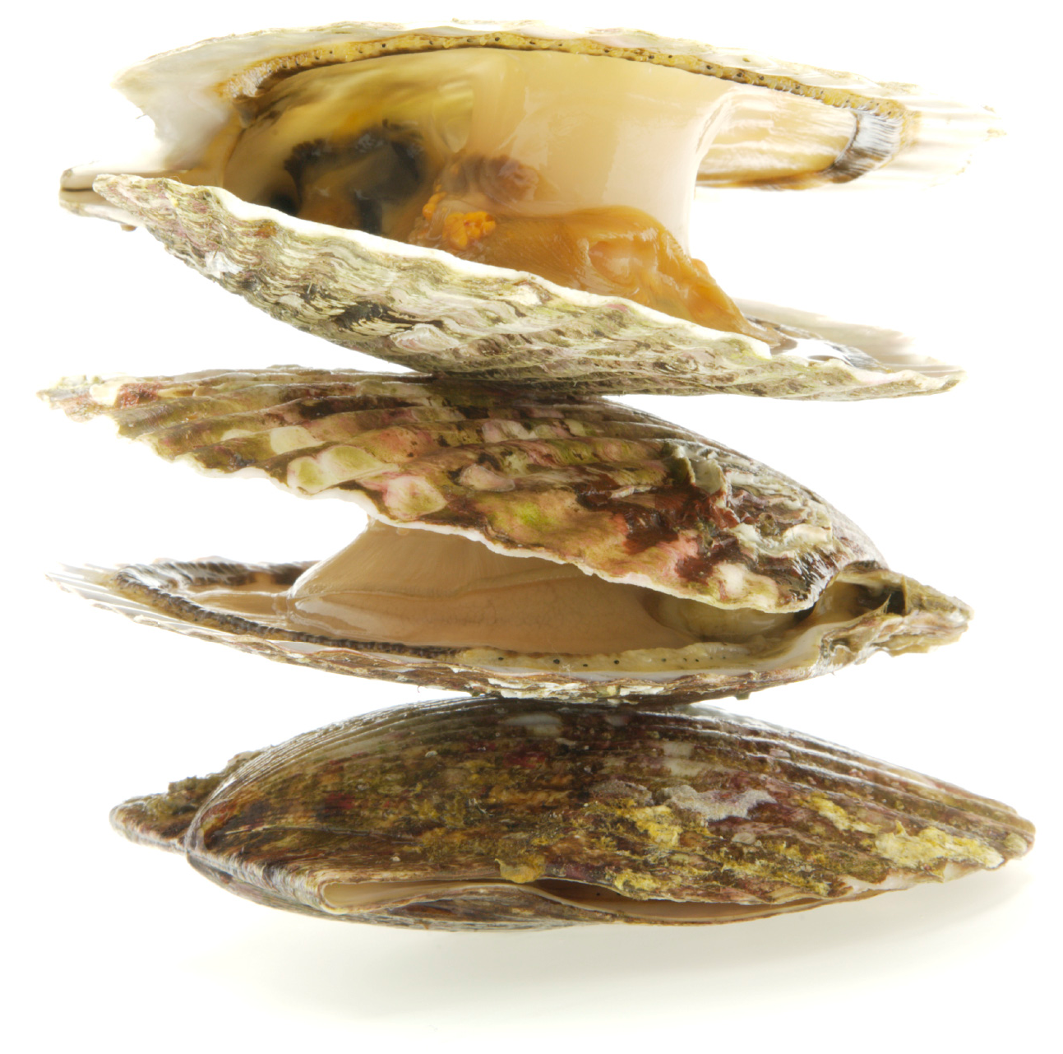
Introduction
This leaflet deals with your duties when gathering, handling and selling live bivalve molluscs, eg, clams, cockles, mussels, oysters, etc. The commercial production and sale of these is strictly controlled as they have the potential to cause serious illness due to the way in which they feed.
The consumption of contaminated shellfish can cause illness with a range of symptoms from vomiting and diarrhoea to partial paralysis and even death. Live bivalve molluscs are filter feeders therefore any contaminants in the water such as E.coli, viruses and algal toxins can be retained in their flesh. It is critical that gatherers and merchants comply with the shellfish legislation to prevent food poisoning occurring.
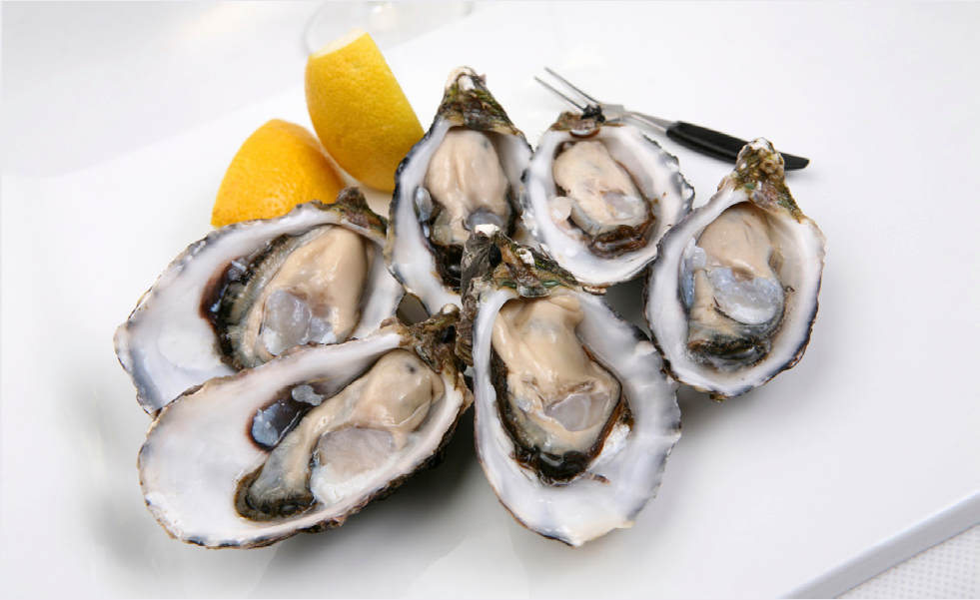

Legislation
EC Regulations 853/2004 and 854/2004 set out criteria relating to the commercial production and sale of live bivalve molluscs from classified production areas. These regulations are law in the UK and are implemented by means of the Food Hygiene (England) Regulations 2006.
Classification
Local Authorities carry out monthly bacteriological sampling of production areas. The results are used, by the Food Standards Agency, to classify these areas according to the E.coli levels in the shellfish sampled.
The classification determines the areas where shellfish can be collected from and how the shellfish have to be treated, after harvesting, to ensure they are safe to eat.
Classification categories
• A class - bivalve molluscs can be harvested for direct human consumption.
• B class - bivalve molluscs can be marketed for human consumption after purification in an approved plant or after relaying in an approved class A relaying area or after being subjected to an EC approved heat treatment process.
• C class - bivalve molluscs can be marketed for human consumption only after relaying for at least two months in an approved relaying area followed, where necessary, by treatment in a purification centre, or after an EC approved heat treatment process.
• Prohibited areas - bivalve molluscs must not be subject to production or be collected.
• Unclassified areas - bivalve molluscs must not be subject to production or be collected.
Chichester Harbour
Chichester Harbour is currently classified for Native Oysters only; no other bivalve molluscs should be harvested from this area for commercial sale.

Up to date categories of the beds within the Harbour can be confirmed by Chichester or Havant Councils or found on the Food Standards website at:
http://www.food.gov.uk/foodindustry/farmingfood/shellfish/shellharvestareas/

Registration documents
Registration documents are an important link in a chain of public health control measures designed to ensure that shellfish placed on the market are safe to eat. It is therefore essential that the origin of the shellfish is known and that this traceability is maintained from harvesting to final sale.
Registration documents are required for all batches of live bivalve molluscs. They are available free of charge on request from your local authority (Chichester District Council or Havant Borough Council). They are serially numbered and must not be photocopied. A new document must be used for each batch.
The completed registration document must accompany each batch at all times during transport from the production area to the place of destination, e.g. purification centre, dispatch centre, relaying area, processing plant. All relevant sections must be completed legibly and indelibly.

