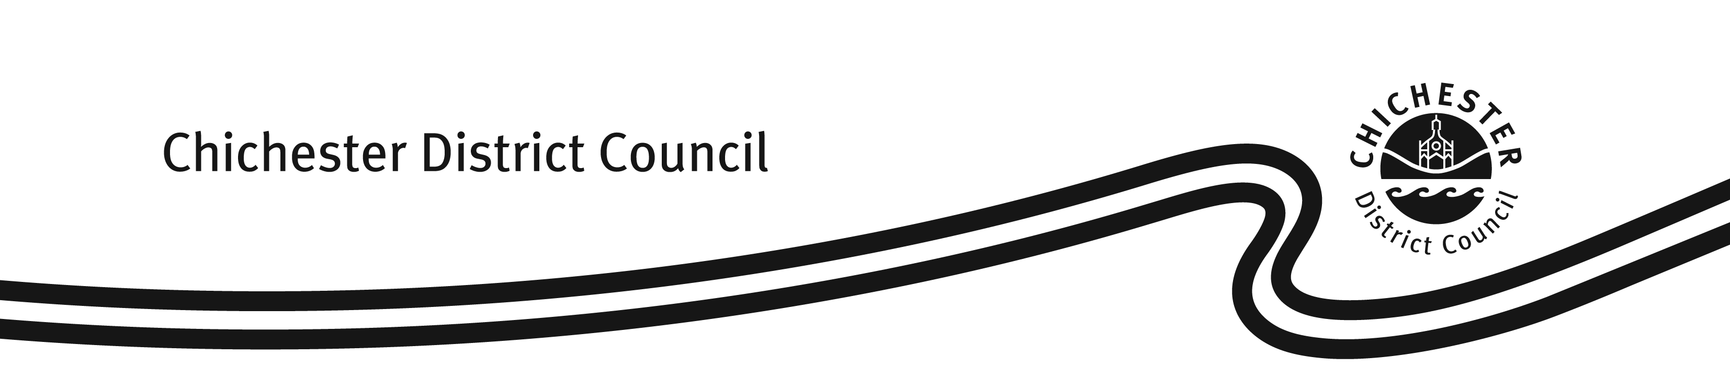
FORM: L68

Case Reference Number:

Club Premises Certificate – Request for a replacement copy
Licensing Act 2003

Where a Club Premises Certificate (the ‘certificate’) is lost, stolen, damaged or destroyed, the club may apply under Section 79 of the Licensing Act 2003 to the issuing Licensing Authority (the ‘Authority’) for a replacement copy.

However, in order for the Authority to issue a replacement, it must be satisfied that the certificate has either been lost, stolen, damaged or destroyed.

This Authority has developed this form to assist clubs in applying for a copy of the certificate. Please ensure the form is completed correctly and the fee paid. It is possible to submit this request by either of the following methods:

Email to: licensing@chichester.gov.uk

Post to: Licensing Team, Housing & Environment Services, Chichester District Council, East Pallant House, 1 East Pallant, Chichester, West Sussex, PO19 1TY

The current fee payable when updating a certificate is £10.50. Payment can be made by debit card by calling our Customer Services Team on 01243 534740. Alternatively payment can be by cheque made payable to ‘Chichester District Council’ or by cash.

CLUB PREMISES CERTIFICATE NUMBER (if known):
SECTION A – Club Certificate Holders Details
Name:

Address:

Tel.: Email:
SECTION B – Premises Details (if different from Section A above)
Name:

Address:

SECTION C
We are:

(a) Requesting a replacement copy of Part A of the Club Premises
Certificate Yes / No

Please explain why:

(b) Requesting a replacement copy of Part B of the Club Premises
Certificate Yes / No

Please explain why:

(c) Enclosing payment of the fee or have made the payment Yes / No

SECTION D - Declaration

I certify that the information contained within this form is correct to the best of my knowledge.

Signature:

Name:

Capacity:

Date:

Useful contact details:

Tel: 01243 534740 Fax: 01243 776766
Email: licensing@chichester.gov.uk Web: http://www.chichester.gov.uk/licensing

(v5 – 08.06.15)

